Xray tool description

Table of Contents
1 Introduction 4
1.1 What’s the point of Xray ? 4
1.2 Document changes 4
1.3 XRay tool evolution since version 5.2 4
2 Installation 5
3 Tool usage 6
3.1 Run 6
3.1.1 Manual load of XrayTool library 7
3.1.2 Automatic load of XrayTool library 8
3.2 Displays 9
3.2.1 Properties display 10
3.2.2 UNO structure display 11
3.2.3 Methods display 12
3.2.4 Detailed display 13
3.2.5 Services display 15
3.2.6 Interfaces display 16
3.2.7 Listeners display 17
3.2.8 Displaying other values 18
3.3 Cascading analysis 19
3.4 API Documentation 21
3.4.1 The API documentation 21
3.4.2 Displaying documentation about an object 22
3.5 Configuring Xray 23
3.5.1 Page 1 23
3.5.2 Page 2 24
4 Xray Menu 25
5 Using Xray with other programming languages 26
5.1 From a Python script within OpenOffice.org 26
5.2 From a BeanShell script within OpenOffice.org 26
5.3 From a Javascript script within OpenOffice.org 27
5.4 Through COM, under MS-Windows 28
5.4.1 From VBA 28
5.4.2 From Delphi 29
6 Credits 31
6.1 Host servers for this tool 31
6.2 Other translations of Xray 31
7 Licences 32
7.1 Documentation 32
7.2 Macro libraries 32

Introduction
This tool was developed on OpenOffice.org then on Apache OpenOffice.
Xray 6.0 was verified as working on
- OpenOffice.org (version 2.4.3 and version 3.3),
- Apache OpenOffice version 3.4,
- LibreOffice 3.4.

What’s the point of Xray ?
The most annoying aspect for a programmer familiar with VBA is that OpenOffice.org’s IDE does not have auto-completion (i.e. automatically propose methods or properties names while typing). This is due to OpenOffice.org’s different design concept. It does not have predefined objects, all necessary Uno objects are instantiated when needed. It is not possible to know statically (at compile time) the properties and methods available in a Uno object variable. You can only find them at runtime, therefore you must call Xray macro with the object to be analysed as argument.
Xray is a tool for the programmer of Basic macros using OpenOffice API. Its purpose is to display the properties, methods, services, interfaces which are provided by an object variable. It does this thanks to the introspection and reflection methods that are available on every UNO object.
Xray can display in a web browser the official API documentation about a property, method, service, interface of an object.
Xray can recursively analyse the current object, if a property contains an API object or if a method returns an API object.
Warning
Xray helps, but it is not an alternative to reading the existing documentation (the Basic Programming Guide, the Developer’s Guide and the IDL description of the SDK).

Document changes
This document describes version 6.0 of Xray tool. Screenshots were done on Apache OpenOffice verrsion 3.4.
The text takes into account the changes occurred in the organization of OpenOffice : takeover of OpenOffice.org by Apache OpenOffice, appearance of LibreOffice.

XRay tool evolution since version 5.2
- Key F4 displays more clearly the characteristics of a property or a method.
- Key F5 initiates an Xray analysis on a property or a method of the object.
- Key Ctrl-F searches in the text of the displayed information.
- Pseudo-properties : the display points out which methods (get and/or set) they correspond to.
Ambiguous properties are indicated.
The pseudo-properties DBG_xxx, specific to Basic, are no more displayed since Xray favorably replaces this primitive tool.
- Attributes : Xray shows the value of the attributes and finds their documentation.
- Methods :
  - the display points out if a parameter is used as output or as input/output ;
  - duplicates of methods are no more displayed ;
  - methods of the same name but of different interfaces are indicated ;
- Xray analysis is possible on a method with one argument of a simple type, and returning a value.
- Arrays :
  - Xray can display all the elements of an array, even a multi-dimensional one ;
  - Xray can analyse an element of an array, or find its documentation if it is a UNO object.
- The lists of services and interfaces supported by the object are more exhaustive.
- The listeners of the object are displayed in a dedicated panel, with details.
- A button displays again the parent object of the currently displayed object.
- You may tune the character font used for information display.
- The Xray panel may be resized in height and width.
- The API documentation can be obtained from a locally stored SDK, or from API pages of a Web server.
- The tool Xray Menu displays a panel from where you can Xray the most usual objects.

Installation
Click on this button to run the installation macro. After confirmation, it will suppress any existing installation of Xray and instal the new version. If your version of OpenOffice is incompatible with this version of Xray, a previous version will be suggested.

You shoud read carefully the description of Xray in the next chapters.
If you want to uninstall Xray libraries from your OpenOffice installation, click here :

Tool usage
Xray does not change anything to the IDE. It is a sub-program that you have to run from your code.

Run
In the macro you are debugging you have to (temporarily) insert a call to Xray macro. Most of the snapshots displayed at chapter 3.2 were done on a Writer document by running this simple macro :
Sub Main
Xray ThisComponent
End Sub
In this other macro example the object corresponding to the first sheet from a Calc document will be displayed :
Document = ThisComponent
AllSheets = Document.getSheets()
MySheet = AllSheets.getByIndex(0)
Xray MySheet

Remark
- If the line of code containing Xray raises an exception this is because the library is not loaded. Read sections 3.1.1 and 3.1.2 .

Manual load of XrayTool library
In order that the main macro Xray be recognized it is mandatory that XrayTool library be loaded. This library is in « My Macros ». The panel shows XrayTool library uncolored if it is not loaded :
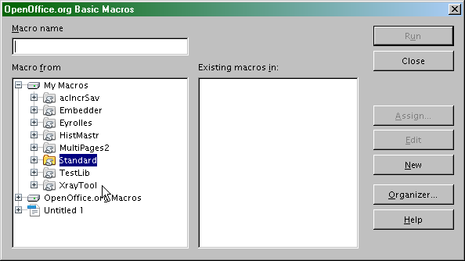
In order to load XrayTool library, just double-click on its name. The branch of its modules unfolds :
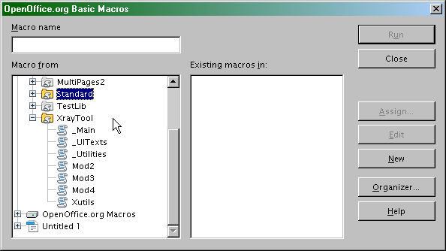

Automatic load of XrayTool library
If you want to avoid manual loading at each OpenOffice startup, install this macro in My Macros.Standard :
Sub LoadingLibraries
BasicLibraries.LoadLibrary("XrayTool")
End Sub
Assign it to « Start Application » event. Make sure that the« Save in » box at bottom displays the correct indication.
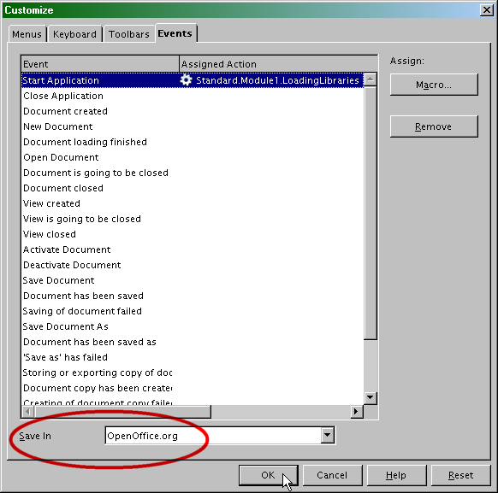
You may use this macro to load other application libraries.

Displays
When your macro runs, a panel will display information about your object. You may display :
- its properties (initial display),
- its methods,
- its services,
- its interfaces,
- its listeners.
Use the scrollbars at top right to increase the dimensions of the window.
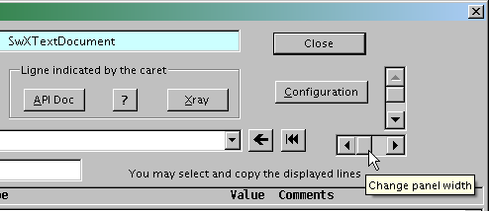
The next table enumerates useful shortcuts.

Shortcut | Usage
key Ctrl-F1  or button [API Doc] | Display documentation about the line pointed by the caret.  See section API Documentation.
key Ctrl-F | Search a text in the displayed information.
key F2 | Select (highlight) /unselect the line pointed by the caret.
key F4  or button [?] | Display details about the line pointed at by the caret.  (Properties display, Methods display)
key F5  or button [Xray] | Analyse by Xray the element at the line pointed at by the caret.  (Properties display, Methods display)  See section Cascading analysis.
Double-click | Like F5. You may deactivate this shortcut, see section Configuring Xray.

Properties display
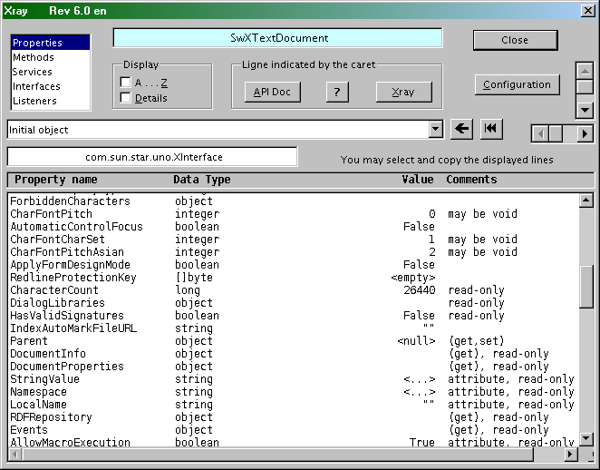
By default, properties are displayed in the order provided by introspection. Check the box « Display A..Z » to display them in alphabetical order.
If the symbol [] precedes the property type, it means that the property contains an array (an API sequence) where each element is of the shown type. The indication struct means that the property is a Uno structure. The indication object is used for the other API objects.
The value of the property is displayed whenever possible. Special cases :
- indication <empty> or <null> means that the property has no value in this context ; an empty array is shown as <empty> ;
- a string content is displayed between double-quotes, except if direct display is not possible (e.g. too long text) where indication <...> is shown instead ; use ket F4 to see the complete text ;
- no value is shown for a type object, struct, or an array , but you may request an Xray on that element (hit key F5).
After you have set the caret on a line (e.g. by mouse click), hit key F4 or the button [?] : you will often get more complete information about that property.

UNO structure display
A UNO structure is displayed in a Properties panel. Each line is an element of the structure. A UNO structure object has no methods, no services, no interfaces, no listeners.
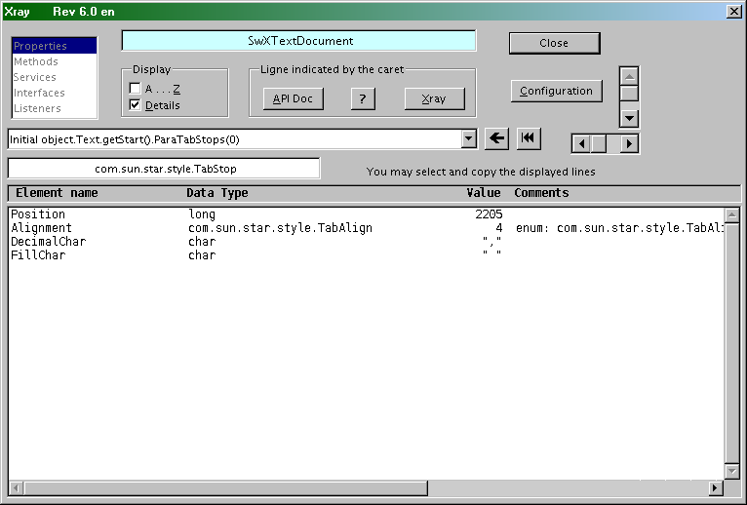

Methods display
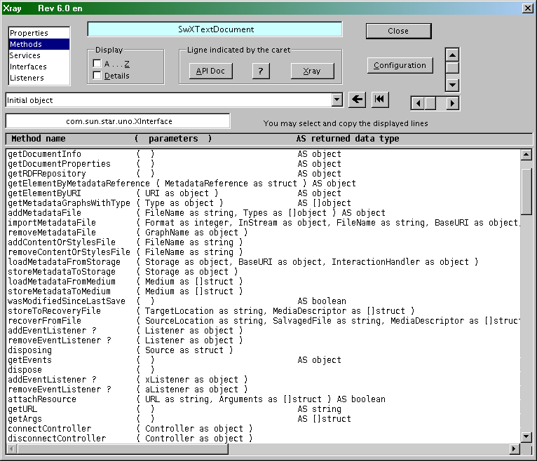
By default, methods are displayed in the order provided by introspection. Check the box « Display A..Z » to display them in alphabetical order.
The second column lists the method parameters, using Basic syntax. The name of each argument is provided by the introspection. The type of each argument is displayed as in the Properties panel.
If the method returns a value, its type is shown in the third column, after AS. Otherwise nothing appears in this column.
The interface exporting the method is indicated in the rightmost column (increase the panel width or use the horizontal scrollbar).
When you find a poorly understandable method, hit key F4 or button [?] after you have put the caret on the line. For example, on the screenshot above, methods addEventListener() and removeEventListener() are marqued with a question mark. The reason is explained in the panel displayed by F4.

Detailed display
The checkbox “ Details ” gives a more detailed display of the properties and methods. This display mode is more difficult to read but more useful to the seasoned programmer.
There is much information, it may be useful to enlarge the panel with the buttons at right. You may push F2 key to highlight the current line and use the horizontal scrollbar.
Hit key Ctrl-F to search a specific term in the panel. If one is already highlighted, it will be searched further down the text at each Ctrl-F. If nothing is highlighted, you will be asked a term to search.
Key F4 or button [?] displays a clearer view of the line indicated by the caret. Ctrl-F works also in the window opened by F4.
You may choose the default display : normal, detailed, natural or alphabetical order, and a panel dimensions to your liking. See section Configuring Xray.
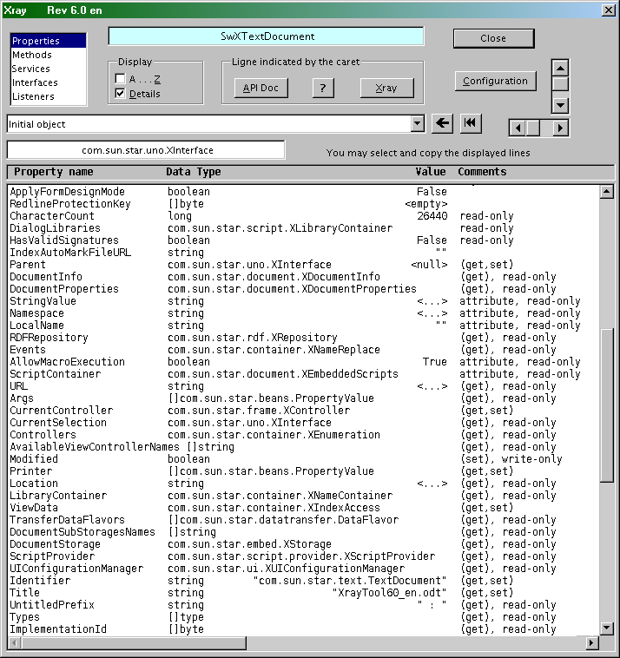
If you enjoy a large screen ...
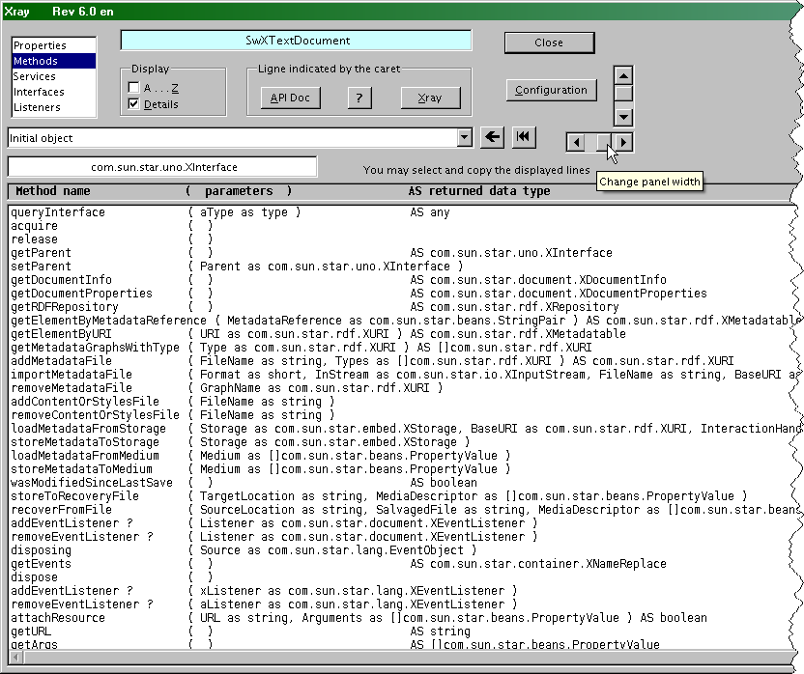
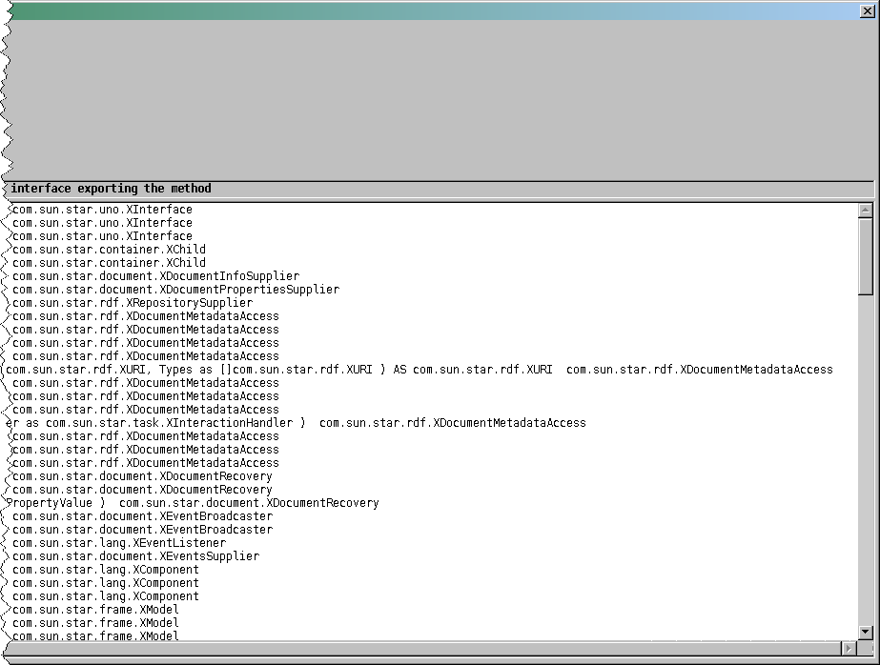

Services display
There are two lists of services :
- services always supported by the object
- available services that may be invoked with the createInstance() method of the object.
Each list is displayed in alphabetical order. You may call the API documentation for any of these services.
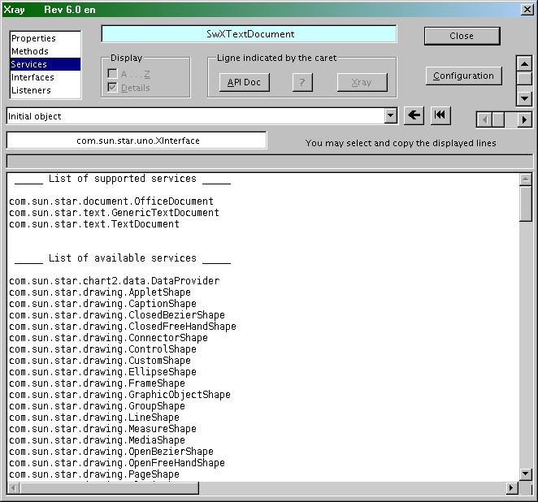

Interfaces display
The names of the interfaces exported by the object are listed in alphabetical order.You may call the API documentation for any of these interfaces.
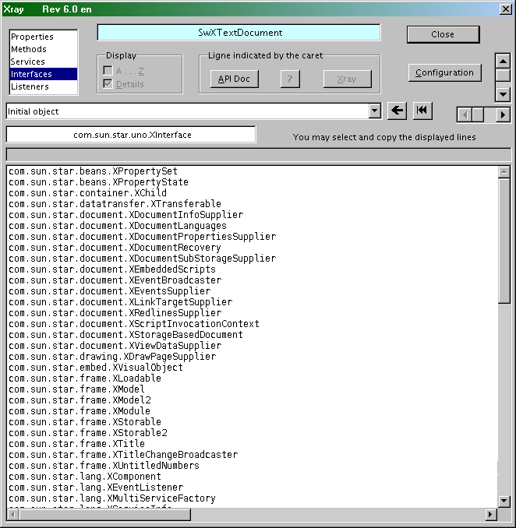

Listeners display
Listeners are interfaces used to watch over events. Xray displays for each listener :
- the events that are watched,
- the methods of the object that use this listener in one of its arguments.
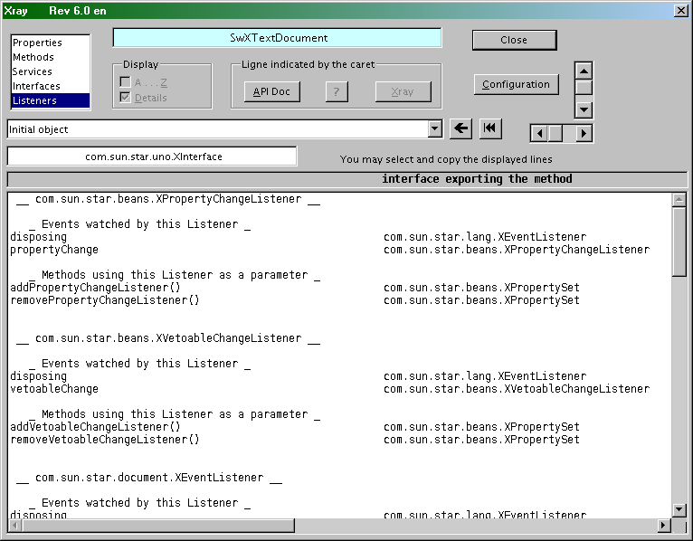
You may look for the API documentation of each method and each event after you have put the caret on the corresponding line.
An event documentation describes a method where the argument, also documented, contains event related data.

Displaying other values
Xray can display a simple value (number, string, etc) as well as any array. You have the same facilities as for an API object.
Xray can show the contents of all the items of an array, limited by the display panel and up to a maximum of 5 dimensions.
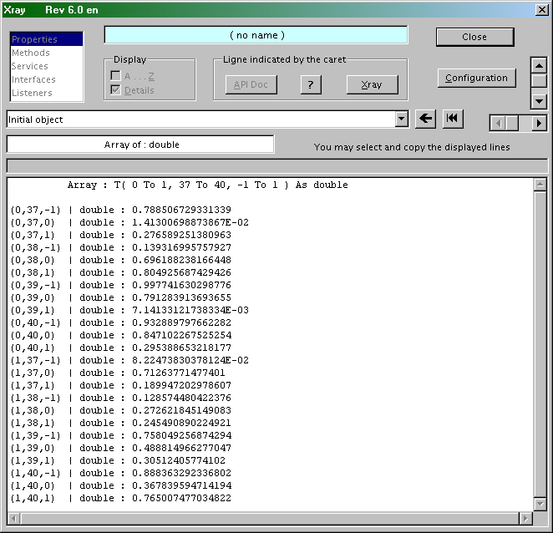

Cascading analysis
In the “ Properties ” panel you can request analysis of one of the properties by putting the caret in the line (with a mouse click) and then clicking on the button [Xray], or hitting F5 key, or with a double-click on the line.
This way you can analyse various objets included in the original object, then objects within these objects, and so on.
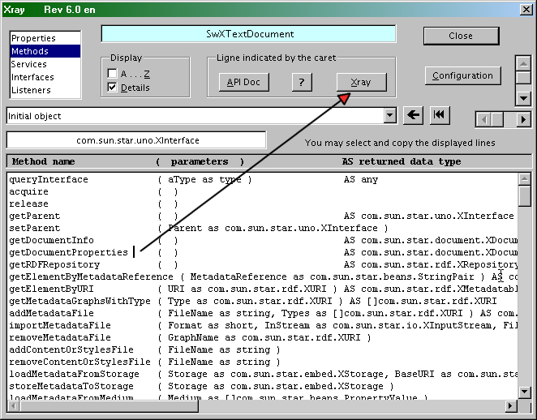
In the “ Methods ” panel you may as well request analysis of the value returned by a method, so long as it does not use any argument or one single argument of a simple type.
If you want to analyse a method with more complex arguments you have to close Xray, return in the editor, and modify the call of Xray by using appropriate arguments, example :
xray MySheet.getCellByPosition(3,5)
The first button right of the drop-down list lets go back to the parent object of the current object. The second button returns to the original object.
In order to go back on any already analyzed object, click on the drop-down list and choose one of the entries.
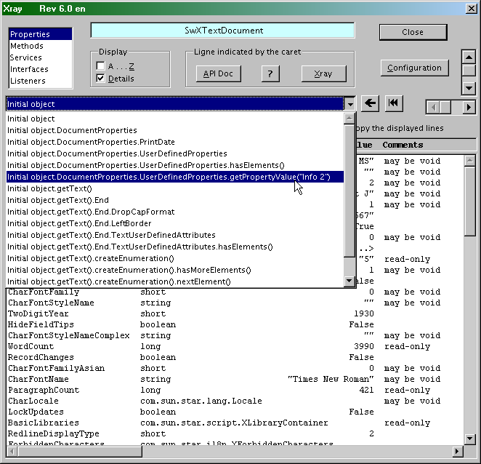

API Documentation
Xray can display in your browser the API documentation about :
- a property,
- a method,
- a service, an interface, a listener.
To do this, Xray must be configured to use the API documentation (see Configuring Xray).

The API documentation
Note for non-english users : API documentation is only available in english.
You find this documentation either on a Web server of Apache OpenOffice or LibreOffice, or in the SDK that you must download and install locally or on your local network.
Web server access does not work well with Apache OpenOffice 3.4.0 due to bug 119399.
It is much more convenient to use the SDK so as to be free from response times of the Web server. The SDK contains other documentations that may be of interest to the experienced programmer.

Downloading the SDK
The indicated addresses were valid at the date of the document.
- The most recent SDK of Apache OpenOffice is downloadable from this page.
- The most recent SDK of LibreOffice is downloadable from this page.
The installer of the SDK shows you the directory where it will be installed. Note this address, as it will be requested in the configuration dialog of Xray.
For example, the SDK of Apache OpenOffice version 3.4 is installed by default, under Windows XP operating system, in the directory :
C:\Program Files\OpenOffice.org 3\Basis\sdk

Finding the API Web server
Xray needs the address of the index file « Global Index A » from which it deducts the adresses of the other files. With your favorite Internet search engine, search for these terms :
- for the API of Apache OpenOffice :
"Apache OpenOffice"+"Global Index A"+"MediaDescriptor"
- for the API of LibreOffice :
"LibreOffice"+"Global Index A"+"MediaDescriptor"
For example, at the date of this document, the address of Global Index A was for Apache OpenOffice :
http://www.openoffice.org/api/docs/common/ref/index-files/index-1.html
and the one for LibreOffice was :
http://api.libreoffice.org/common/ref/index-files/index-1.html
The obtained page address will be requested in the configuration dialog of Xray.

Displaying documentation about an object
Put the caret on the line of the property, method, service or interface you want to see the documentation of. Then click the button [API Doc], or push key Ctrl-F1.
Note : lines beginning with one or more spaces are ignored.
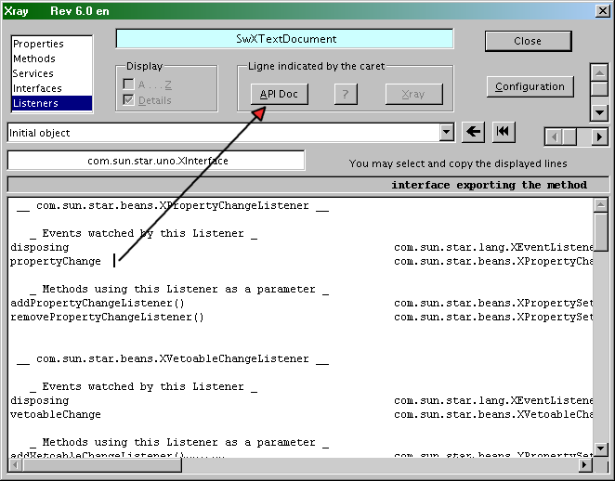
When requesting documentation display it may happen that there is no page available. Either it is an internal detail purposedly undocumented, or the documentation is lacking for this point.

Configuring Xray
Click the button [Configuration] on Xray panel. You will get a window that has two pages. You must switch to the second page in order to validate any change.

Page 1
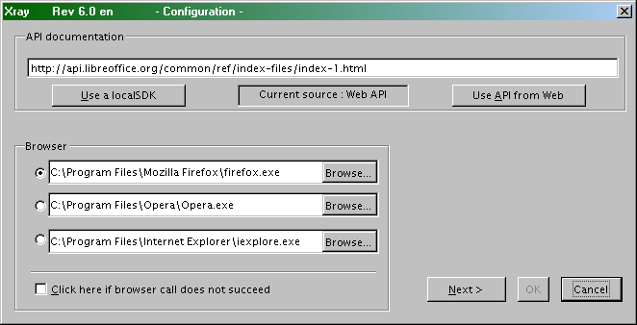

API documentation
Click on one of the two buttons.
You must previously have downloaded and installed the SDK if you want to use it.
If you want to use the API from the Web, you will depend on the availability of an Internet connection, and the availability of the distant server. In order to avoid too slow operations, Xray will download and store locally all the files for alphabetical indexes, and that takes some time.

Browser
You may store up to 3 different browser addresses. Click the button [Browse...] to find the address of the executable file of the browser in your operating system.
If the browser call does not work, try again after checking the option box [Click here ...].

Page 2
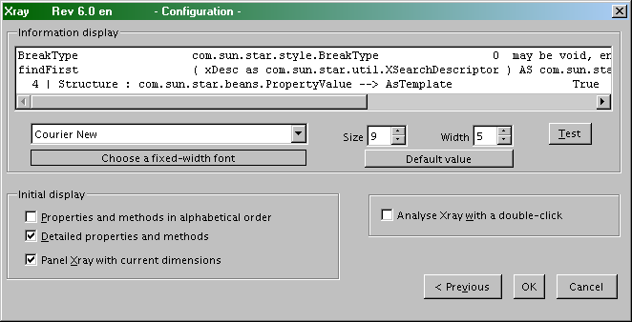

Information display
Some font names are proposed but you may indicate any other font available on your computer. Use a fixed width font. Tune as best fit the height and width of the characters ; click the button [Test] to see an example of display.

Initial display
Choose the display setting at start of Xray.

Double-click
Restarting an Xray analysis with a double-click may be a nuisance when exploring the window by clicks on the scrollbars. You may prefer to use key F5 or the button [Xray].

Xray Menu
This window is displayed by the macro XrayMenu that is situated in the library XrayTool, module XUtils. It can start Xray on usual objects : the current document, the current Calc sheet or Draw slide, a selection in a document (shape, image, cell, word, cursor, etc). It may also convert a system address into an URL address and vice-versa.
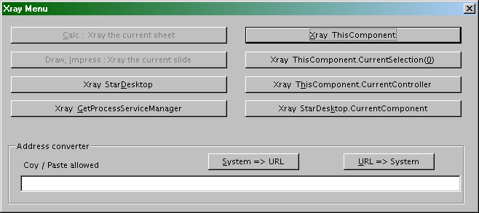
Hint :
Configure OpenOffice to call XrayMenu from a key shortcut like Alt-F5.
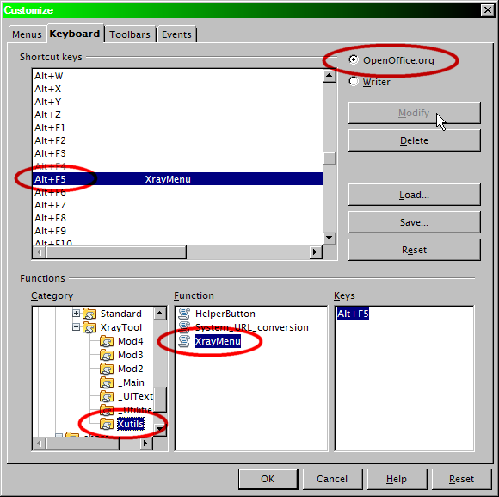
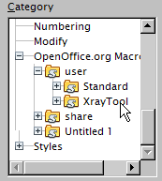

Using Xray with other programming languages
From OpenOffice.org version 2.0 the API offers a new method to call a script. Any programming language able to use the API may call a script written in one of the script languages supported by OpenOffice.org.
So, using this method it is possible to call Xray because it is no more than a Basic script.
The reader is expected to know how to program the API with the languages used here. Pay attention to instructions spanning over more than one line.

From a Python script within OpenOffice.org
Here is the contents of a file which must be stored in the folder user/Scripts/python/ (or in a folder Scripts/python/ within a document). Remember that lines must end with Unix-style Line-Feed.
import uno

from com.sun.star.uno import RuntimeException as _rtex

def xray(myObject):
try:
sm = uno.getComponentContext().ServiceManager
mspf = sm.createInstanceWithContext("com.sun.star.script.provider.MasterScriptProviderFactory", uno.getComponentContext())
scriptPro = mspf.createScriptProvider("")
xScript = scriptPro.getScript("vnd.sun.star.script:XrayTool._Main.Xray?language=Basic&location=application")
xScript.invoke((myObject,), (), ())
return
except:
raise _rtex("\nBasic library Xray is not installed", uno.getComponentContext())

# ___________ example of use _______________

def demoXray():
""" example : using xray in a Writer document """

xTextDoc = XSCRIPTCONTEXT.getDocument()
xText = xTextDoc.Text
xray(xText)
xray("Demo is finished")

g_exportedScripts = demoXray,

From a BeanShell script within OpenOffice.org
Here is the contents of a module in a BeanShell library of a document (or in My Macros).
import com.sun.star.uno.UnoRuntime;
import com.sun.star.uno.XComponentContext;
import com.sun.star.frame.XDesktop;
import com.sun.star.frame.XModel;

// ____________ declaration of BeanShell xray routine _______________

import com.sun.star.script.provider.XScriptProviderFactory;
import com.sun.star.script.provider.XScriptProvider;

void xray(ObjX) {
xCompCont = XSCRIPTCONTEXT.getComponentContext();
sm = xCompCont.getServiceManager();
mspf = sm.createInstanceWithContext("com.sun.star.script.provider.MasterScriptProviderFactory", xCompCont);
xspf = UnoRuntime.queryInterface(XScriptProviderFactory.class, mspf);
scriptPro = xspf.createScriptProvider("");
xsp = UnoRuntime.queryInterface(XScriptProvider.class, scriptPro);
Xscript = xsp.getScript("vnd.sun.star.script:XrayTool._Main.Xray?language=Basic&location=application");
args = new Object [1];
short [ ] [ ] a;
Object [ ][ ] b;
args[0] = ObjX;
Xscript.invoke(args, a, b);
}

// ____________ end of BeanShell xray routine _____________________

import com.sun.star.text.XTextDocument;
import com.sun.star.text.XText;

oDoc = XSCRIPTCONTEXT.getDocument();
xTextDoc = (XTextDocument) UnoRuntime.queryInterface(XTextDocument.class,oDoc);
xText = xTextDoc.getText();

xray(xText);
xray("Demo is finished");

// BeanShell OpenOffice.org scripts should always return 0
return 0;

From a Javascript script within OpenOffice.org
Here is the contents of a module in a Javascript library of a document (or in My Macros).
importClass(Packages.com.sun.star.uno.UnoRuntime);
importClass(Packages.com.sun.star.text.XTextDocument);
importClass(Packages.com.sun.star.text.XText);

importClass(Packages.com.sun.star.lang.XServiceInfo);

// ____________ declaration of JavaScript xray routine _______________

importClass (Packages.com.sun.star.script.provider.XScriptProviderFactory);
importClass (Packages.com.sun.star.script.provider.XScriptProvider);

function xray(ObjX) {
var xCompCont = XSCRIPTCONTEXT.getComponentContext();
var sm = xCompCont.getServiceManager();
var mspf = sm.createInstanceWithContext("com.sun.star.script.provider.MasterScriptProviderFactory", xCompCont);
var xspf = UnoRuntime.queryInterface(XScriptProviderFactory, mspf);
var scriptPro = xspf.createScriptProvider("");
var xsp = UnoRuntime.queryInterface(XScriptProvider, scriptPro);
var Xscript = xsp.getScript("vnd.sun.star.script:XrayTool._Main.Xray?language=Basic&location=application");
var args = new Array(1);
args[0] = ObjX;
var a = new Array( new Array() );
var b = new Array( new Array() );
Xscript.invoke(args, a, b);
};

// ____________ end of JavaScript xray routine _____________________

oDoc = XSCRIPTCONTEXT.getDocument();
xTextDoc = UnoRuntime.queryInterface(XTextDocument,oDoc);
xText = xTextDoc.getText();

xray(xText);
xray("Demo is finished");

Through COM, under MS-Windows
Most of the modern languages available under MS-Windows can handle OpenOffice.org API by using COM. So that you may call the Xray Basic script in a way similar to previous examples.

From VBA
This VBA code creates a new Writer document and calls Xray with the document object as argument. It was tested from Word 2002.
Option Explicit

Sub Main()
Dim sm As Object, DeskTop As Object, oDoc As Object
Dim args()

Set sm = CreateObject("com.sun.star.ServiceManager")
Set DeskTop = sm.createInstance("com.sun.star.frame.Desktop")
Set oDoc = DeskTop.loadComponentFromURL("private:factory/swriter", "_blank", 0, args)
xray oDoc
oDoc.Close True
End Sub

Sub xray(myObject As Object)
Dim sm As Object, mspf As Object, scriptPro As Object, xScript As Object
Dim noargs1() As Variant, noargs2() As Variant, arg1(0) As Variant

Set sm = CreateObject("com.sun.star.ServiceManager")
Set mspf = sm.createInstance("com.sun.star.script.provider.MasterScriptProviderFactory")
Set scriptPro = mspf.createScriptProvider("")
Set xScript = scriptPro.getScript("vnd.sun.star.script:XrayTool._Main.Xray?language=Basic&location=application")
Set arg1(0) = myObject

xScript.Invoke arg1, noargs1, noargs2
End Sub

From Delphi
This Delphi code creates a new Writer document and calls Xray with the document object as argument. It was tested from Delphi 7.
Uses ComObj;

procedure xray(myObject: Variant);
var
ooo, mspf, scriptPro, xScript, arg, noargs1, noargs2: Variant;
begin
ooo:= CreateOleObject('com.sun.star.ServiceManager');
mspf:= ooo.createInstance('com.sun.star.script.provider.MasterScriptProviderFactory');
scriptPro:= mspf.createScriptProvider('');
xScript:= scriptPro.getScript('vnd.sun.star.script:XrayTool._Main.Xray?language=Basic&location=application');
arg:= VarArrayCreate([0,0], varVariant);
arg[0]:= myObject;
noargs1:= VarArrayCreate([0, -1], varVariant);
noargs2:= VarArrayCreate([0, -1], varVariant);
xScript.invoke( arg, noargs1, noargs2);
end;

procedure Main;
var
ooo, Desktop, oDoc, args: Variant;
begin
ooo:= CreateOleObject('com.sun.star.ServiceManager');
Desktop:= ooo.createInstance('com.sun.star.frame.Desktop');
args:= VarArrayCreate([0, -1], varVariant);
oDoc:= Desktop.loadComponentFromURL('private:factory/swriter', '_blank', 0, args);

xray(oDoc);
oDoc.close(True);
end;
An alternative solution, much simpler, is to use the ressources of Delphi_OOo tool available at my Web site. Its unit OooXray is a Delphi-native equivalent of Xray macro, done with help of COM and the display facilities of Delphi 7. Unit OooTools simplifies the API calls.
The same example boils down to this :
Uses ComObj, OOoTools, OooXray;

procedure Main;
Var
oDoc: Variant;
Begin
ConnectOpenOffice;
oDoc:= StarDesktop.LoadComponentFromURL('private:factory/swriter', '_blank', 0, dummyArray);

Xray(oDoc);
oDoc.close(True);
End;

Credits
Author : Bernard Marcelly

Thanks to : Laurent Godard for his useful remarks.

Last modified : June, 3, 2012

Host servers for this tool
English version:
http://bernard.marcelly.perso.sfr.fr/index2.html
French version:
http://bernard.marcelly.perso.sfr.fr/index.html

Other translations of Xray
This document/tool exists in version 5.1 or more recent. See my web page :
http://bernard.marcelly.perso.sfr.fr/index2.html

Licences

Documentation

Appendix

Public Documentation License Notice

The contents of this Documentation are subject to the Public Documentation License Version 1.0 (the "License"); you may only use this Documentation if you comply with the terms of this License. A copy of the License is available at http://www.openoffice.org/licenses/PDL.html.

The Original Documentation is : Description de l’outil Xray
The Initial Writer of the Original Documentation is Bernard Marcelly
Copyright (C) 2003-2012. All Rights Reserved. (Initial Writer contact(s): marcelly@club-internet.fr )

Contributor(s): ______________________________________.
Portions created by ______ are Copyright (C)_________[Insert year(s)].
All Rights Reserved. (Contributor contact(s):________________[Insert hyperlink/alias]).

NOTE: The text of this Appendix may differ slightly from the text of the notices in the files of the Original Documentation. You should use the text of this Appendix rather than the text found in the Original Documentation for Your Modifications.

Macro libraries
The library XrayTool included in this document constitutes a tool which displays information on an OpenOffice API object. Copyright (C) 2003-2012 Bernard Marcelly
Licensed under the Apache License, Version 2.0 (the "License") ; you may not use this file except in compliance with the License.
You may obtain a copy of the License at
http://www.apache.org/licenses/LICENSE-2.0
Unless required by applicable law or agreed to in writing, software distributed under the License is distributed on an "AS IS" BASIS, WITHOUT WARRANTIES OR CONDITIONS OF ANY KIND, either express or implied.
See the License for the specific language governing permissions and limitations under the License.

