Deliverable 1 UMPLE Code:

class Login

{

String username;

String password;

}

class Account

{

* -- 1 Login;

String username;

String password;

1 -- 1 User;

}

class User

{

String lastName;

String firstName;

Date dateOfBirth;

String email;

String phoneNum;

String address;

}

class Administrator

{

isA User;

}

class Service_Provider

{

isA User;

}

class Homeowner

{

isA User;

}

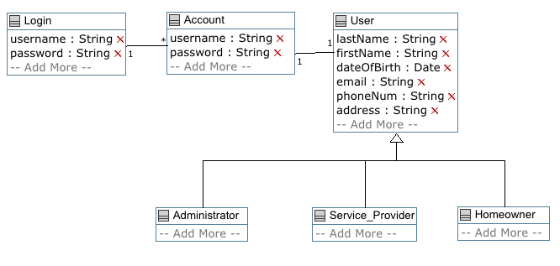

Deliverable2:

The administrator can:

1. Create services (at least 10) to be offered: The list of services may include: Appliance install, carpet cleaning, moving, plumbing, appliance repair, Furniture assembly, Locksmith, painting, window cleaning, Electrical, Mould Remediation, Pest control, Junk Removal, Handyman services.

2. Specifies a rate per hour for the services created.

Code:

class Login

{

String username;

String password;

}

class Account

{

* -- 1 Login;

String username;

String password;

1 -- 1 User;

}

class User

{

String lastName;

String firstName;

Date dateOfBirth;

String email;

String phoneNum;

String address;

}

class Administrator

{

isA User;

}

class Service_Provider

{

isA User;

}

class Homeowner

{

isA User;

}

class Service

{

String serviceId;

String typeOfService;

double hourRate;

* -- 1..* Administrator;

}

