1. **The Session**
   1. **Search The Session for Colm Gannon In Concert**

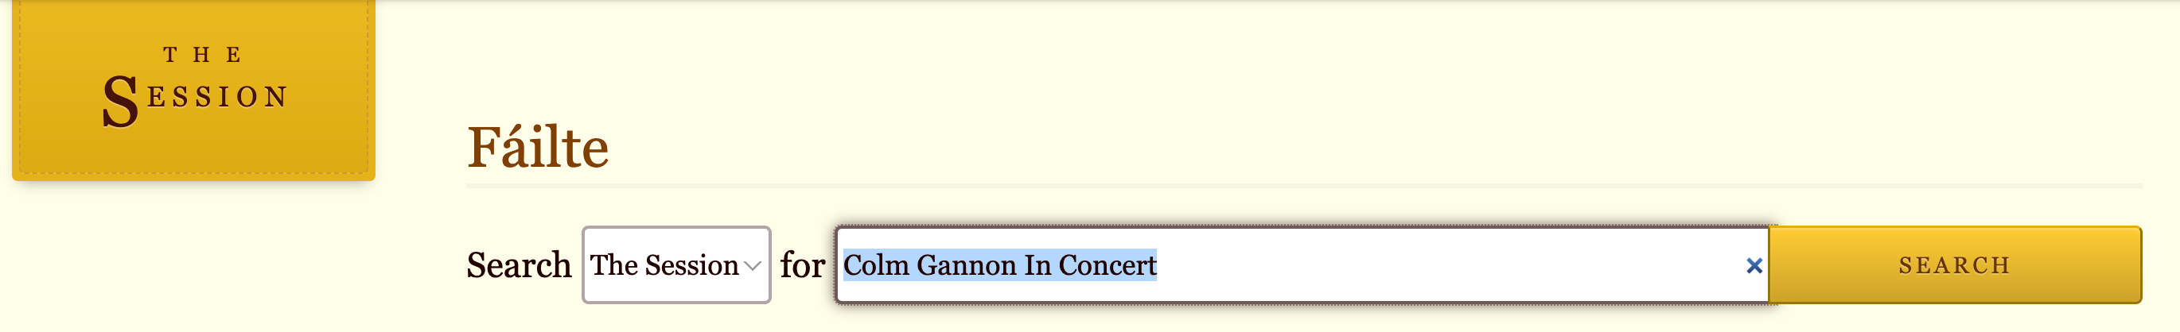

the results are: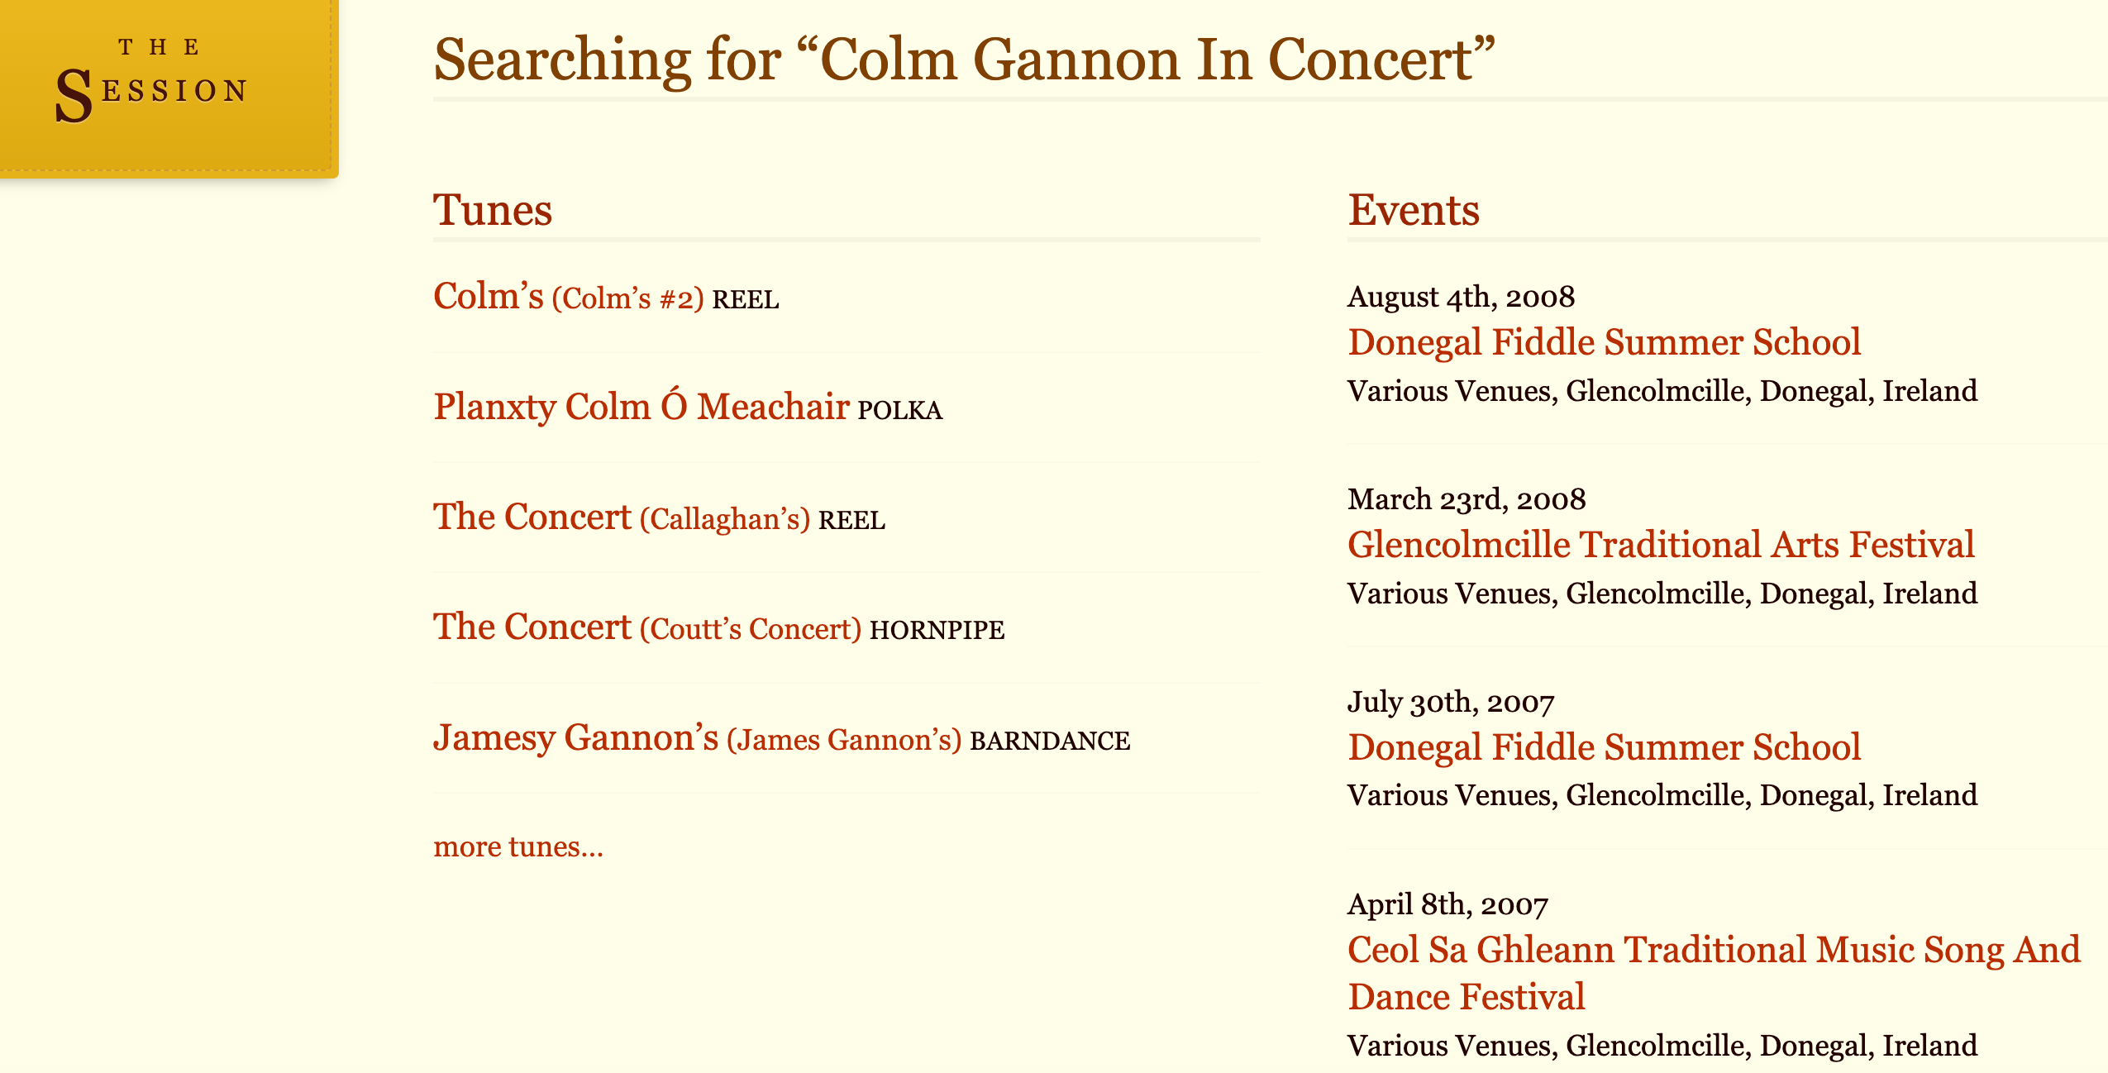

We can not find the event whose name is “Colm Gannon In Concert”. But we tried click the Tune “Colm’s” (Colm:科鲁姆)...

* 1. **Searching jigs in Dmajor for “colm”**

**1.2.1 Webpage Query**

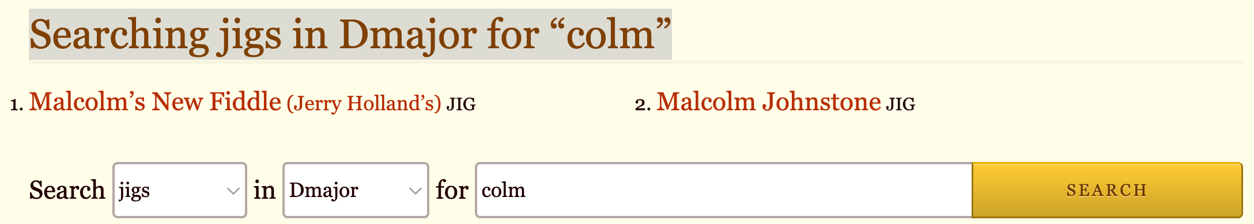

**1.2.2 Using SPARQL against RDF**

```

prefix wd:<http://www.wikidata.org/entity/>

prefix wdt:<http://www.wikidata.org/prop/direct/>

select distinct *

where {

?Tune rdf:type wd:Q170412;

wdt:P2561 ?nameOfTune;

wdt:P2308 "jig";

wdt:P2308 ?Type;

wdt:P826 "D major".

filter(contains(str(?nameOfTune), "colm")).

}

```

The result is like:

1. **MusicBrainz**

Navigation: <https://musicbrainz.org/> > <https://musicbrainz.org/search>

* 1. **Search a Label whose name is “Fall Out Records”**
     1. **Webpage Query**

<https://musicbrainz.org/search?query=Fall+Out+Records&type=label&limit=25&method=direct>

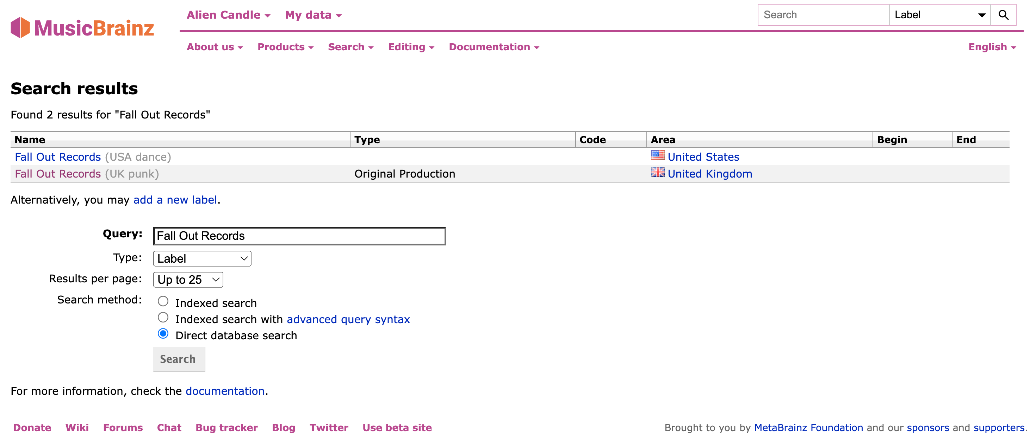

* + 1. **Using SPARQL against RDF**

```

```

* 1. **Please find the Record Label whose genre is punk and whose area is United States.**
  2. **Search ...**

**2.1.1 Webpage Query**

**2.1.2**