**DDO Character Generator V4 Help**

Welcome to the DDO Character Generator V4 help file. DDO Character Generator is a program used to help get the most out of your in game experience by helping you see the options for your character before you face them in game. Not all information about the game is in the planner, but we have tried to add a lot of it. For additional information please check out <http://ddowiki.com> there you will find a lot of information from the types of gear in game to specific abilities of each race and a lot more.

The interface has two different ways to interact with your character. The level by level approach, this most closely resembles how you would build a character in the game. Only seeing the options as they come available to you at the current level. The other method is on an overall very of the character based on the trait you are working with (ie Class, Skill). This method can helps see the overall picture more clearly at one time.

**Opening Screen**

1

10

11

9

8

7

6

5

4

3

2

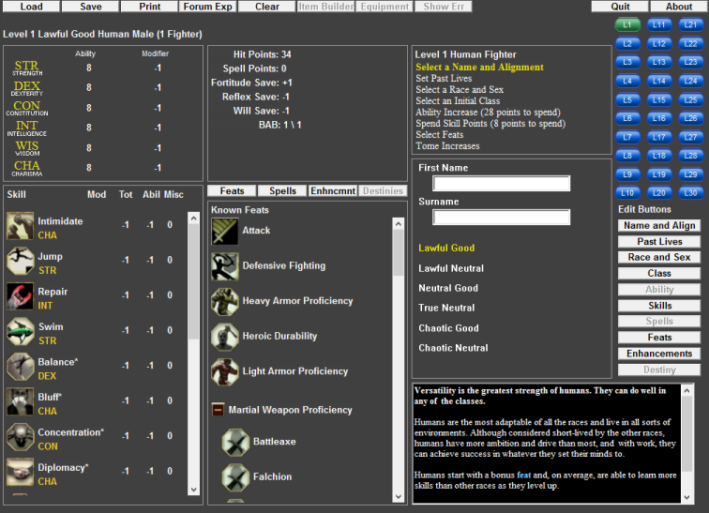

1. Menu Bar and Current Character info
   1. Load – Load an existing character.
   2. Save – Save a character.
   3. Print – Brings up the print character window.
   4. Forum Export – Brings up the Forum Export window.
   5. Clear – Resets the current character to start.
   6. Item Build – Currently disabled.
   7. Equipment – Currently disabled.
   8. Show Errors – If a level button is shown in red this will display the current error(s) in the description box.
2. Attribute Window – Shows the current value of your attributes at the current level. Modified value will appear in ()
3. Current tracked abilities will display here
4. Character Level Interaction Buttons – The current option available for a selected level will be displayed here select desired choice to change the selection box.
5. Level Button – Your current level will be shown in green, click button to change level. If a level has an error in it, button will show in red.
6. Skill Display – Displays the value of the skills at the current level.
7. Special Traits Selection Bar – Select the current special trait to display in the display box.
8. Special Trait Display Box
9. Selection Box – Current options will show here based on the selection in the Character Level Interaction Box
10. Edit Button Menu
    1. Name and Align – Displays the name and Alignment window
    2. Past Lives – Displays the Past Lives window.
    3. Race and Sex – Displays the Race and Sex window.
    4. Class – Displays the Class edit window to edit the class at all levels on one page.
    5. Ability – Displays the Ability window to set Abilities for level 1 and the Abilities increases on one page.
    6. Skills – Displays the Skills window to set the skill for all levels on one page.
    7. Spells – Displays the Spells window to set all spells on one page. – **Currently disabled**.
    8. Feat – Displays the Feat window to set all feat on one page.
    9. Enhancements – Displays the Enhancements window.
    10. Destiny – Displays the Destiny window – **Currently disabled**.
    11. Description Box – Will display information about current selection or messages.

**Name and Alignment**

Enter a Name, Surname and select an Alignment.

Alignment select may affect your choices for Class later.

**Past Lives**

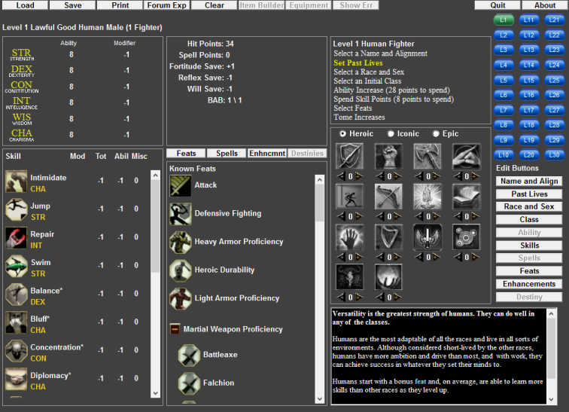

Select your past lives for you Character. Use the radio button to select from Heroic, Iconic, and Epic past lives to add Feat.

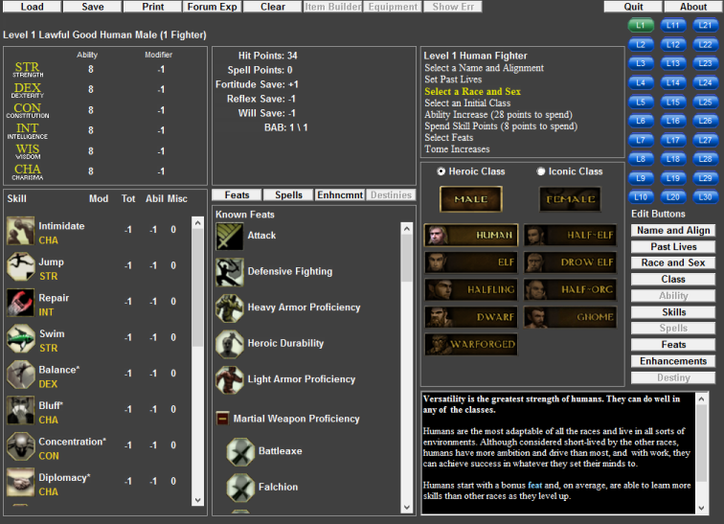

**Race and Sex**

Select you Race and Sex of your character. Use the Radio select from Heroic and Iconic Classes

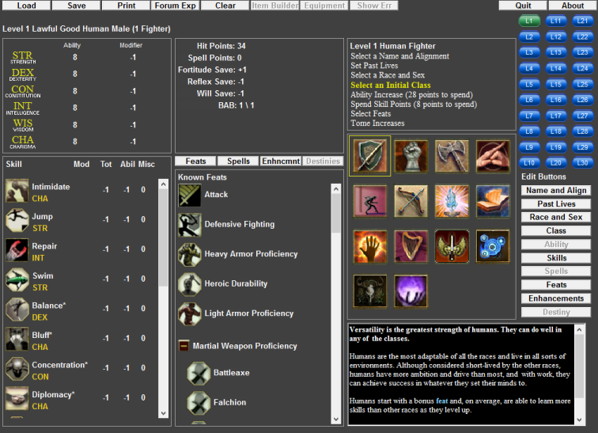

**Initial Class**

Select your Initial Class. If you selected an alignment that does not match your class you current alignment will be changed to one that is allowed by your class. To select the specific alignment you wish to have select the Name and Alignment selector again to select from the allowable options. Check under the menu bar to see if your alignment has been changed.

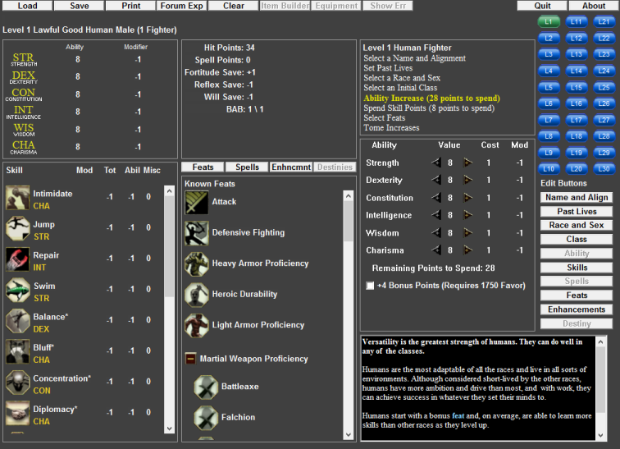**Ability Increase**

Select your desired ability scores. If you are building a character using the option Champion Option from favor select the checkbox.

**Skill Points**

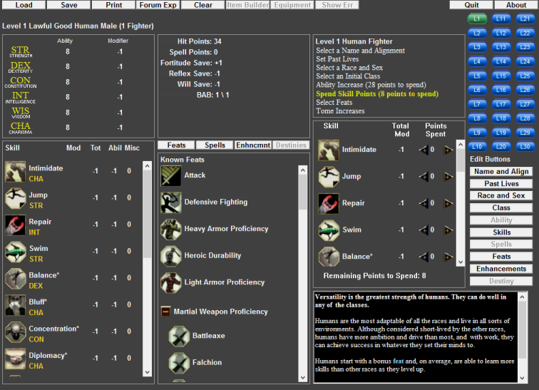

Select how to spend your skill points

**Select Feats**

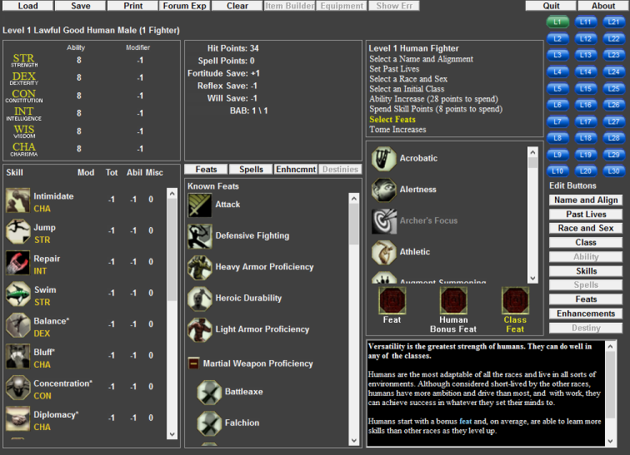

Select your desired Feats for the level by dragging the symbol to the desired feat box. Drag the item out of the box or drop a new item in to remove the current item.

**Tome Increases**

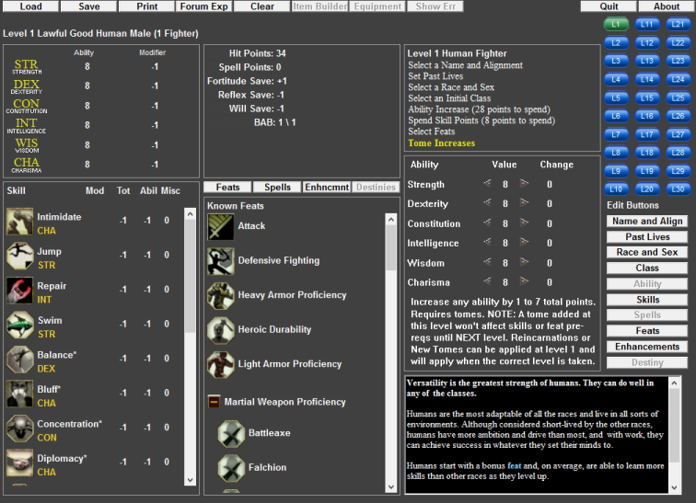

Add Value of the Tome you wish to add. For Tomes from past lives add them at level one. If you plan to add a tome but at a different level add the desired tome at the planned level.

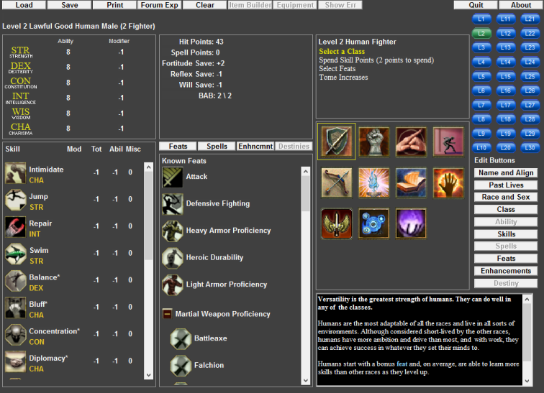

Example of possible options at level 2 that would be displayed.

**Edit Buttons**

**Name and Align** will set the current level to level 1 and Select the Name and Alignment Selector.

**Past Lives** will set the current level to level 1 and Select the Past Lives Selector.

**Race and Sex**  will set the current level to level 1 and Select the Race and Sex Selector.

**Class** will show the below screen. Grayed out classes cannot be chosen due to alignment choices. Drag you desired class to one of the Class selection boxes (1). To remove a selection from Class 2 or 3 right click on the class. Your current BAB at the level will be displayed on the right. Change the class at the desired level by selecting one of the class boxes for that Level.

1

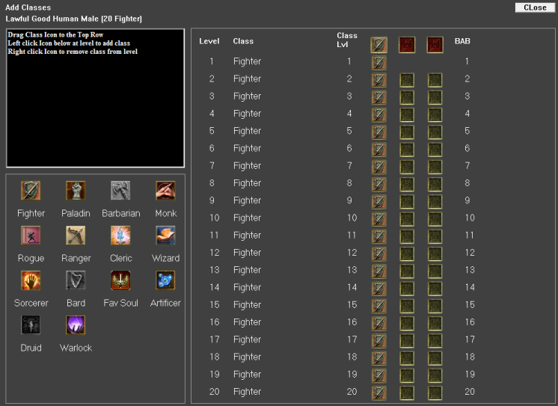

**Skills Window**

With the skill window you will see the Class skill boxes shown in green. Current available skill points can be found on the bottom of the page. Left click in the cell to add a point, Right click in the cell to remove a point. On the far right you will find an autofill panel. Set your desired point total for the skill set the priority level and the program will try to fill all your skills to your set total for you. The Fill Class Skills will only put a point in none class skills if it cannot reach your total by filling Class Skills first. This tries to maximize the total number of skill point achived.

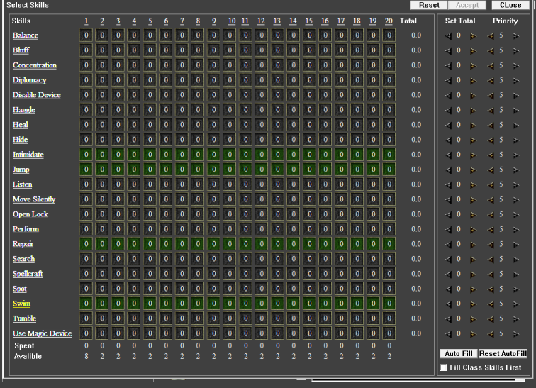

**Feat Window**

The feat window show all level that you have an available feat to be selected with a Green Level Button, Blue Button if it has been selected and Gray if no feat available. The Yellow button is the current level selected. You can drag any feat you would like from the Feat List or Wish List to the desired Feat selection Box or on the Feat wish list box. The description box will give information about the feat. The Selected Feats will display any feat that is currently selected. Use the Reset Level Feats to remove any feats take that level ( this will even clear feats that are not show due to class or race change).

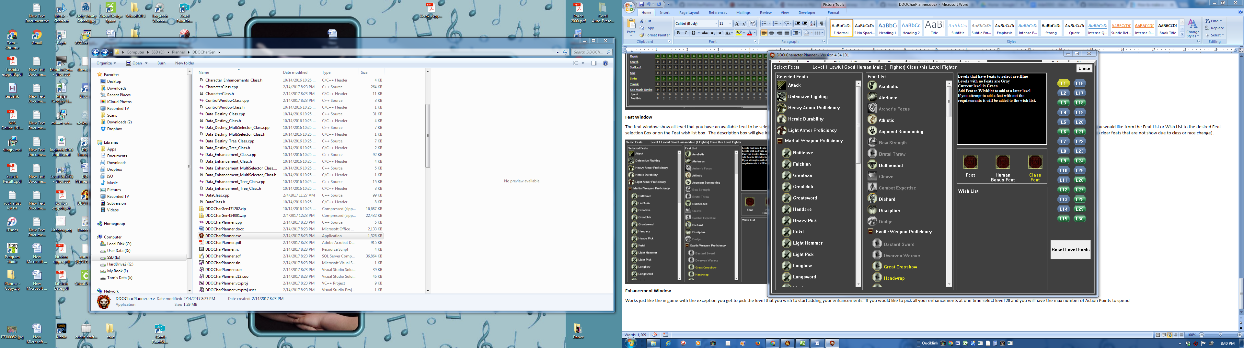

**Ability Window**

Click the 32 Point Build check mark for a favor build. Points Available shows the current amount remaining (includes points from Past Lives). Click on the Ability name in the Level up box to fill all abilities for level up. Enter past life tomes at level 1 to gain tomes points at the earliest possible level. Totals shown are for the level selected on the level bar.

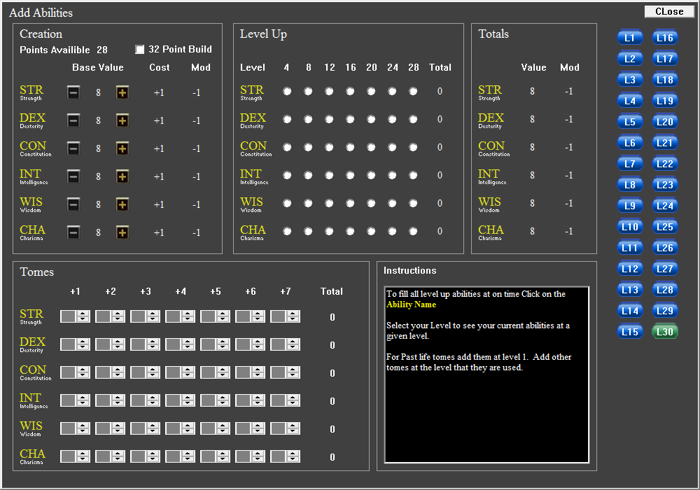

**Enhancement Window**

Works just like the in game with the exception you get to pick the level that you wish to start adding your enhancements. If you would like to pick all your enhancements at one time select level 20 and you will have the max number of Action Points to spend.