0. Pre-Illumination

In this project report we will follow the requirement of Phase IV directly. In Section 1 we gave problem description copied from Web site; in Section 2 we answered 3 questions listed in the project and justified our solution; in Section 3 we exhibited EER diagram with all assumptions; in Section 4 we showed our relational schema after normalization; in Section 5 we gave all requested SQL statements for both views and queries; and in Section 6 we gave dependency diagram induced from relational schemas. Finally, a short summary is given at the end of this report.

1. Problem Description

See the Phase 0.

2. Three Questions

2.1 1. Is the ability to model super-class / subclass relationships likely to be important in such environment? Why or why not?

Ans: Super-class, subclass is very important in our database design. For example, in the hotel, we have lots of different types, such as dining, concierge, housekeeping, etc. Without the super-class/ subclass, we would have to use weak entity type to represent the different types, which could lead to redundance. Now, we use subclasses of employee types and thus, our database achieves BCNF.

2.2

1. There are two rates of membership: Silver Prime & Golden Prime
2. There is another type of employee, shuttle driver. A shuttle driver has an experience year.
3. The hotel has an account in the bank. The accountant either has the authorization to manage this account or not. The account records the profit and cost daily.
4. There is a type of employee as procurement. They purchase goods needed for the hotel.
5. There is a type of employee as advertisement. A member in this apartment has an experience year.

2.3 Justify using a Relational DBMS like Oracle for this project.

See figure 1.

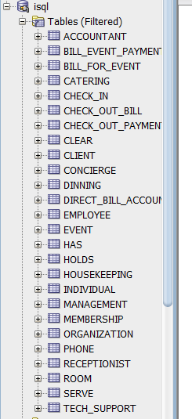

Figure 1: Oracle database implementation for the hotel database design.

3. EER diagram with all assumptions

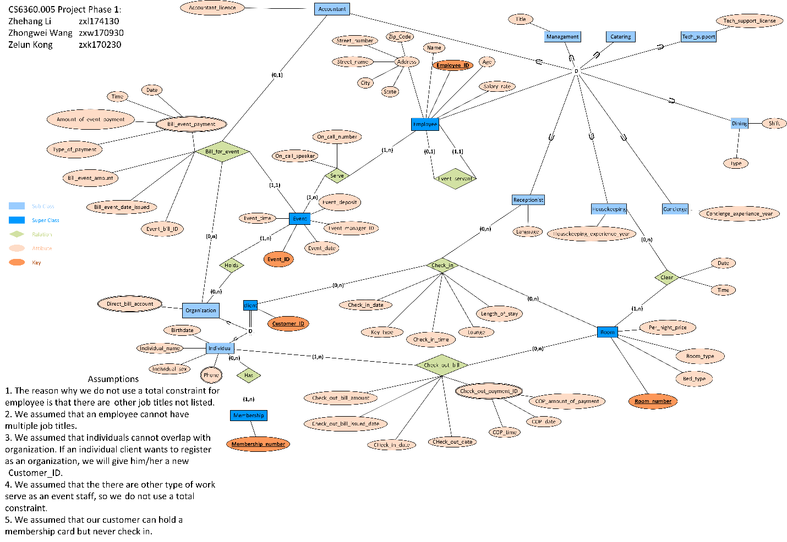

4. Relational Schema in Third Normal Form

4.1 Regular Entity

1. Employee:

|  |  |  |  |  |  |  |  |  |
| --- | --- | --- | --- | --- | --- | --- | --- | --- |
| EmployeeID | Age | Salary_rate | Name | State | City | Street_name | Street_number | Zipcode |

1. Dinning:

|  |  |  |
| --- | --- | --- |
| EmployeeID | Shift | Type |

EmployeeID is a FK referencing to the Employee.EmployeeID.

1. Concierge:

|  |  |
| --- | --- |
| EmployeeID | Concierge_experience_year |

EmployeeID is a FK referencing to the Employee.EmployeeID.

1. Housekeeping:

|  |  |
| --- | --- |
| EmployeeID | Housekeeping_experience_year |

EmployeeID is a FK referencing to the Employee.EmployeeID.

1. Receptionist:

|  |  |
| --- | --- |
| EmployeeID | Language |

EmployeeID is a FK referencing to the Employee.EmployeeID.

1. Tech_support:

|  |  |
| --- | --- |
| EmployeeID | Tech_support_licence |

EmployeeID is a FK referencing to the Employee.EmployeeID.

1. Management:

|  |  |
| --- | --- |
| EmployeeID | Title |

EmployeeID is a FK referencing to the Employee.EmployeeID.

1. Catering:

|  |
| --- |
| EmployeeID |

EmployeeID is a FK referencing to the Employee.EmployeeID.

1. Accountant:

|  |  |
| --- | --- |
| EmployeeID | Accountant_licence |

EmployeeID is a FK referencing to the Employee.EmployeeID.

1. Event:

|  |  |  |  |  |
| --- | --- | --- | --- | --- |
| Event_ID | Event_date | Event_time | Event_manager_ID | Event_deposit |

Event_manager_ID is a FK referencing to the Management.EmployeeID.

1. Client:

|  |
| --- |
| Customer_ID |

1. Organization:

|  |
| --- |
| Customer_ID |

Customer_ID is a FK referencing to the Client. Customer_ID.

1. Individual:

|  |  |  |  |
| --- | --- | --- | --- |
| Customer_ID | Birthdate | Individual_name | Individual_sex |

Customer_ID is a FK referencing to the Client. Customer_ID.

1. Membership:

|  |
| --- |
| Membership_number |

1. Room:

|  |  |  |  |
| --- | --- | --- | --- |
| Room_number | Bed_type | Room_type | Per_night_price |

2.2: Weak Entity (We do not have this☹)

2.3: Mapping 1:1 relationship

Employee:

|  |  |  |  |  |  |  |  |  |  |
| --- | --- | --- | --- | --- | --- | --- | --- | --- | --- |
| EmployeeID | Age | Salary_rate | Name | State | City | Street_name | Street_number | Zipcode | Event_staff_ID |

Event_staff_ID is a FK referencing to the Employee. EmployeeID.

2.4 Mapping 1:N relationship (We do not have this☹)

2.5 Mapping M:N relationship

1. Clear:

|  |  |  |  |
| --- | --- | --- | --- |
| Employee_ID | Room_number | Date | Time |

Employee_ID is a FK referencing to the Housekeeping.EmployeeID.

Room_number is a FK referencing to the Room. Room_number

1. Check_out_bill:

|  |  |  |  |  |  |
| --- | --- | --- | --- | --- | --- |
| Room_number | Customer_ID | Check_out_bill_amount | Check_out_bill_issued_date | Check_in_date | Check_out_date |

Room_number is a FK referencing to the Room. Room_number.

Customer_ID is a FK referencing to the Individual. Customer_ID.

1. Has:

|  |  |
| --- | --- |
| Customer_ID | Membership_number |

Customer_ID is a FK referencing to the Individual. Customer_ID.

Membership_number is a FK referencing to the Membership. Membership_number.

1. Holds:

|  |  |
| --- | --- |
| Event_ID | Customer_ID |

Event_ID is a FK referencing to the Event.Event_ID.

Customer_ID is a FK referencing to the Organization.Customer_ID.

1. Serve:

|  |  |  |  |
| --- | --- | --- | --- |
| Event_ID | Employee_ID | On_call_speaker | On-call_number |

Event_ID is a FK referencing to the Event.Event_ID.

Employee_ID is a FK referencing to the Employee.Employee_ID.

2.6: Mapping of Multivalued Attributes

1. Bill_event_payment:

(Implemented after 2.7)

|  |  |  |  |  |  |
| --- | --- | --- | --- | --- | --- |
| Customer_ID | Event_bill_ID | Date | Time | Amount_of_event_payment | Date_of_payment |

Customer_ID is a FK referencing to the Organization.Customer_ID.

1. Direct_bill_account:

|  |  |
| --- | --- |
| Customer_ID | Direct_bill_account |

Customer_ID is a FK referencing to the Organization.Customer_ID.

1. Phone:

|  |  |
| --- | --- |
| Customer_ID | Phone |

Customer_ID is a FK referencing to the Individual.Customer_ID.

1. Check_out_payment_ID:

|  |  |  |  |  |
| --- | --- | --- | --- | --- |
| Customer_ID | Room_number | COP_time | COP_date | COP_amount_of_payment |

Customer_ID is a FK referencing to the Individual.Customer_ID.

Room_number is a FK referencing to the Room.Room_number.

2.7: Mapping n-ary relationship

1. Check_in:

|  |  |  |  |  |  |  |  |
| --- | --- | --- | --- | --- | --- | --- | --- |
| Customer_ID | Employee_ID | Room_number | Check_in_date | Key_type | Check_in_time | Lounge | Length_of_stay |

Customer_ID is a FK referencing to the Client.Customer_ID.

Employee_ID is a FK referencing to the Receptionist.Employee_ID.

Room_number is a FK referencing to the Room.Room_number.

1. Bill_for_event:

|  |  |  |  |  |  |
| --- | --- | --- | --- | --- | --- |
| Customer_ID | Event_bill_ID | Event_ID | Employee_ID | Bill_event_date_issued | Bill_event_amount |

Customer_ID is a FK referencing to the Organization.Customer_ID.

Event_ID is a FK referencing to the Event.Event_ID.

Employee_ID is a FK referencing to the Accountant.Employee_ID.

4.1 Explanation for format design

Assumption:

* Data format for all Employee ID is an integer with length of 9.
* Age is an integer without any further restriction.
* Salary_rate is a number within [0, 9999999.99].
* Event_deposit is a number within [0, 99999.99]. (Max deposit is roughly one hundred thousand dollars.)
* Room number is a 4 digits number.
* Membership number is a 11 digits number.
* Direct bill account is a 20 char-long string.
* Length of stay is an integer greater than 0.

4.2 Format for Every Relation

|  |  |  |
| --- | --- | --- |
| Relation Name | Attributes | Data Type |
| Employee | EmployeeID | Numeric(9,0) |
| Age | Integer |
| Salary_rate | Numeric(9,2) |
| Name | String<=20 |
| State | String<=2 |
| City | String<=20 |
| Street_name | String<=20 |
| Street_number | String<=20 |
| Zipcode | String<=10 |
| Event_staff_ID | Numeric(9,0) |

|  |  |  |
| --- | --- | --- |
| Relation Name | Attributes | Data Type |
| Dinning | EmployeeID | Numeric(9,0) |
| Shift | String<=10 |
| Type | String<=20 |

|  |  |  |
| --- | --- | --- |
| Relation Name | Attributes | Data Type |
| Concierge | EmployeeID | Numeric(9,0) |
| Concierge_experience_year | Interger |

|  |  |  |
| --- | --- | --- |
| Relation Name | Attributes | Data Type |
| Housekeeping | EmployeeID | Numeric(9,0) |
| Housekeeping_experience_year | Interger |

|  |  |  |
| --- | --- | --- |
| Relation Name | Attributes | Data Type |
| Receptionist | EmployeeID | Numeric(9,0) |
| Language | String<=10 |

|  |  |  |
| --- | --- | --- |
| Relation Name | Attributes | Data Type |
| Tech_support | EmployeeID | Numeric(9,0) |
| Tech_support_licence | String<=100 |

|  |  |  |
| --- | --- | --- |
| Relation Name | Attributes | Data Type |
| Management | EmployeeID | Numeric(9,0) |
| Title | String<=20 |

|  |  |  |
| --- | --- | --- |
| Relation Name | Attributes | Data Type |
| Catering | EmployeeID | Numeric(9,0) |

|  |  |  |
| --- | --- | --- |
| Relation Name | Attributes | Data Type |
| Accountant | EmployeeID | Numeric(9,0) |
| Accountant_licence | String<=20 |

|  |  |  |
| --- | --- | --- |
| Relation Name | Attributes | Data Type |
| Event | Event_ID | Numeric(4,0) |
| Event_date | MM/DD/YYYY, STRING = 10 CHARS |
| Event_time | hh-mm-ss, string = 8 chars |
| Event_manager_ID | Numeric(9,0) |
| Event_deposit | Numeric(7,2) |

|  |  |  |
| --- | --- | --- |
| Relation Name | Attributes | Data Type |
| Client | CustomerID | Numeric(6,0) |

|  |  |  |
| --- | --- | --- |
| Relation Name | Attributes | Data Type |
| Organization | CustomerID | Numeric(6,0) |

|  |  |  |
| --- | --- | --- |
| Relation Name | Attributes | Data Type |
| Individual | CustomerID | Numeric(6,0) |
| Birthdate | MM/DD/YYYY, STRING = 10 CHARS |
| Individual_name | String<=20 |
| Individual_sex | String<=20 |

|  |  |  |
| --- | --- | --- |
| Relation Name | Attributes | Data Type |
| Membership | Membership_number | Numeric(11,0) |

|  |  |  |
| --- | --- | --- |
| Relation Name | Attributes | Data Type |
| Room | Room_number | Numeric(4,0) |
| Bed_type | String<=20 |
| Room_type | String<=20 |
| Per_night_price | Integer |

|  |  |  |
| --- | --- | --- |
| Relation Name | Attributes | Data Type |
| Clear | EmployeeID | Numeric(9,0) |
| Room_number | Numeric(4,0) |
| cDate | MM/DD/YYYY, STRING = 10 CHARS |
| cTime | hh-mm-ss, string = 8 chars |

|  |  |  |
| --- | --- | --- |
| Relation Name | Attributes | Data Type |
| Check_out_bill | Room_number | Numeric(4,0) |
| CustomerID | Numeric(6,0) |
| Check_out_bill_amount | Integer |
| Check_out_bill_issued_date | MM/DD/YYYY, STRING = 10 CHARS |
| Check_in_date | MM/DD/YYYY, STRING = 10 CHARS |
| Check_out_date | MM/DD/YYYY, STRING = 10 CHARS |

|  |  |  |
| --- | --- | --- |
| Relation Name | Attributes | Data Type |
| Has | CustomerID | Numeric(6,0) |
| Membership_number | Numeric(11,0) |

|  |  |  |
| --- | --- | --- |
| Relation Name | Attributes | Data Type |
| Holds | CustomerID | Numeric(6,0) |
| Event_ID | Numeric(4,0) |

|  |  |  |
| --- | --- | --- |
| Relation Name | Attributes | Data Type |
| Serve | Event_ID | Numeric(4,0) |
| EmployeeID | Numeric(9,0) |
| On_call_speaker | String<=20 |
| On-call_number | Numeric(4,0) |

|  |  |  |
| --- | --- | --- |
| Relation Name | Attributes | Data Type |
| Bill_event_payment | CustomerID | Numeric(6,0) |
| Event_bill_ID | Numeric(6,0) |
| pDate | MM/DD/YYYY, STRING = 10 CHARS |
| pTime | hh-mm-ss, string = 8 chars |
| Amount_of_event_payment | Numeric(8,2) |
| Date_of_payment | MM/DD/YYYY, STRING = 10 CHARS |

|  |  |  |
| --- | --- | --- |
| Relation Name | Attributes | Data Type |
| Direct_bill_account | CustomerID | Numeric(6,0) |
| Direct_bill_account | String=20 |

|  |  |  |
| --- | --- | --- |
| Relation Name | Attributes | Data Type |
| Phone | CustomerID | Numeric(6,0) |
| Phone | Numeric(10,0) |

|  |  |  |
| --- | --- | --- |
| Relation Name | Attributes | Data Type |
| check_out_payment_id | CustomerID | Numeric(6,0) |
| Room_number | Numeric(4,0) |
| COP_time | hh-mm-ss, string = 8 chars |
| COP_date | MM/DD/YYYY, STRING = 10 CHARS |
| COP_amount_of_payment | Numeric(8,2) |

|  |  |  |
| --- | --- | --- |
| Relation Name | Attributes | Data Type |
| Check_in | CustomerID | Numeric(6,0) |
| EmployeeID | Numeric(9,0) |
| Room_number | Numeric(4,0) |
| Check_in_date | MM/DD/YYYY, STRING = 10 CHARS |
| Key_type | String<=20 |
| Check_in_time | hh-mm-ss, string = 8 chars |
| Lounge | Boolean |
| Length_of_stay | Integer>0 |

|  |  |  |
| --- | --- | --- |
| Relation Name | Attributes | Data Type |
| Bill_for_event | CustomerID | Numeric(6,0) |
| Event_bill_ID | Numeric(6,0) |
| Event_ID | Numeric(4,0) |
| EmployeeID | Numeric(9,0) |
| Bill_event_date_issued | MM/DD/YYYY, STRING = 10 CHARS |
| Bill_event_amount | Numeric(8,2) |

5 All Requested SQL Statements

5.1 Creation of Database with SQL Statements

5.1.1 Table Creation

--1

create table employee

(employeeid numeric(9,0) primary key,

age number(3) not null,

salary_rate numeric(9,2),

name varchar2(20),

state varchar2(2),

city varchar2(20),

street_name varchar2(20),

street_number varchar2(20),

zipcode varchar2(10),

event_staff_id numeric(9,0) null

)

alter table employee add constraint fk_employee

foreign key (event_staff_id) references employee (employeeid);

--2

create table dinning

(shift varchar2(10) null,

type varchar2(20) null,

employeeid numeric(9,0) primary key

)

alter table dinning add constraint fk_dinning

foreign key (employeeid) references employee (employeeid);

--3

create table concierge

(

concierge_experience_year number(3) null,

employeeid numeric(9,0) primary key

)

alter table concierge add constraint fk_concierge

foreign key (employeeid) references employee (employeeid);

--4

create table housekeeping

(

housekeeping_experience_year number(3) null,

employeeid numeric(9,0) primary key

)

alter table housekeeping add constraint fk_housekeeping

foreign key (employeeid) references employee (employeeid);

--5

create table receptionist

(

language varchar2(10) null,

employeeid numeric(9,0) primary key

)

alter table receptionist add constraint fk_receptionist

foreign key (employeeid) references employee (employeeid);

--6

create table tech_support

(

tech_support_licence varchar2(10) null,

employeeid numeric(9,0) primary key

)

alter table tech_support add constraint fk_tech

foreign key (employeeid) references employee (employeeid);

--7

create table management

(

title varchar2(20) null,

employeeid numeric(9,0) primary key

)

alter table management add constraint fk_management

foreign key (employeeid) references employee (employeeid);

--8

create table catering

(

employeeid numeric(9,0) primary key

)

alter table catering add constraint fk_catering

foreign key (employeeid) references employee (employeeid);

--9

create table accountant

(

accountant_licence varchar2(20) null,

employeeid numeric(9,0) primary key

)

alter table accountant add constraint fk_accountant

foreign key (employeeid) references employee (employeeid);

--10

create table event

(

event_id numeric(4,0) primary key,

event_date date,

event_time timestamp(6) with time zone,

event_manager_id numeric(9,0) not null,

event_deposit numeric(7,2)

)

alter table event add constraint fk_event

foreign key (event_manager_ID) references employee (employeeid);

-- 11. Client

CREATE TABLE client

(

customerid NUMERIC(6,0) PRIMARY KEY

);

-- 12. Organization

CREATE TABLE organization

(

customerid NUMERIC(6,0) PRIMARY KEY

);

ALTER TABLE organization add CONSTRAINT fk_organization

FOREIGN KEY (customerid) REFERENCES client (customerid);

-- 13. Individual

CREATE TABLE individual

(

customerid NUMERIC(6,0) PRIMARY KEY,

birthdate DATE NULL,

individual_name VARCHAR2(20) NULL,

individual_sex VARCHAR2(20) NULL

);

ALTER TABLE individual add CONSTRAINT fk_individual

FOREIGN KEY (customerid) REFERENCES client (customerid);

-- 14. Membersip

CREATE TABLE membership

(

membership_number NUMERIC(11,0) PRIMARY KEY

);

-- 15. Room

CREATE TABLE room

(

room_number NUMERIC(4,0) PRIMARY KEY,

bed_type VARCHAR2(20) NULL,

room_type VARCHAR2(20) NULL,

per_night_price INTEGER NULL

);

-- 16. Clear

CREATE TABLE clear

(

employeeid NUMERIC(9,0) NOT NULL,

room_number NUMERIC(4,0) NOT NULL,

cdate DATE NULL,

ctime TIMESTAMP(6) WITH TIME ZONE,

PRIMARY KEY (employeeid, room_number)

);

ALTER TABLE clear add CONSTRAINT fk_clear1

FOREIGN KEY (employeeid) REFERENCES employee (employeeid);

ALTER TABLE clear add CONSTRAINT fk_clear2

FOREIGN KEY (room_number) REFERENCES room (room_number);

-- 17. check_out_bill

CREATE TABLE check_out_bill

(

room_number NUMERIC(6,0) NOT NULL,

customerid NUMERIC(6,0) NOT NULL,

check_out_bill_amount INTEGER NOT NULL,

check_out_bill_issed_date DATE NOT NULL,

check_in_date DATE NOT NULL,

check_out_date DATE NOT NULL,

PRIMARY KEY (room_number, customerid)

);

-- 18. has

CREATE TABLE has

(

customerid NUMERIC(6,0) NOT NULL,

membership_number NUMERIC(11,0) NOT NULL,

PRIMARY KEY (customerid, membership_number)

);

ALTER TABLE has add CONSTRAINT fk_has1

FOREIGN KEY (customerid) REFERENCES client (customerid);

ALTER TABLE has add CONSTRAINT fk_has2

FOREIGN KEY (membership_number) REFERENCES membership (membership_number);

--19

create table holds

(

customerid number(6,0) not null,

event_id number(4,0) not null,

primary key (customerid, event_id)

)

alter table holds add constraint fk_holds

foreign key (customerid) references Client(customerid);

alter table holds add constraint fk_holds2

foreign key (event_id) references event (event_id);

--20

create table serve

(

event_id number(4,0) not null,

employeeid number(9,0) not null,

oncall_speaker char(20) null,

oncall_number number(4,0),

primary key (event_id, employeeid)

)

alter table serve add constraint fk_serve1

foreign key (employeeid) references employee (employeeid);

alter table serve add constraint fk_serve2

foreign key (event_id) references event (event_id);

//////////////////////////////////////////

--21

create table bill_event_payment

(

customerid numeric(6,0),

event_bill_id numeric(6,0),

pdate date,

ptime TIMESTAMP(6) WITH TIME ZONE,

date_of_payment date,

amount_of_event_payment numeric(8,2),

primary key (customerid, event_bill_id)

)

alter table bill_event_payment add constraint fk_bill_event_payment

foreign key (customerid) references organization (customerid);

-- 22. direct_bill_account

CREATE TABLE direct_bill_account

(

customerid NUMERIC(6,0) NOT NULL,

direct_bill_account VARCHAR2(20) NOT NULL,

PRIMARY KEY (customerid, direct_bill_account)

);

ALTER TABLE direct_bill_account add CONSTRAINT fk_direct_bill_account

FOREIGN KEY (customerid) REFERENCES client (customerid);

-- 23. phone

CREATE TABLE phone

(

customerid NUMERIC(6,0) PRIMARY KEY,

phone NUMERIC(10,0) NULL

)

ALTER TABLE phone add CONSTRAINT fk_phone

FOREIGN KEY (customerid) REFERENCES client (customerid);

-- 24. check_out_payment_id

CREATE TABLE check_out_payment_id

(

customerid NUMERIC(6,0) NOT NULL,

room_number NUMERIC(4,0) NOT NULL,

cop_time TIMESTAMP(6) WITH TIME ZONE,

cop_date DATE NOT NULL,

cop_amount_of_payment NUMERIC(8,2),

PRIMARY KEY (customerid, room_number)

);

ALTER TABLE check_out_payment_id add CONSTRAINT fk_check_out_payment_id1

FOREIGN KEY (customerid) REFERENCES client (customerid);

ALTER TABLE check_out_payment_id add CONSTRAINT fk_check_out_payment_id2

FOREIGN KEY (room_number) REFERENCES room (room_number);

--25

create table check_in

(

customerid numeric(6,0) not null,

employeeid numeric(9,0) not null,

room_number numeric(4,0) not null,

check_in_date date not null,

key_type char(20),

check_in_time TIMESTAMP WITH LOCAL TIME ZONE not null,

length_of_stay numeric(9,0),

lounge numeric(1,0) default '0',

primary key (customerid, employeeid, room_number, check_in_date, check_in_time)

)

alter table check_in add constraint fk_check_in1

foreign key (employeeid) references receptionist(employeeid);

alter table check_in add constraint fk_check_in2

foreign key (customerid) references client(customerid);

alter table check_in add constraint fk_check_in3

foreign key (room_number) references room(room_number);

--26

create table bill_for_event

(

customerid number(6,0) not null,

event_bill_id number(6,0),

event_id number(4,0) not null,

employeeid number(9,0) not null,

bill_event_date_issued date,

bill_event_amount number(8,2),

primary key (customerid, event_bill_id)

)

alter table bill_for_event add constraint fk_bill_for_event1

foreign key (employeeid) references accountant(employeeid);

alter table bill_for_event add constraint fk_bill_for_event2

foreign key (customerid) references organization (customerid);

alter table bill_for_event add constraint fk_bill_for_event3

foreign key (event_id) references event (event_id);

5.1.2 A Database State

--1. employee

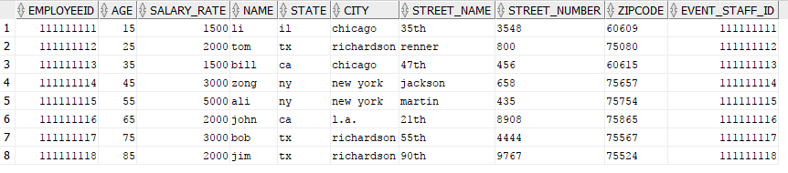

--2. dinning



--3. concierge



--4. housekeeping



--5. receptionist



--6. tech_support



--7. management



--8. catering



--9. accountant



--10. event



-- 11. client

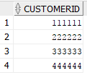

-- 12. Organization



-- 13. Individual

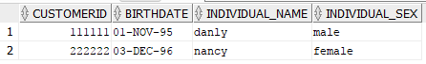

-- 14. Membersip

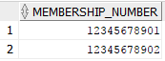

-- 15. Room

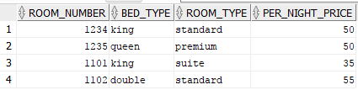

-- 16. Clear



-- 17. check_out_bill



-- 18. has



--19. holds

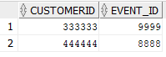

--20. serve

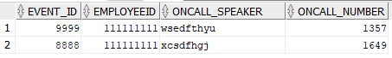

--21. bill_event_payment



-- 22. direct_bill_account



-- 23. phone

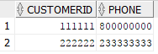

-- 24. check_out_payment_id



--25. check_in



--26. bill_for_event



5.2 Creation of Views (Answer for Question d/Phase III)

1.

CREATE VIEW available_room (room_number) AS

SELECT r.room_number

FROM room r, check_in ci

WHERE r.room_number != ci.room_number

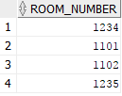

2.

CREATE VIEW popular_event_manager (event_staff_id) AS

select event_manager_id

from event

where TO_CHAR(event_date, 'MMDD') >= TO_CHAR(SYSDATE - 30, 'MMDD')

group by event_manager_id

having count(event_id) > 10

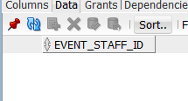

3.

CREATE VIEW frequent_customer (customerID) AS

SELECT i.customerID

FROM individual i, check_in ci

WHERE trunc(ci.Check_in_date, 'YEAR') = trunc(sysdate,'YEAR') and i.customerID = ci.customerID

GROUP BY i.customerID

having COUNT(ci.Check_in_date) >= 10

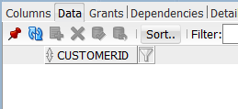

4.

CREATE VIEW popular_room (room_number) AS

SELECT r.room_number

FROM check_in ci, room r

WHERE r.room_number = ci.room_number and trunc(ci.check_in_date, 'YEAR') > trunc(sysdate,'YEAR')

GROUP BY r.room_number

having count (ci.check_in_date) > 30

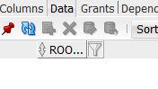

5.3 Creation of SQL Queries (Answer for Question e/Phase III)

--1

select Count(employeeid) as nofEmployees

from dinning

where type = 'lounge' or type = 'bar'



-- 2

SELECT AVG(Salary_rate)

FROM employee

WHERE employee.employeeid IN

(SELECT employeeid

FROM receptionist)



--3

select *

from individual i

where i.CUSTOMERID in (

select customerid

from (

select c.customerid, Sum(c.COP_AMOUNT_OF_PAYMENT)

from check_out_payment_id c

where TRUNC(c.cop_date, 'YEAR') = TRUNC(SYSDATE, 'YEAR')

group by c.customerid

having Sum(c.COP_AMOUNT_OF_PAYMENT) > 1000

))

Result: empty

-- 4

SELECT Check_out_bill_amount

FROM Check_out_bill

ORDER BY Check_in_date ASC



--5

select *

from individual i

where i.CUSTOMERID in (

select customerid

from (

select c.customerid, Sum(c.length_of_stay)

from check_in c

where TRUNC(c.check_in_date, 'YEAR') = TRUNC(SYSDATE, 'YEAR')

group by c.customerid

having Sum(c.length_of_stay) >= 15

)

);

Result: empty

-- 6

select avg(k.AGE_TODAY)

from

(

select d.customerid, TRUNC((SYSDATE - TO_DATE(d.bd, 'YYYY-MM-DD'))/ 365.25) AS AGE_TODAY

from(

select birthdate as bd, i.customerid

from individual i

where i.customerid in

(

select customerid

from check_in c

where c.employeeid in

(

select r.employeeid

from receptionist r

where r.language = 'Spanish'

))

) d

) k



--7

select *

from organization o

where o.customerid in

(

select h.customerid

from holds h

where h.customerid in

(

select b.customerid

from Bill_event_payment b

group by b.CUSTOMERID

having Sum(b.amount_of_event_payment) > 2000

)

group by h.customerid

having Count(Event_id) >= 2

);

Result: empty

-- 8

select *

from(

select b.bill_event_amount

from bill_for_event b

where b.event_id in

(

select event_id

from POPULAR_EVENT_MANAGER, event

)

order by b.bill_event_amount desc

)

where rownum = 1

Result: empty

--9

select *

from event e

where e.event_id in (

select event_id

from(

select b.event_id, b.customerid, max(bill_event_amount)

from bill_for_event b

group by b.event_id, b.customerid

))



-- 10

select *

from(

select c.check_in_date

from

(

select *

from

(

select e.room_number, Count(e.room_number) as shax

from check_in e

group by e.room_number

order by shax desc

)

where rownum = 1

) d, check_in c

where d.room_number = c.room_number

order by c.check_in_date desc

)

where rownum = 1



6. Dependency Diagram