## Interview Test 2 : HTML CSS JavaScript

1 Page HTML

* Landing Page with Slider and List of Items
* Both of them have top bar and footer
* Suggested CSS UI Framework Bootstrap.
* Suggested JavaScript Slider : <https://kenwheeler.github.io/slick/>
* Footer with <a> tag linkage   
  私隱政策和私隱聲明 https://www.esteelauder.com.hk/privacy

條款及細則 https://www.esteelauder.com.hk/terms-conditions

© Estée Lauder Inc

* * This is a mobile site only.
* Please use the image files in the zip file. You only need to demonstrate your technique. The mockup below is just a reference, so you DON’T need to make the images/wordings 100% same as it.

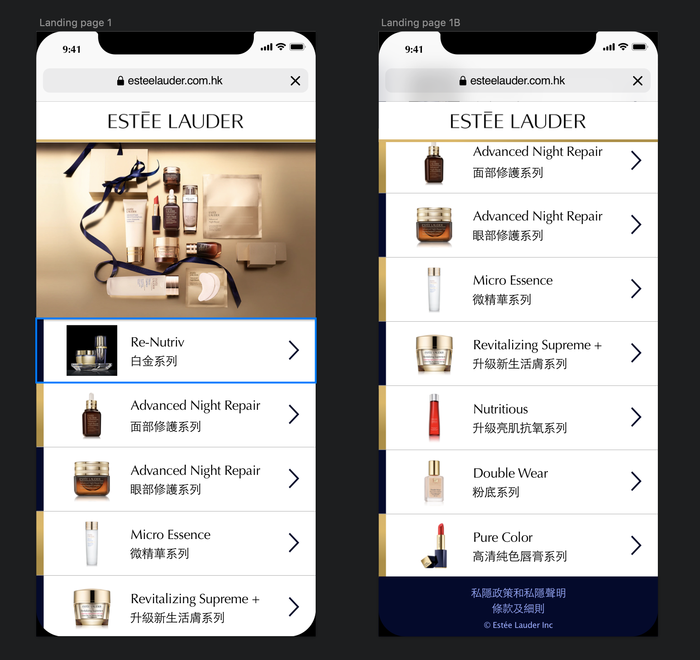

Slider