Desiring Machine
Summary
This project is to build a program that manifests a simple, basic “desire” by making the program perform high-level, complex and unrelated behaviors, hence demonstrating an abstraction to human behaviors.

Description
The main part will be a tree-like structure, in which each node represents a description of something that the machine wants to do, and the children of the node represent things to be done to realize the parent node. Here’s a sample of a small tree:
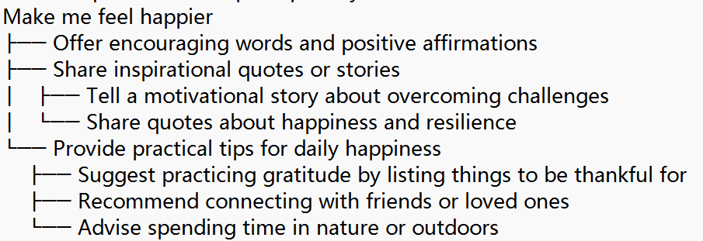
The tree will grow larger and larger, until the leaf nodes represent behaviors seemingly unrelated to the root. Then the program can interact with people by using the behavior described by the leaf nodes, with some TTS technologies.
The so called “desire” is a simple sensor, can be a sound or pressure detector, that inputs a dynamic numerical variable. An algorithm will make the nodes generated tend to align with the basic “desire” described by the root node, that is to say, the program will do anything it can, interact with the environment in various ways, to maximize the given variable.

How Did We Get Interested
This idea comes from our exploration on how to make robots simulate human behaviors. We thought this could be a demonstration of the nature of human behavior. This kind of structure better aligns with psychological theories like psychoanalysis, where analyzers relate seemingly unrelated behaviors of humans to basic, unconscious instincts.
Besides, the tree structure is actually a “localized” version of “Tree of Thoughts”.

Sketch:
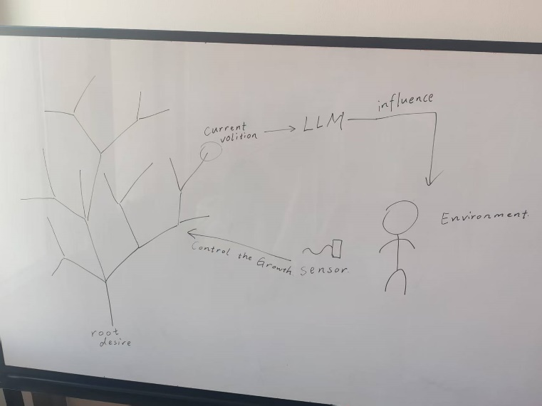
It is a weird kind of reinforcement learning.
Input: A simple sensor, and maybe speech input (STT).
Output: TTS from the robot, which involves its “desire”. Also, a visualization of the previously grown tree, that also can grow during the interaction.
Interaction: Participants will interact with the machine with communication and through the sensor. The machine will manifest its desire through this interaction process.
Technologies: We would use some LLM, TTS technology, also some technology for sensors.
Feelings to Elicit:
Through the interaction, we wish to make the participant feel like it is interacting with something that has strong purpose, so that we can show even a non-human machine can have its own “desire”. Also, we wish to show that human behaviors are nothing but a complicated, concrete version of simple desires such as love, sex, hunger or even electronic or chemical signals in our brain.
Through the visualization of the tree, we show that a machine can have its own “childhood”.

