Report on Air Quality Dataset Processing
Names of the Five
Group 10
Introduction
This is a report on handling Air Quality Dataset [1] to provide insights. It involves visualization, clustering, prediction and improvement of prediction model, and prediction with deep learning. The Air Quality Dataset contains 15 features and 9358 instances about air quality in a city. The dataset is sequential and each instance represents an hour’s measurement. The prediction aim will focus on predicting whether the CO level exceeds a certain threshold in a certain hour.

Preprocessing
We observed the data to be under different scales, hence Z-score normalization would be considerable. Columns labeled as ground truth (GT) have significantly more missing values, and the “NMHC(GT)” column has 90.3% of missing values.
The preprocessing fills the missing values with the mean value of each column. It drops the “NMHC(GT)” column as too many values are missing. It also clips the outliers using Interquartile Range Method, replacing the outliers with Q1 - 1.5IQR (lower bound) and Q3 + 1.5IQR (upper bound). It also adds 12 extra columns containing Booleans to record whether a feature is missing in each instance. After that, it is normalized with Z-score. This forms the processed dataset.

Visualization
We plotted the 2D and 3D visualization of the dataset using t-SNE. The dataset is split by CO level, where one class indicates CO(GT) exceeds a threshold, while the other class indicates it does not exceed the threshold. The plotting procedure does not include the missing columns. The plot shows clear division between the two classes. This indicates that there are highly correlated characteristic patterns among various air quality monitoring indicators related to CO concentration exceedances, and the data exhibits good discriminability. Therefore, constructing a CO exceedance prediction model based on existing features is reasonable and feasible, with significant predictive value and learning potential for this task.
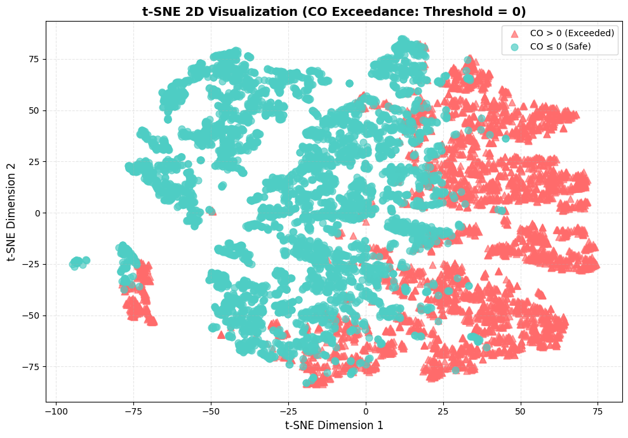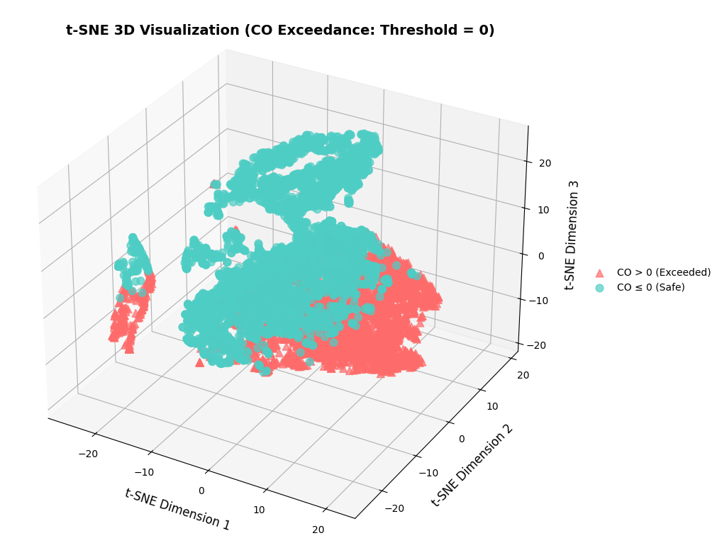
Fig 1. 2D and 3D t-SNE plots.

Clustering (Uncompleted)
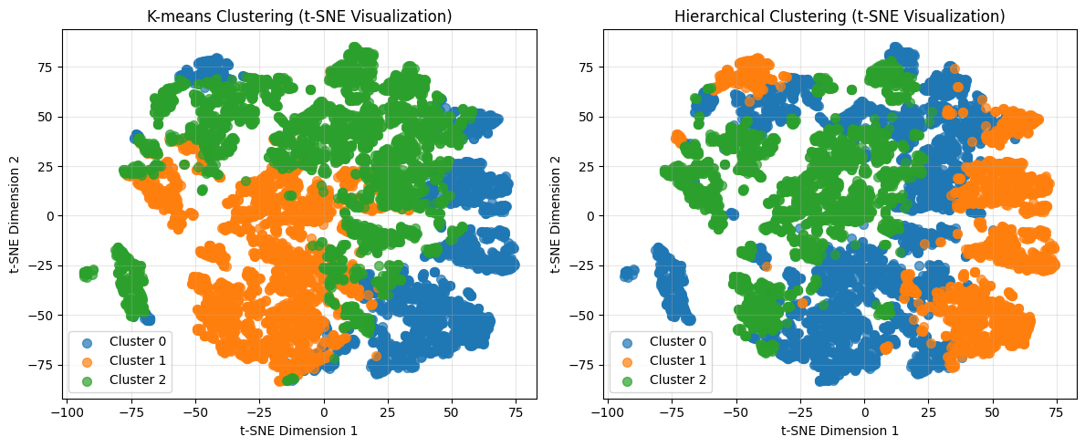
Fig 2.
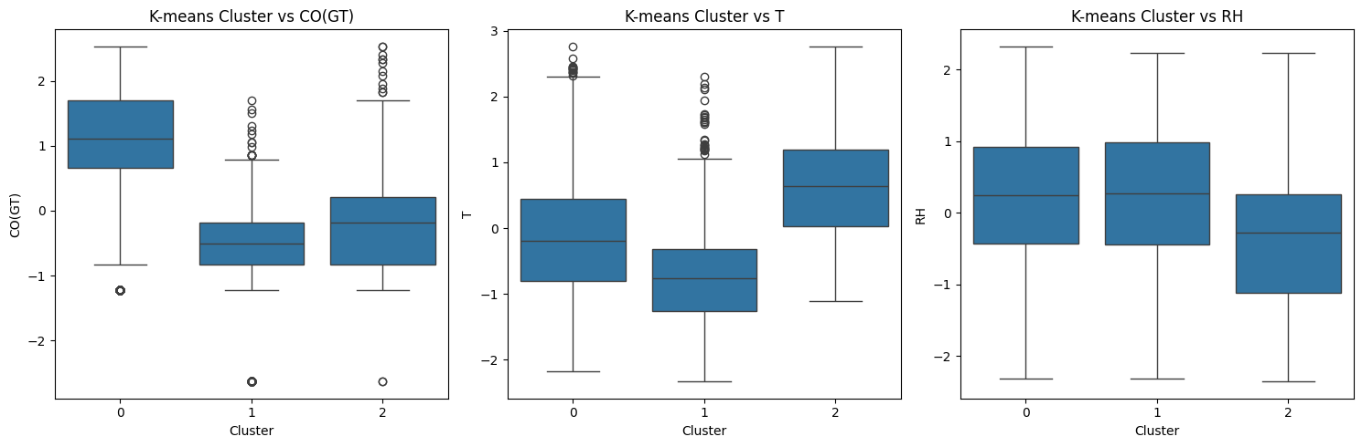
Fig 3.
Table 1.
Basic Prediction
We would like to predict whether the CO level is higher than a threshold in a specific hour. If it exceeds the threshold, we encode 1, otherwise 0. We would use Logistic Regression (LoR) and Decision Tree (DT). They were selected because they are naturally suitable for binary classification tasks.
LoR model fits the data with max iteration number 1000, and DT fits the data with max depth 3. These data dropped the “missing” columns that indicates whether a value is missing in the original dataset, for future comparisons. The prediction results are as below:
 | Logistic Regression | Decision Tree
Train Set Accuracy | 0.8267 | 0.8960
Test Set Accuracy | 0.8262 | 0.8942
All Set Accuracy | 0.8265 | 0.8955
Table 2. Basic Prediction Results.
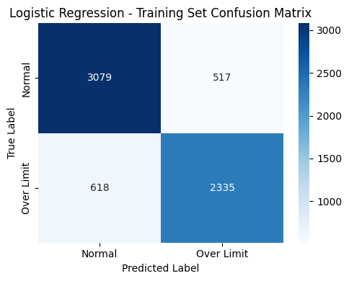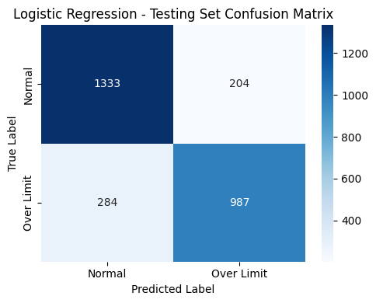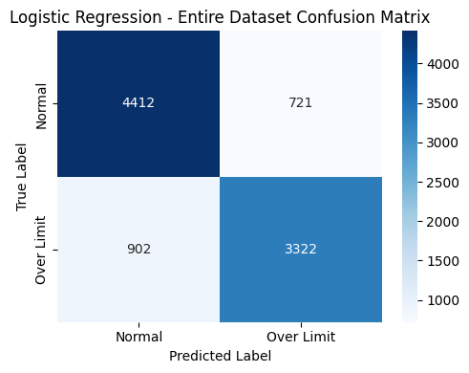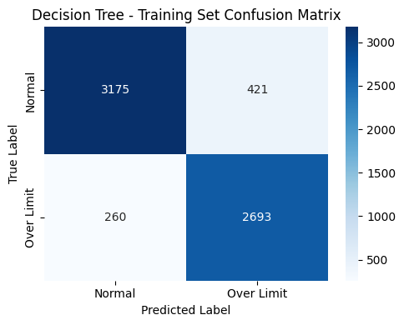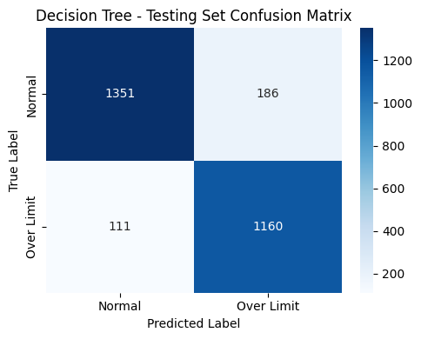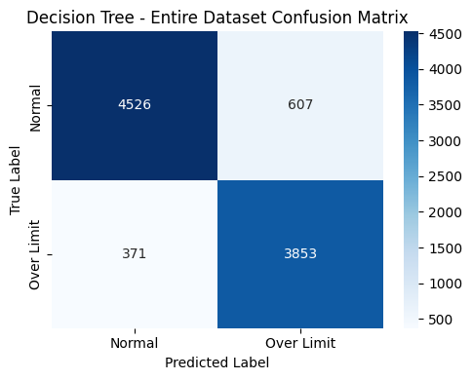
Fig 3. Basic Prediction Confusion Matrices.
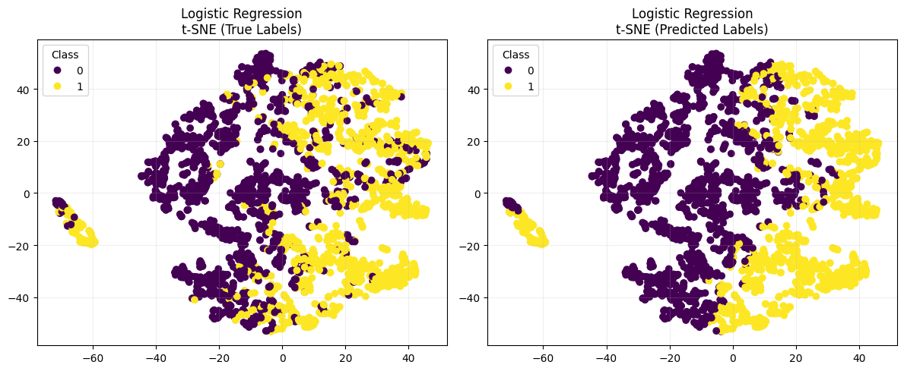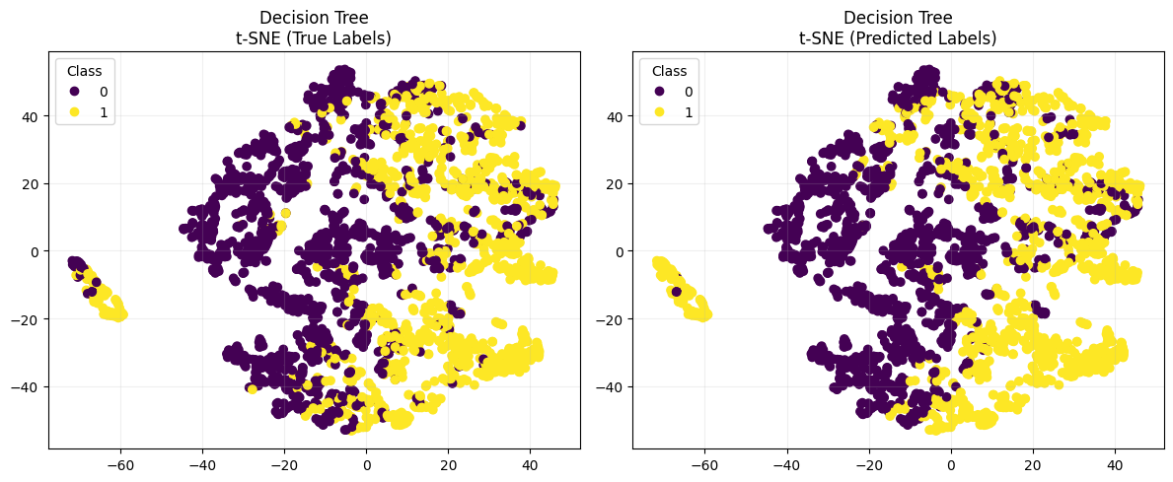
Fig 4. Basic Prediction T-SNE Visualization.
The results show a significant advantage of DT compared to LoR. This is because LoR is a relatively linear model, suitable for datasets or tasks with stronger linear patterns, while DT is suitable for adapting non-linear patterns. As the classification of Air Quality Dataset requires recognizing non-linear patterns, DT becomes more suitable for this task.

Improved Prediction
We would calculate the F1 score and AUROC for the previous two models, also the ROC curves.
 | Logistic Regression | Decision Tree
Train Set Accuracy | 0.8267 | 0.8960
Test Set Accuracy | 0.8262 | 0.8942
All Set Accuracy | 0.8265 | 0.8955
Train Set AUROC | 0.9109 | 0.9401
Test Set AUROC | 0.9147 | 0.9362
All Set AUROC | 0.9120 | 0.9390
Train Set F1 | 0.8045 | 0.8878
Test Set F1 | 0.8018 | 0.8865
All Set F1 | 0.8037 | 0.8874
Table 3. More Basic Prediction Results.
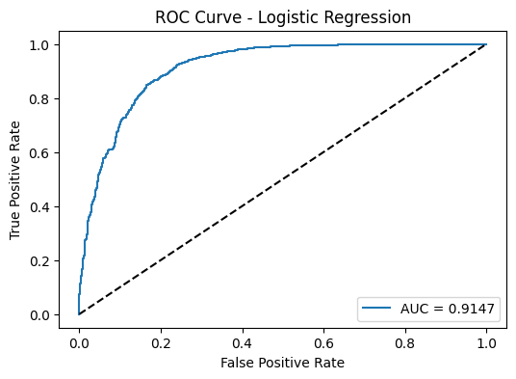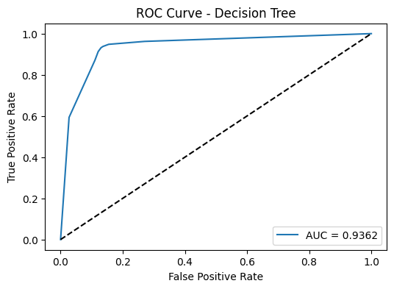
Fig 5. Basic Prediction ROCs for Test Set.
These results show the models do not overfit the dataset, as the metric values for training and for testing datasets are without significant difference. The F1 score further verifies that the DT model boasts better overall classification stability and accuracy, with fewer false positives and false negatives in CO exceedance prediction. Besides, the AUROC metric eliminates threshold dependence, providing a more persuasive evaluation of the two models’ performance. It backs up our interpretation that the decision tree’s superior performance on non-linear data stems from its inherent model advantages. As handling non-linear patterns is required, we would naturally consider adding polynomial in LoR. And for the improvement of DT, we would just add more depth (adding the max depth from 3 to 5). Also, we trained an extra pair of models, adding the columns that contains the information whether the value is missing in the original dataset (“missing” columns).
The improved model shows the results as below:
LoR0: Original LoR model.
DT0: Original DT model with max depth 3.
LoR1: LoR with polynomial features, degree 2.
DT1: DT with max depth 5.
LoR2: LoR with polynomial features, degree 2, also added missing columns.
DT2: DT with max depth 5, also added missing columns.
 | LoR0 | LoR1 | LoR2 | DT0 | DT1 | DT2
Train Accuracy | 0.8267 | 0.8859 | 0.9208 | 0.8960 | 0.9185 | 0.9185
Test Accuracy | 0.8262 | 0.8825 | 0.9195 | 0.8942 | 0.9120 | 0.9131
Train AUROC | 0.9109 | 0.9557 | 0.9752 | 0.9401 | 0.9635 | 0.9604
Test AUROC | 0.9147 | 0.9533 | 0.9729 | 0.9362 | 0.9535 | 0.9515
Train F1 | 0.8045 | 0.8727 | 0.9122 | 0.8878 | 0.9099 | 0.9099
Test F1 | 0.8018 | 0.8687 | 0.9111 | 0.8865 | 0.9030 | 0.9042
Table 4. Basic and Improved Model Prediction Results.
Observing the results of LoR0 and LoR1, we found that adding polynomial features significantly improved the model, as it transforms some of the non-linear patterns into linear patterns, better for LoR models to recognize. Observing the AUROC and F1 results of LoR1 and DT0, we found that LoR model with polynomials starts to outperform the original DT model, but a certain threshold of LoR disables this performance. However, observing the AUROC results of LoR1 and DT1, we see that such capture of non-linear pattern may not be enough to outperform the improved DT model, as deeper DT enables more non-linear patterns to be recognized.
Especially, adding the missing columns significantly improves the LoR model again, but did not improve the DT model. The improvement from LoR1 to LoR2 indicates that the missing columns contain considerably important information, correlated with the CO level, that can be used to improve the prediction results. However, DT models are not sensitive to feature engineering. This is because they discover non-linear features themselves, and this will make their performance determined by max depths, instead of number of features. Also, DT models prefer features with more possible values, like continuous floats, instead of binary Booleans, and this makes the added features useless, making the LoR2 outperform DT2.
These results indicate that LoR models are originally poor at capturing non-linear features, but by feature engineering, it can perform a better result. DT models can originally capture non-linear features, but are not sensitive to feature engineering, and overly prefer features with more possible values, which is a disadvantage.

Prediction with Deep Learning Methods (Uncompleted)

Conclusion (Uncompleted)

Reference (Uncompleted)
[1] S. Vito, Air Quality [Dataset]. Irvine, CA: UCI Machine Learning Repository, 2008. [Online]. Available: https://archive.ics.uci.edu/dataset/360/air+quality. DOI: 10.24432/C59K5F.

