**Java(MVC)+DB**

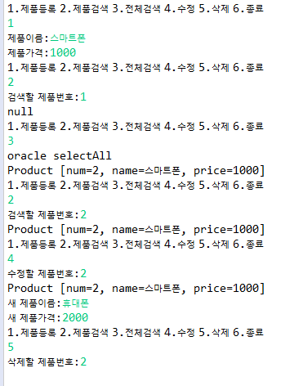

[product.sql]

|  |
| --- |
|  |

|  |
| --- |
| **import** java.sql.Connection;  **import** java.sql.DriverManager;  **public** **class** DBConnect {  } |

|  |
| --- |
| **public** **class** Product {  **private** **int** num;  **private** String name;  **private** **int** price;  } |

|  |
| --- |
| **package** ch20.this_youngjin.productDb.sequence;  **import** java.util.Vector;  **public** **interface** Dao {    **void** insert(Product p);  Product select(**int** num);  Vector<Product> selectAll();  **void** delete(**int** num);  **void** update(**int** num, Product p);  } |

|  |
| --- |
| **package** ch20.this_youngjin.productDb.sequence;  **import** java.sql.Connection;  **import** java.sql.PreparedStatement;  **import** java.sql.ResultSet;  **import** java.sql.SQLException;  **import** java.util.Vector;  **public** **class** OracleDao **implements** Dao {    } |

|  |
| --- |
| **import** java.util.Vector;  **public** **interface** Service {  **void** addProduct();  **void** editProduct();  **void** delProduct();  Product getProduct();  Vector<Product> getProducts();  } |

|  |
| --- |
| **import** java.util.Scanner;  **import** java.util.Vector;  **public** **class** ServiceImpl **implements** Service {    } |

|  |
| --- |
| **package** ch20.this_youngjin.productDb.sequence;  **import** java.util.Scanner;  **import** java.util.Vector;  **public** **class** ProductMain {  **public** **static** **void** main(String[] args) {    Scanner sc = **new** Scanner(System.***in***);  **boolean** flag = **true**;  **int** menu;  Service service = **new** ServiceImpl();  Product p = **null**;  Vector<Product> v = **null**;  **while** (flag) {    }  } |