**request.getSession 연습**

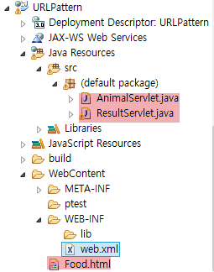

[web.xml]

|  |
| --- |
|  |

[FOOD.html]

|  |
| --- |
| <!DOCTYPE html>  <html>  <head>  <meta charset=*"UTF-8"*>  <title>성격테스트</title>  </head>  <body>  <h3>좋아하는 음식은? </h3>  <form action=*"animal"*>  <input type=*"text"* name=*"FOOD"*>  <input type=*"submit"* value=*"확인"*>  </form>  </body>  </html> |

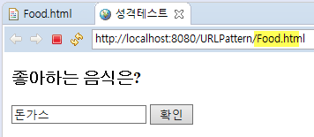

[AnimalServlet.java]

|  |
| --- |
|  |

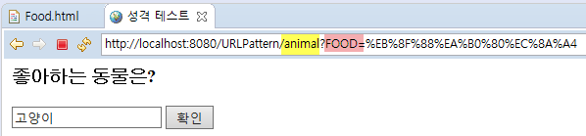

[ResultServlet.java]

|  |
| --- |
|  |

[최종결과]

