DI (Dependency Injection : 의존주입)

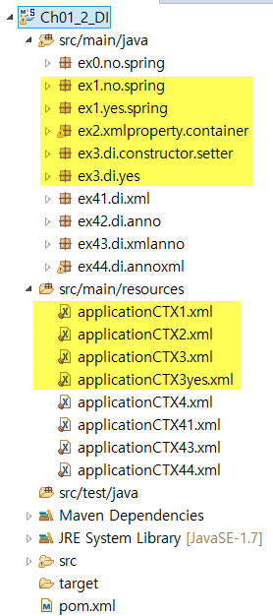

**1. DI & IOC 개념**

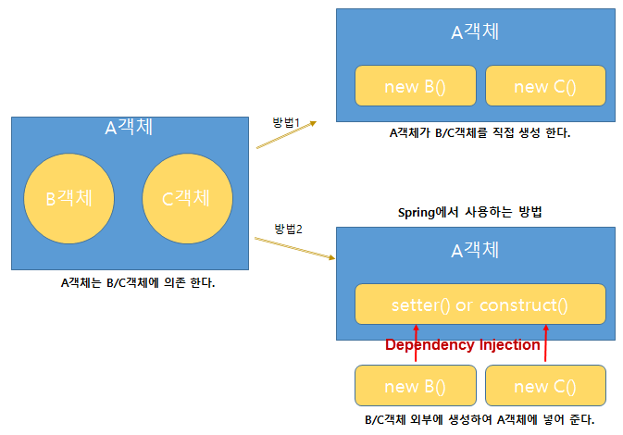

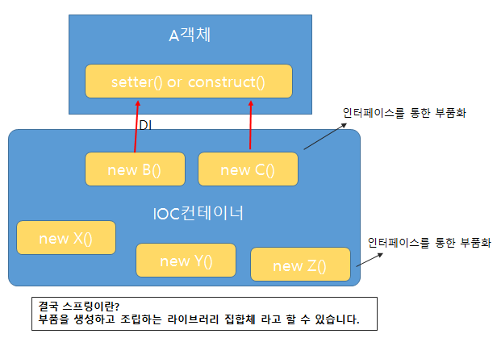

(1) Spring 비교

[실행결과]

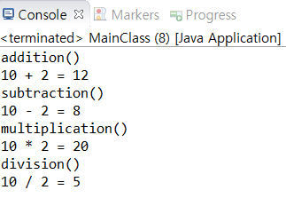

①순수 자바 프로그램

[MainClass.java]

|  |
| --- |
| **package** ex1.no.spring;  **public** **class** MainClass {  **public** **static** **void** main(String[] args) {    MyCalculator myCalculator = **new** MyCalculator();  myCalculator.setCalculator(**new** Calculator());    myCalculator.setFirstNum(10);  myCalculator.setSecondNum(2);      }  } |

|  |
| --- |
| **package** ex1.no.spring;  **public** **class** Calculator {  **public** **void** addition(**int** f, **int** s) {  System.***out***.println("addition()");  **int** result = f + s;  System.***out***.println(f + " + " + s + " = " + result);  }    **public** **void** subtraction(**int** f, **int** s) {  System.***out***.println("subtraction()");  **int** result = f - s;  System.***out***.println(f + " - " + s + " = " + result);  }    **public** **void** multiplication(**int** f, **int** s) {  System.***out***.println("multiplication()");  **int** result = f * s;  System.***out***.println(f + " * " + s + " = " + result);  }    **public** **void** division(**int** f, **int** s) {  System.***out***.println("division()");  **int** result = f / s;  System.***out***.println(f + " / " + s + " = " + result);  }  } |

|  |
| --- |
| **package** ex1.no.spring;  **public** **class** MyCalculator {  Calculator calculator;  **private** **int** firstNum;  **private** **int** secondNum;    **public** MyCalculator() {  }  **public** **void** add() {  calculator.addition(firstNum, secondNum);  }    **public** **void** sub() {  calculator.subtraction(firstNum, secondNum);  }    **public** **void** mul() {  calculator.multiplication(firstNum, secondNum);  }    **public** **void** div() {  calculator.division(firstNum, secondNum);  }    **public** **void** setCalculator(Calculator calculator) {  **this**.calculator = calculator;  }    } |

② Spring 사용

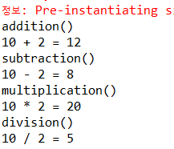

[applicationCTX1.xml]

|  |
| --- |
| <?xml version=*"1.0"* encoding=*"UTF-8"*?>  <beans xmlns=*"http://www.springframework.org/schema/beans"*  xmlns:xsi=*"http://www.w3.org/2001/XMLSchema-instance"*  xsi:schemaLocation=*"http://www.springframework.org/schema/beans*  *http://www.springframework.org/schema/beans/spring-beans.xsd"*>  <bean id=*"calculator"* class=*"ex1.yes.spring.Calculator"* />    <bean id=*"myCalculator"* class=*"ex1.yes.spring.MyCalculator"*>  <property name=*"calculator"*>  <ref bean=*"calculator"*/>  </property>  <property name=*"firstNum"* value=*"10"* />  <property name=*"secondNum"* value=*"2"*></property>  </bean>  </beans> |

|  |
| --- |
| **package** ex1.yes.spring;  **import** org.springframework.context.support.AbstractApplicationContext;  **import** org.springframework.context.support.GenericXmlApplicationContext;  **public** **class** MainClass {  **public** **static** **void** main(String[] args) {  /*  * spring을 사용 하지 않을 경우 MyCalculator myCalculator = new MyCalculator();  * myCalculator.setCalculator(new Calculator());  *  * myCalculator.setFirstNum(10); myCalculator.setSecondNum(2);  *  * myCalculator.add(); myCalculator.sub(); myCalculator.mul();  * myCalculator.div();  */  // 스프링 사용한 경우  // 스프링 컨테이너 생성    // 스프링 컨테이너에서 컴포넌트 객체를 가져옴  myCalculator.add();  myCalculator.sub();  myCalculator.mul();  myCalculator.div();    ctx.close();  }  } |

나머지 2개 프로그램은 위와 동일

**2. 스프링 설정파일**

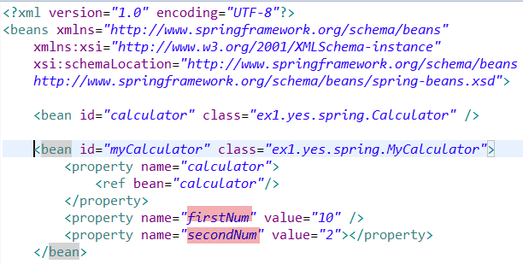

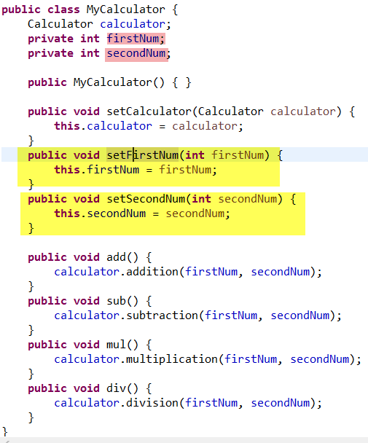

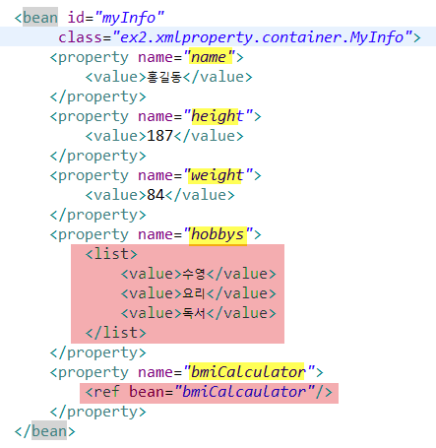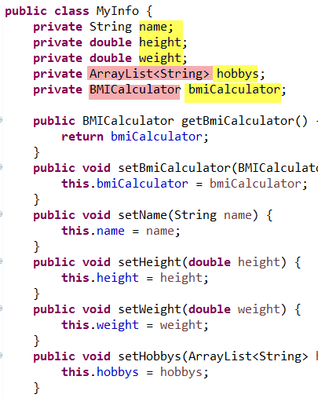

[실행결과]

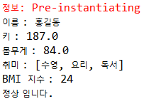

|  |
| --- |
| **package** ex2.xmlproperty.container;  **import** org.springframework.context.support.AbstractApplicationContext;  **import** org.springframework.context.support.GenericXmlApplicationContext;  **public** **class** MainClass {    **public** **static** **void** main(String[] args) {    } |

|  |
| --- |
| **package** ex2.xmlproperty.container;  **import** java.util.ArrayList;  **public** **class** MyInfo {  **private** String name;  **private** **double** height;  **private** **double** weight;  **private** ArrayList<String> hobbys;  **private** BMICalculator bmiCalculator;    **public** BMICalculator getBmiCalculator() {  **return** bmiCalculator;  }  **public** **void** setBmiCalculator(BMICalculator bmiCalculator) {  **this**.bmiCalculator = bmiCalculator;  }  **public** **void** setName(String name) {  **this**.name = name;  }  **public** **void** setHeight(**double** height) {  **this**.height = height;  }  **public** **void** setWeight(**double** weight) {  **this**.weight = weight;  }  **public** **void** setHobbys(ArrayList<String> hobbys) {  **this**.hobbys = hobbys;  }    **public** **void** bmiCalculation() {  bmiCalculator.bmicalculation(weight, height);  }    **public** **void** getInfo() {  System.***out***.println("이름 : " + name);  System.***out***.println("키 : " + height);  System.***out***.println("몸무게 : " + weight);  System.***out***.println("취미 : " + hobbys);  bmiCalculation();  }  } |

|  |
| --- |
| **package** ex2.xmlproperty.container;  **public** **class** BMICalculator {  **private** **double** lowWeight;  **private** **double** normal;  **private** **double** overWeight;  **private** **double** obesity;  **public** **void** bmicalculation(**double** weight, **double** height) {  **double** h = height * 0.01;  **double** result = weight / (h * h);  System.***out***.println("BMI 지수 : " + (**int**) result);  **if** (result > obesity) {  System.***out***.println("비만 입니다.");  } **else** **if** (result > overWeight) {  System.***out***.println("과체중 입니다.");  } **else** **if** (result > normal) {  System.***out***.println("정상 입니다.");  } **else** {  System.***out***.println("저체중 입니다.");  }  }  **public** **void** setLowWeight(**double** lowWeight) {  **this**.lowWeight = lowWeight;  }  **public** **void** setNormal(**double** normal) {  **this**.normal = normal;  }  **public** **void** setOverWeight(**double** overWeight) {  **this**.overWeight = overWeight;  }  **public** **void** setObesity(**double** obesity) {  **this**.obesity = obesity;  }  } |

|  |
| --- |
| <?xml version=*"1.0"* encoding=*"UTF-8"*?>  <beans xmlns=*"http://www.springframework.org/schema/beans"*  xmlns:xsi=*"http://www.w3.org/2001/XMLSchema-instance"*  xsi:schemaLocation=*"http://www.springframework.org/schema/beans http://www.springframework.org/schema/beans/spring-beans.xsd"*>  <bean id=*"bmiCalcaulator"* class=*"ex2.xmlproperty.container.BMICalculator"*>  <property name=*"lowWeight"*>  <value>18.5</value>  </property>  <property name=*"normal"*>  <value>23</value>  </property>  <property name=*"overWeight"*>  <value>25</value>  </property>  <property name=*"obesity"*>  <value>30</value>  </property>  </bean>    </beans> |

3. DI 속성들

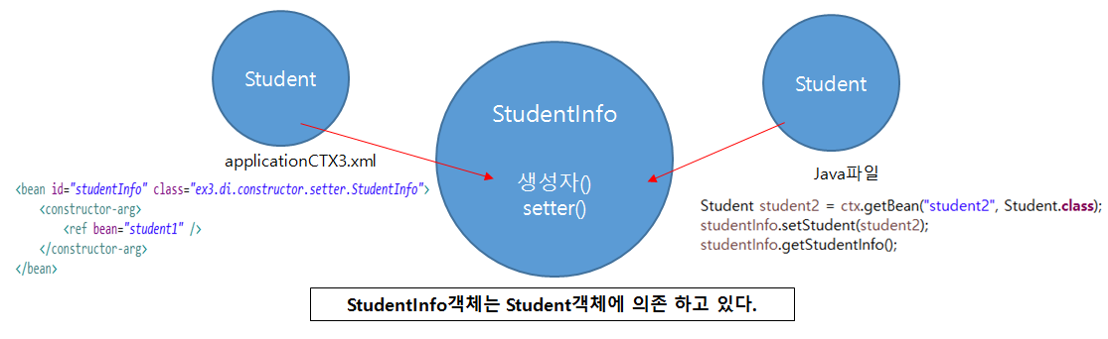

(1) 실습 일반

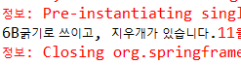

[applicationCTX3yes.xml]

|  |
| --- |
| <?xml version=*"1.0"* encoding=*"UTF-8"*?>  <beans xmlns=*"http://www.springframework.org/schema/beans"*  xmlns:xsi=*"http://www.w3.org/2001/XMLSchema-instance"*  xsi:schemaLocation=*"http://www.springframework.org/schema/beans http://www.springframework.org/schema/beans/spring-beans.xsd"*>      </beans> |

|  |
| --- |
| **package** ex3.di.yes;  **import** org.springframework.context.support.AbstractApplicationContext;  **import** org.springframework.context.support.GenericXmlApplicationContext;  **public** **class** MainClass {  **public** **static** **void** main(String[] args) {    AbstractApplicationContext ctx = **new** GenericXmlApplicationContext("classpath:applicationCTX3yes.xml");  Pencil pencil = ctx.getBean("pencil", Pencil.**class**);  pencil.use();    ctx.close();  }  } |

|  |
| --- |
| **package** ex3.di.yes;  **public** **interface** Pencil {  **public** **void** use();  } |

|  |
| --- |
| **package** ex3.di.yes;  **public** **class** Pencil4B **implements** Pencil {  @Override  **public** **void** use() {  System.***out***.println("4B 굵기로 쓰입니다.");  }  } |

|  |
| --- |
| **package** ex3.di.yes;  **public** **class** Pencil6B **implements** Pencil {  @Override  **public** **void** use() {  System.***out***.println("6B굵기로 쓰입니다.");  }  } |

[Pencil6BWithEraser.java]

|  |
| --- |
| **package** ex3.di.yes;  **public**  {  @Override  **public** **void** use() {  // super.use();  System.***out***.println("6B굵기로 쓰이고, 지우개가 있습니다.");  }  } |

(2) setter & constructor

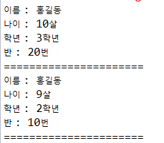

[applicationCTX3.xml]

|  |
| --- |
| <?xml version=*"1.0"* encoding=*"UTF-8"*?>  <beans xmlns=*"http://www.springframework.org/schema/beans"*  xmlns:xsi=*"http://www.w3.org/2001/XMLSchema-instance"*  xsi:schemaLocation=*"http://www.springframework.org/schema/beans http://www.springframework.org/schema/beans/spring-beans.xsd"*>  <bean id=*"student1"* class=*"ex3.di.constructor.setter.Student"*>  <constructor-arg>  <value>홍길동</value>  </constructor-arg>  <constructor-arg>  <value>10살</value>  </constructor-arg>  <constructor-arg>  <value>3학년</value>  </constructor-arg>  <constructor-arg>  <value>20번</value>  </constructor-arg>  </bean>    <bean id=*"student2"* class=*"ex3.di.constructor.setter.Student"*>  <constructor-arg value=*"홍길동"* />  <constructor-arg value=*"9살"* />  <constructor-arg value=*"2학년"* />  <constructor-arg value=*"10번"* />  </bean>    <bean id=*"studentInfo"* class=*"ex3.di.constructor.setter.StudentInfo"*>  <constructor-arg>  <ref bean=*"student1"* />  </constructor-arg>  </bean>    </beans> |

|  |
| --- |
| **package** ex3.di.constructor.setter;  **import** org.springframework.context.support.AbstractApplicationContext;  **import** org.springframework.context.support.GenericXmlApplicationContext;  **public** **class** MainClass {  **public** **static** **void** main(String[] args) {    } |

|  |
| --- |
| **package** ex3.di.constructor.setter;  **public** **class** Student {  **private** String name;  **private** String age;  **private** String gradeNum;  **private** String classNum;    **public** Student(String name, String age, String gradeNum, String classNum) {  **this**.name = name;  **this**.age = age;  **this**.gradeNum = gradeNum;  **this**.classNum = classNum;  }  **public** String getName() {  **return** name;  }  **public** **void** setName(String name) {  **this**.name = name;  }  **public** String getAge() {  **return** age;  }  **public** **void** setAge(String age) {  **this**.age = age;  }  **public** String getGradeNum() {  **return** gradeNum;  }  **public** **void** setGradeNum(String gradeNum) {  **this**.gradeNum = gradeNum;  }  **public** String getClassNum() {  **return** classNum;  }  **public** **void** setClassNum(String classNum) {  **this**.classNum = classNum;  }  } |

|  |
| --- |
| **package** ex3.di.constructor.setter;  **public** **class** StudentInfo {  **private** Student student;    **public** StudentInfo(Student student) {  **this**.student = student;  }    **public** **void** getStudentInfo(){  **if**(student != **null**) {  System.***out***.println("이름 : " + student.getName());  System.***out***.println("나이 : " + student.getAge());  System.***out***.println("학년 : " + student.getGradeNum());  System.***out***.println("반 : " + student.getClassNum());  System.***out***.println("======================");  }  }    **public** **void** setStudent(Student student) {  **this**.student = student;  }  } |