**1. ArrayList를 이용하여 게시판 구현하기**

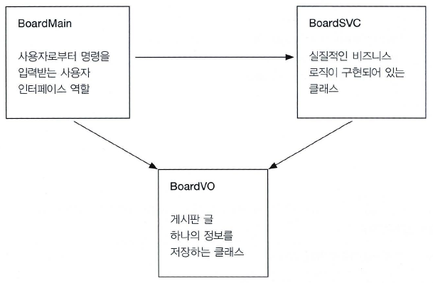

[결과]

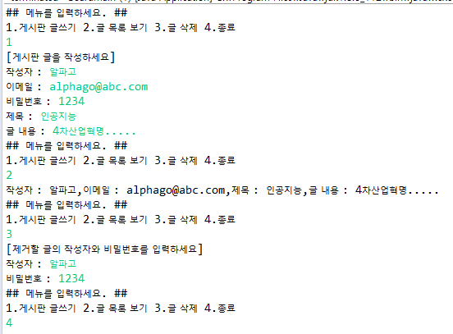

|  |
| --- |
| **package** board.arraylist;  **public** **class** BoardVO {  **private** String register;  **private** String subject;  **private** String email;  **private** String content;  **private** String passwd;    } |

|  |
| --- |
| **package** board.arraylist;  **import** java.util.ArrayList;  **import** java.util.Scanner;  **public** **class** BoardSVC {    //Scanner 입력  **public** **void** writeArticle(Scanner sc) {    }  //boardList 객체에 BoardVO 객체 하나를 요소로 추가,즉,게시판 글 하나를 등록  **private** **void** addArticle(BoardVO boardVO) {  }  //ArrayList 객체에 저장되어 있는 게시판 글 목록을 출력해 주는 메소드  **public** **void** listArticles(Scanner sc) {  }  **public** **void** removeArticle(Scanner sc) {    }  **private** **void** removeArticle(String register, String passwd) {    }  } |

|  |
| --- |
| **package** board.arraylist;  **import** java.util.Scanner;  **public** **class** BoardMain {  **public** **static** **void** main(String[] args) {  **boolean** isStop = **false**;  Scanner sc = **new** Scanner(System.***in***);  BoardSVC boardSVC = **new** BoardSVC();  **do**{    }  **while**(!isStop);  }  } |
|  |

**2. HashMap을 통한 게시판 작성하기**

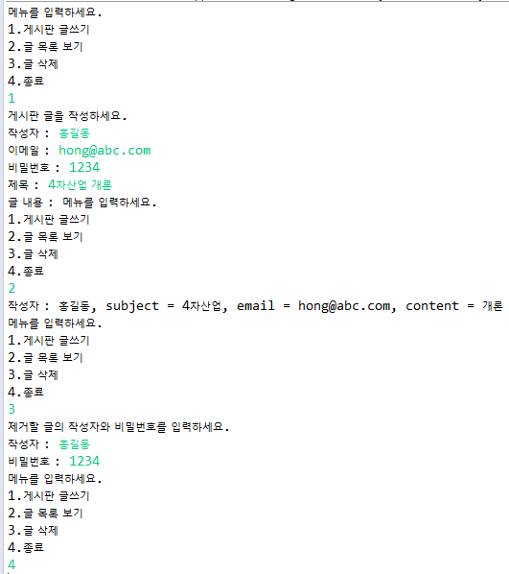

|  |
| --- |
| **import** java.util.ArrayList;  **import** java.util.HashMap;  **import** java.util.Scanner;  **public** **class** BoardSVC {      **public** **void** writeArticle(Scanner sc) {      }  **private** **void** addArticle(HashMap<String,String> boardMap) {      }  **public** **void** listArticles(Scanner sc) {      }  **public** **void** removeArticle(Scanner sc) {      }  **private** **void** removeArticle(String register, String passwd) {      }  } |

|  |
| --- |
| **import** java.util.Scanner;  **public** **class** BoardMain {    **public** **static** **void** main(String[] args) {    **do**{    }**while**(!isStop);  }  } |