**I. EL 표기법을 사용하여 JavaBeans의 Property 값을 출력하기**

[결과]

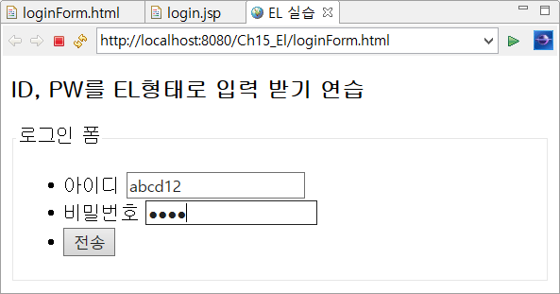

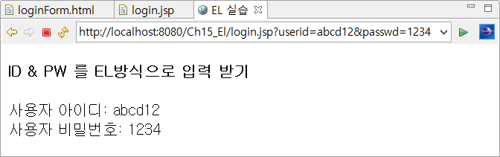

[방법]

1. LoginBean 클래스 생성

|  |
| --- |
| **package** com.bean;  **import** java.io.Serializable;  **public** **class** LoginBean **implements** Serializable {  **private** **static** **final** **long** ***serialVersionUID*** = 1L;  **private** String userid;  **private** String passwd;  **public** LoginBean() {  **super**();  }  **public** String getUserid() {  **return** userid;  }  **public** **void** setUserid(String userid) {  **this**.userid = userid;  }  **public** String getPasswd() {  **return** passwd;  }  **public** **void** setPasswd(String passwd) {  **this**.passwd = passwd;  }  } |

2. [loginForm.html] 작성

|  |
| --- |
| <!DOCTYPE html>  <html>  <head>  <meta charset=*"UTF-8"*>  <title>EL 실습</title>  </head>  <body>  <h3>ID, PW를 EL형태로 입력 받기 연습</h3  >  <form method=*"get"*>    </form>  </body>  </html> |

3. login.jsp

EL표기법을 사용하여 LoginBean에 저장된 property 값을 출력한다

|  |
| --- |
| <%@ page language=*"java"* contentType=*"text/html; charset=UTF-8"*  pageEncoding=*"utf-8"*%>    <!DOCTYPE html>  <html>  <head>  <meta *charset="UTF-8"*>  <title>EL 실습</title>  </head>  <body>  <h4>ID & PW 를 EL방식으로 입력 받기</h4>  사용자 아이디: <br>  사용자 비밀번호: <br>  </body>  </html> |

**※ [추가 작성]**

**입력 Parameter값을 저장하지 않고 바로 출력하기**

[login2.jsp]만 작성할것

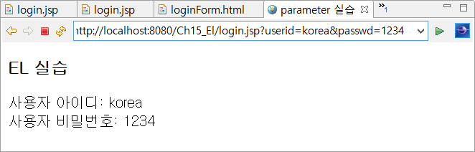

[login.jsp]

|  |
| --- |
| <%@ page language=*"java"* contentType=*"text/html; charset=UTF-8"*  pageEncoding=*"UTF-8"*%>  <!DOCTYPE html PUBLIC "-//W3C//DTD HTML 4.01 Transitional//EN" "http://www.w3.org/TR/html4/loose.dtd">  <html>  <head>  <meta http-equiv=*"Content-Type"* content=*"text/html; charset=UTF-8"*>  <title>parameter 실습</title>  </head>  <body>  <h3>EL 실습</h3>  </body>  </html> |

**II. context 초기화 parameter 값 출력하기**

(EL표기법을 사용하여 context 파라미터 값을 출력하기)

[결과]

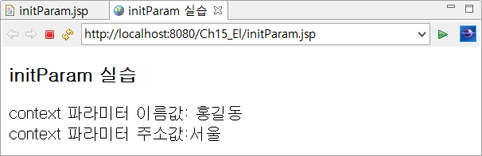

[web.xml]

|  |
| --- |
| <?xml version=*"1.0"* encoding=*"UTF-8"*?>  <web-app xmlns:xsi=*"http://www.w3.org/2001/XMLSchema-instance"* xmlns=*"http://java.sun.com/xml/ns/javaee"* xmlns:web=*"http://java.sun.com/xml/ns/javaee/web-app_2_5.xsd"* xsi:schemaLocation=*"http://java.sun.com/xml/ns/javaee http://java.sun.com/xml/ns/javaee/web-app_3_0.xsd"* id=*"WebApp_ID"* version=*"3.0"*>    </web-app> |

[initParam.jsp]

|  |
| --- |
| <%@ page language=*"java"* contentType=*"text/html; charset=UTF-8"*  pageEncoding=*"UTF-8"*%>  <!DOCTYPE html PUBLIC "-//W3C//DTD HTML 4.01 Transitional//EN" "http://www.w3.org/TR/html4/loose.dtd">  <html>  <head>  <meta http-equiv=*"Content-Type"* content=*"text/html; charset=UTF-8"*>  <title>initParam 실습</title>  </head>  <body>  </body>  </html> |

**III. EL에서 Collection 연습**

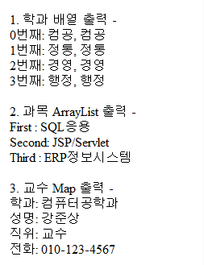

[collections.jsp]

|  |
| --- |
| <%@ page language=*"java"* contentType=*"text/html; charset=UTF-8"* pageEncoding=*"UTF-8"*  import=*"java.util.ArrayList"* import=*"java.util.HashMap"* %> |

**IV. EL의 기본 객체 쿠기**

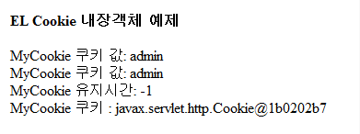

[cookies.jsp]

|  |
| --- |
|  |