JavaBean Servlet

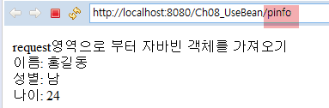

[personalInfo.java]

|  |
| --- |
| **public** **class** PersonalInfo {  **private** String name;  **private** **char** gender;  **private** **int** age;    **public** **void** setName(String name) {  **this**.name = name;  }  **public** String getName() {  **return** name;  }  **public** **void** setGender(**char** gender) {  **this**.gender = gender;  }  **public** **char** getGender() {  **return** gender;  }  **public** **void** setAge(**int** age) {  **this**.age = age;  }  **public** **int** getAge() {  **return** age;  }  } |

[web.xml]

|  |
| --- |
|  |

[personalInfoServlet.java]

|  |
| --- |
| **import** javax.servlet.http.*;  **import** javax.servlet.*;  **import** java.io.*;  **public** **class** PersonalInfoServlet **extends** HttpServlet {    **private** **static** **final** **long** ***serialVersionUID*** = 1L;  **public** **void** doGet(HttpServletRequest request, HttpServletResponse response)  **throws** IOException, ServletException {  }  } |

[customerInfoViewer.jsp]

|  |
| --- |
|  |