**Custom Tag Test**

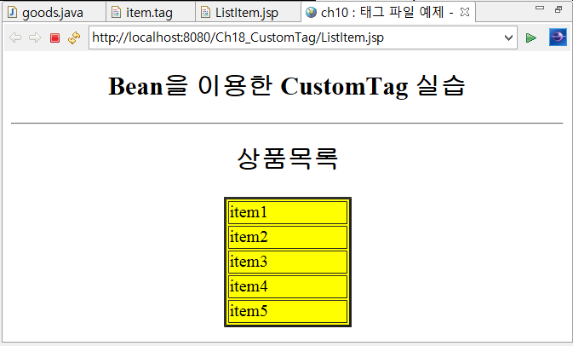

[ item.tag ]

|  |
| --- |
| <%@ tag body-content=*"scriptless"* pageEncoding=*"utf-8"* description=*"item 출력 태그"* %>  <%@ attribute name=*"bgcolor"* %>  <%@ attribute name=*"border"* %> |

[goods.java]

|  |
| --- |
| **package** bean;  **public** **class** goods {  **private** String[] productList = { "item1", "item2", "item3", "item4", "item5" };  **private** **int** num1 = 10;  **private** **int** num2 = 20;    **public** **int** getNum1() {  **return** num1;  }    **public** **void** setNum1(**int** num1) {  **this**.num1 = num1;  }    **public** **int** getNum2() {  **return** num2;  }    **public** **void** setNum2(**int** num2) {  **this**.num2 = num2;  }    **public** String[] getProductList() {  **return** productList;  }    **public** **void** setProductList(String[] productList) {  **this**.productList = productList;  }  } |

[ListItem.jsp]

|  |
| --- |
| <%@ page language=*"java"* contentType=*"text/html; charset=UTF-8"* pageEncoding=*"UTF-8"*%>  <%@ taglib tagdir=*"/WEB-INF/tags"* prefix=*"mytag"*%>  <!DOCTYPE html>  <html>  <head>  <meta charset=*"UTF-8"*>  <title>-태그 파일 예제 - </title>  </head>  <body>  <h2> Bean을 이용한 CustomTag 실습</h2>  <hr>  </body>  </html> |