**1. Team List 만들기**

**1. 축구팀 목록만들기**

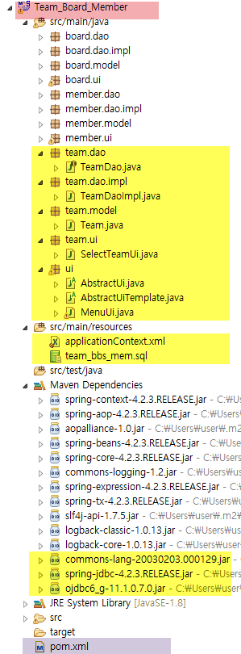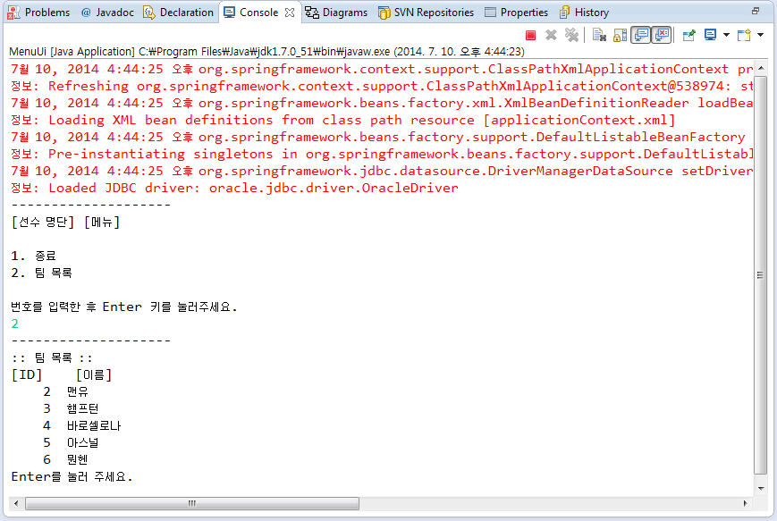

**2. Maven 설정**

|  |
| --- |
| < |

**3. DB연결하기**

[team.sql]

|  |
| --- |
| **--ORA-28000: password expired**  **select * from dba_users;**  **alter user java04 account unlock;**  **alter user java04 identified by java04;**  **create** **table** team(  team_id number,  name varchar2(200)  );  **create** sequence team_seq;  **select** * **from** team; |

[applicationContext.xml] : Spring 설정 파일

|  |
| --- |
| <?xml version=*"1.0"* encoding=*"UTF-8"*?>  <beans xmlns=*"http://www.springframework.org/schema/beans"*  xmlns:xsi=*"http://www.w3.org/2001/XMLSchema-instance"*  xsi:schemaLocation=*"http://www.springframework.org/schema/beans*  *http://www.springframework.org/schema/beans/spring-beans-3.0.xsd"*>    </beans> |

[TeamDao.java] : Interface

|  |
| --- |
| **package** dao;  **import** java.util.List;  **import** model.Team;  **import** org.springframework.dao.DataAccessException;  **public** **interface** TeamDao {    List<Team> getTeamList() **throws** DataAccessException;  } |

[Team.java]

|  |
| --- |
| **package** model;  **public** **class** Team {    **private** Integer id; //team table : team_id  **private** String name; //team table : name    **public** Integer getId() {  **return** id;  }  **public** **void** setId(Integer id) {  **this**.id = id;  }  **public** String getName() {  **return** name;  }  **public** **void** setName(String name) {  **this**.name = name;  }  } |

[RowMapper]

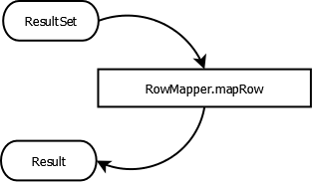

[TeamDaoImpl.java]

|  |
| --- |
| //Spring JDBC를 사용해서 DB에 직접접근  //JdbcDaoSupport클래스를 상속하고 TeamDao인터페이스를 구현  **package** team.dao.impl;  **import** java.sql.ResultSet;  **import** java.sql.SQLException;  **import** java.util.ArrayList;  **import** java.util.List;  **import** team.model.Team;  **import** org.springframework.dao.DataAccessException;  **import** org.springframework.jdbc.core.RowMapper;  **import** org.springframework.jdbc.core.support.JdbcDaoSupport;  **import** team.dao.TeamDao;  **public** **class** TeamDaoImpl **extends** JdbcDaoSupport **implements** TeamDao {  @Override  **public** List<Team> getTeamList() **throws** DataAccessException {  //callback Interface 생성  RowMapper<Team> rowMapper = **new** TeamRowMapper();  //SQL실행  String sql = "select team_id,name from team";  //JdbcDaoSupport는 getJdbcTemplate() 구현(간소화)  **return** getJdbcTemplate().query(sql, rowMapper);  }    **protected** **class** TeamRowMapper **implements** RowMapper<Team>{  **private** List<Team> teamList = **new** ArrayList<Team>();    **public** List<Team> getResults(){  **return** teamList;  }  //rowMapper로부터 한줄씩 받아와서 리스트를 채워준다. (for문이 숨어 있음)  //ResultSet에서 취득한 값을 객체에 넣기  @Override  **public** Team mapRow(ResultSet rs, **int** rowNum) **throws** SQLException {  Team team =**new** Team();  team.setId(rs.getInt("team_id"));  team.setName(rs.getString("name"));  **return** team;  }  }  } |

[AbstractUiTemplate.java]

|  |
| --- |
| **package** ui;  **import** org.apache.commons.lang.StringUtils;  **import** org.apache.commons.lang.NumberUtils;  **public** **abstract** **class** AbstractUiTemplate **extends** AbstractUi {  **public** **void** show() {  // 메뉴 표시  showMenu();  // 콘솔에 입력된 값 취득  String inputedString = getInputedString();  // 입력 문자열이 숫자인지 확인  **if** (isValidNumber(inputedString)) {  // 숫자이면 처리문장 실행  execute(NumberUtils.*createInteger*(inputedString));  }  }  **abstract** **protected** **void** showMenu();  **abstract** **protected** **int** getMaxMenuNumber();  **abstract** **protected** **int** getMinMenuNumber();  **abstract** **protected** **void** execute(**int** number);  **protected** **boolean** isValidNumber(String str) {    // 문자열이 입력이 되고(비어) 있는지?  **if** (StringUtils.*isEmpty*(str)) {  **return** **false**;  // 숫자인지?  } **else** **if** (!StringUtils.*isNumeric*(str)) {  **return** **false**;  }  // 문자열이 숫자 이므로 int로 변환  **int** number = NumberUtils.*createInteger*(str);  // 숫자가 메뉴에 표시되고 있는 번호의 범위인지?  **if** (getMinMenuNumber() <= number && number <= getMaxMenuNumber()) {  **return** **true**;  }  **return** **false**;  }  } |

[AbstractUi.java]

|  |
| --- |
| **package** ui;  **import** java.io.BufferedReader;  **import** java.io.IOException;  **import** java.io.InputStreamReader;  **public** **abstract** **class** AbstractUi {  **protected** String getInputedString(){  BufferedReader input = **new** BufferedReader(**new** InputStreamReader(System.*in*));  **try** {//콘솔에 입력된 값을 취득  **return** input.readLine();  } **catch** (IOException e) {  e.printStackTrace();  }  **return** **null**;  }  **abstract** **public** **void** show();  } |

[SelectTeamUi.java]

|  |
| --- |
| **package** team.ui;  **import** java.util.List;  **import** org.apache.commons.lang.NumberUtils;  **import** team.dao.TeamDao;  **import** team.model.Team;  **import** ui.AbstractUi;  **public** **class** SelectTeamUi **extends** AbstractUi {  **private** TeamDao teamDao;  **public** **void** setTeamDao(TeamDao teamDao) {  **this**.teamDao = teamDao;  }  **public** **void** show() {  // 팀 목록 출력처리  showTeamList(**this**.teamDao.getTeamList());  System.***out***.println("Enter를 눌러 주세요.");  getInputedString();  NumberUtils.*createInteger*("123");  }  **protected** **void** showTeamList(List<Team> teamList) {  System.***out***.println("--------------------");  System.***out***.println(":: 팀 목록 ::");  System.***out***.println("[ID] [이름]");  }  } |

[MenuUi.java]

|  |
| --- |
| //Application 시작후 목록을 표시한후, 메뉴 표시  **package** ui;  **import** org.springframework.context.ApplicationContext;  **import** org.springframework.context.support.ClassPathXmlApplicationContext;  **public** **class** MenuUi **extends** AbstractUiTemplate {  **public** **static** **void** main(String[] args) {  // 스프링 설정파일 읽기  } |