**2. Board List (게시판 목록) 추가하기**

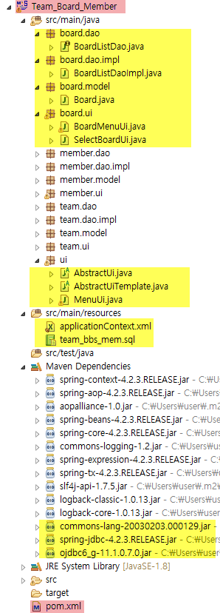 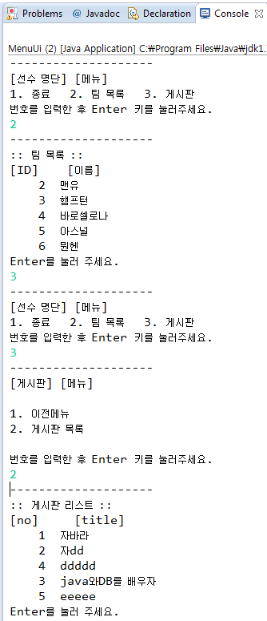

|  |
| --- |
| MenuUi <= BoardMenuUi <= selectBoardUi <= BoardListDao <= dataSource |

[ApplicationContext.xml

|  |
| --- |
| <?xml version=*"1.0"* encoding=*"UTF-8"*?>  <beans xmlns=*"http://www.springframework.org/schema/beans"*  xmlns:xsi=*"http://www.w3.org/2001/XMLSchema-instance"*  xsi:schemaLocation=*"http://www.springframework.org/schema/beans*  *http://www.springframework.org/schema/beans/spring-beans-3.0.xsd"* >  <!-- 데이터베이스 소스 설정 -->  <bean id =*"dataSource"* class=*"org.springframework.jdbc.datasource.DriverManagerDataSource"*>  <property name=*"driverClassName"*>  <value>oracle.jdbc.driver.OracleDriver</value>  </property>  <property name=*"url"*>  <value>jdbc:oracle:thin:@211.183.0.50:1521:orcl</value>  </property>  <property name=*"username"*>  <value>spring/value>  </property>  <property name=*"password"*>  <value>spring</value>  </property>  </bean>    <!-- team list -->  <bean id=*"teamDao"* class=*"dao.impl.TeamDaoImpl"*>  <property name=*"dataSource"* ref=*"dataSource"*></property>  </bean>    <bean id=*"selectTeamUi"* class=*"ui.SelectTeamUi"*>  <property name=*"teamDao"* ref=*"teamDao"*></property>  </bean>    <!-- board list -->    </beans> |

[BoardListDao.java]

|  |
| --- |
| **package** board.dao;  **import** java.util.List;  **import** org.springframework.dao.DataAccessException;  **import** board.model.Board;  **public** **interface** BoardListDao {  List<Board> getBoardList() **throws** DataAccessException;  } |

[BoardListDaoImpl.java]

|  |
| --- |
|  |

[Board.java]

|  |
| --- |
|  |

[SelectBoardUi.java]

|  |
| --- |
|  |

[BoardMenuUi.java]

|  |
| --- |
|  |

[MenuUi.java]

|  |
| --- |
| **package** ui;  **import** org.springframework.context.ApplicationContext;  **import** org.springframework.context.support.ClassPathXmlApplicationContext;  **import** board.ui.BoardMenuUi;  **import** board.ui.SelectBoardUi;  **public** **class** MenuUi **extends** AbstractUiTemplate {  **private** SelectTeamUi selectTeamUi;    **public** **void** setSelectTeamUi(SelectTeamUi selectTeamUi) {  **this**.selectTeamUi = selectTeamUi;  }    **protected** **void** showMenu() {  }  **protected** **int** getMaxMenuNumber() {    }  **protected** **int** getMinMenuNumber() {  }  **protected** **void** execute(**int** number) {  **switch** (number) {  }  }  **public** **static** **void** main(String[] args) {  // 스프링 설정파일 읽기  } |

[AbstractUi.java]

|  |
| --- |
| **package** ui;  **import** java.io.BufferedReader;  **import** java.io.IOException;  **import** java.io.InputStreamReader;  **public** **abstract** **class** AbstractUi {  **protected** String getInputedString(){    }  **abstract** **public** **void** show();  } |

[AbstractUitemplate.java]

|  |
| --- |
| **package** ui;  **import** org.apache.commons.lang.StringUtils;  **import** org.apache.commons.lang.NumberUtils;  **public** **abstract** **class** AbstractUiTemplate **extends** AbstractUi {  **public** **void** show() {  }  **abstract** **protected** **void** showMenu();  **abstract** **protected** **int** getMaxMenuNumber();  **abstract** **protected** **int** getMinMenuNumber();  **abstract** **protected** **void** execute(**int** number);  **protected** **boolean** isValidNumber(String str) {  }  } |