**회원정보(Member List) 추가하기**

MunuUi <=MembermenuUi <=selectMemberUi <=MemberListDao <=datasource

appicationContext.xml

member 패키지 사용

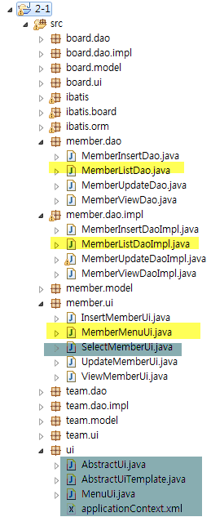 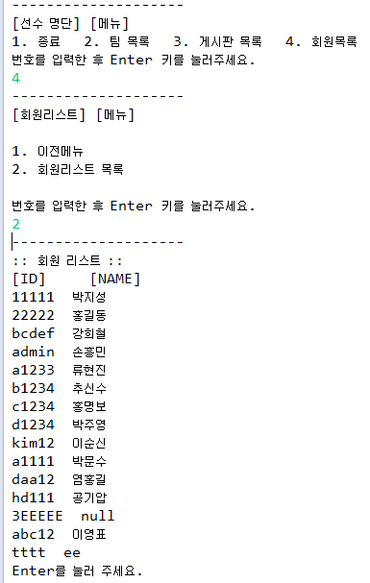

[applicationContext.xml]

|  |
| --- |
| <?xml version=*"1.0"* encoding=*"UTF-8"*?>  <beans xmlns=*"http://www.springframework.org/schema/beans"*  xmlns:xsi=*"http://www.w3.org/2001/XMLSchema-instance"*  xsi:schemaLocation=*"http://www.springframework.org/schema/beans*  *http://www.springframework.org/schema/beans/spring-beans-3.0.xsd"* >  <!-- 데이터베이스 소스 설정 -->  <bean id =*"dataSource"* class=*"org.springframework.jdbc.datasource.DriverManagerDataSource"*>  <property name=*"driverClassName"*>  <value>oracle.jdbc.driver.OracleDriver</value>  </property>  <property name=*"url"*>  <value>jdbc:oracle:thin:@211.183.8.49:1521:orcl1403</value>  </property>  <property name=*"username"*>  <value>java04</value>  </property>  <property name=*"password"*>  <value>java04</value>  </property>  </bean>    <!-- team list -->      </beans> |

[MemberListDao.java]

|  |
| --- |
| **package** member.dao;  **import** java.util.List;  **import** member.model.Member;  **import** org.springframework.dao.DataAccessException;  **public** **interface** MemberListDao {  List<Member> getMemberList() **throws** DataAccessException;  } |

[MemberListDaoImpl.java]

|  |
| --- |
| **package** member.dao.impl;  **import** java.sql.ResultSet;  **import** java.sql.SQLException;  **import** java.util.ArrayList;  **import** java.util.List;  **import** member.dao.MemberListDao;  **import** member.model.Member;  **import** org.springframework.dao.DataAccessException;  **import** org.springframework.jdbc.core.RowMapper;  **import** org.springframework.jdbc.core.support.JdbcDaoSupport;  **public** **class** MemberListDaoImpl **extends** JdbcDaoSupport **implements** MemberListDao {  } |

[Member.java]

|  |
| --- |
| **package** member.model;  **public** **class** Member {  **private** String id,name;  } |

[MemberMenuUi.java]

|  |
| --- |
| **package** member.ui;  **import** org.springframework.context.ApplicationContext;  **import** org.springframework.context.support.ClassPathXmlApplicationContext;  **import** ui.AbstractUiTemplate;  **public** **class** MemberMenuUi **extends** AbstractUiTemplate {  } |

[SelectmemberUi.java]

|  |
| --- |
| **package** member.ui;  **import** java.util.List;  **import** member.dao.MemberListDao;  **import** member.model.Member;  **import** ui.AbstractUi;  **public** **class** SelectMemberUi **extends** AbstractUi {  } |

[MenuUi.java]

|  |
| --- |
| **package** ui;  **import** member.ui.MemberMenuUi;  **import** org.springframework.context.ApplicationContext;  **import** org.springframework.context.support.ClassPathXmlApplicationContext;  **import** board.ui.BoardMenuUi;  **public** **class** MenuUi **extends** AbstractUiTemplate {  } |

[결과]