DI 설정방법2

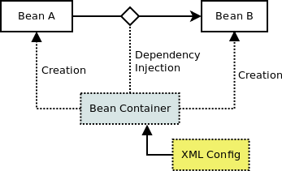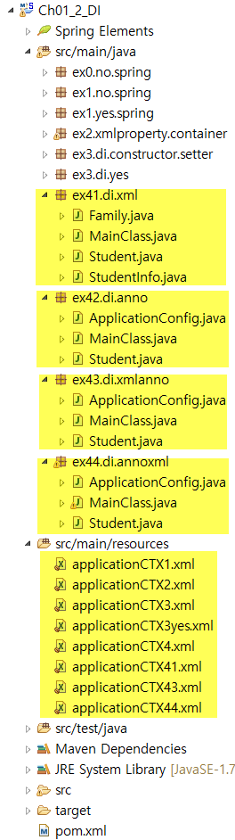

**1. XML 파일을 이용한 DI 설정방법**

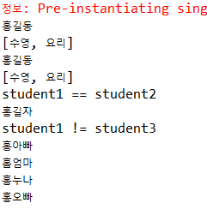

[applicationCTX4.xml]

|  |
| --- |
| <?xml version=*"1.0"* encoding=*"UTF-8"*?>  <beans xmlns=*"http://www.springframework.org/schema/beans"*  xmlns:xsi=*"http://www.w3.org/2001/XMLSchema-instance"*  xsi:schemaLocation=*"http://www.springframework.org/schema/beans http://www.springframework.org/schema/beans/spring-beans.xsd"*>  <bean id=*"student1"* class=*"ex41.di.xml.Student"*>  <constructor-arg value=*"홍길동"* />  <constructor-arg value=*"10"* />  <constructor-arg>  <list>  <value>수영</value>  <value>요리</value>  </list>  </constructor-arg>    <property name=*"height"*>  <value>187</value>  </property>  <property name=*"weight"* value=*"84"* />  </bean>    <bean id=*"sutudentInfo1"* class=*"ex41.di.xml.StudentInfo"*>  <property name=*"student"*>  <ref bean=*"student1"*/>  </property>  </bean>  </beans> |

[applicationCTX41.xml] : namespace를 사용한 방법

|  |
| --- |
| //c namespace: constructor, p namespace: property  <bean id=*"family"* class=*"ex41.di.xml.Family"*  c:papaName=*"홍아빠"* c:mamiName=*"홈엄마"* p:sisterName=*"홍누나"*>  <property name=*"brotherName"* value=*"홍오빠"* />  </bean> |

|  |
| --- |
| <?xml version=*"1.0"* encoding=*"UTF-8"*?>  <beans xmlns=*"http://www.springframework.org/schema/beans"*  xmlns:xsi=*"http://www.w3.org/2001/XMLSchema-instance"*  xmlns:c=*"http://www.springframework.org/schema/c"*  xmlns:p=*"http://www.springframework.org/schema/p"*  xsi:schemaLocation=*"http://www.springframework.org/schema/beans http://www.springframework.org/schema/beans/spring-beans.xsd"*>      </beans> |

[MainClass.java]

|  |
| --- |
| **package** ex41.di.xml;  **import** org.springframework.context.support.AbstractApplicationContext;  **import** org.springframework.context.support.GenericXmlApplicationContext;  **public** **class** MainClass {  **public** **static** **void** main(String[] args) {    String configLocation1 = "classpath:applicationCTX4.xml";  String configLocation2 = "classpath:applicationCTX41.xml";    Student student1 = ctx.getBean("student1", Student.**class**);  System.***out***.println(student1.getName()); //홍길동  System.***out***.println(student1.getHobbys()); // 수영, 요리    StudentInfo studentInfo = ctx.getBean("sutudentInfo1", StudentInfo.**class**);  Student student2 = studentInfo.getStudent(); //student1 == student2  System.***out***.println(student2.getName()); //홍길동  System.***out***.println(student2.getHobbys()); // 수영, 요리    **if**(student1.equals(student2)) {  System.***out***.println("student1 == student2");  }    Student student3 = ctx.getBean("student3", Student.**class**);  System.***out***.println(student3.getName());    **if**(student1.equals(student3)) {  System.***out***.println("student1 == student3");  } **else** {  System.***out***.println("student1 != student3");  }    Family family = ctx.getBean("family", Family.**class**);  System.***out***.println(family.getPapaName());  System.***out***.println(family.getMamiName());  System.***out***.println(family.getSisterName());  System.***out***.println(family.getBrotherName());    ctx.close();  }  } |

[Family.java]

|  |
| --- |
| **package** ex41.di.xml;  **public** **class** Family {  String papaName;  String mamiName;  String sisterName;  String brotherName;    **public** Family(String papaName, String mamiName) {  **this**.papaName = papaName;  **this**.mamiName = mamiName;  }  **public** String getPapaName() {  **return** papaName;  }  **public** **void** setPapaName(String papaName) {  **this**.papaName = papaName;  }  **public** String getMamiName() {  **return** mamiName;  }  **public** **void** setMamiName(String mamiName) {  **this**.mamiName = mamiName;  }  **public** String getSisterName() {  **return** sisterName;  }  **public** **void** setSisterName(String sisterName) {  **this**.sisterName = sisterName;  }  **public** String getBrotherName() {  **return** brotherName;  }  **public** **void** setBrotherName(String brotherName) {  **this**.brotherName = brotherName;  }  } |

[Student.java]

|  |
| --- |
| **package** ex41.di.xml;  **import** java.util.ArrayList;  **public** **class** Student {  **private** String name;  **private** **int** age;  **private** ArrayList<String> hobbys;  **private** **double** height;  **private** **double** weight;    **public** Student(String name, **int** age, ArrayList<String> hobbys) {  **this**.name = name;  **this**.age = age;  **this**.hobbys = hobbys;  }  **public** **void** setName(String name) {  **this**.name = name;  }    **public** **void** setAge(**int** age) {  **this**.age = age;  }  **public** **void** setHobbys(ArrayList<String> hobbys) {  **this**.hobbys = hobbys;  }    **public** **void** setHeight(**double** height) {  **this**.height = height;  }    **public** **void** setWeight(**double** weight) {  **this**.weight = weight;  }    **public** String getName() {  **return** name;  }    **public** **int** getAge() {  **return** age;  }    **public** ArrayList<String> getHobbys() {  **return** hobbys;  }    **public** **double** getHeight() {  **return** height;  }    **public** **double** getWeight() {  **return** weight;  }  } |

[StudentInfo.java]

|  |
| --- |
| **package** ex41.di.xml;  **public** **class** StudentInfo {  **private** Student student;    **public** StudentInfo() {  }    **public** **void** setStudent(Student student) {  **this**.student = student;  }    **public** Student getStudent() {  **return** student;  }  } |

**2. @방법을 이용한 DI 설정방법**

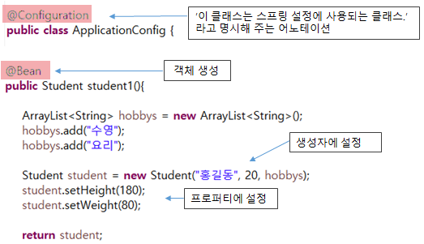

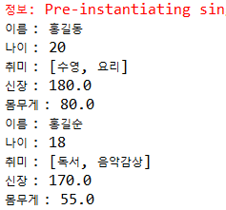

[MainClass.java]

|  |
| --- |
| **package** ex42.di.anno;  **import** org.springframework.context.annotation.AnnotationConfigApplicationContext;  **public** **class** MainClass {  **public** **static** **void** main(String[] args) {      System.***out***.println("이름 : " + student1.getName());  System.***out***.println("나이 : " + student1.getAge());  System.***out***.println("취미 : " + student1.getHobbys());  System.***out***.println("신장 : " + student1.getHeight());  System.***out***.println("몸무게 : " + student1.getWeight());    System.***out***.println("이름 : " + student2.getName());  System.***out***.println("나이 : " + student2.getAge());  System.***out***.println("취미 : " + student2.getHobbys());  System.***out***.println("신장 : " + student2.getHeight());  System.***out***.println("몸무게 : " + student2.getWeight());    ctx.close();  }  } |

[ApplicationConfig.java]

|  |
| --- |
| **package** ex42.di.anno;  **import** java.util.ArrayList;  **import** org.springframework.context.annotation.Bean;  **import** org.springframework.context.annotation.Configuration;  **public** **class** ApplicationConfig {    **public** Student student1(){  ArrayList<String> hobbys = **new** ArrayList<String>();  hobbys.add("수영");  hobbys.add("요리");    Student student = **new** Student("홍길동", 20, hobbys);  student.setHeight(180);  student.setWeight(80);    **return** student;  }      **public** Student student2(){  } |

[Student.java]

|  |
| --- |
| **package** ex42.di.anno;  **import** java.util.ArrayList;  **public** **class** Student {  **private** String name;  **private** **int** age;  **private** ArrayList<String> hobbys;  **private** **double** height;  **private** **double** weight;    **public** Student(String name, **int** age, ArrayList<String> hobbys) {  **this**.name = name;  **this**.age = age;  **this**.hobbys = hobbys;  }  **public** **void** setName(String name) {  **this**.name = name;  }    **public** **void** setAge(**int** age) {  **this**.age = age;  }  **public** **void** setHobbys(ArrayList<String> hobbys) {  **this**.hobbys = hobbys;  }    **public** **void** setHeight(**double** height) {  **this**.height = height;  }    **public** **void** setWeight(**double** weight) {  **this**.weight = weight;  }    **public** String getName() {  **return** name;  }    **public** **int** getAge() {  **return** age;  }    **public** ArrayList<String> getHobbys() {  **return** hobbys;  }    **public** **double** getHeight() {  **return** height;  }    **public** **double** getWeight() {  **return** weight;  }  } |

**3. XML & @을 같이 사용한 방법**

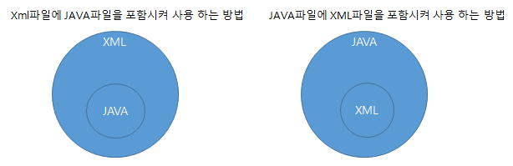

**(1)Xml파일에 Java파일을 포함시켜 사용하는 방법**

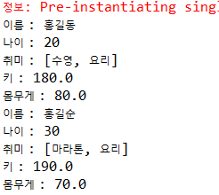

[applicationCTX43.xml]

|  |
| --- |
| <?xml version=*"1.0"* encoding=*"UTF-8"*?>  <beans xmlns=*"http://www.springframework.org/schema/beans"*  xmlns:xsi=*"http://www.w3.org/2001/XMLSchema-instance"*  xmlns:context=*"http://www.springframework.org/schema/context"*  xsi:schemaLocation=*"http://www.springframework.org/schema/beans http://www.springframework.org/schema/beans/spring-beans.xsd*  *http://www.springframework.org/schema/context http://www.springframework.org/schema/context/spring-context-3.2.xsd"*>    <context:annotation-config />  <bean class=*"ex43.di.xmlanno.ApplicationConfig"* />    <bean id=*"student2"* class=*"ex43.di.xmlanno.Student"*>  <constructor-arg value=*"홍길순"*></constructor-arg>  <constructor-arg value=*"30"*></constructor-arg>  <constructor-arg >  <list>  <value>마라톤</value>  <value>요리</value>  </list>  </constructor-arg>  <property name=*"height"* value=*"190"* />  <property name=*"weight"* value=*"70"* />  </bean>  </beans> |

[ApplicationConfig.java]

|  |
| --- |
| **package** ex43.di.xmlanno;  **import** java.util.ArrayList;  **import** org.springframework.context.annotation.Bean;  **import** org.springframework.context.annotation.Configuration;  } |

[MainClass.java]

|  |
| --- |
| **package** ex44.di.annoxml;  **import** org.springframework.context.annotation.AnnotationConfigApplicationContext;  **public** **class** MainClass {  **public** **static** **void** main(String[] args) {      System.***out***.println("이름 : " + student1.getName());  System.***out***.println("나이 : " + student1.getAge());  System.***out***.println("취미 : " + student1.getHobbys());  System.***out***.println("키 : " + student1.getHeight());  System.***out***.println("몸무게 : " + student1.getWeight());    Student student2 = ctx.getBean("student2", Student.**class**);  System.***out***.println("이름 : " + student2.getName());  System.***out***.println("나이 : " + student2.getAge());  System.***out***.println("취미 : " + student2.getHobbys());  System.***out***.println("키 : " + student2.getHeight());  System.***out***.println("몸무게 : " + student2.getWeight());    ctx.close();  }  } |

[Student.java]

|  |
| --- |
| **package** ex43.di.xmlanno;  **import** java.util.ArrayList;  **public** **class** Student {  **private** String name;  **private** **int** age;  **private** ArrayList<String> hobbys;  **private** **double** height;  **private** **double** weight;    **public** Student(String name, **int** age, ArrayList<String> hobbys) {  **this**.name = name;  **this**.age = age;  **this**.hobbys = hobbys;  }  **public** **void** setName(String name) {  **this**.name = name;  }    **public** **void** setAge(**int** age) {  **this**.age = age;  }  **public** **void** setHobbys(ArrayList<String> hobbys) {  **this**.hobbys = hobbys;  }    **public** **void** setHeight(**double** height) {  **this**.height = height;  }    **public** **void** setWeight(**double** weight) {  **this**.weight = weight;  }    **public** String getName() {  **return** name;  }    **public** **int** getAge() {  **return** age;  }    **public** ArrayList<String> getHobbys() {  **return** hobbys;  }    **public** **double** getHeight() {  **return** height;  }    **public** **double** getWeight() {  **return** weight;  }  } |

**(2) Java파일에 Xml파일을 포함시켜 사용하는 방법**

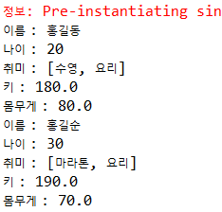

[applicationCTX44.xml]

|  |
| --- |
| <?xml version=*"1.0"* encoding=*"UTF-8"*?>  <beans xmlns=*"http://www.springframework.org/schema/beans"*  xmlns:xsi=*"http://www.w3.org/2001/XMLSchema-instance"*  xsi:schemaLocation=*"http://www.springframework.org/schema/beans http://www.springframework.org/schema/beans/spring-beans.xsd"*>    <bean id=*"student2"* class=*"ex44.di.annoxml.Student"*>  <constructor-arg value=*"홍길순"*></constructor-arg>  <constructor-arg value=*"30"*></constructor-arg>  <constructor-arg >  <list>  <value>마라톤</value>  <value>요리</value>  </list>  </constructor-arg>  <property name=*"height"* value=*"190"* />  <property name=*"weight"* value=*"70"* />  </bean>  </beans> |

[MainClass.java]

|  |
| --- |
| **package** ex44.di.annoxml;  **import** org.springframework.context.annotation.AnnotationConfigApplicationContext;  **public** **class** MainClass {  **public** **static** **void** main(String[] args) {      System.***out***.println("이름 : " + student1.getName());  System.***out***.println("나이 : " + student1.getAge());  System.***out***.println("취미 : " + student1.getHobbys());  System.***out***.println("키 : " + student1.getHeight());  System.***out***.println("몸무게 : " + student1.getWeight());    Student student2 = ctx.getBean("student2", Student.**class**);  System.***out***.println("이름 : " + student2.getName());  System.***out***.println("나이 : " + student2.getAge());  System.***out***.println("취미 : " + student2.getHobbys());  System.***out***.println("키 : " + student2.getHeight());  System.***out***.println("몸무게 : " + student2.getWeight());    ctx.close();  }  } |

[ApplicationConfig.java]

|  |
| --- |
| **package** ex44.di.annoxml;  **import** java.util.ArrayList;  **import** org.springframework.context.annotation.Bean;  **import** org.springframework.context.annotation.Configuration;  **import** org.springframework.context.annotation.ImportResource;  **public** **class** ApplicationConfig {  @Bean  **public** Student student1(){    ArrayList<String> hobbys = **new** ArrayList<String>();  hobbys.add("수영");  hobbys.add("요리");    Student student = **new** Student("홍길동", 20, hobbys);  student.setHeight(180);  student.setWeight(80);    **return** student;  }  } |

[Student.java]

|  |
| --- |
| **package** ex44.di.annoxml;  **import** java.util.ArrayList;  **public** **class** Student {  **private** String name;  **private** **int** age;  **private** ArrayList<String> hobbys;  **private** **double** height;  **private** **double** weight;    **public** Student(String name, **int** age, ArrayList<String> hobbys) {  **this**.name = name;  **this**.age = age;  **this**.hobbys = hobbys;  }  **public** **void** setName(String name) {  **this**.name = name;  }    **public** **void** setAge(**int** age) {  **this**.age = age;  }  **public** **void** setHobbys(ArrayList<String> hobbys) {  **this**.hobbys = hobbys;  }    **public** **void** setHeight(**double** height) {  **this**.height = height;  }    **public** **void** setWeight(**double** weight) {  **this**.weight = weight;  }    **public** String getName() {  **return** name;  }    **public** **int** getAge() {  **return** age;  }    **public** ArrayList<String> getHobbys() {  **return** hobbys;  }    **public** **double** getHeight() {  **return** height;  }    **public** **double** getWeight() {  **return** weight;  }  } |