About the dataset: The microsphere dataset, namely “ball_data”, consists of optical path difference (OPD) distributions (unit: m) from 70 polystyrene microspheres. The samples include microspheres with diameters of 4μm and 8μm (with a specified diameter tolerance of less than 3%, according to the manufacturer), and a refractive index of 1.588. They are immersed in physiological saline with a RI of 1.33.
The red blood cell (RBC) dataset, namely “RBC_data”, contains OPD distributions (unit: m) from 30 healthy human RBCs, and they are immersed in physiological saline with a RI of 1.33. The RBC samples collected from healthy adult male donors, which were isolated from anticoagulated peripheral blood via centrifugation, washed, and finally resuspended in isotonic physiological saline for imaging.
Each OPD distribution image of the dataset has been standardized. Consequently, the OPD images have a uniform resolution of 100 × 100 pixels, corresponding to a physical field of view of 12 × 12 μm².
About data acquisition:The imaging experiments were conducted under standard environmental conditions (room temperature and pressure, 22°C). All data were acquired using a label-free digital cell imager (Biophase system). This system consists of an inverted micro scope (Olympus GX51) and an optical path for phase calculation based on the transport-of-intensity equation (TIE), which is shown in Fig. 1.
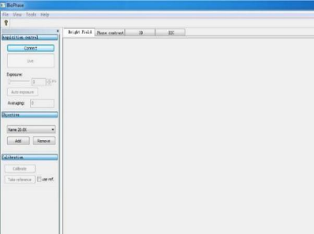
(A) (B) (C)
Fig.1 Key components of the BioPhase imaging system
(A) Photograph of the experimental setup for the Biophase system
(a) Light source (b) Condenser lens (c) Sample platform
(d) Electric platform controller (e) The Phaseview device
(B) Optical path for phase calculation based on TIE (C) The software interface of Biophase
The system uses a halogen lamp with a central wavelength of 574 nm as the light source. Data acquisition utilized a 20x objective (numerical aperture NA = 0.5). In this configuration, the system’s specified lateral resolution is 0.7 μm and its axial (Z) resolution is 0.04 μm.
The microsphere and RBC samples were acquired consecutively within the same experimental session using identical system parameter settings, namely, exposure time of 239.815 ms, frame averaging of 12, and a 20× objective.
Terms of Use: If you use the data and charts, please cite the following paper.
Ji, Y., Fu, S., Zhang, M., Li, X., & Wang, Y. (2020). Characterization of the solution concentration variation in microstructure by phase imaging. Journal of Modern Optics, 67(5), 454-461. https://doi.org/10.1080/09500340.2020.1736352

