DTGen GUI Demonstration
Developed by DMSTEX (http://dmstex.com)

Oracle and Java are registered trademarks of Oracle Corporation and/or its affiliates.

Table of Contents
Introduction: 1
Exercise Setup 1
Exercise #1: Default Maintenance Forms 2
Exercise #2: Data Domain Filterable Grid Edit 26
Exercise #3: Handling of CLOB data 30
Exercise #4: Comprehensive OMNI View Forms 31
Exercise #5: Forms Development Guidelines 34

Introduction:
The exercises in this demonstration are focused on the Graphical User Interface (GUI) "helpers" produced by DTGen. The database schema and data are an extension of the ASOF Demonstration. The "ASOF" demonstration should be reviwed before running these exercises. Serveral concepts introduced in those exercises are not explained here.

With the exception of executing generated scripts, all the functionality in these exercises is available through both command line and graphical user interface (GUI) mode. Issue #23 is an enhancement request to allow executing generated scripts in the GUI. Command line is used in these exercises to expedite progress where needed.

The exercises in this directory are numbered and must be executed in sequential order. The demonstration users must be created with the "create_demo_users.sql" script in the parent directory before the first exercise is run. The demonstration users must be dropped with the "drop_demo_users.sql" script before the "create_demo_users.sql" script can be re-run. These exercises also assume that the default username/password (dtgen/dtgen) is still in use for the generator. Names and passwords are set in the "vars.sql" script and can be modified, if necessary. Also, the DTGen database objects must be installed in the database and the DTGen must be ready to generate code.

Exercise Setup

Command Line:
sqlplus system/password @setup

Exercise Setup modifies the database. However, the changes are mde in APEX

The setup.sql script creates an APEX workspace and user. These need to be in place before the target application can be created in Exercise #1.

Workspace and APEX User DTGEN_DB_DEMO have been setup.

PL/SQL procedure successfully completed.

The output above is the result of a successful execution. Note, setup.sql can also be run as sys or APEX_04000. Also, there is a cleanup.sql script that can be used to remove this setup in APEX. Note that identical database schema objects can be dropped and recreated without dropping and recreating APEX objects.

Exercise #1: Default Maintenance Forms

Command Line:
APEX Forms
sqlplus /nolog @e1
APEX Forms

Exercise #1 modifies the database. The "drop_demo_users.sql" and "create_demo_users.sql" scripts must be used to reset the database before re-running this exercise. The APEX application that is created can be removed or remain as the create_flow.sql scripts will "work around" the existing application.

In this exercise, an empty application will be created in APEX. The database schema and maintenance forms will be generated and loaded into the empty application. Then, navigation lists and breadcrumbs will be updated to integrate the genreated items into the application. The process starts with a login to APEX. The password is "dtgen".

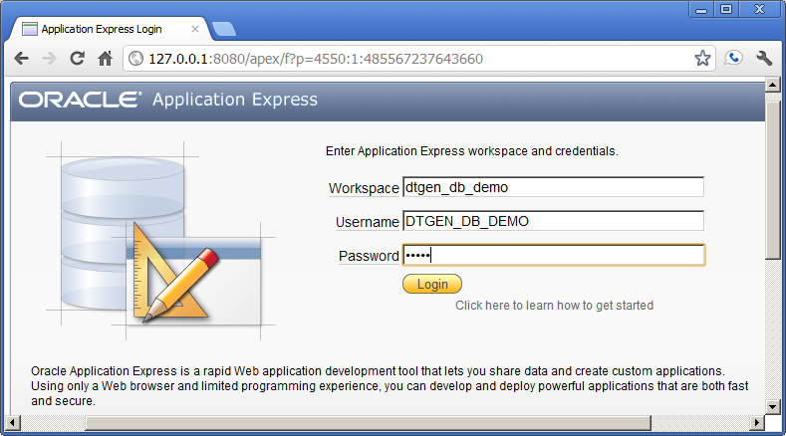
Click the "login" button to login.

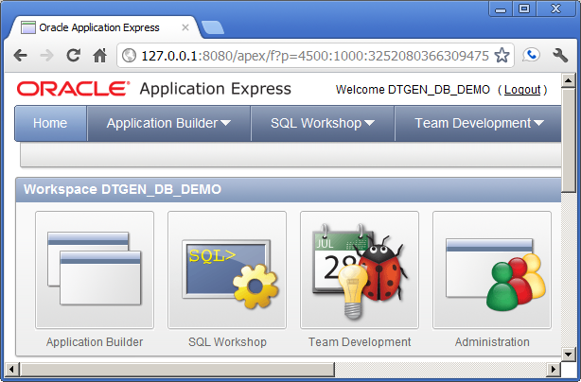
Click the "Application Builder" button.

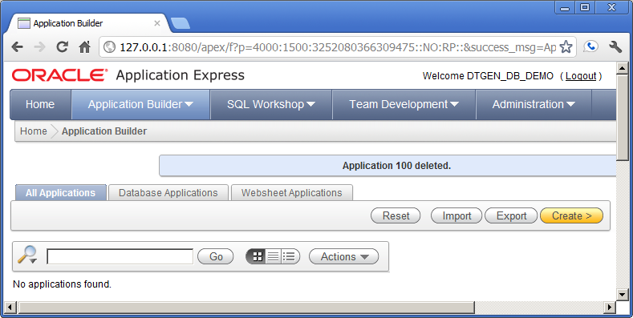
Click the "create" button to create a new application.

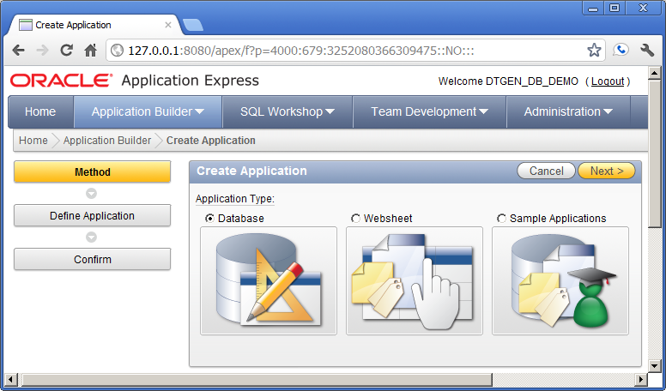
Click the "Database" or the "Next" button.

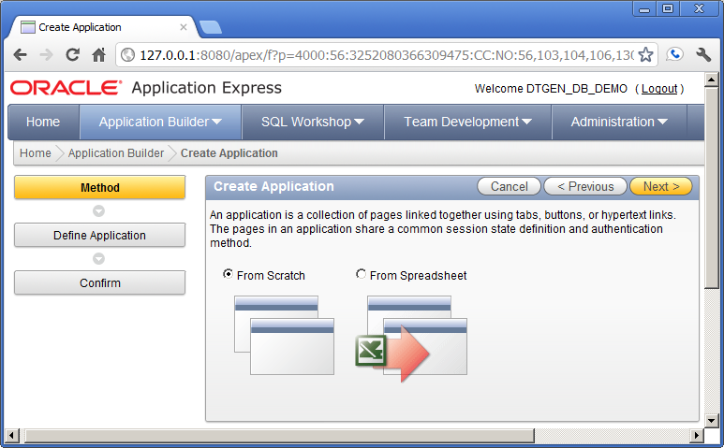
Click the "From Scratch" or the "Next" button.

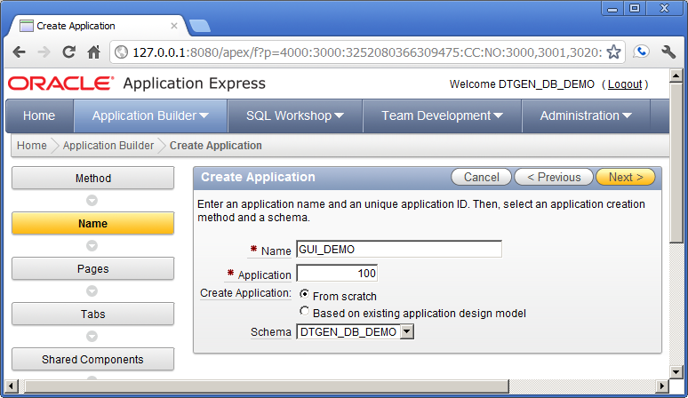
Update the values and click the "Next" button.

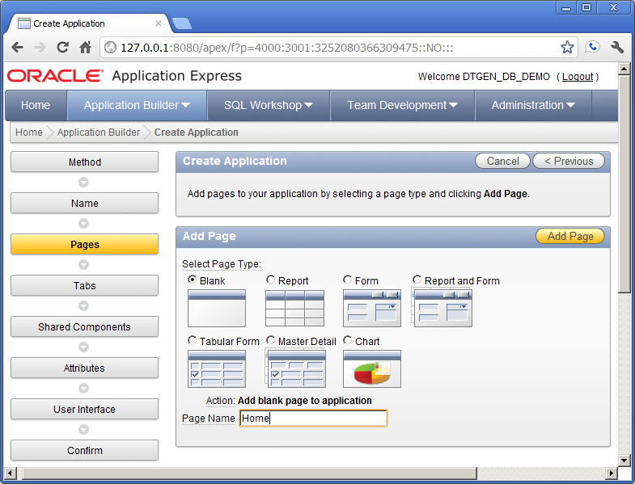
Update the values and click "Add Page".

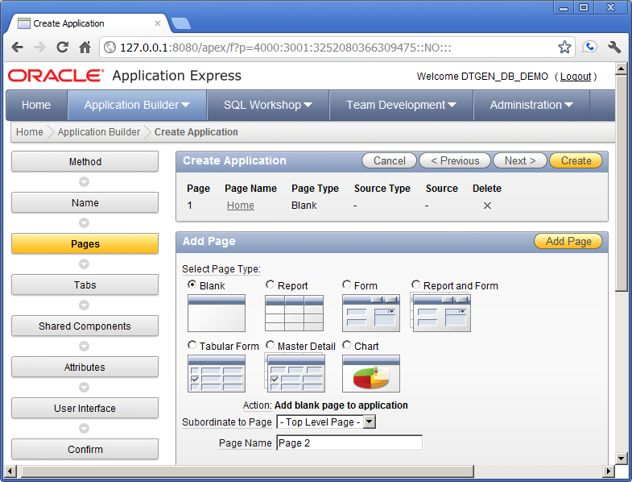
Confirm the values and click the "Next" button
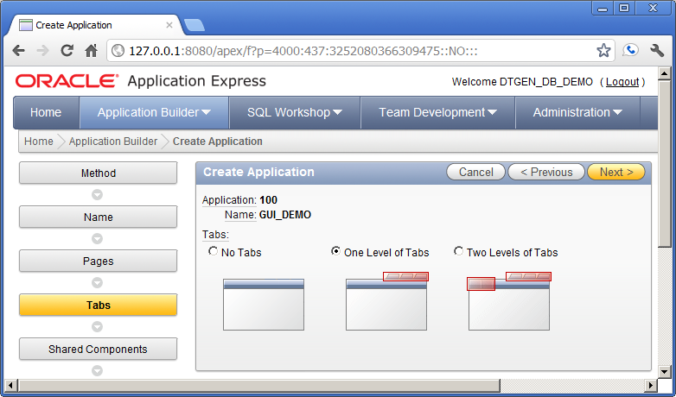
Confirm the values and click the "Next" button

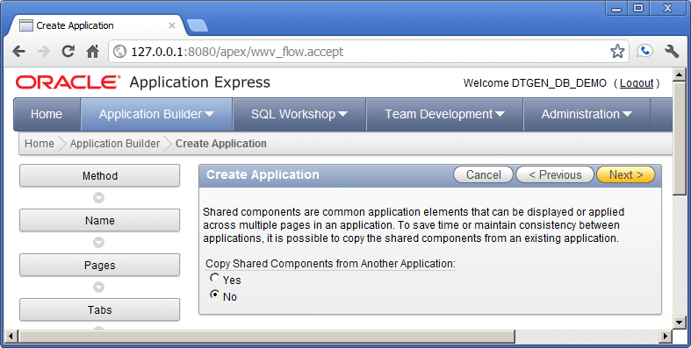
Confirm the values and click the "Next" button.

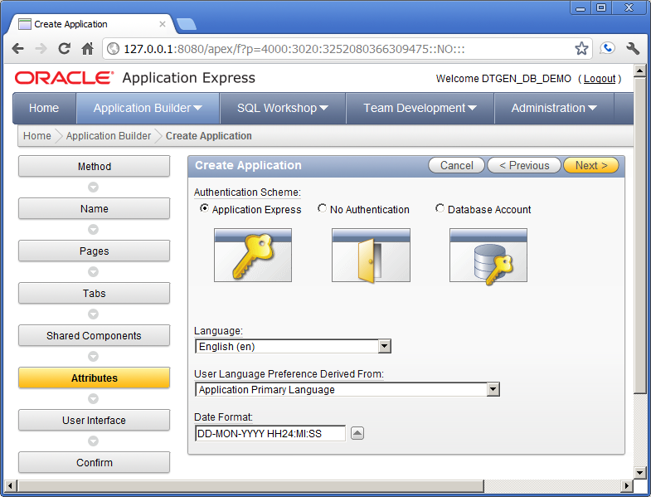
Enter the values and click "Next"

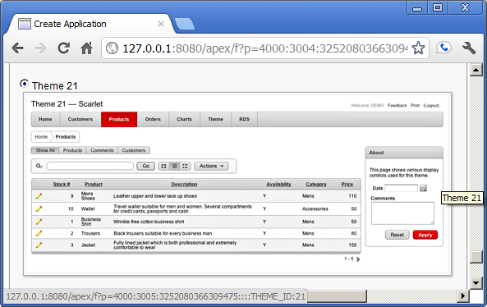
Confirm that Theme 21 is selected.
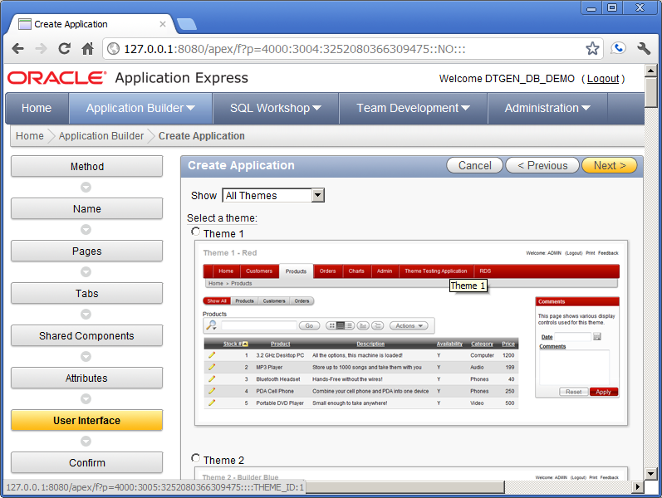
The screen above is the same as the previous screen. Confirm and click the "Next" button.

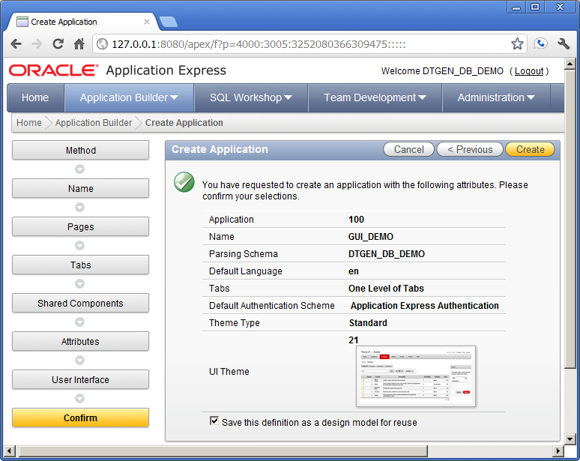
Enter the values and click the "Create" button.
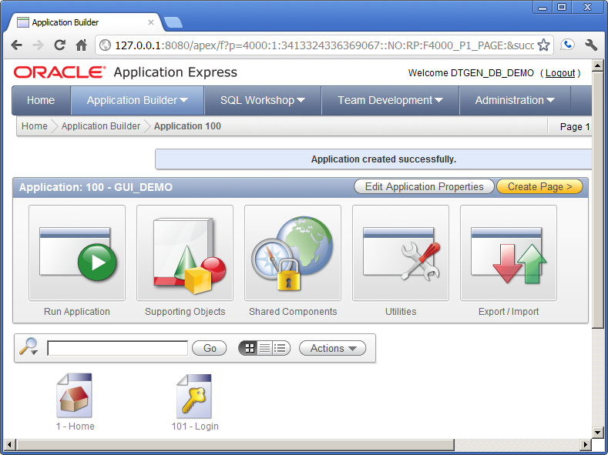
The new application has been created and is ready to receive the generated items from DTGen. The following is the results from executing the e1.sql script.

Login to dtgen
Connected.
Remove old DEMO4 Schema from DTGEN
create a DEMO4 Schema in DTGEN
Generate DEMO4 Application
Capture SQL Scripts

Similar to the other demonstrations, the output shown above is from the e1.LST log file. The details of modifying schema in DTGen and generating will be covered in following exercises. Below is the output from the install.LST log file that follows the SQL script capture in e1.sql.

Login to dtgen_db_demo
Connected.

FILE_NAME
-----------------
-) create_glob

FILE_NAME
----------------
-) create_ods

TABLE_NAME
--------------
*** dept ***

TABLE_NAME
-------------
*** emp ***

FILE_NAME
------------------
-) create_integ

TABLE_NAME
--------------
*** dept ***

TABLE_NAME
-------------
*** emp ***

FILE_NAME
-----------------
-) create_oltp

TABLE_NAME
--------------
*** dept ***

TABLE_NAME
-------------
*** emp ***

FILE_NAME
---------------
-) create_aa

TABLE_NAME
--------------
*** dept ***

TABLE_NAME
-------------
*** emp ***

FILE_NAME
-----------------
-) create_mods

The portion of the e1.sql script that generated the output above is similar to Exercise #1 in the other demonsrations. However, the following portion of the install.LST log file shows the APEX GUI items that were generated by DTGen being installed.

FILE_NAME
-----------------
-) create_flow
APPLICATION 100 - GUI_DEMO
Set Credentials...
Check Compatibility...
API Last Extended:20100513
Your Current Version:20100513
This import is compatible with version: 20100513
COMPATIBLE (You should be able to run this import without issues.)

Set Application ID...
...application processes
...Create Flow Process "SET_USR"
...Shared Lists of values
...Create LOV "JOB NAME"
...Remove page 1000
...Create page 1000: Maintenance Menu
...Navigation Tabs (for Maintenance Menu)
Adding Maintenance Menu Tab to UTIL_TS ...
...Navigation Lists
...Create LIST " Maintenance Menu"
...Create LIST ENTRY "Dept Maint"
...Create LIST ENTRY "Emp Maint"
... Add LIST " Maintenance Menu" to page 1000
...Remove page 1200
...Create page 1200: Utility Log Report
...Create UTIL_LOG Report Plug
...Create Page Processing
...Navigation Tabs (for Utility Log Report)
Adding Utility Log Report Tab to UTIL_TS ...
...Remove page 1400
...Create page 1400: OMNI Reports Menu
...Navigation Tabs (for OMNI Reports Menu)
Adding T_OMNI Tab to UTIL_TS ...
...Navigation Lists
...Create LIST " OMNI Reports Menu"
...Create LIST ENTRY "Dept OMNI"
...Create LIST ENTRY "Emp OMNI"
... Add LIST " OMNI Reports Menu" to page 1400
...Remove page 1600
...Create page 1600: ASOF Reports Menu
...Navigation Tabs (for ASOF Reports Menu)
Adding T_ASOF Tab to UTIL_TS ...
...Navigation Lists
...Create LIST " ASOF Reports Menu"
...Create LIST ENTRY "Dept ASOF"
...Create LIST ENTRY "Emp ASOF"
... Add LIST " ASOF Reports Menu" to page 1600
...Create LIST "Utility Menu"
...Create LIST ENTRY "Maintenance Menu"
...Create LIST ENTRY "Utility Log Report"
...Create LIST ENTRY "OMNI Reports Menu"
...Create LIST ENTRY "ASOF Reports Menu"
Adding Breadcrumbs
...Create BREADCRUMB ENTRY "Maintenance Menu"
...Create BREADCRUMB ENTRY "Dept Maint"
...Create BREADCRUMB ENTRY "Dept Form"
...Create BREADCRUMB ENTRY "Emp Maint"
...Create BREADCRUMB ENTRY "Emp Form"
...Create BREADCRUMB ENTRY "Utility Log Report"
...Create BREADCRUMB ENTRY "OMNI Reports Menu"
...Create BREADCRUMB ENTRY "Dept OMNI"
...Create BREADCRUMB ENTRY "Emp OMNI"
...Create BREADCRUMB ENTRY "ASOF Reports Menu"
...Create BREADCRUMB ENTRY "Dept ASOF"
...Create BREADCRUMB ENTRY "Emp ASOF"

All of the output above is the result of GUI navigation items being installed into APEX. The output from the DEPT and EMP data maintenance forms is below.

TABLE_NAME
--------------
*** dept ***
dept maint1, 10
...Create Shared LOV "DEPT_LOV"
...Remove page 1010
...Create page 1010: Dept Maint
...Create Main Grid Edit
...Create Filter Criteria
...Create Page Processing
Adding Dept Maint Tab to _MAINT_TS ...
dept maint2, 10
...Create ALL Report
...Create History Report
...Create POP_AUDIT Report
dept form, 10
...Remove page 1210
...Create page 1210: Dept Form
...Create DML Form
...Create Page Processing
Adding Dept Form Tab to _FORM_TS ...
dept omni, 10
...Remove page 1410
...Create page 1410: Dept OMNI
...Create Interactive Report
Adding Dept OMNI Tab to _OMNI_TS ...
dept asof, 10
...Remove page 1610
...Create page 1610: Dept ASOF
...Create Interactive Report
Adding Dept ASOF Tab to _ASOF_TS ...
SCHEMA DTGEN_DB_DEMO - User Interface Defaults, Table Defaults

TABLE_NAME
-------------
*** emp ***
emp maint1, 20
...Create Shared LOV "EMP_LOV"
...Create Shared LOV "MGR_EMP_LOV"
...Remove page 1020
...Create page 1020: Emp Maint
...Create Main Grid Edit
...Create Filter Criteria
...Create Page Processing
Adding Emp Maint Tab to _MAINT_TS ...
emp maint2, 20
...Create ALL Report
...Create History Report
...Create POP_AUDIT Report
emp form, 20
...Remove page 1220
...Create page 1220: Emp Form
...Create DML Form
...Create Page Processing
Adding Emp Form Tab to _FORM_TS ...
emp omni, 20
...Remove page 1420
...Create page 1420: Emp OMNI
...Create Interactive Report
Adding Emp OMNI Tab to _OMNI_TS ...
emp asof, 20
...Remove page 1620
...Create page 1620: Emp ASOF
...Create Interactive Report
Adding Emp ASOF Tab to _ASOF_TS ...
SCHEMA DTGEN_DB_DEMO - User Interface Defaults, Table Defaults
- User Interface Defaults, Attribute Dictionary
...done

Loading data into database

At the end of the output above is the indication that the schema data has been loaded. This is the same data used in the ASOF demonstration. The remaining effort is to "connect" the generated navigation items with the empty application in APEX. This effort starts with a refresh of the application builder page (or login as DTGEN_DB_DEMO and navigate to the GUI_DEMO application page if not logged into APEX).

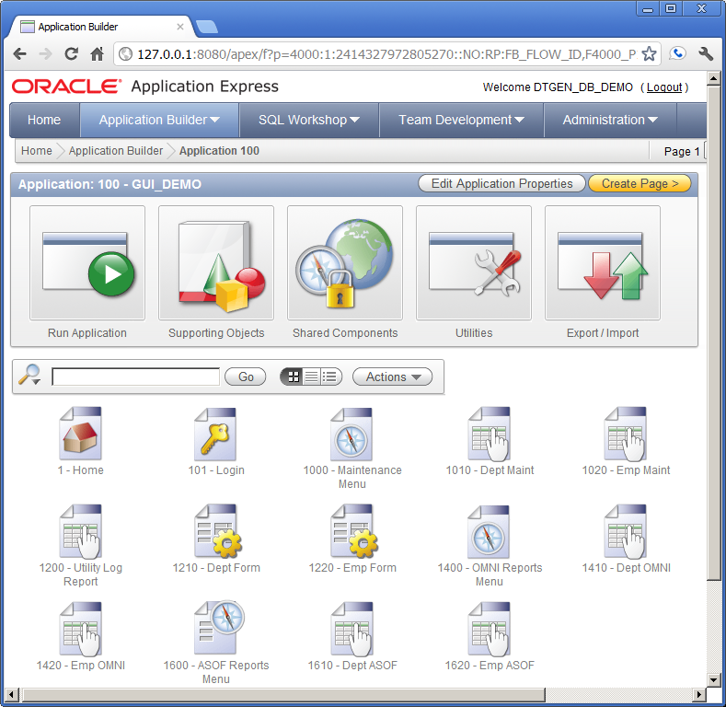
Click the "Shared Components" button

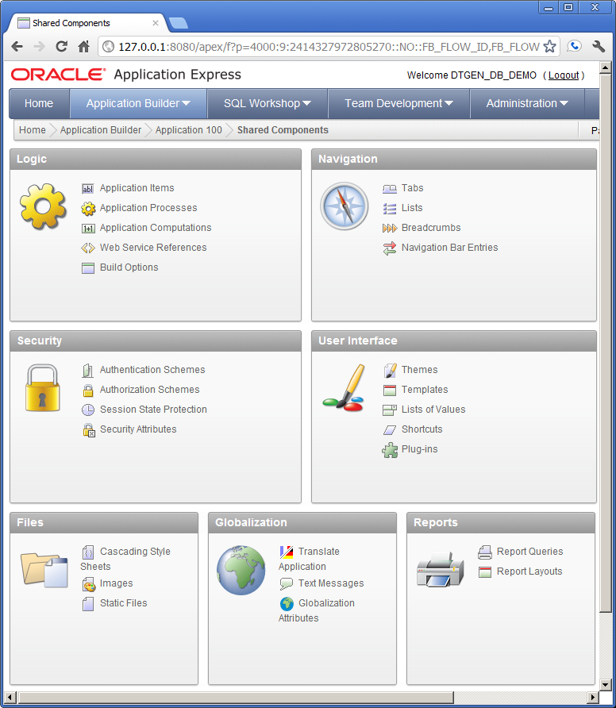

Click the "Lists" link in the "Navigation" pane

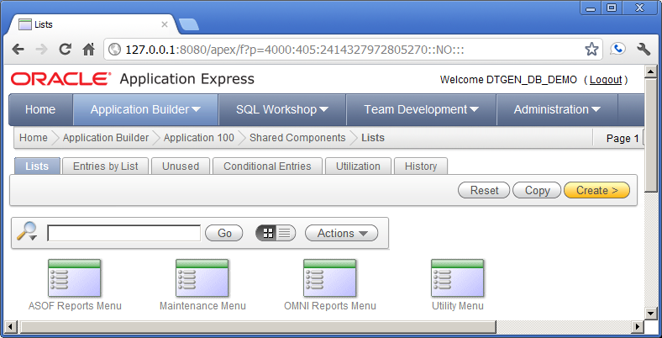
Click the "Utility Menu" icon.

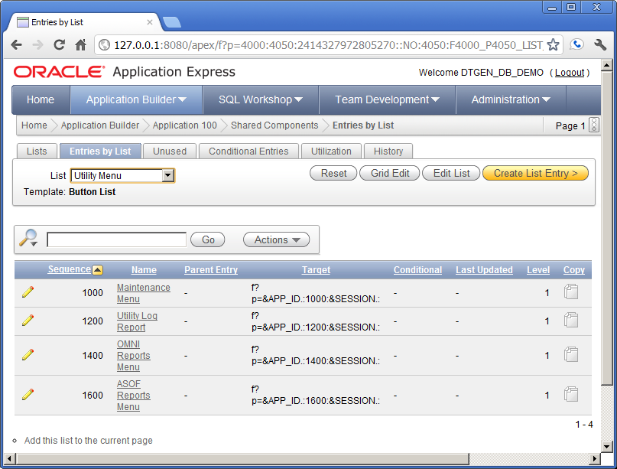
Confirm the "Page 1" is in the upper right and click the "Add this list to the current page" link.

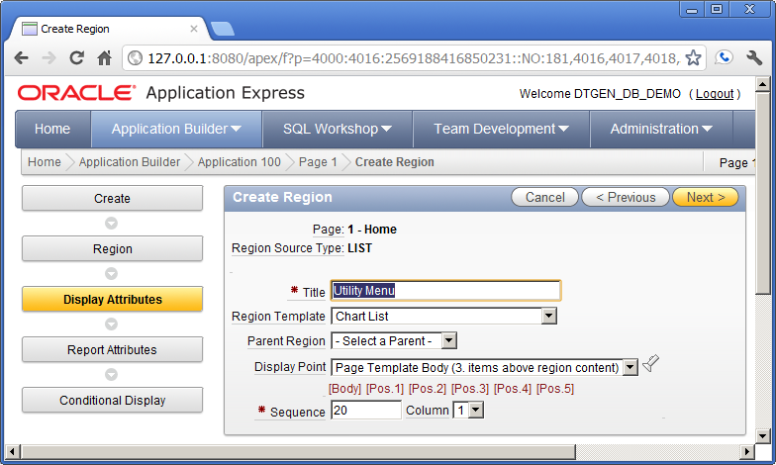
Confirm these values and click the "Next" button

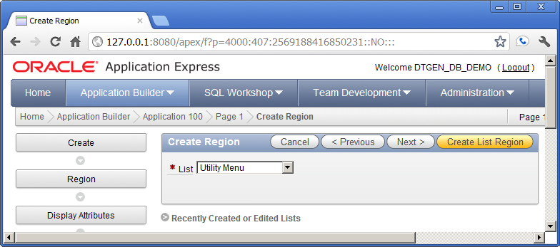
Confirm these values and click the "Create List Region" button

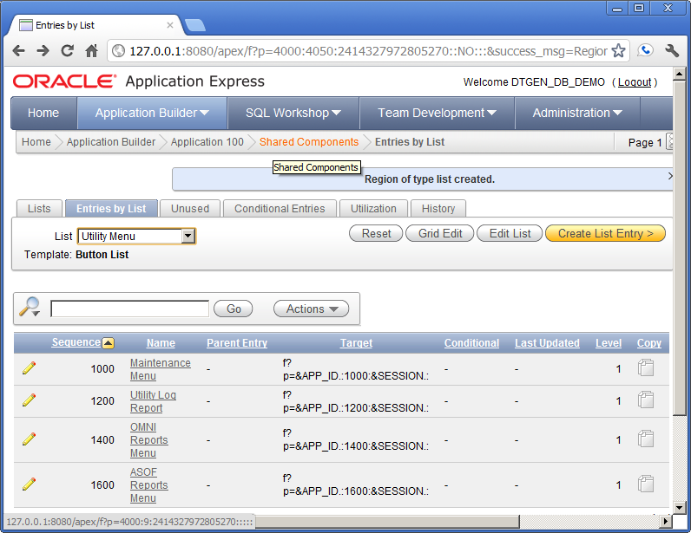
Click the "Shared Components" link in the breadcrumb at the top.

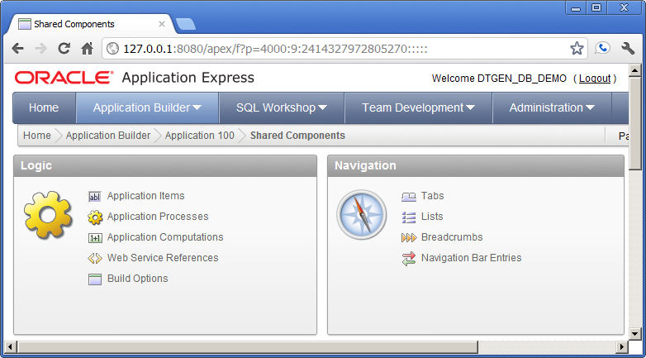
Click the "Breadcrumbs" link in the "Navigation" pane.
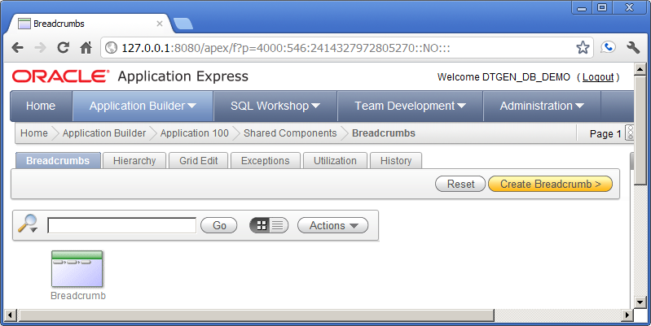
Click the "Breadcumb" Icon at the bottom left

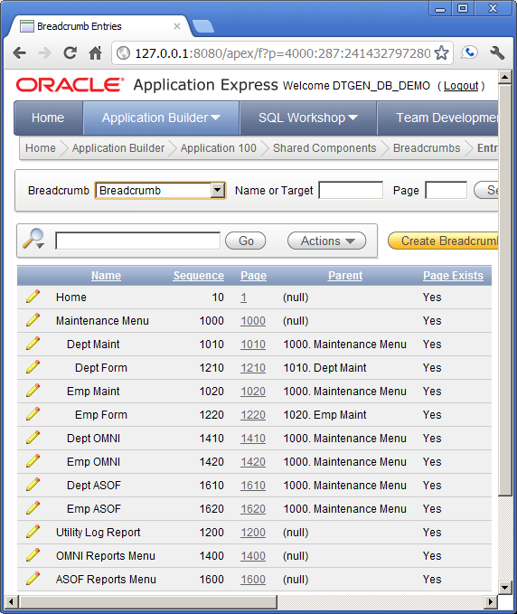

Click the pencil icon to the left of the "Maintenance Menu" name.

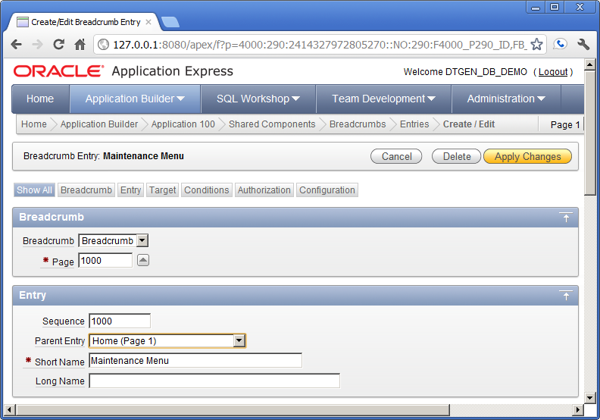

Change the "Parent Entry" to "Home (Page 1)", then click "Apply Changes".

Repeat the above step for the following names:

- Utility Log Report
- OMNI Reports Menu
- ASOF Reports Menu

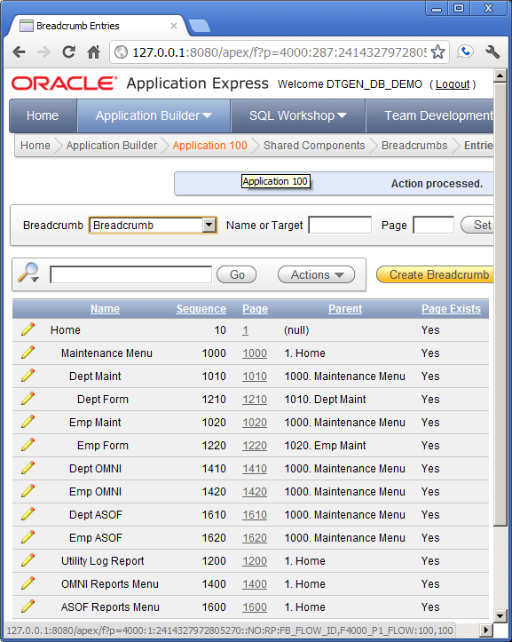
After repeating the steps, confirm values and click the "Application 100" link in the breadcrumb at the top.

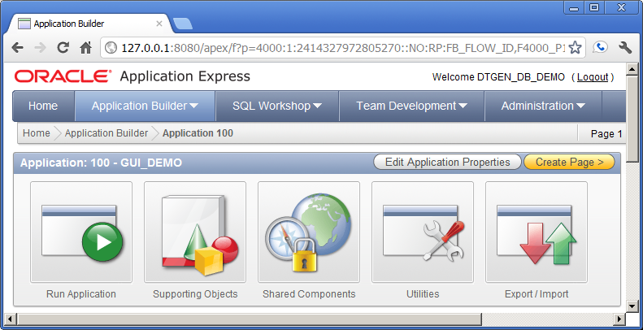
Click the "Run Application" button.

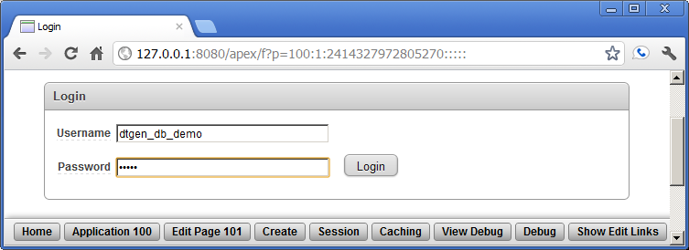
Enter the password "dtgen" and click the "Login" button.

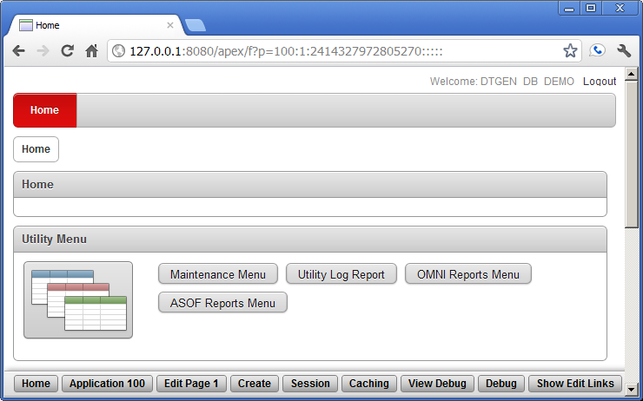
Click the "Maintenance Menu" button in the "Utility Menu" pane.
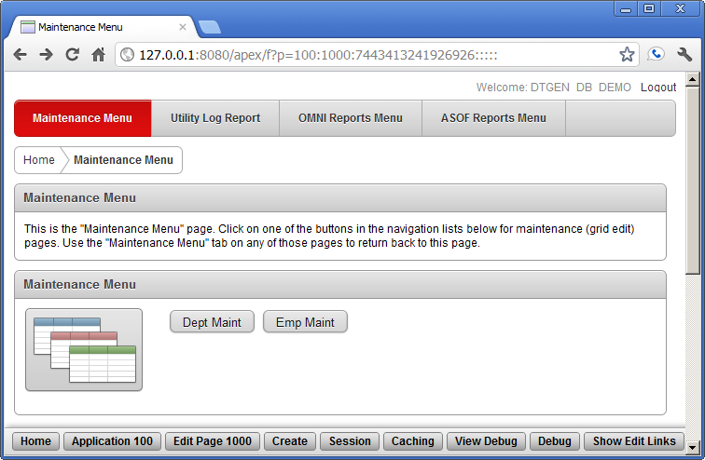

Click the "Dept Maint" button in the "Maintenance Meny" pane.
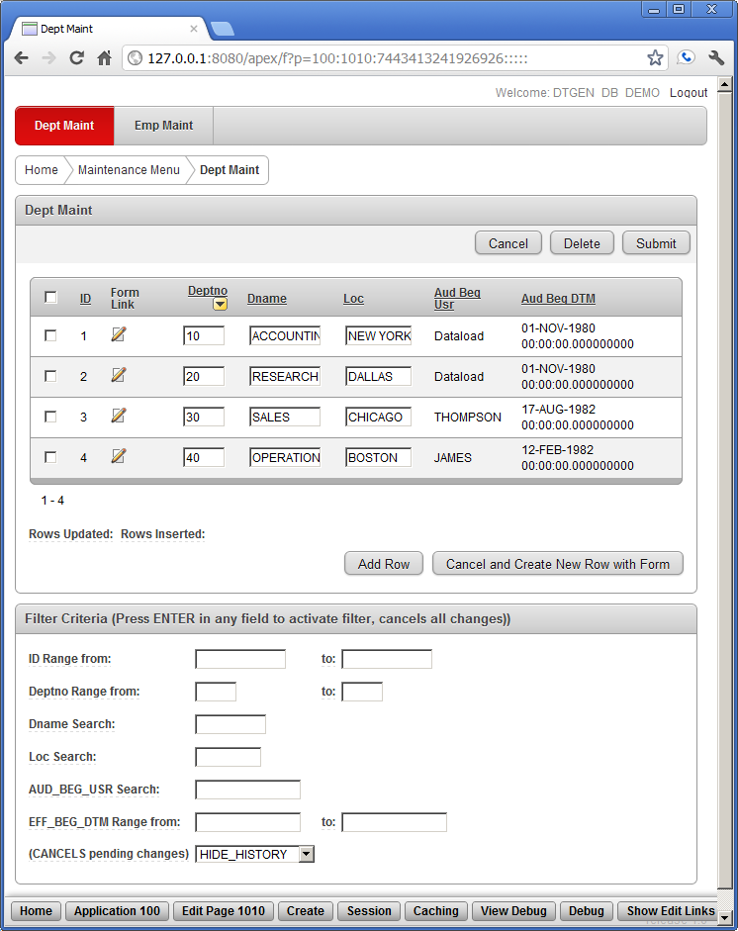
This is the DEPT data maintenance form for the new application in APEX. This is not a completed application. These data maintenance forms and reports are not expected to be used by the application user. They are expected to become part of a super-user or application adminstrator's toolset, if they are used in the application. Customized forms that are more user-friendly should be added to this application before it is released to the application users.

Exercise #2: Data Domain Filterable Grid Edit

Command Line:
sqlplus /nolog @e2

Exercise #2 does not modify the database. This exercise can be repeated without problem.

Exercise #1 finished with a DEPT maintenance form display in the APEX GUI. This exercise starts at that point. The data domain filterable grid edit is shown in the maintenance form. The grid edit portion is in the "Dept Maint" pane. Investigation of the grid edit is not pursued in detail in this exercise. Most of the fields and buttons in the "Dept Maint" pane should be self-evident. All the data sorting and modification should be functional. This is basically the grid edit functionality that APEX offers when creating a new page in an application.

The data domain filter is the "Filter Critera" pane at the bottom of the form. This filter is custom generated for each data type of each data field. As an example of how the filter works, enter "Dataload" in the "AUD_BEG_USR Search:" field and press ENTER. The screen should look like the following:

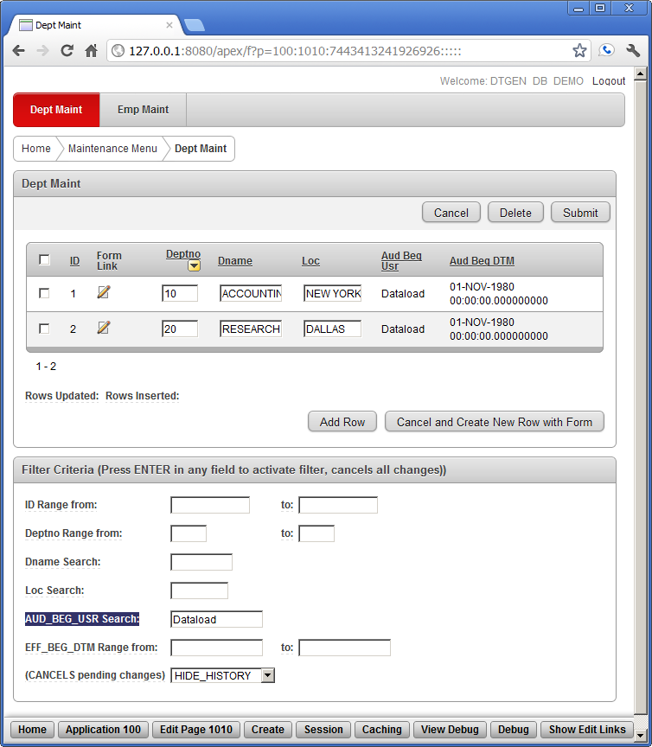

The rows of the grid edit have been reduced to only the rows with an "Audit Begin User" of "Dataload". Select "Show History" at the bottom of the page to get this view at the bottom of the form:

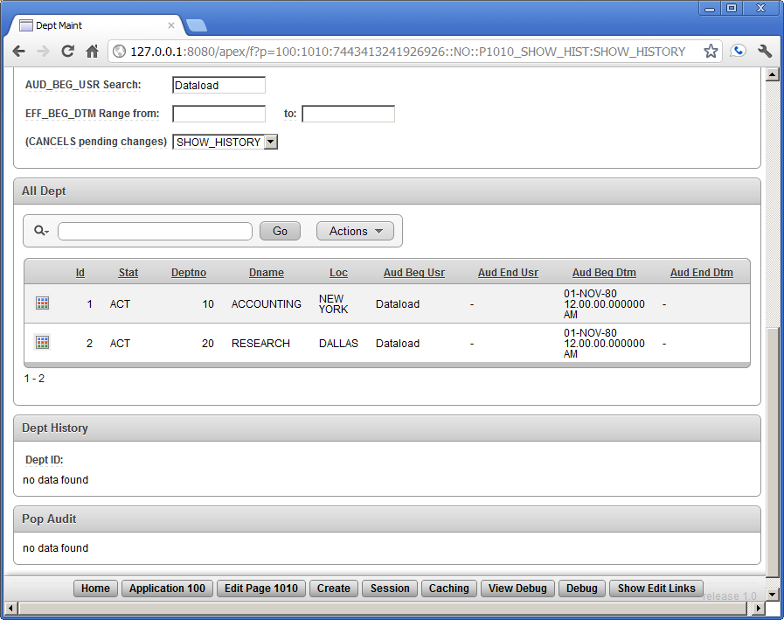

In this bottom part of the form, the "All Instances" view of current and historical data is contained in the "All Dept" pane. This is a standard APEX Interactive Report. Additional filters and sorting can be done via the search bar. Note that the interactive report is filtered by the current limitation on "Audit Begin User". Clear that field and press ENTER to get the following screen:

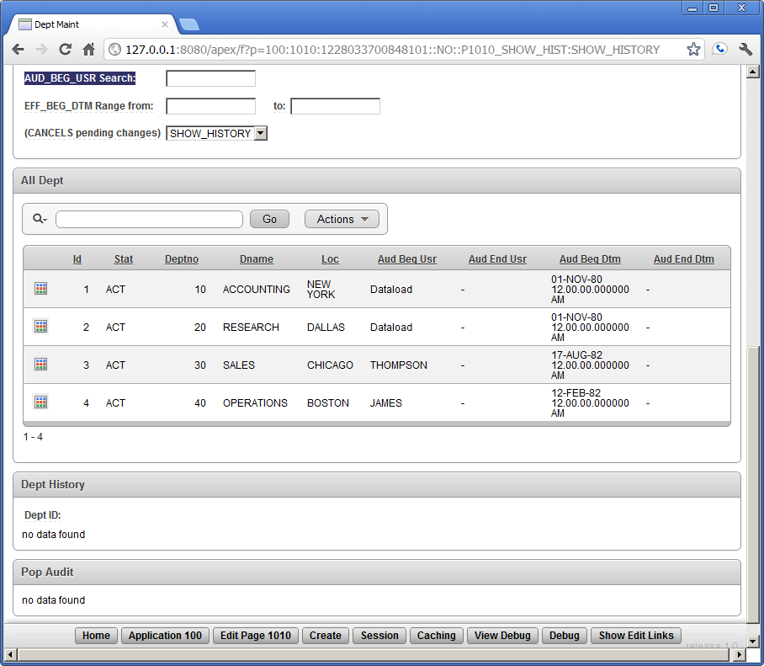

Notice that all the active records appear in the "All Dept" pane, similar to the records in the "Dept Maint" pane (not shown). There are no departments that have been "deleted", so there are no current instances of a department in history (i.e. STAT column has all 'ACT' and no 'AUD'). Click the gird icon at the left side of the SALES record in the "ALL Dept" pane.

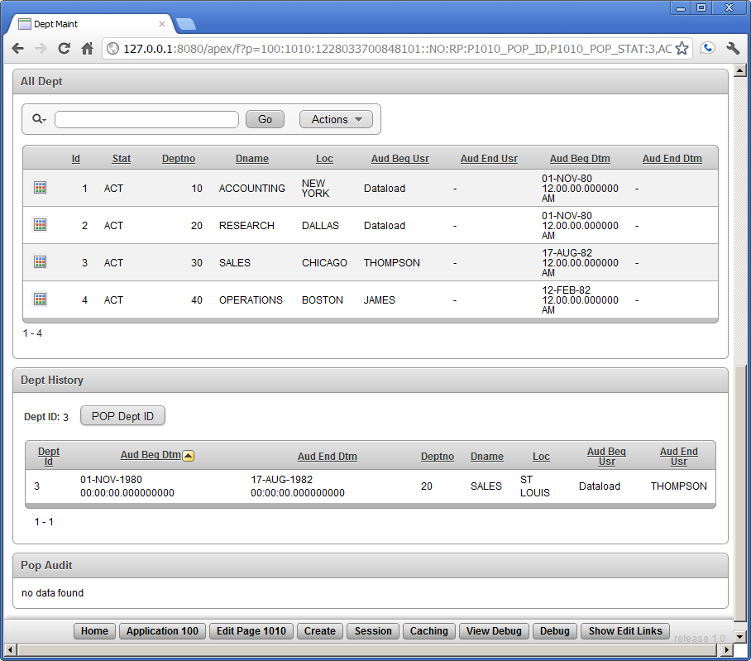

Selecting the SALES department instance in the "All Dept" pane shows the history of the SALES department in the "Dept History" pane. The sales department was in St. Loius from November 1980 before moving to Chicago in August 1982. Click the "POP Dept ID" button in the "All Dept" pane.

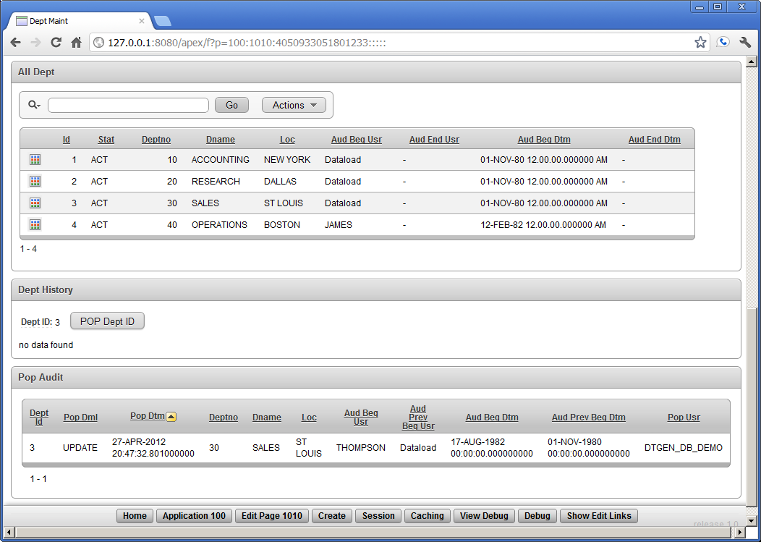

Pressing this button performed an "UNDO" the sales department move to Chicago and created a POP Audit record that is now displayed. Notice that the "Pop Dml" column indicates that an "UPDATE" was undone. Also notice that the "POP Dept ID" button is ready to UNDO the insert that created the department in the first place. This UNDO would also be recorded in the Pop Audit.

The changes made here are permanent in that APEX commits each submit to the database. However, when using the DML API, a POP that is part of a pending transaction can be rolled-back, i.e. UNDO the UNDO. Once the POP is committed, there is no DTGen generated code that can UNDO it.

Exercise #3: Handling of CLOB data

Command Line:
sqlplus /nolog @e3

Exercise #3 does not modify the database. This exercise can be repeated without problem.

In this exercise, we take a trip back in time using the DTGen version of flashback query. The ASOF view on each table returns data that was current during the "util.set_asof_dtm" date/time specified. Referential integrity is not specifically enforced in the AUD and HIST data. However, since referential integrity was enforced at any given time, the data for any point in time should have integrity. (NOTE: Referential integrity is not guaranteed until Issue #2 is resolved. See "http://code.google.com/p/dtgen/issues/detail?id=2 ")

The following query joins the EMP_ASOF and DEPT_ASOF views at a point in time of January 1st, 1983 (midnight).

SQL>
SQL> execute glob.set_asof_dtm(to_timestamp('1983-01-01', 'YYYY-MM-DD'))

PL/SQL procedure successfully completed.

SQL>
SQL> select empno, ename, job, mgr_emp_nk1, hiredate, sal, deptno, dname, loc
2 from emp_asof e, dept_asof d where e.dept_id = d.id
3 order by empno;

EMPNO ENAME JOB MGR_EMP_NK1 HIREDATE SAL DEPTNO DNAME LOC
----- -------- --------- ----------- --------- ----- ------ ---------- --------
7369 SMITH CLERK 7839 17-DEC-80 800 10 ACCOUNTING NEW YORK
7499 ALLEN SALESMAN 7698 20-FEB-81 1600 30 SALES CHICAGO
7521 WARD SALESMAN 7698 22-FEB-81 1250 30 SALES CHICAGO
7566 JONES MANAGER 7839 02-APR-81 2975 20 RESEARCH DALLAS
7654 MARTIN SALESMAN 7698 28-SEP-81 1250 30 SALES CHICAGO
7698 BLAKE MANAGER 7839 01-MAY-81 2850 30 SALES CHICAGO
7782 CLARK MANAGER 7839 09-JUN-81 2450 10 ACCOUNTING NEW YORK
7788 SCOTT ANALYST 7566 09-DEC-82 3000 20 RESEARCH DALLAS
7839 KING PRESIDENT 17-NOV-81 5000 10 ACCOUNTING NEW YORK
7844 TURNER SALESMAN 7698 08-SEP-81 1500 30 SALES CHICAGO
7900 JAMES CLERK 7698 03-DEC-81 950 30 SALES CHICAGO
7902 FORD ANALYST 7566 03-DEC-81 3000 20 RESEARCH DALLAS
7934 MILLER CLERK 7782 23-JAN-82 1300 10 ACCOUNTING NEW YORK

13 rows selected.

Data from the original dmobld.sql script showed that ADAMS the CLERK was hired on January 12th, 1983. Since the query above is for data some 11 days earlier, ADAMS is missing from the list. The following is the same query with "asof_dtm" set one year earler.

SQL>
SQL> execute glob.set_asof_dtm(to_timestamp('1982-01-01', 'YYYY-MM-DD'))

PL/SQL procedure successfully completed.

SQL>
SQL> select empno, ename, job, mgr_emp_nk1, hiredate, sal, deptno, dname, loc
2 from emp_asof e, dept_asof d where e.dept_id = d.id
3 order by empno;

EMPNO ENAME JOB MGR_EMP_NK1 HIREDATE SAL DEPTNO DNAME LOC
----- -------- --------- ----------- --------- ----- ------ ---------- --------
7369 SMITH CLERK 7839 17-DEC-80 800 10 ACCOUNTING NEW YORK
7499 ALLEN SALESMAN 7698 20-FEB-81 1600 20 SALES ST LOUIS
7521 WARD SALESMAN 7698 22-FEB-81 1250 20 SALES ST LOUIS
7566 JONES MANAGER 7839 02-APR-81 2975 20 RESEARCH DALLAS
7654 MARTIN SALESMAN 7698 28-SEP-81 1250 20 SALES ST LOUIS
7698 BLAKE MANAGER 7839 01-MAY-81 2850 20 SALES ST LOUIS
7782 CLARK MANAGER 7839 09-JUN-81 2450 10 ACCOUNTING NEW YORK
7788 SCOTT ANALYST 7566 12-JUN-81 3000 20 RESEARCH DALLAS
7839 KING PRESIDENT 17-NOV-81 5000 10 ACCOUNTING NEW YORK
7844 TURNER SALESMAN 7698 08-SEP-81 1500 20 SALES ST LOUIS
7876 ADAMS CLERK 7566 22-NOV-81 1100 20 RESEARCH DALLAS
7900 JAMES CLERK 7698 03-DEC-81 950 20 SALES ST LOUIS
7902 FORD ANALYST 7566 03-DEC-81 3000 20 RESEARCH DALLAS

13 rows selected.

Notice is that the SALES department is in St. Louis. Sometime during 1982, the SALES department must have been moved to Chicago. With a HIREDATE of January 23rd, 1982, MILLER is not on the list. However, ADAMS the CLERK is back on the list. Given the sequential assignment of EMPNO 7876, ADAMS was hired, left, and re-hired with the same EMPNO (but a new EMP record). More interesting data can be seen on September 1st, 1981 and June 1st, 1981.

Exercise #4: Comprehensive OMNI View Forms

Command Line:
sqlplus /nolog @e4

Exercise #4 modifies the database. The "drop_demo_users.sql", "create_demo_users.sql", and "e1.sql" scripts must be used to reset the database before re-running this exercise.

Each table defined in DTGen as a "LOG" or "EFF" table type has a "POP" or undo package generated for it. The POP function can undo all DML on a record. Below, department 40 will be staffed with new hires and transfers.

SQL>
SQL> select id did, deptno, dname, loc from dept_act;

DID DEPTNO DNAME LOC
--- ---------- -------------- -------------
1 10 ACCOUNTING NEW YORK
2 20 RESEARCH DALLAS
3 30 SALES CHICAGO
4 40 OPERATIONS BOSTON

4 rows selected.

SQL>
SQL> select empno, ename, job, dept_id did, dept_nk1 dept, aud_beg_usr, aud_beg_dtm
2 from emp_act where dept_nk1 = 40;

no rows selected

SQL>
SQL> execute util.set_usr('SMITH');

PL/SQL procedure successfully completed.

SQL>
SQL> -- Add a new manager MCMURRY to the Operations Department
SQL> insert into emp_act (empno, ename, job, mgr_emp_nk1, hiredate, sal, dept_id)
2 values (8156, 'MCMURRY', 'MANAGER', 7839, sysdate, 2975, 4);

1 row created.

SQL>
SQL> -- Add a new analyst WALKER to the Operations Department
SQL> insert into emp_act (empno, ename, job, mgr_emp_nk1, hiredate, sal, dept_nk1)
2 values (8157, 'WALKER', 'ANALYST', 8156, sysdate, 3000, 40);

1 row created.

SQL>
SQL> -- Transfer an analyst SCOTT to the Operations Department
SQL> update emp_act
2 set dept_id = 4
3 ,mgr_emp_nk1 = 8156
4 where empno = 7788;

1 row updated.

SQL>
SQL> -- Transfer a clerk JAMES to the Operations Department
SQL> update emp_act
2 set dept_nk1 = 40
3 ,mgr_emp_nk1 = 8156
4 where empno = 7902;

1 row updated.

SQL>
SQL> commit;

Commit complete.

In the sequence of steps above, department 40 is confirmed to have no employees. SMITH adds two new employees to the department and transfers 2 existing employees . The transaction is commited. However, something went wrong.

SQL>
SQL> select id eid, empno, ename, job, dept_id did, dept_nk1 dept,
2 aud_beg_usr, aud_beg_dtm
3 from emp_act where dept_nk1 = 40;

EID EMPNO ENAME JOB DID DEPT AUD_BEG AUD_BEG_D
--- ----- -------- --------- --- ---- ------- ---------
18 7902 FORD ANALYST 4 40 SMITH 18-APR-12
20 7788 SCOTT ANALYST 4 40 SMITH 18-APR-12
23 8156 MCMURRY MANAGER 4 40 SMITH 18-APR-12
24 8157 WALKER ANALYST 4 40 SMITH 18-APR-12

4 rows selected.

In the department listng above, FORD has been mistakenly transfered to department 40. MILLER will use the POP procedure to undo the "committed" error and re-transfer the correct employee.

SQL>
SQL> execute util.set_usr('MILLER');

PL/SQL procedure successfully completed.

SQL>
SQL> select emp_id eid, empno, ename, dept_id did,
2 aud_beg_usr, aud_beg_dtm, aud_end_usr, aud_end_dtm
3 from emp_hist where empno = 7902;

EID EMPNO ENAME DID AUD_BEG AUD_BEG_D AUD_END AUD_END_D
--- ----- -------- --- ------- --------- ------- ---------
18 7902 FORD 2 SMITH 02-DEC-81 SMITH 18-APR-12

1 row selected.

SQL>
SQL> -- Undo the transfer of FORD to the Operations Department
SQL> declare
2 emp_id number;
3 begin
4 select id into emp_id from emp_act where empno = 7902;
5 emp_pop.at_server(emp_id);
6 end;
7 /

PL/SQL procedure successfully completed.

SQL>
SQL> -- Transfer a clerk JAMES to the Operations Department
SQL> update emp_act
2 set dept_nk1 = 40
3 ,mgr_emp_nk1 = 8156
4 where empno = 7900;

1 row updated.

SQL>
SQL> select id eid, empno, ename, job, dept_id did, dept_nk1 dept,
2 aud_beg_usr, aud_beg_dtm
3 from emp_act where dept_nk1 = 40 or empno = 7902;

EID EMPNO ENAME JOB DID DEPT AUD_BEG AUD_BEG_D
--- ----- -------- --------- --- ---- ------- ---------
17 7900 JAMES CLERK 4 40 MILLER 18-APR-12
18 7902 FORD ANALYST 2 20 SMITH 01-DEC-81
20 7788 SCOTT ANALYST 4 40 SMITH 18-APR-12
23 8156 MCMURRY MANAGER 4 40 SMITH 18-APR-12
24 8157 WALKER ANALYST 4 40 SMITH 18-APR-12

5 rows selected.

SQL>
SQL> select emp_id eid, empno, ename, dept_id did,
2 aud_beg_usr, aud_beg_dtm, aud_end_usr, aud_end_dtm
3 from emp_hist where empno = 7902;

no rows selected

SQL>
SQL> commit;

Commit complete.

In the first query above, FORD's history record is displayed, showing that he was in DEPT_ID 2. MILLER uses the EMP_POP.AT_SERVER procedures to "undo" the last DML on FORD's employment record. Then, MILLER correctly transfers JAMES to department 40 (DEPT_ID 4). Notice that the EMP_ACT record for FORD in the last query shows the original AUD_BEG_DTM of December 1st, 1981. Even though the EMP_ACT and EMP_HIST tables dont' show any record of the POP occuring, the POP was recorded in the EMP_PDAT table.

SQL>
SQL> select emp_id eid, pop_dml, pop_usr, pop_dtm, empno, ename,
2 aud_beg_usr, aud_beg_dtm, aud_prev_beg_usr, aud_prev_beg_dtm
3 from emp_pdat;

EID POP_DM POP_USR POP_DTM EMPNO ENAME AUD_BEG AUD_BEG_D AUD_PRE AUD_PREV_
--- ------ ------- --------- ----- -------- ------- --------- ------- ---------
18 UPDATE MILLER 18-APR-12 7902 FORD SMITH 18-APR-12 SMITH 01-DEC-81

1 row selected.

The query above shows that MILLER "popped" an UPDATE statement on FORD's employment record (ID 18) that was performed by SMITH on April 12th, 2012. Note that the AUD_PREV_BEG_USR of SMITH is the value restored to the AUD_BEG_USR in the EMP_ACT record. Also note that the AUD_PREV_BEG_DTM of December 1st, 1981 is the value restored to the AUD_BEG_DTM in the EMP_ACT record. These values, along with the ID from the original EMP_ACT record, can be used to trace the audit trail back to the original EMP_ACT or EMP_HIST records, regardless of how many times a record is "popped".

Exercise #5: Forms Development Guidelines

Command Line:
sqlplus /nolog @e5

Exercise #5 modifies the database. The "drop_demo_users.sql", "create_demo_users.sql", and "e1.sql" scripts must be used to reset the database before re-running this exercise.

Each record that was originally created in the EMP table is tracked through all the DML performed on it (including the use of the POP procedure). The original record is tracked via the ID it was originally assigned in the EMP table. In the EMP table, each record represents an instance of employment.

SQL>
SQL> select empno, ename, id eid, stat, dept_id did,
2 aud_beg_usr, aud_beg_dtm, aud_end_usr, aud_end_dtm
3 from emp_all order by empno, id;

EMPNO ENAME EID STAT DID AUD_BEG_ AUD_BEG_D AUD_END_ AUD_END_D
----- -------- --- ---- --- -------- --------- -------- ---------
7301 ELLISON 1 HIST 1 DAVIS 30-OCT-80 THOMPSON 30-JUN-81
7344 DAVIS 2 HIST 1 SMITH 28-NOV-81 SMITH 10-DEC-81
7369 SMITH 3 ACT 2 SMITH 28-FEB-83
7499 ALLEN 4 ACT 3 THOMPSON 14-MAY-81
7521 WARD 5 ACT 3 THOMPSON 14-MAY-81
7566 JONES 6 ACT 2 SMITH 30-NOV-81
7654 MARTIN 7 HIST 3 THOMPSON 18-APR-81 THOMPSON 14-MAY-81
7654 MARTIN 14 ACT 3 SMITH 26-SEP-81
7698 BLAKE 8 ACT 3 SMITH 28-NOV-81
7782 CLARK 9 ACT 1 SMITH 01-DEC-81
7788 SCOTT 10 HIST 2 THOMPSON 10-JUN-81 JAMES 07-MAR-82
7788 SCOTT 20 ACT 4 SMITH 18-APR-12
7839 KING 11 HIST 1 THOMPSON 14-JUN-81 SMITH 29-AUG-81
7839 KING 15 ACT 1 SMITH 15-NOV-81
7840 LANE 12 HIST 1 THOMPSON 15-AUG-81 SMITH 28-NOV-81
7844 TURNER 13 ACT 3 SMITH 09-SEP-81
7876 ADAMS 16 HIST 2 SMITH 24-NOV-81 JAMES 15-JUN-82
7876 ADAMS 21 ACT 2 SMITH 09-JAN-83
7900 JAMES 17 ACT 4 MILLER 18-APR-12
7902 FORD 18 ACT 2 SMITH 02-DEC-81
7934 MILLER 19 ACT 1 JAMES 22-JAN-82
8156 MCMURRY 23 ACT 4 SMITH 18-APR-12
8157 WALKER 24 ACT 4 SMITH 18-APR-12

23 rows selected.

In the EMP_ALL query above, EMPNO 7654 MARTIN has 2 instances of employment. The first instance was last modified/entered on April 18th, 1981 and deleted on May 14th, 1981 as captured by EMP ID 7. Later, MARTIN returned to the company, maintained the same EMPNO, but received a new instance of employment as captured by EMP ID 14. The STAT data shows that EMP ID is "ACT" or active, so MARTIN is still employed on this, the second instance of employment. In the example below, SMITH will be retired from the company by deleting the current employment instance from EMP_ACT.

SQL>
SQL> execute util.set_usr('MILLER');

PL/SQL procedure successfully completed.

SQL>
SQL> -- SMITH retires today
SQL> delete from emp_act
2 where empno = 7369;

1 row deleted.

SQL>
SQL> select empno, ename, id eid, stat, dept_id did,
2 aud_beg_usr, aud_beg_dtm, aud_end_usr, aud_end_dtm
3 from emp_all order by empno, id;

EMPNO ENAME EID STAT DID AUD_BEG_ AUD_BEG_D AUD_END_ AUD_END_D
----- -------- --- ---- --- -------- --------- -------- ---------
7301 ELLISON 1 HIST 1 DAVIS 30-OCT-80 THOMPSON 30-JUN-81
7344 DAVIS 2 HIST 1 SMITH 28-NOV-81 SMITH 10-DEC-81
7369 SMITH 3 HIST 2 SMITH 28-FEB-83 MILLER 18-APR-12
7499 ALLEN 4 ACT 3 THOMPSON 14-MAY-81
7521 WARD 5 ACT 3 THOMPSON 14-MAY-81
7566 JONES 6 ACT 2 SMITH 30-NOV-81
7654 MARTIN 7 HIST 3 THOMPSON 18-APR-81 THOMPSON 14-MAY-81
7654 MARTIN 14 ACT 3 SMITH 26-SEP-81
7698 BLAKE 8 ACT 3 SMITH 28-NOV-81
7782 CLARK 9 ACT 1 SMITH 01-DEC-81
7788 SCOTT 10 HIST 2 THOMPSON 10-JUN-81 JAMES 07-MAR-82
7788 SCOTT 20 ACT 4 SMITH 18-APR-12
7839 KING 11 HIST 1 THOMPSON 14-JUN-81 SMITH 29-AUG-81
7839 KING 15 ACT 1 SMITH 15-NOV-81
7840 LANE 12 HIST 1 THOMPSON 15-AUG-81 SMITH 28-NOV-81
7844 TURNER 13 ACT 3 SMITH 09-SEP-81
7876 ADAMS 16 HIST 2 SMITH 24-NOV-81 JAMES 15-JUN-82
7876 ADAMS 21 ACT 2 SMITH 09-JAN-83
7900 JAMES 17 ACT 4 MILLER 18-APR-12
7902 FORD 18 ACT 2 SMITH 02-DEC-81
7934 MILLER 19 ACT 1 JAMES 22-JAN-82
8156 MCMURRY 23 ACT 4 SMITH 18-APR-12
8157 WALKER 24 ACT 4 SMITH 18-APR-12

23 rows selected.

SQL>
SQL> select empno, ename, id eid, dept_id did, aud_beg_usr, aud_beg_dtm
2 from emp_act where empno = 7369;

no rows selected

SQL>
SQL> select empno, ename, emp_id eid, last_active, dept_id did,
2 aud_beg_usr, aud_beg_dtm, aud_end_usr, aud_end_dtm
3 from emp_hist where empno = 7369 order by aud_beg_dtm;

EMPNO ENAME EID LAST MGR_EMP_ID DID AUD_BEG_ AUD_BEG_D AUD_END_ AUD_END_D
----- -------- --- ---- ---------- --- -------- --------- -------- ---------
7369 THOMPSON 3 1 1 DAVIS 15-DEC-80 THOMPSON 25-JUN-81
7369 THOMPSON 3 11 1 THOMPSON 25-JUN-81 SMITH 21-AUG-81
7369 SMITH 3 12 1 SMITH 21-AUG-81 SMITH 01-DEC-81
7369 SMITH 3 15 1 SMITH 01-DEC-81 SMITH 26-FEB-83
7369 SMITH 3 Y 18 2 SMITH 26-FEB-83 MILLER 18-APR-12

5 rows selected.

SQL>
SQL> commit;

Commit complete.

Notice that the STAT of SMITH (EMP ID 3) has changed from ACT to HIST. This shows that EMP ID 3 is no longer an active instance of employment (no longer in EMP_ACT), which is confirmed by the EMP_ACT query. The last query shows that only 1 record, the last record, has a "Y" for LAST_ACTIVE. When the delete was performed on EMP_ACT, this flag was set to recognize there are no more active view records for this entity. Though EMP_ACT has many records for EID 3, the EMP_ALL view only returns the last active record.

