DTGen GUI Demonstration
Developed by DMSTEX (http://dmstex.com)

Oracle and Java are registered trademarks of Oracle Corporation and/or its affiliates.

Table of Contents
Introduction: 1
Exercise Setup 1
Exercise #1: Default Maintenance Forms 2
Exercise #2: Data Domain Filterable Grid Edit 26
Exercise #3: Comprehensive OMNI View Forms 31

Introduction:
The exercises in this demonstration are focused on the Graphical User Interface (GUI) "helpers" produced by DTGen. The database schema and data are an extension of the ASOF Demonstration. The "ASOF" demonstration should be reviwed before running these exercises. Serveral concepts introduced in those exercises are not explained here.

With the exception of executing generated scripts, all the functionality in these exercises is available through both command line and graphical user interface (GUI) mode. Issue #23 is an enhancement request to allow executing generated scripts in the GUI. Command line is used in these exercises to expedite progress where needed.

The exercises in this directory are numbered and must be executed in sequential order. The demonstration users must be created with the "create_demo_users.sql" script in the parent directory before the first exercise is run. The demonstration users must be dropped with the "drop_demo_users.sql" script before the "create_demo_users.sql" script can be re-run. These exercises also assume that the default username/password (dtgen/dtgen) is still in use for the generator. Names and passwords are set in the "vars.sql" script and can be modified, if necessary. Also, the DTGen database objects must be installed in the database and the DTGen must be ready to generate code.

Exercise Setup

Command Line:
sqlplus system/password @setup

Exercise Setup modifies the database. However, the changes are mde in APEX

The setup.sql script creates an APEX workspace and user. These need to be in place before the target application can be created in Exercise #1.

Workspace and APEX User DTGEN_DB_DEMO have been setup.

PL/SQL procedure successfully completed.

The output above is the result of a successful execution. Note, setup.sql can also be run as sys or APEX_04000. Also, there is a cleanup.sql script that can be used to remove this setup in APEX. Note that identical database schema objects can be dropped and recreated without dropping and recreating APEX objects.

Exercise #1: Default Maintenance Forms

Event Sequence:
APEX Forms
sqlplus /nolog @e1
APEX Forms

Exercise #1 modifies the database. The "drop_demo_users.sql" and "create_demo_users.sql" scripts must be used to reset the database before re-running this exercise. The APEX application that is created can be removed or remain as the create_flow.sql scripts will "work around" the existing application.

In this exercise, an empty application will be created in APEX. The database schema and maintenance forms will be generated and loaded into the empty application. Then, navigation lists and breadcrumbs will be updated to integrate the genreated items into the application. The process starts with a login to APEX. The password is "dtgen".

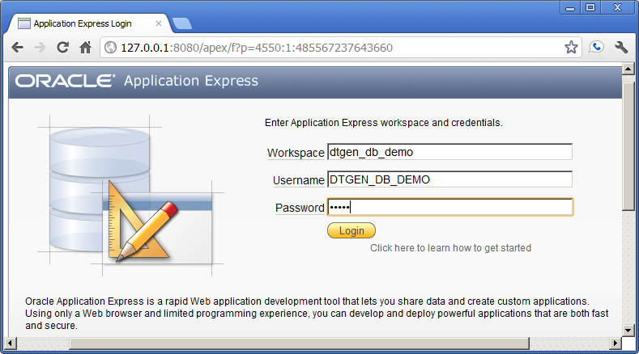
Click the "login" button to login.

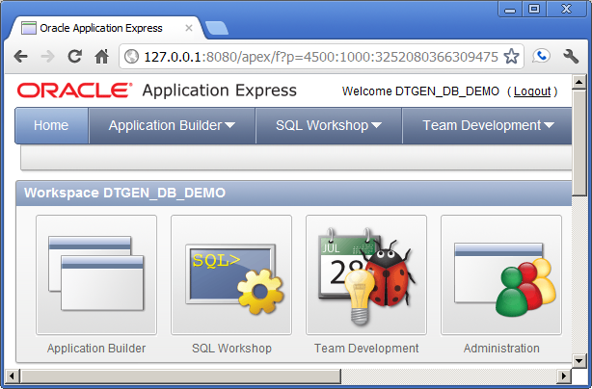
Click the "Application Builder" button.

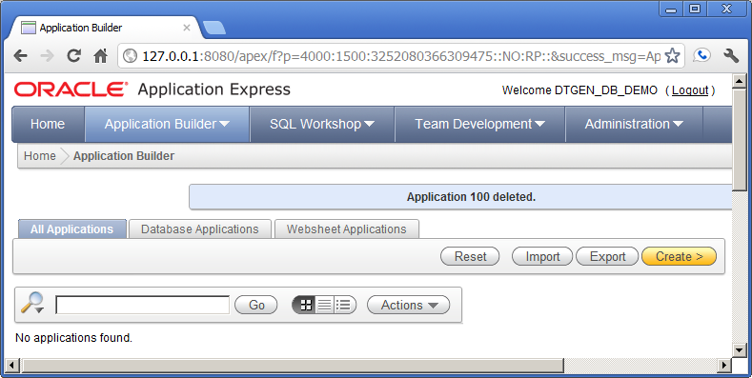
Click the "create" button to create a new application.

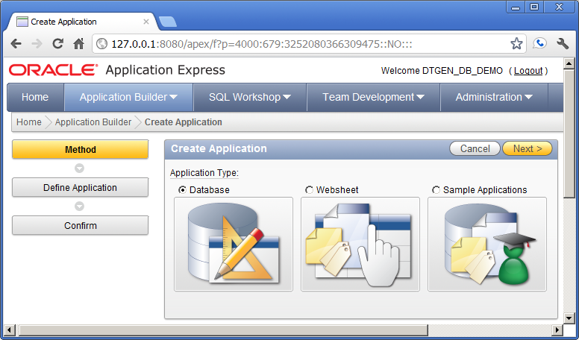
Click the "Database" or the "Next" button.

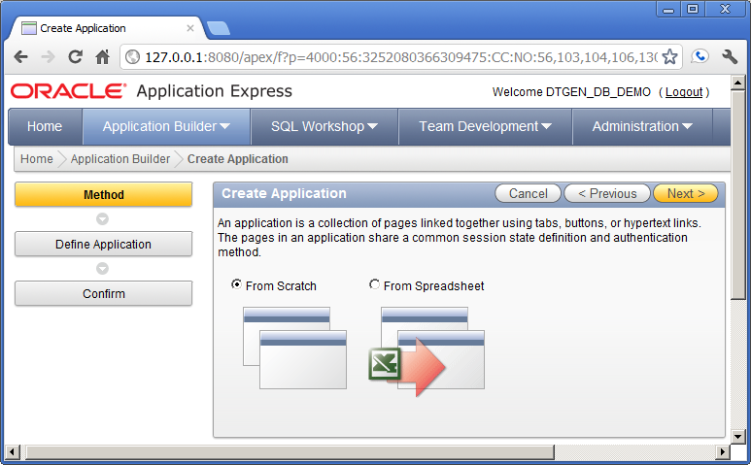
Click the "From Scratch" or the "Next" button.

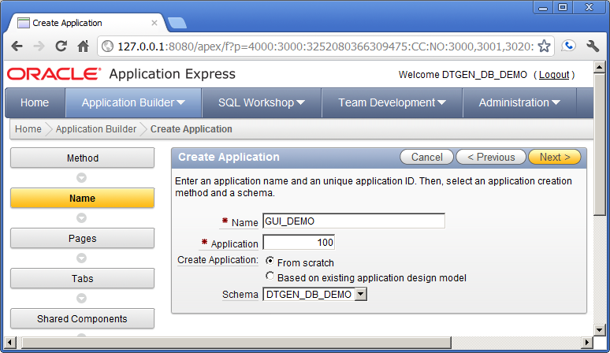
Update the values and click the "Next" button.

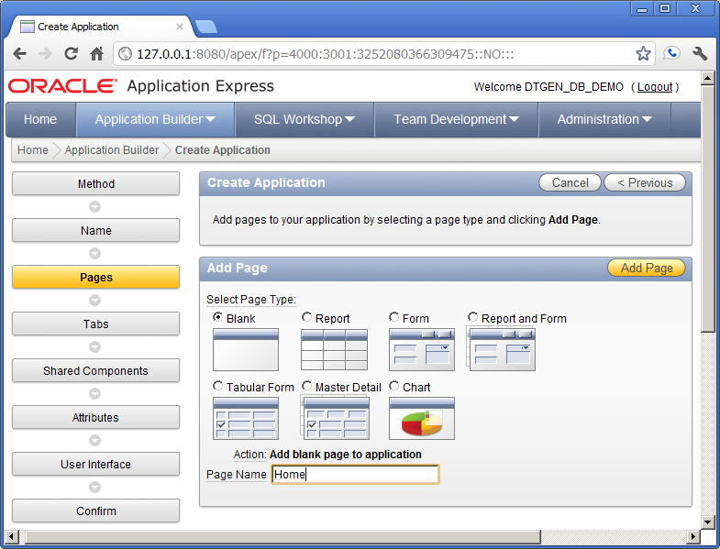
Update the values and click "Add Page".

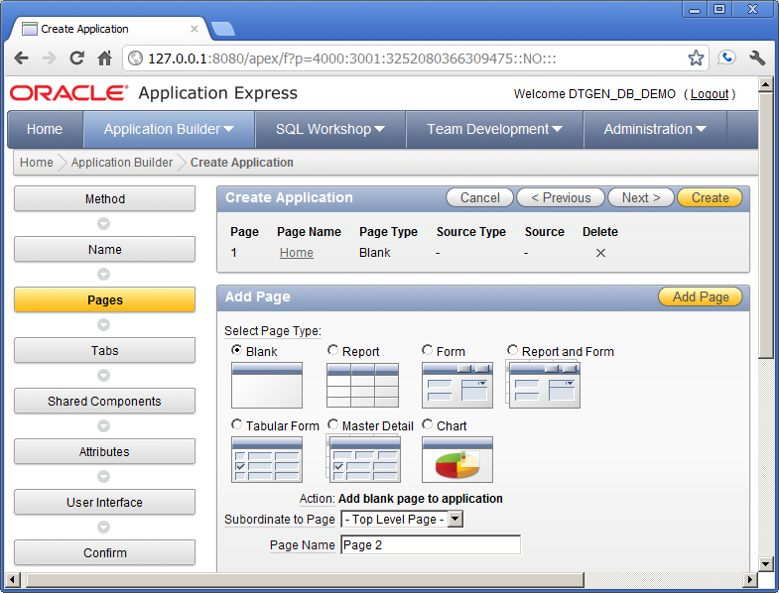
Confirm the values and click the "Next" button
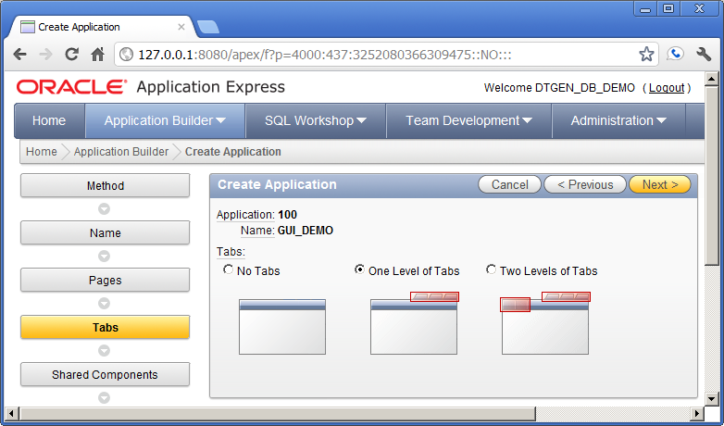
Confirm the values and click the "Next" button

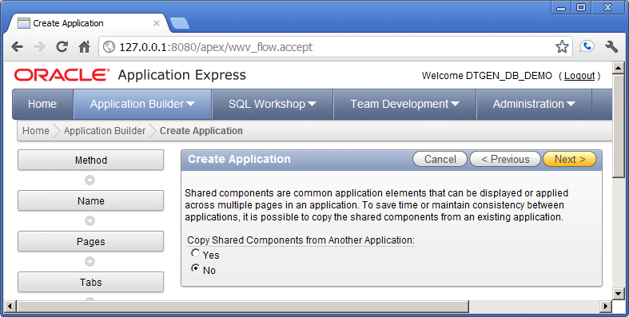
Confirm the values and click the "Next" button.

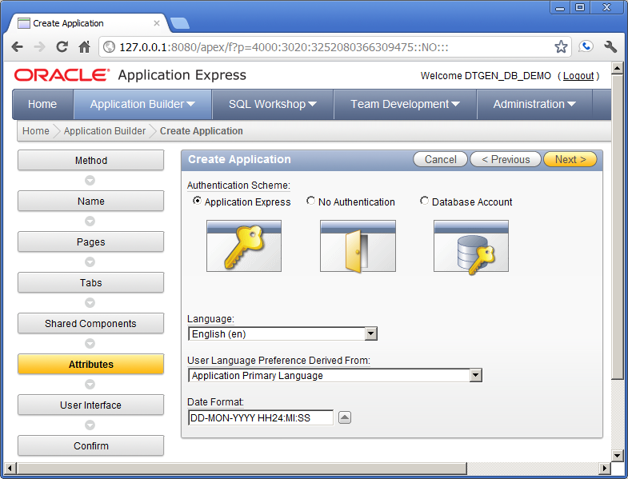
Enter the values and click "Next"

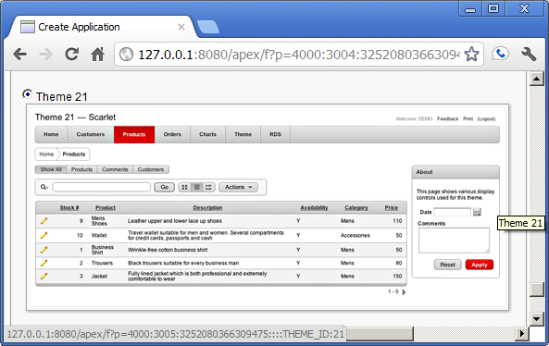
Confirm that Theme 21 is selected.
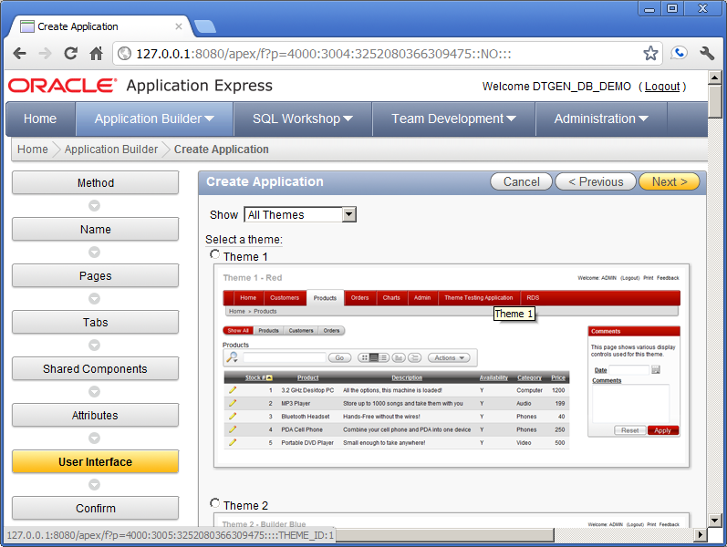
The screen above is the same as the previous screen. Confirm and click the "Next" button.

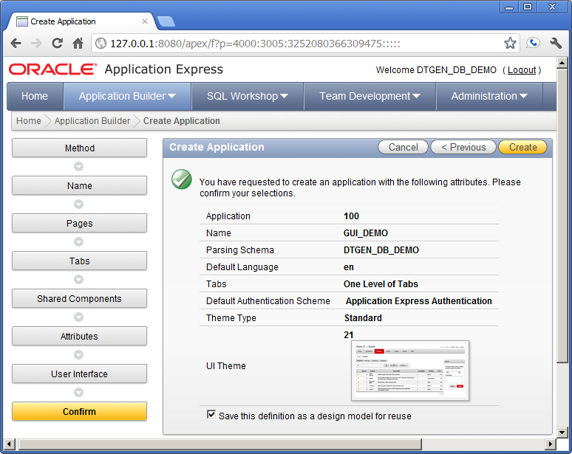
Enter the values and click the "Create" button.
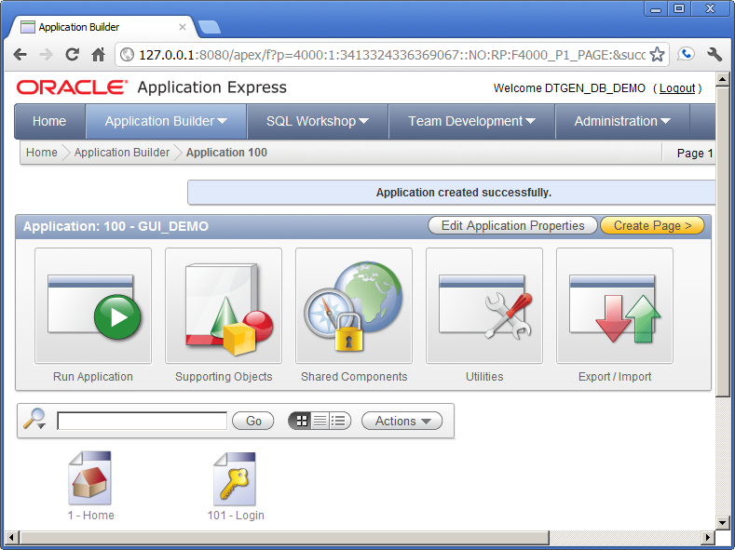
The new application has been created and is ready to receive the generated items from DTGen. The following is the results from executing the e1.sql script (sqlplus /nolog @e1).

Login to dtgen
Connected.
Remove old DEMO4 Schema from DTGEN
create a DEMO4 Schema in DTGEN
Generate DEMO4 Application
Capture SQL Scripts

Similar to the other demonstrations, the output shown above is from the e1.LST log file. The details of modifying schema in DTGen and generating will be covered in following exercises. Below is the output from the install.LST log file that follows the SQL script capture in e1.sql.

Login to dtgen_db_demo
Connected.

FILE_NAME
-----------------
-) create_glob

FILE_NAME
----------------
-) create_ods

TABLE_NAME
--------------
*** dept ***

TABLE_NAME
-------------
*** emp ***

FILE_NAME
------------------
-) create_integ

TABLE_NAME
--------------
*** dept ***

TABLE_NAME
-------------
*** emp ***

FILE_NAME
-----------------
-) create_oltp

TABLE_NAME
--------------
*** dept ***

TABLE_NAME
-------------
*** emp ***

FILE_NAME
---------------
-) create_aa

TABLE_NAME
--------------
*** dept ***

TABLE_NAME
-------------
*** emp ***

FILE_NAME
-----------------
-) create_mods

The portion of the e1.sql script that generated the output above is similar to Exercise #1 in the other demonsrations. However, the following portion of the install.LST log file shows the APEX GUI items that were generated by DTGen being installed.

FILE_NAME
-----------------
-) create_flow
APPLICATION 100 - GUI_DEMO
Set Credentials...
Check Compatibility...
API Last Extended:20100513
Your Current Version:20100513
This import is compatible with version: 20100513
COMPATIBLE (You should be able to run this import without issues.)

Set Application ID...
...application processes
...Create Flow Process "SET_USR"
...Shared Lists of values
...Create LOV "JOB NAME"
...Remove page 1000
...Create page 1000: Maintenance Menu
...Navigation Tabs (for Maintenance Menu)
Adding Maintenance Menu Tab to UTIL_TS ...
...Navigation Lists
...Create LIST " Maintenance Menu"
...Create LIST ENTRY "Dept Maint"
...Create LIST ENTRY "Emp Maint"
... Add LIST " Maintenance Menu" to page 1000
...Remove page 1200
...Create page 1200: Utility Log Report
...Create UTIL_LOG Report Plug
...Create Page Processing
...Navigation Tabs (for Utility Log Report)
Adding Utility Log Report Tab to UTIL_TS ...
...Remove page 1400
...Create page 1400: OMNI Reports Menu
...Navigation Tabs (for OMNI Reports Menu)
Adding T_OMNI Tab to UTIL_TS ...
...Navigation Lists
...Create LIST " OMNI Reports Menu"
...Create LIST ENTRY "Dept OMNI"
...Create LIST ENTRY "Emp OMNI"
... Add LIST " OMNI Reports Menu" to page 1400
...Remove page 1600
...Create page 1600: ASOF Reports Menu
...Navigation Tabs (for ASOF Reports Menu)
Adding T_ASOF Tab to UTIL_TS ...
...Navigation Lists
...Create LIST " ASOF Reports Menu"
...Create LIST ENTRY "Dept ASOF"
...Create LIST ENTRY "Emp ASOF"
... Add LIST " ASOF Reports Menu" to page 1600
...Create LIST "Utility Menu"
...Create LIST ENTRY "Maintenance Menu"
...Create LIST ENTRY "Utility Log Report"
...Create LIST ENTRY "OMNI Reports Menu"
...Create LIST ENTRY "ASOF Reports Menu"
Adding Breadcrumbs
...Create BREADCRUMB ENTRY "Maintenance Menu"
...Create BREADCRUMB ENTRY "Dept Maint"
...Create BREADCRUMB ENTRY "Dept Form"
...Create BREADCRUMB ENTRY "Emp Maint"
...Create BREADCRUMB ENTRY "Emp Form"
...Create BREADCRUMB ENTRY "Utility Log Report"
...Create BREADCRUMB ENTRY "OMNI Reports Menu"
...Create BREADCRUMB ENTRY "Dept OMNI"
...Create BREADCRUMB ENTRY "Emp OMNI"
...Create BREADCRUMB ENTRY "ASOF Reports Menu"
...Create BREADCRUMB ENTRY "Dept ASOF"
...Create BREADCRUMB ENTRY "Emp ASOF"

All of the output above is the result of GUI navigation items being installed into APEX. The output from the DEPT and EMP data maintenance forms is below.

TABLE_NAME
--------------
*** dept ***
dept maint1, 10
...Create Shared LOV "DEPT_LOV"
...Remove page 1010
...Create page 1010: Dept Maint
...Create Main Grid Edit
...Create Filter Criteria
...Create Page Processing
Adding Dept Maint Tab to _MAINT_TS ...
dept maint2, 10
...Create ALL Report
...Create History Report
...Create POP_AUDIT Report
dept form, 10
...Remove page 1210
...Create page 1210: Dept Form
...Create DML Form
...Create Page Processing
Adding Dept Form Tab to _FORM_TS ...
dept omni, 10
...Remove page 1410
...Create page 1410: Dept OMNI
...Create Interactive Report
Adding Dept OMNI Tab to _OMNI_TS ...
dept asof, 10
...Remove page 1610
...Create page 1610: Dept ASOF
...Create Interactive Report
Adding Dept ASOF Tab to _ASOF_TS ...
SCHEMA DTGEN_DB_DEMO - User Interface Defaults, Table Defaults

TABLE_NAME
-------------
*** emp ***
emp maint1, 20
...Create Shared LOV "EMP_LOV"
...Create Shared LOV "MGR_EMP_LOV"
...Remove page 1020
...Create page 1020: Emp Maint
...Create Main Grid Edit
...Create Filter Criteria
...Create Page Processing
Adding Emp Maint Tab to _MAINT_TS ...
emp maint2, 20
...Create ALL Report
...Create History Report
...Create POP_AUDIT Report
emp form, 20
...Remove page 1220
...Create page 1220: Emp Form
...Create DML Form
...Create Page Processing
Adding Emp Form Tab to _FORM_TS ...
emp omni, 20
...Remove page 1420
...Create page 1420: Emp OMNI
...Create Interactive Report
Adding Emp OMNI Tab to _OMNI_TS ...
emp asof, 20
...Remove page 1620
...Create page 1620: Emp ASOF
...Create Interactive Report
Adding Emp ASOF Tab to _ASOF_TS ...
SCHEMA DTGEN_DB_DEMO - User Interface Defaults, Table Defaults
- User Interface Defaults, Attribute Dictionary
...done

Loading data into database

At the end of the output above is the indication that the schema data has been loaded. This is the same data used in the ASOF demonstration. The remaining effort is to "connect" the generated navigation items with the empty application in APEX. This effort starts with a refresh of the application builder page (or login as DTGEN_DB_DEMO and navigate to the GUI_DEMO application page if not logged into APEX).

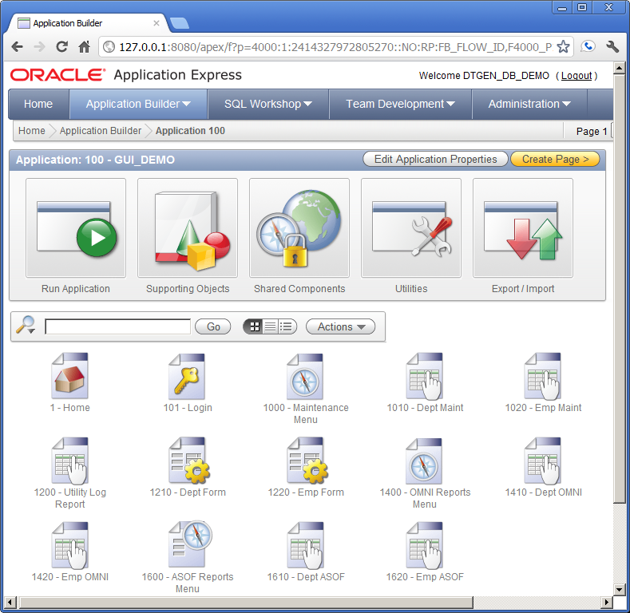
Click the "Shared Components" button

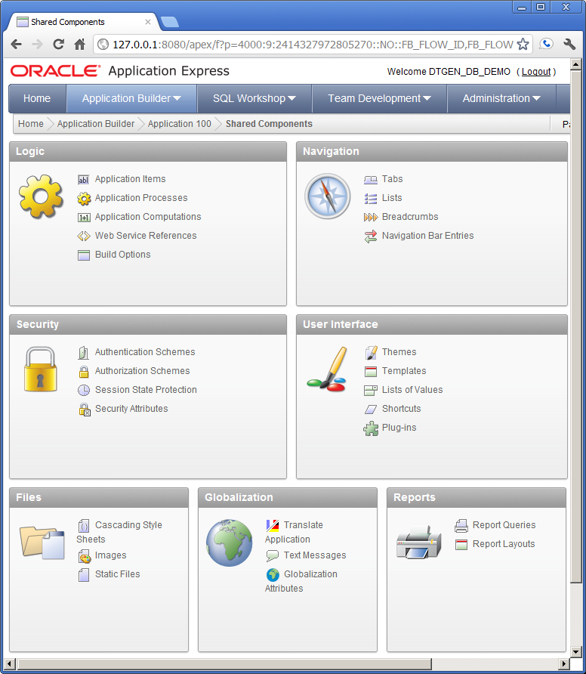

Click the "Lists" link in the "Navigation" pane

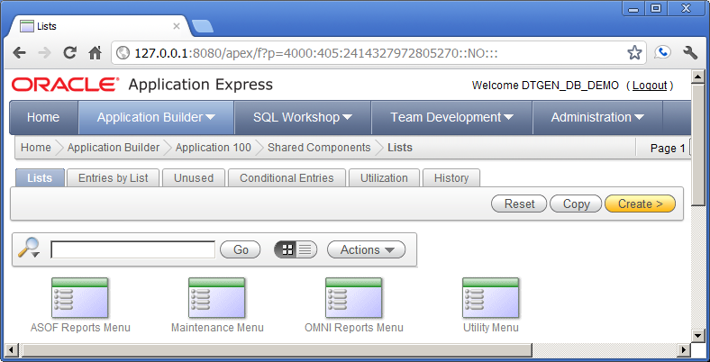
Click the "Utility Menu" icon.

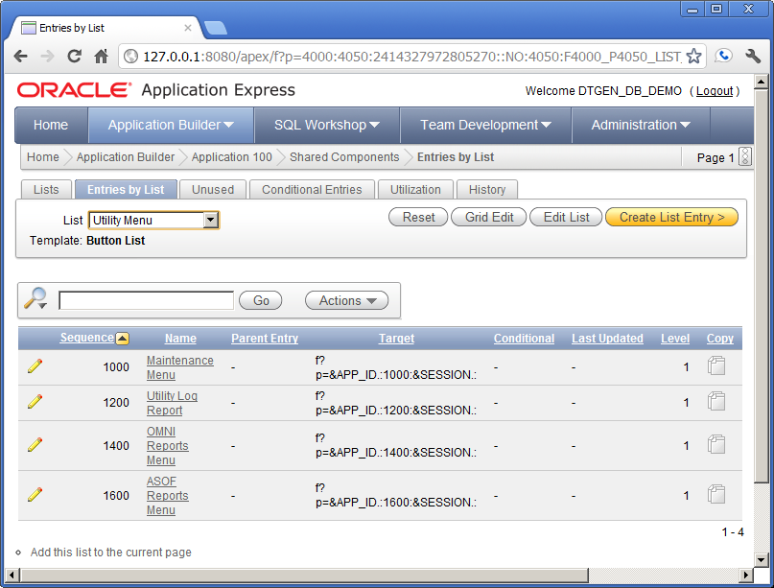
Confirm the "Page 1" is in the upper right and click the "Add this list to the current page" link.

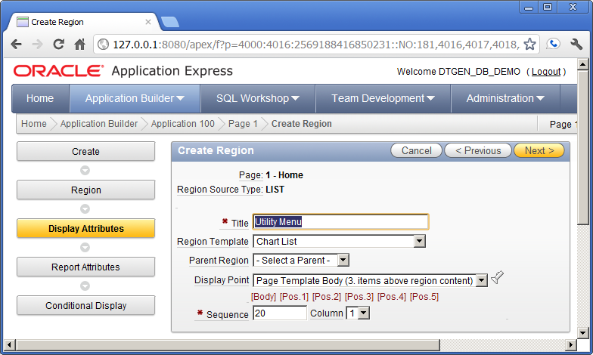
Confirm these values and click the "Next" button

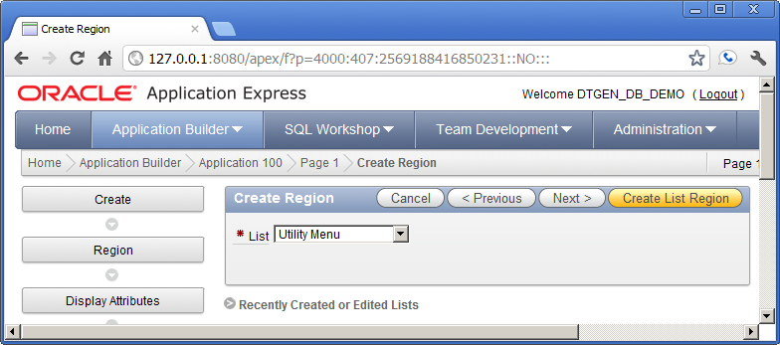
Confirm these values and click the "Create List Region" button

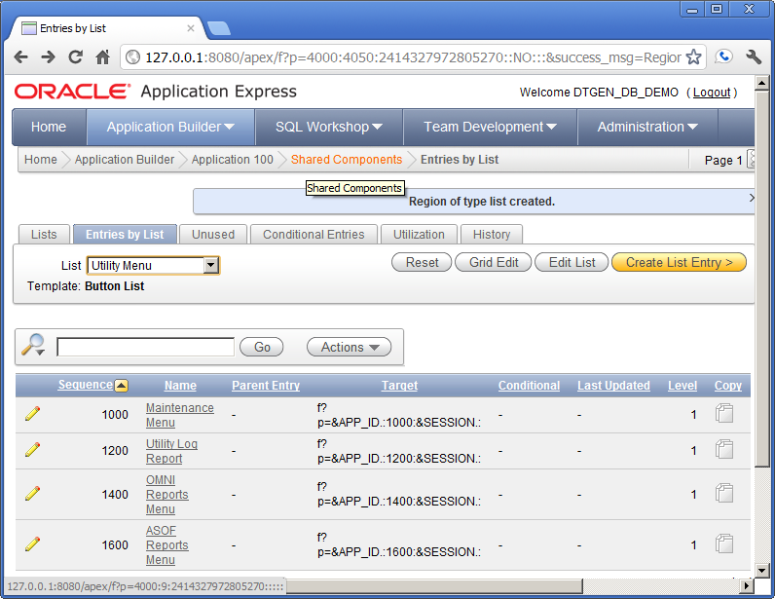
Click the "Shared Components" link in the breadcrumb at the top.

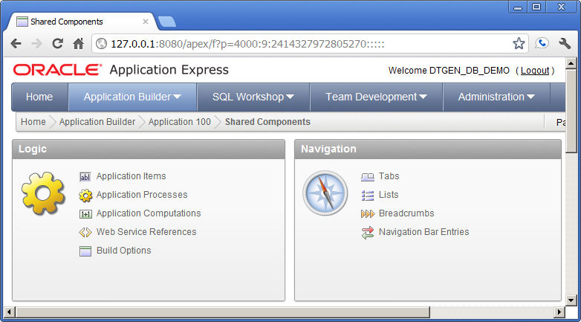
Click the "Breadcrumbs" link in the "Navigation" pane.
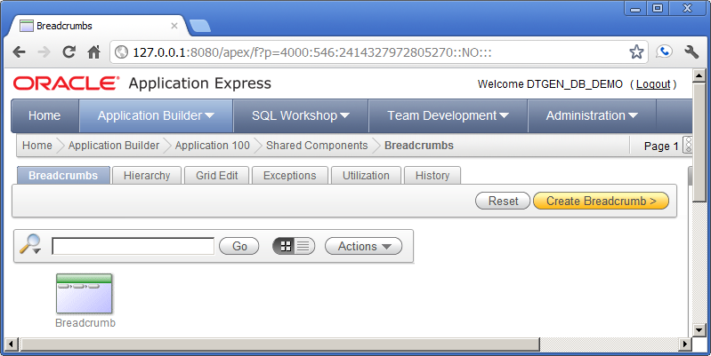
Click the "Breadcumb" Icon at the bottom left

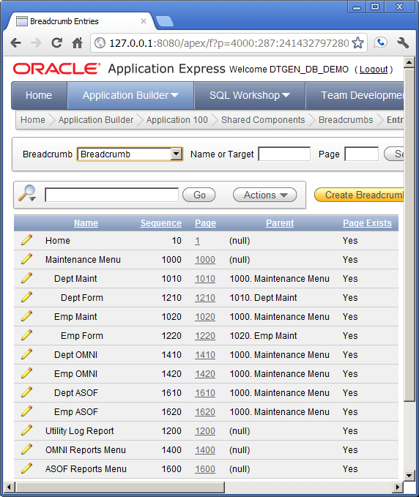

Click the pencil icon to the left of the "Maintenance Menu" name.

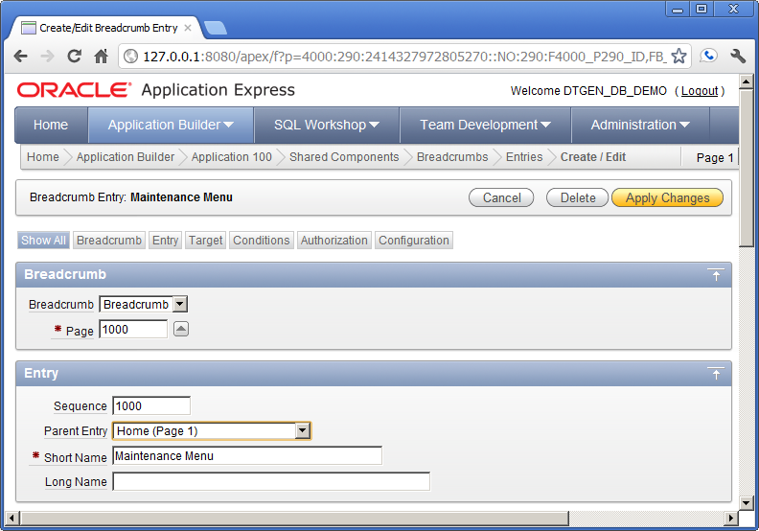

Change the "Parent Entry" to "Home (Page 1)", then click "Apply Changes".

Repeat the above step for the following names:

- Utility Log Report
- OMNI Reports Menu
- ASOF Reports Menu

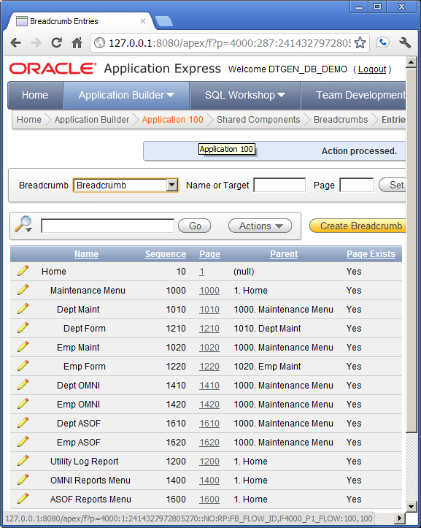
After repeating the steps, confirm values and click the "Application 100" link in the breadcrumb at the top.

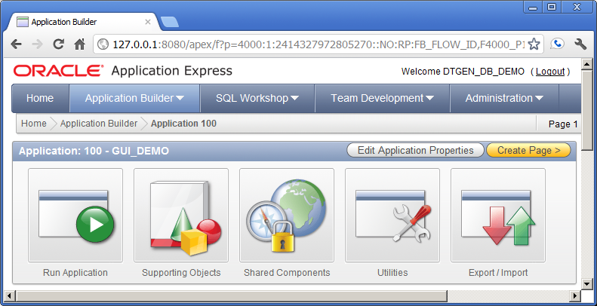
Click the "Run Application" button.

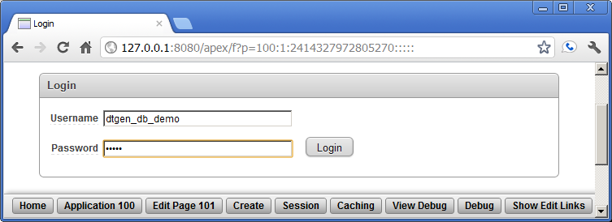
Enter the password "dtgen" and click the "Login" button.

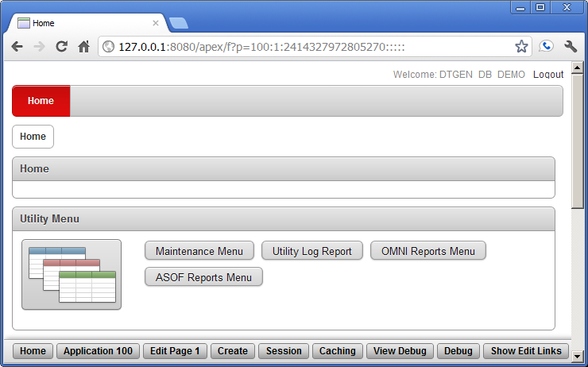
Click the "Maintenance Menu" button in the "Utility Menu" pane.
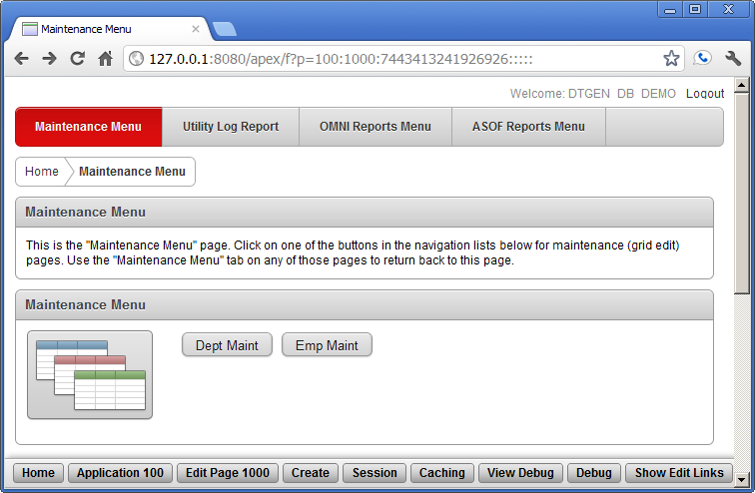

Click the "Dept Maint" button in the "Maintenance Menu" pane.
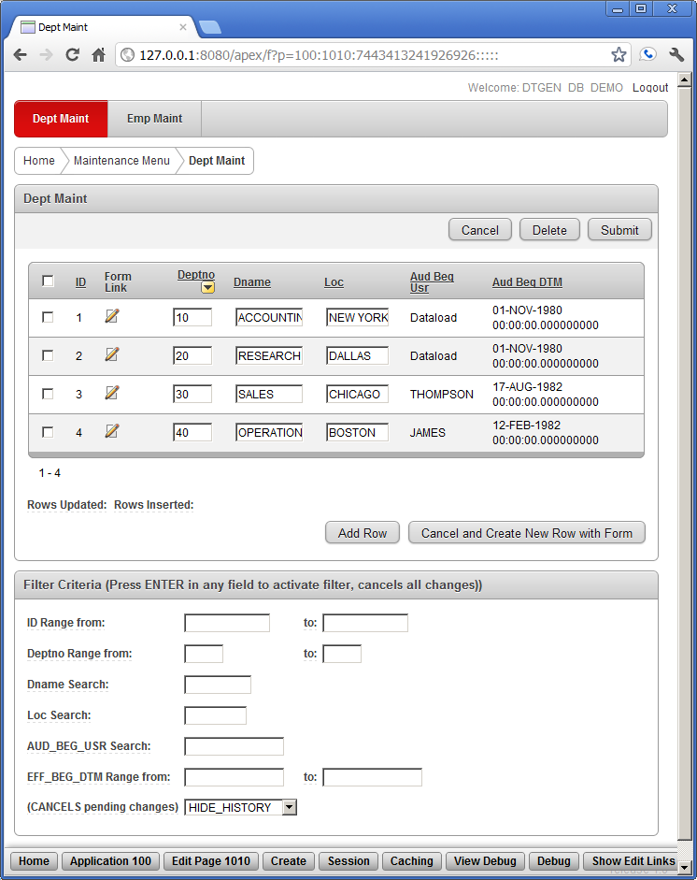
This is the DEPT data maintenance form for the new application in APEX. This is not a completed application. These data maintenance forms and reports are not expected to be used by the application user. They are expected to become part of a super-user or application adminstrator's toolset, if they are used in the application. Customized forms that are more user-friendly should be added to this application before it is released to the application users.

Exercise #2: Data Domain Filterable Grid Edit

Event Sequence:
APEX Forms

Exercise #2 modifies the database. The "drop_demo_users.sql", "create_demo_users.sql", and "e1.sql" scripts must be used to reset the database before re-running this exercise.

Exercise #1 finished with a DEPT maintenance form display in the APEX GUI. This exercise starts at that point. The data domain filterable grid edit is shown in the maintenance form. The grid edit portion is in the "Dept Maint" pane. Investigation of the grid edit is not pursued in detail in this exercise. Most of the fields and buttons in the "Dept Maint" pane should be self-evident. All the data sorting and modification should be functional. This is basically the grid edit functionality that APEX offers when creating a new page in an application.

The data domain filter is the "Filter Critera" pane at the bottom of the form. This filter is custom generated for each data type of each data field. As an example of how the filter works, enter "Dataload" in the "AUD_BEG_USR Search:" field and press ENTER. The screen should look like the following:

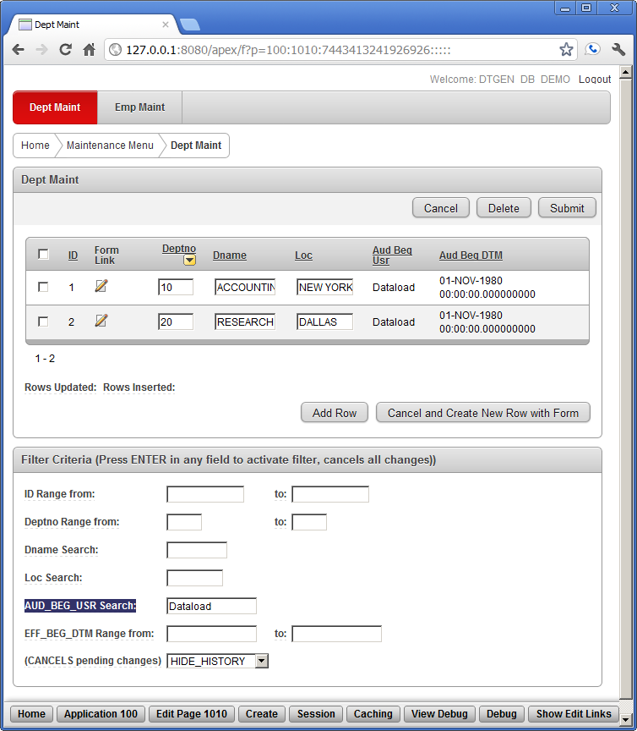

The rows of the grid edit have been reduced to only the rows with an "Audit Begin User" of "Dataload". Select "Show History" at the bottom of the page to get this view at the bottom of the form:

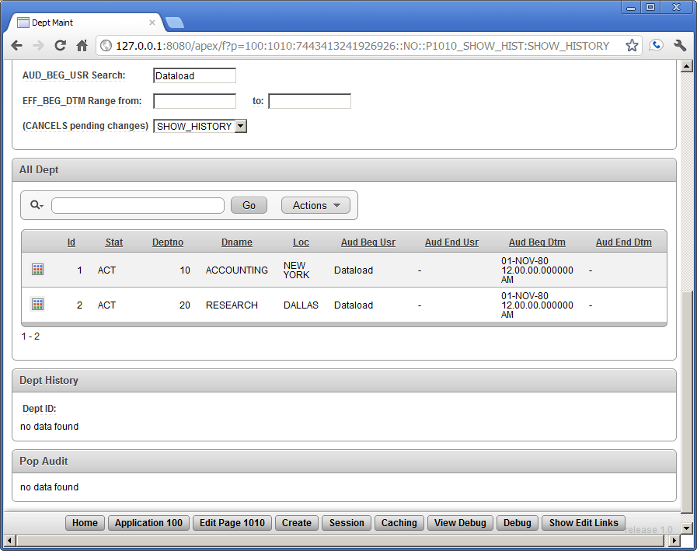

In this bottom part of the form, the "All Instances" view of current and historical data is contained in the "All Dept" pane. This is a standard APEX Interactive Report. Additional filters and sorting can be done via the search bar. Note that the interactive report is filtered by the current limitation on "Audit Begin User". Clear that field and press ENTER to get the following screen:

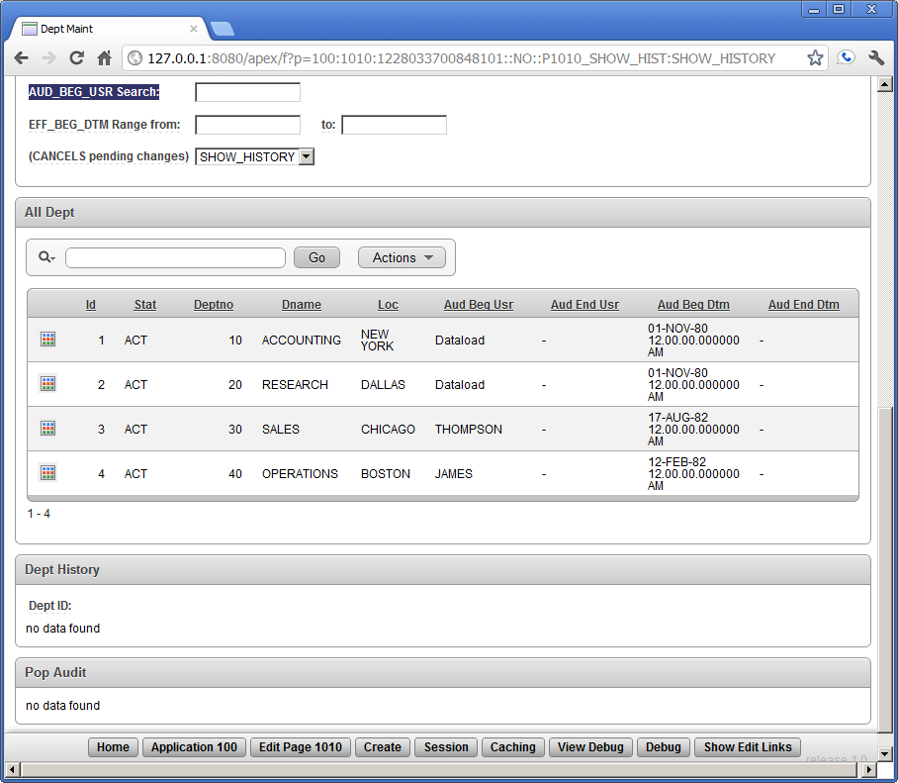

Notice that all the active records appear in the "All Dept" pane, similar to the records in the "Dept Maint" pane (not shown). There are no departments that have been "deleted", so there are no current instances of a department in history (i.e. STAT column has all 'ACT' and no 'AUD'). Click the gird icon at the left side of the SALES record in the "ALL Dept" pane.

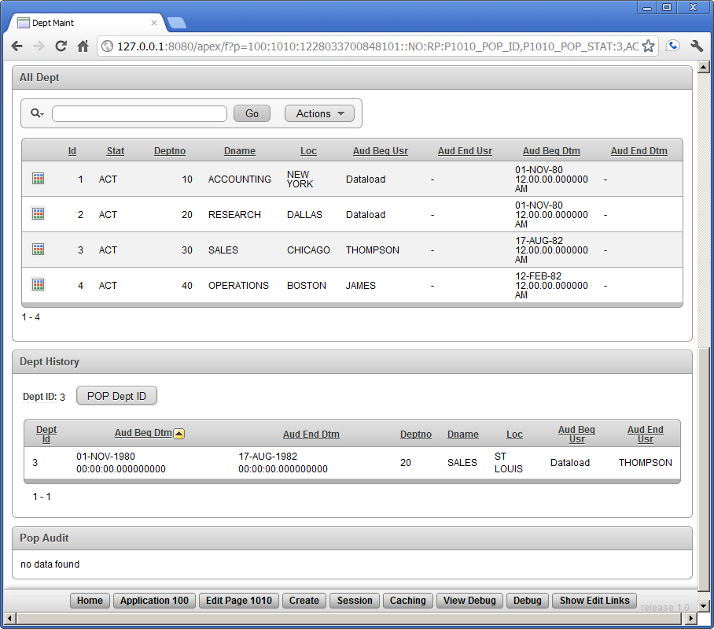

Selecting the SALES department instance in the "All Dept" pane shows the history of the SALES department in the "Dept History" pane. The sales department was in St. Loius from November 1980 before moving to Chicago in August 1982. Click the "POP Dept ID" button in the "All Dept" pane.

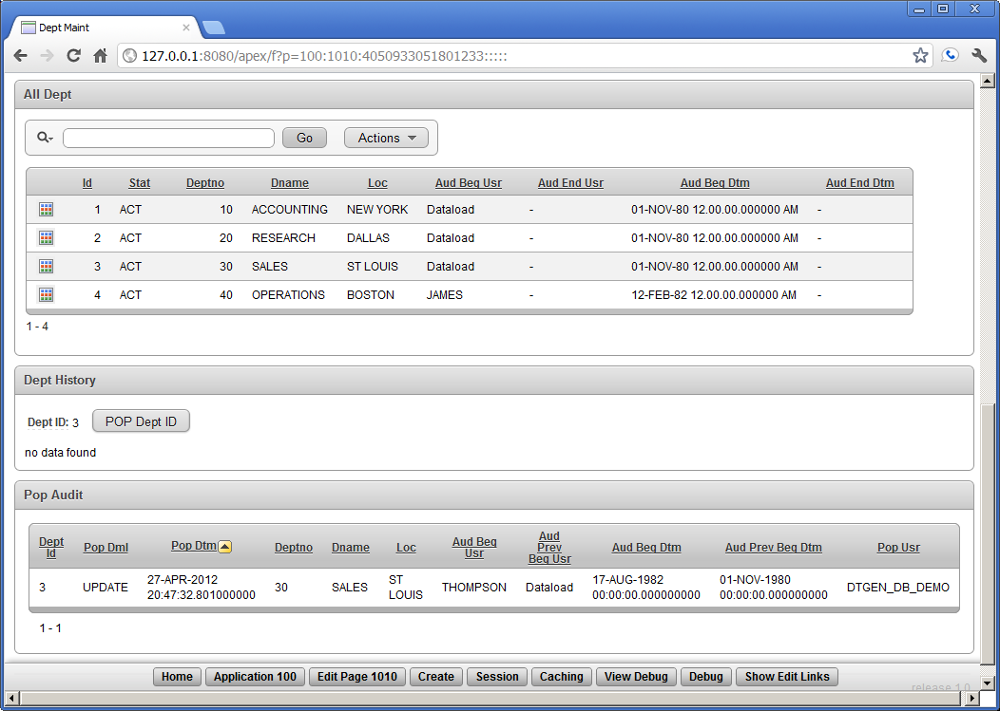

Pressing this button performed an "UNDO" the sales department move to Chicago and created a POP Audit record that is now displayed. Notice that the "Pop Dml" column indicates that an "UPDATE" was undone. Also notice that the "POP Dept ID" button is ready to UNDO the insert that created the department in the first place. This UNDO would also be recorded in the Pop Audit.

The changes made here are permanent in that APEX commits each submit to the database. However, when using the DML API, a POP that is part of a pending transaction can be rolled-back, i.e. UNDO the UNDO. Once the POP is committed, there is no DTGen generated code that can UNDO it.

Exercise #3: Comprehensive OMNI View Forms

Event Sequence:
APEX Forms

Exercise #3 does not modify the database. This exercise can be repeated without problem.

Exercise #2 showed the grid edt, filterable domain data, and also the history of a entity instance, specifically the instance history of the SALES depatment. Between active, history, and pop audit data, coupled with the ability change natural key data and most any other data item, finding a specific record can be a challenge. The OMNI view is a standard APEX interactive report that combines all the data from active, history, and pop audit into one searchable view.

Navigate to the home page of the generated application. If starting this exercise from the end of exercise #2, click the "Home" link in the breadcumb at the top left of the "Dept Main" form. The home page should look like this:

Click the "OMNI Reports Menu" button in the "Utility Menu" pane.

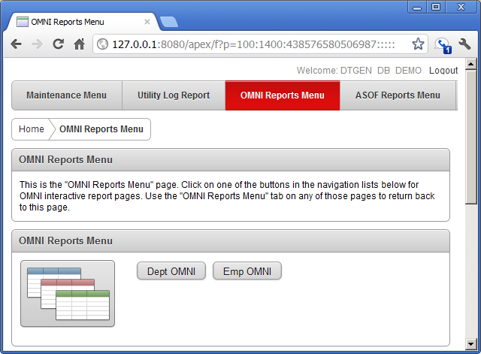
Click the "Emp OMNI" button in the "OMNI Reports Menu" pane.

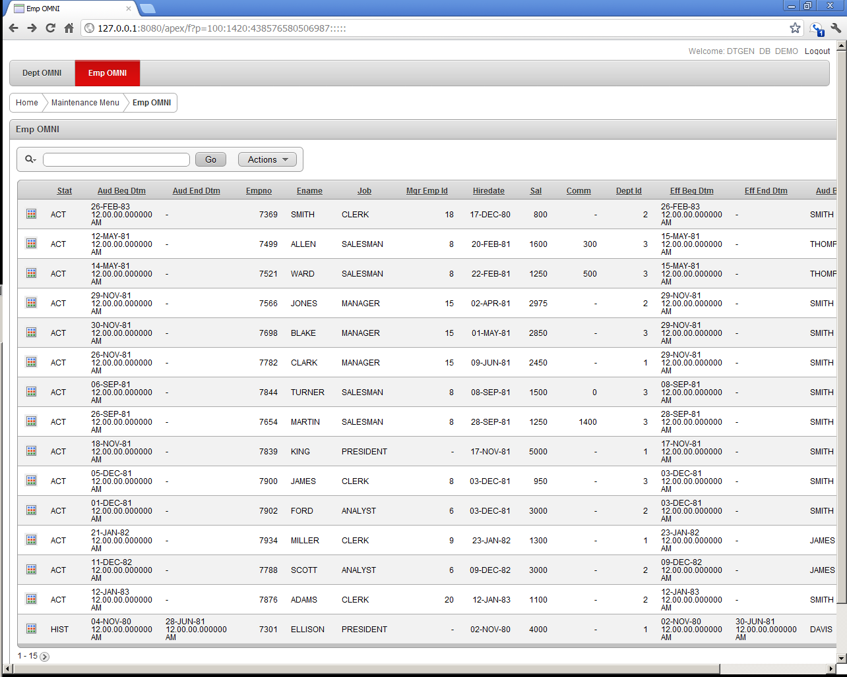
In the form above the first 15 of all the EMP records in the database are shown. These include records from EMP_ACT, EMP_HIST, and EMP_PDAT. To narrow the records to only those that have the name DAVIS, enter DAVIS to the right of the magnifying glass icon and click the "Go" button.

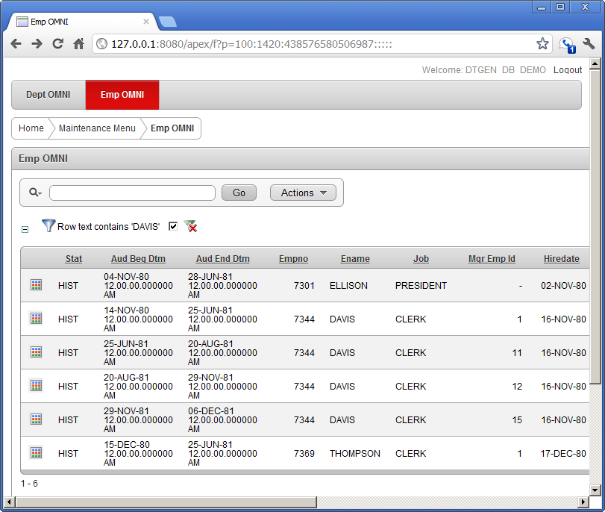
Only 6 records are returned, each with the name DAVIS in the record somewhere. All of these records are from the EMP_HIST table.

Logout of the application clicking the "Logout" link at the top right of the page. Logout of APEX by clicking the "Logout" link at the top right of any APEX page (not shown here).

