Server IP Address: 10.40.18.102

Client IP Address: 10.40.18.60

A. Use iperf and generate tcp and udp traffic. Show the client’s and the server’s

outputs at both occasions separately.

TCP Traffic:

Client’s Output:

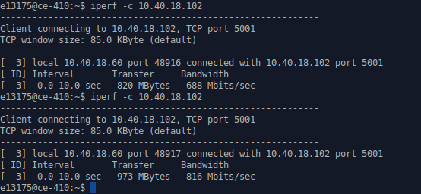

Server’s Output:

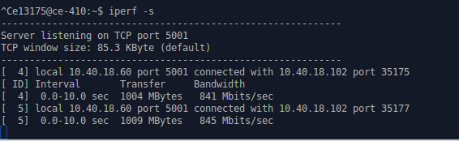

UDP Traffic:

Client’s Output:

Server’s Output:

B. Capture the TCP three way handshake using wireshark

C. Calculate the TCP connection establishment delay by using wireshark.

D. In this communication, the initial sequence numbers are shown as zero in each

direction.Clarify the reason behind that.

E. What TCP options are carried on the SYN packet on your trace?

F. Identify the TCP connection teardown message sequence in the trace.

G. Draw the traffic pattern for both TCP and UDP.

H. Compare the UDP vs TCP throughput and comment on it.

I. Change the MTU size and redraw the TCP graph for MTU=500,1000,1500

J. Identify the reason behind the shown traffic patterns (whether it comes to a

saturation, if not why)?