Student ID: 101669460

Name: Dylan Dinsdale

# Setup Screenshot

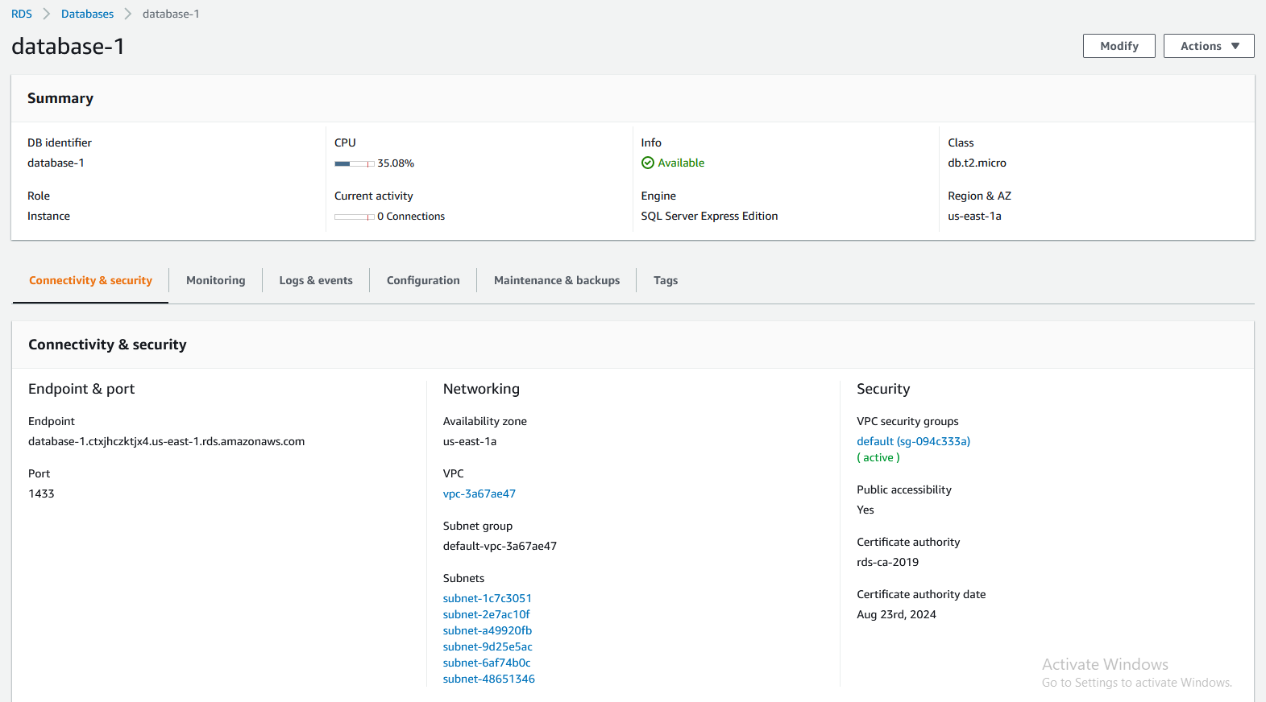

# Task 2 Screenshot







# Task 3 Screenshot

