Part1A: Average accuracy is 67.43%.

Part1B: Average accuracy is 74.19%.

Part1D: Average accuracy is 70.86%.

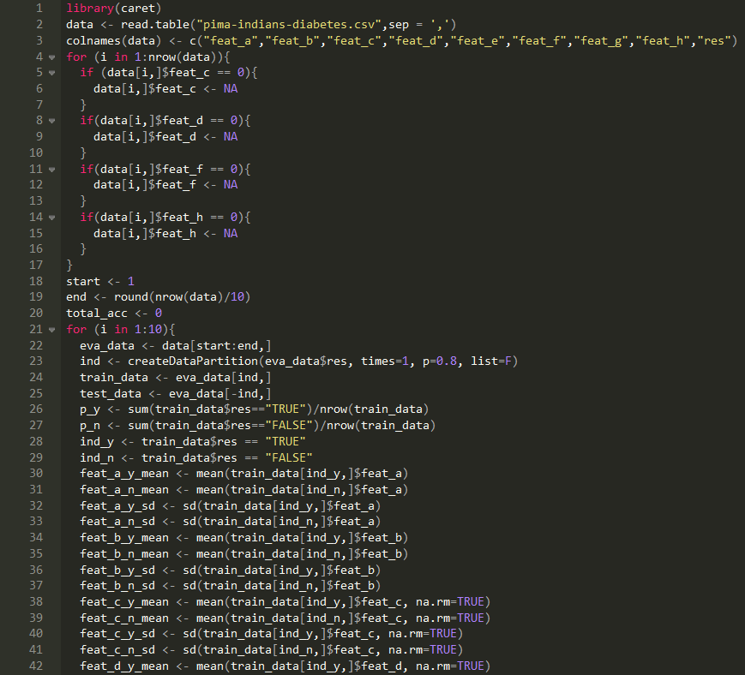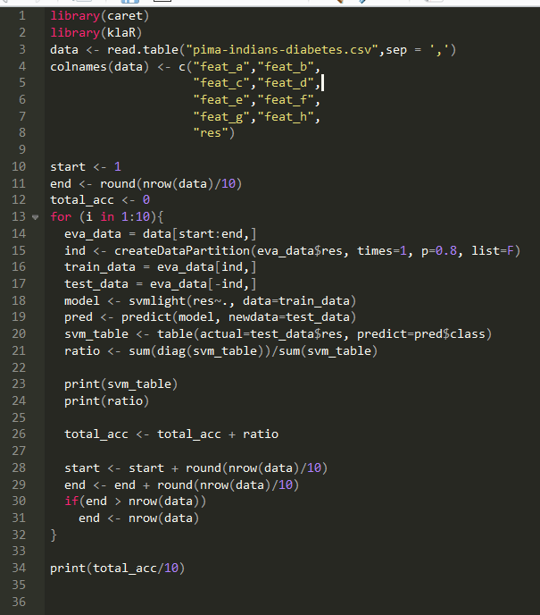

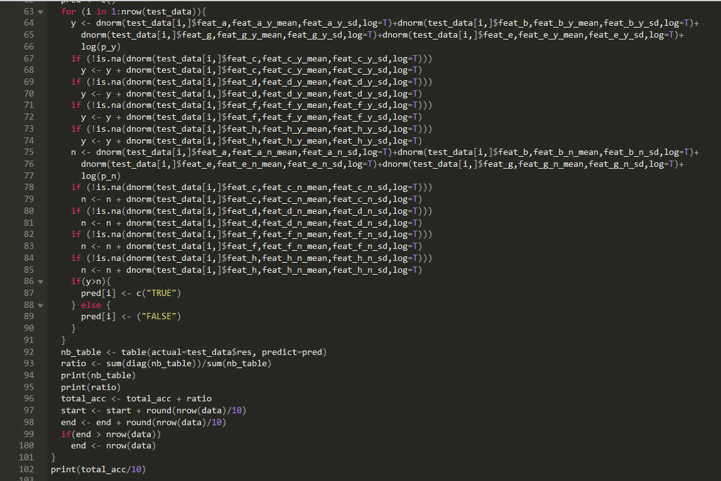

|  |  |
| --- | --- |
| Method | Accuracy |
| Gaussian + untouched | 61.83% |
| Gaussian + stretched | 72.26% |
| Bernoulli + untouched | 83.53% |
| Bernoulli + stretched | 82.27% |
| 10 trees + 4 depth + untouched | 62.43% |
| 10 trees + 4 depth + stretched | 68.14% |
| 10 trees + 16 depth + untouched | 95.19% |
| 10 trees + 16 depth + stretched | 90.20% |
| 30 trees + 4 depth + untouched | 64.93% |
| 30 trees + 4 depth + stretched | 72.26% |
| 30 trees + 16 depth + untouched | 96.90% |
| 30 trees + 16 depth + stretched | 93.57% |

Best Model: random forest model with most tree number and largest depth

Explanation: with large tree number and depth, classify can be more detailed.

|  |  |  |  |
| --- | --- | --- | --- |
| Gaussian + untouched | Gaussian + stretched | Bernoulli + untouched | Bernoulli + stretched |
|  |  |  |  |
|  |  |  |  |
|  |  |  |  |
|  |  |  |  |
|  |  |  |  |
|  |  |  |  |
|  |  |  |  |
|  |  |  |  |
|  |  |  |  |
|  |  |  |  |

