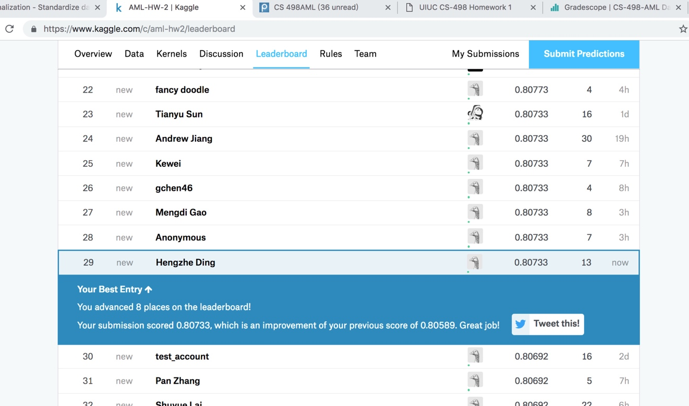

My best test dataset accuracy obtained on Kaggle is 80.733%.

1

1e-1

1e-2

1e-3

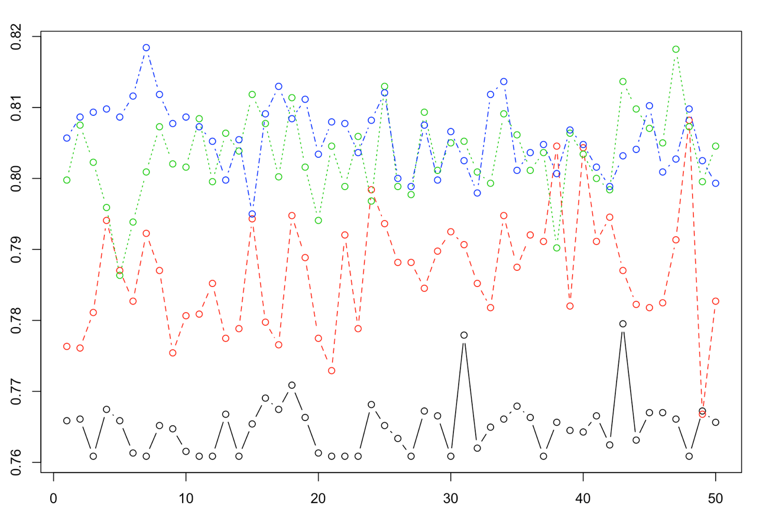

1

1e-1

1e-2

1e-3

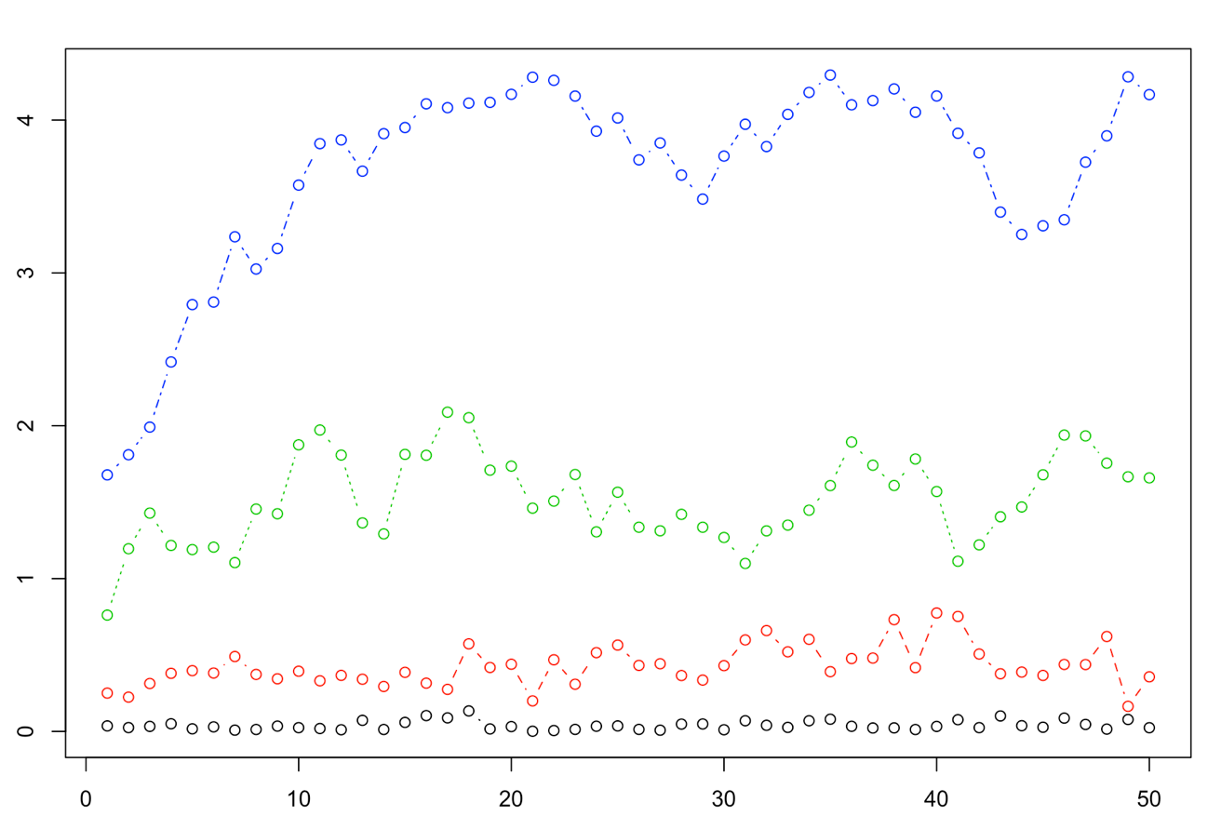

The best value of the regularization constant is 1e-3. The reason why I think it is a good value is that the accuracy result is the best with this constant. In addition, little regularization constant means hyperplane with little margin between the two class, “-1”and “1”, which is good in this case, because the feature vector of two class is close to each other.

My choice of learning rate is 1/(0.01s+50).

Because in the equation of learning rate, m/(s+n), m should be small and n should be large.

Library used & normalizing data:

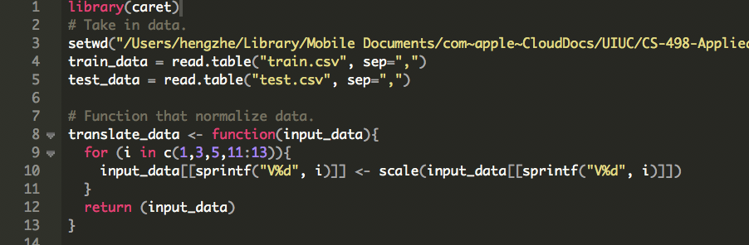

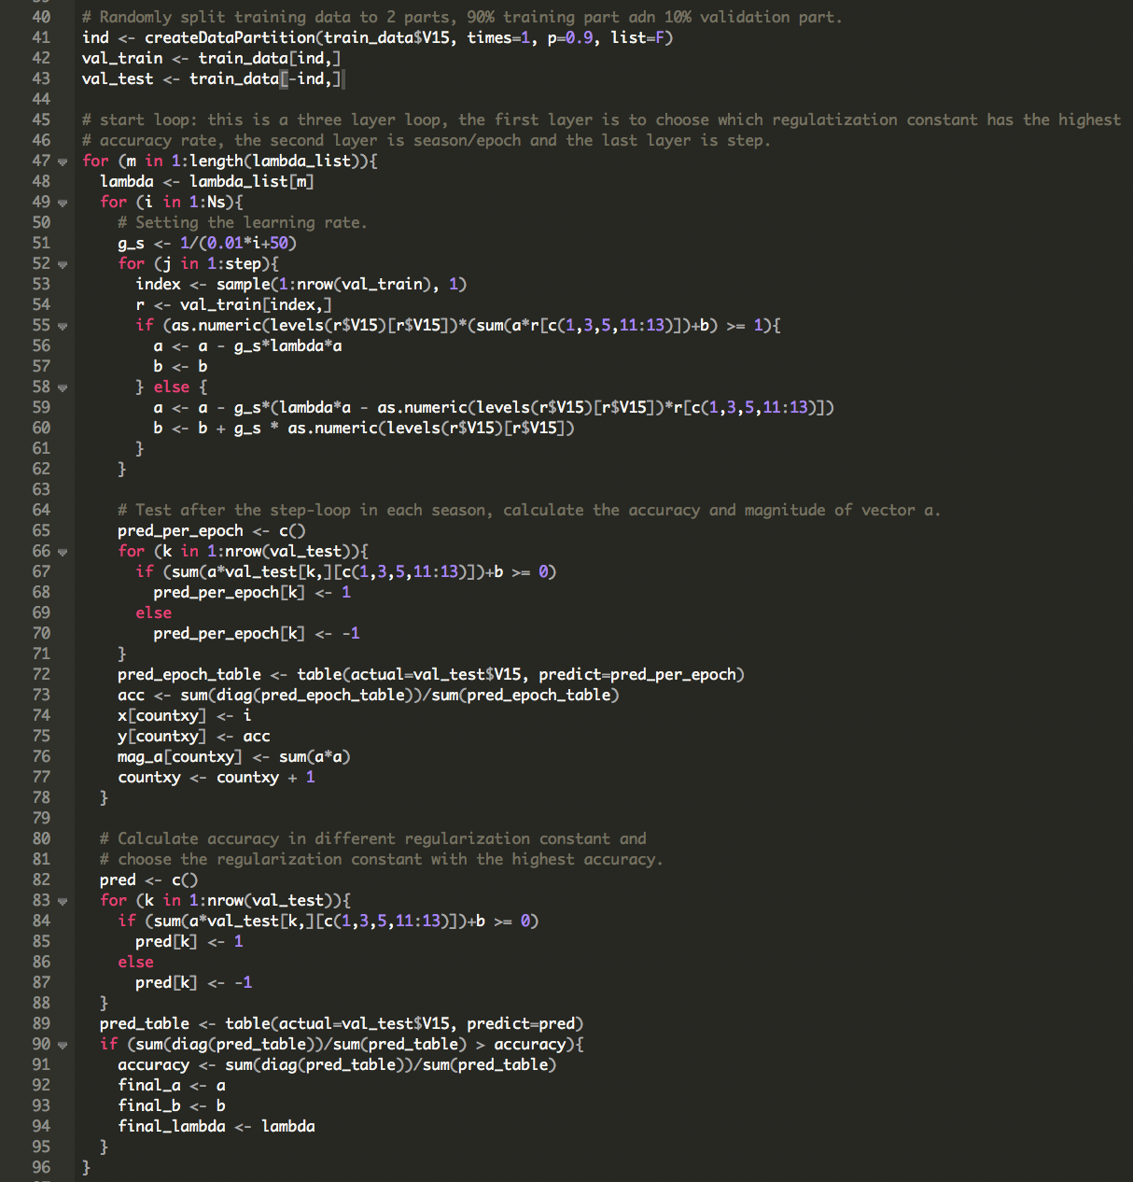SVM training: