**Explanation on** *SupplyChainEnv*

Consider a supply chain example including M factories and N warehouses (in this example 2 factories and 3 warehouses) as follows:

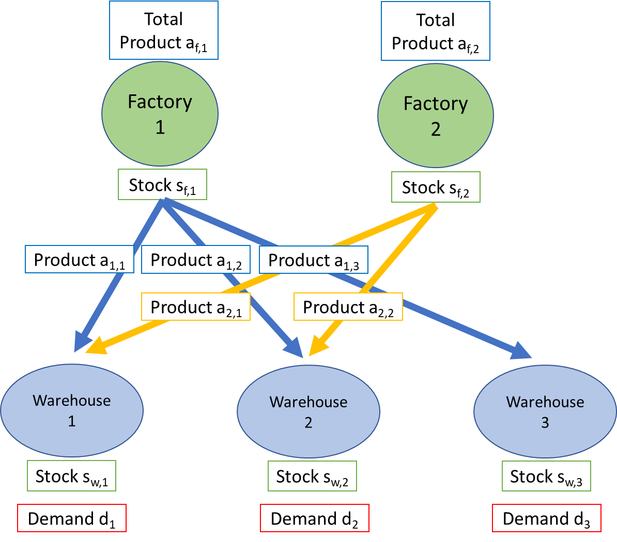

The connection matrix is [[1,1,1],[1,1,0]] in this case, where 1 or 0 denotes whether there is a connection between certain factory and warehouse.

The definition of one-step reward is given as below:

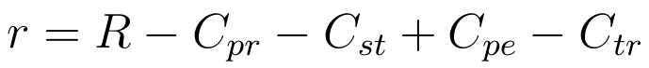

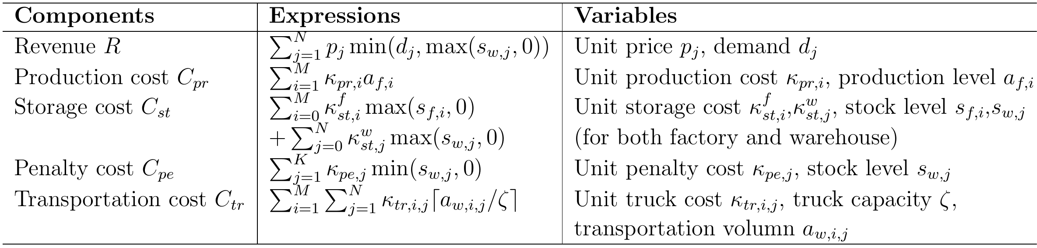

The state transition functions are provided as:

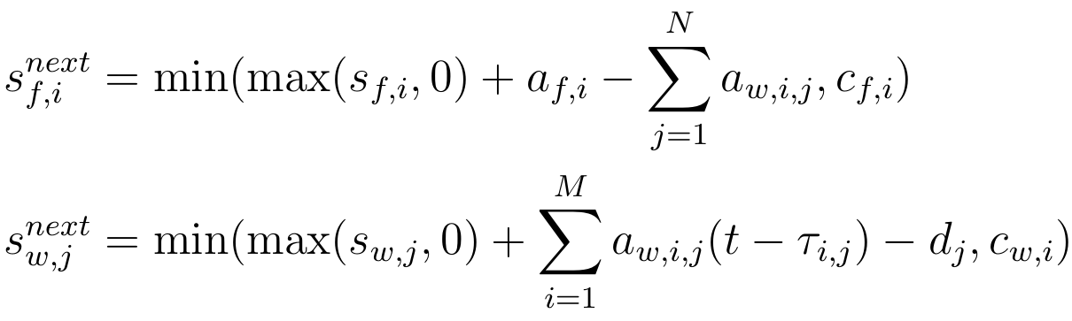

where the lead time is considered by adding a delay into $a_{w}$ in the second equation.

Also, the action ***A*** and state ***S*** with respect to reinforcement learning is defined by

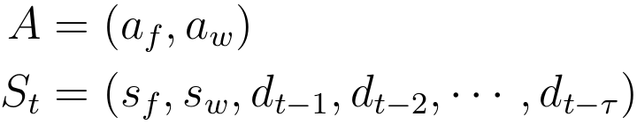

where state ***S*** includes a demand history of $τ$ units.

Having the network structure, system dynamics, and system parameters well setup, I will next explain the detail of this supply chain environment code in python.

* **SupplyChainEnv(con_mat, price, k_pr, k_st, k_pe, k_tr, lead_time, st_max, de_hist_len, zeta)**

The main function well establishes the whole supply chain network structure, and the definitions of each argument are:

**con_mat:** Connection matrix, a M by N matrix (python 2D array)

In the above example, it is given as [[1,1,1],[1,1,0]].

**price:** Unit price vector, a length-N vector

In the above example, it is given as [$p_{1},p_{2},p_{3}$].

**k_pr:** Unit production cost vector, a length-M vector

In the above example, it is given as [$κ_{pr,1},κ_{pr,2}$].

**k_st:** Unit storage cost vector, [[length-M vector],[ length-N vector]]

In the above example, it is given as [$[κ_{st,1}^{f},κ_{st,2}^{f}],[κ_{st,1}^{w},κ_{st,2}^{w},κ_{st,3}^{w}]$].

**k_pe:** Unit penalty cost vector, a length-N vector

In the above example, it is given as [$κ_{pe,1},κ_{pe,2},κ_{pe,3}$].

**k_tr:** Unit transportation cost matrix, a M by N matrix

In the above example, it is given as [[$κ_{tr,1,1}$, $κ_{tr,1,2}$, $κ_{tr,1,3}$],[$κ_{tr,2,1}$, $κ_{tr,2,2}$, 0]].

**lead_time:** Lead time matrix, a M by N matrix

In the above example, it is given as [[$τ_{1,1}$, $τ_{1,2}$, $τ_{1,3}$],[$τ_{2,1}$, $τ_{2,2}$, 0]].

**st_max:** Capacity of stock, [[length-M vector],[ length-N vector]]

In the above example, it is given as [[$c_{f,1}$, $c_{f,2}$],[$c_{w,1}$*, $c_{w,2}$, $c_{w,3}$* ]].

**de_hist_len:** Length of demand history for state vector *S*, scalar

**zeta:** Truck capacity, scalar

The main function will also build blank vector/matrix to store stock level $s_{f}$, $s_{w}$, production/distribution value $a_{f}$*, $a_{w}$* , and demand value $d$.

* **reset(IC_s_f** *(optional)***, IC_s_w** *(optional)***)**

Reset method will clear the vector/matrix for stock level $s_{f}$, $s_{w}$, production/distribution value $a_{f}$*, $a_{w}$* , and demand value $d$. The arguments **IC_s_f** and **IC_s_w** can be used to set the initial conditions for $s_{f}$, $s_{w}$ (or 0 value if not provided). It will return the state vector *S* at the first time step.

* **step(action_f, action_w, demand)**

Step method takes the follows arguments as inputs:

**action_f:** Current action (production value) of factory, a length-M vector

**action_w:** Current action (distribution value) of warehouse, a M by N matrix

**demand:** Current demand, a length-N vector

It will give the output **S_next, one_step_r, terminal:**

**S_next:** State vector *S* for the next time step

**one_step_r:** One step reward, scalar

**terminal:** Terminal indicator, scalar (always zero here)