

**REBOOT: NETWORKING**



May 20, 2016

Boombastics

Institute of Technology, Blanchardstown

# 

Declaration

We, the authors, declare that the material contained in this report, which is submitted for assessment on the programme of education for the award of **B.Sc. Honours Degree in Computing in Information Technology** in The Institute of Technology, Blanchardstown, Dublin 15, Republic of Ireland, is entirely our own work, unless stated through official referencing and citation.

This document has not been submitted, in full or in part, for any other assessment, in this or any other institution, with the exception of those required by our mentors in order to achieve the above qualification.

Acknowledgment

To ensure the success of this assignment, we required a reasonable amount of guidance and support from several reputable individuals. We would like to take this opportunity to convey our utmost gratitude to Dr. Luke Raeside, Department of Informatics faculty, Institute of Technology, Blanchardstown, who was a mentor, supervisor and friend throughout the project process. His endless advice and many consultations for the duration of the academic year was nothing short of excellence.

We would like to that this time to acknowledge the patience and support that our families have given us in our pursuit of achievement. We thank all of those individuals who, directly and indirectly, have added to the harmony which surrounded us during this time.

Abstract

The purpose of this project was to develop and interactive web-based mobile application for third level students who are studying in the area of networking. The software was developed with the theory that this application is adaptable for use with any academic module by altering the content of a database.

The design of this application is based on the concept of a multiple choice quiz with the emphasis on academic learning married with entertainment. While achieving the goal of providing an educational tool for students, this application focused on developing an inviting and easy-to-use game to help support students in the initial learning of networking terms and definitions.

On completion, this application offers a simple and ergonomic front-end design which is user friendly and aesthetically pleasing when held against trending applications. The back-end is flexible and can be adapted to most theoretical modules, with little expertise.

Since the programming is modular, this application can be expanded and altered to fit the needs of the clients’ specific requirements.

Table of Contents

1 Introduction 1

1.1 Aims and Objectives 2

1.2 Target Audience 3

1.3 Main Research Questions 4

1.4 Justification/Benefits 5

1.5 Feasibility 6

1.6 Systems Development Life Cycle (SDLC) 7

1.7 Proposed Methodologies 8

1.8 Application 10

1.9 Deliverables 11

1.10 Conclusion 13

References 14

Table of figures

# Introduction

The essence of this project was to develop and interactive web-based mobile application for third level students who are studying in the area of networking. This section will outline the aims and objectives set out towards the completion of this project. This document will also explain the functionality of the application and the target audience. . The timeline and delegation of tasks is presented in this document using a Gantt-Chart and a Work Breakdown Structure.

After conduction some research with regards to similar applications, it was agreed that although this application represents some applications already in existence, it was recognised that there was a lack of ‘fun-meets-academics’ in the field of networking.

Applications, such as Quiz Net [1], cater for the market in terms of an educational stand point, and applications, such as QuizUp [2], target the market in terms of an entertainment value.

One cannot turn on Facebook without falling over a dozen quizzes that a friend has tried and published. There is an application provided by Facebook to allow users to generate their own quiz [3]. However these type of multiple choice quiz (MCQ) do not offer any form of learning for the user.

It is, therefore, the opinion of this team that there should be an effort to combine entertainment and learning with the emphasis on the user gaining knowledge in the fundamentals of theory in the area of networking.

## Aims and Objectives

Our aim is to develop an application that will be a cross between a game and a quiz for Android devices. Whilst having the academic functionality of an educational quiz, it will have a young, fresh approach to learning. There are possibilities of expansion in the future when it comes to this project for example adding on additional courses such as programming, but for the purpose of this project, the subject matter will be on networking terms and concepts.

## Target Audience

The application has a wide market associated with it. As mentioned in the previous section, there are many quiz applications that fall into either two brackets, education or entertainment. The development team aims to break this tradition and target the application on both sides, aiming the application at a normal computer user or those who are studying networking in any educational institution.

For example it can benefit those who may have done PLC’s but have no networking background. This application can jumpstart the users’ networking knowledge up to a level in which the can keep up with the students with a year of networking fundamentals achieved.

## Main Research Questions

Throughout our extensive research for this project, the team has decided to focus on the following research questions:

1. Is the project feasible within the given time-frame?
2. Is there a learning platform for users in the area of networking fundamentals?
3. Is there an interactive and fun academic environment towards this learning?
4. Can an application be developed for users to feel drawn back to using the application?
5. Is the technology readily available to the development team?
6. What are the primary requirements for this application?
7. What type of security is require to ensure data protection?
8. Has the development team enough knowledge to design, analyse and test the software?
9. Will the self-learning aspects of the project cause the project to fail taking into consideration cost, time, support and availability.
10. What maintenance measures will be evaluated?

## Justification/Benefits

The main objective for this project is to provide a proven method of learning for the user with regards to the topic of networking fundamentals.

It is predicted that this project will result in the development of an application that can provide a new way of learning for the user. There are many benefits associated with this project such as:

1. It allows for the development of an educational application that has a modern new look to it
2. It allows the development team to put new and known skills and abilities to the test.
3. It can provide a great research utility to those who are interested in computing.
4. It can provide an excellent refresher for those currently in the industry.
5. It can be used as a fast-track learning tool for students entering into a computing course with no prior knowledge of networking terms and concepts.
6. This application will prove useful for students with learning difficulties, such as dyslexia, to have access to networking fundamentals in an easy-to-learn environment with instant feedback.

## Feasibility

The feasibility aspect of this project involves a lot of individual learning completed by the each member of the team, focusing specifically at Android application development. This development is aided along by journaled articles such as “Mobile application tools for learning and quiz based on Android” by Dan Cheng and Wang [4] and “The busy coder's guide to advanced Android development” by M Murphy [5].

## Systems Development Life Cycle (SDLC)

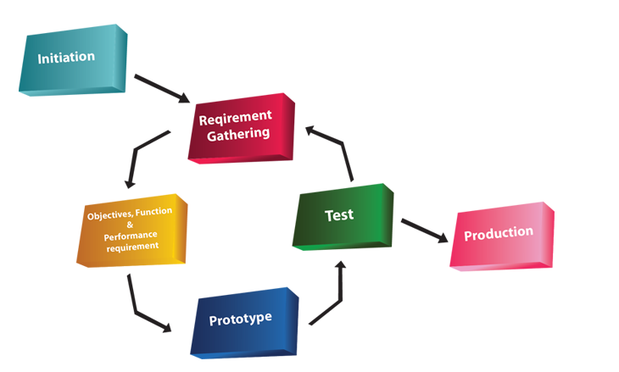The project can have different ways of operating. One way in which the group can implement the project is by the Prototyping SDLC model. The Prototyping model allows the team to work concurrently on three aspects of the SDLC, them being the analysis, design and implementation. This model is on a constant loop until a finished product is completed. The prototyping model is a very fast paced model but allows us to interact with the application more to gain a better understanding of its functionality or areas of improvement that might not have been foreseen with other model approaches.

Figure 1 - The Prototyping Model [6]

## Proposed Methodologies

This is a three person team. Each team member will have a defined role, based on our abilities, strengths and interest of self-learning. Throughout the development, every member of the team will be brought up to speed on the progress of each of the other members. The aim is that all members are proficient with all aspects of the project.

Member 1

This member’s responsibility will be to front the programming side of the project, with the objective to use numerous technologies to work concurrently. This application will use Android SDK [7] to develop the web front for all Android devices which run Froyo 2.2 [8], or newer. With the aim of the app being compatible with 100% of all Android devices, Android’s WebView kit will be used. The next step will be to develop responsive pages with the use of an open source CMS such as WordPress to manage pages.

Member 2

This member will focus on the security issues which may arise with relation to user log in and registration. This involves an extensive amount of research into current hacks and security issues on the market. There is a need to obtain self-signed certs which will be sourced early in the project [9] [10].

There will need to be high-end security measures to ensure that data protection is adhered to for all players, concentrated around the user registration and login.

This member will also assist in the layouts and the look-and-feel of the application

Member 3

This member will target the graphical user interface. The main objective is to develop a smooth and an aesthetic application which will encourage return customers and customer growth. Development of custom imagery for the application will be established using tools such as Adobe Illustrator, Adobe Photoshop and GIMP.

A SQL Database table will be used to contain all questions needed. A second SQL database table will be vital for the storing, accessing and modifying of user login, registration and sessions. These tables will be generated using MySQL.

Group Elements

The team will develop a-state-of-the-art modern, ‘hi-res’ graphics using animation tools such as Adobe Illustrator, Photoshop and GIMP. There is a possibility to use Dreamweaver for transitions.

PhP scripting will be used to consolidate all elements of the application resulting in a smooth application with a modern and fun look’n’feel. For hosting, the team has secured permission from Absorb.ie to have full use of their servers inclusive of a sub-domain and installation of third-party utilities. [11]

## Application

The application will be a cross between a game and a quiz. Whilst having the academic functionality of an educational quiz, it will have a young, fresh approach to learning. For this project, the subject matter will be on networking terms and concepts.

The application will consist of three levels. A description of these levels is detailed in the next section.

Level 1

The first level will be easy, containing definitions and abbreviations on an MCQ basis. One question will have 4 possible answers with only one answer being correct. There is plans to have a pool of 300 questions for the finished product. However, for the sake of this project, it is more feasible to run a beta model with a pool of 10 question.

Level 2

The second level is more difficult. Questions will be based on exam quality definitions and networking syntax on an MCQ basis. One question will have 4 possible answers with only one answer being correct. There is plans to have a pool of 300 questions for the finished product. However, for the sake of this project, it is more feasible to run a beta model with a pool of 10 question.

Level 3

The third level is the most difficult. Questions will be based on the general theory associated with networking on a CCNA level. Each question will be answered textually. This will involve technology which will recognise keywords and strings. There is plans to have a pool of 150 questions for the finished product. However, for the sake of this project, it is more feasible to run a beta model with a pool of 10 question.

Player advancement through levels

In order for the user to move from one level to another, the player must answer ALL the questions in each level. If a question is answered correctly, that question will be flagged ‘true’. If question is answered incorrectly, the program generate next question. The wrong question remains in the cycle until it is answered correctly. All questions are generated randomly.

## Deliverables

The aim is to have a fairly established running BETA model by Christmas break which will leave the next semester for testing and defining our documentation.

In this section, the expected results are examined in order to identify any issues before the project officially begins.

A Work Breakdown Structure and Gantt-Chart, which follow, provide a condensed and visual view at the tasks and predicted timeline of the project.

Expected Results

1. A fully functional Android application.
2. A young, dynamic, fun and educational tool for learning networking fundamentals.
3. A knowledge and understanding of Android development.
4. Implement a new knowledge of security protocols and risk in regards to Android development, focusing on the data protection of users.
5. Learn to combine different languages and technology to ensure an ergonomic and efficient application.
6. Gain experience in the area of teamwork and learning to approach intrapersonal issues.
7. Development of an application which has the potential to be adapted to other academic topics.

Work Breakdown Structure

1. Proposal
2. Research possible technologies required
3. Secure supervisor
4. Research existing applications
5. Research forensic measures required
6. Establish all software requirements
7. Risk analysis 1
8. Develop GUI
9. Develop Database
10. Establish BETA model
11. Risk analysis 2
12. Finalise responsive elements
13. Implementation
14. Testing

Gantt-Chart

This chart shows the division of labour among the development team. It is subject to change.

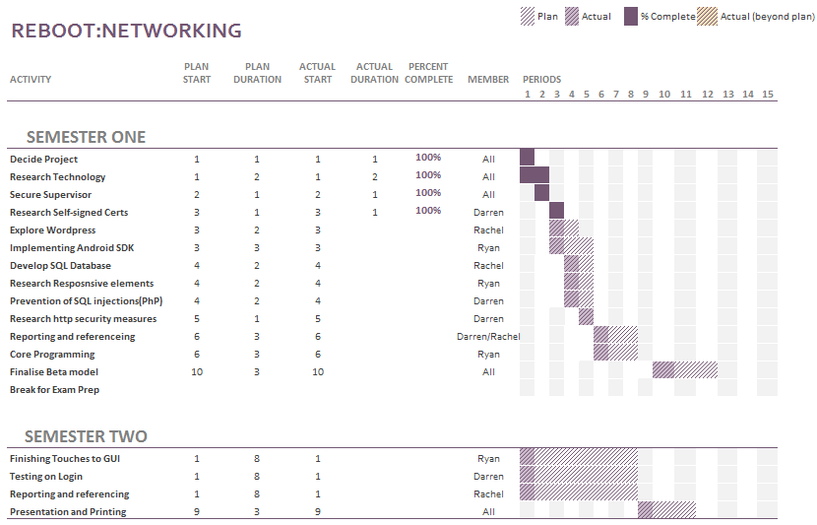

Figure 2 Gantt-Chart

## Conclusion

This application, as it stands, is available and ready for development to begin. A feasibility study will show any changes that may need to be applied. The title and structure will be re-investigated at regular intervals throughout the duration of the project in order to improve the efficiency of the development build.

This product has great potential as it can be expanded in size by merely extending the database. This product has the potential to be phased into other educational areas such as Mathematics, Data Structures, Operating Systems and many more.

The technologies that will be used are openly available and the deadline has been set to ensure the productivity of the project is high.

The team has agreed to dedicate to a tight deadline of January 2016. This will give enough time for testing and allow for any contingency plans to be used if needed.

# Literature review

This chapter contains various investigations with regards to the diverse views of this project. Each member of the development team took a separate segment and researched and reviewed literature which supports one aspect of the overall project.

///talk about what each of the reviews are about and why it’s significant.

**Is a multiple choice quiz (MCQ) an efficient and effective format of assessing students?**

The specific topic of this research is to support, or disparage, the general opinion on using a multiple choice quiz (MCQ) as an efficient and effective format of assessing students.

“In ancient Greece, Socrates tested his students through conversations. Answers were not scored as right or wrong. They just led to more dialogue.”[1]

Over time it has become more apparent that academic testing, especially in the field of science, has become more standardized and in recent years the format has drifted from the essay style testing. The emphasis has shifted towards what the student can recognize, rather than what the student can memorize.

This document is designed to represent both sides of the argument, using accredited sources and a range of beliefs.

## 2.2 Where MCQ testing came from

The attitude regarding multiple choice testing in current academic settings has been argued since the early 1900s when the first evidence of standardized testing was introduced. This is very apparent in the article by Jay Mathews, a staff writer for the Washington Post in 2006 on the subject of how testing students has evolved over time.

Mathews’ article provided a fact-based delivery of the formation of general testing in the United States from the time of Socrates to the time of publication. In this article, he discussed how the progression from essay style testing started to be replaced by the MCQ style around the turn of the 20th century.

*“At the outset of the 20th century, educators began to experiment with tests that took shortcuts around the old essay methods….Frederick J. Kelly of the University of Kansas designed a multiple-choice test in 1914…..Many Americans accepted these tests as efficient tools to help build a society based on merit, not birth or race or wealth.”[1]*

The philosophy surrounding that seems to be speed, both for student and examiner, and accuracy. It was developed with the ethos that students who had difficulty with the focus and drive needed for succeeding academically had a chance to be pitted against those students who found memorising theory less challenging. Multiple choice testing also ensured that all participants were tested on a level playing field without judgements which may arise from the student background or circumstances.

Since the development of the first MCQ, Frederick J. Kelly’s model has not been altered much. The basic structure and objective of the test is simple and relatively unflawed (see figure 1)

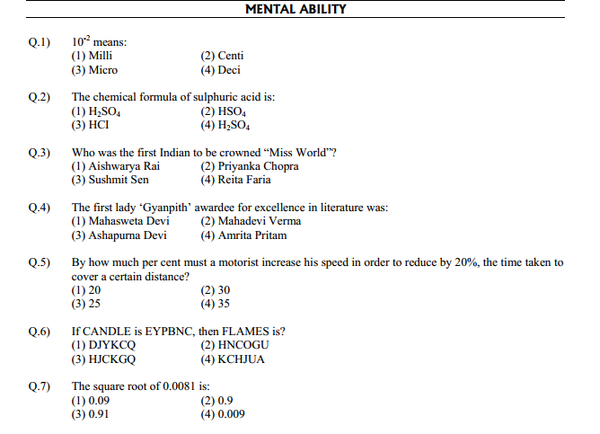

Figure 1 - an example of a Multiple Choice Quiz

## 2.3 MCQ - an effective format for testing?

There have been many arguments in the philosophy of testing in education, for and against.

One person who took an adverse opinion to the multiple choice format for the purpose of academic testing was Diane Ravitch, a historian of education with a Ph.D. from Columbia University. In an article she wrote in “The Chronicle of Higher Education” in March 2006, Ravitch was unimpressed with the lack of essay style testing, especially in the more scientific subjects such as Medicine and Information Technology.

Commenting on the early use of essay exams in the United States, Ravitch wrote "everyone who went to high school, whether they were the children of doctors or farmers or factory workers . . . to study mathematics, science, English literature, composition, history and a foreign language“ [2].

Cathy N. Davidson’s is a distinguished scholar of the history of technology and is a leading innovator in techniques for new professional development and learning methods. She was recognised for her expertise and appointed to the National Council on the Humanities by U.S. President Barak Obama in 2011.

As a reputable speaker and consultant, Davidson is a regular writer for the Harvard Business Review, The Chronicle of Higher Education and The Washington Post.

In her book, “Now You See It”, Ms Davidson expresses her appreciation of Kelly’s theory that multiple choice testing is an efficient method of testing in a scientific academic situation. She agrees that in order to make a test both objective and efficient, questions need to be formulated without ambiguity. Questions must have an answer that is completely right or completely wrong, with no variable interpretations.

*“What the multiple-choice test did avoid, though, was judgment. It was called objective, not because it was an accurate measure of what a child knew but because there was no subjective element in the grading.” Cathy N. Davidson [3]*

Multiple choice questions are considered to be more objective than traditional essay methods as the facts are measured and not the individual opinion. This is a positive for both learner and educational provider for only one answer is right. This ensure that even if opinions vary, any interpersonal differences will not influence the results.

MCQs allows student knowledge to be measured without the challenge for assessors to read handwriting, or understand an answer which has been written in an exam situation where students may not express themselves clearly.

The general consensus in academic circles is that MCQs are regarded as an efficient form of assessment in medicine and the sciences, but in subjects such as humanities, it is viewed as mcq as a ‘dumbing down’ version of learning. The following section highlights some of the advantages and disadvantages of using multiple choice quizzes for assessments.

### 2.3.1 Advantages and disadvantages of using MCQs as a method of testing

In the book, “Computer-assisted assessment of students” by Brown et al, the authors and contributors highlighted many advantages and disadvantages of using MCQs as a method for assessing current students [4][5].

Advantages include the following.

1. MCQs are easy to convert to computer based format.
2. Require much less time to construct.
3. Require much less time to complete.
4. Student tested on ‘recognizing’ rather than ‘memorizing’.
5. Fast return of grade for students.
6. No subjectivity if student is vague in knowledge.
7. Answer is right or wrong…..no discrepancies!

Disadvantages include the following.

1. For more specialized subjects, the complexity of questioning makes MCQ construction time-consuming
2. They do not measure performance in complex areas
3. They do not measure students practical knowledge
4. Students can ‘guess’ a way to success

It is obvious that there is a difference of opinion with regards to the effectiveness of multiple choice quizzes as a form of assessment. However, everyone can agree that MCQs are objective. There is little or no variations in marking, they are easy to mark, they offer immediate feedback, and they test the students’ factual knowledge without prejudice.

In the next section, the author will provide an unbiased comparison between essay style and multiple choice style assessment.

## 2.4 Essay Exams verses Multiple Choice Quiz

Mark G. Christensen, Ph.D., Assistant Executive Vice President and Director of Testing for the National Board of Chiropractic Examiners (NBCE) attended the CLEAR Annual Conference in Phoenix, Arizona, USA. During this conference, Christensen delivered a presentation on the similarities and differences between essay based examinations and multiple choice quizzes. A synopsis of his delivery is presented in the following table [6][7].

*Table 1: Essay vs Multiple-choice*

|  |  |
| --- | --- |
| **Essay Exam** | **MCQ** |
| Quick and easy to construct test | Quick and easy to construct test |
| Answers allow for expansion of thought and understanding on a certain topic | Answers and either right or wrong. There is no room of subjectivity |
| Student must provide answers without prompting | Answers are provided allowing students to guess a way to success |
| Labour-intensive and time-consuming to grade | Immediate grade with little to no labour |
| Can lack objectivity | Grading is objective and completed reliably |
| Assesses the students overall knowledge of the subject matter | Assesses the students ability to recall snippets of knowledge through recognition |
| Measures limited amount of knowledge in an individual test | Questions can cover a vast array of knowledge in a short time |

Christensen is highly regarded by his peers. In his 30 years working with NBCE, he has designed and implemented a testing program for the chiropractic profession which has been adopted by many scientific academic fields around the world. Acceptable methods for assessment comprises the use of written, practical and multiple-choice testing [8].

## 2.5 Conclusion

The aim of this document is to discover if multiple choice testing is an efficient and effective method of assessing students. The research resources are endless on this topic, and each argument is convincing in its own right.

As a student, it is easy to side with the argument for using multiple choice quizzes for assessment. However, when the full picture is taken into consideration, the author can appreciate that MCQs can miss the target when testing the human understanding of the subject matter.

While there is certainly a time and place for MCQ testing, there is serious validity to essay style exams too. For a more in depth look into the design of MCQs, David Jennings, a published lecturer and researcher in UCD, Ireland, wrote 'A Problem and an Opportunity: E-Learning a case for collaboration' to help outline the “do’s and do not’s” of MCQ construction [9].

Multiple choice assessments have been around since 1914, thanks to Mr. Kelly. Its longevity is proof that it is as valid an assessment method in current academic setting as it was a century ago.

## 2.6 References

**[1] J. Mathews**, 'Just Whose Idea Was All This Testing?’, Washingtonpost.com, 2015. [Online]. Available: http://www.washingtonpost.com/wp-dyn/content/article/2006/11/13/AR2006111301007.html. [Accessed: 10- Nov- 2015].

**[2]D. Ravitch**, 'The Fall of the Standard-Bearers', the Chronicle of Higher Education, 2006. [Online]. Available: http://chronicle.com/article/The-Fall-of-the/6169. [Accessed: 13- Nov- 2015].

**[3]C. Davidson**, 'Now You See It: How Technology and Brain Science Will Transform Schools and Business for the 21s t Century'. New York: Penguin, 2011, Chapter 4.

**[4]P. Race, S. Brown, J. Bull, A. Cann and E. Pawley**, *Computer-assisted assessment of students*. London: Kogan Page, 1999, Chapter 4.

**[5] Multiplechoicequestionsservice.com**, 'Advantages of Taking Multiple Choice Questions Tests | Multiple Choice Questions', 2015. [Online]. Available: http://www.multiplechoicequestionsservice.com/multiple-choice-questions-advantages/. [Accessed: 12- Nov- 2015].

**[6]M. Christensen, Ph.D**., 'Essay vs. Multiple-Choice Exams: The Ups and Downs of Each Format', CLEAR Annual Conference, Phoenix, AZ, 2005.

**[7]A. Miller, B. Imrie and K. Cox**, Student assessment in higher education. London: Kogan Page, 1998.

**[8] Chiropractic Economics**, 'National Board of Chiropractic Examiners, NBCE, Mark G. Christensen, Paul M. Tullio Award', 2012. [Online]. Available: http://www.chiroeco.com/nbce-director-of-testing-receives-paul-m-tullio-award/38815/. [Accessed: 10- Nov- 2015].

**[9] David Jennings**; (2006) 'A Problem and an Opportunity: E-Learning a case for collaboration' In: Savin-Baden M. and Wilkie K (eds). Problem Based Learning Online. Open University Press: McGraw-Hill Education.

## 2.7 Bibliography

**[i] A. Littlejohn**, Reusing online resources. London: Kogan Page, 2003.

**[ii]S. Mishra**, 'Reusing Online Resources: A sustainable approach to e-learning', The International Review of Research in Open and Distributed Learning, vol. 5, no. 1, 2004.

**[iii]N. Uddin and E. Gaspar**, 'Game-Based Learning App Based on Google PlayN', IEEE International Conference on Teaching, Assessment and Learning for Engineering (TALE), Bali Dynasty Resort, Kuta, Indonesia, 2013.

**[iv]E. Olayemi,** 'Multiple choice questiones as a tool for assessment in medical education', African Journals Online (AJOL), vol. 12, no. 1, 2012.

## References

[1] Driftwoodsoftware.com, 'Driftwood Software', 2015. [Online]. Available: http://www.driftwoodsoftware.com/quiznet.html. [Accessed: 21- Oct- 2015].

[2] QuizUp, 'QuizUp', 2015. [Online]. Available: https://www.quizup.com/en. [Accessed: 21- Oct- 2015].

[3] Apps.facebook.com, “Quiz on Facebook | Facebook”, 2015. [Online]. Available: https://apps.facebook.com/fb-quizzes/?ref=aw&gclid=Cj0KEQjwqZKxBRDBkNmLt9DejNgBEiQAq8XWPl9BuKL-VuuJVTBNtN7fx9B1k0dwPn427aYd5BjdhaUaAlrX8P8HAQ. [Accessed: 19- Oct- 2015].

[4] L. Dan Cheng and X. Wang, 'Mobile application tools for learning and quiz based on Android', 2013 IEEE 63rd Annual Conference International Council for Education Media (ICEM), 2013.

[5] M. Murphy, “The busy coder's guide to advanced Android development.” United States: Commons Ware, 2011.

[6] Lion Vision, “The Prototyping Model”. 2015. [Online-Image] Available: http://www.lionvisionits.com/Development-Process.aspx. [Accessed: 21-Oct-2015].

[7] Developer.android.com, 'Download Android Studio and SDK Tools | Android Developers', 2015. [Online]. Available: https://developer.android.com/sdk/index.html. [Accessed: 21- Oct- 2015].

[8]A. Highlights, 'Android 2.2 Platform Highlights | Android Developers', Developer.android.com, 2015. [Online]. Available: http://developer.android.com/about/versions/android-2.2-highlights.html. [Accessed: 21- Oct- 2015].

[9] J. Drake, Z. Lanier, C. Mulliner, P. Oliva, S. Ridley and G. Wicherski, “Android hacker's handbook.” Indianapolis, IN: Wiley, 2014.

[10] A. Misra, “Android security.” Boca Raton, FL: CRC Press, 2013.

[11] Absorb, 'Absorb.ie', Absorb.ie, 2015. [Online]. Available: http://absorb.ie. [Accessed: 21- Oct- 2015].