

REBOOT: NETWORKING



May 20, 2016

Boombastics

Institute of Technology, Blanchardstown



Declaration

We, the authors, declare that the material contained in this report, which is submitted for assessment on the programme of education for the award of B.Sc. Honours Degree in Computing in Information Technology in The Institute of Technology, Blanchardstown, Dublin 15, Republic of Ireland, is entirely our own work, unless stated through official referencing and citation.

This document has not been submitted, in full or in part, for any other assessment, in this or any other institution, with the exception of those required by our mentors in order to achieve the above qualification.

Acknowledgment

To ensure the success of this assignment, we required a reasonable amount of guidance and support from several reputable individuals. We would like to take this opportunity to convey our utmost gratitude to Dr. Luke Raeside, Department of Informatics faculty, Institute of Technology, Blanchardstown, who was a mentor, supervisor and friend throughout the project process. His endless advice and many consultations for the duration of the academic year was nothing short of excellence.

We would like to that this time to acknowledge the patience and support that our families have given us in our pursuit of achievement. We thank all of those individuals who, directly and indirectly, have added to the harmony which surrounded us during this time.

Abstract

The purpose of this project was to develop and interactive web-based mobile application for third level students who are studying in the area of networking. The software was developed with the theory that this application is adaptable for use with any academic module by altering the content of a database.

The design of this application is based on the concept of a multiple choice quiz with the emphasis on academic learning married with entertainment. While achieving the goal of providing an educational tool for students, this application focused on developing an inviting and easy-to-use game to help support students in the initial learning of networking terms and definitions.

On completion, this application offers a simple and ergonomic front-end design which is user friendly and aesthetically pleasing when held against trending applications. The back-end is flexible and can be adapted to most theoretical modules, with little expertise.

Since the programming is modular, this application can be expanded and altered to fit the needs of the clients’ specific requirements.

Table of Contents

1 Introduction 1

1.1 Aims and Objectives 2

1.2 Target Audience 3

1.3 Main Research Questions 4

1.4 Justification/Benefits 5

1.5 Feasibility 6

1.6 Systems Development Life Cycle (SDLC) 7

1.7 Proposed Methodologies 8

1.8 Application 10

1.9 Deliverables 11

1.10 Conclusion 13

2 Literature review 14

2.1 Review A: Is a multiple choice quiz (MCQ) an efficient and effective format of assessing students? 15

2.1.1 Where MCQ testing came from 17

2.1.2 MCQ - an effective format for testing? 18

2.1.3 Advantages and disadvantages of using MCQs as a method of testing 20

2.1.4 Essay Exams verses Multiple Choice Quiz 21

2.1.5 Conclusion 22

2.2 Review B: How the implementation of Multiple Choice Quizzes (MCQs) on mobile devices for 3rd level students can aid in their subject of choice. 23

2.2.1 MCQs – are they used? 23

2.2.2 E-Learning and M-Learning 25

2.2.3 Technology in study 26

2.2.4 Web Services for Mobile Learning Applications 28

2.2.5 Conclusion 29

2.3 Review C: A synoptic review in to the technology to be used in the development of an educational application with the subject of Computer Networking 30

2.3.1 Java 30

2.3.2 PHP 31

2.3.3 HTML 32

2.3.4 CSS 33

2.3.5 JavaScript 33

2.3.6 Android 34

2.3.7 Bootstrap Framework 35

2.3.8 Conclusion 36

3 Implementation 37

4 Design 38

4.1 User Interface Design (Wireframes) 38

4.2 Colour 40

4.2.1 Mauve 40

4.2.2 Amethyst 40

4.2.3 Logo 41

4.3 CSS layout 42

4.3.1 Animation 42

4.3.2 General Layout 42

4.4 Research into similar games 44

4.4.1 “Networking Exam” 44

4.4.2 “Cisco Packet Tracer Mobile” 44

4.4.3 “Great Quiz (Trivia game)” 45

4.5 Application Frameworks 46

4.6 Sounds 46

4.7 Back End Design 46

4.8 Proposed Versioning Control System 47

5 Walkthrough 48

6 Tech used and added features 48

6.1 Live Chat 48

6.2 Email 49

7 Testing 51

8 Findings 51

9 Conclusion 51

10 References 52

11 Bibliography 56

Table of figures

Figure 1 - The Prototyping Model [6] 7

Figure 2 - Gantt-Chart 12

Figure 3 - An example of a Multiple Choice Quiz 15

Figure 4 - A graph to show the steady rise in the usage of PhP since January 2000 31

Figure 5 - Example of some PhP syntax 31

Figure 6 - Example of some HTML 32

Figure 7 - Example of some CSS syntax 33

Figure 8 - Example of some JavaScript. 33

Figure 17- code to ensure proper rendering and touch zooming 35

Figure 9 - Home Page 38

Figure 10 - Dropdown Menu on Home page 38

Figure 11 - Sign Up Page 38

Figure 12 - Account Issues From Login Page 38

Figure 13 - Main Menu 39

Figure 14 - Settings 39

Figure 15 - Change Language 39

Figure 16 - Quiz 39

Figure 18 - Home Page of "Network Exam" application 44

Figure 19 - An example of a question in "Cisco Packet Tracer Mobile" 44

Figure 20 - An example of a question in "Great Quiz" 45

# Introduction

The essence of this project was to develop and interactive web-based mobile application for third level students who are studying in the area of networking. This section will outline the aims and objectives set out towards the completion of this project. This document will also explain the functionality of the application and the target audience. . The timeline and delegation of tasks is presented in this document using a Gantt-Chart and a Work Breakdown Structure.

After conduction some research with regards to similar applications, it was agreed that although this application represents some applications already in existence, it was recognised that there was a lack of ‘fun-meets-academics’ in the field of networking.

Applications, such as Quiz Net [1], cater for the market in terms of an educational stand point, and applications, such as QuizUp [2], target the market in terms of an entertainment value.

One cannot turn on Facebook without falling over a dozen quizzes that a friend has tried and published. There is an application provided by Facebook to allow users to generate their own quiz [3]. However these type of multiple choice quiz (MCQ) do not offer any form of learning for the user.

It is, therefore, the opinion of this team that there should be an effort to combine entertainment and learning with the emphasis on the user gaining knowledge in the fundamentals of theory in the area of networking.

## Aims and Objectives

Our aim is to develop an application that will be a cross between a game and a quiz for Android devices. Whilst having the academic functionality of an educational quiz, it will have a young, fresh approach to learning. There are possibilities of expansion in the future when it comes to this project for example adding on additional courses such as programming, but for the purpose of this project, the subject matter will be on networking terms and concepts.

## Target Audience

The application has a wide market associated with it. As mentioned in the previous section, there are many quiz applications that fall into either two brackets, education or entertainment. The development team aims to break this tradition and target the application on both sides, aiming the application at a normal computer user or those who are studying networking in any educational institution.

For example it can benefit those who may have done PLC’s but have no networking background. This application can jumpstart the users’ networking knowledge up to a level in which the can keep up with the students with a year of networking fundamentals achieved.

## Main Research Questions

Throughout our extensive research for this project, the team has decided to focus on the following research questions:

1. Is the project feasible within the given time-frame?
2. Is there a learning platform for users in the area of networking fundamentals?
3. Is there an interactive and fun academic environment towards this learning?
4. Can an application be developed for users to feel drawn back to using the application?
5. Is the technology readily available to the development team?
6. What are the primary requirements for this application?
7. What type of security is require to ensure data protection?
8. Has the development team enough knowledge to design, analyse and test the software?
9. Will the self-learning aspects of the project cause the project to fail taking into consideration cost, time, support and availability.
10. What maintenance measures will be evaluated?

## Justification/Benefits

The main objective for this project is to provide a proven method of learning for the user with regards to the topic of networking fundamentals.

It is predicted that this project will result in the development of an application that can provide a new way of learning for the user. There are many benefits associated with this project such as:

1. It allows for the development of an educational application that has a modern new look to it
2. It allows the development team to put new and known skills and abilities to the test.
3. It can provide a great research utility to those who are interested in computing.
4. It can provide an excellent refresher for those currently in the industry.
5. It can be used as a fast-track learning tool for students entering into a computing course with no prior knowledge of networking terms and concepts.
6. This application will prove useful for students with learning difficulties, such as dyslexia, to have access to networking fundamentals in an easy-to-learn environment with instant feedback.

## Feasibility

The feasibility aspect of this project involves a lot of individual learning completed by the each member of the team, focusing specifically at Android application development. This development is aided along by journaled articles such as “Mobile application tools for learning and quiz based on Android” by Dan Cheng and Wang [4] and “The busy coder's guide to advanced Android development” by M Murphy [5].

## Systems Development Life Cycle (SDLC)

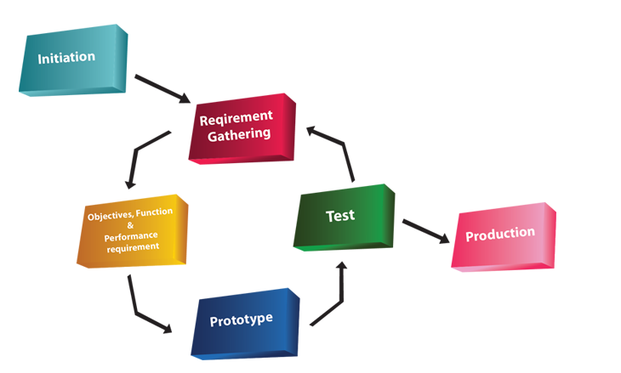The project can have different ways of operating. One way in which the group can implement the project is by the Prototyping SDLC model. The Prototyping model allows the team to work concurrently on three aspects of the SDLC, them being the analysis, design and implementation. This model is on a constant loop until a finished product is completed. The prototyping model is a very fast paced model but allows us to interact with the application more to gain a better understanding of its functionality or areas of improvement that might not have been foreseen with other model approaches.

Figure - The Prototyping Model [6]

## Proposed Methodologies

This is a three person team. Each team member will have a defined role, based on our abilities, strengths and interest of self-learning. Throughout the development, every member of the team will be brought up to speed on the progress of each of the other members. The aim is that all members are proficient with all aspects of the project.

Member 1

This member’s responsibility will be to front the programming side of the project, with the objective to use numerous technologies to work concurrently. This application will use Android SDK [7] to develop the web front for all Android devices which run Froyo 2.2 [8], or newer. With the aim of the app being compatible with 100% of all Android devices, Android’s WebView kit will be used. The next step will be to develop responsive pages with the use of an open source CMS such as WordPress to manage pages.

Member 2

This member will focus on the security issues which may arise with relation to user log in and registration. This involves an extensive amount of research into current hacks and security issues on the market. There is a need to obtain self-signed certs which will be sourced early in the project [9] [10].

There will need to be high-end security measures to ensure that data protection is adhered to for all players, concentrated around the user registration and login.

This member will also assist in the layouts and the look-and-feel of the application

Member 3

This member will target the graphical user interface. The main objective is to develop a smooth and an aesthetic application which will encourage return customers and customer growth. Development of custom imagery for the application will be established using tools such as Adobe Illustrator, Adobe Photoshop and GIMP.

Member 4

At the mid-point of development, it was proposed to initiate a fourth member to the team. This member’s primary responsibility was to develop an extensive and in-depth testing system. Using Unit Testing, this member will challenge the application source code to identify any vulnerabilities which exist, which will in turn help eliminate any flaws which may not be recognised until the application is released for beta testing.

There will be a separate chapter dedicated to this category later in the documentation which will include a log of all the tests, their functions, the expected result, the actual result, and any recommendations or changes made to the code to ensure test passing.

A SQL Database table will be used to contain all questions needed. A second SQL database table will be vital for the storing, accessing and modifying of user login, registration and sessions. These tables will be generated using MySQL.

Group Elements

The team will develop a-state-of-the-art modern, ‘hi-res’ graphics using animation tools such as Adobe Illustrator, Photoshop and GIMP. There is a possibility to use Dreamweaver for transitions.

PhP scripting will be used to consolidate all elements of the application resulting in a smooth application with a modern and fun look’n’feel. For hosting, the team has secured permission from Absorb.ie to have full use of their servers inclusive of a sub-domain and installation of third-party utilities. [11]

## Application

The application will be a cross between a game and a quiz. Whilst having the academic functionality of an educational quiz, it will have a young, fresh approach to learning. For this project, the subject matter will be on networking terms and concepts.

The application will consist of three levels. A description of these levels is detailed in the next section.

Level 1

The first level will be easy, containing definitions and abbreviations on an MCQ basis. One question will have 4 possible answers with only one answer being correct. There is plans to have a pool of 300 questions for the finished product. However, for the sake of this project, it is more feasible to run a beta model with a pool of 10 question.

Level 2

The second level is more difficult. Questions will be based on exam quality definitions and networking syntax on an MCQ basis. One question will have 4 possible answers with only one answer being correct. There is plans to have a pool of 300 questions for the finished product. However, for the sake of this project, it is more feasible to run a beta model with a pool of 10 question.

Level 3

The third level is the most difficult. Questions will be based on the general theory associated with networking on a CCNA level. Each question will be answered textually. This will involve technology which will recognise keywords and strings. There is plans to have a pool of 150 questions for the finished product. However, for the sake of this project, it is more feasible to run a beta model with a pool of 10 question.

Player advancement through levels

In order for the user to move from one level to another, the player must answer ALL the questions in each level. If a question is answered correctly, that question will be flagged ‘true’. If question is answered incorrectly, the program generate next question. The wrong question remains in the cycle until it is answered correctly. All questions are generated randomly.

## Deliverables

The aim is to have a fairly established running BETA model by Christmas break which will leave the next semester for testing and defining our documentation.

In this section, the expected results are examined in order to identify any issues before the project officially begins.

A Work Breakdown Structure and Gantt-Chart, which follow, provide a condensed and visual view at the tasks and predicted timeline of the project.

Expected Results

1. A fully functional Android application.
2. A young, dynamic, fun and educational tool for learning networking fundamentals.
3. A knowledge and understanding of Android development.
4. Implement a new knowledge of security protocols and risk in regards to Android development, focusing on the data protection of users.
5. Learn to combine different languages and technology to ensure an ergonomic and efficient application.
6. Gain experience in the area of teamwork and learning to approach intrapersonal issues.
7. Development of an application which has the potential to be adapted to other academic topics.

Work Breakdown Structure

1. Proposal
2. Research possible technologies required
3. Secure supervisor
4. Research existing applications
5. Research forensic measures required
6. Establish all software requirements
7. Risk analysis 1
8. Develop GUI
9. Develop Database
10. Establish BETA model
11. Risk analysis 2
12. Finalise responsive elements
13. Implementation
14. Testing

Gantt-Chart

This chart shows the division of labour among the development team. It is subject to change.

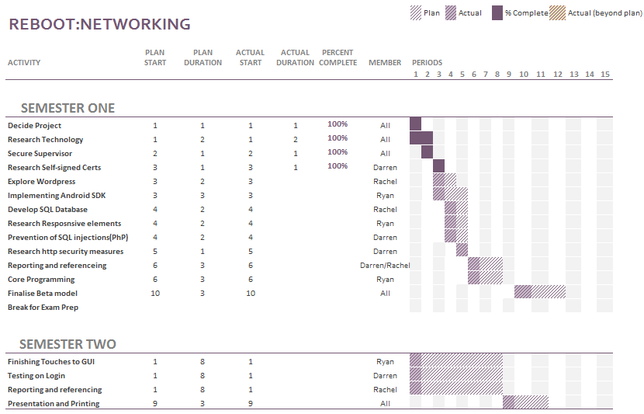

Figure 2 - Gantt-Chart

## Conclusion

This application, as it stands, is available and ready for development to begin. A feasibility study will show any changes that may need to be applied. The title and structure will be re-investigated at regular intervals throughout the duration of the project in order to improve the efficiency of the development build.

This product has great potential as it can be expanded in size by merely extending the database. This product has the potential to be phased into other educational areas such as Mathematics, Data Structures, Operating Systems and many more.

The technologies that will be used are openly available and the deadline has been set to ensure the productivity of the project is high.

The team has agreed to dedicate to a tight deadline of January 2016. This will give enough time for testing and allow for any contingency plans to be used if needed.

# Literature review

This chapter contains various investigations with regards to the diverse views of this project. Each member of the development team took a separate segment and researched and reviewed literature which supports one aspect of the overall project.

Review A: Is a multiple choice quiz (MCQ) an efficient and effective format of assessing students?

This review is an investigation into the attitudes and finding with regards to the significance and reliability of multiple choice quizzes (MCQ) in the assessment of academics.

Author: Rachel Egan

Review B: How the implementation of multiple choice questions on mobile devices for 3rd level students can aid in their subject of choice.

This review take a secondary look into the value of using MCQs as a form of assessment for students with particular emphasis on the medium of presentation. This section investigates the importance of convenient access to assessments with immediate feedback from the viewpoint of the assessed. It continues by exploring the various strategies and technologies that can be used to achieve optimum results.

Author: Ryan Mackenzie

Review C: A research in to the technology to be used in the development of an educational application with the subject of Computer Networking

The focus of this review is to show all of the technologies that will be used in the making of our application. With computer networking growing and becoming more and more complicated by each passing years, more and more technologies are needed to improve the accessibility to the practical use of it.

Author: Darren Cosgrave

## Review A: Is a multiple choice quiz (MCQ) an efficient and effective format of assessing students?

The specific topic of this research is to support, or disparage, the general opinion on using a multiple choice quiz (MCQ) as an efficient and effective format of assessing students.

“In ancient Greece, Socrates tested his students through conversations. Answers were not scored as right or wrong. They just led to more dialogue.”[12]

Over time it has become more apparent that academic testing, especially in the field of science, has become more standardized and in recent years the format has drifted from the essay style testing. The emphasis has shifted towards what the student can recognize, rather than what the student can memorize.

This document is designed to represent both sides of the argument, using accredited sources and a range of beliefs.

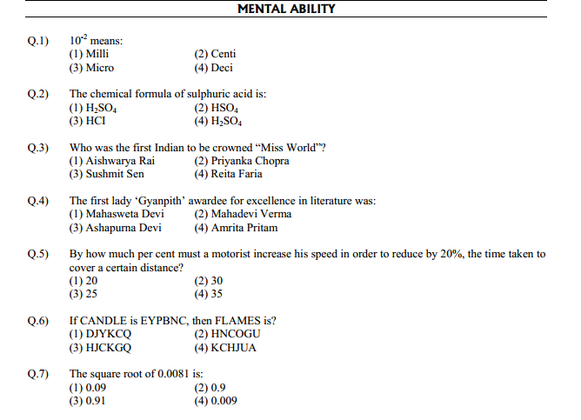

Figure 3 - An example of a Multiple Choice Quiz

### Where MCQ testing came from

The attitude regarding multiple choice testing in current academic settings has been argued since the early 1900s when the first evidence of standardized testing was introduced. This is very apparent in the article by Jay Mathews, a staff writer for the Washington Post in 2006 on the subject of how testing students has evolved over time.

Mathews’ article provided a fact-based delivery of the formation of general testing in the United States from the time of Socrates to the time of publication. In this article, he discussed how the progression from essay style testing started to be replaced by the MCQ style around the turn of the 20th century.

*“At the outset of the 20th century, educators began to experiment with tests that took shortcuts around the old essay methods….Frederick J. Kelly of the University of Kansas designed a multiple-choice test in 1914…..Many Americans accepted these tests as efficient tools to help build a society based on merit, not birth or race or wealth.”[12]*

The philosophy surrounding that seems to be speed, both for student and examiner, and accuracy. It was developed with the ethos that students who had difficulty with the focus and drive needed for succeeding academically had a chance to be pitted against those students who found memorising theory less challenging. Multiple choice testing also ensured that all participants were tested on a level playing field without judgements which may arise from the student background or circumstances.

Since the development of the first MCQ, Frederick J. Kelly’s model has not been altered much. The basic structure and objective of the test is simple and relatively unflawed (see figure 3)

### MCQ - an effective format for testing?

There have been many arguments in the philosophy of testing in education, for and against.

One person who took an adverse opinion to the multiple choice format for the purpose of academic testing was Diane Ravitch, a historian of education with a Ph.D. from Columbia University. In an article she wrote in “The Chronicle of Higher Education” in March 2006, Ravitch was unimpressed with the lack of essay style testing, especially in the more scientific subjects such as Medicine and Information Technology.

Commenting on the early use of essay exams in the United States, Ravitch wrote "everyone who went to high school, whether they were the children of doctors or farmers or factory workers . . . to study mathematics, science, English literature, composition, history and a foreign language“ [13].

Cathy N. Davidson’s is a distinguished scholar of the history of technology and is a leading innovator in techniques for new professional development and learning methods. She was recognised for her expertise and appointed to the National Council on the Humanities by U.S. President Barak Obama in 2011.

As a reputable speaker and consultant, Davidson is a regular writer for the Harvard Business Review, The Chronicle of Higher Education and The Washington Post.

In her book, “Now You See It”, Ms Davidson expresses her appreciation of Kelly’s theory that multiple choice testing is an efficient method of testing in a scientific academic situation.

She agrees that in order to make a test both objective and efficient, questions need to be formulated without ambiguity. Questions must have an answer that is completely right or completely wrong, with no variable interpretations.

*“What the multiple-choice test did avoid, though, was judgment. It was called objective, not because it was an accurate measure of what a child knew but because there was no subjective element in the grading.”*

*Cathy N. Davidson [14]*

Multiple choice questions are considered to be more objective than traditional essay methods as the facts are measured and not the individual opinion. This is a positive for both learner and educational provider for only one answer is right. This ensure that even if opinions vary, any interpersonal differences will not influence the results.

MCQs allows student knowledge to be measured without the challenge for assessors to read handwriting, or understand an answer which has been written in an exam situation where students may not express themselves clearly.

The general consensus in academic circles is that MCQs are regarded as an efficient form of assessment in medicine and the sciences, but in subjects such as humanities, it is viewed as mcq as a ‘dumbing down’ version of learning. The following section highlights some of the advantages and disadvantages of using multiple choice quizzes for assessments.

### Advantages and disadvantages of using MCQs as a method of testing

In the book, “Computer-assisted assessment of students” by Brown et al, the authors and contributors highlighted many advantages and disadvantages of using MCQs as a method for assessing current students [15][16].

Advantages include the following.

1. MCQs are easy to convert to computer based format.
2. Require much less time to construct.
3. Require much less time to complete.
4. Student tested on ‘recognizing’ rather than ‘memorizing’.
5. Fast return of grade for students.
6. No subjectivity if student is vague in knowledge.
7. Answer is right or wrong…..no discrepancies!

Disadvantages include the following.

1. For more specialized subjects, the complexity of questioning makes MCQ construction time-consuming
2. They do not measure performance in complex areas
3. They do not measure students practical knowledge
4. Students can ‘guess’ a way to success

It is obvious that there is a difference of opinion with regards to the effectiveness of multiple choice quizzes as a form of assessment. However, everyone can agree that MCQs are objective. There is little or no variations in marking, they are easy to mark, they offer immediate feedback, and they test the students’ factual knowledge without prejudice.

In the next section, the author will provide an unbiased comparison between essay style and multiple choice style assessment.

### Essay Exams verses Multiple Choice Quiz

Mark G. Christensen, Ph.D., Assistant Executive Vice President and Director of Testing for the National Board of Chiropractic Examiners (NBCE) attended the CLEAR Annual Conference in Phoenix, Arizona, USA. During this conference, Christensen delivered a presentation on the similarities and differences between essay based examinations and multiple choice quizzes. A synopsis of his delivery is presented in the following table [17] [18].

*Table 1: Essay vs Multiple-choice*

|  |  |
| --- | --- |
| Essay Exam | MCQ |
| Quick and easy to construct test | Quick and easy to construct test |
| Answers allow for expansion of thought and understanding on a certain topic | Answers and either right or wrong. There is no room of subjectivity |
| Student must provide answers without prompting | Answers are provided allowing students to guess a way to success |
| Labour-intensive and time-consuming to grade | Immediate grade with little to no labour |
| Can lack objectivity | Grading is objective and completed reliably |
| Assesses the students overall knowledge of the subject matter | Assesses the students ability to recall snippets of knowledge through recognition |
| Measures limited amount of knowledge in an individual test | Questions can cover a vast array of knowledge in a short time |

Christensen is highly regarded by his peers. In his 30 years working with NBCE, he has designed and implemented a testing program for the chiropractic profession which has been adopted by many scientific academic fields around the world. Acceptable methods for assessment comprises the use of written, practical and multiple-choice testing [19].

### Conclusion

The aim of this document is to discover if multiple choice testing is an efficient and effective method of assessing students. The research resources are endless on this topic, and each argument is convincing in its own right.

As a student, it is easy to side with the argument for using multiple choice quizzes for assessment. However, when the full picture is taken into consideration, the author can appreciate that MCQs can miss the target when testing the human understanding of the subject matter.

While there is certainly a time and place for MCQ testing, there is serious validity to essay style exams too. For a more in depth look into the design of MCQs, David Jennings, a published lecturer and researcher in UCD, Ireland, wrote 'A Problem and an Opportunity: E-Learning a case for collaboration' to help outline the “do’s and do not’s” of MCQ construction [20].

Multiple choice assessments have been around since 1914, thanks to Mr. Kelly. Its longevity is proof that it is as valid an assessment method in current academic setting as it was a century ago.

## Review B: How the implementation of Multiple Choice Quizzes (MCQs) on mobile devices for 3rd level students can aid in their subject of choice.

In this section, it will be discussing how existing research papers and developments have contributed to the area of study with regards to the use of MCQs in an academic environment. It will be considered how MCQs have been developed and used over time, as well as the fundamental alternative forms of learning amid theoretical assessment and MCQs.

The primary focus of this section is to identify how Android devices and web-based services can be used to provide a platform for E-learning and M-learning in current educational models.

### MCQs – are they used?

As discussed in the previous review, MCQs have been a universal method of assessing students for a substantial period. They are prevalent in a variety of educational institutions with evidence in the majority of 2nd and 3rd level education providers.

Dependant on the subject format, MCQs can take on varying shapes. Traditionally, the layout of an MCQ has followed a ‘one question, one answer from a selection of four possible answers’.

MCQs are generally found in a surface approach to education, where a student is required to recall information based on the resources they have studied. However, some students prefer to take a deep approach to education which is based primarily on practical learning. This latter approach does not necessarily leave a student at a disadvantage with regards to MCQ assessments as the student can recognise the majority of concepts with a reduced chance of error.

K. Tang, a Chinese professor, conducted a study where first year physiotherapy students, when preparing for their examinations, took a surface approach to their assignments. Conversely, when it came to examinations took a deep approach, which is a more intensive approach to learning. This quantitative study demonstrated that students tend to employ different learning approaches or strategies in different situations, according to their perception of the assessment requirements. Students are likely to adopt a surface approach to learning if they anticipate a form of assessment that requires little more than knowledge-based factual recall (e.g. a quiz, multiple-choice questions or a short answer examination) [21].

In a paper by Karen Scouller, she provides research by Proseser, Thomas and Bain which reads

*“…two studies investigating the relationship between student’s learning approaches and performance outcome in their MCQ examinations and both using a quantitative measure of student achievement (MCQ examination marks) have reported different findings. They reported a strong relationship between successful performance and deep general orientations to study (Scouller and Prosser 1994) and between better grades and the employment of a deep level approach (Thomas and Bain 1981; reported in Watkins 1982). This study similarly uses quantitative measures of student achievement: students’ assignment essay marks and their MCQ examination results.”* [22]

This describes how MCQs have been shown to match, if not exceed, the results that come from written examinations.

There are many difference between MCQs and written assessments. The most notable variance is that a written exam is more costly on time when it comes to the exam being constructed, and subsequently, graded. In contrast, an MCQ can be generated using databases linked to MCQ generators. The most obvious difference is that when an MCQ has been developed, it is easy to manipulate and regenerate, as well as giving an almost instant graded result if the MCQ has been utilised digitally.

As discussed in the previous review, written exams are high in work intensity requiring students to regurgitate large quantities of information, with grading potentially being subjected to a lack of objectivity.

### E-Learning and M-Learning

Electronic Learning (E-Learning) can be defined by the Oxford Dictionary as

*“Learning*[*conducted*](http://www.oxforddictionaries.com/definition/english/conduct#conduct__8)*via electronic media, typically on the Internet” [23]*

E-learning makes it possible for students to study using computer technology. The main advantage of this the freedom for self-disciplined learning as opposed to being required to always physically attend classes. E-learning is a relatively new system which is becoming common practice for a wider range of students such as people with disability, parents and those in full-time employment. Open University™ was founded in 1964 by British scientist, Michael Young, Baron Young of Dartington, to offer education to those individuals who could not physically attend lectures [24]. The Open University™ offers a vast array of online courses with the added advantage of flexibility and less costly to the student.

When merged with more recent technology such as smart phones and tablets, E-learning has become extremely accessible and efficient. In the paper “Implementation of Android Based Mobile Learning Application as a Flexible Learning Media” by Kurniawan Teguh Martono and Oky Dwi

Nurhayati, they summarize M-Learning as follows:

“Mobile learning as an intersection of Mobile Computing and E-Learning providing resources that can be accessed in anywhere has capability in an excellent searching system, rich interaction and full support towards an effective learning and performance-based assessment. In addition, it has a characteristic of not being dependent on time and space. Education requires an alternative learning model typically not dependent on time and space. It is also expected that the alternative model can facilitate knowledge sharing and knowledge visualization in order to make knowledge more interesting and easy to understand.” [25]

### Technology in study

Technology is currently playing a huge part in today’s society where everything is considered ‘smart’ and there is a vast amount information at our fingertips. The Internet of Things (IoT) is going be a phrase that we hear used quite bit. It refers to everyday objects having network capabilities and transmitting data as well as receiving data, such as smart phones, smart refrigerators and smart watches [26].

It is believed that by 2020 that there will be 50 billion devices connected to the internet as reported by Jonathan Strickland [27] a leading member of staff at www.howstuffworks.com. This supports the argument of utilizing technology in order to learn and vice-versa how technology can learn from us. 3rd level students use laptops, computers, tablet computers and smart phones all on a daily basis either to access social media platforms, games or educational tools, this is best summed up by Stan Kurkovsky’s abstract to which states:

“Young people are often viewed as the driving force behind the innovation in mobile technology, since they comprise the majority of early adopters and most avid users of mobile gadgets and applications, especially mobile games. Many contemporary college students grew up surrounded by computer games and electronic gadgets and, therefore, may better relate to mobile technology than to the desktops dominating current academic environment.” [28]

In the paper Kurkovsky mentions how, in the opinion of today’s college students, there is a serious under-use of current technology with regards to E-learning, despite mobile interaction often having a much more entertainment-orientated value. Kurkovsky also references a study by IBM released in October 2008 in which over 50% of consumers in the United States would prefer to use their mobile devices over PC’s for their internet usage, this was taken from an age group of 15-30 year olds.

Technology in study (e-learning) on mobile devices can, not only provide a valuable research component for the students to gather information and study, but it can provide a platform in which students can access this information on the move whether they are on public transport, in a coffee shop or out of country.

Considering that mobile technology is already prevalent in the lives of college students, by developing an application such as this MCQ game that can test their knowledge as well as provide a fun and interactive way of learning, it is a remarkable gain for the student. It can also benefit that of the educator with the existence of applications such as “Socrative” [29]. This application provides a venue for educators to host a quiz and provide real-time results of students’ knowledge priceless information by highlighting levels of knowledge and understanding of each segment of the module.

### Web Services for Mobile Learning Applications

Mobile learning applications are constantly being developed on different technologies and platforms such as iPhones IOS, Android’s APK’s, Windows Phone and Linux. Paul Pocatilu PhD has completed several research papers bases on the elements involved in developing and maintaining Mobile Learning [30].

An M-learning system has minimum specifications and must consist of the following components:

* Mobile learning device
* Mobile learning software
* Mobile learning content

Pocatilu also mentioned the actions students can take when it comes to the m-learning system:

* Take online course
* Take exam
* Send feedback
* Send homework and projects

Pocatilu outlines his opinion on educator involvement and the tools that they should have:

* Deal with content management
* Prepare tests
* Assess test, homework, projects take by students
* Send feedback
* Communicate with students

There are many web services that can provide hosting and tools that can further help with the development of mobile applications. Web hosting allows for a global communication across all platforms. This means that if a multiple choice question is hosted online, the application is compatible to run on an iPhone with the same precision as on an Android system.

### Conclusion

When measured against traditional written assessments, multiple choice quizzes have repeatedly proved to be the paramount form of assessment in most educational fields. This review also highlights the benefit of pairing mobile technology with the format of MCQs to encourage and engage students.

The way in which students interact with these quizzes can have a fun yet beneficial impact on their education. Not only can it benefit the academic but it can also benefit the educator in a way that it can improve learning plans as well as monitoring individual performance.

## Review C: A synoptic review in to the technology to be used in the development of an educational application with the subject of Computer Networking

In this section, the technology available for the development of this project is explored. A brief synopsis of these technologies is offered. The technology covered in this investigation includes Java, JavaScript, PhP, HTML, CSS and Android.

### Java

Java is a general purpose programming language that was developed at Sun Microsystems by James Gosling. In 1991, a small team of engineers created the language “O.A.K” to help in the development of handheld devices and set-top boxes. When this failed, they went back to the drawing board. In 1995, Java was created. The language itself follows some of the basic rules of its competitor, C and C++, but the syntax and functionality was unique and expansive, with a lot of room for further expansion [33].

These days, Java is used mainly as a foundation in the development of web-based applications and services. Its usage in mobile technology has climaxed in the past 6 years, with advancements in the language. In 2014, Java SE 8 was launched. This version carried additional functional programming features, improved integration with JavaScript and parallel processing using streams.

Java is object-oriented modelled on C++, but it is simplified to eliminate common programming errors. Compiled Java code can run on most devices because Java interpreters and runtime environments exist for most operating systems, including Windows™ and Unix™. By 2007, most Java technologies were released under the GNU General Public License.

Java is most renowned for its use on the World Wide Web. Java applets are easy to download from a Web server and can be run on a Java-compatible Web browser. It is common to have Java as an automatically installed program on most new laptops and PCs.

### PHP

PhP originally stood for Personal Home Page but stands for PHP: Hypertext Pre-processor [34]. PhP is a server-side scripting language designed for web development but also used as a general-purpose programing language. Developed by Rasmus Lerdorf in 1994, early versions of PhP were not intended to be a new programming language but as it grew larger and larger, a development team began to form and improve the code quality making it more powerful from PhP3 to the current development of PhP7. The latest version is expected to be released in November 2015[1].

Over the years PhP has improved and has gained momentum every day. As you can see in fig 1 it show that more and more users using PhP, from January 2000 to March 2005

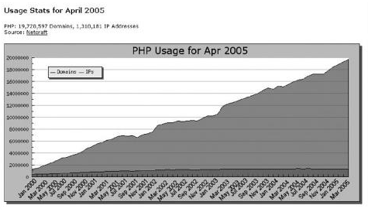

Figure 4 - A graph to show the steady rise in the usage of PhP since January 2000

<?php

if(isset($_POST['username']))

{

$username = $_POST['username'];

$password = $_POST['password'];

// require_once("include/db_connect.php");

require_once("config/db.php");

// $db_link = db_connect("majorgroupproject");

Figure - Example of some PhP syntax

### HTML

Developed by Tim Berners-Lee in the late 1980s, HTML is an acronym for Hypertext Markup Language.

“Web users ultimately want to get at data quickly and easily. They don't care as much about attractive sites and pretty design.”

Tim Berners-Lee

HTML is, essential, a set of markup symbols inserted into an electronic file that will be displayed on the World Wide Web via browser pages. Each individual markup symbol is commonly referred to as a “*tag”* or element.

Its logical structure permits intelligent information processing which is necessary for organisation, communication, indexation and discovery on the web. The added benefit of HTML is that it supports the translation of audio, video and animation into an electronic document by using software such as Java applets, QuickTime or ActiveX.

The latest version HTML5 was released on 28th October 2014. However there is always new and improved ideas being developed and tested with vast improvements being made to advance the user experience in web design and development.

have brought out there new HTML5 on 28 October 2014 [35].

<!DOCTYPE html PUBLIC "-//W3C//DTD XHTML 1.0 Transitional//EN" "http://www.w3.org/TR/xhtml1/DTD/xhtml1-transitional.dtd">

<html xmlns="http://www.w3.org/1999/xhtml" xml:lang="en" lang="en">

<head>

<!--<meta http-equiv="Content-Type" content="text/html; charset=utf-8"/>-->

<meta name="viewport" content="width=device-width, initial-scale=1">

<title>About</title>

Figure 6 - Example of some HTML

### CSS

CSS is an acronym for Cascading Style Sheets. It is a style language that defines layout of HTML documents. It is responsible for formatting structured content which includes fonts, colours, margins, backgrounds, lines and advanced positioning [36]. CSS was developed by Håkon Wium Lie and Bert Bos and introduced in 1996.

CSS revolutionized the world of Web Design by allowing developers to manage the aesthetic aspects of the website from one stylesheet.

body{

background-color:#C3C3E5;

}

#title{

color:white;

font-size:18px;

padding-left:10px;

}

Figure - Example of some CSS syntax

### JavaScript

JavaScript is a programing language used in web development. Developed by Netscape, JavaScript is used to add dynamic and interactive elements to a website. JavaScript is influenced by java and c. JavaScript is a client side scripting language which means source code is processed by the user and not the server. Due to this JavaScript can run after a web site has loaded without internet connection to the server [37].

Figure - Example of some JavaScript.

This is the JavaScript used to develop the contact form on the application.

<a id="foxyform_embed_link_769550" href="http://www.foxyform.com/">foxyform</a>

<script type="text/javascript">

(function(d, t){

var g = d.createElement(t),

s = d.getElementsByTagName(t)[0];

g.src = "http://www.foxyform.com/js.php?id=769550&sec_hash=97a87424aa7&width=350px";

s.parentNode.insertBefore(g, s);

}

(document, "script"));

</script>

### Android

Android is an open source operating system used for mobile devices. It is currently developed by Google™ and its programming is based on the Linux™ kernel. It was primarily designed with advancement in touchscreen technology in mind and that has transpired into fast-track developments in smart phones, smart televisions, smart watches and tablets, to name just a few.

Due to Android being open source, developers can modify and change the OS for their own preferences and styles. This is further enhanced by the fact that the ordinary person can self –learn and develop simple applications using accessible and widely available IDEs. As a result, the market is flooded with amateur applications for absolutely everything. But it still is a developing field, so there is plenty of room for all participants.

Android’s user interface is based on direct manipulation, using gestures such as *touch, swipe, pinch or tap* to access or move objects on the GUI (Graphical User Interface).

As of February 2016, Android 4.4 "KitKat" is the single most widely used Android version, operating on 35.5% of all Android devices accessing Google Play. The second most popular is other Lollipop versions (5.0-5.1.1) which has a combined total of 34.1% of the user market [40].

“Marshmallow” is the newest release and was launched in October 2015. It is slowly building momentum and is expected to replace all other versions by mid-2016.

### Bootstrap Framework

There are many advantages to using Bootstrap. The following identifies some of these advantages and how Bootstrap was used to implement certain aspects of this application [48].

#### Flexibility and Responsiveness

Bootstrap is a flexible framework as it can work on multiple platforms. This allows any program developed using Bootstrap to be compatible with the majority of devices on the current market. It is also renowned for being user-friendly. With the built-in tutorials, even an amateur can learn how to use Bootstrap to its fullest extent. The instructions and functionalities are logical, and most of the necessary actions open source and therefore accessible.

Bootstrap make use of certain HTML5 doctype properties which offers a better quality of resources.

#### Mobile First

Bootstrap v2 contained optional mobile friendly styles. However, with the introduction of Bootstrap v3, mobile functionalities can be implemented from the beginning of any project. This has been a key development as most all online activities are application based, or have an application attachment.

<meta name="viewport" content="width=device-width, initial-scale=1">

Figure 17- code to ensure proper rendering and touch zooming

#### Typography and links

Bootstrap sets basic global typography, display and link styles. Essentially this translates as it is easy to manipulate background colours, fonts, lines, padding and manipulation of other features such as a colour change only on a hover function of a link.

### Conclusion

As presented in this review, there is an extensive range of technologies and programming languages involved in the development of this program. These elements must work together in harmony and compatibility is always a concern.

For this project, the team was already familiar with using Eclipse as the IDE for the majority of the programming as it is compatible with HTML, PhP, CSS and Java.

It is important to use versions of the software which will co-exist with newer and older devices so that most all of those wishing to use this application, the software is accessible to them too without monstrous expense or the need for a large amount of memory in the user device.

# Implementation

* Structure of code
* Database Schema Design
* Code snippets

# Design

## User Interface Design (Wireframes)

|  |  |
| --- | --- |
| 1. Home page   C:\Users\Rachel\AppData\Local\Microsoft\Windows\INetCache\Content.Word\1.home.png  Figure 9 - Home Page | 1. Dropdown Menu on the Home Page   Figure 10 - Dropdown Menu on Home page |
| 1. Sign Up Page   Figure 11 - Sign Up Page | 1. Account Issues From Login Page   C:\Users\Rachel\AppData\Local\Microsoft\Windows\INetCache\Content.Word\4. accountIssuesFromLoginPage - reset account.png  Figure 12 - Account Issues From Login Page |
|  |  |
| 1. Main Menu   Figure 13 - Main Menu | 1. Settings   Figure 14 - Settings |
| 1. Change Language   Figure 15 - Change Language | 1. Quiz   Figure 16 - Quiz |

The wire framing was generated using an online tool at *www.wireframe.cc* [47].

## Colour

For the purpose if this application, the development team decided that the colours used could play a large part of successfulness. After some research, it was decides that purple was a strong choice.

The colour scheme had to be attractive, as well as psychologically sound. Therefore, it was agreed that the main colour would be mauve, while the application would have trims of amethyst.

Although this may seem a frivolous aspect of the overall project, colour is regarded as a form of none verbal communication. Colour choice could make the difference when trying to generate repeat customers. An application is only as successful as what its audience makes it.

Together with the idealism of aesthetics, there has been vast studies into the effects that colour has on the brain. In the field of psychology, purple is recognised for its combined attributes of red and blue. Red signifies fire, motivation and power while blue creates a calm, bright atmosphere. By combining these values, there is a greater chance to promote an academic, resourceful environment for the user [41].

For the purpose of this application, the development team selected mauve and amethyst.

### Mauve

Mauve falls somewhere between lilac and lavender in the purple spectrum. It is recognised to promote best choice and decisions with humans while encouraging a person to do the right thing. Mauve has also been noted for creating a sense on commonness and the will to improve oneself. This can be beneficial to the attractiveness of this application by encouraging users to aim high with the best choice in the forefront of their goals.

### Amethyst

Amethyst is regarded as a mystical colour. It can stimulate deeper thinking and rational decision making. For this application, the users are subconsciously guided towards a logical, and correct, answer. This also allows the user to recognise errors in their choice for further use [42].

### Logo

C:\Users\Rachel\Desktop\3rd yr project\logoTransparent\logoTransparent.pngWith regards to the logo, it has been proven, by the sheer volume in existence, that blue is the most common colour to use when developing an application logo. For this reason, the team came to the conclusion that we needed a strong, yet recognisable, colour for our logo.

“Chase, American Express™, and IBM™© choose blue because the colour suggests trust, strength and dependability” [43]

## CSS layout

When this project was planned, it was considered best choice to use JQuery’s to manipulate the CSS throughout the software.

On further investigation, it was apparent that by using Bootstrap, the development was going to take a new direction. Bootstrap was the obvious choice for what was intended for this application.

### Animation

There is a vast pool of animations which favour a Bootstrap framework when using animation CSS.

Animation done in BS   
<https://daneden.github.io/animate.css/>

Backup site if other doesn’t work

[https://developer.mozilla.org/en-US/docs/Web/CSS/CSS_Animations/Using_CSS_animations](https://www.facebook.com/l.php?u=https%3A%2F%2Fdeveloper.mozilla.org%2Fen-US%2Fdocs%2FWeb%2FCSS%2FCSS_Animations%2FUsing_CSS_animations&h=qAQEf1ezj)

swoop in for headings

zoom out for buttons

The vision I have is when you login the buttons float in from the left. When you click a button it goes in button goes small and opacity goes to 0.5, then goes back to normal and float right, where the new options of the button clicked float in form the left. Thinking of floating all of them in a group or at different speeds

### General Layout

header:

hold nav bar…universal effects

2 navs – one when logged in – access to quiz, setting,

Not logged in – access to reg new account,

Account issues: access to contact admin to recover or change settings

About contact and T&Cs aere common – bioth are online

Footer:

Included into all pagesw – universal

T&C, privacy policy ( link to pdfs) copyright tag and publication year

Logo :

Source image for logo on home page + logged in page

Favicon of our logo for our web version

Dropdown:

echo '<div class="collapse navbar-collapse" id="bs-example-navbar-collapse-1">';

depending on device size, web = nav bar

phone = tree

shading on main bs buttons

box-shadow: 10px 10px 5px #888888;

gray shading

**quiz page**

**thre are 3 div tags** <div id="questions">( Qs and As using RB)

</div> <div id="error">(if no A submitted = error)

</div> <div id="result">(Final screen)

</div> which represent db data

**as a result of making the quiz using JS (dg-quiz-maker.js) [ ]**

**this file takes in JSON file that vontains all qs and As**

**JS file renders all the data out to the div and also contains the logic for the quiz**

**Answer button reads value from RB and stores that to array……**

**Holds submitted As in array(starting Index1)**

**Return array for results**

**Calcs of #right/wrong**

**Forces user to submit A, no missed Qs**

**Singular display of Qs**

**[**[http://www.dhtmlgoodies.com/?whichScript=quiz-maker](http://l.facebook.com/l.php?u=http%3A%2F%2Fwww.dhtmlgoodies.com%2F%3FwhichScript%3Dquiz-maker&h=iAQEa1F2o)***]***

## Research into similar games

While there are a vast array of academic multiple choice applications in existence, there is a common trend that these applications accommodate for either fun or learning. It is rare to find an application which accommodates for both. It was the primary aim of this project to try and incorporate both of these elements with the same emphasis.

### “Networking Exam”

Figure - Home Page of "Network Exam" application

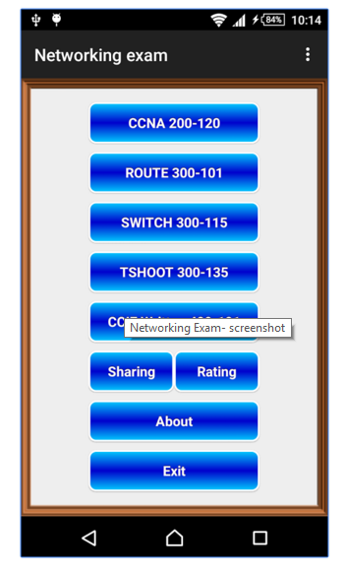

This application is one of the best on the market at this present time. It has a phenomenal scope of questions and resources, yet it lacks the enjoyment of validation and success [44].

It is easy to agreed that the content of the questions covers all that is needed for Cisco CCNA and CCNP examinations, and more, including

* Point-to-point protocols
* IPv6
* HSRP
* Frame relay
* TCP/UDP
* VLAN
* BGP
* Troubleshooting

However, that fact can be a disadvantage too as the user may become disinterested and confused. With such an overwhelming range of subject matter, this application could be intimidating to a user who needs to learn the fundamentals of computer networking. The aim of the ReBoot: Networking application is to concentrate on the novice aspects of the subject of networking as a whole.

### “Cisco Packet Tracer Mobile”

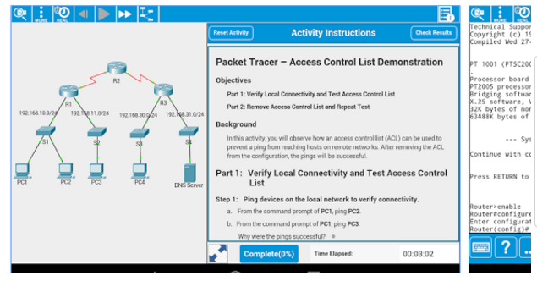

A product of Cisco™©, this application focuses on the syntax and simulated physical networking [45].

This proves to be a vital study tool, but is completely academic and provides no entertainment value.

Figure - An example of a question in "Cisco Packet Tracer Mobile"

### “Great Quiz (Trivia game)”

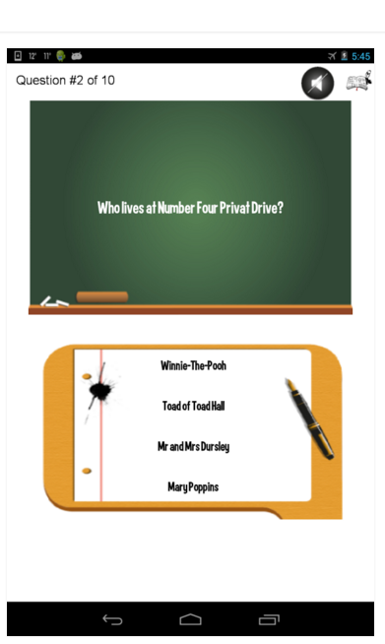

This example has a more youthful, fresh approach to a multiple choice quiz. Aesthetically, it has some fun elements and is graphically appealing to the user [46].

The content of this quiz is more to the standard which this project is being designed for. The objective is to contain this playful Look’n’feel with the usefulness of the academia.

Figure - An example of a question in "Great Quiz"

## Application Frameworks

All internet browsing full adv of the hTML5 functionality with

Building for these native apps

Iphone5 (safari) that come with ifone – native install

Android, webkit - Built custom browser from that – webview kit

Easily manipulated such as padding- extensions , on/off JS, popups, all web based quirky functions

On top is the HTML5 which runs view port along with BS to perfectly fit the device

All based on classes….polymorphism

Php modularisation – usin the include tag to call indipendant classes to run together to form 1 web page

<?php include 'include/headerLOGIN.php';?>

<?php include 'levels/db_conn.php'; ?>

## Sounds

## Back End Design

SQL with PhP – what it can do

* Php communicating with database
* Change score
* Move levels
* Update user info
* Request info
* Security(hashing pass)

## Proposed Versioning Control System

This application was developed and managed using a Git distributed version control. This was administered through Atlassian BitBucket™ and was accessed using SourceTree™.

The ReBoot: Networking repository can be viewed at <https://bitbucket.org/ryanjmackenzie/thirdyearproject>

All members had administration rights to this repository for the duration of the development. However, for continuity purposes, these administration rights are revoked to preserve the program.

# Walkthrough

* Home / login
* Main menu
* Level 1
* Level 2
* Level 3
* Contacts with live chat
* Sign up
* About
* Settings
  + Change password
  + Change email
  + Change username
  + Change language
    - Changing the audio only at this point
    - Plan to use Google translate linking to url

# Tech used and added features

Used **CPanel** to manage our server. UI on the apache server. Most common UI presently.

Access company web mail, admin permisions, firewall, stats(to monitor DDOS), autoreponders, config DB files

**Hosted** at hostgator server provider and the domain registered by absorb.ie

## Live Chat

* <https://dashboard.tawk.to/?lang=en>
* Registered using [info@boombastics.absorb.ie](mailto:info@boombastics.absorb.ie) and password Boombastics04.
* Boombastics is the company, and all 4 members are agents
* Each agent has an account with Tawt.to
* The agents can talk to each other privately
* Many agents to one client
* Many functions
  + Change name
  + Print transcript
  + Email transcript
  + Sound on
  + Upload file
  + End chat

Translate page

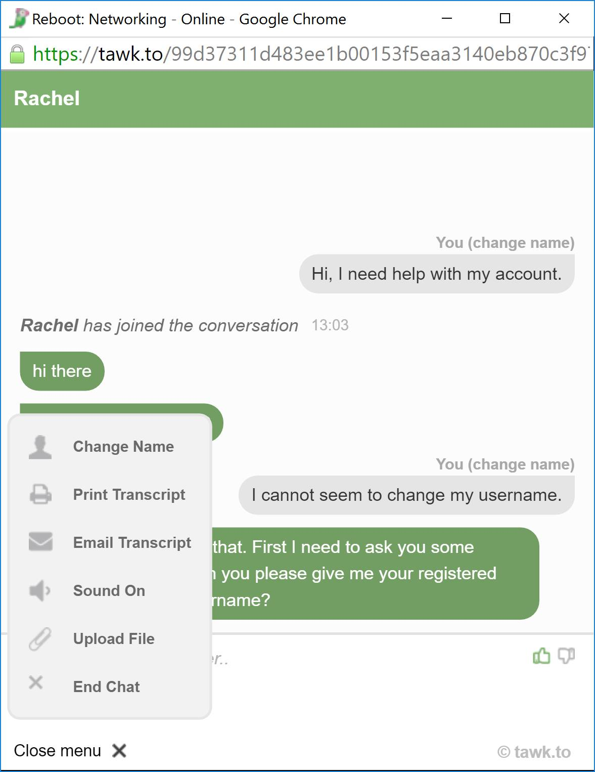

## Email

Email [info@boombastics.absorb.ie](mailto:info@boombastics.absorb.ie)

Password: Boombastics4

Forwarding all mail to go to our student accounts (all 4 of us)

Test sent from Ryan to info@ and Rachel received it – via email only

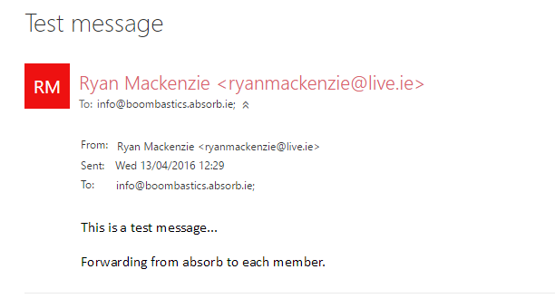

Test sent from Ryan to info@ and Rachel received it – via contacts page only

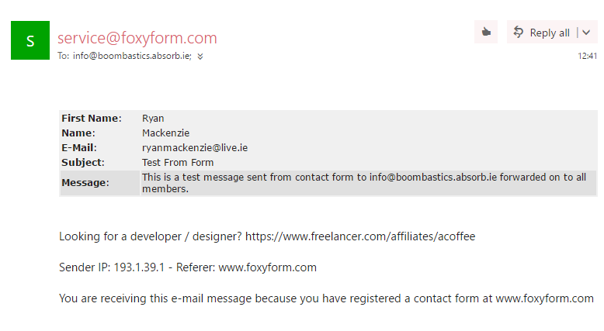

Contacts page post message from ryan

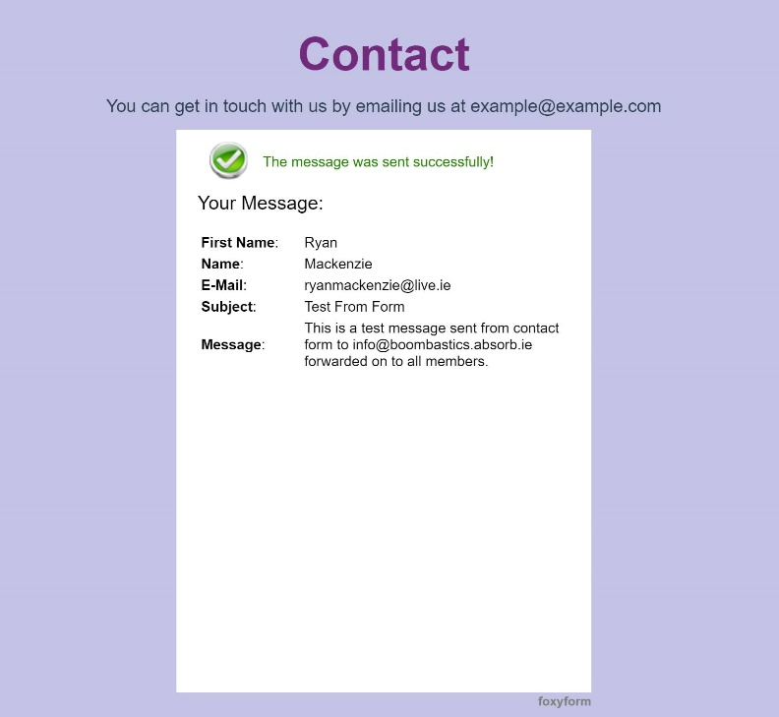

# Testing

# Findings

If we had more time

Problems encountered

# Conclusion

# References

[1] Driftwoodsoftware.com, 'Driftwood Software', 2015. [Online]. Available: http://www.driftwoodsoftware.com/quiznet.HTML. [Accessed: 21- Oct- 2015].

[2] QuizUp, 'QuizUp', 2015. [Online]. Available: https://www.quizup.com/en. [Accessed: 21- Oct- 2015].

[3] Apps.facebook.com, “Quiz on Facebook | Facebook”, 2015. [Online]. Available: https://apps.facebook.com/fb-quizzes/?ref=aw&gclid=Cj0KEQjwqZKxBRDBkNmLt9DejNgBEiQAq8XWPl9BuKL-VuuJVTBNtN7fx9B1k0dwPn427aYd5BjdhaUaAlrX8P8HAQ. [Accessed: 19- Oct- 2015].

[4] L. Dan Cheng and X. Wang, 'Mobile application tools for learning and quiz based on Android', 2013 IEEE 63rd Annual Conference International Council for Education Media (ICEM), 2013.

[5] M. Murphy, “The busy coder's guide to advanced Android development.” United States: Commons Ware, 2011.

[6] Lion Vision, “The Prototyping Model”. 2015. [Online-Image] Available: http://www.lionvisionits.com/Development-Process.aspx. [Accessed: 21-Oct-2015].

[7] Developer.Android.com, 'Download Android Studio and SDK Tools | Android Developers', 2015. [Online]. Available: https://developer.Android.com/sdk/index.HTML. [Accessed: 21- Oct- 2015].

[8] A. Highlights, 'Android 2.2 Platform Highlights | Android Developers', Developer.Android.com, 2015. [Online]. Available: http://developer.Android.com/about/versions/Android-2.2-highlights.HTML. [Accessed: 21- Oct- 2015].

[9] J. Drake, Z. Lanier, C. Mulliner, P. Oliva, S. Ridley and G. Wicherski, “Android hacker's handbook.” Indianapolis, IN: Wiley, 2014.

[10] A. Misra, “Android security.” Boca Raton, FL: CRC Press, 2013.

[11] Absorb, 'Absorb.ie', Absorb.ie, 2015. [Online]. Available: http://absorb.ie. [Accessed: 21- Oct- 2015].

[12] J. Mathews, 'Just Whose Idea Was All This Testing?’ Washingtonpost.com, 2015. [Online]. Available: http://www.washingtonpost.com/wp-dyn/content/article/2006/11/13/AR2006111301007.HTML. [Accessed: 10- Nov- 2015].

[13] D. Ravitch, 'The Fall of the Standard-Bearers', the Chronicle of Higher Education, 2006. [Online]. Available: http://chronicle.com/article/The-Fall-of-the/6169. [Accessed: 13- Nov- 2015].

[14] C. Davidson, 'Now You See It: How Technology and Brain Science Will Transform Schools and Business for the 21s t Century'. New York: Penguin, 2011, Chapter 4.

[15] P. Race, S. Brown, J. Bull, A. Cann and E. Pawley, *Computer-assisted assessment of students*. London: Kogan Page, 1999, Chapter 4.

[16] Multiplechoicequestionsservice.com, 'Advantages of Taking Multiple Choice Questions Tests | Multiple Choice Questions', 2015. [Online]. Available: http://www.multiplechoicequestionsservice.com/multiple-choice-questions-advantages/. [Accessed: 12- Nov- 2015].

[17] M. Christensen, Ph.D., 'Essay vs. Multiple-Choice Exams: The Ups and Downs of Each Format', CLEAR Annual Conference, Phoenix, AZ, 2005.

[18] A. Miller, B. Imrie and K. Cox, Student assessment in higher education. London: Kogan Page, 1998.

[19] Chiropractic Economics, 'National Board of Chiropractic Examiners, NBCE, Mark G. Christensen, Paul M. Tullio Award', 2012. [Online]. Available: http://www.chiroeco.com/nbce-director-of-testing-receives-paul-m-tullio-award/38815/. [Accessed: 10- Nov- 2015].

[20] David Jennings; (2006) 'A Problem and an Opportunity: E-Learning a case for collaboration' In: Savin-Baden M. and Wilkie K (eds). Problem Based Learning Online. Open University Press: McGraw-Hill Education.

[21a] Kirkwood, Adrian and Price, Linda (2008). Assessment and Student Learning – a fundamental relationship and the role of information and communication technologies. Open Learning, 23(1) pp. 5–16.

[21b] Tang, K. (1992), ‘Perceptions of task demand, strategy attributions and student learning’, Research and Development in Higher Education 15, 474–480.

[22] Scouller, K.M. and Prosser, M. (1994). ‘Students’ experiences in studying for multiple choice question examinations’, Studies in Higher Education 19, 267–279

 [23] Oxforddictionaries.com, "e-learning - definition of e-learning in English from the Oxford dictionary", 2016. [Online]. Available: http://www.oxforddictionaries.com/definition/english/e-learning. [Accessed: 02- Dec- 2015].

 [24]"Michael Young - Dartington", Dartington, 2016. [Online]. Available: https://www.dartington.org/about/our-history/dartington-whos-who/michael-young/. [Accessed: 06- Dec- 2016].

[25] Kurniawan Teguh Martono and Oky Dwi Nurhayati, "IMPLEMENTATION OF ANDROID BASED MOBILE LEARNING APPLICATION AS A FLEXIBLE LEARNING MEDIA," International Journal of

Computer Science Issues (IJCSI), vol. 11, pp. 168, 2014.

[26] YouTube, 'What is The Internet of Things?’ 2015. [Online]. Available: https://www.youtube.com/watch?v=LVlT4sX6uVs. [Accessed: 20- Nov- 2015].

[27]"About Jonathan Strickland", HowStuffWorks, 2011. [Online]. Available: http://science.howstuffworks.com/jonathan-strickland-author.htm. [Accessed: 06- Apr- 2016].

[28] S. Kurkovsky, "Can mobile game development foster student interest in computer science?" in Games Innovations Conference, 2009. ICE-GIC 2009. International IEEE Consumer Electronics Society's, 2009, pp. 92-100.

[29]"Socrative", Socrative.com, 2016. [Online]. Available: http://www.socrative.com/. [Accessed: 06- Apr- 2016].

[30] Paul POCATILU, "Developing Mobile Learning Applications for Android using Web Services," Informatica Economica Journal, vol. 14, pp. 106-115, 2010.

[31] PhP.net, (2015). *PHP: Hypertext Preprocessor*. [Online] Available at: http://www.PhP.net [Accessed 14 Nov. 2015].

[32] "PHP: History of PHP - Manual", Php.net, 2016. [Online]. Available: http://php.net/manual/en/history.php.php. [Accessed 14 Nov. 2015].

[33] Computerhope.com, (2015). “What is java?” [Online] Available at: http://www.computerhope.com/jargon/j/java.htm [Accessed 17 Nov. 2015].

[34] "PHP: News Archive - 2015", Php.net, 2015. [Online]. Available: http://php.net/archive/2015.php. [Accessed: 13- Nov- 2015].

[35] SearchSOA, (2015). What is HTML (Hypertext Markup Language)? - Definition from WhatIs.com. [Online] Available at: http://searchsoa.techtarget.com/definition/HTML [Accessed 16 Nov. 2015].

[36] Lie, H. and Bos, B. (1997). Cascading style sheets. Harlow, England: Addison Wesley Longman.

[37] Techterms.com, (2015). JavaScript Definition. [Online] Available at: http://techterms.com/definition/javascript [Accessed 18 Nov. 2015].

[38] Techterms.com, (2015). Android Definition. [Online] Available at: http://techterms.com/definition/Android [Accessed 20 Nov. 2015].

[39] "Android 6.0 Marshmallow: all the key features explained - AndroidPIT", AndroidPIT, 2016. [Online]. Available: https://www.androidpit.com/android-m-release-date-news-features-name. [Accessed: 13- Nov- 2015].

[40] E. Protalinski, "16 months in, Lollipop becomes the most used Android version",VentureBeat, 2016. [Online]. Available: http://venturebeat.com/2016/03/08/16-months-in-lollipop-becomes-the-most-used-android-version/. [Accessed: 13- Apr- 2016].

 [41] J. Gage, Color and meaning. Berkeley: University of California Press, 1999, pp. 21-38.

[42] "Meaning of Colors in Color Psychology", Empowered By Color, 2016. [Online]. Available: http://www.empower-yourself-with-color-psychology.com/meaning-of-colors.html. [Accessed: 03- Nov- 2015].

[43] E. Futterman, "Which Color Should You Use For Your Icon?” The Next Web, 2014. [Online]. Available: http://thenextweb.com/dd/2014/04/01/standing-sea-blue-color-pick-icon/. [Accessed: 19- Oct- 2015].

[44] Play.google.com, 2016. [Online]. Available: https://play.google.com/store/apps/details?id=com.namsunix.networkingexam&rdid=com.namsunix.networkingexam. [Accessed: 06- Oct- 2015].

[45] Play.google.com, 2016. [Online]. Available: https://play.google.com/store/apps/details?id=com.netacad.PacketTracerM. [Accessed: 06- Oct- 2015].

[46] Play.google.com, 2016. [Online]. Available: https://play.google.com/store/apps/details?id=net.equasoft.quizclass. [Accessed: 06- Oct- 2015].

 [47]"Wireframe.cc - minimal wireframing tool", Wireframe.cc, 2016. [Online]. Available: https://wireframe.cc/. [Accessed: 19- Oct- 2015].

[48] Mark Otto, "CSS · Bootstrap", Getbootstrap.com, 2016. [Online]. Available: http://getbootstrap.com/css/. [Accessed: 16- Oct- 2015].

# Bibliography

1. A. Littlejohn, Reusing online resources. London: Kogan Page, 2003.
2. S. Mishra, 'Reusing Online Resources: A sustainable approach to e-learning', The International Review of Research in Open and Distributed Learning, vol. 5, no. 1, 2004.
3. N. Uddin and E. Gaspar, 'Game-Based Learning App Based on Google PlayN', IEEE International Conference on Teaching, Assessment and Learning for Engineering (TALE), Bali Dynasty Resort, Kuta, Indonesia, 2013.
4. E. Olayemi, 'Multiple choice questiones as a tool for assessment in medical education', African Journals Online (AJOL), vol. 12, no. 1, 2012.
5. Li Dan Cheng and Xiao Cheng Wang, "Mobile application tools for learning and quiz based on Android," in 2013, pp. 1-1.
6. K. Scouller, "The influence of assessment method on students’ learning approaches: Multiple choice question examination versus assignment essay, "Higher Education, vol. 35, pp. 453-472, 06, 1998.
7. A. Wu and A. I. Wang, "Comparison of Learning Software Architecture by Developing Social Applications versus Games on the Android Platform, "International Journal of Computer Games Technology, vol. 2012, pp. 1-10, 2012.

1. Note: Release date was December 2015 ( <http://php.net/archive/2015.php> )