

**REBOOT: NETWORKING**



May 20, 2016

Boombastics

Institute of Technology, Blanchardstown

# 

Declaration

We, the authors, declare that the material contained in this report, which is submitted for assessment on the programme of education for the award of **B.Sc. Honours Degree in Computing in Information Technology** in The Institute of Technology, Blanchardstown, Dublin 15, Republic of Ireland, is entirely our own work, unless stated through official referencing and citation.

This document has not been submitted, in full or in part, for any other assessment, in this or any other institution, with the exception of those required by our mentors in order to achieve the above qualification.

Acknowledgment

To ensure the success of this assignment, we required a reasonable amount of guidance and support from several reputable individuals. We would like to take this opportunity to convey our utmost gratitude to Dr. Luke Raeside, Department of Informatics faculty, Institute of Technology, Blanchardstown, who was a mentor, supervisor and friend throughout the project process. His endless advice and many consultations for the duration of the academic year was nothing short of excellence.

We would like to that this time to acknowledge the patience and support that our families have given us in our pursuit of achievement. We thank all of those individuals who, directly and indirectly, have added to the harmony which surrounded us during this time.

Abstract

The purpose of this project was to develop and interactive web-based mobile application for third level students who are studying in the area of networking. The software was developed with the theory that this application is adaptable for use with any academic module by altering the content of a database.

The design of this application is based on the concept of a multiple choice quiz with the emphasis on academic learning married with entertainment. While achieving the goal of providing an educational tool for students, this application focused on developing an inviting and easy-to-use game to help support students in the initial learning of networking terms and definitions.

On completion, this application offers a simple and ergonomic front-end design which is user friendly and aesthetically pleasing when held against trending applications. The back-end is flexible and can be adapted to most theoretical modules, with little expertise.

Since the programming is modular, this application can be expanded and altered to fit the needs of the clients’ specific requirements.

Table of Contents

Table of figures

# Introduction

The essence of this project was to develop and interactive web-based mobile application for third level students who are studying in the area of networking. This section will outline the aims and objectives set out towards the completion of this project. This document will also explain the functionality of the application and the target audience. . The timeline and delegation of tasks is presented in this document using a Gantt-Chart and a Work Breakdown Structure.

After conduction some research with regards to similar applications, it was agreed that although this application represents some applications already in existence, it was recognised that there was a lack of ‘fun-meets-academics’ in the field of networking.

Applications, such as Quiz Net [1], cater for the market in terms of an educational stand point, and applications, such as QuizUp [2], target the market in terms of an entertainment value.

One cannot turn on Facebook without falling over a dozen quizzes that a friend has tried and published. There is an application provided by Facebook to allow users to generate their own quiz [3]. However these type of multiple choice quiz (MCQ) do not offer any form of learning for the user.

It is, therefore, the opinion of this team that there should be an effort to combine entertainment and learning with the emphasis on the user gaining knowledge in the fundamentals of theory in the area of networking.

## Aims and Objectives

Our aim is to develop an application that will be a cross between a game and a quiz for Android devices. Whilst having the academic functionality of an educational quiz, it will have a young, fresh approach to learning. There are possibilities of expansion in the future when it comes to this project for example adding on additional courses such as programming, but for the purpose of this project, the subject matter will be on networking terms and concepts.

## Target Audience

The application has a wide market associated with it. As mentioned in the previous section, there are many quiz applications that fall into either two brackets, education or entertainment. The development team aims to break this tradition and target the application on both sides, aiming the application at a normal computer user or those who are studying networking in any educational institution.

For example it can benefit those who may have done PLC’s but have no networking background. This application can jumpstart the users’ networking knowledge up to a level in which the can keep up with the students with a year of networking fundamentals achieved.

## Main Research Questions

Throughout our extensive research for this project, the team has decided to focus on the following research questions:

1. Is the project feasible within the given time-frame?
2. Is there a learning platform for users in the area of networking fundamentals?
3. Is there an interactive and fun academic environment towards this learning?
4. Can an application be developed for users to feel drawn back to using the application?
5. Is the technology readily available to the development team?
6. What are the primary requirements for this application?
7. What type of security is require to ensure data protection?
8. Has the development team enough knowledge to design, analyse and test the software?
9. Will the self-learning aspects of the project cause the project to fail taking into consideration cost, time, support and availability.
10. What maintenance measures will be evaluated?

## Justification/Benefits

The main objective for this project is to provide a proven method of learning for the user with regards to the topic of networking fundamentals.

It is predicted that this project will result in the development of an application that can provide a new way of learning for the user. There are many benefits associated with this project such as:

1. It allows for the development of an educational application that has a modern new look to it
2. It allows the development team to put new and known skills and abilities to the test.
3. It can provide a great research utility to those who are interested in computing.
4. It can provide an excellent refresher for those currently in the industry.
5. It can be used as a fast-track learning tool for students entering into a computing course with no prior knowledge of networking terms and concepts.
6. This application will prove useful for students with learning difficulties, such as dyslexia, to have access to networking fundamentals in an easy-to-learn environment with instant feedback.

## Feasibility

The feasibility aspect of this project involves a lot of individual learning completed by the each member of the team, focusing specifically at Android application development. This development is aided along by journaled articles such as “Mobile application tools for learning and quiz based on Android” by Dan Cheng and Wang [4] and “The busy coder's guide to advanced Android development” by M Murphy [5].

## Systems Development Life Cycle (SDLC)

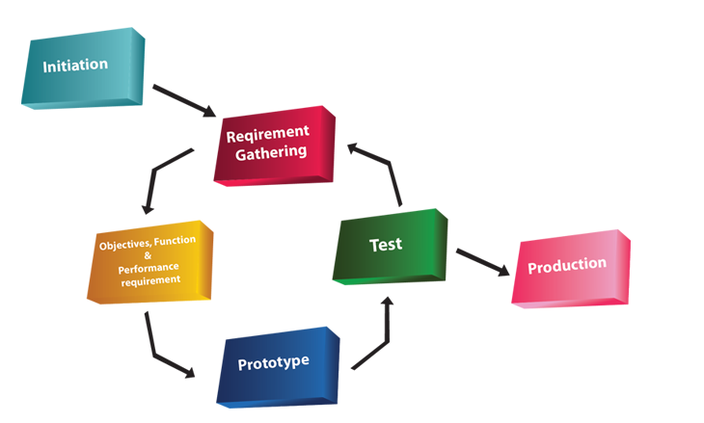The project can have different ways of operating. One way in which the group can implement the project is by the Prototyping SDLC model. The Prototyping model allows the team to work concurrently on three aspects of the SDLC, them being the analysis, design and implementation. This model is on a constant loop until a finished product is completed. The prototyping model is a very fast paced model but allows us to interact with the application more to gain a better understanding of its functionality or areas of improvement that might not have been foreseen with other model approaches.

Figure 1 - The Prototyping Model [6]

## Proposed Methodologies

This is a three person team. Each team member will have a defined role, based on our abilities, strengths and interest of self-learning. Throughout the development, every member of the team will be brought up to speed on the progress of each of the other members. The aim is that all members are proficient with all aspects of the project.

Member 1

This member’s responsibility will be to front the programming side of the project, with the objective to use numerous technologies to work concurrently. This application will use Android SDK [7] to develop the web front for all Android devices which run Froyo 2.2 [8], or newer. With the aim of the app being compatible with 100% of all Android devices, Android’s WebView kit will be used. The next step will be to develop responsive pages with the use of an open source CMS such as WordPress to manage pages.

Member 2

This member will focus on the security issues which may arise with relation to user log in and registration. This involves an extensive amount of research into current hacks and security issues on the market. There is a need to obtain self-signed certs which will be sourced early in the project [9] [10].

There will need to be high-end security measures to ensure that data protection is adhered to for all players, concentrated around the user registration and login.

This member will also assist in the layouts and the look-and-feel of the application

Member 3

This member will target the graphical user interface. The main objective is to develop a smooth and an aesthetic application which will encourage return customers and customer growth. Development of custom imagery for the application will be established using tools such as Adobe Illustrator, Adobe Photoshop and GIMP.

A SQL Database table will be used to contain all questions needed. A second SQL database table will be vital for the storing, accessing and modifying of user login, registration and sessions. These tables will be generated using MySQL.

Group Elements

The team will develop a-state-of-the-art modern, ‘hi-res’ graphics using animation tools such as Adobe Illustrator, Photoshop and GIMP. There is a possibility to use Dreamweaver for transitions.

PhP scripting will be used to consolidate all elements of the application resulting in a smooth application with a modern and fun look’n’feel. For hosting, the team has secured permission from Absorb.ie to have full use of their servers inclusive of a sub-domain and installation of third-party utilities. [11]

## Application

The application will be a cross between a game and a quiz. Whilst having the academic functionality of an educational quiz, it will have a young, fresh approach to learning. For this project, the subject matter will be on networking terms and concepts.

The application will consist of three levels. A description of these levels is detailed in the next section.

Level 1

The first level will be easy, containing definitions and abbreviations on an MCQ basis. One question will have 4 possible answers with only one answer being correct. There is plans to have a pool of 300 questions for the finished product. However, for the sake of this project, it is more feasible to run a beta model with a pool of 10 question.

Level 2

The second level is more difficult. Questions will be based on exam quality definitions and networking syntax on an MCQ basis. One question will have 4 possible answers with only one answer being correct. There is plans to have a pool of 300 questions for the finished product. However, for the sake of this project, it is more feasible to run a beta model with a pool of 10 question.

Level 3

The third level is the most difficult. Questions will be based on the general theory associated with networking on a CCNA level. Each question will be answered textually. This will involve technology which will recognise keywords and strings. There is plans to have a pool of 150 questions for the finished product. However, for the sake of this project, it is more feasible to run a beta model with a pool of 10 question.

Player advancement through levels

In order for the user to move from one level to another, the player must answer ALL the questions in each level. If a question is answered correctly, that question will be flagged ‘true’. If question is answered incorrectly, the program generate next question. The wrong question remains in the cycle until it is answered correctly. All questions are generated randomly.

## Deliverables

The aim is to have a fairly established running BETA model by Christmas break which will leave the next semester for testing and defining our documentation.

In this section, the expected results are examined in order to identify any issues before the project officially begins.

A Work Breakdown Structure and Gantt-Chart, which follow, provide a condensed and visual view at the tasks and predicted timeline of the project.

Expected Results

1. A fully functional Android application.
2. A young, dynamic, fun and educational tool for learning networking fundamentals.
3. A knowledge and understanding of Android development.
4. Implement a new knowledge of security protocols and risk in regards to Android development, focusing on the data protection of users.
5. Learn to combine different languages and technology to ensure an ergonomic and efficient application.
6. Gain experience in the area of teamwork and learning to approach intrapersonal issues.
7. Development of an application which has the potential to be adapted to other academic topics.

Work Breakdown Structure

1. Proposal
2. Research possible technologies required
3. Secure supervisor
4. Research existing applications
5. Research forensic measures required
6. Establish all software requirements
7. Risk analysis 1
8. Develop GUI
9. Develop Database
10. Establish BETA model
11. Risk analysis 2
12. Finalise responsive elements
13. Implementation
14. Testing

Gantt-Chart

This chart shows the division of labour among the development team. It is subject to change.

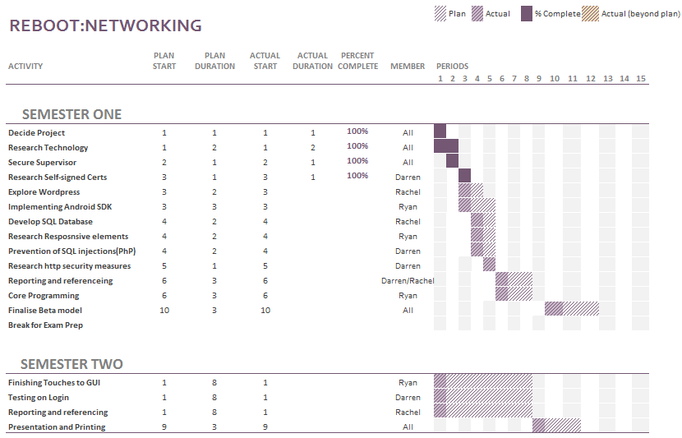

Figure 2 - Gantt-Chart

## Conclusion

This application, as it stands, is available and ready for development to begin. A feasibility study will show any changes that may need to be applied. The title and structure will be re-investigated at regular intervals throughout the duration of the project in order to improve the efficiency of the development build.

This product has great potential as it can be expanded in size by merely extending the database. This product has the potential to be phased into other educational areas such as Mathematics, Data Structures, Operating Systems and many more.

The technologies that will be used are openly available and the deadline has been set to ensure the productivity of the project is high.

The team has agreed to dedicate to a tight deadline of January 2016. This will give enough time for testing and allow for any contingency plans to be used if needed.

## References

[1] Driftwoodsoftware.com, 'Driftwood Software', 2015. [Online]. Available: http://www.driftwoodsoftware.com/quiznet.html. [Accessed: 21- Oct- 2015].

[2] QuizUp, 'QuizUp', 2015. [Online]. Available: https://www.quizup.com/en. [Accessed: 21- Oct- 2015].

[3] Apps.facebook.com, “Quiz on Facebook | Facebook”, 2015. [Online]. Available: https://apps.facebook.com/fb-quizzes/?ref=aw&gclid=Cj0KEQjwqZKxBRDBkNmLt9DejNgBEiQAq8XWPl9BuKL-VuuJVTBNtN7fx9B1k0dwPn427aYd5BjdhaUaAlrX8P8HAQ. [Accessed: 19- Oct- 2015].

[4] L. Dan Cheng and X. Wang, 'Mobile application tools for learning and quiz based on Android', 2013 IEEE 63rd Annual Conference International Council for Education Media (ICEM), 2013.

[5] M. Murphy, “The busy coder's guide to advanced Android development.” United States: Commons Ware, 2011.

[6] Lion Vision, “The Prototyping Model”. 2015. [Online-Image] Available: http://www.lionvisionits.com/Development-Process.aspx. [Accessed: 21-Oct-2015].

[7] Developer.android.com, 'Download Android Studio and SDK Tools | Android Developers', 2015. [Online]. Available: https://developer.android.com/sdk/index.html. [Accessed: 21- Oct- 2015].

[8]A. Highlights, 'Android 2.2 Platform Highlights | Android Developers', Developer.android.com, 2015. [Online]. Available: http://developer.android.com/about/versions/android-2.2-highlights.html. [Accessed: 21- Oct- 2015].

[9] J. Drake, Z. Lanier, C. Mulliner, P. Oliva, S. Ridley and G. Wicherski, “Android hacker's handbook.” Indianapolis, IN: Wiley, 2014.

[10] A. Misra, “Android security.” Boca Raton, FL: CRC Press, 2013.

[11] Absorb, 'Absorb.ie', Absorb.ie, 2015. [Online]. Available: http://absorb.ie. [Accessed: 21- Oct- 2015].