**Data from the collection trip to the Hawai’i Institute of Marine Biology 2013 and 2014**

Samples from the Hawai’i collection trip in June of 2013 were sequenced using an Illumina Miseq next generation sequencing platform. This resulted in 12,730,293 sequence reads that were clustered at 97% sequence similarity into 104,567 (Operational Taxonomic Units) OTUs. Samples from the Hawai’i collection trip that took place in May through June of 2014 were sequenced the Illumina Miseq next generation sequencing platform, this resulted in 11,750,346 sequence reads being generated which clustered into 386,641 observed OTUs at 97% sequence identity. For further analysis, reads from both sequencing runs were joined together. A total of 24,480,639 sequences from two sequencing files from the previous runs were concatenated together. Subsampled open reference OTU picking was performed by clustering sequences at 97% identity, which resulted in a total number of 760,809 observed OTUs. A median number of 53,635 OTUs were observed across all samples. Following the initial run of OTU picking, observations that were observed less than twice within a sample were filtered out. Filtering of singletons and doubletons resulted in 641,690 OTUs being filtered out of of the initial OTU table, for a total of 119,119 OTUs in the filtered OTU table.

**Within sample diversity (alpha diversity) for combined surgeonfish data**

In order to characterize diversity within the samples(also referred to as alpha diversity), observed species and phylogenetic diversity were averaged on every sample category. Alpha diversity was analyzed by sampling one individual fish and each individual gut section; for example, fish number 1 could have the middle of the gut sampled once or twice. The gut sections of surgeonfish were sampled by swabbing gut contents or placing gut contents into a microcentrifuge tube. Alpha diversity metrics were applied to both sections, and the score for that metric was averaged. The second category of samples that was analyzed for alpha diversity consisted of samples that did and did not possess *Epulopiscium fishelsoni*. Observed species is a metric that calculates the amount of unique OTUs that are found when sequences are subsampled from a given fish sample. For alpha rarefaction, surgeonfish gut samples were rarefied at a level of 22,000 sequences per sample.

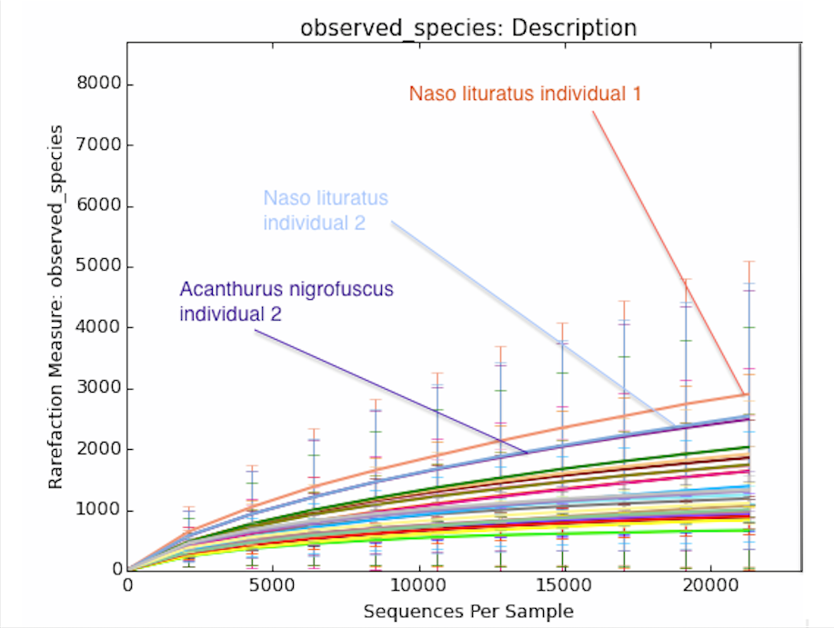

**Figure 1) Rarefaction plot displaying the amount of within sample diversity measured by the amount of unique OTUs in samples collected from different species of individual surgeonfish.The number of observed species are on the y-axis and the number of sequences sampled are on the x axis.**

In order to categorize samples, individual fish were categorized based on the order of species collected e.g., the first *Naso lituratus* collected was labeled *N.lituratus*.1. Samples were taken from the oral cavity and along the gastrointestinal tract for each fish; samples were labeled according to the order the fish species were collected and according to the section of the gastrointestinal tract that was sampled. Samples were also labeled based on their possession of *Epulopiscium fishelsoni,* if a particular sample had any trace of *E. fishelsoni*, that sample was marked to indicate its possession.

Samples from *Naso lituratus* individual number 1 had the most unique OTUs observed, with an average of 2,909.650 OTUs observed, when compared to all of the samples taken from every other individual. *N. lituratus* individual number 2had an average of 2,544.56 unique OTUs observed, which was the second largest number out of any individual fish sampled.

Another analysis for the amount of unique OTUs observed was completed for the samples that were taken along the gut sections of individual fish. Two samples from the middle of the gut of *Acanthurus nigrofuscus* individual number 2 had an average of 5,432 unique OTUs observed, and an average of 5,173 unique OTUs were observed in the middle portion of the gut samples of *A.nigrofuscus* individual number 1.

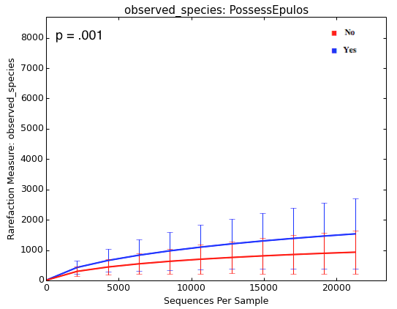

**Figure 2) Rarefaction plot that displays the amount of within sample diversity in terms of observed species for samples that possess *Epulopiscium fishelsoni* and samples that do not. The number of observed species are on the y-axis and the number of sequences sampled are on the x axis. On the upper right part of the graph is the bonferroni corrected p-value of a t-test between samples that possess Epulopiscium and samples that do not.**

Surgeonfish samples were also analyzed for the number of unique OTUs based on whether *Epulopiscium fishelsoni* was present in that sample (Figure 2). The number of samples that possessed *E. fishelsoni* was 110, 53 samples did not. An average of 1,535.77 unique OTUs were observed in samples that possessed *Epulopiscium*, compared to samples that did not have *Epulopiscium*,which had an average of 931.3 unique OTUs. There was a significant difference in the mean number of observed species in samples that possessed *Epulopiscium* and samples that did not (bonferroni corrected p-value = .001). However a sample that did possess *E. fishelsoni* and a sample that did not could be from the same individual fish, this means that samples are not independent of one another. Previous studies have found that presence of *E*. *fishelsoni* leads to adecreases the pH to 6.5 in the middle 30 - 40% of the gastrointestinal tract and the anterior and posterior portions of the gastrointestinal tract remain at a pH of 7.2 - 7.8 ( Pollak, Montgomery *et al* 1994). Future work could address whether sections of the surgeonfish gastrointestinal tract that have a low pH and *E. fishelsoni* have higher degrees of biodiversity. Phylogenetic diversity (PD) is a quantitative metric, which calculates the minimum amount of branches needed in a phylogenetic tree to cover a given set of taxa (Faith DP, 1992). Results of phylogenetic diversity analysis by individual and gut section showed that the samples from the middle section of *Acanthurus nigrofuscus* individual number 2 had an average phylogenetic diversity score of 372.03. Midgut samples from *A. nigrofuscus* individual number 1 had a phylogenetic diversity score of 362.695; this was the second largest score among any individual and gut section from the phylogenetic diversity analysis. Samples that possessed *E. fishelsoni* were compared to samples that did not possess *E. fishelsoni* via the phylogenetic diversity metric.Samples that were shown to possess *E. fishelsoni* had an average phylogenetic diversity score of 142.294, compared to a lower phylogenetic diversity score of 98.639 for samples that did not have *E. fishelsoni*.

**Taxonomic summaries of microbial communities in surgeonfish gut microbiome communities**

A taxonomic summary was compiled for each sample in the surgeonfish gut microbiome analysis, however this summary failed to show the genus *Epulopiscium.* In order to properly show *Epulopiscium* as a genus in the output when taxa summaries were analyzed, the way taxonomy was assigned had to be changed. The confidence level for a taxonomy assignment, using the Ribosomal Database Project(RDP) classifier, had to be changed to 0.5 from 0.8 to properly assign the taxonomy of the genus *Epulopiscium*. In order for verification that the RDP classifier produced correctly assigned *Epulopiscium* sequences, the bioinformatics program Primer Prospector (Walters *et al*, 2011) was used to slice out the 515f - 806r regions (the region of DNA that the primers amplify) of the 16S rRNA sequences of BLAST hits for *Epulopiscium fishelsoni* and used BLAST hits to align them against sequences that were part of the QIIME analysis of the surgeonfish gut microbiome.

**Sample Name**

|  |  |  |  |  |  |  |
| --- | --- | --- | --- | --- | --- | --- |
| Taxonomy | Nu15Mid2 | Nu1 Post 3 | Nu1 Ant 12 | Nu 15  oral cavity | Nu1 Mid 1 | Nu 15 Mid1 |
| k:Bacteria,p;Firmicutes,c:Clostridia,o:Clostridiales,f:Lachnospiraceae,g:Epulopiscium | 19.9% | 0% | .2% | 0% | 0% | 66.4% |

**(Table 1) This figure shows the percentage of *Epulopiscium* present in selected samples from surgeonfish species of *Naso Unicornis*.**

**Sample Name**

|  |  |  |  |  |  |  |
| --- | --- | --- | --- | --- | --- | --- |
| Taxonomy | Nl 17 Mid 1 | Nl 18 Mid 2 | Nl 19 mid 2 | Nl 19 Post 1 | Nl 19 Mid 1 | Nl 18 Post 1 |
| k:Bacteria,p;Firmicutes,c:Clostridia,o:Clostridiales,f:Lachnospiraceae,g:Epulopiscium | 53.3% | 3.4% | 49.9% | 29.4% | 1.1% | 6.44% |

**(Table 2) This figure shows the percentage of *Epulopiscium* present in selected samples from surgeonfish species of *Naso lituratus.***

When summaries of the taxonomy of the microbial community composition of surgeonfish gut samples were analyzed, the genus *Epulopiscium* was present in the largest relative abundance in samples from the surgeonfish species of *Naso lituratus* and *Naso unicornis*. Samples from the middle of the gastrointestinal tract of *Naso unicornis* had the highest average relative abundance of *E.fishelsoni* out of any other gastrointestinal sections sampled among any other surgeonfish species (Table 3). The middle of the gastrointestinal tract of *Naso lituratus* had the second highest average relative abundance of *E. fishelsoni* out of any surgeonfish species.

|  |  |  |  |  |
| --- | --- | --- | --- | --- |
|  | *A. blochii* | *A. leucoparieus* | *A. nigrofuscus* | *A. olivaceus* |
| section of gut | relative abundance of *E.fishelsoni* |  |  |  |
| oral cavity | NA | NA | NA | 1.3% |
| stomach | NA | .1% | NA | NA |
| anterior | NA | NA | .5% | NA |
| middle | NA | NA | .9% | NA |
| posterior | NA | .1% | .1% | NA |
| section of gut | *A.triostegus* | *A. xanthopterus* | *N. lituratus* | *N. unicornis* |
| oral cavity | .2% | NA | .1% | NA |
| stomach | NA | NA | 2% | .3% |
| anterior | NA | NA | 6.7% | .2% |
| middle | NA | .1% | 12.4% | 19% |
| posterior | NA | NA | 4.5% | .1% |
| section of gut | *Z. flavescens* | *Z. veliferum* |  |  |
| oral cavity | NA | NA |  |  |
| stomach | NA | .3% |  |  |
| anterior | NA | NA |  |  |
| middle | 8.6% | .3% |  |  |
| posterior | 4.5% | .1% |  |  |

T**able 3) Table showing the average relative abundance of *Epulopiscium fishelsoni* in each section along the surgeonfish gastrointestinal tract for each species of surgeonfish collected in Hawai’i in 2011, 2013, and 2014.**

**Core microbiome of the surgeonfish gut**

There are interspecies commonalities in the gut microbiota of surgeonfish species. Species of surgeonfish that have a macroscopic diet, or have a diet that consists of multicellular seaweed, share microbiota. *N. lituratus*, *N. unicornis*, and *Acanthurus leucoparieus* share the genera *Ralstonia* and *Sediminibacterium* as core members of their microbiome, with 56 out of 75 samples containing these two genera*.* *Z. flavescens* and *Z. veliferum* share the genus and species *Acinetobacter johnsonii* as a core member of their microbiome; *Acinetobacter johnsonii* was present in 44.2/68 of all samples from *Z. veliferum* and *Z. flavescens*. These two species of surgeonfish have a diet that consists of microscopic algae. *A. xanthopterus*, *A. oliveaceus,* and *A. blochii* have a diet that consists of detritus(e.g., dead plant material, fecal matter, and dead wood). Four phylotypes were shared in 16/19 samples from surgeonfish species with the diet category of detritus. Of the microbiota that these detritivores share, the genera *parainfluenza* and *sublava* are part of the phylum Proteobacteria. Genus *Fusobacterium* is gram negative andbelongs to the gram phylum *Fusobacteria,* the last of the Genera listed is from order *Lactobacillales,* which is part of the phylum Firmicutes. 6 out of six midgut samples and 12.6 out 21 samples from across all gut regions from *N. unicornis* contained *E. fishelsoni*. *E. fishelsoni* was found only found to be prevalent as a core microbiome member in *N. unicornis* out of 10 fish species sampled.

**Between sample diversity (Beta Diversity) of the surgeonfish gut microbiome**

In order to determine which metadata category drove the most variation, between-sample diversity (Beta diversity) was calculated between surgeonfish gastrointestinal tract samples over many metadata categories. Microbial communities in surgeonfish gastrointestinal samples were compared based on the section of the gut sampled, the Illumina sequencing run that samples had been processes in, and the type of diet that each surgeonfish species had.

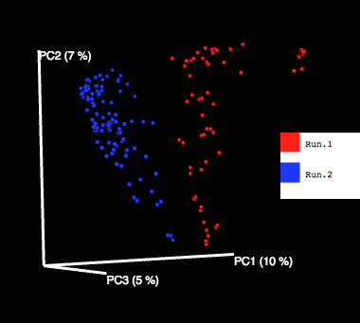

**Fig 3) PCoA plot of unweighted Unifrac distances of surgeonfish gut samples from different Illumina sequencing runs.**

A student’s t-test with 999 Monte Carlo permutations was performed to determine if there was a significant difference in the mean unweighted Unifrac distances in and between individual samples that were part of Illumina sequencing runs in 2013 and 2014.There was a significant (bonferroni p-value = .003) difference in the community membership in surgeonfish gut microbiome samples that were from different Illumina Miseq runs. There are several differences in the sequencing runs; for example, the first sequencing run was performed with samples that were collected in Hawai’i in 2013, and contents from the gastrointestinal tract were placed in their entirety into microcentrifuge tubes and stored in glycerol. The second Illumina sequencing run consisted of samples that were collected in 2014 via cotton swab; this meant that less gut content was present on the swab. It is unknown whether the temporal difference (approximately 1 year), or the method of sampling are drivers in the significant difference in phylogenetic relatedness between microbial communities present in these samples. Although there may be major differences in the sampling techniques and time periods in which these samples were collected, other researchers have noticed significantly different Unifrac distances between different sequencing runs (Chase, Caporaso, *et al* 2014).

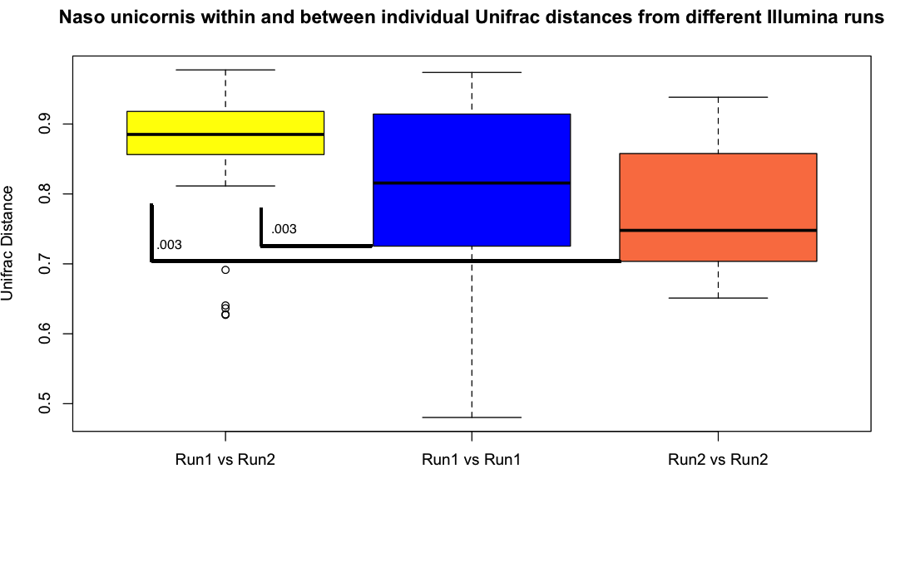**Figure 4) Within and between individual Unifrac distances from two Illumina runs containing samples from *N. unicornis.* Unifrac distances are on the y axis and run number is on the x axis. Bonferroni p-values are displayed above the brackets.**

This result adds another variable to inter-surgeonfish species and intra-surgeonfish species gut microbial community comparisons. When comparing sections along regions of the gastrointestinal tract among the same surgeonfish species, the run number that samples were sequenced in creates an added degree of variability in comparisons in Unifrac distances. *N. unicornis* samples from the first sequencing run were significantly different from *N. unicornis* samples from the second sequencing run. The mean values of within and between individual Unifrac distances in the posterior gut section of *Naso unicornis* were compared and there is almost a significant difference (bonferroni corrected p = .057) between samples from different Illumina runs. The posterior section of the gastrointestinal tract in *N.unicornis* is very significant from other sections of the middle and posterior sections of the gastrointestinal tract (Figure 5), even when samples from both Illumina runs are included in the comparison.

Samples from the oral cavity, stomach, anterior, middle, and posterior gastrointestinal tract sections from individuals of the same species were compared. Of the 10 species that were compared in this study, *Naso unicornis* was the only species of surgeonfishthat exhibited significant differences between microbial communities along sections of the gut.

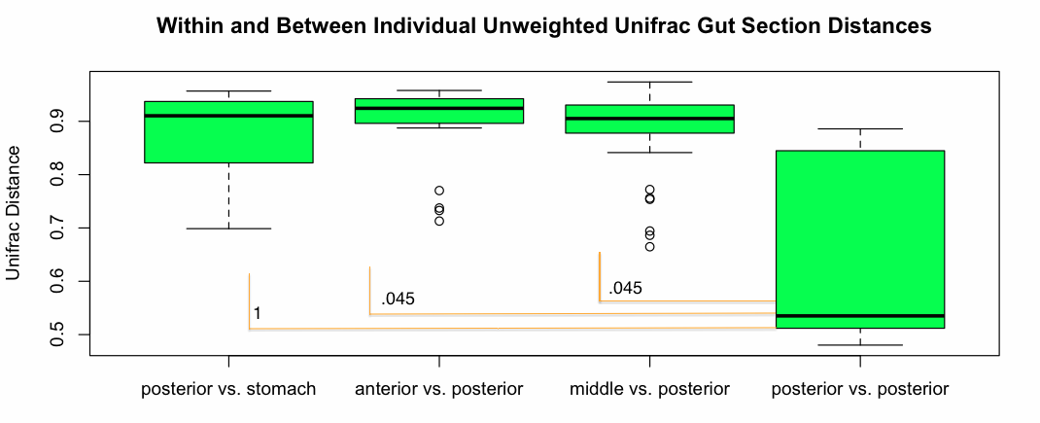

**Figure 5) Boxplots of within and between sample Unifrac distances for each section in the gut of the surgeonfish species *Naso Unicornis.* Bonferroni p-values are located beneath each gut section they correspond with.**

Unweighted Unifrac distances in sections of the gastrointestinal tract of five out of six individual *Naso unicornis* were compared using a two tailed t-test with 999 Monte Carlo permutations. The posterior section of the gastrointestinal tract possessed significantly different microbial communities compared to the anterior and middle sections of the gastrointestinal tract (**Figure 5**). However, the stomach was not significantly different from the posterior sections of the gut.

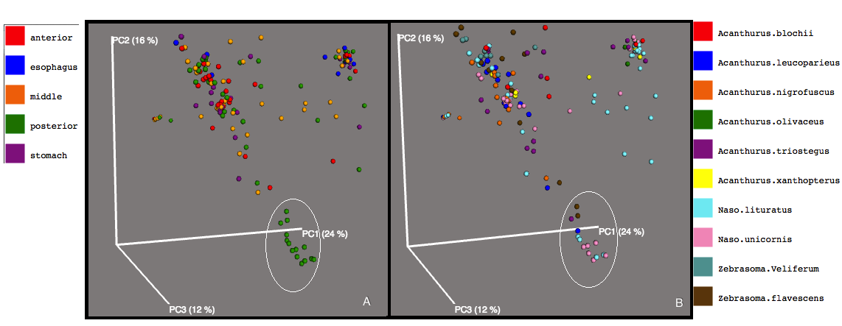

**Figure 6) A) PCoA plot of weighted Unifrac distances of surgeonfish samples colored by gut section. B) PCoA plot of weighted Unifrac distances of surgeonfish samples colored by surgeonfish species.**

Food is stored at night in the posterior section of the gastrointestinal tract and fermentation of carbohydrates occurs ( Pollak *et al* 1988, Clements *et al* 2014). With this food, a high abundance of microbes inhabit the posterior section of the gastrointestinal tract of surgeonfish (Clements and Choat, 1995). Weighted Unifrac distances were calculated for samples along the gastrointestinal tract from all species, posterior samples from many surgeonfish species, but mainly samples from *N. unicornis* and *N. lituratus* clustered independently from other fish gut samples (**Figure 6**). Both species of surgeonfish have a diet that consists of macroalgae which contain a high amount of carbohydrates, which in turn are fermented by microbes into short chain fatty acids (SCFAs). When a comparison of 18 tropical marine fishes were analyzed for (SFCA) levels, *N. lituratus* and *N. unicornis* possessed the highest levels of SCFAs (Clements and Choat, 1995). Furthermore, the highest levels of SCFAs in these fish species were found in the posterior region of the gastrointestinal tract.

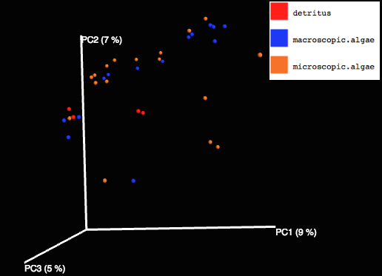

**Figure 7) PCoA plot of unweighted Unifrac distances from anterior surgeonfish gut samples categorized by diet type. Microbial communities that were found in surgeonfish gut microbiomes were not more similar to each other in membership if the surgeonfish hosts have the same type of diet.**

Results from previous studies indicate a difference in surgeonfish gut microbiota based on diet type (Miyake *et al*, 2015). An analysis was performed using the data collected from Hawai’i, which was as similar as possible to the experiment conducted by Miyake *et al*. The anterior portion of the surgeonfish gut was sampled and unweighted Unifrac was used to determine if there were any similarities between bacterial communities based on diet type. However, when species of surgeonfish collected from Hawai’i were classified based on diet type (**Figure 7**), results indicated that microbial communities from surgeonfish with the same diet type were not significantly related phylogenetically. This result may indicate that there is a difference in the combination of physiology, phylogenetics, environment, and ecology in surgeonfish species from the Red Sea compared with surgeonfish species inhabiting Hawaiian coral reefs.

**Biodiversity of surgeonfish gut microbial communities compared to human gut microbial communities**

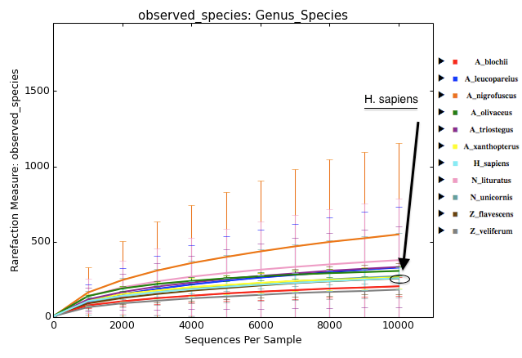

**Figure 8) Rarefaction plot displaying the amount of unique OTUs for surgeonfish sampled in the surgeonfish gut microbiome project and human gut samples from the college student microbiome project. The genus and species for each organism is labeled on the right axis.**

This section compares the diversity present in two different but very selective and specialized environments. The alpha diversity of human gut samples from the college student microbiome project was compared with the alpha diversity of gut samples from 10 surgeonfish species. The average amount of unique observed OTUs, were compared between the surgeonfish species sampled and *H. sapiens* using a closed reference OTU table and a rarefaction depth of 10,000 sequences/sample. Gut samples from species of *A. nigrofuscus,* and *N. lituratus*, have more unique observed OTUs than samples from *H. sapiens* in the college student microbiome study (**Figure 8**). *A.nigrofuscus* had the most unique observed OTUs with an average of 548.7 unique observations between all samples in that species. *N. lituratus* had an average of 378.2 unique OTUs, which was the second largest number of unique OTUs observed. *H. sapiens* had an average of 259.02 unique OTUs observed. Of the 10 species of surgeonfish sampled, *N. lituratus* had a significantly different average number of unique observed OTUs when compared to *H. sapiens* (fdr p-value = .027).

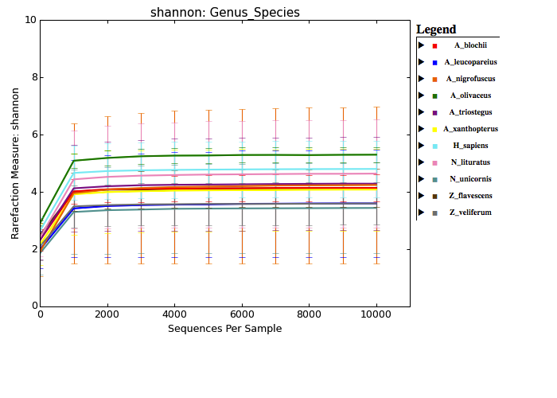

**Figure 9) Rarefaction plot showing the average Shannon diversity score for the gut of each species of surgeonfish and *Homo sapiens*. The average Shannon diversity score is on the y axis and the number of sequences per sample is on the x axis.**

Shannon diversity (Shannon, 1948) was measured for samples from each species of surgeonfish and compared to the fecal samples that were taken as part of the college student microbiome project. *Acanthurus olivaceus* had the highest Shannon diversity out of any species, human or surgeonfish, that was sampled. This means that microbial communities in samples from the gut section of *A. olivaceus* had the largest amount of species present and had a high degree of evenness in the abundance of the OTUs that were present in those samples (**Figure 9**). However, only *Z. veliferum* had an average Shannon score that was significantly different from *H. sapiens* (fdr corrected p-value = .02).These observations were made using an OTU table that is composed of any observations that match a reference set of sequences at 97% identity. Any sequences that fail to hit a reference sequence are discarded, in contrast to open reference techniques, which cluster sequences *de novo* that do not hit a reference sequence.Therefore, it is hard to infer from these analyses that the surgeonfish gut has a higher level of microbial diversity, than the human gut microbiome.

Although it has been demonstrated that vertebrate gut microbiomes are more similar to each other than to environmental microbiomes ( Ley, Lozupone *et al*, 2008), differences still exist between the surgeonfish gut microbiome and the human gut microbiome. Recent sequencing studies have shown that fish gut microbial communities more closely resemble communities from vertebrate gut systems, rather than the ocean environment (Sullam *et al*, 2012). Humans, unlike surgeonfish, have a diet that is highly variable among different subpopulations. Analyzed closely, the differences in diet between humans in certain countries, or even individuals in the same country who exhibit a different lifestyle, can be large. However, when the microbiomes of humans from a large population are compared to other primate species, their microbial communities are most similar to omnivorous primates including ring tailed lemurs, black lemurs, mongoose lemurs, bonobos, and spider monkeys (Ley, Lozupone *et al*, 2008). These species of primates can all be classified as omnivores that have a diet consisting of mainly fruit. Previous research has demonstrated that there is a significant difference between the microbiomes of omnivores and herbivores, and that diet may be the main factor that drives this difference (Muegge *et al*, 2011).

|  |
| --- |
| Diet Category by Species of Surgeonfish |

|  |  |
| --- | --- |
| Diet Category | Surgeonfish Species |
| Detritivore | *A.blochii, A.xanthopterus, A.olivaceus* |
| Macroscopic algaevore | *N.lituratus*, *N.unicornis,Z. veliferum* |
| Microscopic algaevore | *A. leucoparieus, A.nigrofuscus, A. triostegus, Z. flavescens* |

**Table 4) Diet category by species of surgeonfish.**

In contrast, surgeonfish have some variation in their diet between species, but can broadly be classified as herbivores. Surgeonfish have an herbivorous diet that varies in composition depending on species. On many coral reefs, surgeonfish are the dominant vertebrate herbivores in their ecosystem ( Montgomery and Gerking, 1980). Surgeonfish in this study can be subdivided into three main diet types: detritivores, macroscopic algavores, and microscopic algavores (**Table 4**). Detritivores play a major role in the coral reef ecosystem by eating decomposing organic matter. Microbes are very important in the consumption of detritus by surgeonfish; they often cover two to ten percent of the surface area of macrophyte detritus (Mann, 2000). Most fish that are detritivores do not possess the enzymes necessary to break down the main constituent of their diet, and rely on their gut microbiome to aid in digestion of decaying organic matter. As larvae, sea lampreys are filter feeding detritivores and during this stage exhibit a much more diverse microbiome than during the parasitic part of their lifecycle (Tetlock *et al*, 2012). *A.olivaceus* is classified as a detritivore, which could translate to it possessing a more diverse gastrointestinal microbial assemblage. Micro and macro algavores are herbivores with muscular stomachs that use hindgut fermentation to break down short chain fatty acids. Algavore surgeonfish species are shown to possess high levels of short chain fatty acids (SFCAs) in their gastrointestinal tract ( Clements and Choat, 1995). Microbes are highly abundant in the hindgut portion of the gastrointestinal tract as they play an integral role in fermenting carbohydrates into short chain fatty acids.