**Methods**

Sixty-two samples were collected from surgeonfish off of the coast of Oahu, Hawaii in July 2013, and another four samples were collected from Oahu earlier in 2011. *Naso lituratus* was the only species of surgeonfish collected from Oahu in 2011. The fish species that were collected in July 2013 were: *Naso lituratus, Naso unicornis*, *Acanthurus leucoparieus, Acanthurus triostegus, Acanthurus nigrofuscus* and *Zebrasoma flavescens.*

In total 163 surgeonfish gastrointestinal samples were collected off of the coast of Oahu, Hawaii in July 2011, July 2013, and May 2014. Only four samples were used from the collection trip in 2011, 62 samples were collected in 2013, and the remaining 97 samples were collected in 2014.

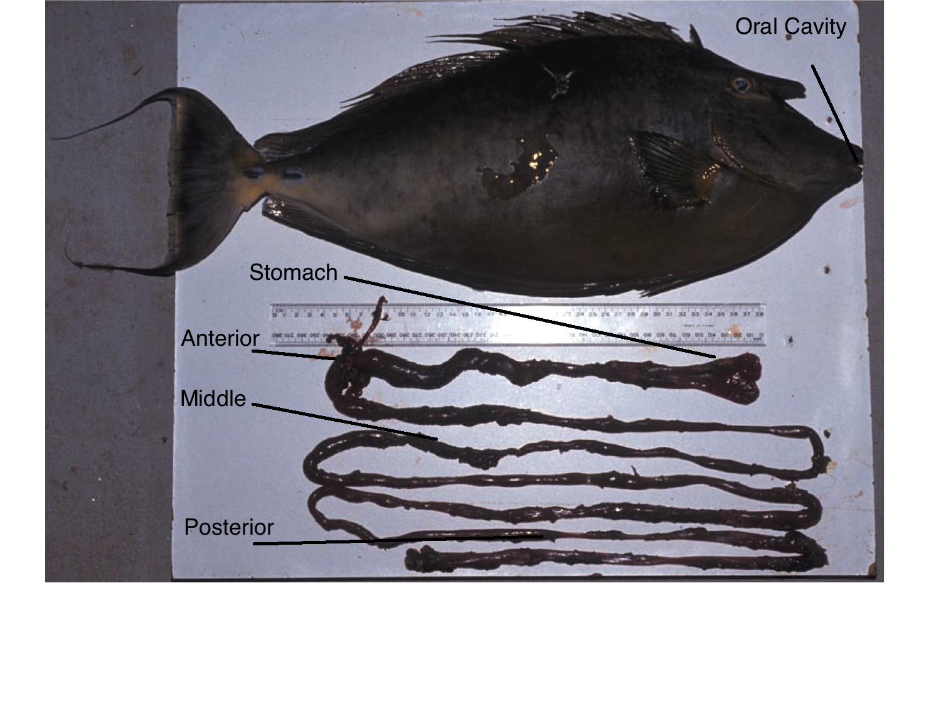**Figure 1) Dissection of *Naso lituratus* gastrointestinal tract, the oral cavity is labeled along with the stomach, anterior, middle, and posterior sections of the gut. Photo taken from presentation by Kendall Clements.**

|  |
| --- |
| Surgeonfish species collected in June 2011,June 2013 and May of 2014 from O’ahu, Hawai’i |

|  |  |  |
| --- | --- | --- |
| Sample ID  3Ab  Al11,Al12,12  An9, An10,11,7  Ao20, Ao20  At14,At4, 9  Ax16  Nl17,Nl18, Nl19, Nl8,1,3, MG1, HG1  Nu15, Nu1, 2, 6, 10, 13  Zf5,8  Zv6 | Fish Species  *Acanthurus blochii*  *Acanthurus leucoparieus*  *Acanthurus nigrofuscus*  *Acanthurus olivaceus*  *Acanthurus triostegus*  *Acanthurus xanthopterus*  *Naso lituratus*  *Naso unicornis*  *Zebrasoma flavescens*  *Zebrasoma veliferum* | Number of individuals collected  1  3  4  2*  3*  1  6  6  2  1 |
|
|
|
|
|
|
|
|
|
|

**Table 3)** **List of surgeonfish species collected in both Hawai’ian collection trips. Sample IDs are in the left column ,the name of the species is in the center column, number of replicate fish collected is in the right column. Numbers with an asterisk mean that more fish were caught, but due to poor sample quality were not included in further analysis.**

Samples were taken from the intestinal regions of the surgeonfish gut. An incision was made and fluid from the gut was collected and placed into 1.5 ml microcentrifuge tubes. Sections of the gastrointestinal tract were taken from the stomach, the anterior, the middle, and the posterior. The samples were then transported to Flagstaff, Arizona and kept frozen at -20 °C until DNA was extracted.

**DNA Extraction**

**PCR Conditions**

All Polymerase Chain Reaction (PCR) reactions were performed in 96-well plates on the BIO RAD iCycler thermal cycler in the Environmental Genetics and Genomics Laboratory (Enggen) .

In order to confirm the presence of bacteria in samples, the V4 hypervariable region of the 16S rRNA gene was amplified with the primers 515F and 806R. When running PCR reactions, 1 𝝻l of DNA template was added to each well in a row of a 96-well plate, along with .8 𝝻l of combined primers at 1mM, .6 𝝻l of mgcl2 at 1.5 mM, 2.6 𝝻l of water, and 5 𝝻l of Phusion master mix, which consisted of 0.01 U/uL Phusion Hot Start II Polymerase Thermo Fisher, 1X Phusion HF buffer (Thermo Fisher), 3.0mM MgCl2, 6% glycerol, and 200 uM dNTPs. PCR reagents were loaded into rows of a 96-well plate, 1 𝝻l of DNA template was added to each well, and the 96-well plate was then sealed, vortexed, spun down and briefly centrifuged. A 10:1 dilution was performed by transferring 1 𝝻l of of the previous PCR reaction to a new well with 9 𝝻l of master mix, Mgcl2, H2O, and combined primers, the plate was then sealed, vortexed for five seconds and spun down in a centrifuge. PCR reactions prior to sequencing were performed on the Illumina Miseq with the following conditions: 95C for two minutes, followed by 30 cycles of 95C for two minutes, 55C for one minute, 60C for four minutes, followed by a 10C hold until the plate was taken off of the thermocycler block and stored at 4C until gel electrophoresis could be performed. PCR amplification products were visualized using a .8% agarose gel using 1X sodium boric acid as a running buffer. During gel electrophoresis, agarose gels were ran for 15 minutes at 250 volts and 150 mA, with a KAPA 10 kb DNA ladder.

**Illumina Sequencing**

Prior to sequencing, all samples were normalized to one ng/𝝻l following quantification by Picogreen fluorescence. In order to construct a library we amplified the V4 domain of bacterial 16S DNA using primers 515F ( 5’-GTGCCAGCMGCCGCGGTAA-3’) and 806R ( 5’- GGACTACHVGGGTATCTAAT-3’) both of these primers were modified to contain an Illumina adapter region for sequencing on the Illumina Miseq, and on the forward 515F primer a Hamming error-correcting barcode was added to enable multiplexing of sequences. All samples were amplified in triplicate and combined prior to purification. Prior to sequencing, a bead cleanup was performed to remove any unincorporated primers. Purified samples were then run on an Illumina Miseq for a 2 X 150 paired end run.

**Third collection trip May 2014**

A third collection trip was conducted on May 22 - May 30th of 2014 to go to Oahu, Hawai’i in order to collect samples off of Coconut Island in Kaneohe Bay.Twenty-one individual fish were collected and dissected from various points off of Coconut Island. Surgeonfish were collected from the dates of May 23rd, 2014 - May 29th, 2014. Fish were collected from areas around the island such as the Tamashoiro Market, a reef pool off of Coconut island, the Sampan Channel, the Lanai channel, and the Electric Beach off of Oahu, Hawai’i. Samples were collected mostly in the morning hours from 8:30 am to 10:30 am and dissection was performed in the afternoon. Sampling along the gastrointestinal tract was performed in a similar fashion to the procedure used in July of 2013. However, sampling inside the gastrointestinal tract was performed using sterile cotton swabs.

|  |
| --- |
| Surgeonfish species collected in May of 2014 from O’ahu Hawai’i |

|  |  |  |
| --- | --- | --- |
| Sample ID | Fish Species | Number of replicates collected |
| 3Ab | *Acanthurus blochii* | 1 |
| Al11,Al12 | *Acanthurus leucoparieus* | 2 |
| An9, An10 | *Acanthurus nigrofuscus* | 2 |
| Ao20, Ao20 | *Acanthurus olivaceus* | 2 |
| At14,At4 | *Acanthurus triostegus* | 2 |
| Ax16 | *Acanthurus xanthopterus* | 1 |
| Nl17,Nl18, Nl19, | *Naso lituratus* | 4 |
| Nu15, Nu1 | *Naso unicornis* | 2 |
| Zf5 | *Zebrasoma flavescens* | 1 |
| Zv6 | *Zebrasoma veliferum* | 1 |

**Table 2) Information on the species and the quantity of surgeonfish collected from Hawai’i in May 2014. The left column displays the sample ID names that fish were given, the center column displays the species of fish collected, and the right column displays the number of replicate samples that were collected.**

**Direct to PCR Amplification**

The direct to PCR approach(Flores *et al*,2012) was used to extract, and directly amplify DNA from the surgeonfish gastrointestinal tract. However, gel electrophoresis showed that DNA amplified from the samples had too many nonspecific products. Therefore, the direct to PCR protocol was not used for further DNA extractions.

**Plant DNA extraction in 96 - well plates**

Due to the direct to PCR protocol yielding products that were not pure enough for next generation sequencing, another plant protocol was used to extract DNA in 96 well plates.

First, a small amount of SiC particles were added to each well in the plate, then a small amount of cotton swab was added to each well over the SiC particles. Following that 40 𝝻l of .25 M NaOH was added to each well, and sealed with strip caps. The material in the plate was then ground using a mixer mill at 28 Hz for 30 seconds. A denature program was then used on a thermal cycler with the following protocol: 4 minutes at 95 C, 1 minute at 4C, and 10C forever; the plate was then centrifuged briefly at 2,000 rpm. Next, 130 𝝻l of .1M Tris-HCl pH 8.0 was added to each well and sealed with foil; the plate was then centrifuged for 10 minutes at 3500 rpm. Next 150 ul of supernatant was added to a clean 96 well plate. Next, 15 𝝻l 3M NaOAc, pH 5.2 was added to each well. Following this, 120 𝝻l of isopropanol was added to each well, the plate was sealed, and mixed by inversion. The plate was then centrifuged at 3,500 rpm for 60 minutes. After centrifugation, the supernatant was discarded and the plate was inverted on a paper towel and centrifuged for 10 seconds at 200 rpm. Following this, 100 ul of 70% EtOH was added to each well and the plate was sealed. Next the plate was centrifuged for 20 minutes at 3,500 rpm. Then, the plate was centrifuged at 200 rpm for 10 seconds. Following brief centrifugation, the plate was dried by leaving it unsealed for 6 minutes in a vacuum centrifuge at 60 C. Finally, 20 ul TE was added to each well for the final step.

PCR reactions were performed in 96-well plates on the BIO RAD iCycler thermal cycler in Enggen . The V4 hypervariable region of the 16S rRNA region was used with the primers being 515 forward to 806 Reverse. Reaction volumes were 10 𝝻l for each PCR reaction, reagents and their concentrations were .8 𝝻l of combined primers at 1 mM, .6 𝝻l of mgcl2  at 1.5 mM, 2.6 𝝻l of water, 5 𝝻l of a master mix that consisted of 0.01 U/uL KAPA2G Fast DNA Polymerase, 1X KAPA2G Fast buffer, 3mM mgcl2, 6% glycerol, and 200 𝝻M dNTPs. All 16S rRNA PCR reactions prior to sequencing and on the Illumina Miseq instrument were performed with the following conditions: 95C for two minutes, followed by 30 cycles of 95C for two minutes, 55C for one minute, 60C for four minutes, followed by a 10C hold until the plate was taken off of the block.

PCR amplification products were visualized using gel electrophoresis using a one percent agarose gel with SYBR Safe nucleic acid stain. Electrophoresis gels were ran for 15 minutes at 250 volts and 150 mA, with a KAPA 10 kb ladder.

**Bead Cleanup (**Andrew Krohn, July 2013. Adapted from Rohland & Reich, 2012)

Bead cleanups were performed with .1 % carboxyl-modified Sera-Mag magnetic Speed-beads and a magnetic 96 well plate. Approximately equal volume of bead solution as the sample was added to each well of a 96 well plate. The solution was pipetted up and down multiple times to properly mix the solution. The plate was then spun down briefly at approximately 1,200 rpm and covered then placed on a 96 well magnetic plate for ten minutes. Next, the plate was kept on a 96 well magnetic plate for two to five minutes, then the liquid in the wells was disposed of. Next 100 uL of 70% EtOH was added, after 30 seconds the EtOH was pipetted off and new EtOH was added, again the EtOH was pipetted off. The plate was then dried at 60 C in a vacuum centrifuge for 2- 4 minutes or until the wells were dry. Next, 20 ul of 10 mM Tris-Cl pH 8.8 was added to each well and the plate was vortexed and spun down, then placed on the magnet for approximately two minutes.

Finally, the elutant was transferred to a new well of a 96 well plate and stored at -20C until samples could be sequenced.

|  |
| --- |
| Surgeonfish species collected in June 2011,June 2013 and May of 2014 from O’ahu, Hawai’i |

|  |  |  |
| --- | --- | --- |
| Sample ID | Fish Species | Number of individuals collected |
| 3Ab | *Acanthurus blochii* | 1 |
| Al11,Al12,12 | *Acanthurus leucoparieus* | 3 |
| An9, An10,11,7 | *Acanthurus nigrofuscus* | 4 |
| Ao20, Ao20 | *Acanthurus olivaceus* | 2* |
| At14,At4, 9 | *Acanthurus triostegus* | 3* |
| Ax16 | *Acanthurus xanthopterus* | 1 |
| Nl17,Nl18, Nl19, Nl8,1,3, MG1, HG1 | *Naso lituratus* | 6 |
| Nu15, Nu1, 2, 6, 10, 13 | *Naso unicornis* | 6 |
| Zf5,8 | *Zebrasoma flavescens* | 2 |
| Zv6 | *Zebrasoma veliferum* | 1 |

**Table 3)** **List of surgeonfish species collected in both Hawai’ian collection trips. Sample IDs are in the left column ,the name of the species is in the center column, number of replicate fish collected is in the right column. Numbers with an asterisk mean that more fish were caught, but due to poor sample quality were not included in further analysis.**

**Data Analysis**

For all data analysis, similar procedures were used to analyze data for each sequencing run, with some exceptions. In total 163 surgeonfish gut samples were analyzed, which included; 10 oral cavity, 24 stomach,39 anterior, 39 middle, and 51 posterior samples. The V4 hypervariable region of the 16S rRNA gene was amplified using barcoded PCR with 515F and 806R primers that were developed as protocol for the Earth Microbiome Project (Caporaso, Lauber et al. 2012). A metadata mapping file was created with sample IDs matching one of several metadata categories. After samples were run on the Illumina Miseq, raw Illumina fastq files were demultiplexed, quality filtered with a phred quality score of 19. Samples were then analyzed using QIIME 1.9.0 (Caporaso *et al*, 2010), with the exception of data from the first and prelminary collection trips in July of 2011 and 2013, which was processed with QIIME 1.8.0.

Sequences were then chimera filtered using usearch 61, and non chimeric sequences were filtered out from the demultiplexed output. Subsampled open reference (Rideout, He *et al*. 2014) Operational Taxonomic Units (OTUs) were assigned using the QIIME implementation of uclust (Edgar 2010), with the Greengenes 13_8 reference sequence set (McDonald, Price et al. 2011) using a threshold of 97% pairwise identity. If a sequence failed to hit the reference database, the sequence was assigned an OTU, and any forthcoming sequences could be compared to that new reference OTU. Sequences that were assigned to a new OTU were included in downstream analysis, but no taxonomy would be assigned to them. Output reference sequences of open reference OTU picking were then aligned using PyNAST (Caporaso, Bittinger *et al*, 2010), filtering was applied with a lanemask, which defines when a position in a DNA sequence should be filtered out when building a phylogenetic tree. A phylogenetic tree was built using FastTree (Price, Dehal et al. 2010), in order to calculate phylogenetic diversity metrics. Next, taxonomy was assigned to each sequence using the RDP taxonomy classifier (Wang, Garrity *et al*, 2007).Due to the Ribosomal Database Project taxonomy classifier having a default confidence threshold of .8, taxa summary plots failed to show *Epulopiscium* as a genus, and showed the correct taxonomic assignment to the class level. Sequences from the taxonomic class *Clostridia* were identified in the OTU map and filtered from the representative set sequence file, and a new *Clostridia* only sequence file was then created. The *Clostridia* only sequence filewas searched against the NCBI database reference collection using BLAST against known *Epulopiscium fishelsoni* sequences. Next, the confidence level for the RDP taxonomy assignment classifier was changed to .5, which confirmed the presence of *Epulopiscium* as a genus in taxonomic summary plots. In order to confirm that the RDP taxonomy classifier had made the correct taxonomic assignment, Primer Prospector(Walters and Caporaso, 2011) was used to slice out regions which corresponded to the 515 - 806R primers in the Greengenes 13_8 representative sequence set. Next, the QIIME script parallel_blast.py was used to determine if the sequences assigned to the genus *Epulopiscium* by the RDP taxonomy assignment classifierhad a high degree of similarity to the refererence sequences in Greengenes 13_8.

Following taxonomy assignment, a “raw” OTU table was created combining the open reference OTU table and the taxonomy assignment file created as an output from RDP taxonomic assignment. A phylogenetic tree was then generated using the pynast aligned open reference sequences. Finally, in order to filter out any observations in the OTU table that may have been attributed to sequencing error, observations that were observed only once or twice were filtered out of the OTU table. Random sampling of of 21,159, and 21,282 sequences per sample were chosen for the first, second and combined sequencing runs respectively. Initial alpha diversity metrics, beta diversity metrics, and taxonomic summary plots were computed using the core_diversity_analyses.py script in QIIME. Alpha diversity metrics were calculated using the observed species metric,phylogenetic diversity (PD) (Faith, 1992), and the Shannon-Weaver Index (Shannon, 2001). Beta diversity was calculated using both weighted and unweighted Unifrac (Lozupone and Knight, 2005). Both distance matrices and OTU tables were filtered on a per individual and per species basis using the scripts filter_distance_matrix.py for distance matrices and filter_samples_from_otu_table.py to filter OTU tables. Both OTU tables and distance matrices were filtered on a per species and per individual fish species basis. In order to compare the within individual and between individual Unifrac distances in a sample category, make_distance_boxplots.py was performed with 999 Monte Carlo permutations using a two sample t-test with a bonferroni correction to correct for multiple comparisons. Comparisons of shannon diversity, observed, species, and Chao 1 species richness alpha were computed using the compare_alpha_diversity.py script in QIIME using 999 monte carlo permutations and a false discovery rate correction in order to correct for multiple comparisons. In order to analyze OTUs that are shared across surgeonfish species at equal or greater than 50%, the compute_core_microbiome.py script was used on OTU tables on a per species basis.

**Human gut and surgeonfish gastrointestinal tract data analysis**

Analysis was performed to determine the alpha diversity in the human gastrointestinal tract and the surgeonfish gastrointestinal tract. A closed reference OTU table from the college student microbiome project was filtered for only OTUs that pertain to gut samples with the QIIME script filter_samples_from_otu_table.py. OTU tables from the college student microbiome project and the OTU table from the surgeonfish study were combined using the QIIME script merge_otu_tables.py. Next, the mapping file for the gut habitat only from the college student microbiome project and the mapping file from the surgeonfish gut microbiome project were combined via the merge_mapping_files.py script in QIIME. A new column in the mapping file was added that described the genus and species of the organism samples were taken from. Alpha diversity metrics of observed species and the Shannon-Weaver Index were computed using the QIIME script core_diversity.py, with the taxonomy summary and beta diversity workflows suppressed. Both otu tables were sampled randomly at 10,000 sequences per sample. A two sample t-test was performed to determine if the mean values for the Shannon Index and observed species were significantly different across metadata categories using the compare_alpha_diversity.py script in QIIME.