The results from the college student microbiome project illustrated that individuals show a great deal of temporal variation in their microbiome over time, and this variability is a personalized feature. Four body habitats: the forehead, tongue, palm, and gut were sampled over a period of ten weeks. In order to characterize temporal variability of each habitat the coefficient of variation (CV=standard deviation/mean) for the alpha diversity metrics of phylogenetic diversity, observed otus, and Shannon index were calculated. The body habitats that showed the most variation through time were the skin surface habitats, particularly the forehead and palm habitat. The skin habitats showed the highest amount of alpha diversity and also showed a high degree of temporal variability in community membership from week to week across all individuals. The skin regions of the forehead and the palm are largely uncovered and in theory these areas are predicted to be exposed to a large number of taxa that could be dispersed on skin surfaces. When compared to the gut or the tongue communities, the skin communities possessed the fewest amount of shared phylotypes. The palm communities varied significantly in community structure and membership. This is likely attributed to the variety of other habitats of the body that the palm comes in contact with, as well as hand-washing routines. The variability of microbial communities in one body habitat did not predict the variability of communities in other body habitats, with the exception of the palm and the forehead body habitats.

What makes this study unique is that this is the first study to examine a large number of individuals during a long period of time. Analyzing the variation in the microbiome of a large group of individuals for seven or more weeks enabled us to investigate questions concerning the temporal variation within and between individuals. Through the use of median Unifrac values it was demonstrated that individuals were highly variable in the degree of temporal variability in their community membership and structure. Single factor linear models using median Shannon index values, along with weighted or unweighted Unifrac values, were used to measure diversity and stability; there was a negative correlation with variability and diversity.

Next we compared week to week samples from an individual, and examined if these samples exhibited a time decay effect in their microbial community structure. In this case, a time decay effect would mean that an individual would possess more similar microbial communities when samples taken closer together in time are compared than samples that were taken farther apart in time. Thus, in order to determine if samples had a time decay effect in microbial community structure, samples were compared from the same individual that they were taken from during weeks one through ten of the study. Several different types of analyses were performed, and in each of these analyses samples were separated by body habitat, individual sampled, and the weeks that samples were collected. Community structure was compared by using both the weighted and unweighted Unifrac metrics, along with statistical tests to determine if the difference in community structure between samples was significant.

The first type of analysis was procrustes analysis, which is an analysis of two data sets. The data sets studied in this analysis came from weeks one through ten of the study, by comparing week one with results of each subsequent week of the study. If communities from a sample are more similar to each other then the distances between the two sets of coordinates in the distance matrix will be small. In a Monte Carlo simulation, sample IDs in the principal coordinates are shuffled and M2 values are computed. The Monte Carlo p-value is calculated by figuring out the proportion of M2 values that are lower than the actual M2 values.

If a result is significant, the p-value has to be significant along with a low M2 value. If a time decay effect in microbial community structure had been observed from week to week in samples taken from the same individual, the result would have been that points in the PC plots would have been close together, and that the resulting P-values and M2 values would be as close to zero as possible. However, the result observed for both procrustes analysis of weighted and unweighted Unifrac PCoA plots was that when week one of the study was compared to all other weeks, both the P-values and the M2 values were high and were not significant. The principal coordinates for samples for one body site in week one of the study were not closer to coordinates in samples from week two of the study. In theory, if an individual’s microbiome varied gradually over time, it would vary less between smaller periods of time than larger periods of time. There was no time-decay relationship with the variability between bacterial communities; samples collected closer together in time did not exhibit more similarity in communities than samples that were collected farther apart in time.

When conducting a study that has a large amount of individuals involved, it is crucial that all participants are committed to completing the duration of the study. However, it is always expected that a few people may commit to the project then change their minds. In the college student microbiome project, 122 people began participating in the study, and only 88 people sampled themselves for seven weeks or more. Seven weeks is the minimum number of weeks an individual must have sampled themselves for that individual to be included in the time-series analysis.

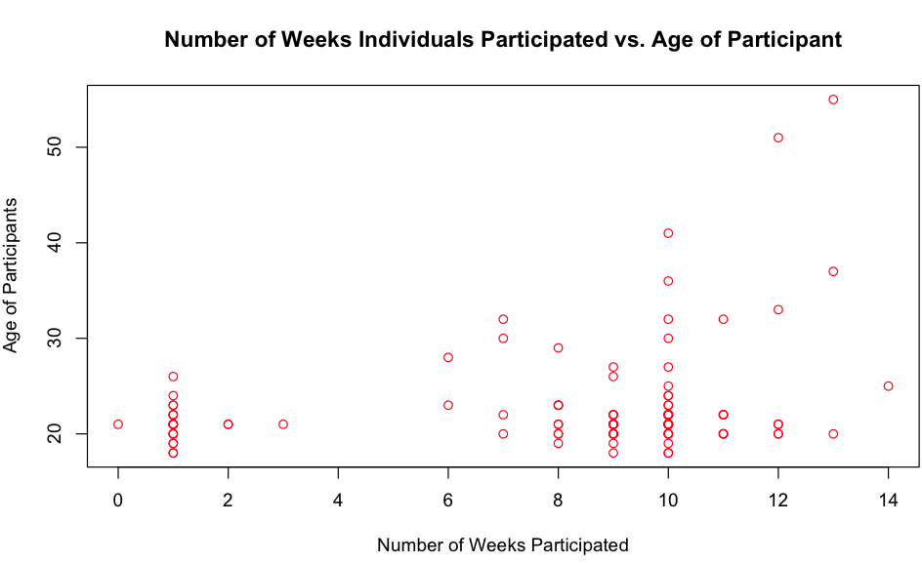

**Figure 1) This figure shows the difference between the age of participants in the student microbiome study and the number of weeks that they participated in the study.**

The mean age of all the individuals who participated in the study was 21 years of age, the median age was 23.05 years, the range in ages was 18 - 55 years. The gender makeup of the study featured a nearly two to one ratio of females to males, 78 females and 40 males began participating in the study, four individuals did not report their gender. Three universities participated in the study, 48 people attended Northern Arizona University, 78 attended the University of Colorado at Boulder, and 28 attended North Carolina State University.

During the course of the first ten weeks of the study, 28 participants dropped out in the first week, which was the week when the largest amount of participants dropped out. The mean age of individuals who dropped out of the study in the first week was 21.1 years of age. The next largest dropout rate in the study was during week nine, with 19 individuals failing to drop off samples after that week.

The third largest dropout rate occurred on week eight, where nine individuals dropped out. NCSU and UCB each had a dropout rate of ten individuals in the first week of the study, both of which superseded NAU. Thirty-four individuals completed the study through ten weeks, those individuals did not give any more samples, the median age of this group was 22, the average age was 23.08. There was a significant difference(𝞪 = .05) in the ages of a participants and the mean number of weeks in which they participated in the study (One way ANOVA P = .0178).

Three universities participated, with Northern Arizona University(NAU) having the highest number of participants. From the three universities, North Carolina State University had the highest dropout rate of the study with 13 individuals from weeks zero to six. The average age of participants at NAU was 24.4 years old, the average age at UCB was 21 years old, and the average age at NCSU was 21.15 years if age. There was a significant difference(𝞪 = .05) in the university that a participant attended and the mean amount of weeks that individuals participated in the study (One way ANOVA P = .0158).

Although gender was an important category to consider when analysis was being performed on the student microbiome project, gender did not have a significant effect in the participation rate in the study. Sixty four percent of participants in the study were females, and 32% of participants were males. The gender makeup of each university at NAU was 18 males and 28 females, UCB had 12 males and 33 females, and NCSU had ten males and 16 females. There was no significant difference with the gender of the participant and the mean number of weeks that an individual participated in the study.