Applicant: | Xihe (Ningbo) Fashion Technology Co., Ltd.
Address: | 3rd Floor, Block B, Hengyu Center, No. 200th Kechuang North Road, Haishu District, Ningbo City, Zhejiang Province, China
Contact Person: | Annie

Sample Description: | Shell fabric
Collection: | YOGURT COLLECTION | Colour: | 50 PASTEL BLUE
Season: | Spring-summer 26 | Fabric Content:
End Use: | TOP/trousers | Manufacturer: | -
Ref No.: | 37052530/37082529 | Order No. | 4800888948/4500888949/  4500888946/4500888947
Style No.: | 300604MP TOP YOGURT/  300605MP Trousers | Buyer:
Testing Stage: | Bulk | Retest-Previous Report No.: | -
Package Test: | Individual Test Items

Care Instruction: |  |  |  |  | 

Receipt Date of Sample: | Received on 2026-03-31
Date of Testing: | From 2026-03-31 to 2026-04-03
Sample Submitted: | The sample(s) and its (their) information was (were) submitted by applicant and identified.
Test Result: | Refer to next page.

TÜV SÜD Certification and Testing (China) Co., Ltd. Ningbo Branch
Prepared by: | Authorized by:
 | 
________________  Kiki Lu  Softlines Department | _____________________  Debra Cui  Softlines Department

Description of The Test Subject
Sample | Description | Photo
 | 63% viscose 37% linen woven fabric in 50 PASTEL BLUE | 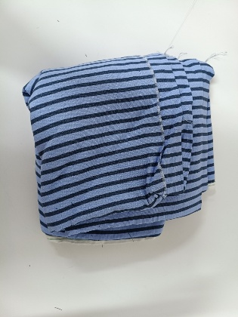

Conclusion
Test Items |  | Test Component | Conclusion
Individual Test Items
 | Determination of the slippage resistance of yarns at a seam in woven fabrics | A | Pass
 | Dimensional Change after washing | A | Fail
 | Colour Fastness to light | A | Fail

Remarks: | Pass = Meet Client’s Requirement | Fail = Below Client’s Requirement
 | * = No Specified Requirement | # = No Comments
 | N/A = Not Applicable | - = Not Conducted

TEST RESULTS

1 | Determination of the slippage resistance of yarns at a seam in woven fabrics
 | ISO 13936-1:2004
 | Slippage At 6mm | A | Client’s Requirement
 | Seam//Warp (N) | >200 | ≥150N
 | Seam//Weft (N) | >200 | ≥150N

2 | Dimensional Change after washing
 | ISO 5077:2007/ISO 3759:2011/ISO 6330:2021; Procedure No.:3M; Using horizontal axis, front-loading type machine: Machine wash at 30°C with 2 kg Total dry mass and ECE(A) detergent +TAED+ sodium perborate, line dry.
 | After 1 Wash | A | Client’s Requirement
 | Lengthwise (%) | -7.1 | ±3%
 | Widthwise (%) | -1.4 | ±3%

 | Remarks: | (+) Means Extension; (-) Means Shrinkage

3 | Colour Fastness to light
 | ISO 105-B02:2014; Use Water Cooled Xenon Arc Lamp
 | Up to Grade 5 | A | Client’s Requirement
 | Grade(blue wool standard) | 4 | ≥5

-End of The Test Report-

