

D4.2
The
DE-CONSPIRATOR FIMI Attribution Event Dataset

Organisation
dd/mm/yyyy






Project Information
ACRONYM | DE-CONSPIRATOR
TITLE | Detecting and Countering Information Suppression from A Transnational Perspective
GRANT AGREEMENT No | 101132671
START DATE OF THE PROJECT | 01/01/2024
DURATION OF THE PROJECT | 36 months (2024-2026)
TYPE OF ACTION | Research and Innovation Action (RIA)
TOPIC | HORIZON-CL2-2023-DEMOCRACY-01-02
COORDINATOR | Ozyegin University from Türkiye
PROJECT OVERVIEW | DE-CONSPIRATOR aims to explore how FIMI is currently deployed by Russia and China over Europe, by mapping, understanding, assessing and predicting different FIMI strategies and their effects on EU Members States and Partner Countries. DE-CONSPIRATOR uses state-of-the-art research methods and works closely with stakeholders to fully understand the success factors, manifestations, and impacts of Russian and Chinese FIMI and to provide data-driven policy solutions. By integrating various data sources and developing a comprehensive, multilingual database of FIMI incidents, the project intends to shield European democracies against internal and external FIMI threats, all while safeguarding freedom of expression and journalism integrity.

LEGAL NOTICE
The information and views set out in this report are those of the authors and do not necessarily reflect the official opinion of the European Union. Neither the European Union institutions and bodies nor any person acting on their behalf may be held responsible for the use which may be made of the information contained therein.

Document Information
DX.Y: Title of deliverable: | D4.2: The DE-CONSPIRATOR FIMI Attribution Event Dataset
Issued by: | Özyeğin University
Issue date: | 30/09/2026
Due date: | 30/09/2026
Work Package Leader: | Özyeğin University
© DE-CONSPIRATOR Consortium, 2024-2026
Reproduction is authorised provided the source is acknowledged.
Grant Agreement: 101132671 | Research and Innovation Action | 2024 – 2026 | Duration: 36 months
Topic: HORIZON-CL2-2023-DEMOCRACY-01-02. Type of Action: Research and Innovation Action (RIA)

Dissemination Level
PU | Public | X
PP | Restricted to other programme participants (including the EC Services)
RE | Restricted to a group specified by the consortium (including the EC Services)
CO | Confidential, only for members of the consortium (including the EC)

Version Control Sheet
Version | Date | Main modifications | Organisation
0.1 | 29/08/2026 | First complete draft for consortium review. | OzU
0.2 | 14/09/2026 | Internal review responses are collected. | OzU
1.0 | 22/09/2026 | The recommendations by the internal reviewers are applied and the deliverable finalized. | OzU
1.1 | 30/09/2026 | Reproducibility corrections after the internal reviews: dataset release v2.4.2 adopted throughout; Figures 3, 6, 15, 16 and 19 regenerated from the released file; the institutional-remit comparison withdrawn; the concentration, actor, quotation and response figures reconciled across the report, the codebook and the portal. | OzU
1.2 | 30/09/2026 | Trimmed edition for submission: Sections 2 to 7 merged into two sections, method detail deferred to the codebook, 7 duplicate figures removed, interoperability folded into the limitations; dataset release v2.4.3 with the registries workbook. | OzU

Main Authors
Name | Organisation
Assoc. Prof. Akin Unver | Özyeğin University
Dr. Azade Eryigit | Özyeğin University

Quality Reviewers
Name | Organisation
Dr. Jannis Kreienkamp | AdC
Dr. Bharath Ganesh | UvA

Table of Contents
Executive Summary 6
1. Introduction 7
2. Why we built an attribution record rather than a detector 8
3. What existing resources and the FIMI definition leave open 33
4. Design of the dataset 15
5. The document corpus 17
6. Extraction, verification and validation 19
7. Exploratory analysis 22
8. Limitations and interoperability 34
9. Implications for European policy 35
10. Access, licensing and maintenance 37
11. Conclusion 39
Supporting materials 39

List of Tables
Table 1: Precision of automated detection at news-archive scale, using the agreement rates measured above, treated as sensitivity and specificity, and a hypothetical classifier operating at 99% on both measures. 10
Table 2: Existing resources compared on five dimensions. 13
Table 3: Corpus construction stages. 17
Table 4: The 10 largest contributing institutions, counted at the canonical parent level. A jointly authored document contributes to each parent institution behind it, so the column sums to more than the number of jointly reported incidents. 18
Table 5: Results of the stratified validation sample. Records in the third column had the coded attribution supported by the quoted span; the remainder were either questionable or unsupported. 21
Table 6: Attributed states, over the 1,841 incidents for which a source names one. 24
Table 7: Completeness of response and impact fields. 33
Table 8: Supporting material and where it sits in the codebook. 39

List of Figures
Figure 1: Attributed incidents by year of occurrence and by year of publication. The publication curve trails the occurrence bars throughout the series. 23
Figure 2: Delay between an incident occurring and its first institutional attribution. Incidents reported in the year they occurred are shown in red. 23
Figure 3: Interval between occurrence and publication, by type of attributing institution. Boxes show the interquartile range and the red line the median. 24
Figure 4: Attributed state actor by year of occurrence. 25
Figure 5: Share of each institution type’s incidents attributed to Russia and to China. 26
Figure 6: Share of incidents in which the source identifies a specific actor; in the remainder the source characterises the actor loosely. 26
Figure 7: Most frequently recorded target countries, with the share of each country’s incidents drawn from that country’s own institutions shown in navy. 27
Figure 8: Recorded incidents per million inhabitants. Countries with no recorded incidents are shown in grey. Projection is Lambert azimuthal equal-area centred on Europe; boundaries are illustrative and imply no position on status. 28
Figure 9: Attribution flows between jurisdictions. Navy segments publish attributions; grey segments appear only as targets. Loops outside the ring are institutions reporting on their own country, sized by volume. Covers 2,412 of 3,029 incidents (80%): the target analysis population, less incidents without a recorded target or with an institution whose jurisdiction we have not yet classified. Targets receiving fewer than 10 attributions are pooled as Other targets. 29
Figure 10: Share of each year’s published attributions by type of attributing institution. 30
Figure 11: Most frequently coded DISARM techniques. Codes derive from analytical labels; a per-incident coding pass remains outstanding, as Section 8 explains. 31
Figure 12: Primary event type recorded for incidents attributed to Russia and to China, as a share of each state’s attributed incidents. 31
Figure 13: Confidence expressed by the source in its own attribution, by type of attributing institution. 32
Figure 14: Reported evidence of coordination against stated confidence in the attribution, as row percentages. We derive the underlying coordination field during extraction and have not yet verified it against source text, so this figure remains preliminary. 32

Abbreviations

ACLED | Armed Conflict Location and Event Data Project
CSV | Comma-separated values, the format of the data file
DISARM | Open-source framework describing the tactics, techniques and procedures used in information manipulation
DSA | Digital Services Act
EEAS | European External Action Service
FIMI | Foreign Information Manipulation and Interference
FIMI-ISAC | FIMI Information Sharing and Analysis Centre
GEC | Global Engagement Center, United States Department of State
GTD | Global Terrorism Database
ISO | International Organization for Standardization, here the ISO 8601 date format
LLM | Large language model
OpenCTI | Open platform for managing threat intelligence, used by several FIMI-ISAC members
OPIE | Online Political Influence Efforts dataset
SGDSN | Secrétariat général de la défense et de la sécurité nationale, France
STIX | Structured Threat Information Expression, a machine-readable format for threat intelligence
TTP | Tactics, techniques and procedures
UCDP | Uppsala Conflict Data Program

Executive Summary
In this deliverable we present an event-level dataset of the attributions of foreign information manipulation and interference that European and allied institutions have published, together with the reasoning that shaped how we built it. The dataset records 3,029 distinct incidents drawn from 534 documents published by 97 canonical institutions across Europe and allied jurisdictions. It covers 113 recorded target countries and incidents dated between 1903 and 2026, of which 2,682 of the 2,801 incidents with a known year of occurrence (95.8%) fall in 2013 or later. Every record carries a verbatim quotation from the source document that supports it.
The European Union regulates and responds to foreign information manipulation without a shared record of the incidents that its own institutions have attributed. Individual institutions publish detailed and expert reports, in incompatible formats, on different schedules, and without common identifiers for actors, targets or techniques. Anyone who wants to know how European institutions attribute this behaviour, how quickly they do so, or whether they corroborate one another must at present read several hundred documents by hand. We built the dataset to close that gap.
Before we built it, we tested the most direct alternative, in which a language model reads a news archive and identifies incidents of information manipulation for itself. We rejected that alternative on two independent grounds. The first is arithmetic. In the controlled test reported in Section 2, a second language model agreed with the extraction model’s own labels on redacted text for 97.5% of the incidents the extraction model had confirmed and for 95.0% of those it had rejected. These rates measure agreement between two model passes, because the reference labels are the pipeline’s own, so we do not treat them as a validation against institutional judgement.
When we apply the same rates to a news archive in which genuine incidents are rare, they produce approximately 51 false positives for every incident correctly identified, and a hypothetical classifier operating at 99% on both measures would still produce 10. Genuine incidents are rare in a news archive, so false positives dominate, and no classifier demonstrated on this task reaches the specificity that would change the result.
The second ground is accountability. A system that labels open news items as foreign manipulation passes judgement on speech, and the great majority of the items it would flag would be ordinary domestic politics.
We therefore designed the dataset so that the judgement of what constitutes foreign information manipulation stays with the institutions that already make it publicly and answer for it. European institutions hold the area expertise, the sources and the public accountability to decide whether an incident constitutes foreign information manipulation, and they exercise that judgement when they publish. They do not publish in a form that allows their attributions to be counted or compared, and the dataset supplies that form. We use automated extraction only to locate and structure attributions that institutions have already made, and we anchor every extracted field to a quotation that a reader can check against the source document.
Four findings follow from the dataset, and each describes how European institutions attribute foreign information manipulation. Institutions publish slowly: across the 2,708 incidents in the latency population, the median interval between an incident and its earliest appearance in an institutional report is 1 year, the mean is 2.13 years, and 26.2% of those incidents are first reported 3 or more years afterwards. Institutional reports rarely document what followed an attribution: source documents record an official response for 24.8% of the 3,029 incidents and an international response for 7.6%, and these figures describe what institutions reported and say nothing about whether anyone acted. Reporting is highly concentrated: 8 canonical institutions account for half of the 2,797 incidents with an identified reporting institution, 21 account for 80%, and the NATO Strategic Communications Centre of Excellence alone accounts for 515 incidents, 17.0% of all 3,029. Independent corroboration is rare: under our conservative linkage rule, only 30 of 3,029 incidents (less than 1%) are reported by more than one institution in separate documents.
We develop 5 recommendations from these findings in Section 9. Reporting on foreign information manipulation should carry timeliness expectations, because a system with a 1-year median delay cannot function as early warning. Institutions should link each attribution to a defined response pathway, because source documents record no official response for 75.2% of incidents. Member states that publish little should receive capacity support, because the record cannot distinguish an institution that detected an episode and did not publish it from one that lacked the capacity to detect it. A common incident schema and structured exchange should become obligatory, because the Union cannot at present distinguish where manipulation is concentrated from where reporting is concentrated. Reporting should also record which criterion an institution applied, because institutions attribute on a mixture of grounds and a reader cannot tell which.
The dataset supports claims about the structure, intensity and dynamics of European institutional attribution of foreign information manipulation, and it does not support claims about the incidence, distribution or trend of foreign information manipulation itself. We reproduce any mistake the institutions in our corpus made, and no field in the dataset lets us detect it.

1. Introduction
European institutions have published attributions of foreign information manipulation for a decade. Intelligence services describe operations in annual reviews, specialised government units publish technical investigations of coordinated networks, and civil-society organisations document campaigns during election periods. This material is now considerable in volume and often high in quality, and researchers and policymakers can still barely use it, because each institution writes in its own format, names actors in its own way, and describes incidents at whatever level of aggregation suits its purpose. Without a common record, nobody can count the incidents these institutions have attributed.
A policymaker who wants to know whether attribution has become faster over the past 5 years cannot find out, and an analyst who wants to know whether two institutions have described the same operation must read both reports in full. A researcher who wants to model which countries are targeted must first decide whether apparent variation reflects exposure or reporting effort, and no existing resource lets the researcher draw that distinction.
We address that absence with a dataset in which each row is a single attributed incident, described in structured fields, tied to the document and page it came from, and accompanied by a verbatim quotation supporting the attribution. The dataset covers 3,029 distinct incidents drawn from 534 documents published by 97 canonical institutions under 108 source identities; 526 of the 534 documents contribute at least one incident that we retain as its representative record, and Sections 4 and 6 define the representative record and the source identity.
The deliverable also offers an ontology for building FIMI event datasets and a framework for standardising a scattered attribution field. We align that framework with the vocabulary that the EEAS and DISARM already use, and we provide a crosswalk to STIX and OpenCTI so that European practitioners can map the record into the tools they run.
The deliverable also sets out an accountable and transparent method for logging FIMI incident data. Building the record requires reading tens of thousands of pages, more than any team can read by hand, so we must use some automated reading, and we therefore had to decide what automated systems should be permitted to do.
We tested the strongest version of the automated approach, in which a language model reads news reports and decides for itself which describe foreign information manipulation. The approach produces about 51 false flags for every genuine incident at news-archive prevalence, a ratio that follows from the rarity of incidents and that better models do not repair, and it would turn a FIMI detection service into an instrument for suppressing speech. Section 2 sets out the test and the case against unsupervised detection of FIMI incidents, and Sections 4 to 6 describe a design in which automated reading performs only tasks that human expert annotation can check.
DE-CONSPIRATOR has approached the measurement of foreign information manipulation from several directions, and this deliverable is one of them. D2.3 examined how Russian and Chinese strategic and military doctrines conceive of information as an instrument of policy. D3.1 developed a method for tracing the domestic actors who amplify manipulation, working upward from Telegram channels through cross-platform hyperlinks. D3.3 carried that method through to results, mapping the domestic media outlets and communities through which foreign narratives reach European audiences. D4.1 produced an instrument that allows a defender to judge, in the moment, how significant a given incident is and whether to respond to it. D6.1 and D6.2 measured public exposure to manipulation through surveys across 13 countries.
We borrow from those deliverables selectively, above all on how human experts annotate what constitutes FIMI beyond disinformation, and Sections 4 and 6 set out what we take from each in the design of the dataset and its coding. Our coding choices rest on conceptual decisions the project made earlier, and a reader who wants to contest a coding choice can trace it back to the deliverable in which we made it.
Section 2 explains why we need an event-level record of attribution, reports our experiment on the automated detection of FIMI incidents, and gives the reasons we did not pursue it. Section 3 reviews the resources that already exist, including a comparison with the EUvsDisinfo database, sets out the conceptual problem we found in the FIMI definition, and asks whether the concept has produced an object of study distinct from disinformation. Section 4 sets out the design of the dataset, Section 5 describes how we assembled the document corpus and what it covers, and Section 6 describes the extraction pipeline together with the validation we ran on it. Section 7 presents the exploratory analysis. Section 8 states the limitations and why a combined FIMI dataset is not currently constructible, and Section 9 draws the policy implications. Section 10 covers access and maintenance, and Section 11 concludes. The codebook and the registries workbook carry the supporting materials.

2. Why we built an attribution record rather than a detector
Foreign information manipulation is now the subject of European legislation, diplomatic action and institutional capacity-building. The Digital Services Act creates obligations for very large platforms in relation to systemic risks that include coordinated manipulation. The European External Action Service maintains a threat-reporting function and a public exchange with member states and civil society. Member states have established dedicated units. All of this activity proceeds without a public record of the incidents that European institutions have themselves identified and attributed.
The European Union already holds event records in adjacent policy domains. On armed conflict it draws on the Uppsala Conflict Data Program and the Armed Conflict Location and Event Data Project, both of which record individual events with dates, locations and participants. On terrorism it draws on the Global Terrorism Database. On cybersecurity, structured threat intelligence formats allow organisations to exchange incidents in machine-readable form. In each case an event record makes it possible to ask whether a problem is growing, where it is concentrated, and whether responses have made any difference.
European institutions have built some components of such a system, and none has built the record. The DISARM framework provides a shared vocabulary for describing techniques. The FIMI-ISAC provides a venue in which member organisations exchange findings. The European External Action Service publishes periodic threat reports containing incident counts. We found no persistent, public, machine-readable record in which incidents attributed by many institutions can be counted, compared across institutions and traced to the attributing document, and Section 3 examines how the resources the European External Action Service published in 2026 bear on that claim.
We built the record to answer 4 questions, and Section 7 answers each of them. First, policy documents describe the European response as early warning, and a record that carries both an occurrence date and a publication date shows whether institutions publish at that speed. Second, analysts understand attribution as a step towards sanction, prosecution, platform enforcement or rebuttal, and a record of whether each source document reports an official or international response shows whether action follows. Third, if a few institutions produce most of the record, the European picture of the threat depends on their continued funding and independence, and an institution field shows how records distribute across institutions. Fourth, when two institutions independently describe the same operation their agreement carries weight that neither report carries alone, and incidents identified separately from the documents that report them show how often that happens. Each answer describes the European institutional system.
We could most directly build such a record by giving a language model a large archive of news reporting and asking it to identify the items that describe manipulation. The archive already exists, the reading is cheap, and the resulting record would not depend on whether any institution had chosen to publish. We examined this approach before adopting the design described in Section 4, and we rejected it on two grounds, which the following paragraphs set out.
We tested the approach on the dataset itself. We drew 80 incident descriptions: 40 that the extraction model had classified as manipulation and 40 drawn from the 80 it had rejected. The 20 rejected records in the Section 6 validation sample come from the same 80 rejected records, so the two samples are not independent. We stripped each description of every cue that would make the classification trivial: we replaced named actors, state names and their adjectives with placeholders, and we removed terms that presuppose the answer, such as propaganda, disinformation, influence operation and the names of known operations. A second language model then classified each item by a single rule, whether it describes a foreign state or state-linked actor manipulating the information environment of another country, and we fixed its predictions before consulting the labels.
The second model agreed with the reference label for 77 of the 80 items: positive-label agreement of 97.5% (39 of 40; 95% interval 88.9% to 99.7%) and negative-label agreement of 95.0% (38 of 40; 95% interval 84.9% to 98.9%). The reference labels are the pipeline’s own, recorded in model_fimi_status, so the test measures agreement between two model passes on redacted text and does not measure accuracy against the judgements institutions published.
The row identifiers of both samples, the redacted inputs, the model version and settings, the predictions and the scoring script form the detection folder that Section 10 lists among the materials deposited with the repository record.
We then applied the measured rates, treated as sensitivity and specificity, to a corpus of the size and composition the approach would require. A news archive contains reporting on elections, protests, legislation, crime, sport and commerce, and only a small proportion of its items describe a foreign manipulation incident. In a corpus of 1,000,000 news items in which 1 in 1,000 describes an incident, the measured rates would yield 975 correct identifications and 49,950 false ones, roughly 51 false flags for every correct one. Table 1 sets out the arithmetic across a range of assumptions.
Better models do not repair this ratio. False positives scale with the 999,000 non-incident items and true positives with the 1,000 incidents, so the share of flagged items that are genuine falls in proportion to prevalence, and improving sensitivity, which is what most model development optimises, operates only on the small numerator. A classifier at 99% on both measures would still produce 10 false flags per correct identification, and the ratio worsens as prevalence falls; no classifier has demonstrated 99% on a task whose positive class rests on contested political judgement. Raising the decision threshold reduces false positives and increases missed incidents, so it changes which error dominates without lowering the total.
A future system with higher specificity, a staged design that retrieves candidates before classifying them, or a higher-prevalence corpus might reach usable precision. The performance demonstrated so far does not justify labelling items across a whole archive without human review.

Table 1: Precision of automated detection at news-archive scale, using the agreement rates measured above, treated as sensitivity and specificity, and a hypothetical classifier operating at 99% on both measures.
Incidents per million items | Precision, measured classifier | False flags per correct one, measured | Precision, 99% / 99% classifier | False flags per correct one, 99% / 99%
50,000 (5%) | 0.507 | 1.0 | 0.839 | 0.2
10,000 (1%) | 0.165 | 5.1 | 0.500 | 1.0
5,000 (0.5%) | 0.089 | 10.2 | 0.332 | 2.0
1,000 (0.1%) | 0.019 | 51.2 | 0.090 | 10.1
500 (0.05%) | 0.010 | 102.5 | 0.047 | 20.2
100 (0.01%) | 0.002 | 512.8 | 0.010 | 101.0

The test was easier than the task the approach would face, in three respects. Two language models of the same class agree with each other more readily than either agrees with a human coder, so agreement with the extraction model’s labels overstates agreement with expert coding. Each item was an analyst-written summary in which someone had already isolated and bounded the incident, whereas a news archive presents an incident, if at all, as one strand among several. Redaction could not remove every contextual signal, since an item describing accounts impersonating a national broadcaster carries information about coordination that no redaction of state names removes. We measured no performance against expert judgement, so the rates set no bound on that performance in either direction.
Whoever classifies a piece of public communication as foreign interference removes it from the category of domestic political expression, and that removal has consequences for the person or outlet that published the material. In the European regulatory environment it can bear on platform enforcement and on the obligations of very large online platforms. When an institution makes that judgement it does so in public, under a name, with evidence it can be asked to produce, and with the possibility of being contradicted. A classifier operating over an archive makes the same judgement at scale, without evidence a subject could contest, and without any body that answers for it.
Most of the items such a system would flag are ordinary political argument. Table 1 shows that flagged non-incidents would outnumber genuine incidents by 51 to 1 at the measured rates. Much of the political argument a news archive contains criticises governments, and some of it appears in minority languages or in outlets outside the mainstream. Such a system would create a risk to freedom of expression under Article 11 of the Charter, because its false positives would fall on dissenting and minority-language speech and its output would carry the authority of a European research instrument, and its accuracy on the rare true positives does not offset that risk.
DE-CONSPIRATOR has itself described the mechanisms by which actors suppress information, including the abuse of platform reporting mechanisms to remove inconvenient content and the manipulation of algorithmic exposure. A tool that automatically labels published material as foreign interference would supply exactly the instrument those mechanisms exploit, and we do not propose to build one.
We drew one design rule from both objections. Institutions that make the judgement publicly, and answer for it, should continue to decide whether something constitutes foreign information manipulation. Automated systems can read large quantities of text and extract structured information from it reliably, provided that a reader can check every extraction against the source. In the design set out in Section 4, institutions decide what counts as foreign information manipulation, the extraction model reads their documents and structures the attributions, and every field carries a quotation that a reader can check against the source.
The three items the second model classified differently from the pipeline show where the concept itself is unsettled. One was an anonymous page circulating Icelandic-language material against left-wing politicians, one the campaign to conceal the poisoning of Alexey Navalny, and one a series of cyberattacks on Ukrainian power infrastructure. Each falls on a boundary: between domestic and foreign activity, between concealing information and manipulating it, and between attacking infrastructure and attacking the information environment. Section 3 shows that institutions themselves contest those boundaries. Where expert institutions disagree about whether an episode falls inside the concept, a classifier has no ground truth to approximate.
These boundary disputes arise because the governing definition turns on deceptive behaviour, and institutions least often publish, or claim to hold, evidence of behaviour: infrastructure, coordination, audience selection and intent. An institution that is confident an episode is hostile, and has no evidence of deception, describes what it can observe, which is the content and the harm. National intelligence services state high confidence in 75% of their attributions, more often than any other institution type, and disclose least about the basis of that confidence. The dataset therefore records what an institution stated separately from what it disclosed, and Section 7 shows that the two do not track one another.

3. What existing resources and the FIMI definition leave open
Several substantial resources record aspects of foreign information manipulation, and we borrow from each of them what it does well. Five families of resource are relevant: the EUvsDisinfo database, platform disclosures, investigative reports, academic datasets, and the conflict and terrorism event datasets that serve as models. We assess each on the same 5 questions: what the unit of observation is, where the material comes from, who decides whether an item counts, how the resource is maintained, and whether a machine can process it.
The best known European resource is the EUvsDisinfo database, which the East StratCom Task Force of the European External Action Service maintains. It reports 19,749 collected and debunked cases as of August 2026. Each entry records a claim that has appeared in pro-Kremlin media, together with a refutation. Our comparison below uses two published research extracts, a case-level file of 14,497 records and an article-level file of 18,249 records, and we cite the live database only for its current total. Researchers also cite a third extract of 8,522 unique English debunk pages, and published work often treats the 19,749, 14,497 and 8,522 figures as if they counted the same thing.
The unit of observation is a claim as it appeared in a particular article. A single coordinated campaign may generate hundreds of entries, and a campaign that produced no identifiable false claim generates none, even where the manipulation consisted of coordinated inauthentic amplification of accurate material. The East StratCom Task Force alone decides what enters the database, so the resource records one organisation’s judgement and cannot show how other European institutions judge the same material. Critics of the database argue that it cannot separate false messages from messages that merely align with Russian foreign policy, and Section 2 has argued that who makes that distinction matters.
Social media companies periodically publish accounts of the coordinated networks they have removed. Meta issues adversarial threat reports, Google’s Threat Analysis Group publishes bulletins, and between 2018 and 2021 Twitter released a large archive of accounts attributed to state-linked operations. These disclosures are detailed and are often the only public source of platform-internal evidence such as account creation dates or advertising expenditure. The unit is a takedown defined by the platform’s own enforcement categories, and the platforms decide both what they detect and what they disclose. Twitter has not updated its archive since 2021, so a resource that depends on a commercial firm’s voluntary disclosure can stop without notice.
Organisations including Graphika, the Digital Forensic Research Lab, Recorded Future, Correctiv and CheckFirst publish investigations of individual operations. These reports are frequently the origin of the attributions that later appear in official documents, and their technical depth exceeds that of most government publications. Each report is written as a narrative of one operation, and no shared schema, common actor naming or systematic index exists across organisations. The same operation may appear under different names in reports by different organisations, and establishing that two reports describe the same activity generally requires expert reading. Commercial access restrictions cover some of the material.
The closest existing resources are academic. The Online Political Influence Efforts dataset records influence operations identified in public reporting, coded for actor, target and objective, and the Stanford Internet Observatory maintains an archive of platform takedown material with analytical write-ups. These resources share our aim of turning scattered reporting into structured records, and they differ from ours in unit size and in how recent their coverage is. Their coders record an influence effort at the level of a campaign directed by one actor at one target country over a period of years, which is a coarser unit than the incident. Both cover recent European material thinly, and individual research groups maintain them without institutional guarantee.
The conflict and terrorism datasets serve as models for our design, and analysts often misdescribe what those datasets record. Analysts sometimes assume that the Uppsala Conflict Data Program and the Armed Conflict Location and Event Data Project record events as they occurred, and that our dataset differs from them in recording only what institutions said. Both projects build their datasets from reporting, principally media reporting supplemented by partner organisations, and their documentation says so. Their distributions therefore reflect where journalists were present as well as where violence occurred.
Researchers trust those datasets because their compilers follow 4 practices. The compilers apply explicit definitional thresholds, so that anyone can examine and contest the criteria for inclusion. They triangulate across sources and record how many sources support each event. They code uncertainty explicitly, including the precision of dates and the confidence of actor identification. They decline to code intent and restrict themselves to what can be observed and reported.
We match the first, third and fourth of those practices by design, as Section 4 explains. Source triangulation, the second, is largely unavailable in this domain: Section 7 shows that 30 of 3,029 incidents (less than 1%) are independently corroborated. European institutions rarely corroborate one another, and Section 9 builds a recommendation on that finding.
The literature on those datasets supplies two further lessons. First, studies of conflict and protest event data have shown consistently that reporting is a biased sample of events, and the shape of that bias is known. Coverage declines with distance from population centres, with the absence of journalists, and with the political cost of reporting; it increases with the involvement of prominent actors and with the availability of dramatic material. Observed event counts therefore confound the intensity of activity with the intensity of observation, and any analysis that treats counts as measures of activity inherits that confound. The distributions in Section 7 face the same problem, with the added complication that the observers here are institutions with security mandates and political principals.
We use two responses to that bias. Comparison within a single source holds the observing institution constant, so it cannot generate spurious variation between periods or actors that the same reporter observed. Treating the reporting process itself as the object of study turns the bias into a finding about the observing institutions, and this deliverable does that throughout. A third response, modelling the detection process, is unavailable to us, because it requires several independent observations of each event and more than 99% of the incidents here are observed by one institution. Decisions about what counts as one event also produce large differences in counts, and Section 6 measures that problem directly in this corpus.
Second, research on the public attribution of cyber operations has established that attribution is a decision taken under uncertainty, in which technical evidence is one input among several, and in which the choice to speak publicly is separable from the choice to form a private judgement.
Two implications follow for this dataset. The absence of an attribution is not evidence of the absence of a judgement, since an institution may hold a firm view and decline to publish it. Every distribution in Section 7 is therefore conditioned on the decision to publish, and the data cannot show that conditioning.
Institutions also differ in the confidence language they use. Because attribution is a decision under uncertainty, institutions have developed vocabularies for expressing how much uncertainty remains, of which the estimative language used by intelligence services is the most formalised. Those vocabularies are not standardised across institution types, and Section 7 shows that the confidence an institution states does not track the evidence it discloses. An analyst comparing confidence levels across institutions is therefore comparing conventions as much as beliefs, and we record the stated language precisely so that an analyst can make that comparison explicitly.
No existing resource records incidents at the level of the individual event, across many institutions and jurisdictions, with the attributed actor named as the attributing institution named it, with each record anchored to a verifiable quotation, coded against a shared technique framework, and distributed in a form that a machine can read. Table 2 summarises the comparison.
Table 2: Existing resources compared on five dimensions.
Resource family | Unit | Source basis | Who adjudicates | Coverage of European institutions | Machine-readable
Debunk registries | Claim instance | Monitored media | Single institution | One institution | Partly
Platform archives | Takedown | Platform-internal | Platform | None | Yes, when released
Vendor investigations | Operation narrative | Original research | Publishing organisation | Some | No
Academic datasets | Campaign | Public reporting | Research team | Partial | Yes
Conflict datasets | Event | Media and partners | Trained coders | Not applicable | Yes
This dataset | Attributed incident | Institutional reports | Publishing institution | 97 institutions | Yes

EUvsDisinfo is the resource most often set beside ours, and the two cannot be merged. Its country field records the country a claim concerns, ours the information space a claim was directed at, and a merge would silently corrupt the target distribution of whichever dataset absorbed the other. The two resources also answer different questions: theirs can say which outlet published a claim, in what language and what it asserted; ours can say who attributed it, to which actor, with what confidence, using which technique, and whether anyone responded.
We can compare the composition of the two resources. Over the window they share, with ours restricted to incidents attributed to Russia, we compare 716 of our incidents against 14,497 of their cases. The two profiles of attention differ by a total variation distance of 0.34, meaning that 34% of one profile would have to move to match the other. We devote proportionally 8.8 times more attention to Latvia, 8.6 times more to Bulgaria and 2.9 times more to Georgia, and they devote more to Ukraine, the United States, Poland, Belarus and Syria: we cover the small European states with active national institutions, and they cover the large theatres a central monitoring unit watches. Their output peaks in 2020 and ours in 2022, the year of the full-scale invasion of Ukraine.
The European External Action Service published its fourth annual report on foreign information manipulation threats in March 2026, 5 months before this deliverable was due. That report analyses 540 incidents detected during 2025, attributes 29% to Russia and 6% to China while leaving 65% unattributed, and records that 27% of incidents involved artificial intelligence, a rise of 259% on 2024. It introduces the FIMI Deterrence Playbook, a framework organised around 4 intervention phases covering organisational structures, digital infrastructure, content production and amplification. The Service also launched the FIMI Explorer, which it describes as the first publicly available interactive dashboard on information manipulation activities and intends as a long-lived resource with regular updates.
These publications leave open the gap that Table 2 identifies: neither provides a downloadable, cross-institutional, event-level record in which each entry carries the attributing institution, the document and page, and the supporting quotation. The FIMI Explorer presents incidents the Service itself detected, through an interface; our dataset records what 97 institutions across Europe and allied jurisdictions said, in a file a researcher can download and recompute. The two are complements: the annual report gives the Union’s own threat picture, and this dataset gives the cross-institutional record.
The Deterrence Playbook organises intervention around making manipulation costly, which requires evidence about which responses followed which attributions. Section 7 shows that attributing documents record an official response for 24.8% of incidents and an international response for 7.6%, and Section 9 builds on that finding.
The definition we inherit, adopted by the European External Action Service and used in D4.1, holds that foreign information manipulation and interference is a pattern of behaviour that is intentional, coordinated and manipulative in character. Under that definition the behaviour must be deceptive, and the content need not be misleading. The formulation is deliberate: it lets an institution attribute coordinated amplification of accurate material, and it excludes an honest error. It also admits a category, accurate content published openly with hostile intent, whose size the dataset can measure.
Three properties of a communication vary independently: whether what is said is true, whether its origin is concealed or its popularity manufactured, and whether it damages the interests of those it reaches. We operationalise manipulative character through the second property, because an institution can evidence concealed origin and manufactured popularity from a published document, and a different operationalisation would give different figures. Under that reading neither falsity nor adverse effect is necessary or sufficient.
No instrument built to detect the phenomenon captures one combination: a foreign state saying something accurate, under its own name, in order to damage. That is public diplomacy conducted adversarially. Adversarial public diplomacy is lawful and protected under the same provisions as domestic political speech, democracies practise it as much as their opponents do, and no reading of the governing definition makes it manipulation.
The dataset lets us measure how much of the record sits in that combination. Table 17 of the codebook maps each recorded actor type onto a disclosure axis, so that any reader can regenerate the figures. Among the 1,600 incidents where the source identified a specific actor type, 1,071 (66.9%) are openly attributable, that is states including officials acting in office, state media and diplomatic missions, and 529 (33.1%) are concealed, that is named operations, proxy networks and intelligence services. Combining that axis with the coordination evidence each source reported gives 518 incidents (17.1% of 3,029) attributed to an openly identifiable actor with no strong evidence of coordination, of which institutions state high confidence in 332. The clearest cases, because the actor is a state body acting under its own name, are the 69 incidents attributed to diplomatic missions, 63 of them at high confidence: an embassy objecting to a Swedish newspaper editorial, an embassy criticising named analysts in the Czech Republic, a consulate funding influencer promotion of an Olympic Games. We made the mapping ourselves, and we pool weak, absent and unrecorded coordination evidence, so the 66.9% to 33.1% split is the firmer figure.
Every resource examined above is blind to that combination for structural reasons: a debunk register requires something false to disprove, a platform archive records takedowns that follow inauthenticity, and a classifier trained on falsity cannot detect true content while one trained on adverse effect sweeps in ordinary political criticism. In 518 of this dataset’s 3,029 records (17.1%), the published evidence does not demonstrate both the behavioural and the coordination elements of the definition under our operationalisation. The finding concerns what institutions disclose: the source did not evidence the behaviour, and whether it occurred lies outside the record. Section 9 sets out the consequence for policy.
Critics of the field argue, and we share the concern, that research on foreign information manipulation returns repeatedly to false and misleading content and has not named a phenomenon distinct from disinformation and propaganda. The DISARM framework lets us test that criticism, because it describes the full operational chain of an influence operation: 391 techniques in 16 tactics across 4 phases. Every technique code in the dataset resolves against the DISARM Foundation’s master data, 77 codes across 12,518 technique mentions. The corpus touches 14 of the 16 tactics, and the techniques that dominate it concern infrastructure and amplification: the laundering of information assets, amplification through inauthentic sites, automated forwarding by bots, fake experts and constructed personas. Institutions describe infrastructure and inauthentic amplification, which classical research on disinformation did not systematically record.
Institutions have not moved their attention to either end of the chain. Of 12,518 technique mentions, the Plan phase accounts for 26.5%, Prepare for 43.6% and Execute for 29.9%; the Assess phase accounts for none, and 2 tactics, Assess Effectiveness and Target Audience Analysis, have no coverage in 3,029 incidents from 526 documents. Source documents record evidence of impact for 35.6% of incidents, an official response for 24.8% and an international response for 7.6%. Within this record, institutions now describe the network that carries a claim as well as the claim itself, and they do not describe intent, audience selection or effect, which the definition of interference requires.

4. Design of the dataset
The dataset records attributed incidents. An incident is a bounded episode of information manipulation as an institution describes it in a document: an identifiable activity, conducted by an identified or characterised actor, directed at an identified target, at a stated or inferable time. One row corresponds to one incident as described in one document.
Because a document’s statement defines the row, the same underlying operation described by two institutions produces two rows, and the dataset records the duplicate description. We subsequently link those rows to a common incident identifier, which allows a user to count either institutional statements or distinct incidents. Section 6 describes the linkage procedure and Section 7 reports what it found.
The design rests on a distinction between judgement and reading. Deciding that an episode constitutes foreign information manipulation requires evidence that is generally absent from any text: knowledge of infrastructure, of coordination patterns, of actor identity, and often of intelligence sources. Institutions possess that evidence, or claim to, and they accept public responsibility for the resulting judgement. Reading a published report and recording what it says requires no such evidence, and anyone with access to the document can check the accuracy of the reading.
The dataset therefore contains no field in which we assert whether an attribution is correct. It records what institutions claimed, with what stated confidence, on what disclosed basis. A reader who doubts a record can consult the quoted span and the cited page. A reader who doubts the underlying attribution must take that up with the institution that made it, which is the appropriate place for such a dispute.
The European attribution ecosystem comprises at least 97 institutions publishing in many languages, on irregular schedules, with no shared vocabulary for actors, techniques or targets, and no incentive for any individual institution to make its output comparable with anyone else’s. An intelligence service writes an annual review for a domestic political audience, a specialised technical unit writes a forensic report for a policy audience, and a civil-society organisation writes an election monitoring report for donors and journalists. Each institution writes for its own audience, and no institution publishes its attributions in a form that another could count or compare. No institution will consolidate the record, and the measurements in Section 7 on reporting delay, on the coupling between attribution and response, on concentration and on corroboration exist only in the aggregate.
A dataset built from published reports records the output of a process with several stages, and each stage can remove material that the preceding stage contained. An incident enters this dataset only if 5 conditions hold in sequence. The manipulation must occur; some institution must detect it; that institution must judge the evidence sufficient to attribute it; it must then decide to publish the attribution instead of retaining it internally; and the resulting document must be retrieved by the corpus construction described in Section 5 and its content correctly extracted. A record in the dataset is evidence that all 5 conditions held. The absence of a record is consistent with the failure of any one of them, and the dataset contains no information that would distinguish which.
Observed counts are therefore the product of an occurrence rate and a chain of conditional probabilities, none of which we observe separately. Section 7 reports 117 incidents per million inhabitants for Latvia and 1.6 for Germany. That ratio combines differences in exposure, detection capability, evidentiary threshold, publication practice and retrieval, and our analysis cannot apportion it between them. Presenting such a ratio as a measure of relative targeting would attribute the whole of it to exposure alone.
Two consequences for analysis follow, and we use both in Section 7. Comparisons that hold the observing institution constant are more defensible than comparisons across institutions, because a single institution’s detection and publication practices, while unknown, are at least approximately stable. Comparisons of composition are more defensible than comparisons of level, because the share of an institution’s own output devoted to one actor or one target does not depend on how much that institution publishes overall. The domestic-share analysis in Section 7 rests on this principle.
We nonetheless estimate 3 quantities directly, because they are properties of the published record itself and so escape this difficulty. The interval between occurrence and publication is measured within records that exist, so it describes the speed of the institutions that did publish. The proportion of incidents described by more than one institution is a property of the corpus. The proportion of records that report an official response is a property of what institutions wrote. Section 7 builds on these 3 quantities, and they count as findings about the attribution system because they require no assumption about unobserved manipulation.
Three questions about validity arise for a dataset of this kind. The first asks whether the fields capture what the source documents say. A reader can answer that question by inspection, and the quotation verification and the sample assessment in Section 6 measure it. The relevant standard is that an independent reader holding the source document should reach the same coded values, and the available evidence indicates that dates and target countries meet this standard more reliably than attribution fields do.
The second asks whether the concept the dataset operationalises is coherent. The concept is the public attribution of foreign information manipulation by an institution, and it is well defined in the sense that anyone can identify its instances: an attribution either appears in a published document or it does not. It is less well defined at the boundaries that Section 2 identified, where institutions themselves disagree about whether domestic actors, concealment or cyber operations fall within it. The dataset records how each institution resolved those disagreements, so the boundary becomes an observable variable.
The third asks whether the dataset predicts or corresponds to anything outside itself. The dataset answers this question least well, and we did not build it to answer it. No external criterion exists against which anyone could validate attribution counts, because no independent measure of foreign information manipulation exists. The nearest available comparison is with survey measures of public exposure, which DE-CONSPIRATOR has collected separately, and Section 10 identifies that comparison as the most informative external check we can perform.
Each row of the released file carries 81 variables in 13 blocks: identification, temporal, actor, target, technique and provenance fields, each defined in Section 4 of the codebook with its type, completeness and permitted values. We record the actor by category, because event data needs the split between state and non-state actors and the type of non-state actor, and because the released file then carries no personal name in a structured field.
Seven fields record the extraction model’s own judgement, including whether the model considered the incident to constitute foreign information manipulation and whether it inferred an intent. We retain these fields because they document what the pipeline produced and because Section 6 uses them as evidence about model behaviour. They carry a model_ prefix, and we exclude them from every analysis in Section 7; Section 8 sets out the reasoning.
The schema also distinguishes fields that record what a source stated from fields that record what a coder or a script derived, because the two carry different evidentiary status. A stated confidence level is a fact about the document, whereas the actor category is an inference about the kind of entity the document meant, and only the first is recoverable by a reader holding the source.
We code incidents against the DISARM framework, which the EEAS and the FIMI-ISAC both use, so that records can be related to existing European practice. The dataset uses the expanded 391-technique reference, and we remap codes appearing in older documents under the earlier 136-technique version, recording each remapping in a dedicated field so that the original code remains recoverable.
Records carry a mean of 4.30 technique codes and draw on 77 of the 391 techniques. We assigned the codes from analytical labels applied during extraction, and a second pass assigning techniques directly from each incident remains outstanding. The technique distributions in Section 7 therefore indicate how institutions describe manipulation and do not yet constitute a full technical coding.
Because the FIMI-ISAC operates on OpenCTI and exchanges material in the STIX format, Appendix D of the codebook provides a crosswalk that maps incidents, actors and techniques onto STIX objects. We aligned the crosswalk with the exchange European practitioners already run, because practitioners adopt what fits the tools they use.

5. The document corpus
The dataset can only record what the corpus contains, so the way we assembled the corpus determines what the dataset can and cannot support. In this section we describe the assembly as a protocol, state what the corpus covers, and identify what we know to be missing.
We built the corpus in 5 stages, which Table 3 lists, and institutions entered the registry at different stages.
Table 3: Corpus construction stages.
Stage | Activity | Output | Contributors
1 | We compiled the institutions identified in earlier DE-CONSPIRATOR deliverables into an initial registry. | Initial institution list | Project team
2 | Consortium partners and the advisory board nominated further institutions in their own jurisdictions and fields. | Registry expanded to 145 institutions | Consortium partners, advisory board
3 | We assessed each institution for relevance on a 3-point scale and flagged whether it publishes attributions rather than commentary. | Scored registry | Project team
4 | We built publication inventories for institutions above the relevance threshold, then retrieved and verified the documents. | 690 files retrieved | Researchers, assisted by automated site mapping
5 | We deduplicated files by content hash and screened them for machine-readable text. | 686 unique files, 680 submitted to extraction | Project team
We combined automated and human work to retrieve documents. We used language models to generate publication inventories from institutional websites, listing candidate documents. Researchers then retrieved each candidate, confirmed that it originated from the institution in question, and verified that it contained specific attributions. No document entered the corpus without human confirmation.
Of the 680 documents submitted to extraction, 534 yielded at least one attributed incident. We retained the remaining 146 in the corpus record, and they produced no rows, generally because they discussed foreign information manipulation in general terms without describing specific incidents.
Our sample is purposive. Experts in the field considered the selected institutions relevant, and we did not select them at random from a defined population, so we can assign no probability of inclusion to any document. For the institutions in the registry, we sought every publicly available attribution document as of the collection date, and each institution’s record notes what we retrieved and what we sought unsuccessfully.
The corpus contains 534 documents that yielded incidents, published by 97 canonical institutions. These include national intelligence and security services, specialised government units, European Union bodies, multinational centres of excellence, academic centres and civil-society organisations. Incidents in the dataset are dated between 1903 and 2026 and concern targets in 113 countries. Of the 2,801 incidents with a known year of occurrence, 2,682 (95.8%) fall in 2013 or later; the small number of historical cases enter the record because contemporary institutions described them while establishing long-run patterns.
A few institutions publish most of the record. Among the 2,797 incidents for which we identify a reporting institution, 8 canonical parent institutions account for half and 21 account for 80%. The largest single contributor, the NATO Strategic Communications Centre of Excellence, accounts for 515 incidents, or 17.0% of all 3,029. Table 4 lists the 10 largest contributors.
Table 4: The 10 largest contributing institutions, counted at the canonical parent level. A jointly authored document contributes to each parent institution behind it, so the column sums to more than the number of jointly reported incidents.
Parent institution | Incidents | Share of 3,029
NATO Strategic Communications Centre of Excellence | 515 | 17.0%
Atlantic Council, including the Digital Forensic Research Lab | 256 | 8.5%
Center for the Study of Democracy | 131 | 4.3%
European Centre of Excellence for Countering Hybrid Threats | 119 | 3.9%
Media Development Foundation (Georgia) | 110 | 3.6%
Global Engagement Center (US State Department) | 94 | 3.1%
Latvian State Security Service | 92 | 3.0%
Secrétariat général de la défense et de la sécurité nationale (France) | 89 | 2.9%
EU DisinfoLab | 88 | 2.9%
FIMI-ISAC | 88 | 2.9%
We count at the parent level throughout this deliverable. Counting instead by published source identity gives 10 identities for half the record and 23 for 80%, because the Digital Forensic Research Lab and the Atlantic Council publish under separate labels while resolving to one parent. Section 6 describes how we resolved the two levels, and Section 7 treats this concentration as a finding about the European attribution system.
The documents differ considerably in how much they yield. Across the 526 documents that produced incidents in the deduplicated build, the median document yields 3 incidents and the mean 5.8, and the difference reflects a small number of very productive documents. Of those documents, 115 yield a single incident each, while 23 yield 20 or more. The most productive single document, a NATO Strategic Communications Centre of Excellence study of Russian information operations, yields 53.
An institution decides to publish a document, and the analyst who writes it decides how many incidents it contains. A study that treats a campaign as 40 incidents and a study that treats it as one represent similar amounts of institutional effort and similar amounts of public commitment, and they contribute very differently to any count. Analysts concerned with institutional behaviour may therefore work better at the document level, and the dataset retains the document identifier on every record so that they can.
One document type dominates the corpus. Reports account for the overwhelming majority of records, with research papers, factsheets, briefs, handbooks and bulletins together accounting for a small remainder. Our retrieval strategy sought downloadable documents, so the dataset represents the considered, formally published end of institutional attribution. Press releases, social media statements by official accounts, and parliamentary answers all constitute public attribution and are largely absent.
Document production has grown steadily. The corpus contains 25 documents published in 2019, 53 in 2021, 82 in 2024 and 109 in 2025. Part of this growth is real and reflects the establishment of new institutions and the expansion of existing mandates after 2018. Part is an artefact of retrieval, since recent material is easier to locate and more likely to remain accessible online than material published a decade ago. We cannot separate the two, and analyses of growth in institutional output should treat the earlier years as under-sampled.
Four categories of material are absent from the corpus: web-only attributions, image-only scans, institutions that yielded no documents, and non-English material.
- Institutions that publish attributions only as web pages, with no downloadable document, are under-represented. The United States Department of Justice is the clearest case: its attributions appear in press releases and indictments published as web pages, and our retrieval process, built around documents, did not capture them. They require a separate ingestion route.
- We retrieved 5 documents as image-only scans without a machine-readable text layer, and we excluded them from extraction instead of processing them through optical character recognition.
- Some institutions in the registry yielded no documents, either because we could not access their publications or because their output proved to contain commentary and no attributions. They remain in the registry with a null retrieval record.
- Material published in languages other than English is probably under-retrieved relative to English-language material, because we built inventories and screened them primarily in English. This gap probably lowers the counts for countries whose institutions publish only in their national language, which bears on the geographic distribution in Section 7.
Several DE-CONSPIRATOR partners appear in the corpus as source institutions. The Center for the Study of Democracy contributes 131 incidents, and partner networks in Latvia and Georgia overlap with organisations whose publications the corpus includes.
Partner authorship risks the consortium validating its own material, and 3 measures address that risk. We processed partner-authored documents through the same pipeline as all others, with no separate handling. No partner reviewed the extraction of its own institution’s material. We excluded records drawn from partner-authored documents from the validation sample described in Section 6, so that the accuracy figures reported there do not depend on material the consortium produced. The dataset carries an institution field, and any analyst who wishes to exclude partner-authored records entirely can do so.
The registry itself embodies a judgement. This is a dataset about European institutional attribution, built by a consortium funded by the European Union, with European institutions among its intended users, and Section 8 discusses the boundary the registry draws.

6. Extraction, verification and validation
The pipeline converts documents into structured records and then applies checks at several points. Section 5 of the codebook sets out the pipeline in full; in this section we describe the design decisions that determine what the dataset can support.
We segmented documents into passages, and a language model read each passage under instructions to identify attributed incidents and to populate the schema fields for each. The instruction set requires that every record carry a verbatim quotation from the passage supporting the attribution, that fields be left empty where the source is silent, and that the actor be recorded as the source names it, which we later replace with an actor category in the released file. Across the corpus we processed 34,746 pages in approximately 5 hours at a cost of USD 38.69.
At this cost we can re-extract the corpus annually or after any schema change, which hand-coded resources of comparable size cannot afford, and Section 10 returns to maintenance.
The instruction set is the principal control on what the pipeline produces, and Section 5 of the codebook states its provisions. Two rules changed during development. The first run permitted quotations of any length and produced reconstructed passages in place of copies, so the revised rule requires one contiguous span of 15 to 35 words copied character for character. The first run also recorded patterns of activity without a datable episode, so the revised rule requires an identifiable episode and admits a trend statement only where the source itself frames it as a discrete claim.
We compared 3 models on a common sample before the full extraction, intending to select the most reliable extractor, and the comparison produced the clearest available evidence for the argument in Section 2. One model verified perfectly: we found every quotation it produced in the source text. The same model classified 53% of the records it extracted as confirmed foreign information manipulation and classified none at all as not constituting it, while the other 2 models produced confirmed-manipulation rates of 25% and 14% on the same material. A model that classifies none of its extractions as outside the definition applies no threshold, and its quotation accuracy does not change that.
Reading and judging are separate capacities. Faithfully reproducing what a document says is a reading task, and a script can verify it mechanically. Deciding whether an episode constitutes foreign manipulation is a judgement, and a model can be perfect at reading while badly calibrated at judging. We therefore treat the model’s own classifications as pipeline artefacts and exclude them from analysis, as Section 2 also concludes from the classification test.
Because every record must carry a supporting quotation, a script can check the accuracy of that quotation without human judgement. We search for each quotation in the source passage, first exactly and then by approximate match. The first full run matched 80.3% of quotations. Inspection of the failures showed that the model was reconstructing long passages from memory: the median failed quotation ran to 46 words. Restricting quotations to a single contiguous span of 15 to 35 words and requiring exact copying raised the match rate to 98.9%. That figure describes the extraction run, and we did not store the outcome per record, so this release reports no record-level verification outcome. The residual failures concentrate in documents with irregular text layers, where hyphenation and column breaks defeat matching.
A verified quotation shows that the document contains the sentence attributed to it. It does not show that the structured fields correctly represent what the sentence means, and it says nothing about whether the institution’s attribution was correct.
We applied 4 operations to the extraction output, and each is reversible because we retain the original values: we normalised institution names, linked duplicate incident descriptions, coded actors by category, and remapped DISARM codes as Section 4 describes.
We normalised institution names. Extraction preserved names as documents wrote them, producing 212 distinct strings for 108 publishing identities and 97 canonical parent institutions, and concentration measures require those variants to be merged. Normalisation took 6 passes, each prompted by an audit. Automatic string matching failed in both directions, merging distinct organisations whose names resemble one another and splitting single organisations whose names contain a conjunction, so a curated alias table replaced it. The institutions sheet of the registries workbook carries the resulting registry and the aliases sheet the complete mapping from the 212 extracted strings.
We linked duplicate incident descriptions. We identified records describing the same underlying incident by comparing incident text within blocks defined by target country, actor and distinctive title terms, and we linked them where similarity, date proximity and actor compatibility all supported it. Linkage is deliberately conservative: every record begins as its own incident and merges only when a rule fires. This yields 3,029 distinct incidents on the conservative criterion, and 2,813 if we also merge every candidate pair in the review band. The true figure lies between the two, and 307 candidate pairs await human adjudication.
The result differs substantially from what our draft methodology anticipated, which was between 2,000 and 2,600 incidents. Cross-document duplication is far rarer than we expected, and Section 7 treats the rarity as a finding about the attribution system.
We coded actors by category. Extraction preserved 1,272 distinct actor strings, of which 783 appear exactly once, and resolving that tail by string similarity failed. The released field actor_named therefore holds one of 9 categories separating state actors from the types of non-state actor, and Table 18 of the codebook gives the rule. ACLED and UCDP distinguish actor type and maintain a curated registry of named actors; this release distinguishes actor type, and Section 10 lists the registry as further work. Individuals named in this corpus are heads of state, ministers, legislators and ministry spokespeople acting in office, and we code them as state actors.
Quotation verification is mechanical and covers the whole dataset. Establishing whether the structured fields correctly represent the quoted material requires human reading, and we drew a sample for that purpose. We selected 60 records, 20 from each of 3 strata defined by the model’s own classification. The stratification concentrates attention on the 3 regions where automated checks are blind: records the model was confident about, records it rejected, and records it found ambiguous. We assessed each record on whether the quoted span supports the coded attribution, whether the coded dates are consistent with the source, and whether the target country is correct.
Table 5: Results of the stratified validation sample. Records in the third column had the coded attribution supported by the quoted span; the remainder were either questionable or unsupported.
Stratum | n | Attribution supported | Attribution unsupported | Dates or country incorrect
Classified as manipulation | 20 | 12 | 3 | 3
Classified as not manipulation | 20 | 20 | 0 | 0
Classified as borderline | 20 | 13 | 3 | 4
All | 60 | 45 (75.0%) | 6 (10.0%) | 7

Dates and target countries are reliable in this sample, at 95.0% and 93.3% respectively. Records the model classified as not constituting foreign information manipulation were correct in all 20 cases, and the exclusions were well founded: domestic political actors, commercially motivated campaigns and cyber operations without an informational payload. Records the model classified confidently as manipulation were the weakest group, with 3 clear errors, including one where the quoted span recorded only that a person had participated in a panel discussion, and one where the attributed actor was a non-state terrorist organisation and therefore outside the definition of foreign information manipulation entirely.
A language model of the same class as the extractor adjudicated the 60 records, so the assessment is not independent of the pipeline, and human ratification of the 60 judgements is outstanding. The sample sheet carries a column for that ratification. Until we complete it, the figures in Table 5 are a machine-assisted triage that directs the human task.
Readers of the same document can disagree in 2 ways: on which incidents it contains, and on the field values of an agreed incident. The first is a question about how a reader divides continuous text into discrete units. Content analysis distinguishes these as unitising and coding reliability, and they require different statistics: agreement on units is measured by comparing the boundaries readers place in a text, while agreement on codes is measured over the units both readers identified. Coders can agree on field values and disagree on unit boundaries, and the resulting counts are still unreliable because a count depends on the units.
We have computed neither statistic, because both require at least two independent readings of the same documents. The validation above is a single reading of one pipeline’s output, so it shows whether the coded values follow from the source and cannot show whether a second coder would reproduce them. Section 10 specifies a reliability study, which would require 2 coders working independently from a frozen rule set on a common subset of documents, with agreement computed separately for unitising and for each field. The conventional standard for treating a coded variable as suitable for confirmatory analysis is a Krippendorff’s alpha of at least 0.80, with values between 0.67 and 0.80 supporting descriptive use only.
The validation sample is small. We divided 60 records into 3 strata of 20, which yields confidence intervals that are wide relative to the differences of interest: an observed rate of 12 correct out of 20 carries a 95% interval running from roughly 0.39 to 0.79, which is compatible with performance that would be acceptable and with performance that would not. We designed the sample to identify the kinds of error that occur and to direct human attention efficiently, and it does not estimate an error rate precisely. Estimating an accuracy rate to within 5 percentage points would require several hundred records, which is feasible and which we have not done. The 20 records in the rejected stratum come from the same pool of 80 rejected incidents that supplied the 40 test items in Section 2, and the deposited row identifiers of both samples let a reader establish the overlap.
Model comparison supplies one further measure of reliability: 2 models reading the same 79 passages agreed on which incidents those passages contained in only 23 cases. Differences arose mainly from how finely each model divided continuous narrative into separate incidents. No inter-annotator agreement statistic exists for this dataset, and this figure is the closest available indication of how much the boundaries between incidents depend on the reader. Section 8 treats it as a limitation on any analysis that depends on incident counts.

7. Exploratory analysis
The analysis that follows describes the European attribution system. Every distribution we report here is the joint product of whatever activity took place and of which institutions chose to write about it, and this dataset cannot separate the two contributions. Where a finding describes reporting more plausibly than activity, we mark it as a finding about reporting.
The released file holds 3,131 records because some incidents are described in more than one document, and unless we note otherwise we calculate figures over the 3,029 distinct incidents, using one representative record per incident.
Section 4 sets out why observed counts cannot be read as measures of activity, and we apply that reasoning throughout. We make 3 kinds of statement below: direct measurements of the published record, such as how long institutions take to publish, which we treat as findings; compositional comparisons within an institution or a group of institutions, which hold the observer constant and which we treat as reliable comparisons; and statements about levels across countries or institutions, which confound activity with observation and which we report with that confound identified.
Counts also depend on how a reader divides continuous narrative into episodes, which Section 6 measured in this corpus. Where an analysis depends on how many incidents there are, the figure inherits whatever rule drew the boundaries, and Section 8 quantifies the resulting uncertainty. Proportions are more robust than absolute counts on this point, since a systematic tendency to split or merge affects numerator and denominator together.
Recorded incidents rise from a low base in the early 2010s to a peak in 2022, with local maxima in 2014, 2016 and 2020. The pattern follows the sequence of events that drew European institutional attention: the annexation of Crimea, the 2016 elections in the United States, the pandemic, and the full-scale invasion of Ukraine. The series shows when institutions wrote, and we cannot determine from it whether manipulation itself rose in those years.
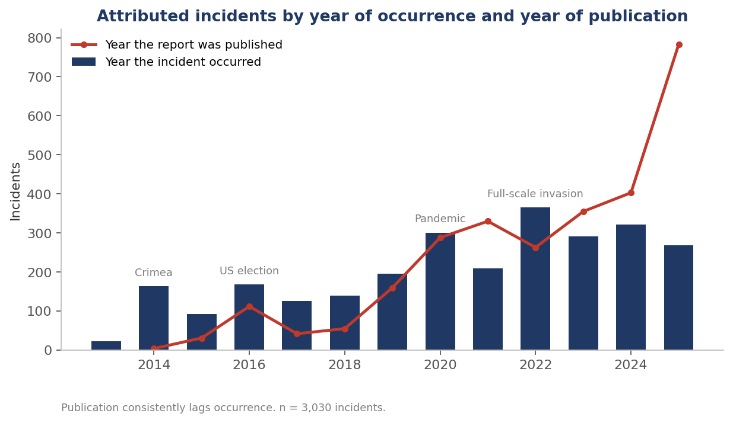
Figure 1: Attributed incidents by year of occurrence and by year of publication. The publication curve trails the occurrence bars throughout the series.

Policy documents promise early warning, so we measure the interval between an incident and its first appearance in an institutional document. Across the 2,708 incidents occurring in 2010 or later for which we can compute an interval, the median delay between occurrence year and publication year is 1 year and the mean is 2.13 years. Institutions report 646 of those 2,708 incidents (23.9%) in the year they occur, and 26.2% first appear 3 or more years afterwards. Across the full record, including the 84 historical incidents predating 2010, the mean rises to 2.85 years.
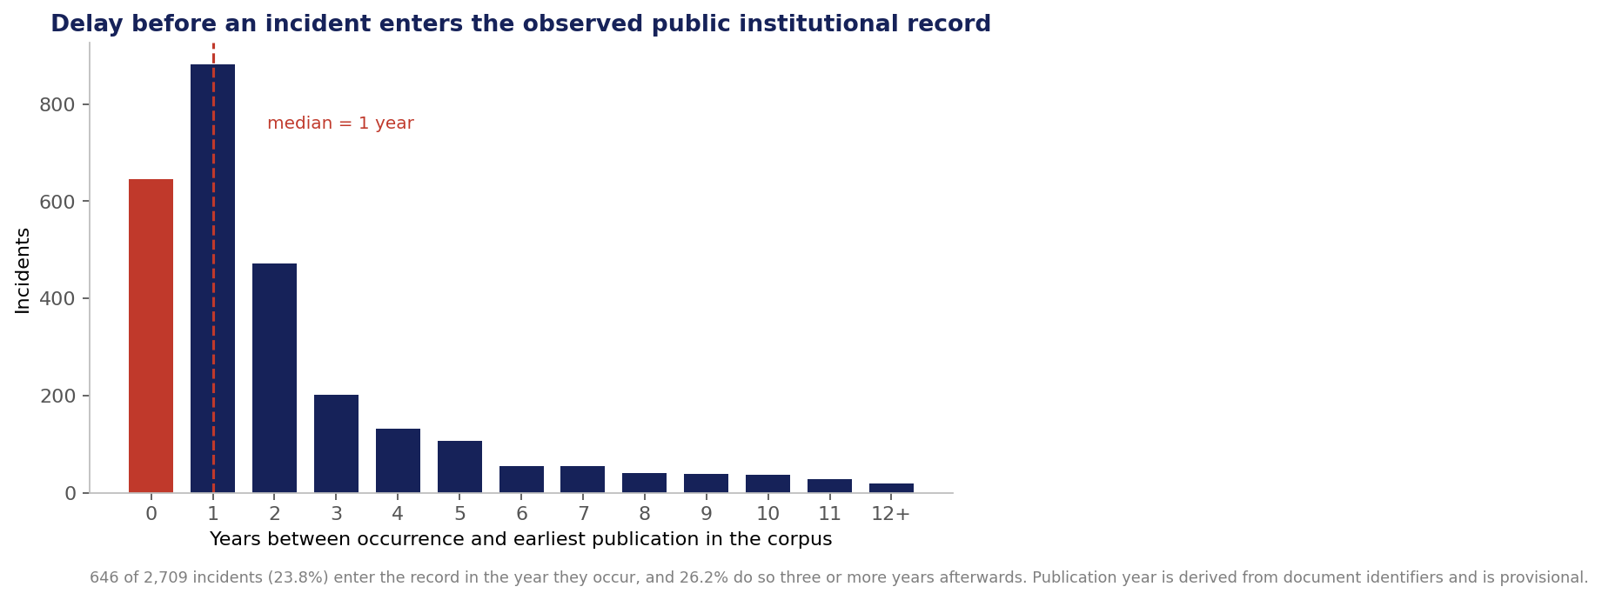
Figure 2: Delay between an incident occurring and its first institutional attribution. Incidents reported in the year they occurred are shown in red.
Part of this delay is unavoidable, because institutions need time to assemble evidence and some operations become visible only in retrospect. Part of it is structural: many of the largest contributing institutions publish annually, which places a floor under how quickly an incident can appear. In either case, half of all incidents wait at least a year for public attribution, so the record cannot yet serve as the early warning that policy documents describe.
The delay distribution is strongly right-skewed, with a mode at 1 year, a tail beyond a decade, and a mean well above the median. Two distinct processes produce it. The concentration at 0 and 1 year reflects institutions reporting on events within their current reporting cycle, and publication cadence mainly governs its size. The tail reflects retrospective attribution, in which an institution describes an incident years after it occurred, either because evidence emerged later or because a report revisits earlier events to establish a pattern. The two activities carry different policy implications, and Section 9 treats them separately.
We derive publication year from the source document identifier, so the measure records when the document appeared. Where an institution attributes an incident privately and publishes later, our measured interval overstates the analytical delay and understates the disclosure delay. The figure is the interval between occurrence and public availability, which the policy argument in Section 9 requires; the interval between occurrence and an institution’s private judgement is shorter and unobserved.
Delay varies across the system. National intelligence services publish closest to the events they describe, with a median of 1 year and an upper quartile of 1, while NATO bodies and national government units carry the longest delays, with a median of 2 years and upper quartiles of 4. Civil-society organisations and European Union bodies fall between, at a median of 1 year. Figure 3 groups institutions by the released institution_type field as the codebook’s Appendix G sets out. That classification is incomplete: 60 of the 108 source identities carry no type yet, and their 397 incidents (14% of the incidents with a named institution) appear as a separate group in this figure and in the 3 later figures by institution type.
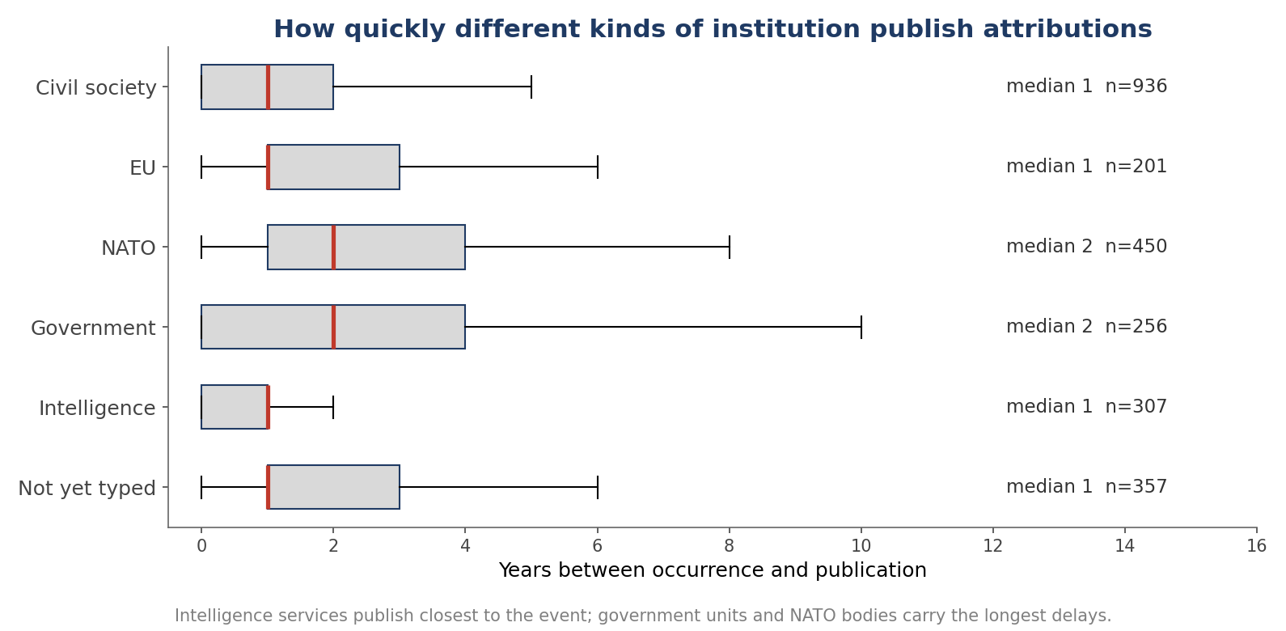
Figure 3: Interval between occurrence and publication, by type of attributing institution. Boxes show the interquartile range and the red line the median.
Where a source records an attributed state, Russia accounts for 1,443 incidents, China for 223, Belarus for 79 and Iran for 43, out of 1,841 incidents carrying an attributed state. Russia outnumbers China by approximately 6.5 to 1, and that ratio combines institutional remit, activity, detectability and analytical capacity, which the dataset cannot separate.
Table 6: Attributed states, over the 1,841 incidents for which a source names one.
Attributed state | Incidents | Share of the 1,841 attributed | Note
Russia | 1,443 | 78.4% | Present across the full period and in most jurisdictions
China | 223 | 12.1% | Concentrated after 2019 and in reporting on the pandemic
Belarus | 79 | 4.3% | Largely in Baltic and Polish reporting
Iran | 43 | 2.3% | Largely in United States and Israeli reporting
Other states | 53 | 2.9% | Georgia, India, Saudi Arabia, Serbia and 5 further states
No state named | 1,188 | not applicable | Excluded from the denominator above

Sources also characterise the actor by category, independently of the attributed state. Across the 2,603 incidents carrying a characterised actor, 1,685 (64.7%) are attributed to a state actor and 918 (35.3%) to a non-state actor. Within the non-state group, state-linked proxy networks account for 512, other non-state actors for 226, hacker collectives for 62, political movements for 58, civil-society organisations for 23, media outlets for 22 and commercial firms for 15. The remaining 426 of 3,029 incidents carry no characterised actor.
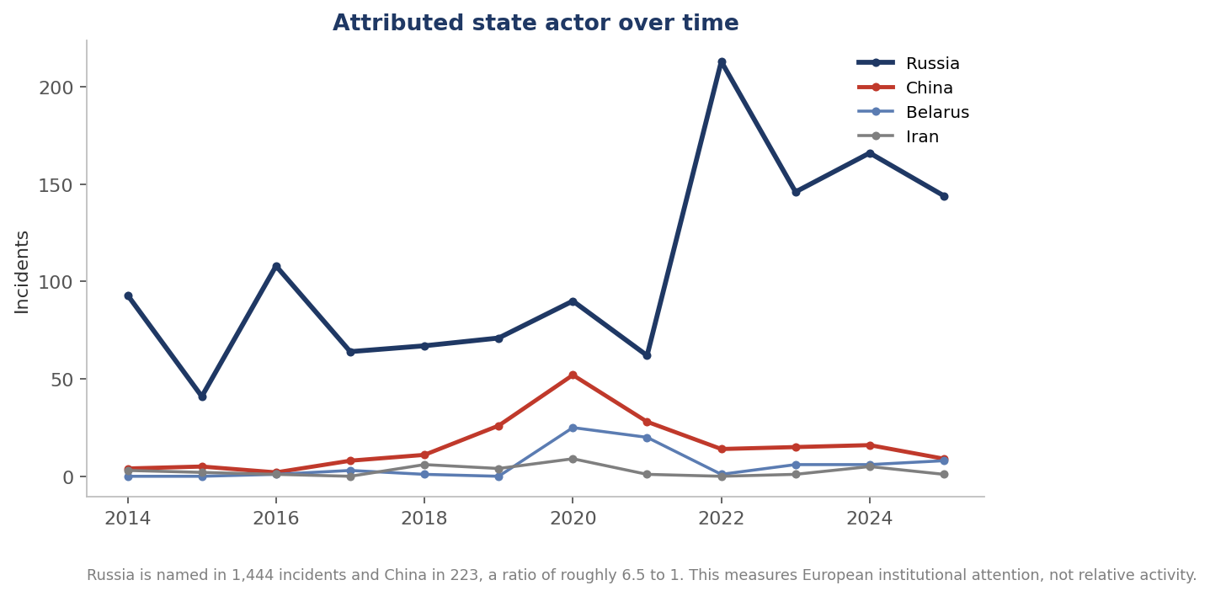
Figure 4: Attributed state actor by year of occurrence.

DE-CONSPIRATOR was designed around Russian and Chinese manipulation, and D2.3 gives doctrinal reasons for treating both as major actors. European institutions attribute to Russia 6.5 times as often as to China. Institutional remit may explain part of the imbalance, if services with a national security mandate report on the actor that concerns their own jurisdiction. This release cannot test that explanation, because the file carries no field recording each institution’s remit, and Section 10 lists that field as further work. Other explanations lie in the relative volume of Russian and Chinese activity directed at Europe, in how readily each is detected and evidenced, and in the analytical capacity European institutions have built for each. This dataset cannot distinguish between those explanations, so the ratio does not measure relative activity.
The imbalance holds across every type of attributing institution. Each type attributes to Russia between 5 and 8 times as often as to China: the ratio is highest among NATO and European Union bodies, at 7.8 and 7.7 to 1, and lowest among national government units and civil-society organisations, at 5.3 and 5.5 to 1. Figure 5 groups the released institution_type field into the 6 groups the codebook lists in its Appendix G; the 232 incidents without an identified institution appear in no group.
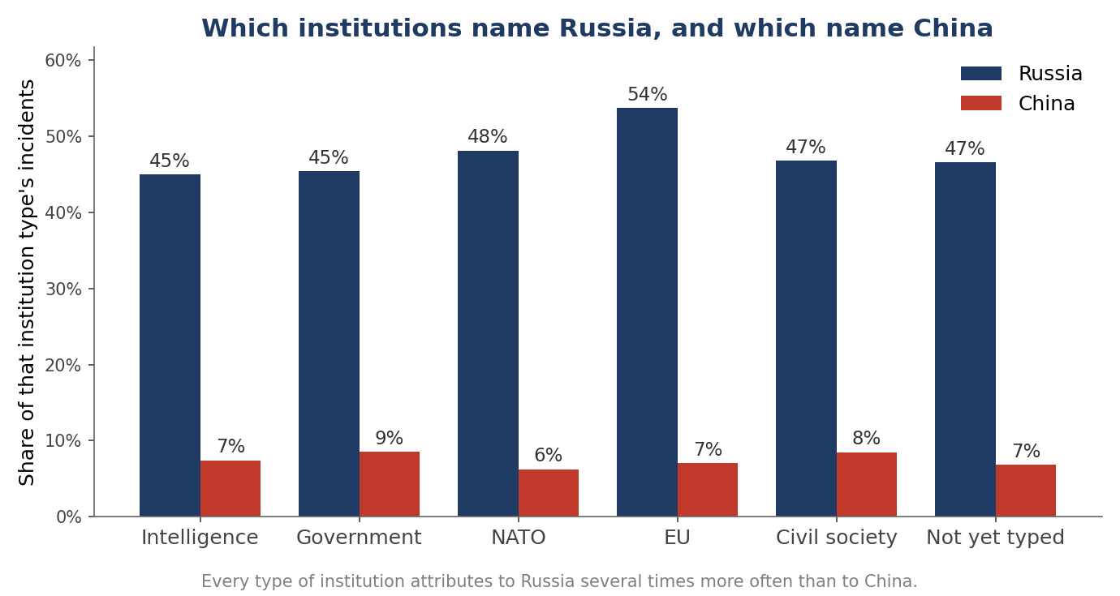
Figure 5: Share of each institution type’s incidents attributed to Russia and to China.
Sources record an actor type where they characterise the actor. Institutions name states directly in 615 cases, named operations such as recognised campaign labels in 303, state media outlets in 277, proxy networks in 161, individuals in 110, diplomatic missions in 69 and intelligence services in 65. A large group of 1,003 incidents carries no resolvable actor type, generally because the source characterised the actor only loosely, for example as accounts belonging to a pro-Kremlin information sphere, and a further 426 incidents carry no actor type at all. The share of incidents in which a source identifies a specific actor has varied across the period without improving steadily.
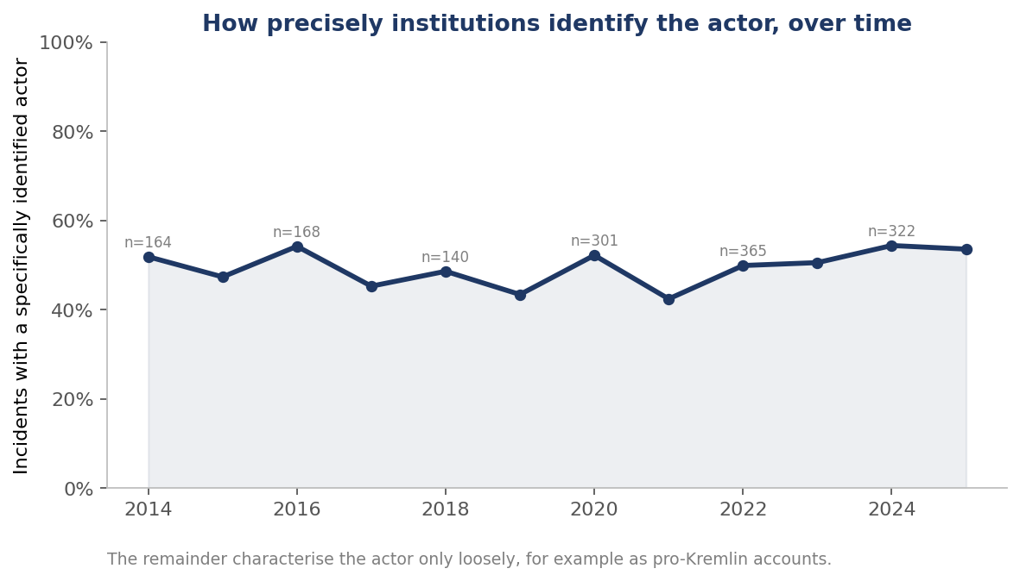
Figure 6: Share of incidents in which the source identifies a specific actor; in the remainder the source characterises the actor loosely.
Ukraine is the most frequently recorded target with 404 incidents, followed by the United States with 246, Latvia with 220, Georgia with 140, France with 139 and Germany with 135. We compute these figures over the target analysis population of 2,912 incidents, which excludes the 117 target assignments we have not resolved. Sources record incidents against targets in 112 countries within that population, and 113 across the whole record.
Latvia ranks third, above France and Germany, and Latvian publishing explains much of that position: Latvia has a population of under 2 million, and Latvian institutions produced 137 of the 213 Latvian incidents whose reporting institution we have mapped to a jurisdiction (64%). Georgia shows the same pattern more strongly at 69%, and Estonia at 53%. Institutions outside Germany report almost the whole German record, since German institutions account for 3 of 118 mapped incidents.
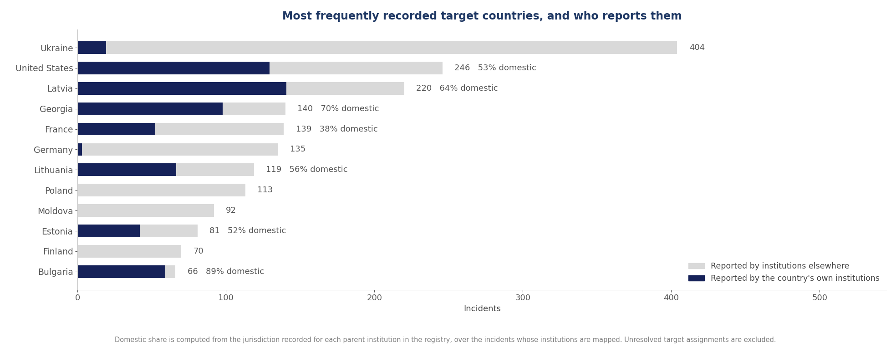
Figure 7: Most frequently recorded target countries, with the share of each country’s incidents drawn from that country’s own institutions shown in navy.
We match institutions to countries by name, and several bodies with national remits carry no country name, so the domestic shares above are lower bounds. We record institution jurisdiction for 97.2% of incidents where a source identifies the reporting institution, and we compute the domestic shares over that mapped population.
Per million inhabitants, Latvia records 117 incidents, Estonia 59 and Georgia 38, while Germany records 1.6, the United Kingdom 0.9 and the United States 0.7.
A gradient of this magnitude, spanning 2 orders of magnitude between Latvia and the United States, is associated in this record with the volume of domestic publishing, and the sampling frame cannot separate publishing capacity from exposure. The apparent European map of foreign information manipulation is substantially a map of which countries have institutions that publish attributions. A member state that publishes little will appear lightly targeted, and no field in current European reporting distinguishes low exposure from low publication.
Figure 8 removes the effect of country size and leaves a gradient running from the eastern flank to western Europe. Figure 7 shows the same pattern: Bulgaria, Georgia and Latvia owe most of their record to their own institutions, while institutions in other countries wrote the records of Ukraine, Poland and Germany. The countries that appear most affected are therefore the countries whose institutions publish most, a pattern that exposure alone would not produce.
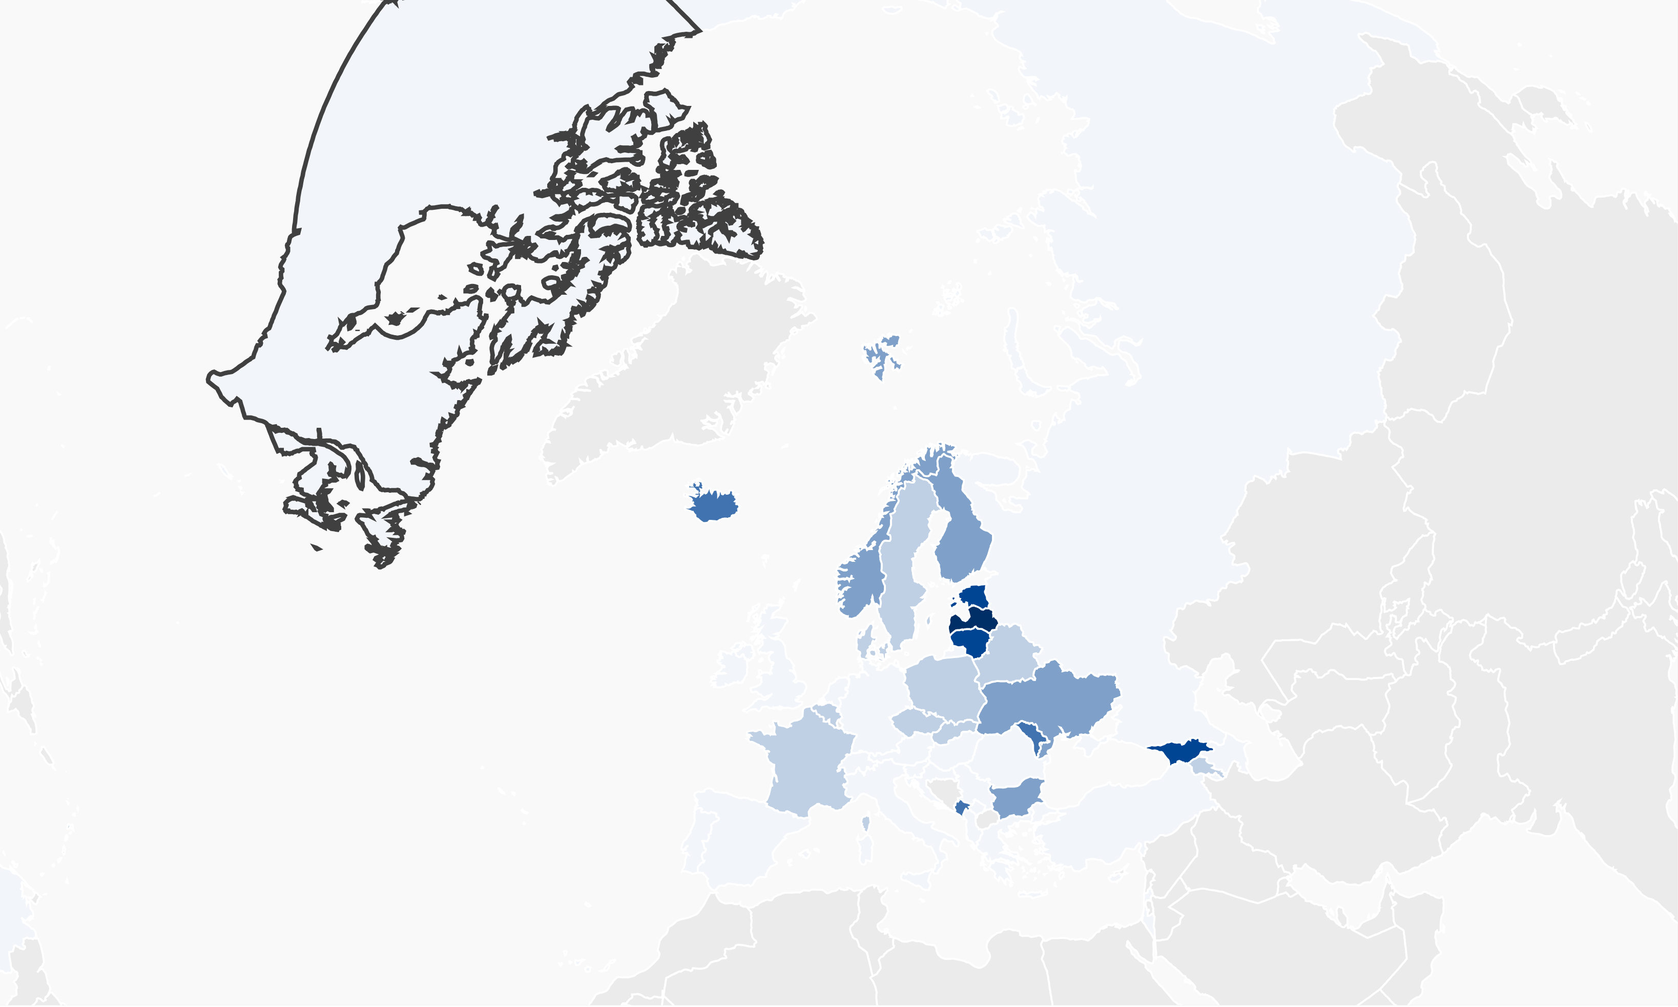
Figure 8: Recorded incidents per million inhabitants. Countries with no recorded incidents are shown in grey. Projection is Lambert azimuthal equal-area centred on Europe; boundaries are illustrative and imply no position on status.
Three structural features of the record bear directly on policy: concentration, the near-absence of corroboration, and the domestic focus of each institution. We did not anticipate the third when we designed the dataset.
Concentration is the first: 8 canonical parent institutions account for half of the 2,797 incidents with an identified reporting institution and 21 for 80%, as Section 5 reported, and the NATO Strategic Communications Centre of Excellence alone accounts for 515 incidents, 17.0% of the dataset. The European picture of foreign information manipulation therefore rests on a small number of organisations, and the withdrawal or defunding of any one of the largest would visibly change what the Union knows about its own information environment.
Incidents produced by the same institution share its detection practices, thresholds and interests, so they are not independent observations. With 8 institutions accounting for half the record, the effective number of independent observations for any institution-level comparison is closer to the number of institutions than to the number of incidents, and an analysis that treats incidents as independent overstates its precision. We set out the implication for estimation at the end of this section.
The second feature is the near-absence of corroboration. Of 3,029 distinct incidents, 30 (less than 1%) are described in separate documents by more than one independent institution under our conservative linkage rule. That rule merges 2 records only where similarity, date proximity and actor compatibility all support it, so 30 is a lower bound; Section 6 gives the upper bound of 2,813 incidents and the 307 pairs awaiting adjudication, and corroboration would rise if those merges were made. A further 31 incidents involve more than one institution through joint authorship of a single document, giving a broader measure of 61 incidents (2.0%). On the stricter measure, which is the one that bears on corroboration, 2,999 of 3,029 incidents rest on a single institutional account.
We did not expect this result. Our draft methodology anticipated substantial cross-institutional duplication, and we built the linkage procedure to remove it. Two readings are possible, and the evidence supports each in part. European institutions may report largely non-overlapping sets of incidents, each attending to its own jurisdiction and its own sources. Institutions also individuate incidents differently, describing what may be a single operation at different levels of aggregation, so that no procedure comparing descriptions can recover some genuine overlap. Different individuation supports the case for a common incident schema, because institutions cannot recognise overlap without a shared way of bounding an incident.
Each institution reports overwhelmingly on its own jurisdiction, which explains much of the rarity of corroboration. The Latvian State Security Service records 89 of its 92 incidents against Latvia. The Media Development Foundation records 92 of its 110 against Georgia. Among the 10 largest contributors, only the NATO Strategic Communications Centre of Excellence spreads its output widely, across 53 target countries.
Institutions each watch their own information space and a few multinational bodies watch broadly, which explains both the rarity of corroboration and a target map that tracks publication capacity, and it means that the loss of a single broad-remit institution would matter disproportionately.
Grouping every attributing institution by the country or multinational body it belongs to yields 19 attributing jurisdictions and, among the countries they write about, 84 targets that receive at least 2 attributions. Figure 9 arranges every country on a single ring, so that a country that both attributes and is attributed appears once; the 36 targets receiving at least 10 attributions are shown individually and the rest are pooled. The diagram covers the 2,412 incidents in the target analysis population that carry both a recorded target and an institution whose jurisdiction we have classified. Ribbons running across the circle are attributions about another country; ribbons that loop outside the ring are institutions reporting on their own.
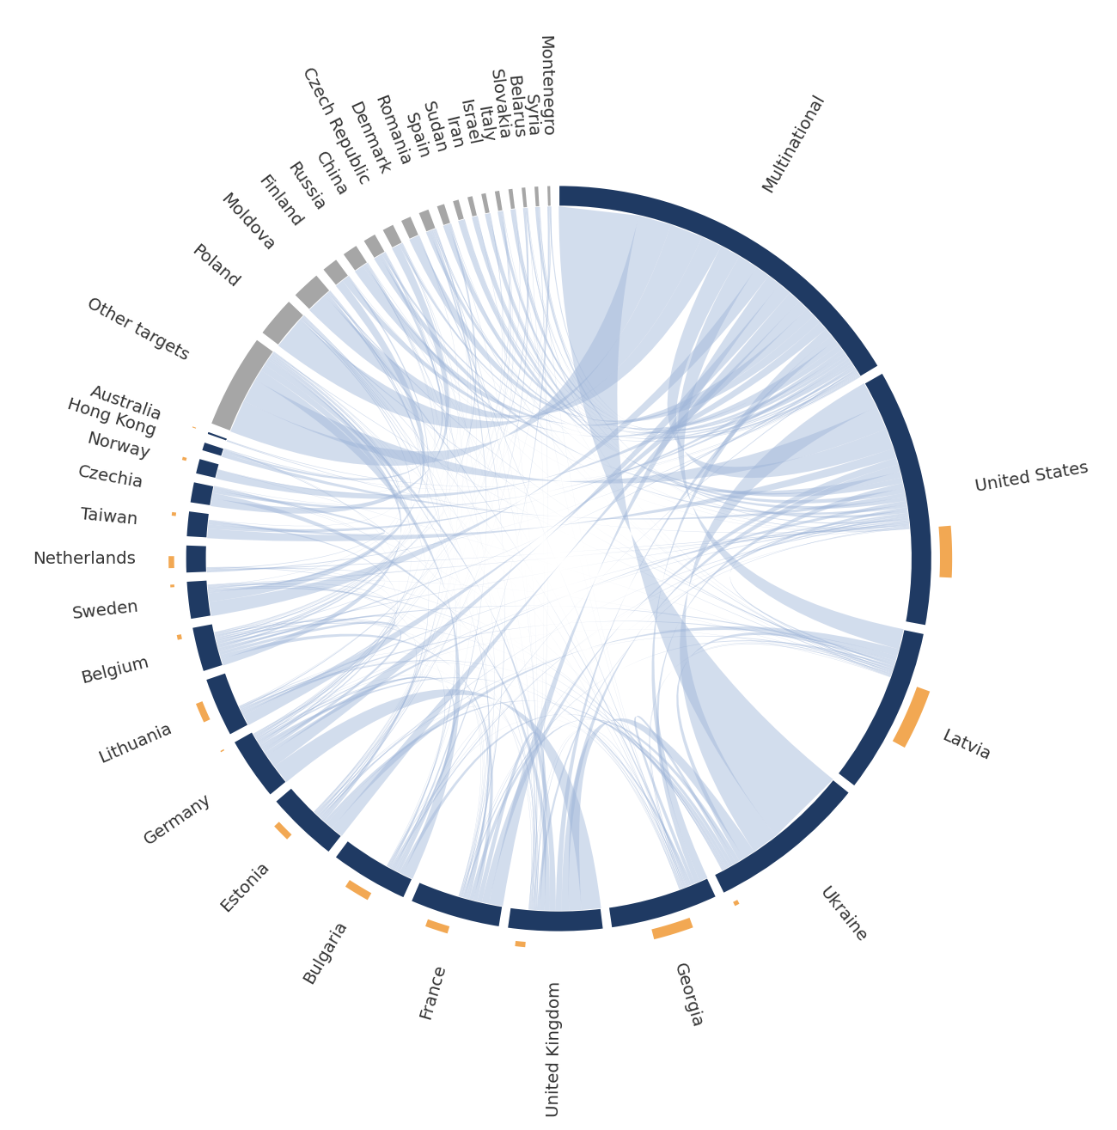
Figure 9: Attribution flows between jurisdictions. Navy segments publish attributions; grey segments appear only as targets. Loops outside the ring are institutions reporting on their own country, sized by volume. Covers 2,412 of 3,029 incidents (80%): the target analysis population, less incidents without a recorded target or with an institution whose jurisdiction we have not yet classified. Targets receiving fewer than 10 attributions are pooled as Other targets.
Self-reporting accounts for 638 of the 2,412 attributions in the covered subset (26%), and the loops concentrate in a small group of countries: Latvia with 137, the United States with 116, Georgia with 91, Bulgaria with 58, France with 52 and Lithuania with 45. Multinational bodies form the largest single segment, with 901 attributions, and have no loop, because they have no home information space. Countries that do not write about themselves enter the record through them. Ukraine is the largest segment with almost no attributing role, receiving 371 attributions while Ukrainian institutions produce 11 within this corpus. The diagram shows how rarely 2 institutions look at the same incident.
The composition of the record has shifted over time. Civil-society organisations produced 17% of the attributions published in 2016 and 46% of those published in 2025, while the share produced by national intelligence services fell from 45% in 2017 to 9% in 2025. The NATO share varies most from year to year, between 59% in 2016 and 6% in 2025, because a small number of large NATO StratCom reports dominate the years in which they appear.
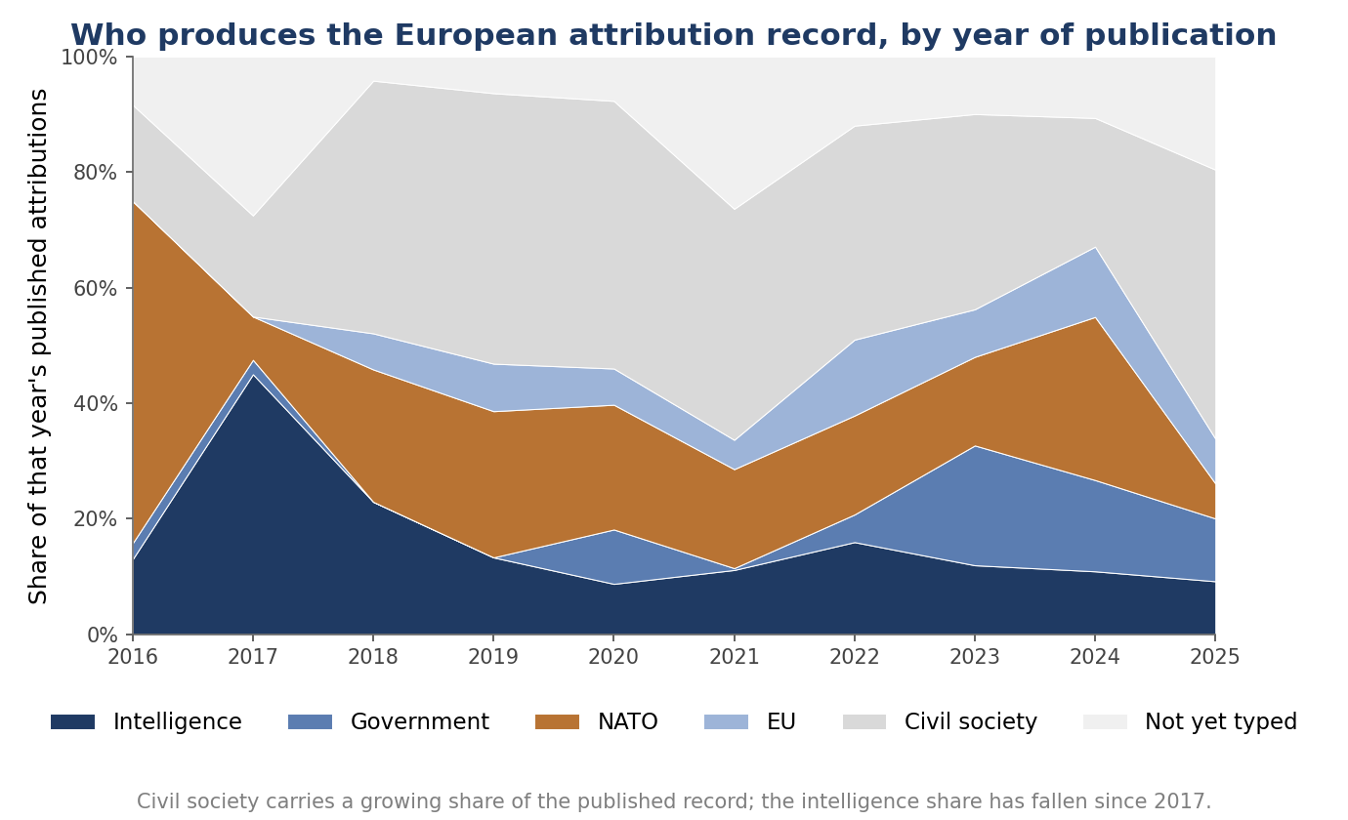
Figure 10: Share of each year’s published attributions by type of attributing institution.
Incidents carry a mean of 4.30 DISARM technique codes and draw on 77 of the 391 techniques in the framework. The most frequent are the development of text-based content, response to breaking news or an active crisis, the discrediting of credible sources, the laundering of information assets and the amplification of narratives through inauthentic sites.
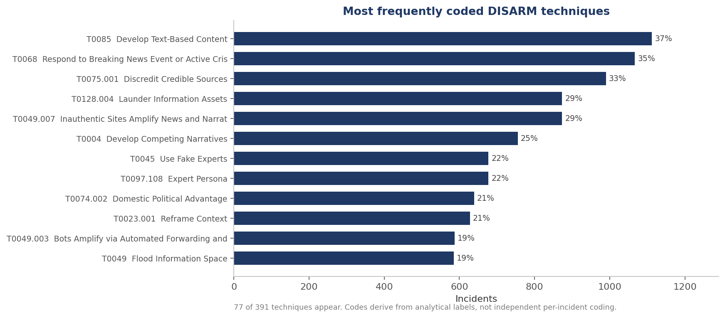
Figure 11: Most frequently coded DISARM techniques. Codes derive from analytical labels; a per-incident coding pass remains outstanding, as Section 8 explains.
Institutions use 77 of 391 techniques because reports describe what analysts observed, and observation is easier for content production and amplification than for planning, resourcing or the assessment of effect, so the record shows only the techniques that institutions can observe.
Institutions more often record incidents attributed to Russia as contesting crisis narratives and as election-related, and incidents attributed to China as political signalling and as distorting policy debate.
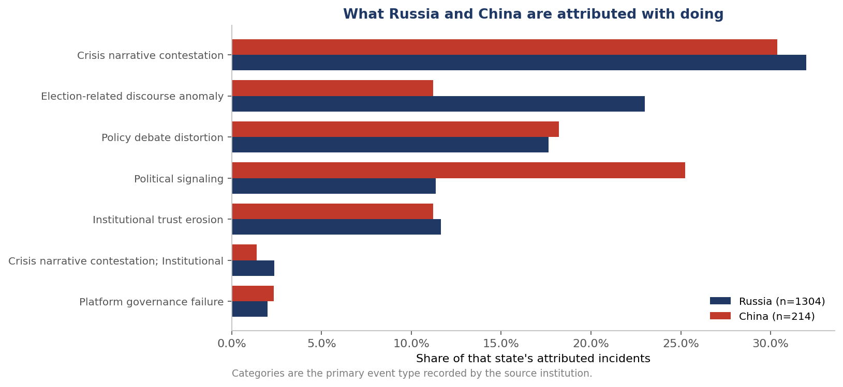
Figure 12: Primary event type recorded for incidents attributed to Russia and to China, as a share of each state’s attributed incidents.
How institutions express confidence in their own attributions also varies by type. Intelligence services state high confidence in 75% of their attributions (253 of 338), more than any other category, while European Union bodies state high confidence in 52% (117 of 227) and civil-society organisations in 54% (563 of 1,037).
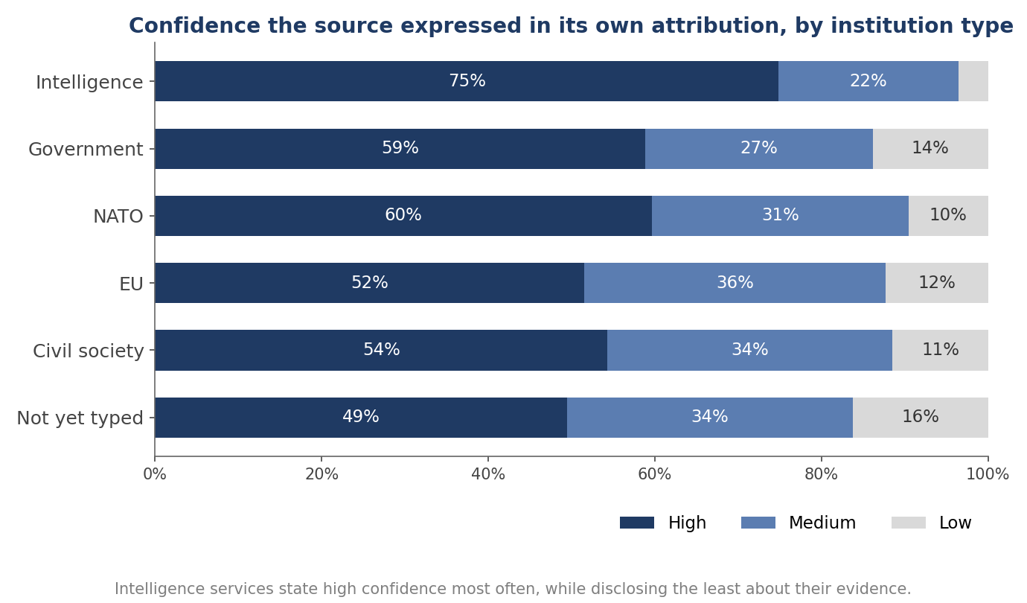
Figure 13: Confidence expressed by the source in its own attribution, by type of attributing institution.
Stated confidence does not track the evidence a report discloses. Among incidents where the source described the evidence of coordination as weak, a substantial proportion are nonetheless attributed at high confidence. Across the whole record, 1,133 of 3,029 incidents (37.4%) carry weak, absent or unrecorded coordination evidence. This pattern is a finding about reporting convention, since a report may rest on evidence it does not publish, and intelligence services in particular routinely withhold sources. A confidence statement therefore does not indicate evidentiary strength, and the dataset records the two separately.
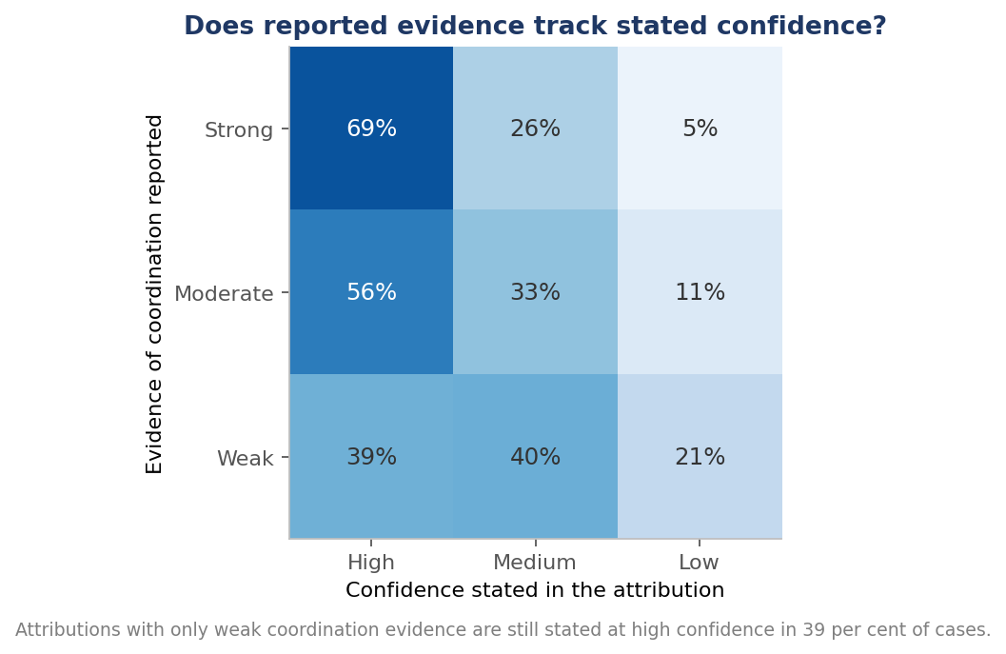
Figure 14: Reported evidence of coordination against stated confidence in the attribution, as row percentages. We derive the underlying coordination field during extraction and have not yet verified it against source text, so this figure remains preliminary.
Sources leave the platform on which an incident occurred unknown or unrecorded for 1,054 incidents, and a further 613 they attribute to legacy media without a more specific channel. Sources record evidence of impact for 35.6% of incidents, an official response for 24.8% and an international response for 7.6%. The release distinguishes a source that describes no response from a field that was never populated: for 2,097 incidents (69.2%) the extracted passage describes no official response, and for 182 the field was not populated.
Table 7: Completeness of response and impact fields.
Field | Populated | Reading
Evidence of impact | 1,077 of 3,029 (35.6%) | Institutions rarely assess whether manipulation achieved anything
Official response | 750 of 3,029 (24.8%) | Three quarters of attributed incidents record no official response, and for 2,097 the extracted passage describes none
International response | 231 of 3,029 (7.6%) | Coordinated response is exceptional
Platform identified | 1,975 of 3,029 (65.2%) | Channel information is often absent or aggregated as legacy media
The attributing document records no official response for 75.2% of incidents and no international response for 92.4%, so attributing institutions document what followed an attribution only rarely. These figures describe what source documents record, and an institution or a government may have responded without reporting it; the dataset holds no field that would show this. A government may respond privately, through a demarche or a measure documented elsewhere, and such a response may well deter. A response absent from the attribution record cannot be evaluated through that record, so the Union cannot at present tell which attributions were followed by action.
Three further fields, geographic scope, content format and language, describe the character of recorded incidents. Geographic scope records how widely institutions understood an incident to reach. National incidents dominate with 1,517 records, followed by transnational incidents with 1,125, regional with 244, European Union-wide with 79 and local with 63. The Union-wide figure is small for a dataset assembled for a European project. Institutions rarely describe an incident as targeting the Union as such; they describe it as targeting a member state, or as crossing several. We cannot determine whether the small Union-wide figure reflects the manipulation or the national mandates of the institutions. Either way, a response architecture organised around Union-wide threats addresses a category that the attribution record populates thinly.
Sources record content format for 89% of incidents, of which text accounts for 1,433, mixed-format material for 609 and video for 234. Text probably predominates because analysts can collect, search and quote it, while video and image material cannot be handled with the same tools, so the format distribution partly describes institutional capability.
Sources record the language of the manipulated content for only 20% of incidents. Where they record it, English appears most often with 147 incidents, followed by Russian with 91 and Chinese with 30. The low completion rate makes the distribution uninformative about the corpus as a whole, and the 80% gap is a reporting failure that a common schema could close at little cost, because language is central to how manipulation reaches an audience and to which analysts can detect it.
We intend the dataset for reuse, and Sections 2 and 3 of the codebook state which analyses it bears. Analyses of timing are the best supported, because the interval between occurrence and publication is measured within existing records for the 2,708 incidents with a computable interval, which we call the latency population. The measured distribution is truncated in its most recent years, because the file holds no incident that has not yet been attributed, and correcting for that would require an external incident population. Analyses of composition and of level carry the weights set out at the start of this section.
Analyses that model counts directly must cluster standard errors at the institution level, because incidents nest within documents and documents within institutions, and with 8 institutions producing half the record the effective sample size for institution-level comparison is far smaller than the row count suggests. Analyses requiring corroboration are not supported. Capture-recapture methods, which estimate the unobserved population from how often independent observers record the same event, need substantial overlap, and 30 corroborated incidents in 3,029 is too little; this is the main reason the dataset cannot be extended into an estimate of total manipulation. Analyses treating the model-generated judgement fields as data are unsound, for the reasons in Sections 2 and 4. Analyses of technique distribution should await the second DISARM pass. Analyses depending on precise incident counts should await the reliability study described in Section 10 and the adjudication of the 307 candidate duplicate pairs.

8. Limitations and interoperability
Several limitations constrain what this dataset can support, and the first affects every user. Every record depends on an institutional judgement that we do not evaluate. Where an institution attributed wrongly, the dataset reproduces the error faithfully and contains no field that would reveal it. This follows from the design: the alternative, in which we adjudicate attributions ourselves, is the approach we reject in Section 2. The dataset records claims, and no field in it distinguishes a correct claim from a mistaken one.
Institutional attributions are generally well founded, since institutions have access to evidence no external analyst can obtain. Our dataset nonetheless provides no mechanism for detecting the cases where an institution is wrong, and a record of claims accumulated at scale can acquire an appearance of established fact that no individual claim in it possesses. The dataset separates what an institution asserted from what it disclosed, and an analysis that counts assertions as established incidents discards that separation.
We assembled the corpus by expert nomination, so we can assign no inclusion probability and no correction for selection is available. The known gaps in Section 5, particularly web-only attributions and non-English material, are likely to interact with the geographic distribution in Section 7. The reporting pattern documented there is a general property of the dataset and affects every country in it.
The comparison reported in Section 6, in which 2 models agreed on incident boundaries in 23 of 79 passages, indicates that how a reader divides continuous narrative into discrete incidents varies considerably. Analyses that depend on counts of incidents are therefore more fragile than analyses that depend on the attributes of incidents. A shared rule for individuating incidents, tested for agreement between coders, would remove the largest known source of uncertainty in incident counts.
Two features of the corpus affect comparative use. We conducted retrieval principally in English, so institutions publishing only in national languages are likely to be under-represented, and the effect will fall unevenly across member states. Institutions have also had little time to attribute incidents that occurred close to the collection date, so the most recent years are systematically incomplete in a way that will resolve as later reports appear, and analyses of trend over the final 2 or 3 years of the series remain provisional for this reason.
We performed quotation matching during extraction and did not retain the per-record outcome. We have assessed whether the structured fields correctly represent the quoted material on 60 records, by a machine-assisted procedure that awaits human ratification, and the figures in Table 5 are not accuracy statistics until we complete that ratification.
We assigned DISARM codes from analytical labels produced during extraction, and we have not yet coded each incident directly against the framework. The distributions in Section 7 indicate how institutions describe manipulation, and they become a technical classification only after the second pass.
Seven fields record the extraction model’s judgement about whether an incident constitutes foreign information manipulation and what intent lay behind it. These fields are poorly calibrated, as Sections 2 and 6 show, and we exclude them from every analysis here. We retain them because removing them would conceal part of what the pipeline produced. Their model_ prefix marks them as pipeline output, and no analysis in this deliverable uses them.
The dataset contains incidents targeting countries far outside Europe, including Nigeria, Sudan, Colombia and the Philippines, which enter because European and allied institutions wrote about them. These records show what European and allied institutions attend to, and the target field lets an analysis of the European information space exclude them. We retain records from institutions outside Europe, chiefly in the United States, for comparison, and the institution field identifies them.
A curated alias table now resolves institution names, and a user can rely on them. Actor names never reached that standard, and we no longer release them: of the 1,272 actor strings extraction preserved, 783 appeared exactly once, and a single mention provides no internal evidence for deciding whether two spellings denote the same actor, so the released file codes the actor by category, as Section 6 describes. An analyst can compare state with non-state actors and can distinguish types of non-state actor, and cannot count incidents per named actor entity. Section 10 records a curated actor registry as further work.
The dataset spans incidents from 1903 to 2026, although all but 84 fall after 2010, and the institutional field changed substantially over that period. Several of the largest contributing institutions did not exist at the start of the series: governments and multinational bodies established dedicated units and centres through the late 2010s, and the FIMI vocabulary itself entered European usage only after 2018. Earlier incidents therefore enter the record largely through retrospective reporting by institutions founded later, while recent incidents enter through contemporaneous reporting by a much larger and differently composed set of observers. Comparisons across the full period therefore compare different observing systems as well as different years.
The structured actor fields of the released file name no individual, and 2 provenance fields do. The attributing-entity fields record the entity that made the attribution as the source names it, which in some rows is an office-holder speaking for the institution, such as a minister, an agency head or a spokesperson. The consortium agreed at its Istanbul General Assembly that office-holders named in that capacity remain, because the attribution is an act of the office and the source document already carries the name. The cited_sources field carries the bylines and author names of cited material as ordinary bibliographic metadata. We replaced the free-text actor field with the actor category described in Section 6, and we retired actor_canonical and actor_resolution_status. Of the 3,029 incidents, 451 carried a personal name in the free-text actor field and 943 carried one in the canonical actor field, and none now does. The remaining structured fields, actor_type, actor_state, observed_actors and suspected_actors, hold no personal name either.
Names do remain in the 4 free-text fields: the incident title, the description, the supporting quotation and the reasoning note. Only the supporting quotation is verbatim source text; the extraction pipeline writes the other 3 from the source material. We keep all 4 because the quotation is the audit trail, and a reader who cannot see the sentence behind a coded row cannot check the coding. We do not report how many rows this affects, because any count depends on a name detector whose error rate we have not measured, and a figure of that kind would suggest a precision we cannot support. Every name in these fields originates in a document that is already public, and we added no name that the sources do not contain. One safeguard remains necessary: a correction route allowing any named person or institution to contest a record, which Section 10 specifies.
A consortium funded by the European Union has built a record of how European institutions attribute foreign interference, and has decided which institutions belong in the registry. A particular community of experts drew that boundary around what counts as legitimate attribution. We publish the registry at Appendix A of the codebook, and the criteria behind it in Section 5 of the codebook, so that a reader can examine and contest the boundary.
Nobody can currently construct a combined FIMI dataset, and this dataset shows why. Across the resources we examined the unit of observation differs, no resource publishes a rule for dividing narrative into incidents, actor identity has no shared registry, target and date fields share names while measuring different things, attribution provenance is mostly absent, and institution identity requires curation that does not scale. Our design retains verbatim source strings beside every normalised value, separates stated from derived values, carries stable identifiers, date precision and a controlled actor vocabulary, and aligns to DISARM and STIX through the crosswalk in Appendix D of the codebook, so that a future integrator would not have to reconstruct what the sources said. We offer a diagnosis, made on real material, of what a common standard would have to resolve.

9. Implications for European policy
Five recommendations follow from Section 7. Each addresses a property of the European attribution system, because the dataset measures that system, and we close the section by stating what the recommendations do not rest on.
Attribution reporting should carry timeliness expectations. The European response to foreign information manipulation is organised around rapid alert and early warning, and the median incident waits 1 year for its first public attribution while 26.2% wait 3 years or more. Institutions publishing at these intervals cannot supply early warning.
Two changes would shorten the interval. Institutions that publish attributions annually should additionally publish incident records as they complete attributions, in a structured format, without holding them for the annual cycle. The European External Action Service and the FIMI-ISAC, which already operate structured exchange mechanisms, are the natural venues. Reporting arrangements should also state expected intervals between attribution and disclosure, so that delay becomes visible and can be managed.
A timeliness expectation would need to distinguish the two processes visible in the delay distribution. Contemporaneous reporting, where an institution describes an incident within its current cycle, could reasonably be held to a disclosure target measured in weeks once an institution has formed an attribution. Retrospective reporting, where an institution describes an incident years later as part of establishing a pattern, serves a different purpose and should not be discouraged by a target it cannot meet. The reporting arrangement should also record when an institution formed its judgement as well as when it published. That record would make the interval between private assessment and public disclosure measurable, and policy has most influence over that interval.
Attribution should connect to a defined response pathway. The attributing document records no official response for 75.2% of incidents and no international response for 92.4%, so the public record shows a response following attribution in a quarter of cases.
Where the European Union wishes attribution to deter, attribution needs a defined subsequent step, whether that is platform enforcement under the Digital Services Act, listing under sanctions instruments, diplomatic demarche, or a public rebuttal by a named body. Recording the response alongside the attribution, in the same structured format, would make the coupling measurable.
Recording the response would also make evaluation possible. The Union cannot at present determine whether attribution accompanied by sanction has different consequences from attribution alone, because the outcome of an attribution is recorded in only a quarter of cases and never in a form that permits comparison. A field recording the response taken, its date and its instrument would convert a large body of existing practice into evidence about what works, at little additional cost, because the institutions already write the reports.
The Union should support publication capacity where it is weakest. Eight canonical institutions produce half of the 2,797 incidents with an identified reporting institution. Countries whose institutions publish extensively appear heavily targeted, and countries whose institutions publish little appear untroubled: Latvia records more incidents than France or Germany, and Latvian institutions produced 137 of the 213 mapped Latvian incidents (64%).
The Union therefore cannot tell low exposure from low publication, and it cannot allocate attention or resources on that basis. Supporting attribution capacity in member states that publish little would improve the evidence base at modest cost, because the institutions that publish most are small.
Capacity support need not mean new institutions. This dataset cannot distinguish an institution that detected an episode and did not publish from one that lacked the capacity to detect it, so we do not claim to know which constraint binds. The publication constraint is cheap to address if it applies: a body that already monitors its information environment may not publish structured incident records, either because no format exists or because no obligation attaches. Providing the format, and attaching a modest reporting expectation to existing funding streams, would enlarge the record substantially without creating new organisations.
A common incident schema should become obligatory. More than one institution independently corroborates 30 of 3,029 incidents (less than 1%), so European institutions attribute in parallel. Part of the reason is that institutions have no shared way of bounding and describing an incident, so they cannot recognise genuine overlap.
A common schema, aligned with DISARM and exchangeable in the STIX format that the FIMI-ISAC already uses, would allow institutions to recognise when they are describing the same operation. A European record that can be corroborated requires structured incident reporting from bodies receiving Union funding in this field. This dataset provides no basis for ranking the schema against other reforms; it shows what a common record makes visible and how much is currently invisible for want of one.
The schema does not need to be elaborate. Seven fields carry most of the analytical weight in this deliverable: what happened, when, to whom, attributed to which actor, with what stated confidence, on what disclosed basis, and with what response. An institution already writing a narrative report could populate them in minutes, so the cost of adoption is low. No common definition of the fields exists and no instrument requires them; the revision of European counter-disinformation instruments could supply both.
Reporting should also record which criterion an institution applied. Sections 2 and 3 show that institutions attribute on a mixture of grounds, and that a reader cannot tell which. An attribution may rest on evidence that the origin was concealed, on evidence that amplification was manufactured, on the falsity of the content, or on the judgement that the effect was hostile. These are different claims with different implications, and institutions at present record them identically.
Two additions to reporting practice would record the criterion. The first records whether the institution asserts concealed origin, false content, or both. The second has reports state which stage of the operational chain they describe, distinguishing an account of a message from an account of an asset network and from an account of an operation with a target and an intended effect. The DISARM framework already supplies the vocabulary for the second, and Section 3 shows that the Target Audience Analysis and Assess Effectiveness tactics have no coverage in the record.
Without these distinctions the Union cannot tell whether its institutions are identifying hostile operations or recording adversarial communication, and the 17.1% of the record documented in Section 3 shows that the question arises in practice.
None of these recommendations rests on a claim about how much foreign information manipulation occurs, where it is increasing, or which state is most active. The dataset cannot support such claims and does not make them. Its distributions describe European institutional behaviour, and using them as a threat picture would reproduce the reporting biases documented in Section 7 while presenting them as measurements of adversary activity.

10. Access, licensing and maintenance
We froze the analyses in this deliverable against dataset release v2.3.3. Release v2.4 consolidated that frozen release into a single flat file and recoded the actor field into a controlled vocabulary, and neither step changed any frozen headline figure. Two corrections followed the internal review. Release v2.4.1 withdrew one record, a year-level trend statement carrying no platform, format or language, which reduced the incident total from 3,030 to 3,029 and every dependent figure by at most 1. The same release restored 129 quotations and the cited_sources field to their unnormalised form. Release v2.4.2 restored the annotated value None recorded in the 4 response and evidence fields, so that a passage that describes no response can be told apart from a field that was never populated, and added a flag recording, for each row without an identified institution, whether its source document names one elsewhere. Release v2.4.3, the submission release, drops 7 columns that were empty or held one constant value; no remaining value changed.
The released file holds 3,131 rows and 81 variables, and the registries workbook carries the institution, source identity, document, alias and correction registers as 5 sheets. The SHA-256 digest of the released file is 737f23bea8fabfd312c5903730d2b9022be7e6cd9eaeb09a5ae30bcaa26fa649, and the digest of the v2.3.3 file is ef1ddf7f663fe4894c40b243e7acc85e8831093010e7aeac29d0a8b9290e1b3d. Section 8 of the codebook lists the principal quantities in this deliverable with the expression that reproduces each from the released file, and the script reproduce_figures.py in the supporting materials runs those expressions in full. The script make_figures.py regenerates the 5 figures revised after the internal review, Figures 3, 5, 9, 10 and 13; Figure 8 additionally requires the population denominators in Appendix H of the codebook, and the remaining figures are drawn from the released fields by the procedures the text describes.
The submission package contains 5 deliverable files: this report, the data file DCFIMIEvent_v2_4_3.csv, the registries workbook, the codebook and the public web portal. Everything the earlier releases distributed as separate registries, relations and provenance files now sits either on the row itself or in a codebook appendix.
We will deposit the dataset in an open repository with a persistent identifier of its own. Until that identifier is minted, 10.3030/101132671 identifies the project alone, and a citation of the dataset must carry that qualification.
Any institution or individual named in the dataset may contest a record. Because every record carries the source document, page and quotation, anyone can check a contested record quickly against its source. We record corrections in a changelog and never apply them silently, so that analyses conducted on earlier versions remain interpretable. Where an institution states that this dataset has misrepresented its published position, we make and record the correction. Where an institution wishes to revise the attribution it originally published, we record both the original claim and the revision, since a change in institutional position is itself part of what the dataset documents.
A full re-extraction of the corpus costs approximately USD 39 and 5 hours of processing. Annual refresh is therefore inexpensive, and the practical constraint on maintenance is the human work of retrieving new documents and ratifying validation samples. Several comparable resources, including the Twitter archive and the academic datasets described in Section 3, depend on maintainers who may stop, and re-extraction at this cost removes the largest recurring expense of keeping this one current.
We intend the dataset to support 3 kinds of work. For research, it provides a structured record of institutional attribution behaviour that can be analysed on the terms set out in Section 7, and joined to external data on trade, alliance membership, electoral calendars or institutional resourcing to examine what shapes attribution. For policy evaluation, it measures properties of the European attribution system, including its speed, its coverage and the coupling between attribution and response, against which reform of that system could be assessed. For practitioners, it provides a searchable index of published attributions with quotations and page references, which reduces the cost of establishing what has already been said about a given actor, target or operation.
We do not intend it as a threat assessment, for the reason Section 9 gives: its distributions describe institutional attention, and an analyst who reads them as a measure of where manipulation is concentrated will reproduce the reporting patterns documented in Section 7.
Nine items of further work remain, and each addresses a limitation stated in Section 8 or a gap stated above.
- Human ratification of the 60-record validation sample, and adjudication of the 307 candidate duplicate pairs awaiting review.
- A written rule for individuating incidents, tested for agreement between at least 2 coders across languages, which would address the limitation in Section 8.
- A second DISARM pass assigning techniques directly per incident, replacing the derivation from analytical labels.
- An ingestion route for attributions published only as web pages, which would close the gap identified in Section 5.
- Verified publication dates in documents.csv, replacing the identifier parsing described in Section 7 and releasing the 5 quarantined negative-lag records.
- A join with the survey measurements in D6.1 and D6.2, comparing where institutions attribute incidents with where populations report exposure. This is the nearest available external check on the reporting pattern documented in Section 7, since public exposure is measured independently of whether any institution published an attribution.
- A curated registry of named actor entities, built the way Appendix A of the codebook builds the institution registry, which would let an analyst count incidents per named actor as well as per actor category.
- Verification of the coordination-evidence field against source text, which Section 7 identifies as necessary before anyone can rely on the relationship between disclosed evidence and stated confidence.
- Extension of the institution registry to record remit for every institution, and jurisdiction for the 311 incidents (10%) whose institution carries none, which would let any reader reproduce the comparison of broad-remit and domestic-remit institutions that this version withdrew from Section 7.

11. Conclusion
This deliverable presents a record of 3,029 incidents of foreign information manipulation attributed by 97 canonical European and allied institutions, and the reasoning that determined how we built the record. Our central methodological decision was to leave the judgement of what constitutes manipulation with the institutions that already make it publicly and under accountability, and to confine automated reading to tasks whose accuracy a reader can check against the source. Section 2 sets out why the more ambitious alternative fails. Language models read well, and the alternative still fails because the events sought are rare and because labelling published speech as foreign interference requires an accountable author.
The resulting record shows a European attribution system that works slowly, documents its own consequences rarely, depends on a small number of institutions, and records independent corroboration for fewer than 1% of its incidents. The median incident waits 1 year for attribution, the attributing document records no official response for 75.2% of incidents, 8 canonical institutions produce half the 2,797 incidents for which we identify a reporting institution, and more than one institution independently describes 30 of 3,029 incidents (less than 1%). These are properties of the system that responds to foreign information manipulation, and they are measurable only because we have brought the individual attributions into a common form.
Two features of the record surprised us. We expected the rarity of corroboration to be a processing problem, and it is a property of the system; that rarity removes capture-recapture estimation, the main technique by which conflict datasets estimate what they have missed. Each institution reports mainly on its own country, which is consistent with that rarity and with the finding that the apparent geography of manipulation follows the geography of institutional capacity.
The methodological result applies beyond this dataset. Any attempt to build a record of rare, contested events by automated classification over a large corpus will encounter the same arithmetic. Automated reading should be confined to extraction from sources where someone has already exercised judgement and where a reader can check the result, and that conclusion applies wherever a classifier’s false positives would fall on legitimate activity. That situation is common in the governance of online speech, and we offer the demonstration in Section 2 as evidence in that wider argument as well as a justification of our design.
The dataset describes what European institutions have publicly attributed, an object narrower than the threat itself and the one over which European policy has direct control. It does not describe how much foreign information manipulation there is or where it is growing, and no use of it should suggest otherwise.

Supporting materials
A codebook accompanies this deliverable and carries the supporting material that earlier drafts promised as annexes. Table 8 lists what it contains and where.
Table 8: Supporting material and where it sits in the codebook.
Codebook location | Content
Sections 1 to 3 | Unit of analysis, file structure, and what the dataset does and does not measure.
Section 4 | All 81 variables in 13 blocks, with type, completeness, permitted values and definition.
Section 5 | Corpus construction, the extraction instruction set, post-processing and validation.
Section 6 | Date precision, reporting delay, the two corroboration measures, DISARM coding, actor coding, and the relationship between stated confidence and disclosed evidence.
Section 8 | The main tabulated figures, with the expression that reproduces each from the released file.
Section 9 | Release history, the variables retired from v2.4 to v2.4.3, the rebuild procedure, citation and licence.
Appendix A | The 97 canonical parent institutions with jurisdiction, type and counts; the institutions sheet of the registries workbook.
Appendix B | The 108 published source identities with their parent institutions; the source_identities sheet.
Appendix C | The 534 source documents with institution, year, type and incident count; the documents sheet.
Appendix D | The interoperability crosswalk to EUvsDisinfo, OPIE, conflict data, DISARM and STIX.
Appendix E | The correction register, 47 items of which 5 remain open; the corrections sheet.
Appendix F | The mapping from the 212 extracted institution strings to source identities and parent institutions; the aliases sheet.
Appendix G | The institution type groups behind Figures 3, 5, 10 and 13.
Appendix H | The population denominators behind Figure 8.
The project holds 4 items that earlier drafts listed as annexes and will deposit them with the repository record: the full annotation methodology, the detection folder (the 80 row identifiers, the redacted inputs, the model version and settings, the fixed predictions and the scoring script), the 60-record validation sample with its row identifiers and adjudications, and the DISARM remapping table. The corrections sheet of the registries workbook tracks each of them.
References
References are listed alphabetically. Footnotes give short-form citations; full details appear here. This section falls outside the page limit for the deliverable.
Bar-Hillel, Maya. ‘The Base-Rate Fallacy in Probability Judgments.’ Acta Psychologica 44, no. 3 (1980): 211-33.
Charter of Fundamental Rights of the European Union. OJ C 326, 26 October 2012, 391-407.
DE-CONSPIRATOR. D2.3: Capturing FIMI in Strategic and Military Doctrines of Russia and China. DE-CONSPIRATOR Consortium, 2024.
DE-CONSPIRATOR. D3.1: Methodology Working Paper. Amsterdam: Universiteit van Amsterdam, 31 December 2024.
DE-CONSPIRATOR. D3.3: The DIMI Sphere: Alternative Media Networks and Narrative Interfaces. Amsterdam and Groningen: Universiteit van Amsterdam and Rijksuniversiteit Groningen, 31 December 2025.
DE-CONSPIRATOR. D4.1: FIMI Significance Indicator Scorecard. DE-CONSPIRATOR Consortium, 10 June 2025.
DE-CONSPIRATOR. D6.1 and D6.2: Survey Deliverables on FIMI Exposure and Attribution. DE-CONSPIRATOR Consortium, 2025.
DISARM Foundation. DISARM Framework. https://www.disarm.foundation/framework.
Earl, Jennifer, Andrew Martin, John D. McCarthy and Sarah A. Soule. ‘The Use of Newspaper Data in the Study of Collective Action.’ Annual Review of Sociology 30 (2004): 65-80.
Egloff, Florian J. Semi-State Actors in Cybersecurity. Oxford: Oxford University Press, 2022.
European Commission. Communication on the European Democracy Shield. Brussels, 2025.
European Union External Action Service. 1st EEAS Report on Foreign Information Manipulation and Interference Threats. Brussels: EEAS, 2023.
European Union External Action Service. 2nd EEAS Report on Foreign Information Manipulation and Interference Threats. Brussels: EEAS, January 2024.
European Union External Action Service. 3rd EEAS Report on Foreign Information Manipulation and Interference Threats. Brussels: EEAS, March 2025.
European Union External Action Service. 4th EEAS Report on Foreign Information Manipulation and Interference Threats: Dismantling the FIMI House of Cards. Brussels: EEAS, March 2026.
European Union External Action Service. FIMI Explorer. Brussels: EEAS, 2026. https://www.eeas.europa.eu/.
EUvsDisinfo. Disinformation Cases Database. East StratCom Task Force, European External Action Service. https://euvsdisinfo.eu/disinformation-cases/.
FIMI-ISAC. Country Report: FIMI in the 2025 German Federal Election. FIMI Information Sharing and Analysis Centre, 2025.
Gorwa, Robert, Reuben Binns and Christian Katzenbach. ‘Algorithmic Content Moderation: Technical and Political Challenges in the Automation of Platform Governance.’ Big Data & Society 7, no. 1 (2020): 1-15.
Hénin, Nicolas. FIMI: Towards a European Redefinition of Foreign Interference. Brussels: EU DisinfoLab, 2023.
Krippendorff, Klaus. Content Analysis: An Introduction to Its Methodology. 4th ed. Thousand Oaks: Sage, 2019.
Martin, Diego A., Jacob N. Shapiro and Julia G. Ilhardt. ‘Introducing the Online Political Influence Efforts Dataset.’ Journal of Peace Research 60, no. 5 (2023): 868-76.
National Consortium for the Study of Terrorism and Responses to Terrorism. Global Terrorism Database Codebook. College Park: University of Maryland, 2022.
Newman, Hannah. Foreign Information Manipulation and Interference Defence Standards: Test for Rapid Adoption of the Common Language and Framework ‘DISARM’. Helsinki: Hybrid CoE and NATO StratCom COE, 2022.
Nimmo, Ben. The Breakout Scale: Measuring the Impact of Influence Operations. Washington, DC: Brookings Institution, 2020.
OASIS Open. STIX Version 2.1. OASIS Standard, 10 June 2021.
Office of the Director of National Intelligence. Intelligence Community Directive 203: Analytic Standards. Washington, DC: ODNI, 2015.
Pamment, James. The EU’s Role in Fighting Disinformation: Crafting a Disinformation Framework. Washington, DC: Carnegie Endowment for International Peace, 2020.
Raleigh, Clionadh, Andrew Linke, Håvard Hegre and Joakim Karlsen. ‘Introducing ACLED: An Armed Conflict Location and Event Dataset.’ Journal of Peace Research 47, no. 5 (2010): 651-60.
Regulation (EU) 2022/2065 of the European Parliament and of the Council of 19 October 2022 on a Single Market For Digital Services (Digital Services Act). OJ L 277, 27 October 2022.
Rid, Thomas and Ben Buchanan. ‘Attributing Cyber Attacks.’ Journal of Strategic Studies 38, nos. 1-2 (2015): 4-37.
Sundberg, Ralph and Erik Melander. ‘Introducing the UCDP Georeferenced Event Dataset.’ Journal of Peace Research 50, no. 4 (2013): 523-32.
UK Government Communication Service. RESIST 2 Counter-Disinformation Toolkit. London: Cabinet Office, 2021.
Weidmann, Nils B. ‘A Closer Look at Reporting Bias in Conflict Event Data.’ American Journal of Political Science 60, no. 1 (2016): 206-18



GA 101132671



DE-CONSPIRATOR



DE-CONSPIRATOR

@deconspirator.bsky.social‬

Partners



Regulation (EU) 2022/2065 of the European Parliament and of the Council of 19 October 2022 on a Single Market For Digital Services (Digital Services Act), Articles 34 and 35.
EEAS, 3rd EEAS Report on Foreign Information Manipulation and Interference Threats (Brussels: European Union External Action Service, 2025).
Sundberg and Melander, ‘Introducing the UCDP Georeferenced Event Dataset’, Journal of Peace Research 50, no. 4 (2013): 523-32; Raleigh et al., ‘Introducing ACLED: An Armed Conflict Location and Event Dataset’, Journal of Peace Research 47, no. 5 (2010): 651-60.
National Consortium for the Study of Terrorism and Responses to Terrorism, Global Terrorism Database Codebook (College Park: University of Maryland, 2022).
DISARM Foundation, DISARM Framework, https://www.disarm.foundation/framework; see also Newman, Foreign Information Manipulation and Interference Defence Standards: Test for Rapid Adoption of the Common Language and Framework ‘DISARM’ (Helsinki: Hybrid CoE, 2022).
The base-rate problem in rare-event classification is long established; see Bar-Hillel, ‘The Base-Rate Fallacy in Probability Judgments’, Acta Psychologica 44, no. 3 (1980): 211-33.
Charter of Fundamental Rights of the European Union, Article 11. On the risks of automated content classification for expression see Gorwa, Binns and Katzenbach, ‘Algorithmic Content Moderation’, Big Data & Society 7, no. 1 (2020).
DE-CONSPIRATOR D4.1, FIMI Significance Indicator Scorecard (2025), section 4.2, ‘Information Suppression Dimensions’.
EUvsDisinfo, Disinformation Cases Database, East StratCom Task Force, European External Action Service, https://euvsdisinfo.eu/disinformation-cases/.
For the critique see, among others, Hénin, FIMI: Towards a European Redefinition of Foreign Interference (Brussels: EU DisinfoLab, 2023); and the discussion of definitional contestation in DE-CONSPIRATOR D4.1, section 3.3.
The Twitter Moderation Research Consortium archive is described in DE-CONSPIRATOR D3.1, section 3.1.4, which estimates its volume at approximately 10TB covering 2012 to 2021.
Martin, Shapiro and Ilhardt, ‘Introducing the Online Political Influence Efforts Dataset’, Journal of Peace Research 60, no. 5 (2023): 868-76.
On media-driven reporting bias in event data see Weidmann, ‘A Closer Look at Reporting Bias in Conflict Event Data’, American Journal of Political Science 60, no. 1 (2016): 206-18.
Weidmann, ‘A Closer Look at Reporting Bias in Conflict Event Data’, American Journal of Political Science 60, no. 1 (2016): 206-18; Earl et al., ‘The Use of Newspaper Data in the Study of Collective Action’, Annual Review of Sociology 30 (2004): 65-80.
Rid and Buchanan, ‘Attributing Cyber Attacks’, Journal of Strategic Studies 38, nos. 1-2 (2015): 4-37; Egloff, Semi-State Actors in Cybersecurity (Oxford: Oxford University Press, 2022).
For the United Kingdom convention see the PHIA probability yardstick reproduced in DE-CONSPIRATOR D4.1, section 3.2.4; for the United States convention see Office of the Director of National Intelligence, Intelligence Community Directive 203, Analytic Standards.
EEAS, 4th EEAS Report on Foreign Information Manipulation and Interference Threats: Dismantling the FIMI House of Cards (Brussels: European Union External Action Service, March 2026).
EEAS, FIMI Explorer, https://www.eeas.europa.eu/, launched alongside the 4th threat report in March 2026.
DISARM Foundation, DISARM Red Framework; on adoption see EEAS, 2nd EEAS Report on Foreign Information Manipulation and Interference Threats (2024).
OASIS Open, STIX Version 2.1, OASIS Standard (2021); FIMI-ISAC, Country Report: FIMI in the 2025 German Federal Election (2025), which documents the OpenCTI pipeline used by member organisations.
We document the retrieval procedure in Section 5 of the codebook.
We report costs at the API prices in force at the time of extraction, and they exclude the human work of corpus assembly and verification.
Krippendorff, Content Analysis: An Introduction to Its Methodology, 4th ed. (Thousand Oaks: Sage, 2019), chapters 11-12, which sets out the distinction between unitising and coding reliability and the alpha statistic appropriate to each.
Krippendorff, Content Analysis, 356-57. The thresholds are conventions rather than derived standards, and we report them here as the benchmark the reliability study will use.
On the range of available responses see EEAS, 2nd EEAS Report on Foreign Information Manipulation and Interference Threats (2024), which sets out the ignore, contain, minimise and redirect options analysed in DE-CONSPIRATOR D4.1, section 3.2.6.
The European Democracy Shield and the revision of the Code of Practice on Disinformation both create occasions at which the Union could introduce such an expectation.

