

Credit Scoring Model

Exploratory Data Analysis Report

Report Generated: April 22, 2026

Derese E.

1. Executive Summary
This report presents a comprehensive Exploratory Data Analysis (EDA) of a credit scoring dataset containing 150,000 borrower records. The analysis aims to understand the characteristics of borrowers, identify patterns related to credit default risk, and provide insights for building a predictive model.
Key Findings:
- The dataset contains 12 features including demographic, financial, and credit history variables
- Missing values were identified in MonthlyIncome (19.82%) and NumberOfDependents (2.62%)
- Mean imputation was successfully applied to handle missing values
- Significant outliers were detected in multiple features, particularly in debt-related metrics
- Strong correlations exist between delinquency-related features and default risk
- Age, debt ratio, and credit utilization show distinct patterns between defaulters and non-defaulters

2. Data Overview

2.1 Dataset Description
The credit scoring dataset consists of 150,000 observations with 12 variables. The target variable is "SeriousDlqin2yrs" which indicates whether a borrower experienced 90 days past due delinquency or worse in the past 2 years.

2.2 Feature Description
Feature | Description
BorrowerID | Unique identifier for each borrower
SeriousDlqin2yrs | Target variable: 1 = default, 0 = no default
RevolvingUtilizationOfUnsecuredLines | Total balance on credit cards divided by credit limits
age | Age of borrower in years
NumberOfTime30-59DaysPastDueNotWorse | Number of times 30-59 days past due
DebtRatio | Monthly debt payments divided by monthly gross income
MonthlyIncome | Monthly income of borrower
NumberOfOpenCreditLinesAndLoans | Number of open loans and credit lines
NumberOfTimes90DaysLate | Number of times 90+ days past due
NumberRealEstateLoansOrLines | Number of mortgage and real estate loans
NumberOfTime60-89DaysPastDueNotWorse | Number of times 60-89 days past due
NumberOfDependents | Number of dependents in family

3. Data Quality Assessment

3.1 Missing Values Analysis
Missing value analysis revealed that two features contain missing data:
- MonthlyIncome: 29,731 missing values (19.82%)
- NumberOfDependents: 3,924 missing values (2.62%)
To address these missing values, mean imputation was applied to both features. This method replaces missing values with the mean of the observed values for each feature, preserving the overall distribution while allowing all records to be used in subsequent analysis.

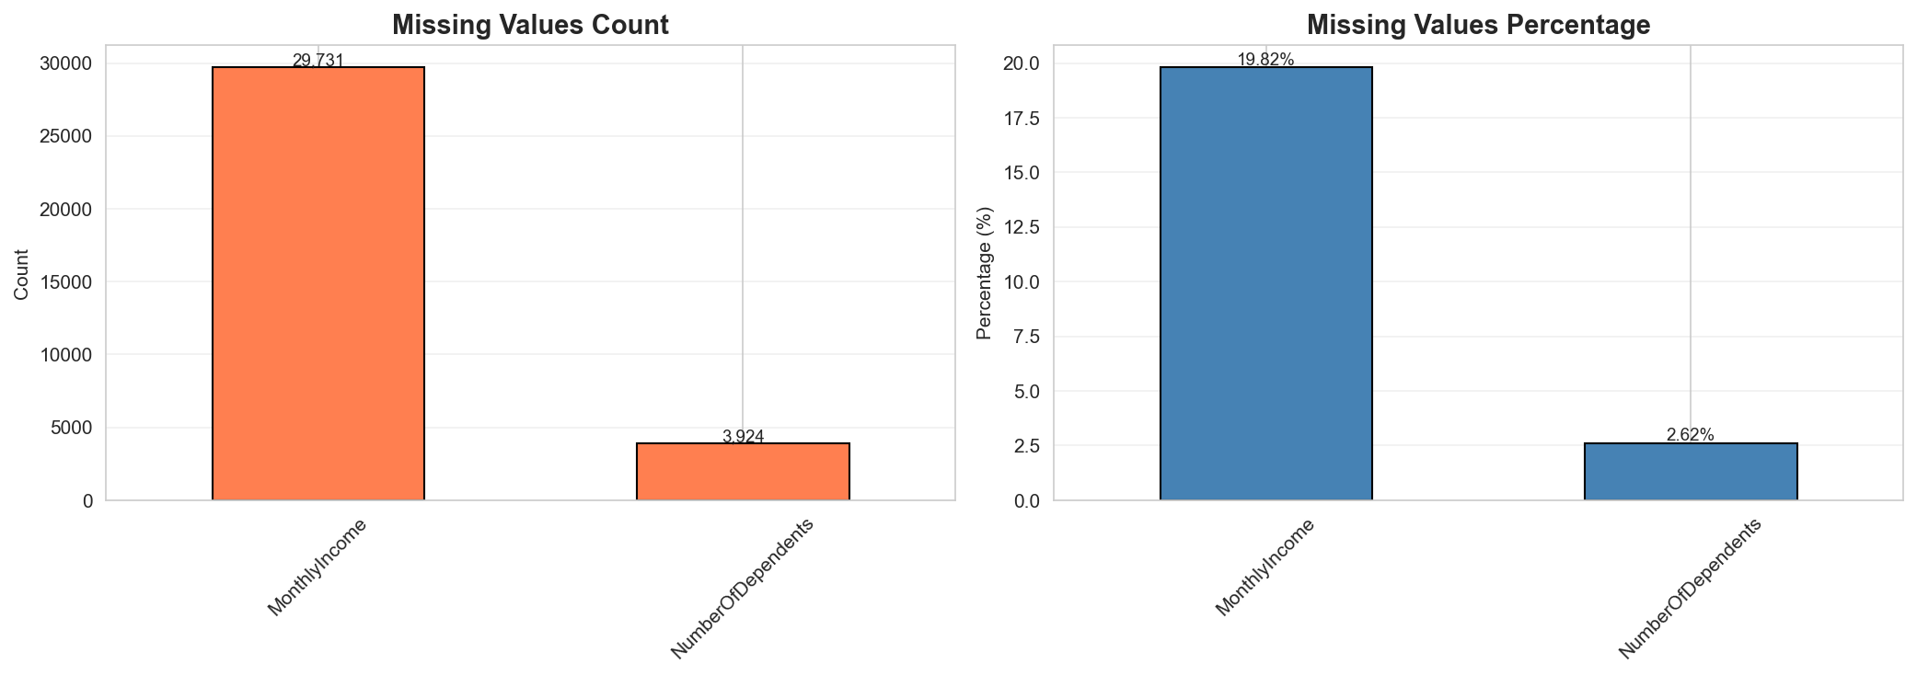
Figure 1: Missing Values Distribution

3.2 Outlier Detection
Outlier analysis using the Interquartile Range (IQR) method identified significant outliers across multiple features. The features with the highest percentage of outliers include:
- RevolvingUtilizationOfUnsecuredLines: High percentage of extreme values
- DebtRatio: Substantial outliers indicating borrowers with very high debt-to-income ratios
- NumberOfTime30-59DaysPastDueNotWorse: Outliers representing borrowers with frequent delinquencies
- Age: Some extreme values at both ends of the distribution
These outliers are important as they may represent high-risk borrowers and should be carefully considered during model development. Techniques such as winsorization or log transformation may be applied during feature engineering.

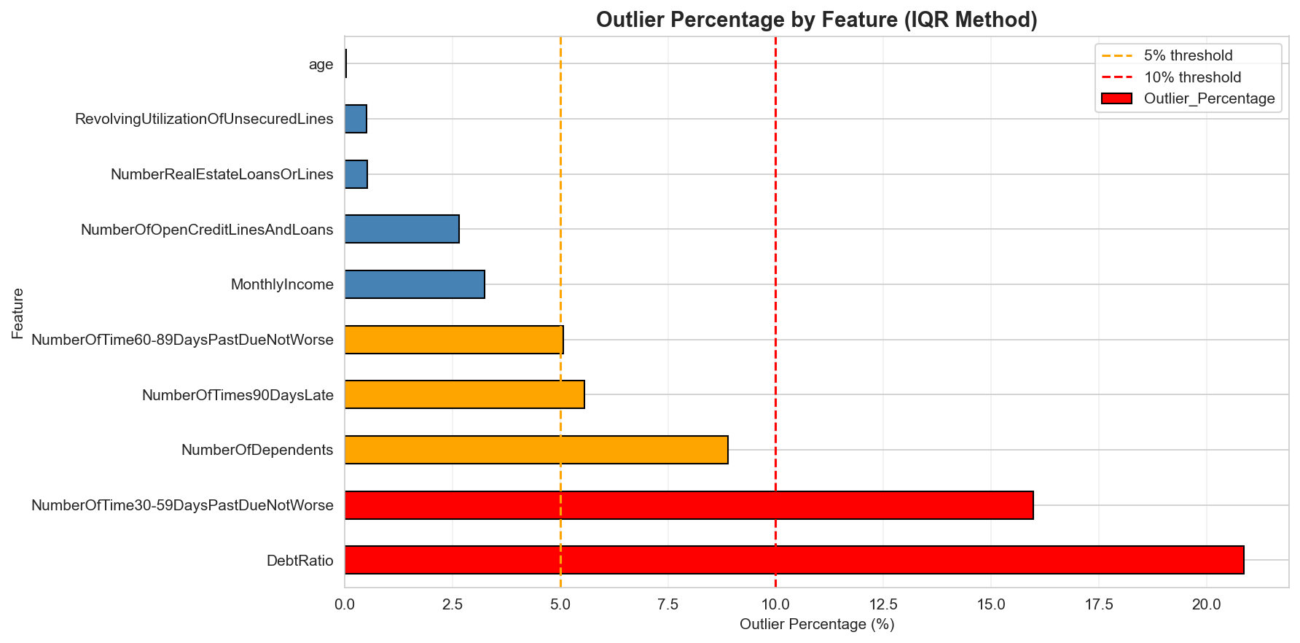
Figure 2: Outlier Percentage by Feature

4. Univariate Analysis
Univariate analysis examines each feature individually to understand its distribution, central tendency, and spread. This analysis provides insights into the characteristics of the borrower population.

4.1 Age Distribution
The age distribution shows that most borrowers are between 30 and 60 years old, with a peak around 45-50 years. The distribution is approximately normal with a slight right skew, indicating a mature borrower base.

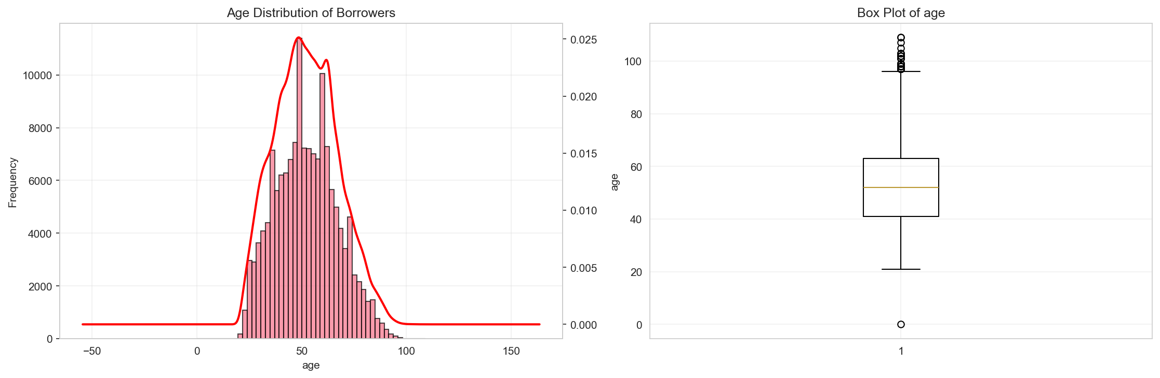
Figure 3: Age Distribution of Borrowers

4.2 Credit Utilization
The revolving credit utilization shows a highly right-skewed distribution, with most borrowers maintaining utilization below 50%. However, a significant number of borrowers have utilization rates exceeding 100%, which may indicate over-leveraging and higher default risk.

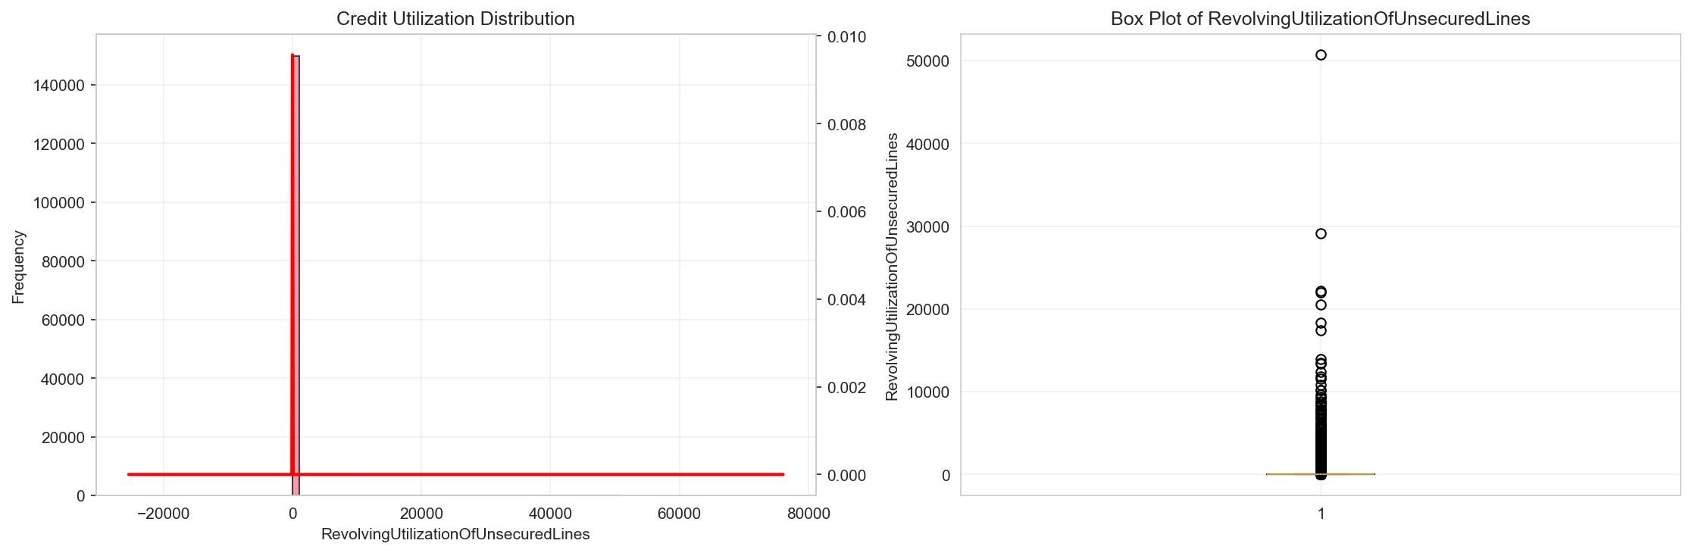
Figure 4: Credit Utilization Distribution

4.3 Debt Ratio
The debt ratio distribution reveals that while most borrowers have manageable debt-to-income ratios, there is a long tail of borrowers with extremely high ratios. This suggests a segment of the population that may be financially stressed.

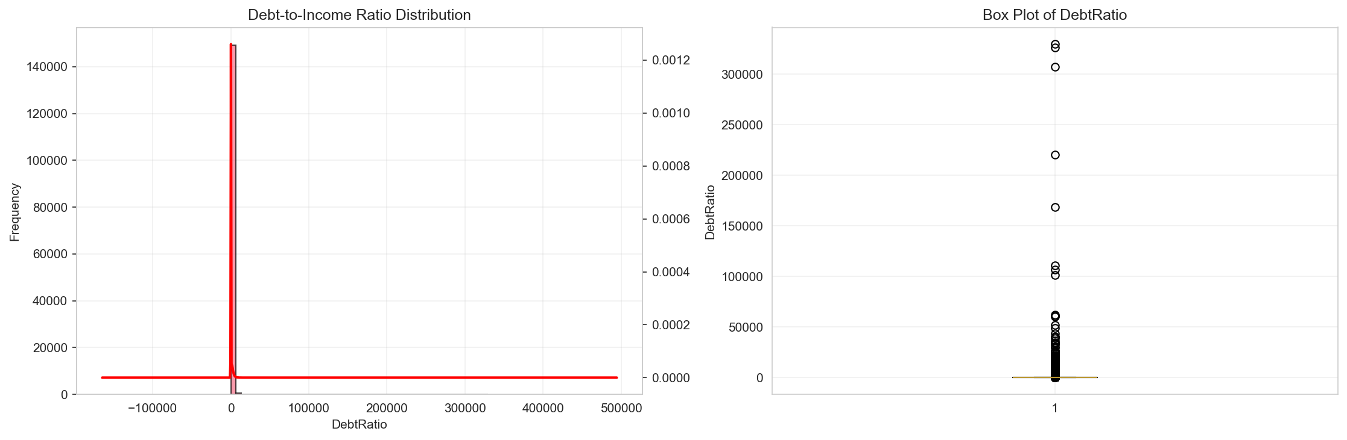
Figure 5: Debt Ratio Distribution

4.4 Monthly Income
Monthly income shows a right-skewed distribution with most borrowers earning between $3,000 and $10,000 per month. The presence of very high-income outliers suggests a diverse borrower base spanning multiple income brackets.

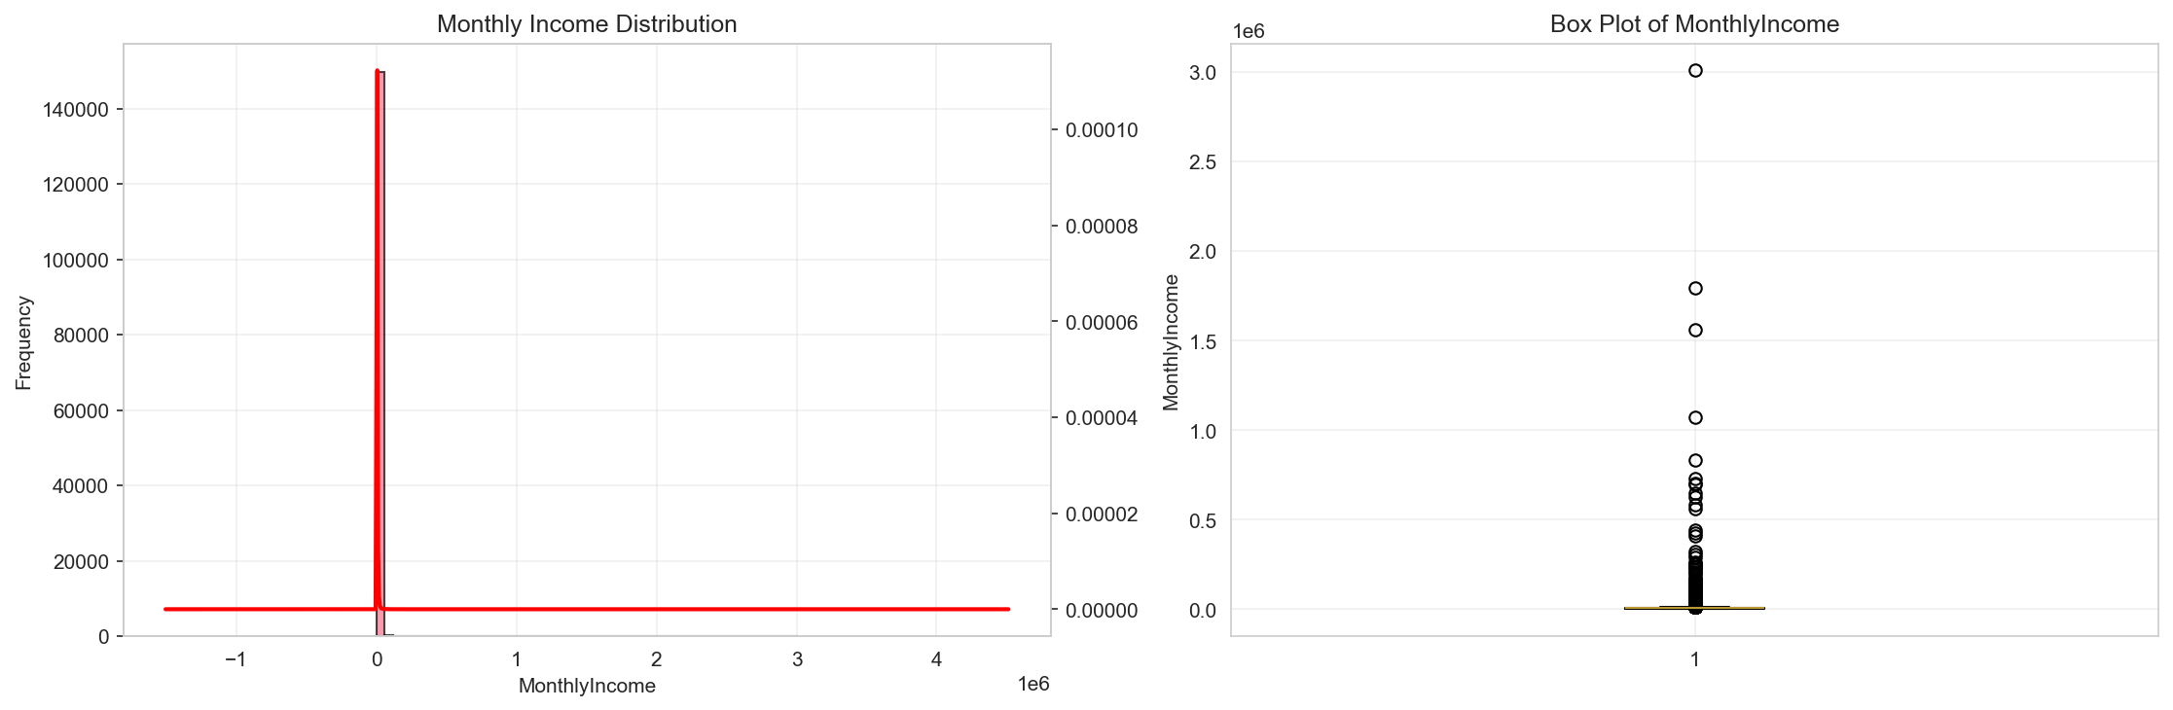
Figure 6: Monthly Income Distribution

4.5 Delinquency Patterns
Analysis of delinquency-related features shows that the majority of borrowers have no history of late payments. However, those with delinquencies show patterns that strongly correlate with default risk.

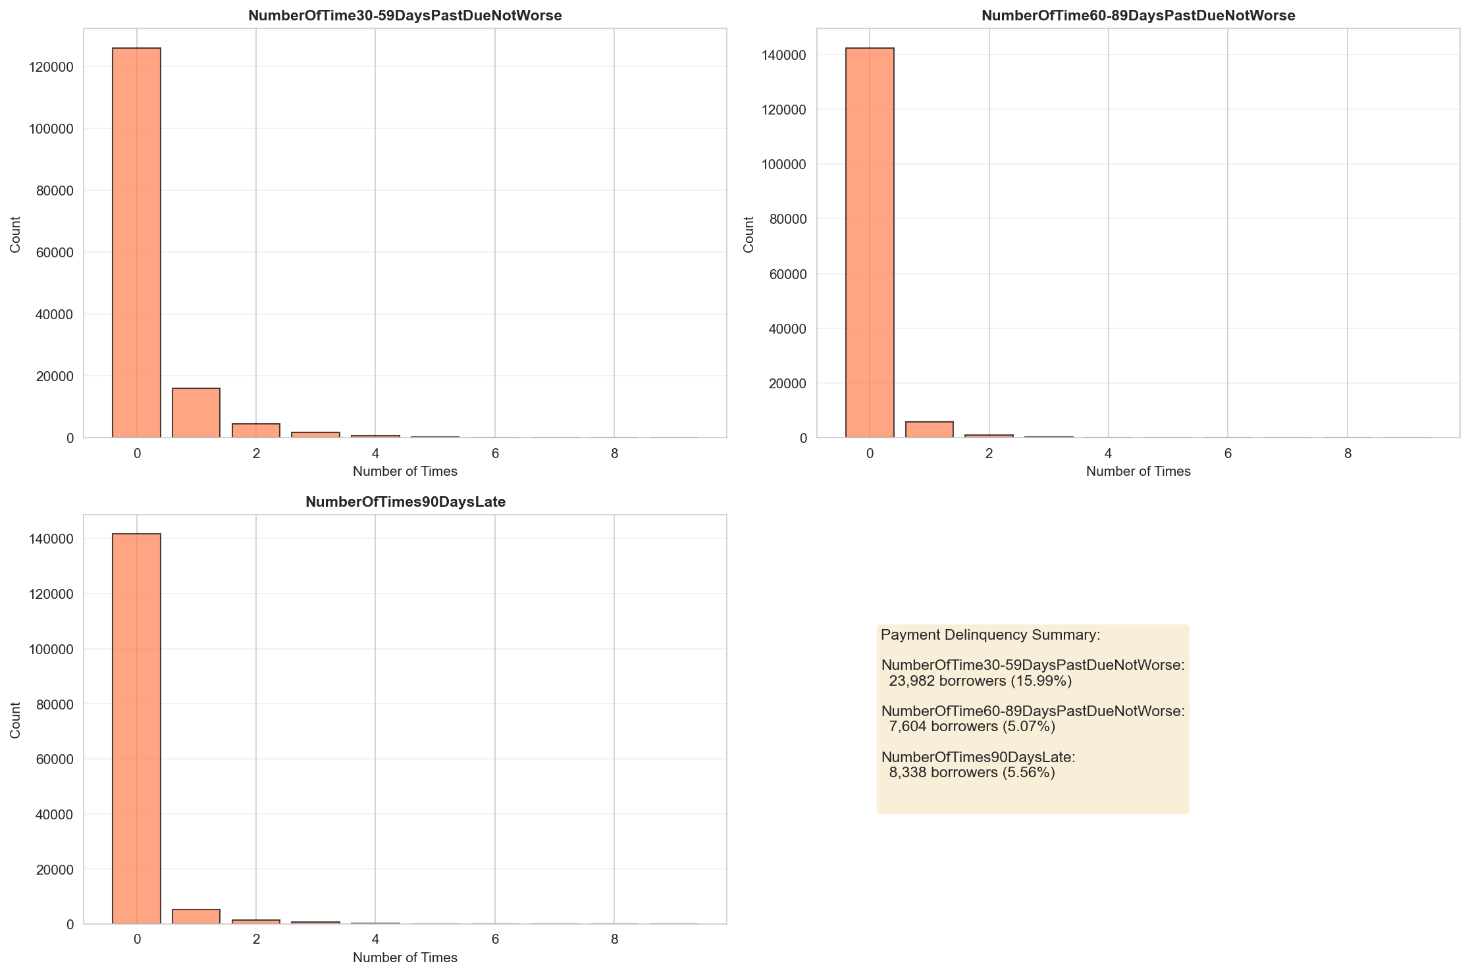
Figure 7: Delinquency Analysis

5. Bivariate Analysis
Bivariate analysis explores relationships between individual features and the target variable (SeriousDlqin2yrs). This analysis helps identify which features are most predictive of default risk.

5.1 Age vs Default Risk
The relationship between age and default risk shows that younger borrowers (under 30) and very old borrowers (over 70) tend to have higher default rates. Middle-aged borrowers (40-60) demonstrate the lowest default rates, likely due to greater financial stability.

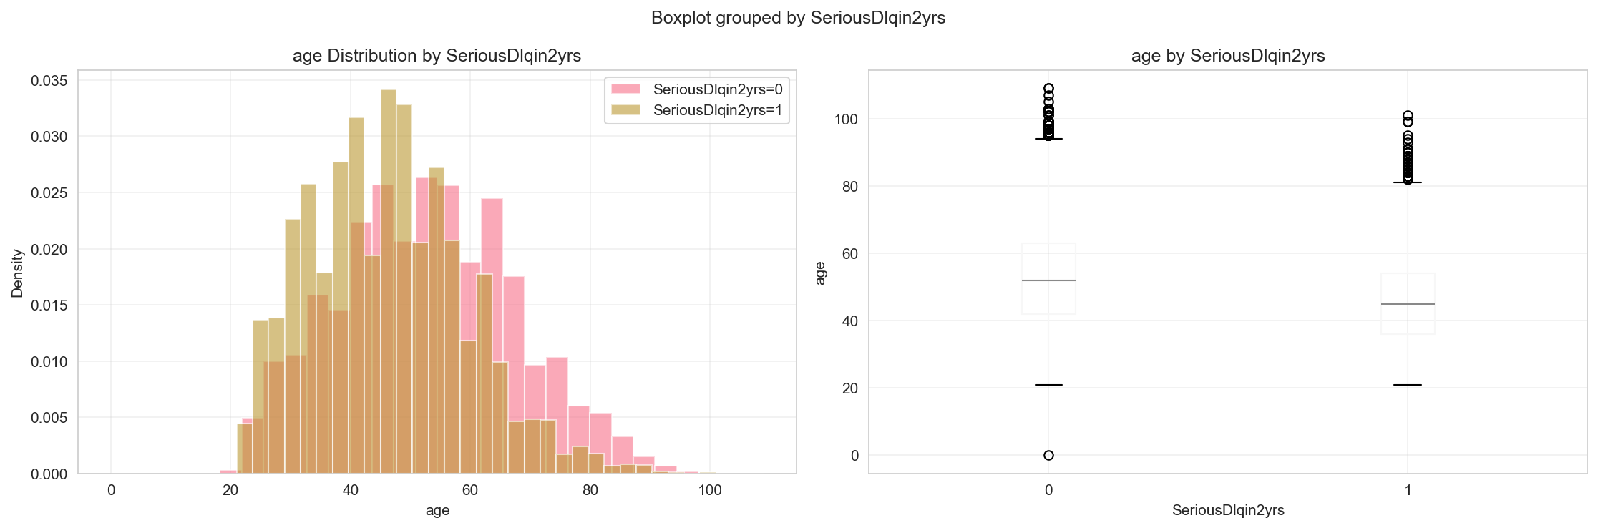
Figure 8: Age vs Default Risk

5.2 Credit Utilization vs Default Risk
Credit utilization shows a strong positive relationship with default risk. Borrowers with utilization rates above 80% have significantly higher default rates, indicating that high credit utilization is a strong predictor of financial distress.

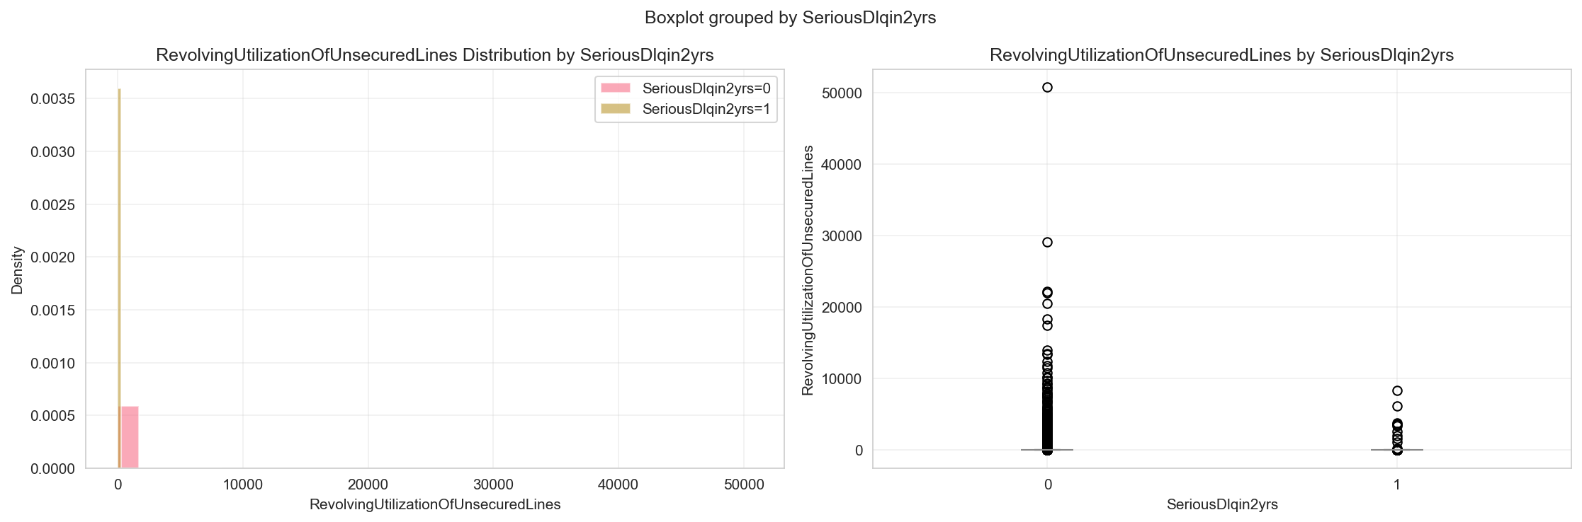
Figure 9: Credit Utilization vs Default Risk

5.3 Debt Ratio vs Default Risk
Debt ratio demonstrates a clear relationship with default probability. Borrowers with debt ratios exceeding 0.5 (50% of income going to debt payments) show markedly higher default rates, confirming that debt burden is a critical risk factor.

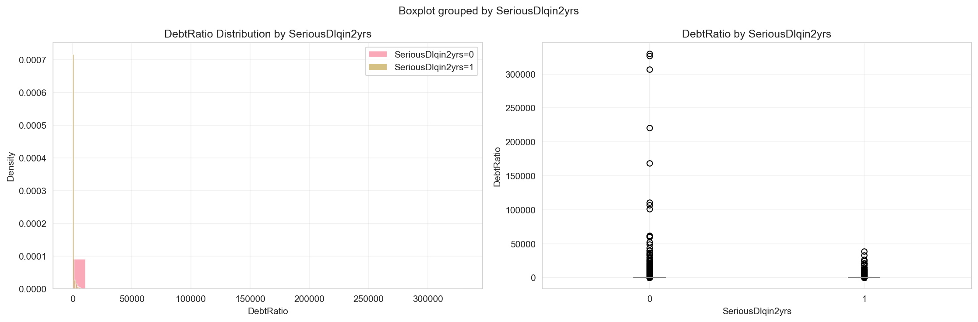
Figure 10: Debt Ratio vs Default Risk

5.4 Monthly Income vs Default Risk
Monthly income shows an inverse relationship with default risk. Lower-income borrowers exhibit higher default rates, while higher-income borrowers are more likely to remain current on their obligations.

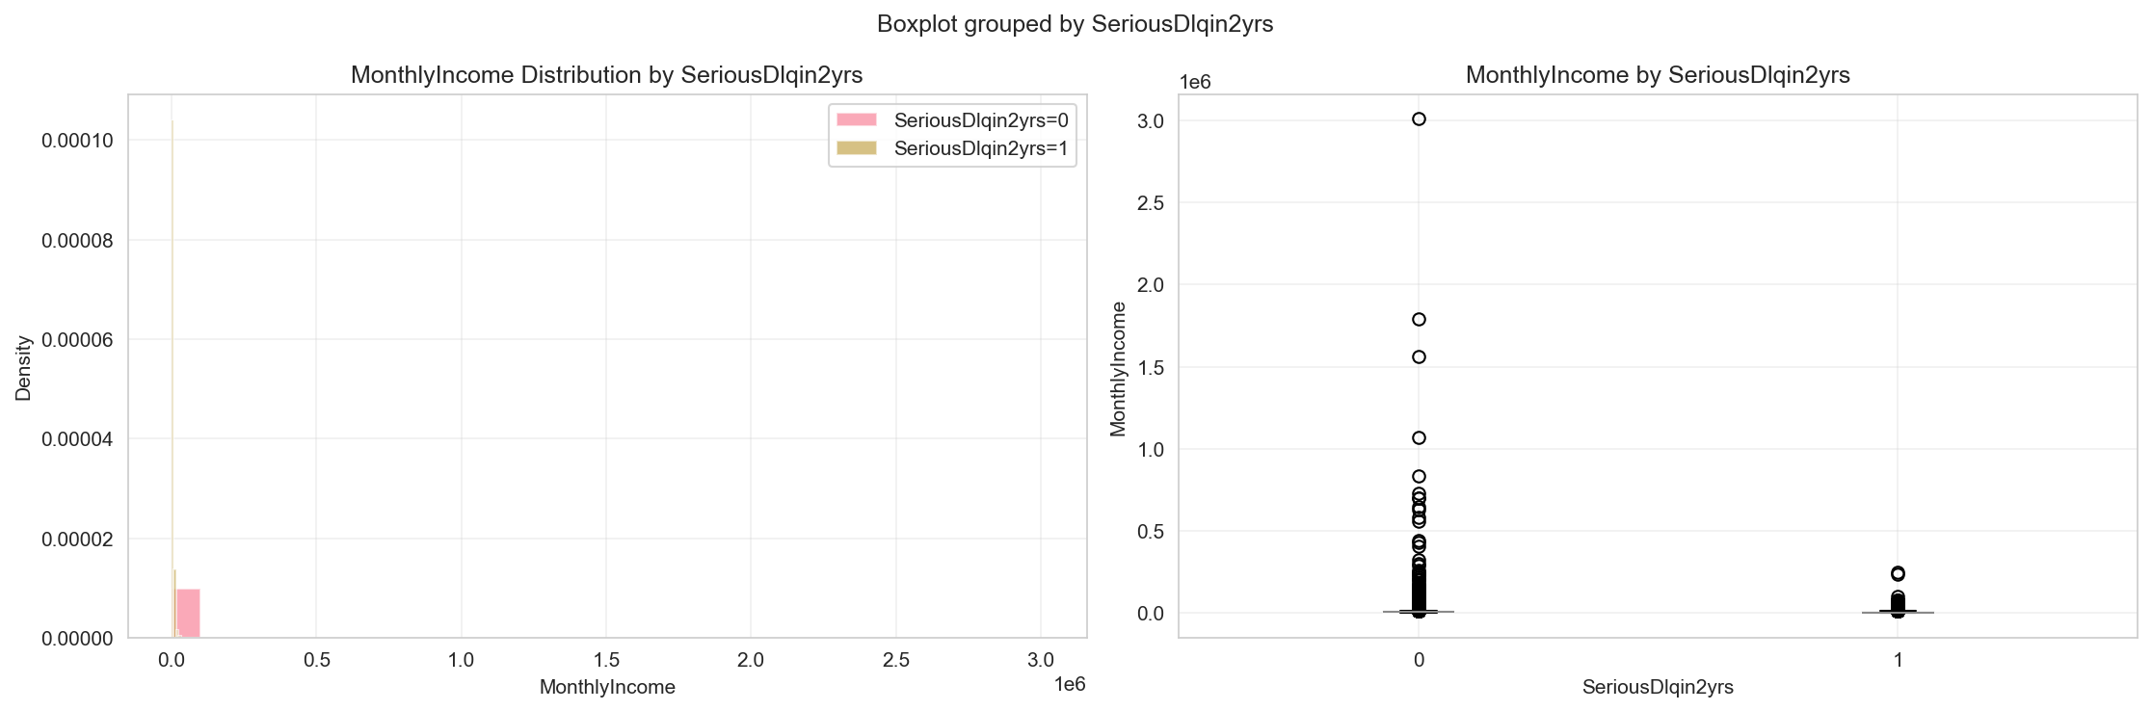
Figure 11: Monthly Income vs Default Risk

5.5 Feature-Target Correlation
Correlation analysis reveals the strength of linear relationships between features and the target variable. Delinquency-related features show the strongest correlations with default risk, followed by debt-related metrics.

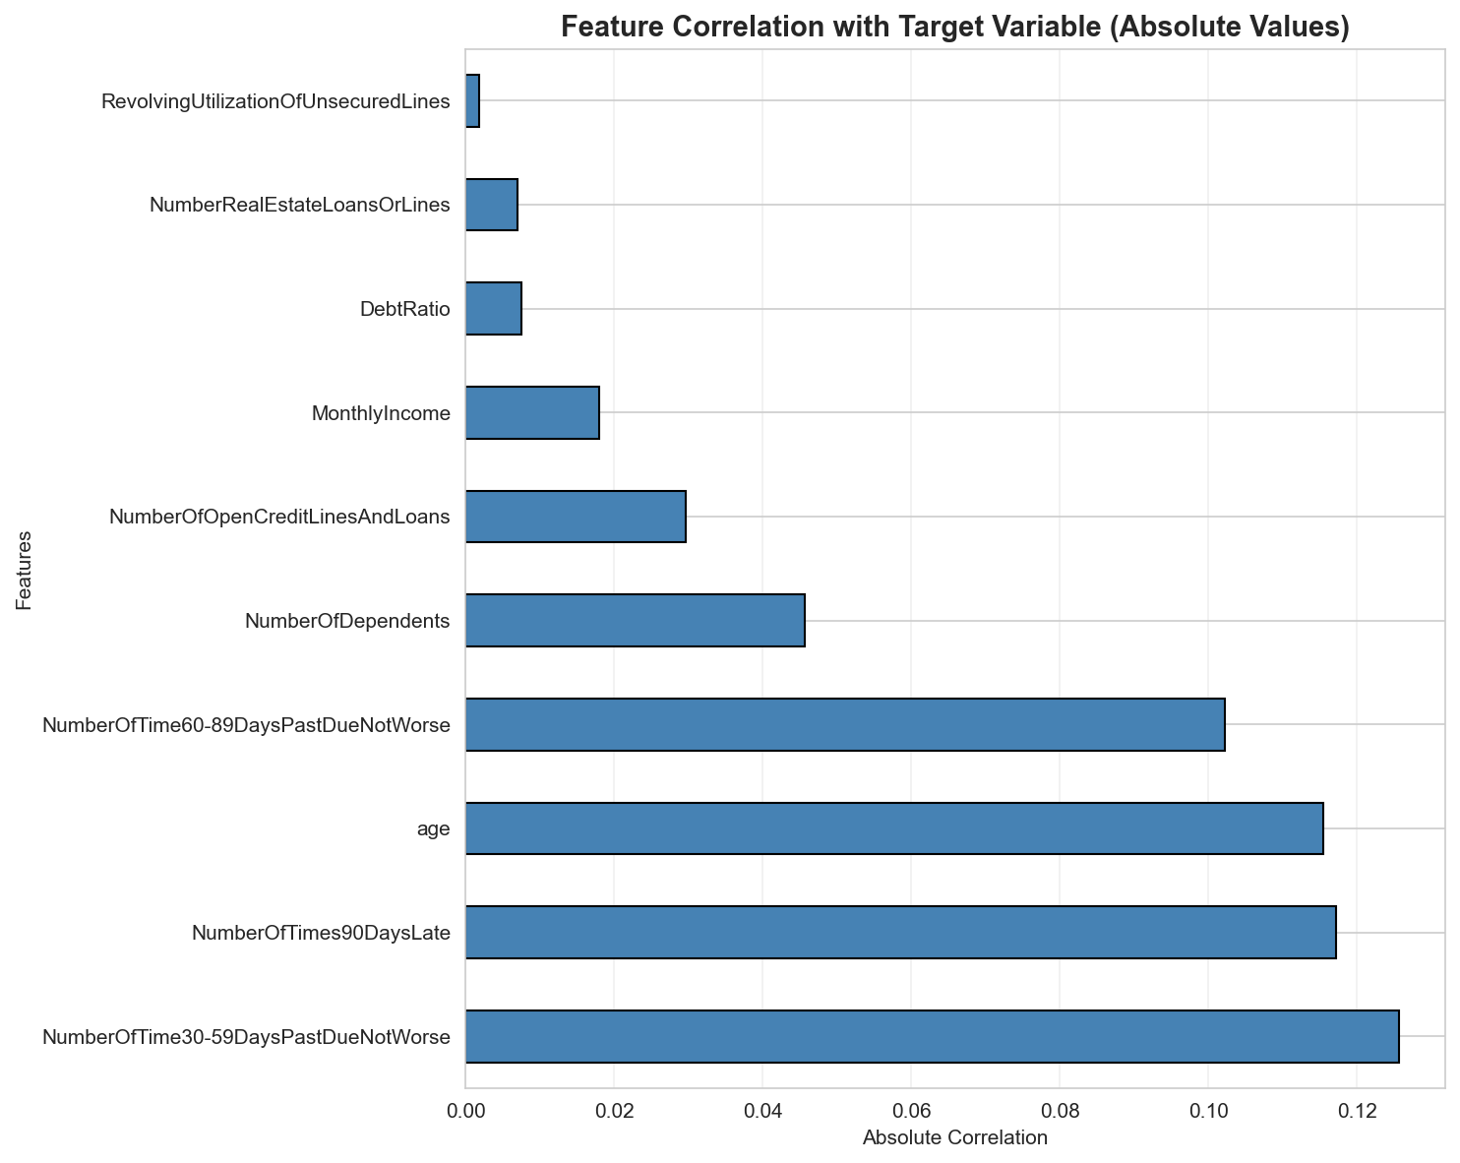
Figure 12: Feature-Target Correlation

6. Multivariate Analysis
Multivariate analysis examines relationships among multiple features simultaneously, revealing complex patterns and interactions that may not be apparent in univariate or bivariate analysis.

6.1 Correlation Matrix
The correlation matrix reveals several important relationships:
- Strong positive correlations among delinquency-related features (30-59, 60-89, and 90+ days late)
- Moderate correlation between age and number of real estate loans
- Weak correlation between monthly income and most other features
- The target variable shows strongest correlations with delinquency features

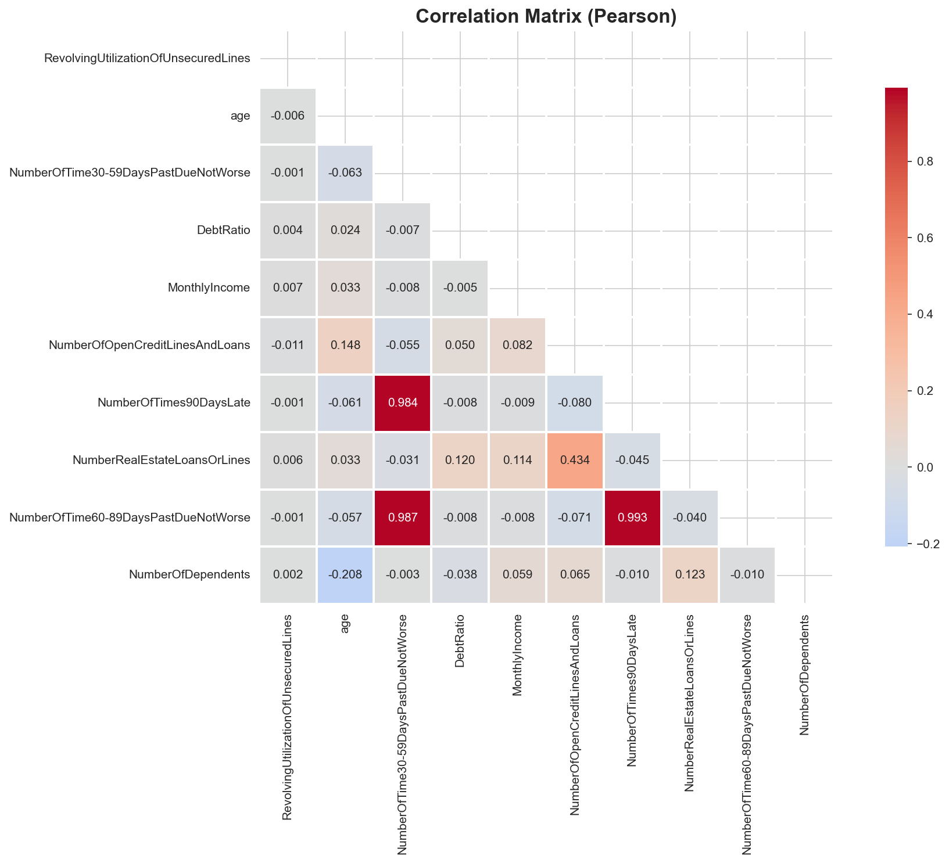
Figure 13: Feature Correlation Matrix

6.2 Feature Importance for Target Prediction
Analysis of feature correlations with the target variable identifies the most important predictors:


Figure 14: Feature Correlations with Target Variable

6.3 Pairwise Relationships
The pairplot visualization shows relationships among key features, colored by default status. This reveals distinct patterns and clusters that differentiate defaulters from non-defaulters.

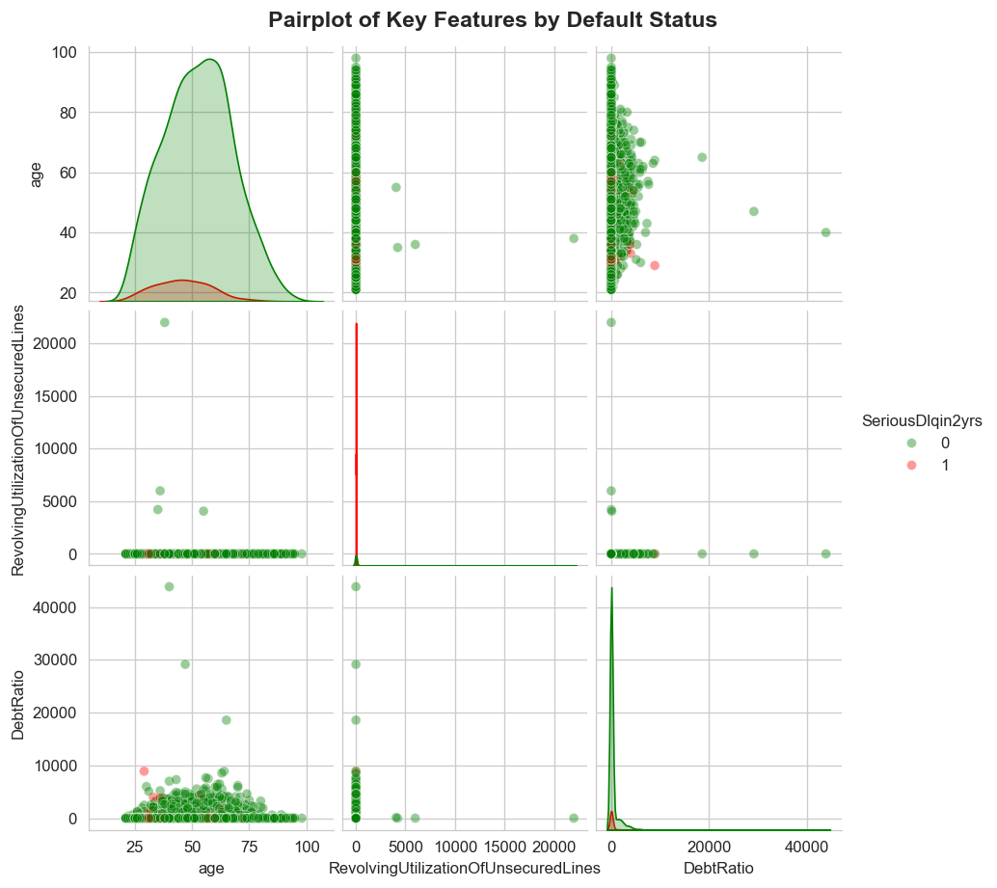
Figure 15: Pairwise Relationships of Key Features

7. Conclusions and Recommendations

7.1 Key Insights
- Delinquency history is the strongest predictor of future default risk
- High credit utilization (>80%) and high debt ratios (>50%) are significant risk indicators
- Age shows a U-shaped relationship with default risk, with younger and older borrowers at higher risk
- Lower income levels are associated with increased default probability
- Multiple features show strong intercorrelations, suggesting potential for dimensionality reduction

7.2 Recommendations for Model Development
- Prioritize delinquency-related features in the predictive model
- Consider feature engineering to create interaction terms between debt ratio and income
- Apply appropriate transformations to handle skewed distributions (log transformation for income, debt ratio)
- Implement outlier treatment strategies such as winsorization or capping at percentiles
- Consider age binning to capture the non-linear relationship with default risk
- Evaluate feature selection techniques to address multicollinearity among delinquency features
- Ensure proper handling of class imbalance in the target variable during model training

7.3 Data Quality Considerations
While mean imputation was applied to handle missing values, alternative imputation strategies should be considered during model development:
- Evaluate the impact of different imputation methods (median, mode, predictive imputation)
- Consider creating missing value indicators as additional features
- Assess whether missing values in MonthlyIncome and NumberOfDependents are missing at random
- Monitor model performance on records with imputed values versus complete records

7.4 Next Steps
- Feature Engineering: Create derived features based on insights from EDA
- Feature Selection: Apply statistical tests and model-based selection methods
- Model Development: Train and evaluate multiple classification algorithms
- Model Validation: Implement cross-validation and holdout testing strategies
- Model Interpretation: Use SHAP values or similar techniques to explain predictions
- Deployment Planning: Design monitoring and retraining strategies for production

8. Appendix

8.1 Technical Details
Analysis Tools:
- Python 3.x
- Pandas for data manipulation
- NumPy for numerical computations
- Matplotlib and Seaborn for visualization
- Jupyter Notebooks for interactive analysis

Data Processing:
- Missing value imputation: Mean method
- Outlier detection: IQR method (Q1 - 1.5*IQR, Q3 + 1.5*IQR)
- Correlation method: Pearson correlation coefficient

8.2 Dataset Statistics
Metric | Value
Total Records | 150,000
Total Features | 12
Target Variable | SeriousDlqin2yrs
Missing Values (Before Imputation) | 33,655
Missing Values (After Imputation) | 0
Numerical Features | 11
Categorical Features | 1 (Target)

