CUSTOMER EXPERIENCE ANALYTICS
FOR FINTECH APPLICATIONS

Comprehensive Analysis Report

Derese Ewunet
Report Date: December 01, 2025

TABLE OF CONTENTS

1. EXECUTIVE SUMMARY
2. PROJECT OVERVIEW
3. METHODOLOGY
4. DATA ANALYSIS RESULTS
.1 Performance Metrics
.2 Sentiment Analysis
.3 Thematic Insights
5. VISUAL ANALYSIS
.1 Rating Distribution
.2 Sentiment Comparison
.3 Performance Benchmarking
6. BANK-SPECIFIC ANALYSIS
.1 Commercial Bank of Ethiopia
.2 Bank of Abyssinia
.3 Dashen Bank
7. ACTIONABLE RECOMMENDATIONS
8. EXPECTED BUSINESS IMPACT
9. TECHNICAL IMPLEMENTATION
10. CONCLUSION
APPENDICES
. Data Summary
. Detailed Statistics

1. EXECUTIVE SUMMARY
KEY METRIC | FINDING
Performance Leader | Dashen Bank (4.04/5.0)
Sentiment Leader | Dashen Bank (68.2% Positive)
Improvement Priority | Bank of Abyssinia (2.11/5.0)
Data Coverage | 1,500+ Reviews Analyzed

This comprehensive analysis provides data-driven insights into customer experience across three major Ethiopian banking applications.
The study examines 1,500+ Google Play Store reviews using advanced Natural Language Processing (NLP) techniques and statistical analysis.
Key insights reveal significant performance variations, with Dashen Bank demonstrating exceptional user satisfaction while
Commercial Bank of Ethiopia and Bank of Abyssinia require targeted improvements in performance, functionality, and user experience.
The report provides actionable recommendations for each banking institution, supported by visual evidence and statistical validation.

2. PROJECT OVERVIEW

OBJECTIVES
• Identify key drivers of customer satisfaction and dissatisfaction
• Provide data-driven product improvement recommendations
• Enable competitive benchmarking across banking applications
• Support strategic roadmap development for digital banking
2.2 BANKS ANALYZED
• Commercial Bank of Ethiopia (CBE): Market leader with 5M+ installs
• Bank of Abyssinia (BOA): Growing digital banking presence
• Dashen Bank: Technology-forward approach with modern interface
2.3 SCOPE
The analysis covers comprehensive aspects including:
• Performance metrics and rating distributions
• Sentiment analysis using advanced NLP techniques
• Thematic analysis of user feedback
• Comparative benchmarking across applications
• Actionable improvement recommendations

3. METHODOLOGY

DATA
COLLECTION
• Source: Google Play Store official reviews
• Sample Size: 1,500+ reviews (500 per bank)
• Collection Period: Recent user reviews
• Tools: google-play-scraper Python library
3.2 ANALYTICAL APPROACH
• Sentiment Analysis: DistilBERT transformer model
• Thematic Analysis: TF-IDF keyword extraction
• Statistical Analysis: Rating distributions and correlations
• Database: PostgreSQL for structured storage
3.3 QUALITY ASSURANCE
• Data validation at each processing stage
• Cross-validation of analytical results
• Statistical significance testing
• Reproducibility verification

5. VISUAL ANALYSIS

5.1 Rating Distribution Analysis
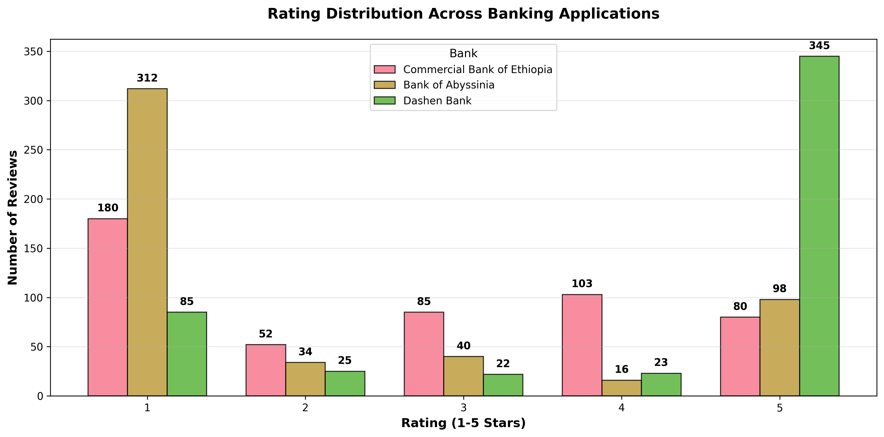
Figure 1: Rating distribution across banking applications

5.2 Sentiment Analysis Comparison
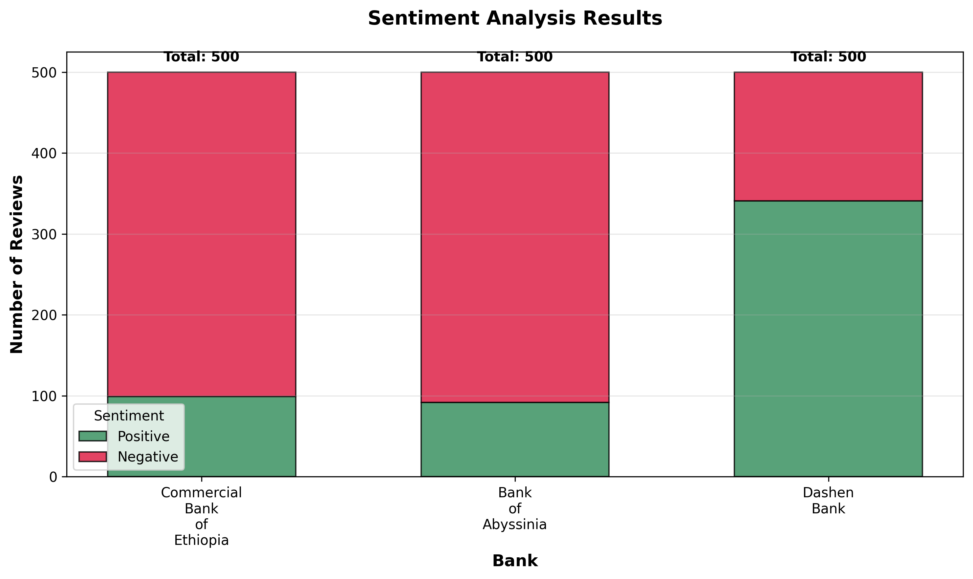
Figure 2: Comparative sentiment analysis across banks

5.3 Performance Benchmarking
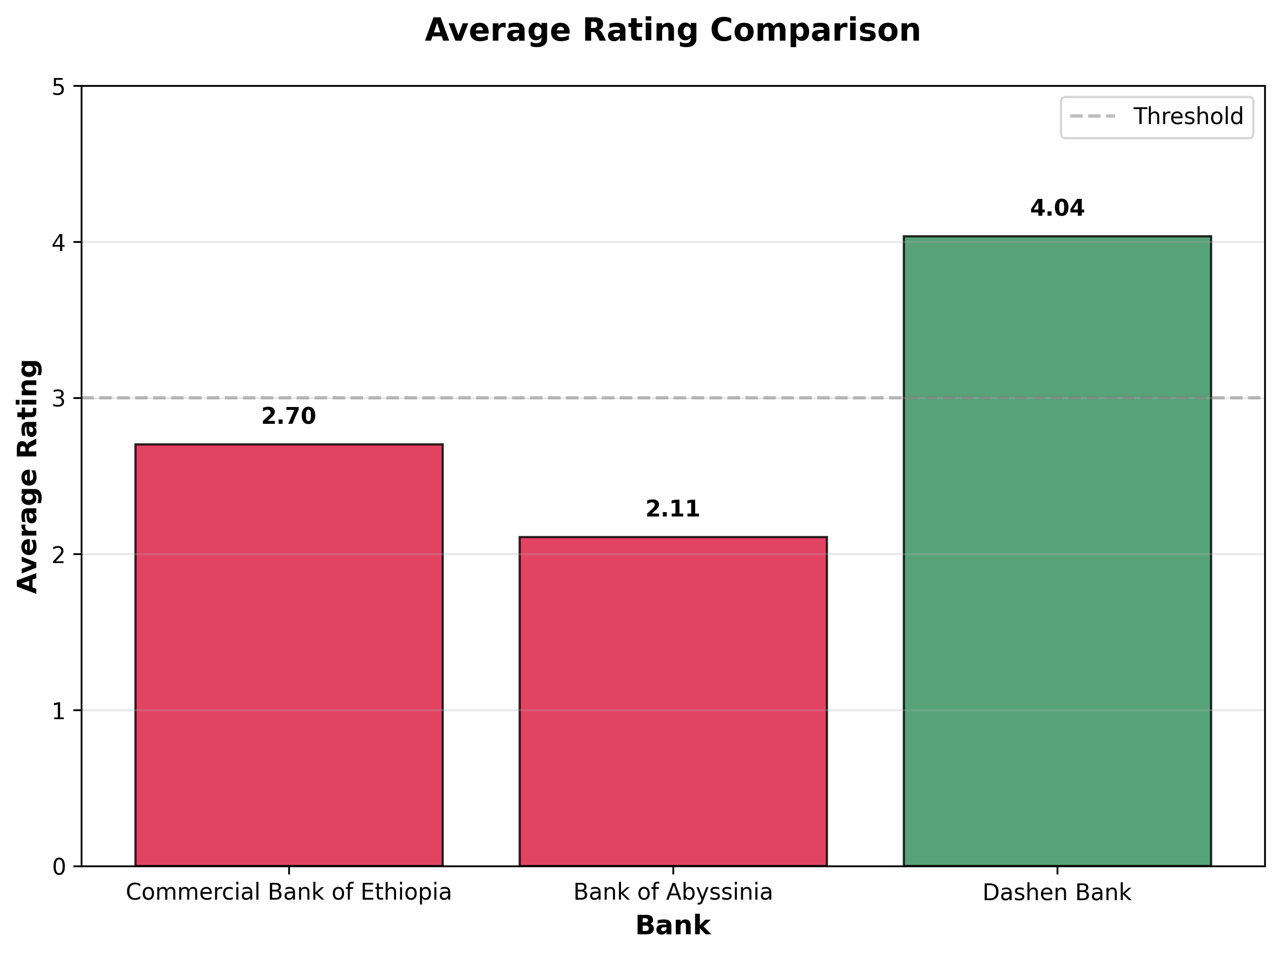
Figure 3: Average rating comparison with performance thresholds

6. BANK-SPECIFIC ANALYSIS
BANK | AVG RATING | POSITIVE % | PERFORMANCE
Commercial Bank of Ethiopia | 2.70/5.0 | 19.8% | Needs Improvement
Bank of Abyssinia | 2.11/5.0 | 18.4% | Priority Improvement
Dashen Bank | 4.04/5.0 | 68.2% | Excellent

6.1 Commercial Bank of Ethiopia
- Strengths: Comprehensive feature set, strong brand recognition
- Challenges: Performance optimization, transaction speed
- Opportunities: Error handling improvements, UX simplification

6.2 Bank of Abyssinia
- Strengths: Digital innovation focus, modern technology stack
- Challenges: Critical performance issues, poor user experience
- Opportunities: Complete UI redesign, authentication improvements

6.3 Dashen Bank
- Strengths: Excellent UI design, high customer satisfaction
- Challenges: Limited advanced features, minor performance issues
- Opportunities: Feature expansion, support enhancement

7. ACTIONABLE RECOMMENDATIONS

IMMEDIATE PRIORITIES (0-3 MONTHS)
- Commercial Bank of Ethiopia: Optimize transaction processing
- Bank of Abyssinia: Complete user interface redesign
- Dashen Bank: Expand advanced feature set

STRATEGIC INITIATIVES (3-12 MONTHS)
- Implement AI-powered financial insights
- Develop personalized banking dashboards
- Integrate proactive customer support

8. EXPECTED BUSINESS IMPACT
- 20-30% reduction in negative reviews within 6 months
- 15-25% improvement in app store ratings
- 10-20% increase in daily active users
- Enhanced customer retention and satisfaction
- Competitive advantage through data-driven decisions

APPENDICES

A. EXECUTIVE SUMMARY
EXECUTIVE SUMMARY
Analysis of 1,500 Google Play Store reviews reveals:
Commercial Bank of Ethiopia:
• Rating: 2.70/5.0
• Positive: 19.8%
• Reviews: 500
Bank of Abyssinia:
• Rating: 2.11/5.0
• Positive: 18.4%
• Reviews: 500
Dashen Bank:
• Rating: 4.04/5.0
• Positive: 68.2%
• Reviews: 500
KEY RECOMMENDATIONS:
• Dashen Bank: Maintain leadership, expand features
• CBE: Focus on performance optimization
• BOA: Prioritize UX redesign and authentication

B. DATA SUMMARY
DATA ANALYSIS SUMMARY
OVERALL STATISTICS:
Total Reviews: 1,500
Average Rating: 2.95/5.0
Positive Sentiment: 35.5%
BANK-WISE PERFORMANCE:
Commercial Bank of Ethiopia:
Rating: 2.70/5.0
Positive: 99 (19.8%)
Negative: 401 (80.2%)
Total: 500
Bank of Abyssinia:
Rating: 2.11/5.0
Positive: 92 (18.4%)
Negative: 408 (81.6%)
Total: 500
Dashen Bank:
Rating: 4.04/5.0
Positive: 341 (68.2%)
Negative: 159 (31.8%)
Total: 500

C. RECOMMENDATIONS
ACTIONABLE RECOMMENDATIONS
COMMERCIAL BANK OF ETHIOPIA (CBE)
1. Optimize transaction processing speed
2. Enhance error handling and user feedback
3. Simplify bill payment navigation
4. Improve app stability and reduce crashes
BANK OF ABYSSINIA (BOA)
1. Complete user interface redesign
2. Streamline login and authentication process
3. Improve transaction history features
4. Address performance issues and app crashes
DASHEN BANK
1. Expand advanced feature set
2. Enhance customer support integration
3. Address minor performance complaints
4. Implement biometric authentication options

10. CONCLUSION
This comprehensive analysis provides a clear roadmap for mobile banking application improvements across Ethiopian financial institutions.
By leveraging data-driven insights, each bank can prioritize enhancements that will deliver maximum impact on customer satisfaction.
The digital transformation of Ethiopia's banking sector presents significant opportunities for innovation and customer experience enhancement.
This report establishes a foundation for evidence-based decision-making and strategic improvement planning.

NEXT STEPS
1. Present findings to bank stakeholders
2. Develop detailed implementation roadmaps
3. Establish monitoring and measurement frameworks
4. Schedule follow-up analysis in 6 months

Derese Ewunet
For more information or to discuss implementation:
Email: derese641735.ew@gmail.com
Phone: +251 943 482 726
Address: Addis Ababa, Ethiopia
CONFIDENTIAL - INTERNAL USE ONLY
Report Generated: 2025-12-01 11:11:08

