To get started with Blocky on the M5Stick:

1. Download the CH9102 drivers for your operating system from [m5-docs (m5stack.com)](https://docs.m5stack.com/en/download).

For Windows, you’ll want CH9102_VCP_SER_Windows.

This is the USB to Serial converter drivers that is included in the M5StickC.

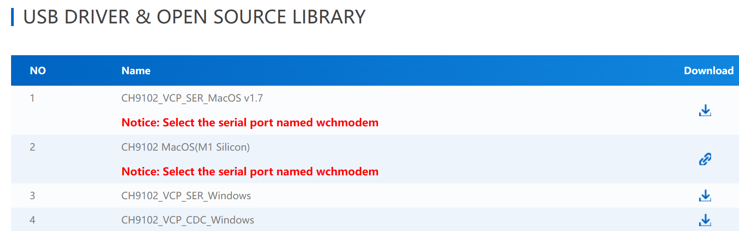

1. Download and unzip the M5Burner software. This will be the tool to flash the firmware onto the device. Pick the right one for your Operating System. 😊

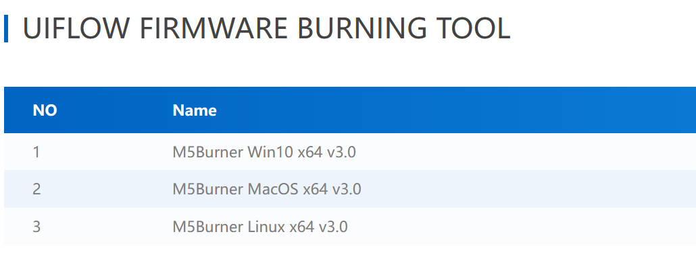

Unzip that to a directory and run it. Windows Smart Screen may stop execution because it's an unknown file. If you see the Smart Screen dialog, you can click "More Info" and "Run Anyway."

1. In M5Burner, select the “StickC” Section. This is for the entire StickC family of devices from M5, including other devices in addition to the “StickC Plus2” provided by the conference. Any firmware you want to flash should read “Plus2” to ensure compatibility.

For the conference, we’re using UIFlow_StickC_Plus2 as the base.   
You’ll need to hit the “Download” button on that firmware in order to see the “Configure” button.

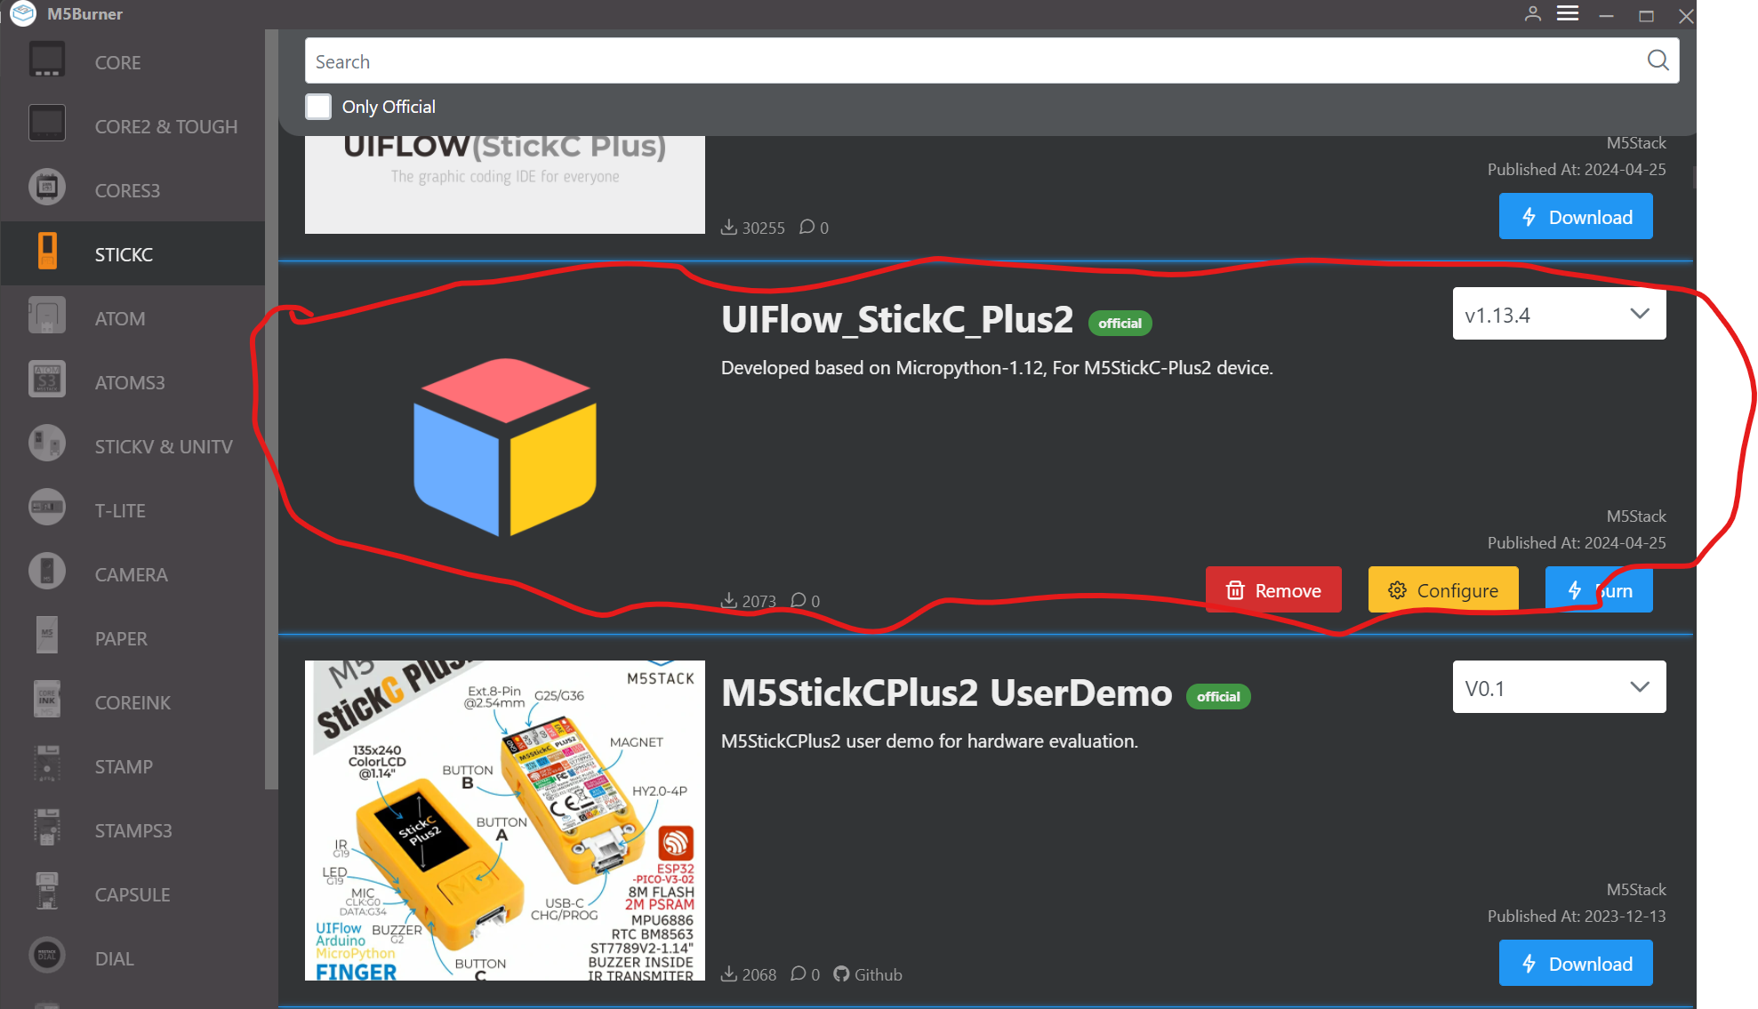

1. From here, you can hit the “Configure” button to modify the EEPROM settings, which include the 802.11 Wireless creds, where the device connects when it boots, and other settings.

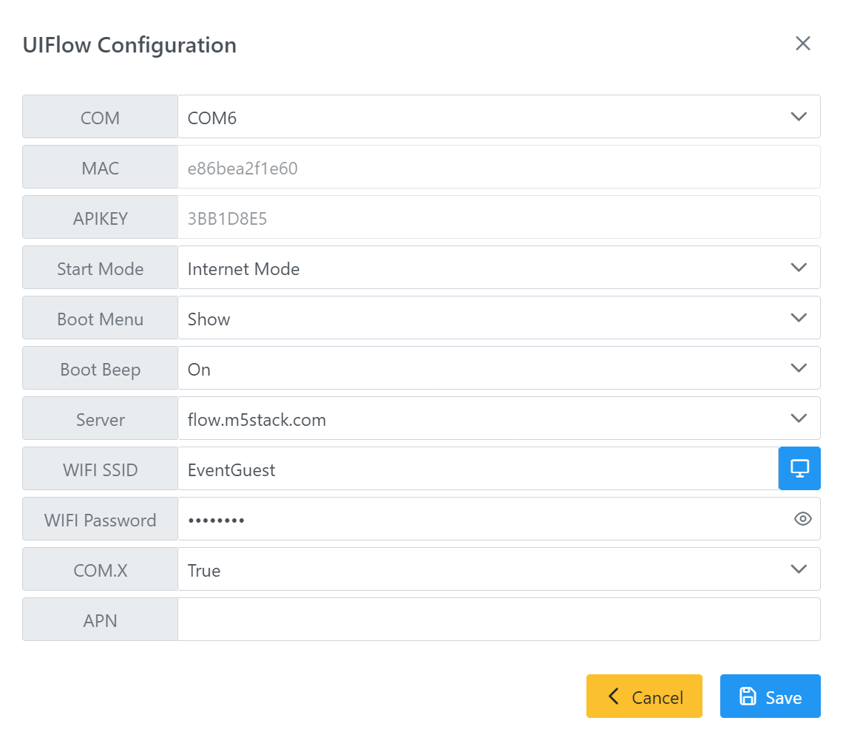

Some settings:  
“Start Mode” – This is the behavior of the device when it’s powered on.

Internet Mode – This uses the wifi creds specificed in the WIFI SSID and WIFI Password to connect to the Internet, and then connects to the Server specified. The example here shows the conference center wireless network, and a UIFlow 1.0 server of “flow.m5stack.com”

App Mode – This runs the default “main.py” file saved in the flash on the device.

USB Mode – Allows programming over USB>

To start, we’ll set it to Internet Mode with the above settings. Replace the Wireless credentials with your wireless creds.

Click Save.

1. From here, the device will reboot, connect to 802.11, and then connect to “flow.m5stack.com”

If the screen is Blue, it’s good. If the screen is Red, it’s bad. Here blue means it has a connection to the server, and is ready for programming via UIFlow.

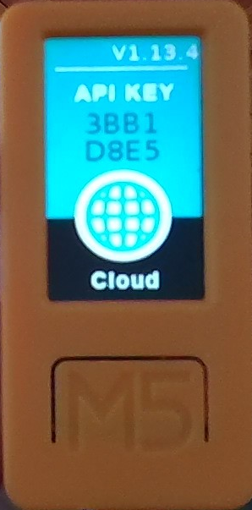

1. Open a web browser and connect to “https://flow.m5stack.com”

You’ll be presented with a screen to select UIFlow1.0 vs 2.0. We used 1.0, and if you want to use the features of 2.0, you can reflash your device, sign up for an account on M5, and repeat the above process for 2.0. 😊

Choose UIFlow 1.0 on the left, and click Confirm.

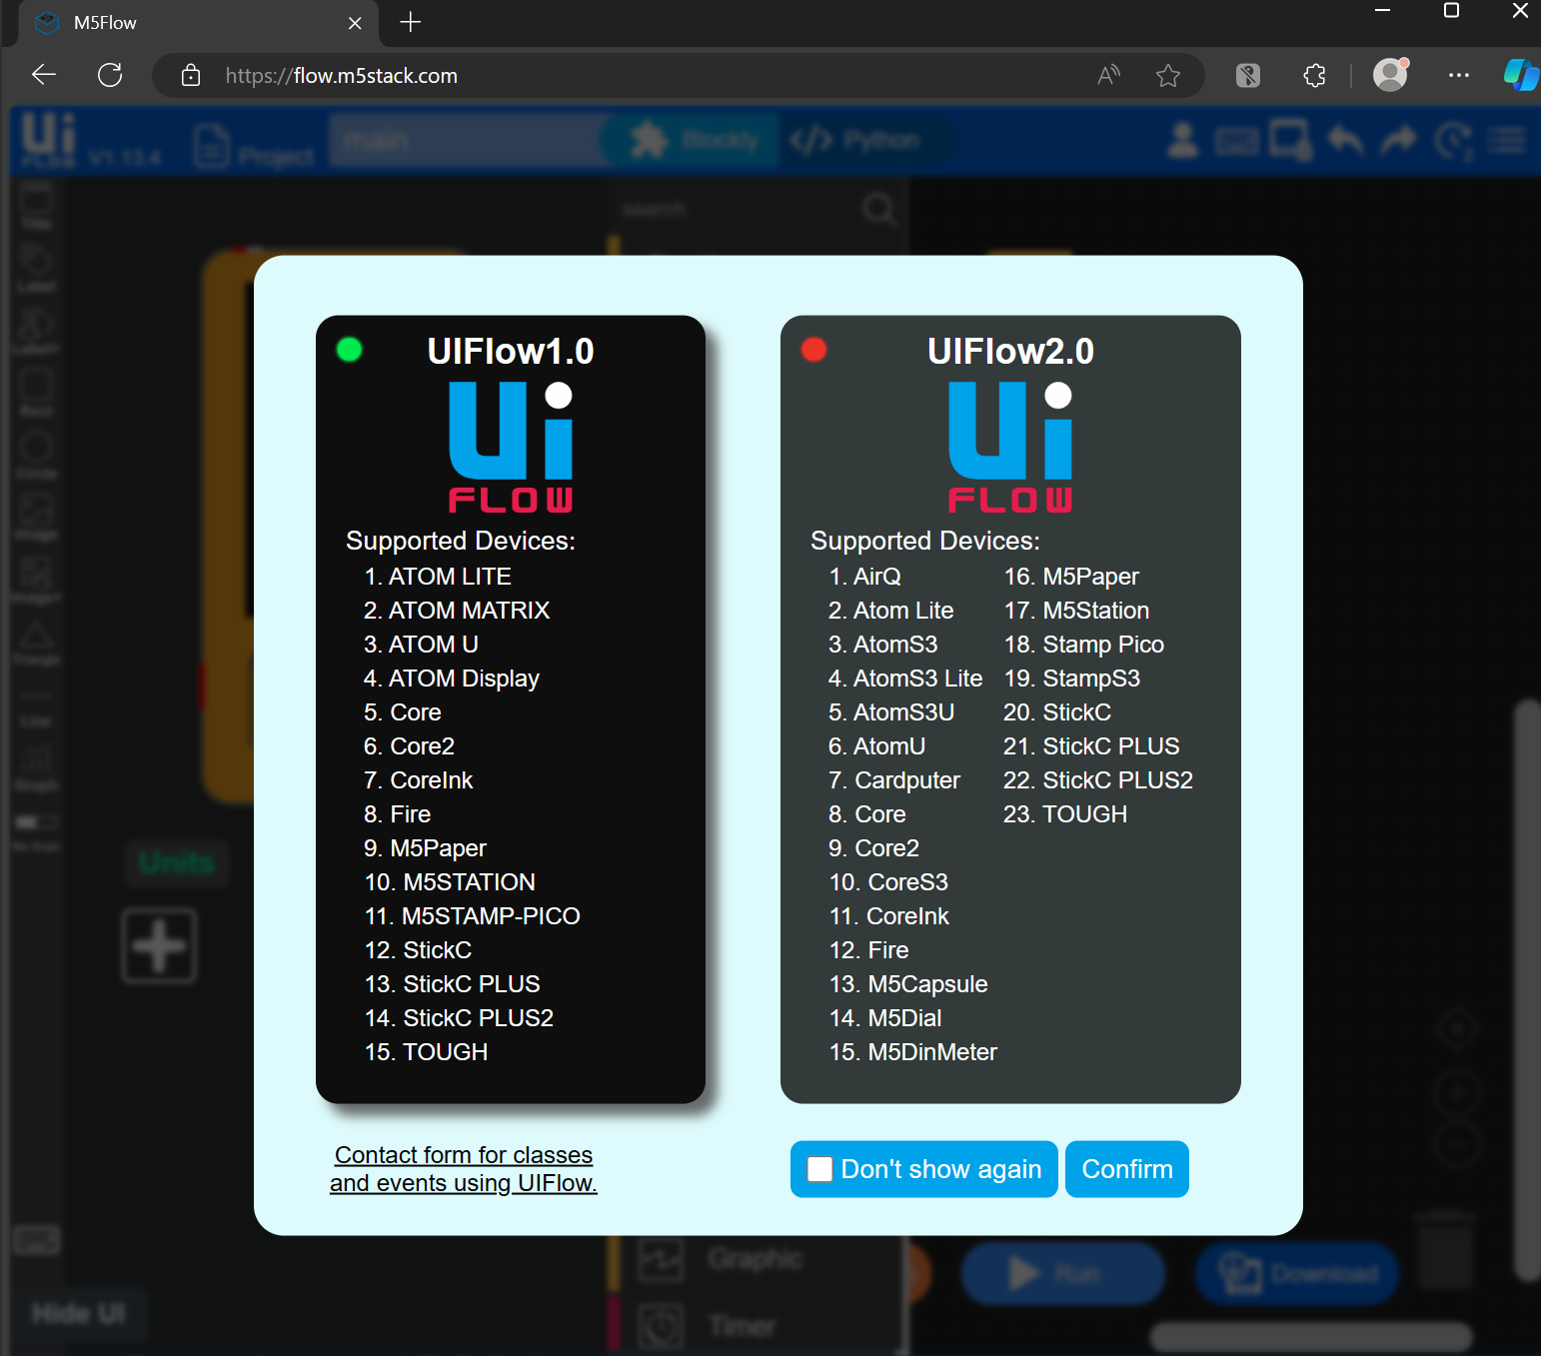

1. You can walk through the tutorial, which comes recommended, or hit skip.

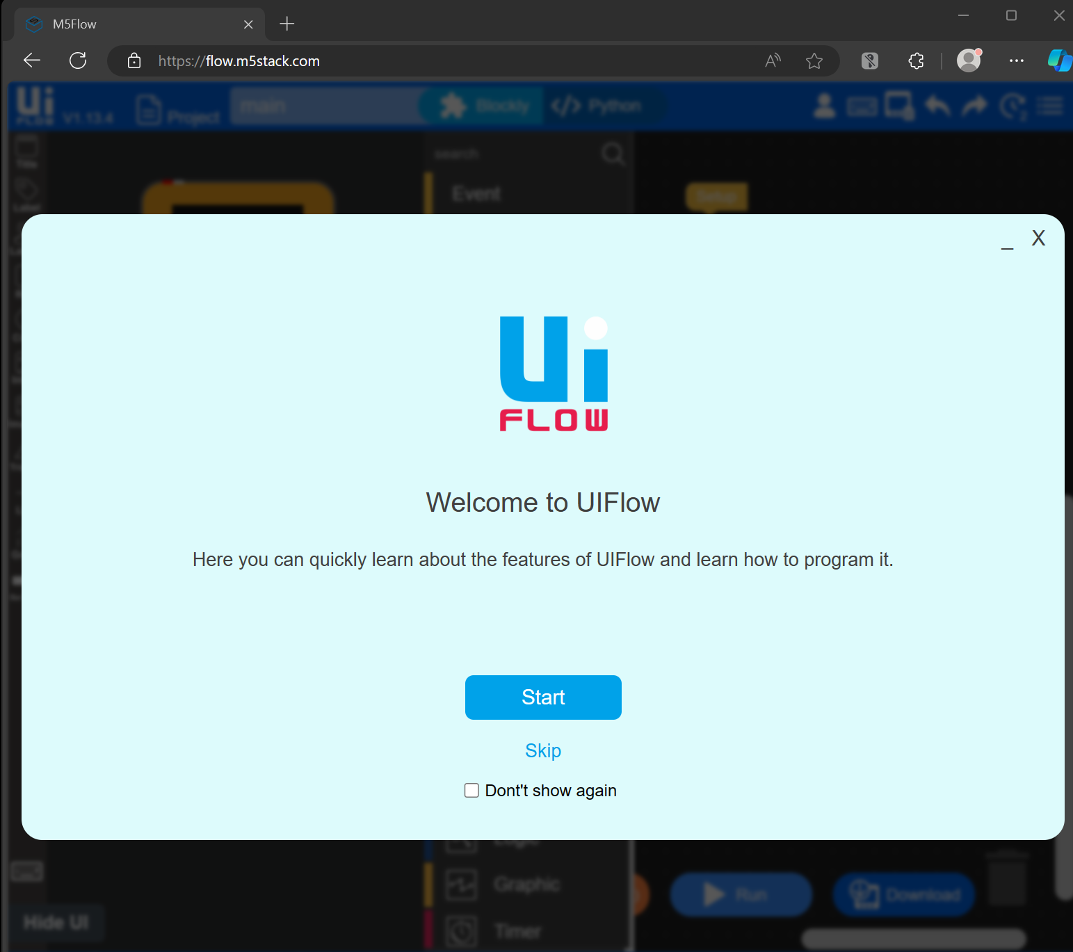

1. You should be staring at a Blocky development window.

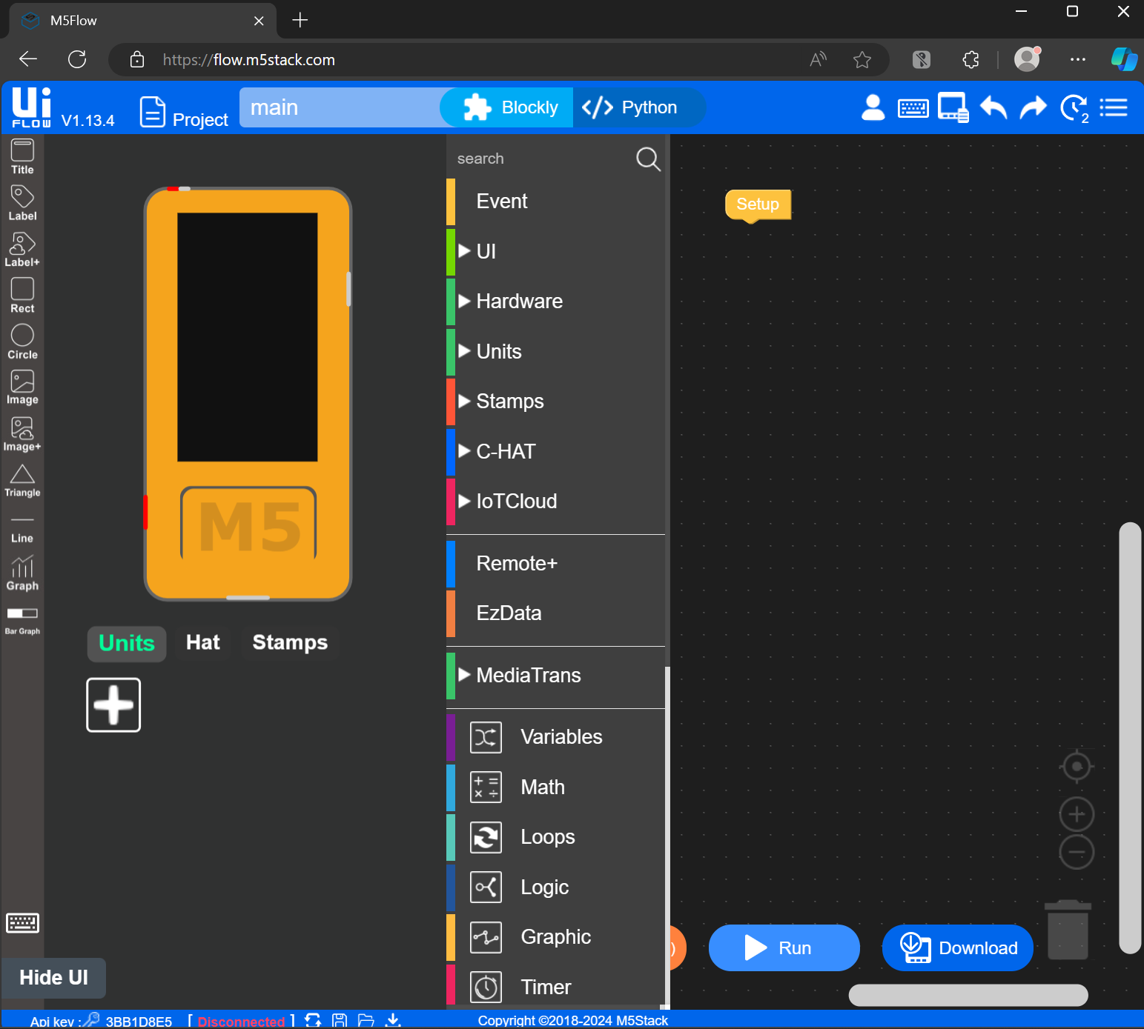

1. In the upper right hand corner is a modified hamburger menu. Click it, and go to Settings.

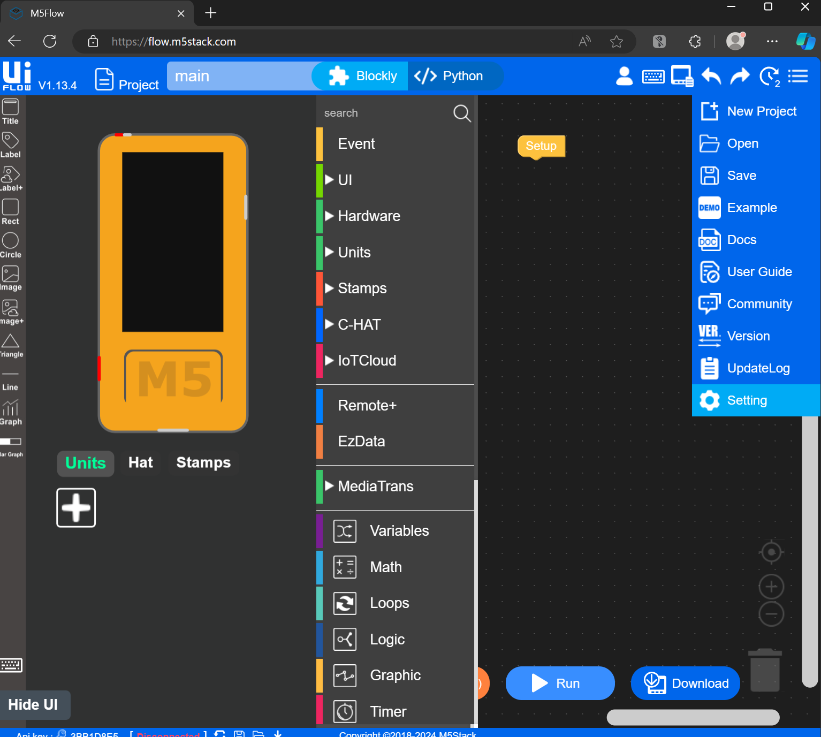

1. In the Settings Menu, enter the API Key displayed on the front of your device, or from the M5Burner Configure Screen. Make sure the server matches the server configured in the M5Burner Configure Screen, and choose the appropriate device from the pictures. The StickC Plus 2 is currently on the upper right, but they may shift locations. Click OK.

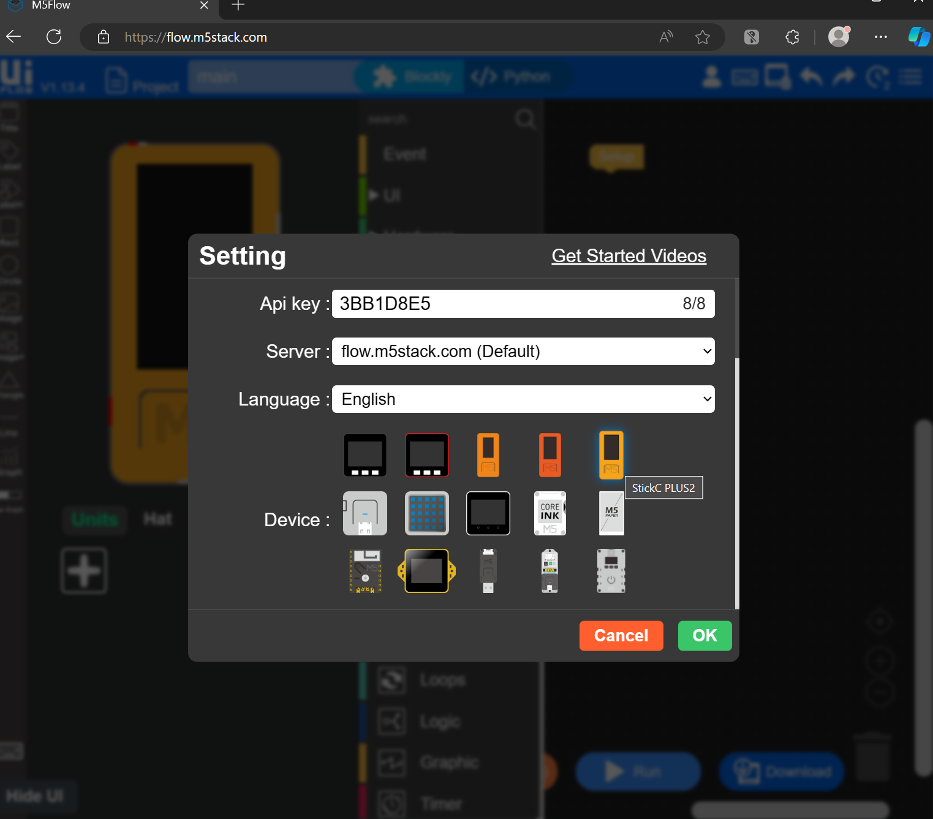

1. Once you’re back at the Blocky screen, you can click “Hide UI” if you’re on a limited screen resolution. You should be able to click the “Run” botton, and you should see status messages in the upper right that says “Connecting”

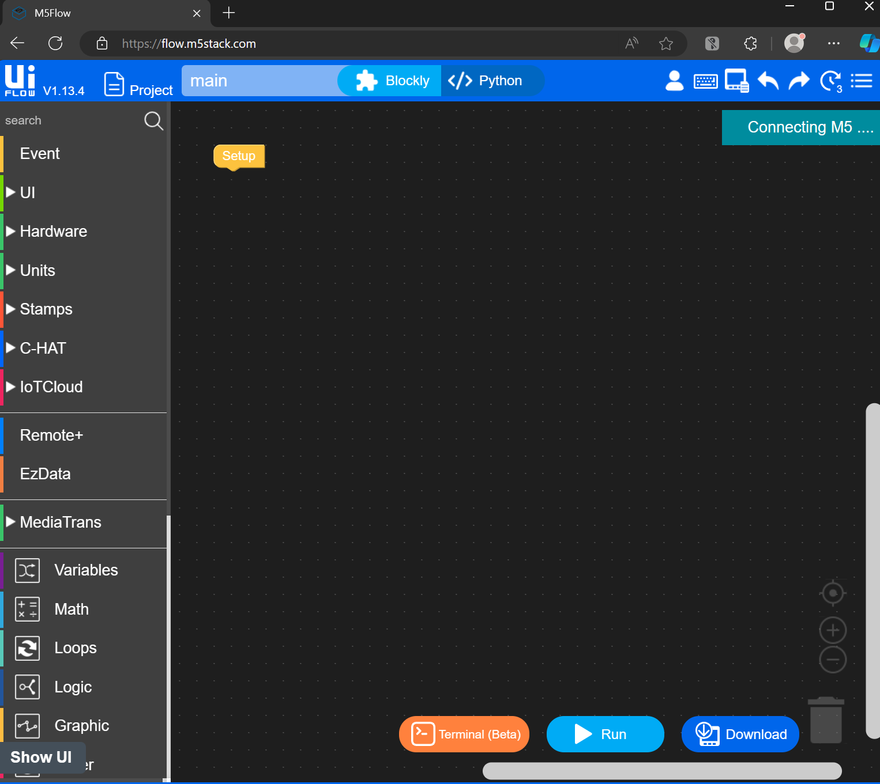

The bottom left-hand sign should now show “Connected” in green.



1. Now lets write some sample code!

Click on the “Show UI” button, and click on the background of the mock-up of the M5StickC. This will let you set a background color of your choice.

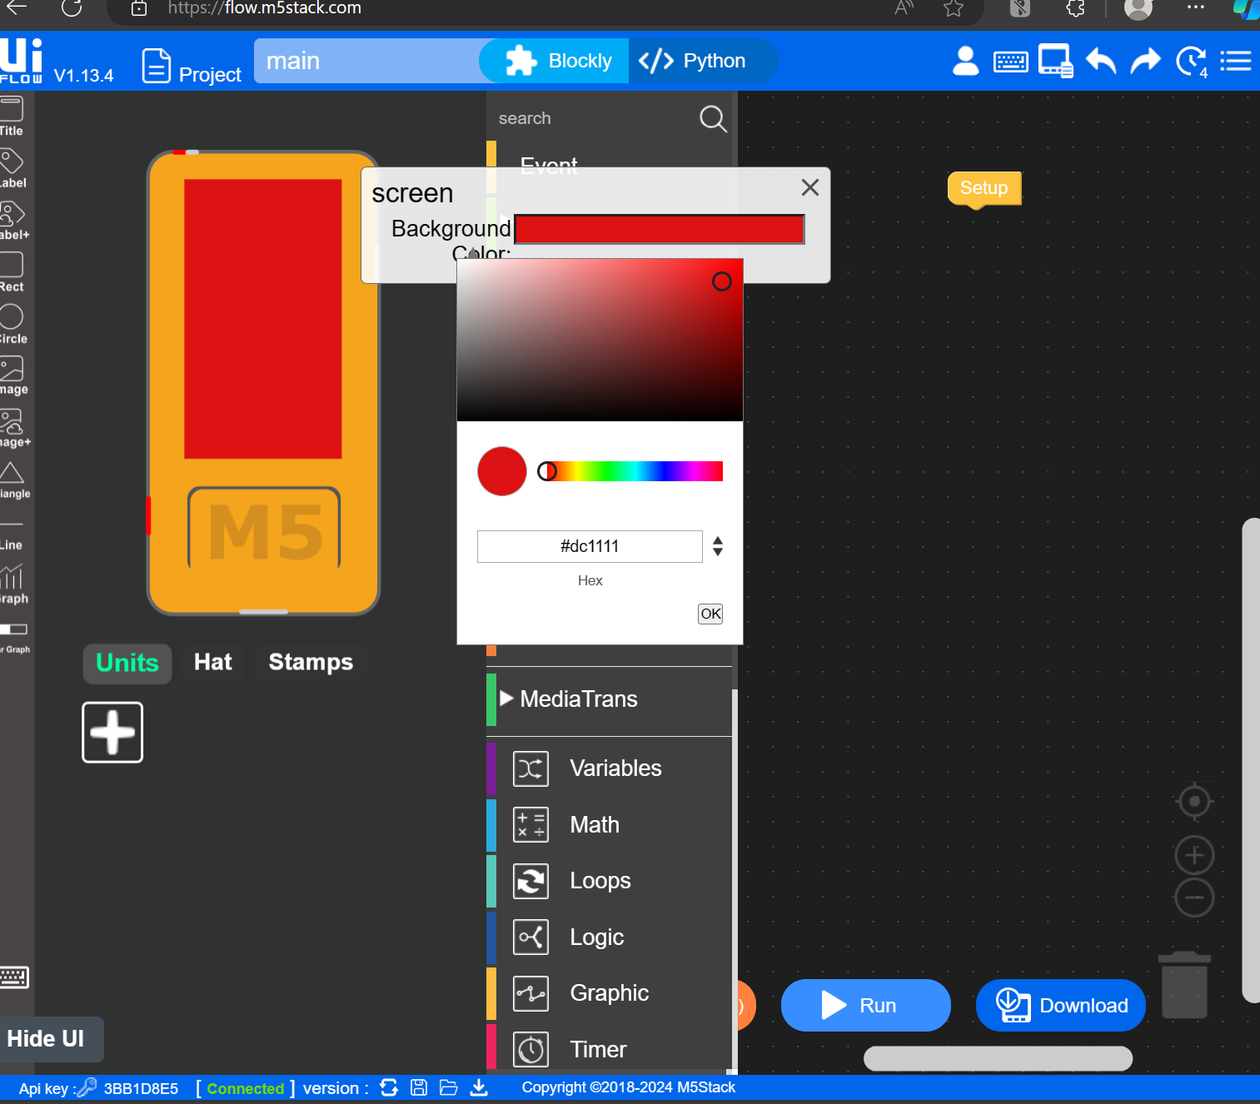

If you click “Python” in the top center of the screen, you can see the Blocky code translated to Python.

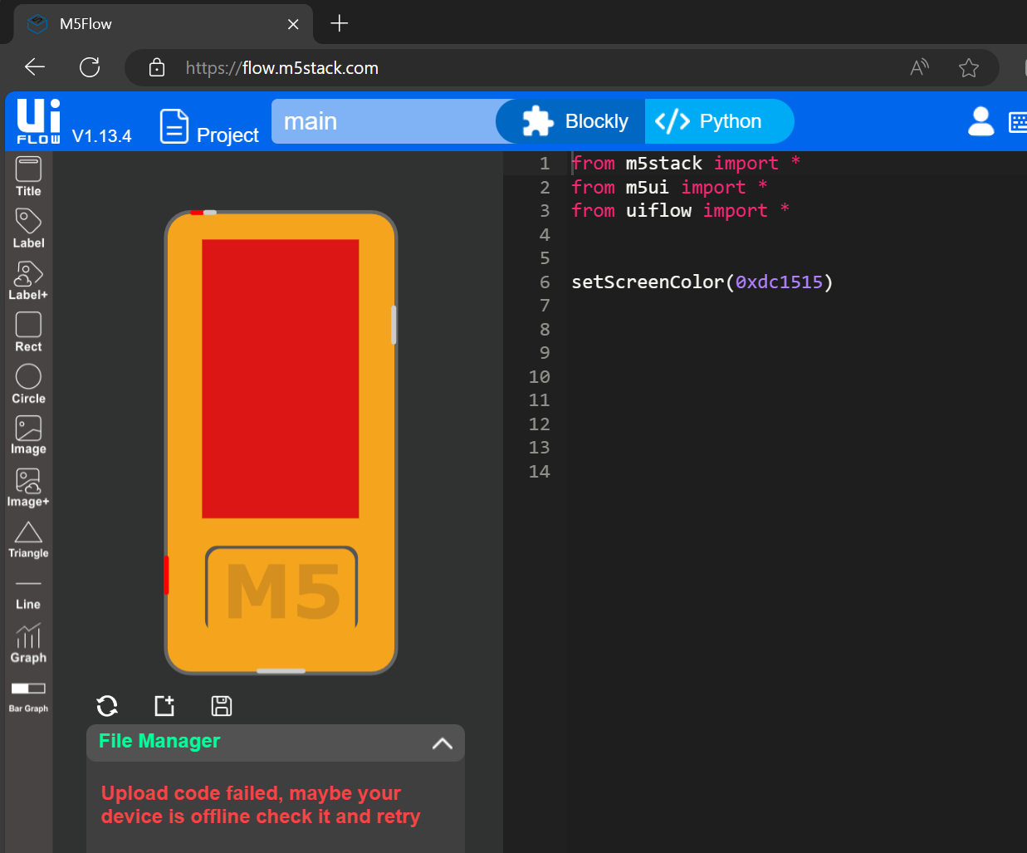

1. Click “Run” and the code should run on your M5StickC.

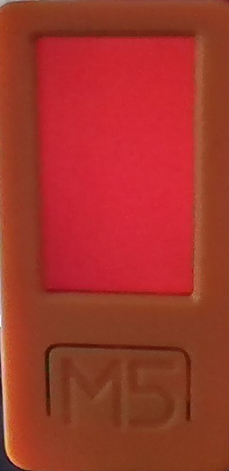

1. If you need a hand with code, ideas, or troubleshooting, let us know in Discord!