AirIQ
AI-Powered Urban Air Quality Intelligence Platform
System Architecture Document (SAD)
Version: 1.0 | Status: Draft for Engineering Review
Date: June 2026 | Classification: Confidential
Owner: Engineering Lead | Linked to: PRD v1.0, FRD v1.0, TRD v1.0, NFR v1.0, DRD v1.0
Companion artefact: AirIQ_OpenAPI.yaml (API Contract)

1. Document Purpose and Scope
This System Architecture Document (SAD) describes how every service in the AirIQ platform talks to every other service: which components exist, what they are responsible for, how data physically moves between them, and which protocol governs each interaction. It is the bridge between the Technical Requirements Document (TRD), which lists the technology choices, and the running system.
This document covers five artefacts in addition to prose: the Architecture Diagram (container view), the Data Flow Diagram (how raw data becomes a citizen advisory), the Entity Relationship Diagram (the core database schema), and the Agent Interaction Map (how the four AI agents chain together). The full machine-readable endpoint contract is delivered separately as AirIQ_OpenAPI.yaml and summarised in Section 9.

2. Architectural Style and Principles
- Event-driven core: all raw data enters through Kafka topics so that ingestion is decoupled from processing speed and a slow downstream consumer never blocks a fast upstream producer.
- Multi-agent AI layer: pollution attribution, forecasting, and enforcement ranking are built as three independent, independently-deployable agent services rather than one monolithic model, so each can be retrained and redeployed on its own schedule.
- LLM as orchestration layer, not source of truth: the Coordinator Agent only synthesises and translates outputs that the three deterministic/ML agents have already produced — it never invents an AQI number or a source attribution.
- Geospatial-native storage: every record that matters operationally is keyed to a ward polygon in PostGIS, so attribution, forecast, enforcement, and advisory data can always be joined on location.
- API-first: the FastAPI Gateway is the single ingress for every client (web, mobile, IVR); no client talks to the database or an agent service directly.
- Cloud-agnostic, container-first: every service ships as a container behind Kubernetes so the same architecture runs on AWS (primary) or GCP (secondary) without redesign.

3. Service Inventory
The table below is the canonical list of deployable services. “Talks To” lists only direct, first-degree calls — see Section 5 for the full request path.
Service | Responsibility | Talks To | Protocol
Ingestion Service | Validates incoming records against JSON Schema v7 and publishes to the correct Kafka topic | Kafka brokers | Kafka producer API
Data Lake (S3/GCS) | Stores Bronze (raw), Silver (cleansed), Gold (feature-ready) data partitioned by source/year/month/day | Spark, ML agent services | S3 / GCS object API
Spark + dbt Processing | Cleans, deduplicates, gap-fills, and joins raw feeds into model-ready features | Data Lake, PostGIS | Spark SQL, JDBC
Attribution Agent | Infers ward-level source-category percentages with confidence scores | Feature store, Coordinator, PostGIS | Internal REST (gRPC optional)
Forecasting Agent | Produces 24h/72h PM2.5 grid forecasts with uncertainty bands | Feature store, Coordinator, PostGIS | Internal REST
Enforcement Agent | Ranks enforcement targets from attribution + forecast + emission registry | Attribution Agent output, Forecasting Agent output, PostGIS | Internal REST
Coordinator Agent | Orchestrates the three agents and calls the LLM to generate advisories and summaries | All three agents, Anthropic Claude API, PostGIS | Internal REST + HTTPS (external)
FastAPI Gateway | Single public ingress; JWT auth, rate limiting, REST + GraphQL routing | PostGIS, Redis, all agent services | HTTPS / REST / GraphQL
Redis Cache | Holds pre-computed map tiles, forecast layers, and the daily advisory set | FastAPI Gateway | Redis wire protocol
PostGIS + TimescaleDB | System of record for spatial and time-series data | Every processing and serving component | PostgreSQL wire protocol
Web Dashboard (Next.js) | City Officer / Policy Maker UI | FastAPI Gateway | HTTPS / REST
Mobile App (React Native) | Citizen advisory + Inspector field UI | FastAPI Gateway, Firebase Cloud Messaging | HTTPS / REST, push
IVR (Exotel / Twilio) | Voice delivery of advisories in regional languages | FastAPI Gateway (advisory endpoint), PSTN | HTTPS / REST + telephony

4. Communication Patterns

4.1 Synchronous Calls
- Every client request (web, mobile, IVR) is synchronous REST/GraphQL against the FastAPI Gateway, served from Redis where possible and falling back to PostGIS/TimescaleDB on a cache miss.
- The Coordinator Agent calls the Anthropic Claude API synchronously per advisory batch, with structured JSON in and structured JSON out (tool use), so the response can be validated against the advisory schema before being cached.
- Inter-agent calls during a scheduled run (Attribution -> Enforcement, Forecasting -> Enforcement, all three -> Coordinator) are synchronous internal REST calls, each completing in under 500ms per ward per the TRD's latency budget.

4.2 Asynchronous / Event-Driven Calls
- All ingestion is asynchronous: producers publish to Kafka and return immediately; consumers (Spark jobs) process at their own pace, which protects the pipeline from upstream bursts (e.g. a satellite batch landing all at once).
- Celery + Redis dispatches scheduled agent runs (forecast every 6h, enforcement list at 5:50 AM, advisory generation at 6:30 AM) and mobile/IVR notification delivery, decoupling the generation of a result from its delivery to a device.
- The Coordinator Agent subscribes to an internal completion event from each of the three agents rather than polling, so advisory generation starts the moment the slowest upstream agent finishes.

4.3 Failure Handling
- Kafka consumer groups retry with exponential backoff; a message that fails validation three times is routed to a dead-letter topic for manual review rather than blocking the partition.
- If the Claude API call times out or returns a low-confidence flag, the Coordinator Agent falls back to a pre-approved templated advisory in English and logs the fallback for next-day human review (see NFR ACCL-04).
- If an upstream agent (e.g. Forecasting) fails to complete by its SLA, the Enforcement Agent proceeds with attribution-only ranking and flags the recommendation list as “partial — forecast unavailable” rather than blocking the 6:00 AM SLA.

5. Architecture Diagram
The container-level view below follows a simplified C4 model: external data sources on top, the five processing layers defined in the TRD in the middle, and the people who consume the output at the bottom. Every arrow is a real network call; there are no implicit dependencies.
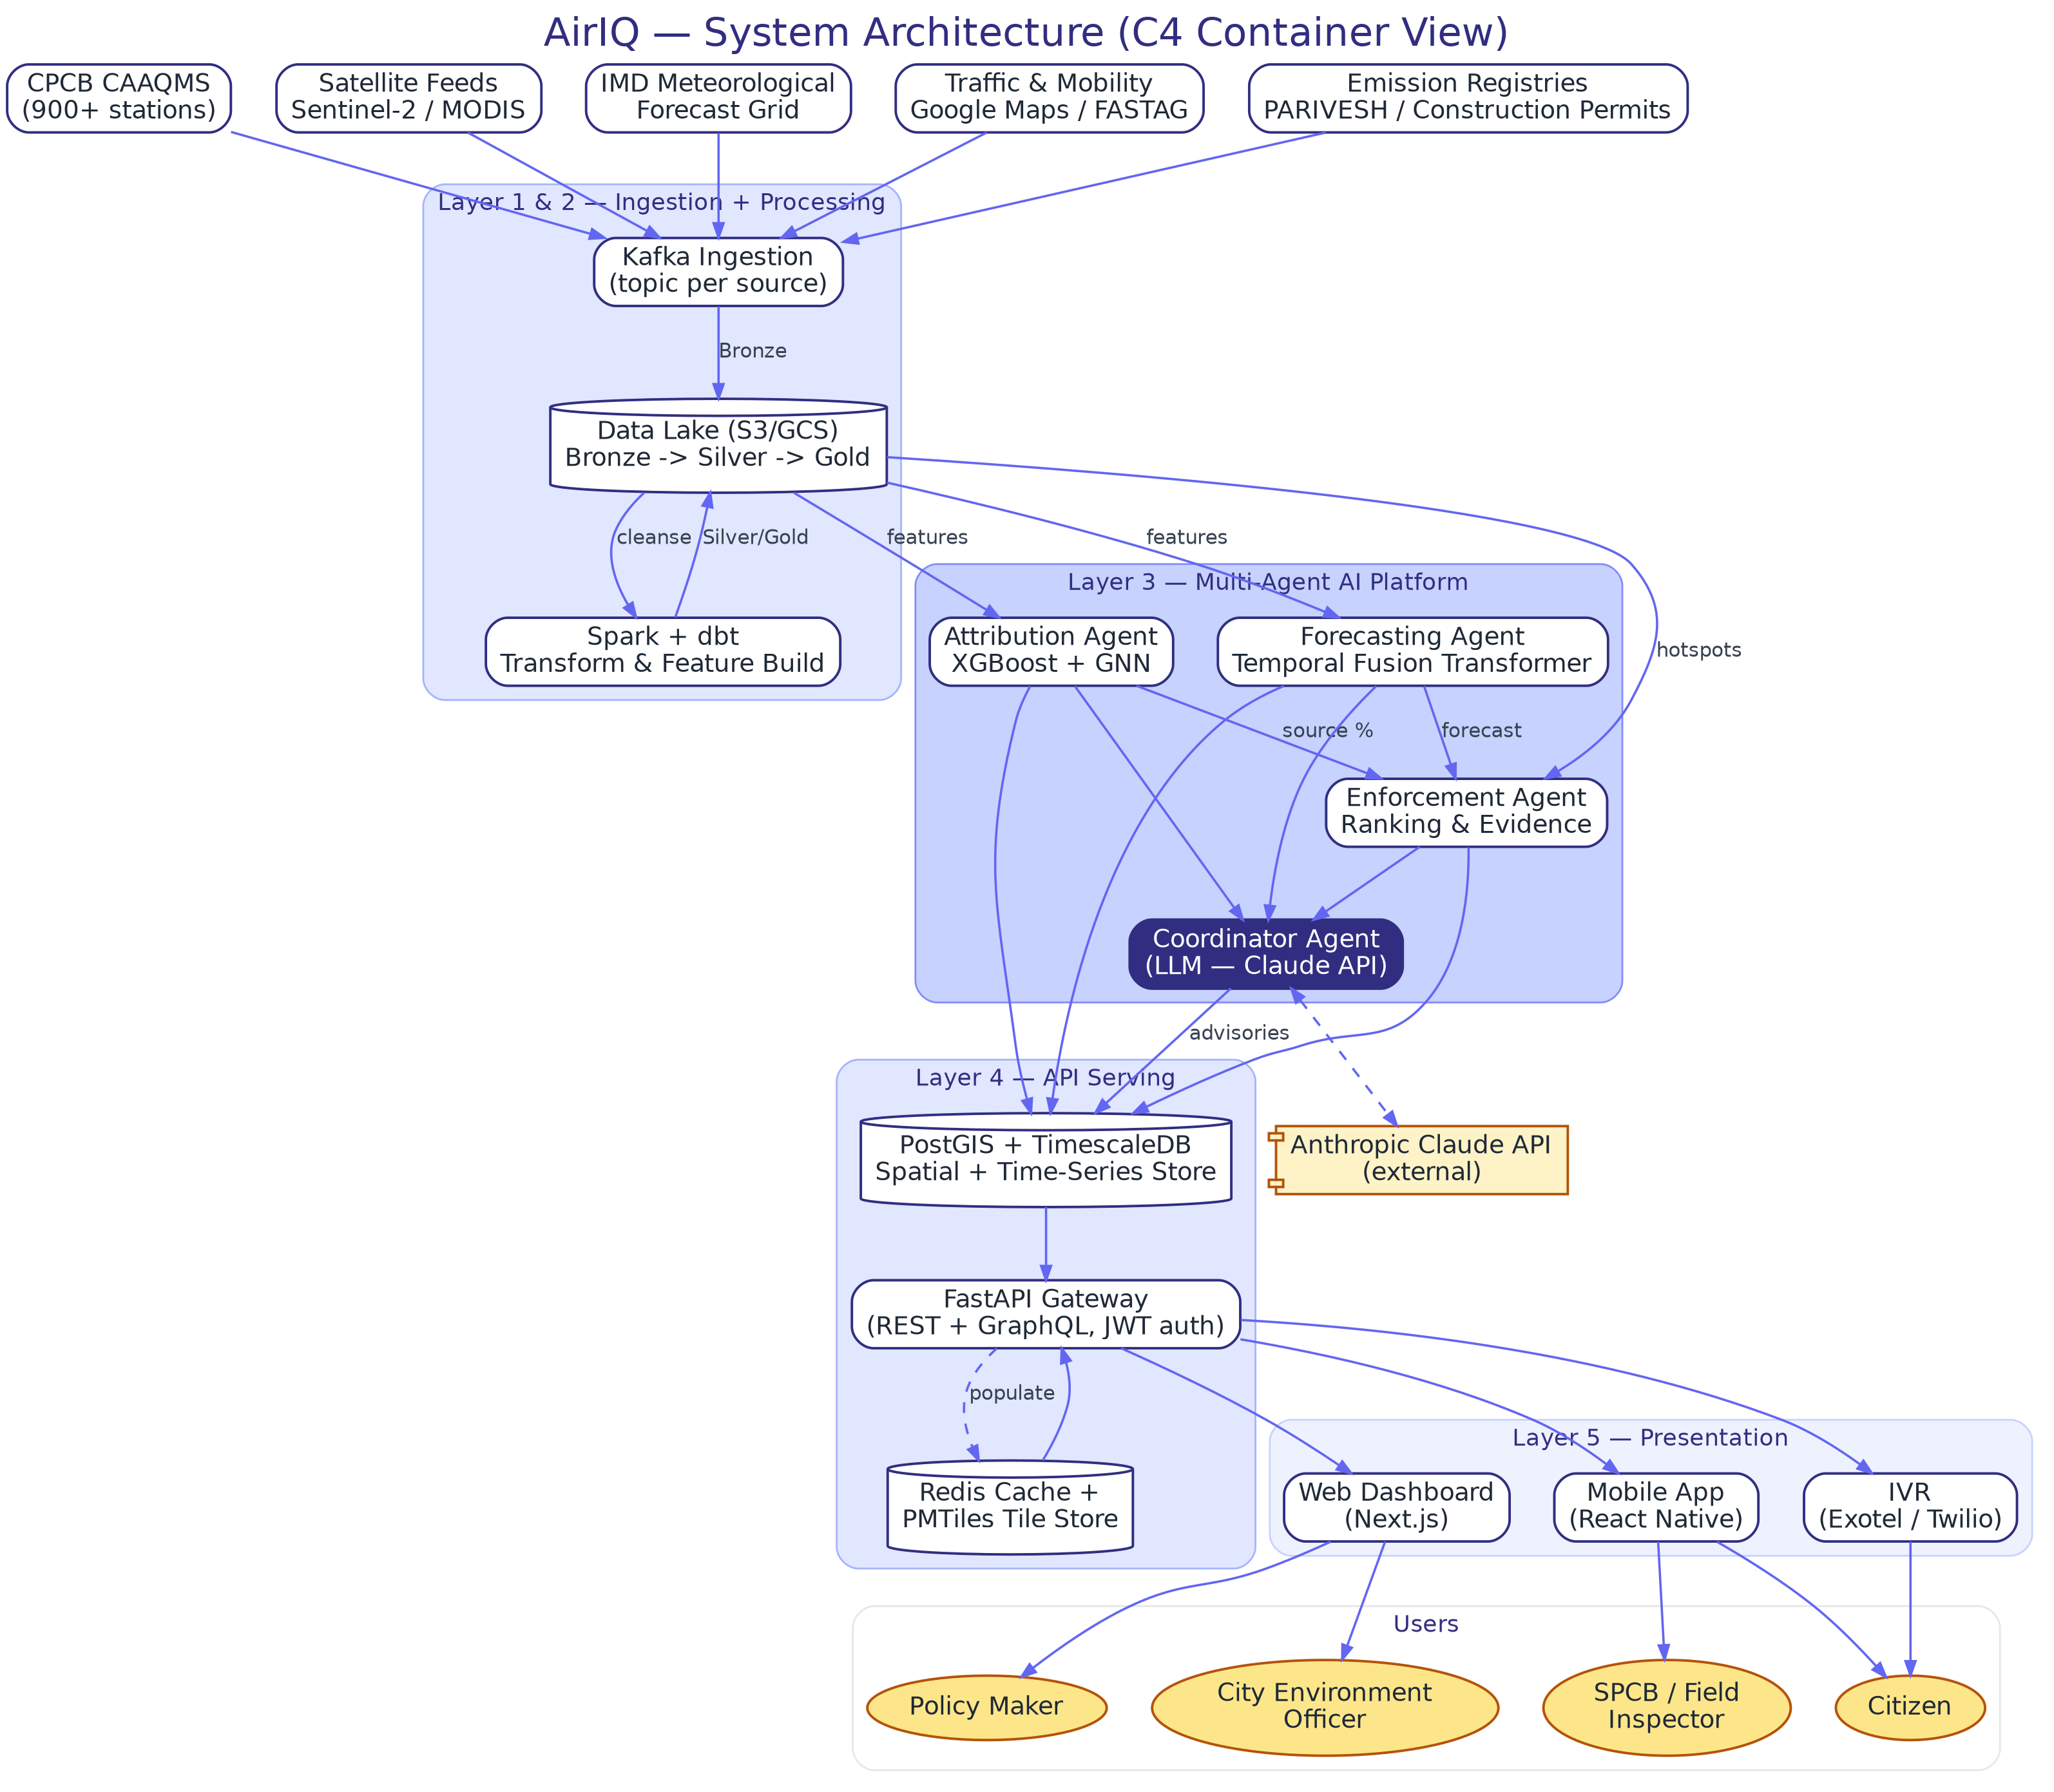
Figure 1 — C4 container view: data sources -> ingestion/processing -> multi-agent AI platform -> API serving -> presentation -> users.
Two details are easy to miss on first read: the Coordinator Agent is the only service with a network path to the public internet (the Claude API), and the FastAPI Gateway is the only service any client is allowed to reach — every other box is internal-only, enforced at the VPC and security-group level (see NFR SEC-01 to SEC-03).

6. Data Flow Diagram
The Level-1 DFD below traces a single record's journey using standard Yourdon notation: open rectangles are external entities, ellipses are processes, and cylinders are data stores. It deliberately ignores which service hosts which process — that mapping is Section 3 — and focuses only on what transforms the data and what is persisted at each step.
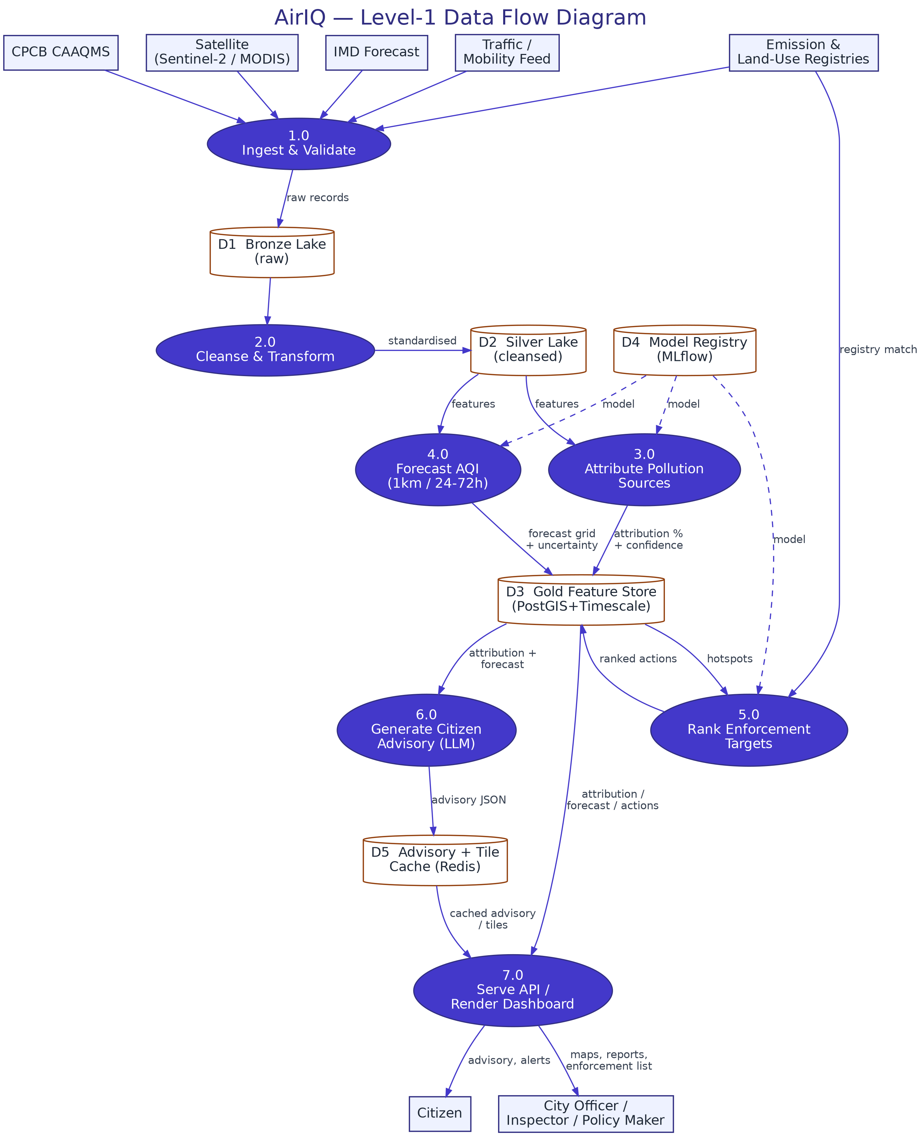
Figure 2 — Level-1 DFD: raw feeds enter at Process 1.0 and exit as an advisory, alert, or enforcement list at Process 7.0.
Three numbered processes (3.0 Attribute, 4.0 Forecast, 5.0 Rank Enforcement) correspond exactly to the three specialised agents in Section 8; Process 6.0 is the Coordinator Agent's advisory-generation responsibility, and Process 7.0 is the FastAPI Gateway.

7. Entity Relationship Diagram
The ERD below shows the core operational schema (PostGIS + TimescaleDB). It omits purely administrative tables (e.g. audit logs, RBAC role tables) covered in the NFR, and shows only the primary key (PK) and foreign key (FK) relationships needed to understand how a query travels from a sensor reading to an advisory.
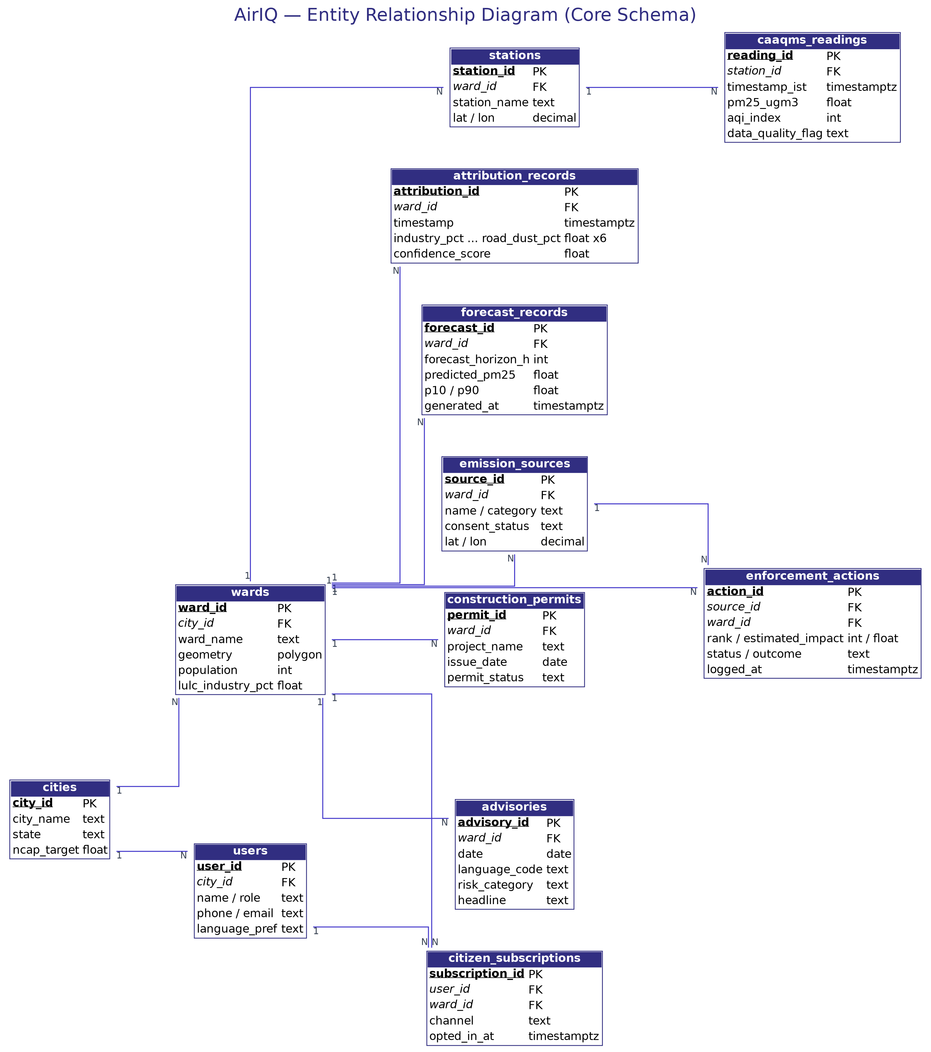
Figure 3 — Core schema. ‘wards’ is the spatial join key almost every other table hangs off.
Notice that wards is the busiest table in the diagram by design: every analytical output in AirIQ (attribution, forecast, enforcement, advisory) is computed and stored at ward granularity so that a single spatial join always answers “what is happening in this ward right now.” caaqms_readings is the one high-volume table (15-minute cadence x 900+ stations) and is the reason TimescaleDB hypertables, not plain PostgreSQL tables, back it — see DRD Section 2 for retention policy.

8. Agent Interaction Map
The map below is the authoritative reference for how the four AI agents chain together. The numbered arrows show execution order for a normal daily cycle, not network topology (that is Section 5).
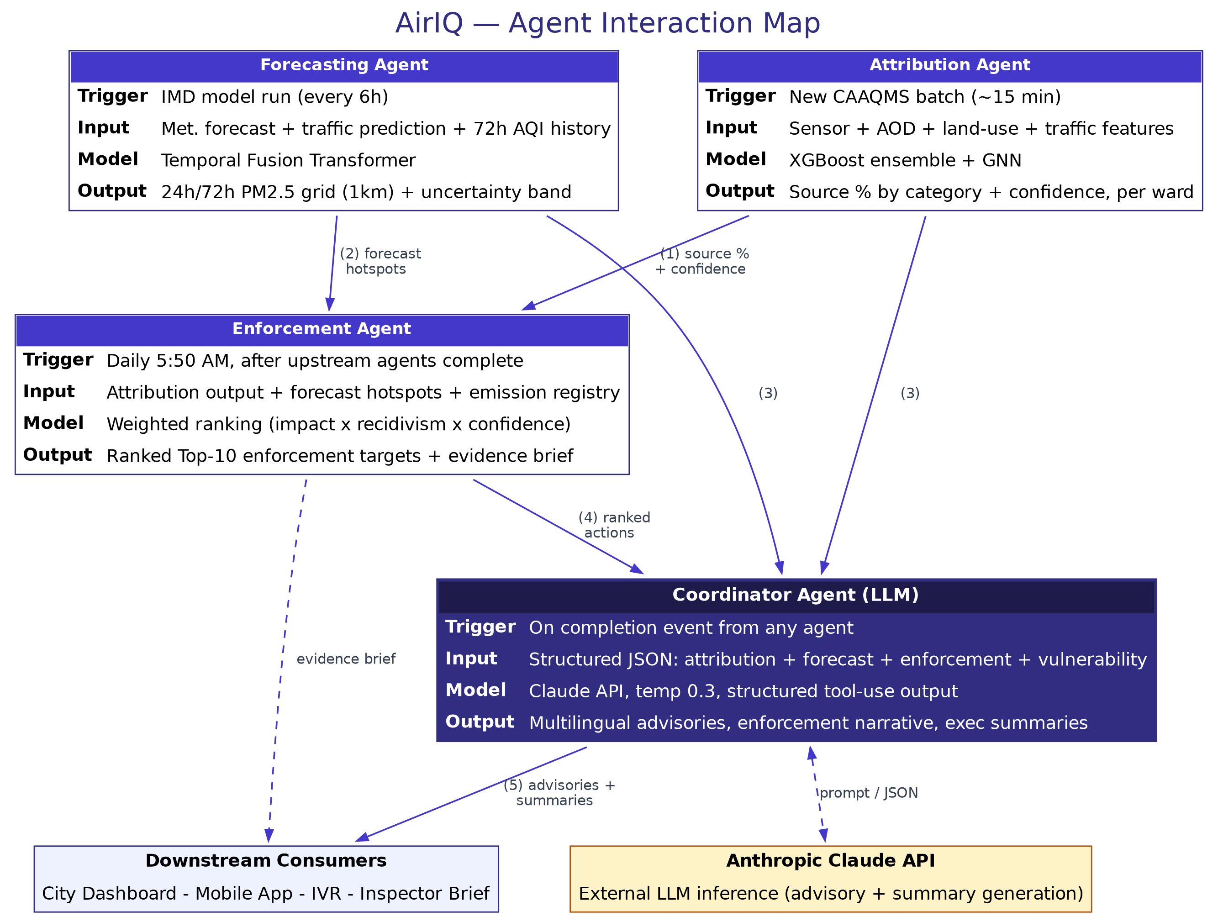
Figure 4 — Execution order: (1)-(2) Attribution and Forecasting feed Enforcement; (3) all three feed the Coordinator; (4) Enforcement's ranked list reaches the Coordinator; (5) the Coordinator publishes advisories and summaries.

8.1 Chaining Logic in Prose
- Attribution Agent and Forecasting Agent run independently and in parallel — neither waits on the other.
- Enforcement Agent waits on both: it cannot rank a target without knowing which source category dominates (Attribution) and whether conditions are about to worsen (Forecasting).
- Coordinator Agent waits on all three, because a citizen advisory references current attribution, the next-24h forecast, and — when relevant — today's enforcement action, in one paragraph.
- Coordinator Agent is the only service permitted to call the external Claude API; this keeps the LLM API key out of every other service's reach (see NFR SEC-03) and lets all governance over prompt content live in one place.
- If the Claude API is degraded, the Coordinator still publishes structured (non-narrative) attribution, forecast, and enforcement data through the Gateway — only the natural-language layer is affected.

9. API Contract Reference
The full, machine-readable contract — every path, method, request/response schema, and error code — is maintained separately as an OpenAPI 3.0 document, AirIQ_OpenAPI.yaml, delivered alongside this SAD. This keeps the contract usable directly by codegen tools (e.g. openapi-generator) instead of being trapped in prose. The table below is a human-readable summary of the primary endpoints; it is not authoritative — the YAML file is.
Endpoint | Purpose
GET /api/v1/attribution/ward/{ward_id} | Latest source-attribution percentages and confidence for one ward
GET /api/v1/attribution/ward/{ward_id}/timeseries | Historical attribution time-series for a ward, up to 12 months
GET /api/v1/forecast/ward/{ward_id} | 24h/72h AQI forecast with uncertainty band for one ward
GET /api/v1/forecast/city/{city_id} | City-wide 1km grid forecast, used for the map view
GET /api/v1/enforcement/daily-list | Today's ranked Top-10 enforcement targets
POST /api/v1/enforcement/{action_id}/log | Field inspector logs an inspection outcome
GET /api/v1/advisory/ward/{ward_id} | Today's citizen advisory in the requested language
GET /api/v1/cities/compare | Multi-city comparative metrics for the policy-maker dashboard
POST /api/v1/citizens/subscribe | Citizen opts in to push/IVR advisory delivery for a ward
GET /api/v1/health | Liveness/readiness probe used by Kubernetes and uptime monitoring

10. Deployment Topology
Deployment environments and infrastructure sizing are defined in full in TRD Section 6; this section restates only the architectural boundary that matters for this document: in every environment, the FastAPI Gateway is the sole component exposed outside the VPC. All other services in Section 3 — including every AI agent and the database — sit in private subnets with no public IP and no inbound route from the internet.
Boundary | Exposed To | Enforcement Mechanism
FastAPI Gateway | Public internet (HTTPS only) | ALB + WAF, JWT validation, rate limiting
AI Agent services + Coordinator | Internal VPC only | Security groups; no public IP; mTLS between pods
PostGIS / TimescaleDB / Redis | Internal VPC only, gateway + processing tier | Security groups; IAM-scoped DB credentials
Coordinator -> Claude API | Outbound HTTPS to api.anthropic.com only | Egress allow-list at the NAT gateway

11. Related Documents
Document | Content
PRD v1.0 | Goals, personas, scope, success metrics
FRD v1.0 | Feature-level user stories and acceptance criteria
NFR v1.0 | Performance, availability, security, and compliance targets referenced throughout this document
DRD v1.0 | Full schema and source-profile detail for every data source feeding Section 6 and 7
TRD v1.0 | Technology choices and infrastructure sizing referenced in Section 10
AirIQ_OpenAPI.yaml | Machine-readable API contract referenced in Section 9

