DEAL.JS: An Extensible Language for Inspectable Human–AI Research Programming
Mohammad Fathi; Mehrdad CheshmeSohrabi; Ahmad Shabani; Ali Mansouri
Department of Knowledge and Information Science, University of Isfahan, Isfahan, Iran

Abstract
Context: AI-assisted programming can reduce the effort required to draft software, but it does not remove the need to establish that an implementation faithfully executes a research method. This paper examines how an explicit source representation can make program intent, translation, and execution evidence available for review.
Objective: We present DEAL (Declarative and Extensible Abstract Language) and DEAL.JS, its JavaScript-targeting implementation, as a constrained, natural-language-like programming representation that can be inspected by researchers, generated or revised with AI assistance, and compiled into JavaScript using defined language rules.
Methods: We describe the language constructs, modular vocabulary mechanism, and five-stage source-to-source compiler; define analytical conditions for deterministic translation and semantic preservation; and evaluate a synthetic catalog workflow covering extraction-shaped inputs, normalization, validation, deduplication, and serialization. A 19-check JavaScript test suite assesses the stated application data contract. No human-participant study or live web acquisition was conducted.
Results: All 19 checks in the accompanying reconstructed case-validation suite passed. Of five synthetic records, two were accepted (40%) and three rejected (60%): one duplicate identifier, one missing or invalid main price, and one discount outside the permitted interval. The results support the tested transformation and storage rules for these fixtures only; they do not measure whole-language conformance, live extraction accuracy, usability, AI-generation success, or performance.
Conclusion: DEAL.JS demonstrates an implemented architecture for combining domain-oriented commands, configurable vocabulary, contextual handlers, and embedded JavaScript under a source-to-source compiler. Its contribution is a reviewable program representation and an explicit basis for testing—not evidence that readable syntax by itself guarantees correctness, reproducibility, or improved human performance. Comparative compiler, extraction, human-comprehension, and AI-generation studies remain necessary.
Keywords: AI-assisted programming; controlled natural language; domain-specific languages; source-to-source compilation; program comprehension; reproducible research; web data extraction.

Introduction
Research software often sits at the boundary between domain expertise and software engineering. A researcher may understand the scientific method in depth without having equivalent experience in software design, testing, debugging, and maintenance. End-user software engineering research has long documented that the work required to create dependable software extends beyond writing an initial program [1,2]. The resulting challenge is to represent a research procedure precisely enough to execute, while keeping its consequential decisions available for inspection. [1,2]
AI-assisted code generation changes how software can be drafted, but generated code still requires independent verification. User studies have identified difficulties in understanding, editing, and debugging model-generated code, while execution-based evaluations show that apparent plausibility is not a reliable proxy for functional correctness [3–5]. For research workflows, this creates a representational problem: a natural-language request and a large implementation are insufficient unless a reviewer can trace the link between methodological intent, executable operations, and observed results. [3–5]
DEAL (Declarative and Extensible Abstract Language) addresses this problem by providing a constrained programming representation with explicit control structures, reusable commands, configurable vocabulary, and contextual handlers. DEAL.JS is its JavaScript-targeting implementation. Its compiler translates recognized DEAL constructions into JavaScript while permitting ordinary JavaScript to coexist in the same source file [6]. The proposed workflow keeps the program itself—not an explanatory paragraph or a model-generated rationale—as the central artifact for human review and machine execution.
The design draws on controlled-language research and established approaches to domain-specific language engineering [7,8]. Its contribution is not the invention of readable keywords or modular programming; it is the integration of a stable structural language, replaceable vocabulary, domain modules, a mixed-source adoption path, and inspectable target generation in a research-oriented workflow. Readability is therefore treated as a design property to evaluate, not as proof of usability or correctness. [7,8]
This article makes five contributions:
- It specifies a shared, executable source representation for researcher intent, AI-assisted revision, and conventional runtime execution.
- It documents DEAL.JS language constructs and the five-stage compilation architecture, including JavaScript interoperability.
- It presents a synthetic catalog workflow that combines acquisition-oriented orchestration, extraction-shaped records, preprocessing, validation, and persistence.
- It states conditional semantic requirements for vocabulary localization and reuse across alternative target backends.
- It separates implemented functionality and case-level assertions from the additional evidence needed to establish compiler conformance, human comprehension, AI-generation performance, and operational cost.
The analysis is organized around three research questions:
- RQ1: Which representation and compiler mechanisms connect domain-level review with executable implementation?
- RQ2: Under what explicit conditions can vocabulary adaptation and alternative backends preserve observable behavior?
- RQ3: How can acquisition, extraction, preprocessing, and persistence be composed into a reviewable research workflow?
RQ1 is addressed by the language model and compilation architecture; RQ2 by conditional semantic contracts; and RQ3 by the worked synthetic workflow and its data-contract checks. Effects on human comprehension, AI-generation success, and operational performance are not treated as results because those outcomes were not measured in this study.

Research problem and design rationale

Three forms of opacity
“Opacity” arises at several distinct levels in AI-assisted research. Model interpretability concerns the relationship between learned computation, predictions, and post-hoc explanations; these concepts should not be conflated [9–11]. Programming-language design addresses a different object: the explicit procedure through which data are acquired, transformed, analyzed, and stored. Improving the visibility of that procedure does not, by itself, explain the internal workings of a neural model. [9–11]
We distinguish model opacity (internal learned computation), program opacity (the procedure expressed in source code), and workflow opacity (the links among data sources, transformations, dependencies, and outputs). DEAL primarily targets program and workflow opacity by placing consequential operations in an identifiable executable artifact. If a workflow invokes an opaque predictive model, the invocation conditions and downstream uses can be inspected even though the model’s internal computation remains a separate interpretability problem.
This distinction defines what the representation should expose: which observations enter an analysis, which transformations are applied, which criteria exclude records, what dependencies are loaded, and which external effects occur. Domain commands can make those choices easier to locate, but their implementations and contracts must remain inspectable. Readability and computational evidence are complementary; neither substitutes for the other.

The communication gap
The proposed workflow assigns separate responsibilities to each participant. Researchers define the scientific objective and judge domain validity; an AI system may draft or revise the program; the compiler translates supported source constructions; and the runtime executes the generated program. This arrangement supports review without transferring scientific authority to the compiler or presuming that AI-produced source is correct.
Figure 1 summarizes the collaboration loop. Its central control is artifact identity: the reviewed source, generated JavaScript, configuration, dependencies, and execution record should refer to the same program version. When observations disagree with expectations, this record allows investigation of whether the cause lies in a domain rule, command implementation, translation, dependency, or runtime condition.
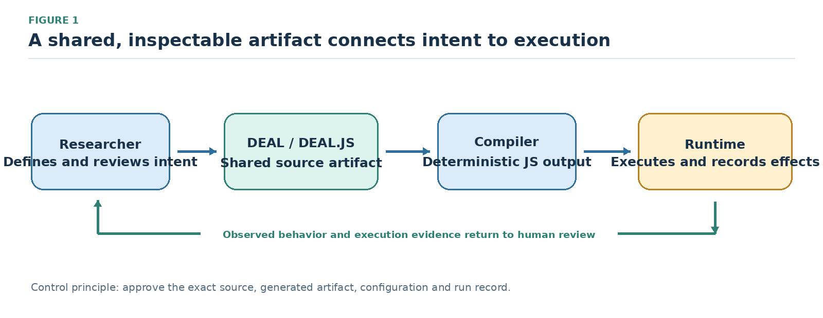
Figure 1. Shared executable representation linking researcher intent, AI-assisted revision, compilation, and execution. The diagram is conceptual; the reviewed source, generated target, configuration, and run record should be version-linked.

Objectives and requirements
The design is guided by seven objectives: reviewable intent, precise translation, incremental adoption, domain reuse, adaptable vocabulary, reproducibility, and reuse of the core model across backends. Table 1 maps these objectives to implementation mechanisms and to evidence that would be needed to evaluate them.
Table 1. Design objectives, corresponding mechanisms, and evaluation criteria.
Objective | DEAL design response | Criterion for evaluation
Reviewable research intent | Domain commands and explicit control structures | Correct comprehension and detection of seeded semantic errors
Precise execution | Constrained grammar and target-source generation | Agreement with independently specified observable behavior
Incremental adoption | Ordinary JavaScript alongside DEAL instructions | Completion of mixed-source tasks without unnecessary rewrites
Reusable domain knowledge | Commands and importable modules | Reuse across tasks with documented input/output contracts
Adaptable human vocabulary | Replacement reserves and optional readability words | Semantic equivalence across vocabulary configurations
Research reproducibility | Executable workflow plus versioned inputs and dependencies | Re-execution from archived materials with matching relevant outputs
Cross-language reuse of the model | Separation of language concepts from backend implementation | Equivalent behavior on a declared portable subset
Reproducible computational research requires recording inputs, program versions, parameters, dependencies, and relevant intermediate outputs; otherwise, written methods may diverge from the procedures that actually ran [12]. The FAIR principles emphasize findability, accessibility, interoperability, and reuse of data and metadata [13]. DEAL can provide an inspectable program artifact within such a record, but the language alone does not provide provenance capture, guarantee rerun equivalence, or confer FAIR compliance. [12,13]

Related work and comparative positioning

Controlled language and programming accessibility
Controlled natural languages restrict vocabulary and grammar to make language more tractable for formal interpretation [7]. Domain-specific language design similarly uses task-oriented abstractions to expose domain concepts while retaining defined computational semantics [8]. DEAL applies these ideas to research programming: its natural-language-like surface remains a constrained formal language, and vocabulary extension does not imply unrestricted interpretation of ordinary prose. [7,8]
Programming syntax is an empirical design choice, not a self-validating usability feature. Experiments have found that notation affects novice performance, while replication work cautions that familiar words do not make programming uniformly intuitive [14,15]. Accordingly, DEAL’s readability should be evaluated using behavioral-comprehension tasks, error detection, and editing performance—not inferred from its English-like appearance. [14,15]
The Cognitive Dimensions framework provides a vocabulary for analyzing notation properties such as closeness of mapping, hidden dependencies, diffuseness, and error-proneness [16]. Applied to DEAL, it highlights a trade-off: domain commands may bring a scientific concept closer to its implementation, while implicit handler state or excessive abstraction may conceal dependencies. Command contracts and routes to underlying JavaScript should therefore remain discoverable. [16]
Research on programmers’ mental models shows that comprehension depends on the information available to readers, prior knowledge, and their ability to reason about program behavior [17]. The relevant question for DEAL is whether reviewers can predict and explain a program’s behavior accurately, not whether its vocabulary sounds conversational. [17]
SmellDSL offers a recent example of empirical evaluation for a domain-specific notation, examining specification performance and user acceptance rather than relying solely on a language-design argument [18]. A corresponding DEAL study should measure task accuracy and errors alongside completion time and perceived usability. [18]

English-like scripting and extensible languages
_hyperscript is a relevant comparator because it combines English-like scripting with DOM-oriented operations and JavaScript interoperability [19,20]. It demonstrates that readable web scripting is an established design direction. DEAL’s stated distinction is its emphasis on a common research-program artifact, explicit target-source generation, and configurable vocabulary; this is a difference in emphasis, not a claim that comparable languages lack readability or extensibility. [19,20]
LiveCode provides a command-oriented programming environment with human-readable control structures [21]. Its collection and text-container operations also illustrate why comparisons must align data semantics: iterating over a delimiter-based text chunk is not necessarily equivalent to iterating over a structured JavaScript array. [21]
SugarJ explores library-based syntax extension through imported grammar and desugaring rules [22]. DEAL’s RESERVE mechanism is narrower: it adapts selected vocabulary and readability words without claiming to support arbitrary grammar rewriting. The comparison therefore concerns the level and cost of extension, not equivalence in expressive power. [22]

Web extraction and executable AI reasoning
WebL treated web-page retrieval and document manipulation as language-level tasks [23], while later surveys have catalogued a broad range of web data extraction methods and applications [24]. Web extraction is consequently a useful demonstration domain for DEAL’s composition mechanisms, not a novelty claim for extraction itself. [23,24]
Program-aided language models demonstrate an architecture in which generated programs are executed by conventional tools [25]. PICARD and grammar-constrained decoding show how structural restrictions can reduce invalid outputs in language-generation pipelines [26,27]. These approaches motivate evaluating DEAL as a constrained target representation, but do not establish that a model generates DEAL more accurately than JavaScript or another formal language. [25–27]
Recent work on assurance for AI-written software has also considered the practical limits of human supervision [28]. Because that source is a preprint, it is used here as emerging context rather than as established consensus. DEAL’s relevant contribution is a program artifact that can be inspected and tested against independent requirements. [28]

Limitations addressed by the integrated design
Existing languages address different parts of the software-engineering problem: general-purpose languages offer mature ecosystems; English-like scripting emphasizes accessible surface syntax; extensible languages allow selected syntax changes; and web-oriented languages support retrieval or markup operations. Table 2 positions DEAL as an integration of these concerns. It does not imply that the compared systems lack domain libraries, modularity, or their own ways to support research work.
Table 2. Established approaches and the integration problem addressed by DEAL.
Approach | Established strength | Work otherwise left to the user | DEAL response
JavaScript | Target-language execution and rich host integration | Organize low-level operations into a research-facing review vocabulary | Layer domain commands over inspectable target code
Python | Direct sequence iteration and conventional program structure | Coordinate library-specific APIs and distinguish workflow intent from implementation detail | Offer a common command-oriented orchestration surface
_hyperscript | English-like web scripting, selectors, async transparency | Establish research-specific data contracts and provenance conventions | Emphasize a versioned research program and generated target artifact
LiveCode | Human-oriented commands and chunk/array operations | Reconcile its execution and data model with a JavaScript-oriented environment | Preserve a mixed-JavaScript adoption path
SugarJ | Composable syntax extensions and desugaring | Engineer grammar extensions when only vocabulary adaptation is required | Separate lightweight vocabulary changes from structural grammar changes
WebL | Integrated web retrieval and markup processing | Connect extraction notation to a broader human–AI review and localization workflow | Treat extraction as one reusable domain module
The contribution is architectural rather than a claim that previous languages lacked readable syntax or modularity. Comparable domain libraries can be written in JavaScript or Python, so an evaluation must isolate the effects of representation from the effects of the underlying APIs, task specification, documentation, and user familiarity [14,19–24,29].

Research design and analytical framework
This study follows a design-science orientation: it examines a constructed language artifact, the rationale for its mechanisms, and an illustrative workflow addressing a defined research-programming problem [30]. It combines descriptive analysis of the language architecture with a bounded functional evaluation of the application data contract. The evaluation is not a controlled experiment with users or a benchmark of AI-generated programs.
The primary unit of analysis is an executable workflow whose control flow, data decisions, dependencies, and side effects can be reviewed together. We distinguish artifact properties—such as command forms and the compiler pipeline—from outcomes requiring empirical measurement, including comprehension, generation success, performance, and generalized extraction accuracy.
The analysis addresses three relationships: translation of domain-oriented instructions into explicit source structures; normalization of configured vocabulary to canonical instructions; and execution of generated JavaScript under a declared host environment. Determinism and semantic preservation are stated as analytical contracts over source text, vocabulary, dependencies, compiler settings, initial state, backend, environment, and observable behavior.
The case study uses five synthetic catalog records to exercise title and identifier normalization, duplicate detection, missing numeric input, a valid zero boundary, discount validation, derived-price calculation, provenance fields, serialization, and in-memory persistence. For this revision, the helper and test harness were reconstructed from the data rules described in the supplied manuscript. The included 19-check suite ran under Node.js v22.16.0. It uses only synthetic inputs and a document-shaped test double: no live web endpoint was queried and no human participants were involved. It therefore tests the stated application contract, not extraction accuracy, whole-compiler conformance, usability, AI-generation advantages, or performance. The supplementary bundle contains the helper, tests, and captured output for repetition.

Language design and syntax

Design principles
The five design principles are abstraction oriented toward intent, explicit and deterministic compilation, hybrid interoperability with JavaScript, modular extensibility, and reusable operations. They are intended to make domain decisions visible without promising that all users will find the language easier or that every implementation is correct.
The term “declarative” describes one design tendency, not the entirety of the language. DEAL.JS also supports sequencing, loops, assignments, and native JavaScript. Domain commands can hide incidental mechanics, but they do not eliminate mutable state or control flow; generated source alone does not guarantee optimization, security, or logical correctness.

The four-part language model
DEAL is organized around four complementary concepts: structures, commands, reserves, and handlers, while conventional JavaScript remains available within the same source. Structures define control flow and grouping; commands encapsulate reusable operations; reserves adapt selected vocabulary; and handlers expose the current execution context. Table 3 summarizes constructs relevant to the workflows studied here.
Table 3. Core language mechanisms and representative syntax.
Mechanism | Representative syntax | Computational role
Declaration | ASSUME CONST threshold IS 10; | Bind a constant; alternative forms select let or var
Branching | IF condition, procedure; ELSE procedure; | Make conditional logic explicit
Iteration | FOR EACH item OF items, procedure; | Iterate over collection items (IN denotes distinct behavior)
Conditional repetition | WHILE condition, procedure; | Repeat while a condition holds (do ... while available in JS)
Grouping | BEGIN ... END; or DO ... END; | Delimit a procedure block
Callable block | DOING ... END; | Represent an encapsulated, reusable computation block
Failure handling | TRY ... CATCH err, ... FINALLY ...; | Separate normal execution, error recovery, and cleanup
Continuations | THEN, OTHERWISE, ANYWAY | Express success, rejection, and finalization paths
Promise construction | WILL procedure THEN procedure; | Introduce a promise-oriented asynchronous computation
Function command | COMMAND clean(value = "") { ... } | Register a reusable custom operation
Definition command | COMMAND settings = { ... }; | Register a reusable value or configuration object
Action command | # task BEGIN ... END; | Define and immediately execute a repeatable action
Delegation | const #dataset = value; | Register a case-adapted identifier
Vocabulary replacement | RESERVE into AS ","; | Map human vocabulary to a canonical token sequence
Readability word | RESERVE the; | Admit stylistic words with zero computational overhead
Module inclusion | USE scraper; | Import domain vocabulary and implementation modules
Collection operators | WHERE, ORDER BY, LIMIT | Perform filtering, sorting, and range restriction
Context handlers | DOCUMENT, RESPONSE, LOADED, FETCHED, ITS | Reference the active workspace or current operation
Table 3 documents representative forms rather than a complete normative grammar. A production specification would also need to define operator precedence, name resolution, scope, argument binding, error conditions, and the observable contract of each library command. These details are essential for deterministic interpretation, irrespective of surface readability.
Readable operators include BE for assignment, IS for equality, EQUALS for strict equality, and AND/OR for logical composition, with context-sensitive rules in declarations. Operations such as SELECT and COLLECT can express projection and collection construction. These aliases remain meaningful only when their coercion, field naming, missing-value, and argument-order semantics are precisely specified.

Explicit declarations and ordinary source
The ASSUME construction makes binding intent transparent: CONST declares a constant, VAR selects a traditional variable declaration, and LET (or an omitted modifier) establishes a block-scoped lexical binding. Listing 1 pairs DEAL syntax with its direct JavaScript translation, showing how readable declarations preserve familiar target-language semantics.

Code snippet
ASSUME CONST threshold IS 10;
ASSUME VAR attempts IS EQUAL 0;
ASSUME LET accepted BE [];
ASSUME completed EQUALS false;

JavaScript
const threshold = 10;
var attempts = 0;
let accepted = [];
let completed = false;
Listing 1. Explicit declarations make binding intent visible while retaining conventional JavaScript declarations as an alternative. The keyword ASSUME denotes a binding construction here; it is not a probabilistic assertion or a formal proof assumption.
Hybrid source files support incremental adoption: routine workflow orchestration can use DEAL commands, while specialized mathematical expressions or object manipulation can remain ordinary JavaScript. The intention is not to render every operator into prose, but to provide an abstraction boundary between research-level intent and implementation mechanics.

Commands and document-like notation
Commands represent actions, functions, definitions, and delegated identifiers, and can be invoked in functional or sentence-like forms. Listing 2 shows an author-defined normalization command whose body is ordinary JavaScript. Separating the command’s domain-facing name from its implementation makes the transformation reusable, provided its behavior is documented and tested.

Code snippet
COMMAND cleanTitle(value = "") {
return String(value).normalize("NFKC")
.replace(/\s+/gu, " ").trim();
}
ASSUME CONST title IS cleanTitle(" Alpha study ");
Listing 2. An author-defined command exposing a clearly named preprocessing operation. The example’s contract is Unicode NFKC normalization, whitespace collapse, and trimming; the name alone is not the specification.
Document-like notation permits selected Markdown-like list markers and emphasis conventions. Heading-like action definitions may execute when defined, so executable structures must remain distinguishable from headings that serve only presentation, comments, declarations, and literal data.
Case adaptation is selective. Registered DEAL vocabulary, structures, commands, and handlers are case-adapted, while user-defined identifiers and property names retain their documented spelling rules unless explicitly delegated or normalized. Predictable name resolution therefore depends on the language’s declared conventions rather than global case-insensitivity.

Compiler architecture and execution model

Configured compilation pipeline
The DEAL.JS compiler is implemented in C# and uses a five-stage source-to-source pipeline: tokenization, preprocessing, parsing, assembly, and code generation. It builds on a JavaScript-oriented engine framework that orchestrates transformations separately from the runtime that executes generated code [6,31–35,38]. Figure 2 summarizes the separation between compilation and host-dependent execution.
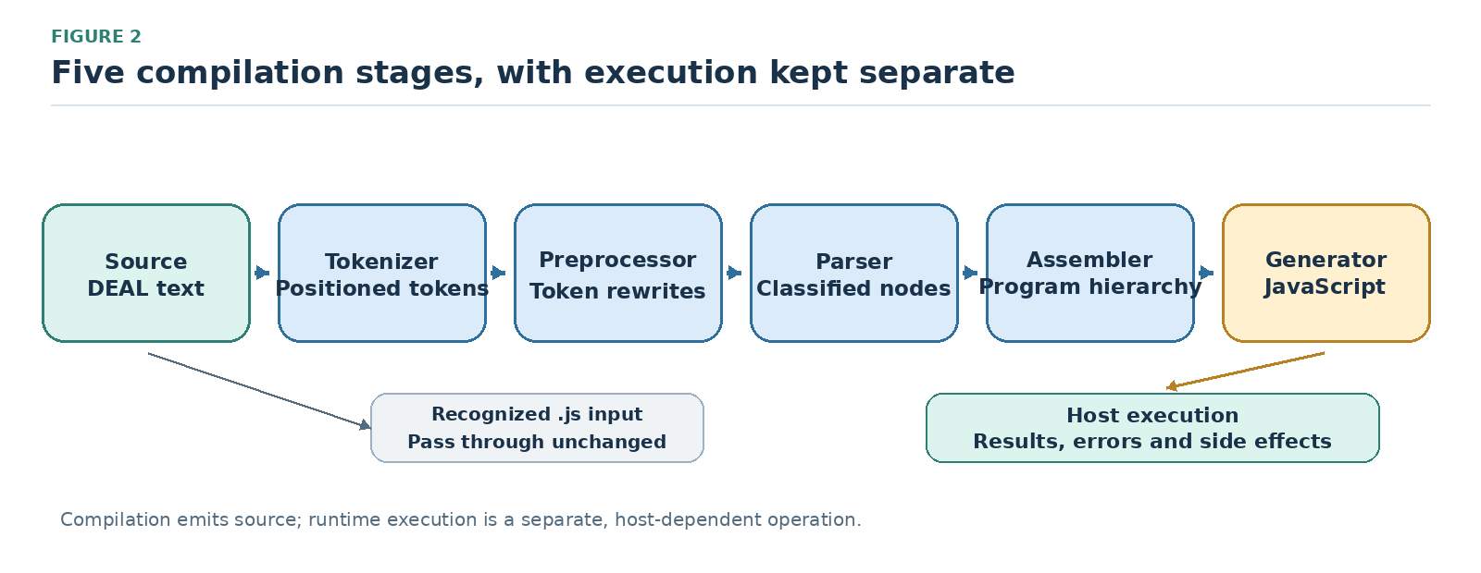
Figure 2. DEAL.JS source-to-source compilation architecture. DEAL input passes through five compiler stages; recognized JavaScript input can follow the documented passthrough path. Runtime execution remains a separate host-dependent operation.
The tokenizer recognizes source elements and vocabulary adaptations, including module imports and RESERVE mappings. The preprocessor exposes token-rewrite processing; the parser classifies token sequences into nodes; the assembler builds the program hierarchy; and the generator emits JavaScript. These stages identify architectural responsibilities, but their existence does not itself demonstrate preservation for every valid JavaScript construction.
The implementation supports two interoperability paths. Mixed DEAL/JavaScript input traverses the language pipeline, whereas a source identified as a JavaScript file may be returned unchanged. The passthrough path enables reuse of existing JavaScript resources, but it should be tested against filename resolution, encoding, and module-loading edge cases [6,31,33,38].

Representations and stage contracts
The stage interfaces transform representations such as source text, positioned tokens, classified nodes, assembled program structures, and JavaScript text. Table 4 summarizes the transition and its associated review obligation. These are architectural contracts; they should not be mistaken for a statically enforced type system across every stage.
Table 4. Compilation stages, intermediate representations, and semantic-preservation requirements.
Stage | Representation transition | Review obligation
Tokenizer | Source text to positioned tokens | Preserve literals and distinguish vocabulary from user identifiers
Preprocessor | Tokens to a token array; default token processing is pass-through | Make any configured rewrite explicit
Parser | Tokens to locally classified nodes | Preserve statement categories and declaration intent
Assembler | Nodes to a hierarchical, node-derived program | Preserve grouping, scope, and continuation attachment
Generator | Program structure to JavaScript source | Preserve operations and expose inspectable target code
Executor | Generated source to host-defined results and effects | Check permissions, effects, failures, and completion
Tokens carry type, value, and position metadata. Syntax-tree nodes add structural relationships, including child references, parent links, and flags, while dedicated walkers support traversal. These features can support source-linked explanations and diagnostics; complete source-map correctness and diagnostic-location precision, however, require separate tests.

Modules, commands, and runtime boundaries
The runtime maintains command dictionaries and reserve mappings, while USE resolves resources through the language and engine infrastructure. A domain module therefore couples vocabulary with implementation resources. Reproducible builds should record exact resource versions or hashes, dependency order, and environment configuration.
Compilation and execution are separate responsibilities. The ClearScript V8 host is one supported execution environment and exposes selected host facilities; the execution interface can accommodate other hosts. Generated JavaScript remains dependent on the APIs and permissions available in each target environment [32,34,35].
The local-resource module exposes file and directory operations, including save, append, prepend, delete, and existence checks, through a resource-provider interface. In particular, local.save(object, path) delegates to the host’s SetFileContents(path, object) operation [36]. This argument contract should remain explicit because it crosses the language–host boundary and produces persistent side effects. [36]
Module resolution considers extensionless resources and supported .deal, .djs, and .js forms; directory-based modules may resolve through an index resource or enumerate directory entries. A resource not already registered can be compiled and executed before inclusion is recorded. Figure 3 depicts this resolution-and-reuse path; reproducible use also requires recording which resource was resolved.
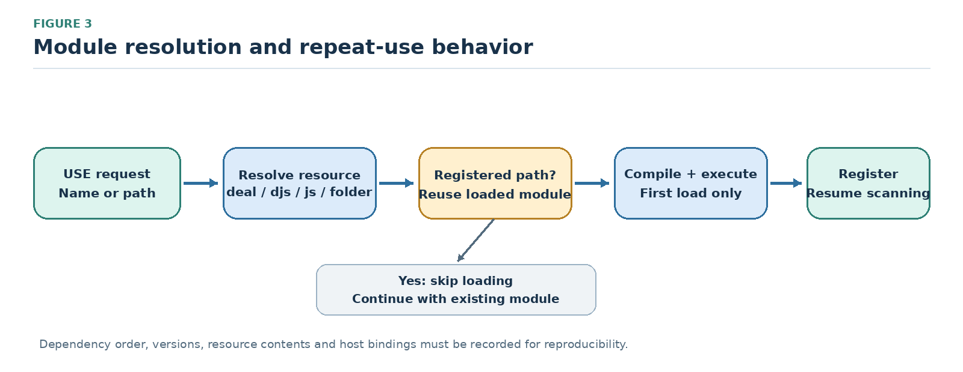
Figure 3. Module resolution and repeated-use behavior. A registered resource can be reused; first use resolves, compiles, and executes the resource before scanning resumes. Dependency versions and host bindings remain part of the reproducibility record.
Imported modules can introduce code and side effects as well as new vocabulary, so module loading belongs within the workflow’s trust boundary. Deployment should identify dependencies, declare host bindings, and restrict resource access. ClearScript’s exposure of .NET functionality makes isolation and permission policies responsibilities of the host environment, not consequences of readable syntax [32,34,35].
The diagnostic model records fields such as identifiers, severity, source ranges, and diagnostic codes; Output.Errors and orchestration logs expose error information. These facilities should not be described as an established automated-repair loop. Any AI-repair evaluation should record the exact diagnostics supplied to the model and use an independent functional oracle to judge the repair [4,5,27].

Determinism, preservation, and reproducibility
We formalize compilation determinism using the analytical function:

$C_{b}(s,v,m,o,σ_{0})=j_{b},(1)$

where $s$ represents source text, $v$ represents vocabulary configuration, $m$ comprises ordered module versions and contents, $o$ includes compiler settings, $σ_{0}$ captures initial compilation state, and $b$ identifies the target backend. Together, these terms define the compilation context $κ$. The determinism contract guarantees identical target output for identical source code and context, including any influential module-initialization inputs. It does not require external data sources or randomized analyses to remain static across runs.
Translation correctness requires an additional empirical relation:

$Obs(Exec_{b}(C_{b}(s,κ),e))=Spec(s,e),(2)$

where $e$ identifies the controlled execution environment and observations include outputs, errors, persistent file modifications, and relevant event order. The right-hand side must originate from an independent specification or oracle. Agreement with a compiler's own generated output is never sufficient as a standalone correctness criterion.
Reproducible research additionally requires preserving input snapshots, runtime and module versions, external responses, random seeds, locale settings, and permission scopes where relevant [12,13]. DEAL contributes the inspectable program artifact to this record; it does not replace the surrounding provenance and environment record. [12,13]

Worked application: web retrieval to research-ready storage

Task and data model
The worked application models a structured catalog workflow: retrieve a page or API response, extract records, normalize text, compute a derived variable, validate constraints, detect duplicate identifiers, and store accepted records separately from rejection reasons. In this article, the catalog is a synthetic test fixture; the workflow illustrates orchestration and data contracts rather than a measured live-site extraction.

$W(u)=SQNXA(u),(3)$

where $A$ acquires a source URL $u$, $X$ extracts raw fields, $N$ normalizes data and derives variables, $Q$ validates constraints and deduplicates records, and $S$ serializes and stores outputs. The output preserves both accepted records and explicit rejection logs. This modular decomposition keeps domain policies transparent while allowing acquisition and storage implementations to be swapped independently.
Our demonstration utilizes five synthetic records designed to test specific data policies. A valid record requires a nonempty identifier and title, a finite nonnegative main price, a finite discount within $[0,1]$, and a nonnegative integer quantity. The derived net price is calculated as:

$p_{net}=round_{2}(p_{main}(1-d)).(4)$

Missing numeric values are rejected rather than silently converted to zero. Duplicate detection retains the first record that passes all validation rules; an invalid record therefore does not reserve an identifier that a later valid record may use.
Table 5. Input conditions and expected outcomes in the synthetic catalog.
Input record | Main price | Discount | Quantity | Required outcome
$p_{1}$, padded title Alpha study | 100 | 0.10 | 2 | Accept; normalized title; net price 90
Duplicate $p_{1}$ | 100 | 0.10 | 2 | Reject as duplicate
$p_{2}$, full-width initial character in Ｂeta study | 0 | 0 | 0 | Accept as Beta study; preserve zero price and quantity
$p_{3}$, missing main price | Missing | 0 | 1 | Reject as invalid
$p_{4}$, discount outside permitted interval | 10 | 1.25 | 1 | Reject as invalid
Figure 4 summarizes the acquisition-to-storage workflow. In a deployed application, the retrieval adapter may use an API client or browser context; the transformations and validation policies must nevertheless remain explicit and testable. Accepted records carry provenance, while rejected records retain source-row identifiers and rejection reasons.
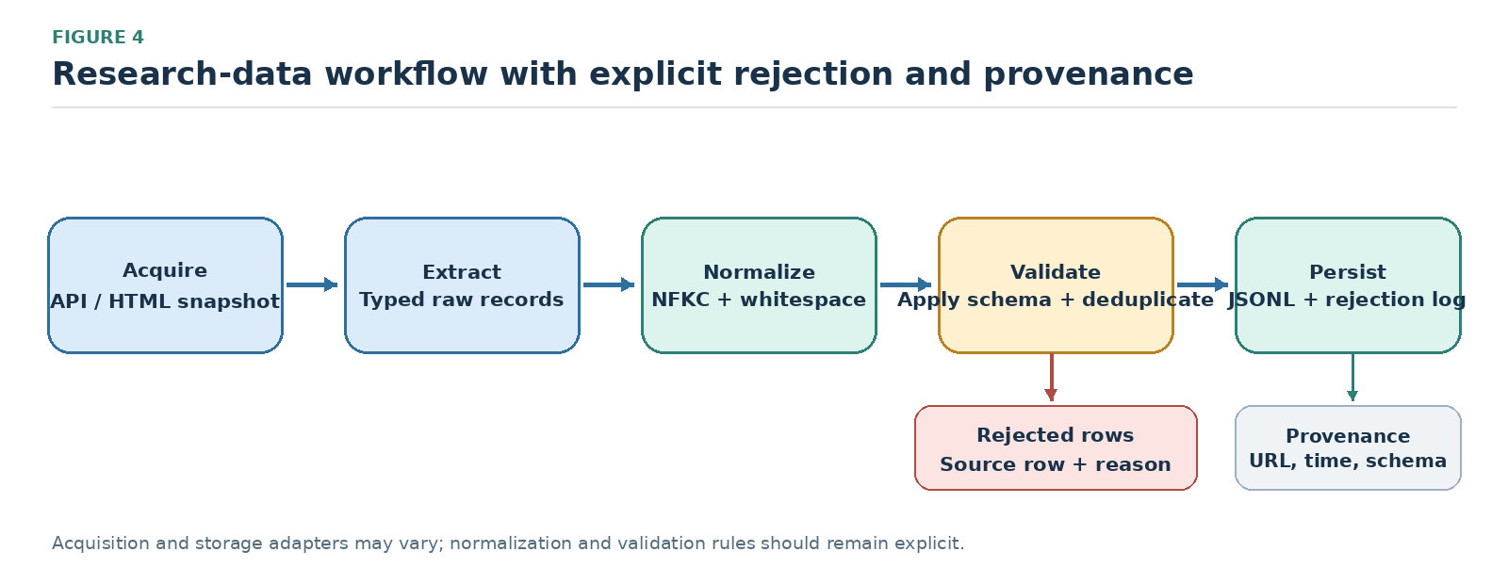
Figure 4. Synthetic research-data workflow showing acquisition, extraction, normalization, validation, deduplication, persistence, rejection logging, and provenance. The diagram describes the application design, not live retrieval results.

Acquisition and extraction
The scraper vocabulary includes FETCH for HTTP requests, LOAD for loading a document into the active context, ALL for selection, and handlers such as DOCUMENT, RESPONSE, LOADED, and FETCHED [6]. Listing 3 demonstrates a concise load–select–append idiom; production use must additionally define completion behavior and context isolation for multiple sources.

Code snippet
USE deal;
USE scraper;
FOR EACH url OF sources,
LOAD url,
THEN APPEND ALL "h3.title", TO destination;
Listing 3. Retrieval, title selection, and output through the load-select-append idiom. A multi-source workflow additionally requires an explicit completion and context-isolation policy.
For structured extraction, a helper receives the document and source identifier as explicit inputs. It selects table.catalog tbody tr, reads each row’s data-id, and extracts the .title, .price, .discount, and .quantity fields. Explicit inputs keep DOM traversal separate from normalization policy and make selector behavior straightforward to test.
An API-first adapter should map response data into the same plain-record schema before normalization. For a standard Fetch Response, JSON parsing is asynchronous and must be awaited or returned through a promise chain [37]. DOM extraction and API parsing are interchangeable only after both adapters meet the same input contract.

Preprocessing, processing, and persistence
Listing 4 composes a single-source workflow. Domain functions extract fields, enforce data contracts, and serialize accepted records; cleanRecords packages normalization into a reusable command. The local resource module makes persistence explicit in the orchestration layer.

Code snippet
USE deal;
USE scraper;
USE deal/data/local;
USE "./deal-case-helpers.js";
COMMAND cleanRecords(rows = [], source = "", time = "") {
return normalizeRecords(rows, source, time);
}
ASSUME CONST sourceURL IS "https://example.org/catalog";
ASSUME CONST destination IS "results/catalog.jsonl";
LOAD sourceURL,
THEN BEGIN
ASSUME CONST capturedAt IS new Date().toISOString();
ASSUME CONST rawRows IS extractRows(DOCUMENT, sourceURL);
ASSUME CONST report IS cleanRecords(rawRows, sourceURL, capturedAt);
local.save(toJSONL(report.accepted), destination);
local.save(JSON.stringify(report.rejected), "results/rejected.json");
END;
OTHERWISE BEGIN
throw new Error("Retrieval failed: " + sourceURL);
END;
Listing 4. DEAL.JS orchestration for acquisition, normalization, validation, and storage. The helper functions are supplied in the accompanying supplement; example.org is a placeholder and no live endpoint was measured.
The helper separates validation from duplicate detection and registers an identifier only after the record passes every data rule. It applies Unicode NFKC normalization, whitespace collapse, finite-number checks, an inclusive discount interval, and integer quantity validation. These policies are application-level rules, not implicit guarantees of the DEAL language.
Accepted rows are serialized as JSON Lines; rejected rows are written separately with source-row positions and reasons. The accepted schema includes source_url, retrieved_at, and schema_version. For an actual study, the archive should additionally preserve raw responses, content hashes, module manifests, compiler version, and permission scopes [12,13].
The storage layer can also be decoupled from document manipulation through a connector interface. The case-validation suite uses an in-memory provider to test serialization and storage behavior without depending on file-system or network variability. These tests establish the behavior of the included fixture and helper only.

Data contracts and rejection semantics
Table 6 states the application’s preprocessing and storage rules independently of the language grammar. Keeping data constraints separate from the selector or retrieval implementation makes it possible for reviewers to evaluate the policy without treating a particular web page as its specification.
Table 6. Accepted-record schema and rejection policy for the synthetic case.
Field or decision | Contract | Rationale or limitation
id, title | Trim identifier; normalize title with NFKC and collapsed whitespace; require both | Full-width characters normalize; identifier case is preserved
main_price, discount | Finite price at least zero; finite discount in [0, 1] | Missing/blank values are invalid, never silently coerced to zero
quantity, net_price | Nonnegative safe-integer quantity; net price rounded to two decimal places | Valid zeros survive; rounding is an explicit case policy
Duplicate detection | Retain the first valid record per identifier | Invalid records do not consume or reserve an identifier
Provenance | source_url, retrieved_at, schema_version on accepted rows | Test timestamp is synthetic; proves no live retrieval event occurred
Rejected records | One-based source_row and rejection reason | Compact rejection log; raw inputs require separate archiving
Figure 5 highlights a critical ordering rule: validation must precede registration in the set of accepted identifiers. If an invalid record were registered first, it could block a later valid record with the same identifier. Compact rejection logs also do not replace archiving the raw source inputs.
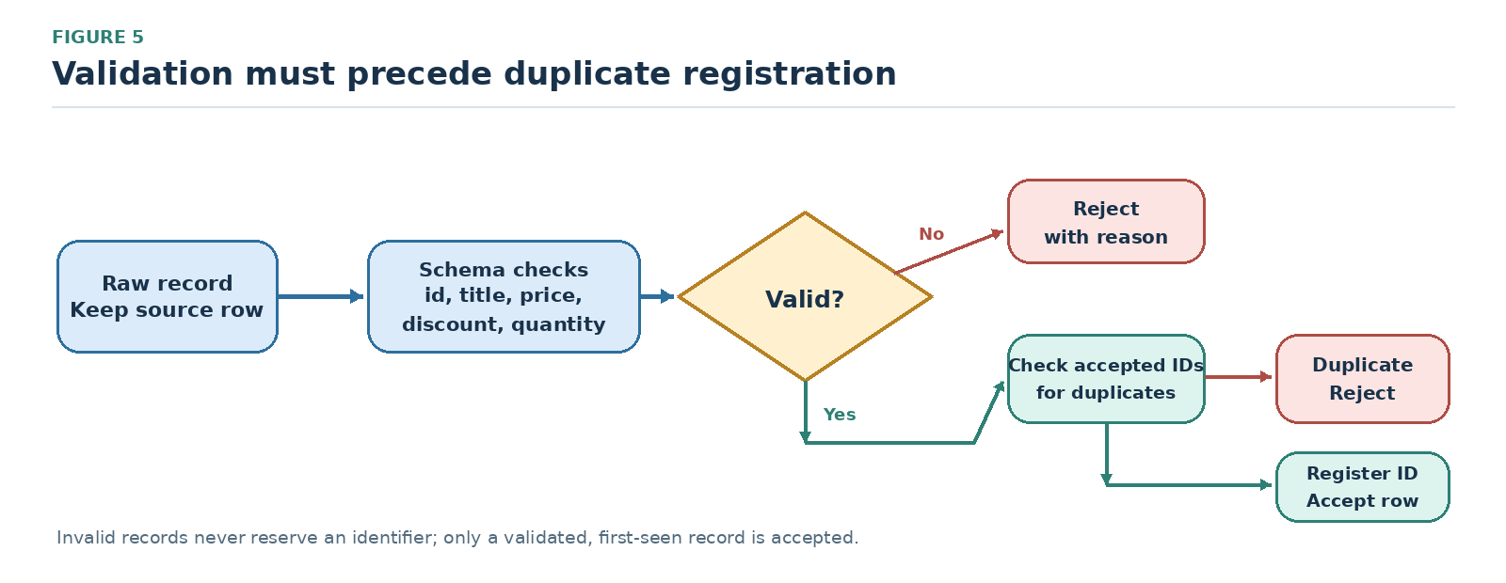
Figure 5. Validation flow for the synthetic data contract. Invalid records are rejected with reasons; among valid records, a previously accepted identifier triggers duplicate rejection. Only a validated first occurrence is registered and accepted.

Completion and failure policy
DEAL continuation forms must preserve the semantics of the underlying JavaScript promises, including success, rejection, and finalization [37]. A workflow is complete only when retrieval, normalization, and required persistence operations have settled, not merely when asynchronous operations have been started. [37]
The single-page example avoids concurrent mutation of one DOCUMENT context. A multi-page workflow should await requests sequentially or use isolated contexts and aggregate their promises. A production protocol should also specify retries, timeouts, failure propagation, partial-output rules, and stable identifiers for reruns.

Comparative examples and contribution analysis

Matched collection task
Listing 5 presents the same simple ordered iteration task in DEAL.JS, JavaScript, Python, and _hyperscript. It aligns the immediate computational intent to illustrate surface differences, but does not constitute a controlled readability experiment. A valid empirical comparison would also control documentation, API familiarity, data semantics, and prior language experience [14,15,19,29].

Code snippet
// DEAL.JS
ASSUME CONST values IS [1, 2, 3];
FOR EACH value OF values, BEGIN
console.log(value);
END;

JavaScript
// JavaScript
const values = [1, 2, 3];
for (const value of values) {
console.log(value);
}

Python
# Python
values = [1, 2, 3]
for value in values:
print(value)

Code snippet
-- _hyperscript
repeat for value in [1, 2, 3]
log value
end
Listing 5. Equivalent iteration intent across four notations. The DEAL form exposes declaration and iteration using readable keywords, but the Python and _hyperscript forms also show that readability is not unique to DEAL.
LiveCode’s corresponding text-container example uses repeat for each item value in values ... end repeat, operating on comma-delimited strings rather than native JavaScript arrays. Such representational differences must be carefully controlled in empirical studies: a fair task comparison requires aligning underlying operations and data semantics, not just surface visual similarity.

Extension mechanisms and web computation
Listing 6 compares two different extension mechanisms. SugarJ uses an imported library to introduce syntax and desugaring rules [22], whereas DEAL’s RESERVE construction adapts selected words to existing language structures. The example supports a narrower vocabulary-extension claim, not equivalence between the systems’ expressive power. [22]

Java
// SugarJ
import pair.Sugar;
public class Test {
private (String, Integer) p = ("12", 34);
}

Code snippet
// DEAL.JS Vocabulary Adaptation
RESERVE every AS "for";
RESERVE the;
every item OF the values, console.log(item);
Listing 6. SugarJ grammar/desugaring extension compared with DEAL vocabulary adaptation. The example illustrates different extension levels and does not claim equivalent expressiveness.
WebL pioneered integrated page retrieval, element operations, and markup algebra for web document processing. Listing 7 places WebL’s page/element abstraction alongside DEAL’s load/select orchestration idiom. Both select third-level heading elements, differing primarily in the underlying language abstractions used to manage documents and outputs.

Code snippet
// WebL-style notation
page := getpage("https://example.org/catalog");
titles := page.Elem("H3");

Code snippet
// DEAL.JS orchestration idiom
LOAD "https://example.org/catalog",
THEN APPEND ALL "h3", TO destination;
Listing 7. Comparable heading-selection intent expressed through WebL-style notation and DEAL.JS. The example illustrates different abstractions; it is not an empirical performance comparison.

Innovation and field-level contribution
Our core innovation is an integrated communication architecture featuring explicit extension boundaries. A shared source artifact makes AI-generated proposals fully editable and reviewable; domain commands encapsulate reusable scientific operations; and mixed-source interoperability enables gradual adoption alongside existing JavaScript codebases. These mechanisms directly bridge the practical divide between a researcher’s scientific description of a method and the software executing it.
A second design feature is the separation of computational operations, human-facing terminology, and implementation technology. A domain module can preserve its operational contract while supporting alternative vocabulary, and another implementation could reuse the language model if it preserved the declared semantics. Such portability remains conditional on explicit mappings, aligned environments, and conformance testing.
The implementation integrates a research-oriented notation, JavaScript source generation, modular operations, and vocabulary adaptation. Its contribution should be evaluated at the system level rather than attributed to a particular keyword or scraping function. The current evidence establishes the existence of these mechanisms and the behavior of the tested synthetic case; it does not yet establish general user or performance benefits.

Multilingual vocabulary and implementation in other languages

Vocabulary localization without changing the task
Vocabulary modules can map alternative human-language expressions to the same canonical computational operations. This may reduce language-specific friction for some users, but evidence on programming-language intuition indicates that effects vary with participants and task context [15]. Localization should therefore be optional and validated with users of the target locale rather than presented as a universal cognitive benefit. [15]
Listing 8 shows illustrative Spanish and French vocabulary fragments using replacement reserves and readability words. These snippets demonstrate the intended mechanism, not production-ready or native-speaker-validated locale packages. Locale-specific tests must also cover identifiers, string literals, phrase boundaries, Unicode handling, and diagnostics.

Code snippet
// Spanish vocabulary fragment
RESERVE para AS "for";
RESERVE cada;
RESERVE de AS "of";
para cada value de values, console.log(value);

Code snippet
// French vocabulary fragment
RESERVE pour AS "for";
RESERVE chaque;
RESERVE de AS "of";
pour chaque value de values, console.log(value);
Listing 8. Illustrative Spanish and French surface forms for a canonical iteration. The fragments should be loaded as separate locale configurations and require equivalence tests before operational use.
Let $\mathcal{N}_\ell$ map source text written in vocabulary $\ell$ into canonical DEAL source. Vocabulary equivalence is formally satisfied when:

$N_{es}(s_{es})=N_{fr}(s_{fr})=s_{c}.(5)$

For a fixed canonical compilation context, vocabulary configurations that normalize to the same canonical source should yield the same target artifact. This separates surface localization from program semantics: an alias module must preserve the intended instruction, not merely translate individual words.
A complete localization design must protect literals and user identifiers, define Unicode and case-collision behavior, document phrase boundaries, and produce intelligible diagnostics. Translation should preserve the computational task rather than translate every token mechanically. Native-speaker review and equivalence testing are required before claiming that a locale improves outcomes for a community [39].

Reimplementation and target-language portability
The DEAL model may be implemented in other host languages, or a compiler backend may target a different language. These are distinct forms of reuse. DEAL.JS is the concrete JavaScript-targeting implementation; alternatives must state the subset they support and preserve the declared observations rather than infer portability from architectural similarity.
The current concrete target is JavaScript. Figure 6 separates vocabulary normalization, canonical language structures, and backend realization. Other targets require explicit semantic mappings, and embedded JavaScript must either be excluded from the portable subset or treated as a host-specific escape boundary.
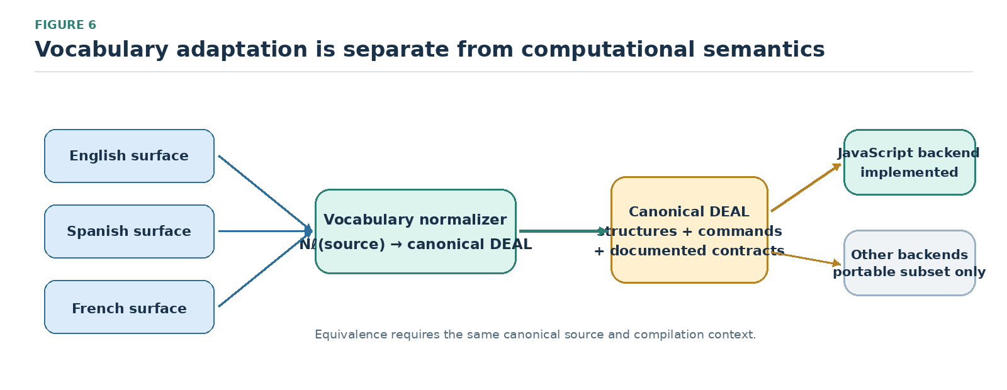
Figure 6. Vocabulary adaptation, canonical DEAL structures, and backend realization. JavaScript is the implemented target; any additional backend requires a declared portable subset and explicit semantic-preservation tests.
For any portable program $p$, the cross-backend preservation condition is defined as:

$Obs(Exec_{a}(C_{a}(p),e_{a}))=Obs(Exec_{b}(C_{b}(p),e_{b})).(6)$

Cross-backend comparisons require aligned execution environments and observation definitions. Numeric precision, strings, missing-value behavior, event order, exceptions, asynchronous effects, and storage encodings are part of the contract. A backend-neutral subset makes these obligations more manageable; arbitrary embedded JavaScript cannot automatically be translated to an unrelated host language.
This separation allows a domain operation, such as normalization, to keep a stable contract while its vocabulary and runtime implementation evolve. It also makes the limit of host interoperability explicit: language-level portability cannot be inferred for code that includes arbitrary, target-specific JavaScript.

Testing strategy and evaluation methodology
The evaluation strategy separates three questions: language conformance, application data-contract correctness, and practical utility for people or AI systems. The results reported here concern the synthetic catalog’s application contract. The remaining protocols are proposed methods for future evaluation, not completed experiments.

Language conformance and regression
Conformance tests should link source constructions to observations specified independently of the implementation. DEAL-specific, native JavaScript, and mixed-source tests should cover structures, user commands, expressions, nested control flow, and asynchronous continuations. Table 7 identifies representative test categories and their corresponding semantic oracles.
Table 7. Conformance categories, test constructions, and semantic oracles.
Language feature | Test construction | Semantic oracle
Core structures | Isolated declarations, branches, loops, and exception paths | Expected bindings, outputs, termination, and error states
Embedded JavaScript | Matched native and mixed-source programs | Agreement with specified JavaScript execution behavior
Nested control flow | Combinations of blocks, scopes, and continuations | Binding visibility, effect order, and completion guarantees
Commands and vocabulary | Reusable operations, aliases, and readability words | Stable operation contracts and equivalent canonical meaning
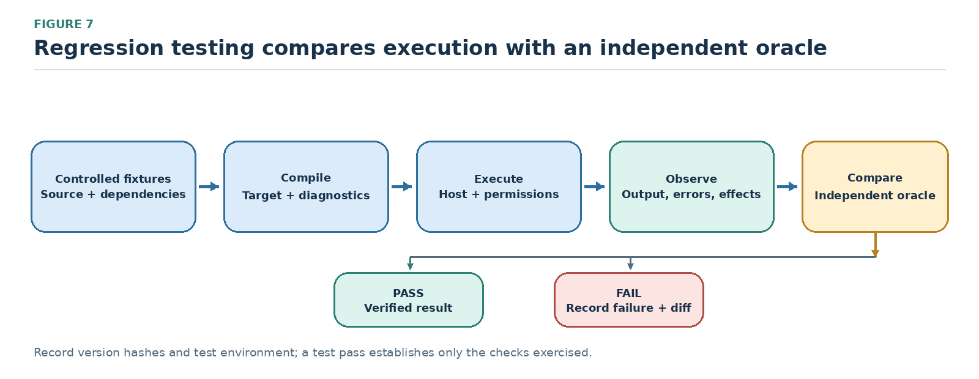
Figure 7. Proposed regression protocol: compile controlled fixtures, execute under a declared host, capture observable effects, and compare them with an independent specification. The protocol is a design proposal for full-system testing, not a report that such a full-system experiment was completed.
A reproducible conformance protocol should start from a controlled compiler state, record generated source and diagnostics, and execute under a declared host contract. Independent oracles should cover outputs, exceptions, persistent storage effects, and asynchronous completion. Malformed syntax, missing modules, conflicting reserves, and unsupported host operations should be included as negative tests, with expected failure behavior defined in advance.
A full suite should divide cases into declarations, branches, loops, commands, reserves, handlers, collection operators, module resolution, and embedded JavaScript. Property-based and metamorphic testing can assess invariants—for example, whether adding declared noise words or permitted capitalization variants changes canonical meaning. Broad independent tests remain necessary because passing a small suite is not evidence of complete correctness.

Application correctness and extraction quality
The synthetic catalog yields deterministic expected outcomes for normalization, validation, serialization, and in-memory persistence. Because no live site was queried, these checks do not measure extraction accuracy. That requires separate tests against HTML and JSON snapshots with independently annotated records and fields.
Extraction evaluation utilizes HTML and JSON fixtures featuring manually annotated records and fields. Critical test cases include missing fields, altered element order, duplicate rows, pagination boundaries, encoding variations, and malformed numeric data. If $R$ represents the retrieved record set and $G$ represents the ground-truth reference set, record-level metrics are calculated as:

$Precision=\frac{|R∩G|}{|R|},Recall=\frac{|R∩G|}{|G|}.(7)$

Precision/recall, field-level accuracy, rejection correctness, and persistence round-trip fidelity measure distinct failure modes and should be reported separately. Archived snapshots enable repeatable regression checks; evaluations against live sites additionally require timestamps and acquisition conditions, and should distinguish site changes from extractor defects.
Table 8. Evaluation layers and their corresponding evidence.
Evaluation layer | Primary question | Evidence and measures
Language conformance | Does each supported construction preserve its specified behavior? | Independent assertions, failures, side-effects, and completion order
Reproducible translation | Does a fixed compilation context reproduce its exact output? | Repeated fresh runs, cryptographic hashes, manifests, and config
Extraction | Are the intended records and fields accurately acquired? | Annotated snapshots; precision, recall, and field-level accuracy
Data transformation | Are normalization, exclusion, and derived variables correct? | Boundary cases, zero/missing distinctions, duplicate policies
Persistence | Are outputs faithfully preserved and attributable? | Read/write round-trip, schema validation, provenance inspection
Human review | Do researchers understand and correctly approve programs? | Comprehension scores, defect detection, false approvals, and time
AI generation | Can an AI produce correct end-to-end programs within budget? | Functional success, repair iterations, latency, and resource use
Localization and portability | Do alternative surfaces and targets preserve behavior? | Canonical equivalence and cross-runtime observations

Human comprehension and calibrated trust
A future human-comprehension study could compare DEAL.JS with JavaScript, Python, and—where tasks overlap—_hyperscript. A counterbalanced design should separate language effects from task order, recruit researchers with limited professional programming experience as the prespecified target population, and assess output prediction, rule modification, error detection, and approval of AI-proposed workflows. No such participant study is reported in this article.
Accurate review is our primary outcome metric. The false-approval rate measures whether a readable surface notation induces misplaced confidence. Let $n_{FA}$ count incorrect workflows erroneously approved and $n_{I}$ count total incorrect workflows reviewed:

$FAR=\frac{n_{FA}}{n_{I}}.(8)$

Completion time, cognitive workload, explanation quality, and qualitative interviews can supplement correctness measures. Sample size should be justified by pilot estimates and a prespecified power or precision analysis, accounting for participant and task variation rather than selected after the outcomes are observed.
Experimental conditions should provide equivalent domain APIs, documentation, training, and task specifications. Analysis should account for prior language familiarity, English proficiency, task and participant effects, and order effects, and should report effect sizes with uncertainty intervals. These controls help distinguish syntax effects from API design and participant experience [14–17,39].

AI generation, performance, and ablation
An AI-generation study should hold task specifications, documentation, library contracts, model versions, and repair budgets constant while varying the output representation. Supplying the same domain API for JavaScript and DEAL would help isolate the representation from library functionality; a structured-schema baseline could estimate benefits attributable to constrained output more generally [4,5,25–27].
End-to-end success demands successful parsing, compilation, runtime completion, and all task-specific output validations. For $N$ evaluation tasks, functional success is defined as:

$FS=\frac{1}{N}\sum_{i=1}^{N}{}z_{i}.(9)$

Here, $z_{i}=1$ only if task $i$ satisfies every mandatory verification check, and $z_{i}=0$ otherwise. Malformed source output and missing dependencies count as failures. First-attempt success and fixed-repair-budget success are tracked as distinct outcomes, accompanied by token usage counts, latency measurements, and human correction effort. Execution-based assessments follow established code-generation evaluation standards; while grammar-constrained decoding guarantees structural syntax validity, it cannot replace rigorous functional verification. [4,5,26,27]
Operational cost should be decomposed into compilation time, module initialization, network latency, data-processing duration, memory, output size, and steady-state runtime. Cold and warm runs should be measured separately. Ablation studies could isolate vocabulary adaptation, document-like presentation, handlers, and domain commands rather than attributing every observed effect to the language as a whole.
Localization experiments should compare identical tasks under controlled vocabulary configurations; backend experiments should begin with a restricted portable subset. Both should publish unsupported constructs and failure cases. These studies would extend the current design analysis without treating implementation presence as proof of general effectiveness.

Design analysis and case-validation results

Representation and extension boundaries
For RQ1, the artifact documents an explicit route from domain commands and control structures through generated JavaScript to host execution. Structures, reusable commands, vocabulary modules, and handlers expose separate design mechanisms without requiring a new structural grammar for every domain. This is an architectural observation grounded in the implementation; its effect on comprehension remains an empirical question.
For RQ2, the equivalence condition is conditional: two vocabulary inputs must normalize to the same canonical source under the same compilation context. If the compiler is deterministic under that context, the generated artifacts should match. Cross-backend equivalence additionally requires a preservation relation and aligned execution environments; it cannot be inferred from a JavaScript implementation alone.

Workflow composition and functional validation
For RQ3, the synthetic workflow composes acquisition-oriented orchestration, record extraction, normalization, validation, derived-variable computation, duplicate handling, and persistence. Separating orchestration from data rules makes each decision inspectable and allows adapters to vary, provided they satisfy the same schema. The present case demonstrates that composition at the level of the supplied helper and test harness.
The reconstructed case-validation suite passed all 19 checks. It accepted two of five synthetic records (40%) and rejected three (60%): one duplicate identifier, one missing or invalid main price, and one discount above 1. The checks cover normalization, price derivation, valid zero values, rejection categories and source-row positions, provenance and schema metadata, JSON Lines round-trip, memory persistence, duplicate-registration ordering, and selector-to-field wiring through a document-shaped test double. The fixed timestamp is fixture metadata, not a measurement of a live retrieval event. Table 9 summarizes the bounded result.
Table 9. Observed outcomes for the reconstructed synthetic catalog case.
Measure | Observed result | Interpretation boundary
Synthetic records | 5 total | Designed fixture; no live source was queried.
Accepted records | 2/5 (40%) | Both records satisfy the stated validation rules.
Rejected records | 3/5 (60%) | One duplicate ID, one invalid/missing main price, and one discount above 1.
Case-validation checks | 19/19 passed (100%) | Applies only to the included reconstructed suite and its specified checks.
Human study / live acquisition | None / none | Human comprehension and live extraction accuracy remain unmeasured.

Interpretation of the evidence
The findings validate the stated application data rules for the specified synthetic fixtures. They do not establish full DEAL.JS language conformance, live web extraction accuracy, vocabulary-equivalence performance, portability to another backend, user comprehension, AI-generation advantage, or operational efficiency. Those claims require separate datasets, independent oracles, and purpose-designed experiments.

Discussion, limitations, and future directions

Implications for human–AI research programming
The principal implication is methodological: human–AI programming can be organized around a shared, executable artifact rather than a prompt followed by an opaque implementation. Researchers can review the inclusion criteria and transformation rules at the level where they are specified, while an AI system may propose revisions and the compiler generates JavaScript. Whether this arrangement improves review accuracy or reduces repair effort must be tested directly.
The value of an abstraction depends on which decisions it makes visible. A normalization command should expose missing-value and duplicate policies when these affect scientific interpretation, even if DOM traversal and serialization remain encapsulated. A reviewable workflow must let users move between domain-level intent, the command contract, its implementation, generated code, and recorded outcomes.

Threats to validity and limitations
The primary construct-validity risk is equating surface readability with actual comprehension. The functional assertions do not measure human oversight, and subjective usability ratings alone would not establish reliable review. The case suite also shares assumptions with the helper under test; independent specifications, deliberately mutated faulty implementations, and differential tests would provide stronger evidence. External validity is limited by the small synthetic fixture and the absence of live data, additional research domains, and user participants.
Domain commands redistribute cognitive complexity rather than eliminate it. Concise syntax can conceal extensive implementation, localized synonyms can create ambiguity, and contextual handlers can introduce implicit dependencies. To keep abstraction accountable, the system should expose command contracts, generated source, module manifests, and execution traces.
Hybrid interoperability supports reuse of existing libraries but creates a boundary for static analysis, security, and cross-backend portability. Readability cannot replace access controls, runtime isolation, or tests, and a correct transformation pipeline cannot establish that source data are representative or that the resulting scientific interpretation is valid.
Implementation scope must be distinguished from evaluation scope. The reported checks concern specified transformation and storage behaviors. Human-participant effects, comparative AI-generation outcomes, live extraction robustness, performance, and cross-backend equivalence remain unmeasured. The equations in this paper specify analytical preservation conditions; they are not machine-checked proofs of the complete compiler.

Research roadmap
Future work should first formalize the language specification and module contracts, then build conformance fixtures with independent semantic oracles. Source-linked tooling that connects each DEAL instruction to generated JavaScript, exact dependencies, and execution traces could improve review and error localization. Such tools should be evaluated for diagnostic precision rather than presumed beneficial.
Additional applications could include bibliographic harvesting, repository mining, corpus preparation, simulation configuration, and experimental data processing. Each domain module should contribute a documented input/output contract, adversarial fixtures, and domain-review guidance. Adding vocabulary without an operational specification would weaken the goal of a shared representation.
Further work should test optional localized diagnostics and documentation, define a backend-neutral subset, and evaluate grammar-aware AI generation under matched task conditions. Any portability claim should specify the supported subset and report unsupported constructs, rather than infer cross-language equivalence from the reuse of compiler stages.
Responsible deployment also requires permission-aware data acquisition, rate limiting, privacy safeguards, access controls, and explicit retention policies. Provenance and standard serialization formats support reuse, but lawful and ethical acquisition depends on the context, applicable rules, and institutional review. None of these safeguards follows automatically from a readable language.

Conclusion
DEAL provides a shared programming representation for workflows involving researchers, AI assistance, and conventional runtime execution. Structures express control flow, commands encapsulate reusable operations, reserves adapt selected vocabulary, and handlers expose contextual objects. DEAL.JS implements these mechanisms through staged source-to-source compilation and interoperability with JavaScript.
The worked catalog case illustrates how acquisition-oriented orchestration, extraction, normalization, derivation, validation, deduplication, and persistence can be expressed as a reviewable workflow. In the reconstructed synthetic suite, 19 checks passed and the five input records yielded two accepted and three rejected rows. This result supports only the specified data contract; it is not evidence of live extraction accuracy or whole-language correctness.
The contribution is therefore a testable language-engineering architecture: human-facing vocabulary remains separate from explicit computational operations, and the generated program can be connected to concrete execution evidence. Whether this representation improves accurate review, generation success, or reuse across scientific domains remains an open empirical question. The next step is controlled comparison with independent oracles and representative users.

Glossary
- DEAL: Declarative and Extensible Abstract Language, the shared programming model examined in this article.
- DEAL.JS: The JavaScript-targeting realization of DEAL.
- Reserve: A declared vocabulary replacement or a permitted readability word.
- Handler: A contextual reference to a current workspace object or operation.
- Canonical normalization: The analytical mapping from a configured human vocabulary to a common structural representation.
- Portable subset: A declared set of language constructions whose operational behavior is formally specified across target backends.

Data availability
The source implementation and related infrastructure are publicly available in version-pinned repositories: DEAL.JS at commit d76dcae3bf157e3969be0bd1f98ed2522defc2b9 (https://github.com/DEAL-X/DEAL-JS/tree/d76dcae3bf157e3969be0bd1f98ed2522defc2b9), DEAL Engine at commit 8800695b1bbe6274f71f581473943ff7943d5036 (https://github.com/DEAL-X/Engine/tree/8800695b1bbe6274f71f581473943ff7943d5036), and DEAL Environment at commit 9ef64b9ae94e1017273f9780a4466973b4d5747d (https://github.com/DEAL-X/Environment/tree/9ef64b9ae94e1017273f9780a4466973b4d5747d). The supplementary ZIP accompanying this revised manuscript contains the reconstructed synthetic-case helper, 19-check suite, and captured test output. No live web responses or participant data were collected for the case validation. No DOI or other persistent identifier has been assigned to this revision’s supplement.
Persistent identifier: Not assigned. A repository release or DOI should be created and recorded before formal submission if required by the target journal.

CRediT authorship contribution statement
The supplied manuscript and source artifacts do not identify individual author contributions. CRediT roles cannot be reliably inferred from author order or the contents of the manuscript; the authors should agree on and verify the role allocation before submission.

Declaration of competing interests
The supplied materials do not contain author-verified competing-interest disclosures. This revision does not infer that no competing interests exist. All authors should confirm and approve the final declaration before submission.

Funding
The supplied materials do not identify a funder, award, or grant number, and they do not establish that the work received no external funding. Funding status should be confirmed by the authors before submission; no award information has been inferred.

Declaration of generative AI and AI-assisted technologies in the writing process
The source manuscript credits Perplexity Computer (GPT 6.1 Sol) with literature discovery, manuscript drafting and revision, case-study code implementation, and SVG diagram preparation. During this revision, ChatGPT (OpenAI) assisted with prose editing, citation checks, reconstruction of conceptual figures from the source captions and descriptions, and preparation and execution of the synthetic validation harness. The figures in this revised file are redrawn explanatory diagrams because the supplied DOCX contained figure captions but no embedded figure images; they do not represent measured experimental observations. No live web acquisition or human-participant study was performed. The authors remain responsible for verifying references, code, formulas, claims, and all final content.

Acknowledgements
No acknowledgements of specific support, individuals, or organizations were supplied in the source materials. Any acknowledgements should be added only after confirmation by the authors.

References
[1] Ko, A. J.; Abraham, R.; Beckwith, L.; Blackwell, A.; Burnett, M.; Erwig, M.; Scaffidi, C.; Lawrance, J.; Lieberman, H.; Myers, B.; Rosson, M. B.; Rothermel, G.; Shaw, M.; and Wiedenbeck, S. (2011). The state of the art in end-user software engineering. ACM Computing Surveys, 43(3). DOI: 10.1145/1922649.1922658. Available at: https://researchdiscovery.drexel.edu/esploro/outputs/journalArticle/The-State-of-the-Art-in/991019167334204721.
[2] Barricelli, B. R.; Cassano, F.; Fogli, D.; and Piccinno, A. (2019). End-user development, end-user programming and end-user software engineering: A systematic mapping study. Journal of Systems and Software, 149, pp. 101-137. DOI: 10.1016/j.jss.2018.11.041. Available at: https://expertise.unimi.it/resource/item/669695?language=en-US.
[3] Vaithilingam, P.; Zhang, T.; and Glassman, E. L. (2022). Expectation vs. Experience: Evaluating the usability of code generation tools powered by large language models. Extended abstracts of the 2022 CHI conference on human factors in computing systems, pp. 1-7. DOI: 10.1145/3491101.3519665. Available at: https://dl.acm.org/doi/pdf/10.1145/3491101.3519665.
[4] Chen, M., et al. (2021). Evaluating large language models trained on code. arXiv:2107.03374. Preprint. Available at: https://arxiv.org/abs/2107.03374.
[5] Liu, J.; Xia, C. S.; Wang, Y.; and Zhang, L. (2023). Is your code generated by ChatGPT really correct? Rigorous evaluation of large language models for code generation. Advances in neural information processing systems, 36. Available at: https://proceedings.neurips.cc/paper_files/paper/2023/hash/43e9d647ccd3e4b7b5baab53f0368686-Abstract-Conference.html.
[6] DEAL-X (n.d.). DEAL.JS: Source code, README, libraries, and samples. Software. Version d76dcae3bf157e3969be0bd1f98ed2522defc2b9; accessed 19 October 2026. Available at: https://github.com/DEAL-X/DEAL-JS.
[7] Kuhn, T. (2014). A survey and classification of controlled natural languages. Computational Linguistics, 40(1), pp. 121-170. DOI: 10.1162/COLI_a_00168. Available at: https://aclanthology.org/J14-1005/.
[8] Spinellis, D. (2001). Notable design patterns for domain specific languages. Journal of Systems and Software, 56(1), pp. 91-99. DOI: 10.1016/S0164-1212(00)00089-3. Linked page is the author’s working-paper rendering, which identifies the preferred publication citation. Available at: https://www.spinellis.gr/pubs/jrnl/2000-JSS-DSLPatterns/html/dslpat.html.
[9] Lipton, Z. C. (2018). The mythos of model interpretability. Communications of the ACM, 61(10), pp. 36-43. DOI: 10.1145/3233231. Available at: https://vis.csail.mit.edu/classes/6.859/readings/pdfs/Lipton-TheMythosOfModelInterpretability.pdf.
[10] Doshi-Velez, F.; and Kim, B. (2017). Towards a rigorous science of interpretable machine learning. arXiv:1702.08608. Position-paper preprint. Available at: https://arxiv.org/abs/1702.08608.
[11] Rudin, C. (2019). Stop explaining black box machine learning models for high stakes decisions and use interpretable models instead. Nature Machine Intelligence, 1, pp. 206-215. DOI: 10.1038/s42256-019-0048-x. Available at: https://www.nature.com/articles/s42256-019-0048-x.
[12] Sandve, G. K.; Nekrutenko, A.; Taylor, J.; and Hovig, E. (2013). Ten simple rules for reproducible computational research. PLOS Computational Biology, 9(10), Article e1003285. DOI: 10.1371/journal.pcbi.1003285. Available at: https://journals.plos.org/ploscompbiol/article?id=10.1371/journal.pcbi.1003285.
[13] Wilkinson, M. D., et al. (2016). The FAIR guiding principles for scientific data management and stewardship. Scientific Data, 3, Article 160018. DOI: 10.1038/sdata.2016.18. Available at: https://www.nature.com/articles/sdata201618.
[14] Stefik, A.; and Siebert, S. (2013). An empirical investigation into programming language syntax. ACM Transactions on Computing Education, 13(4), pp. 19:1-19:40. DOI: 10.1145/2534973. Available at: https://eric.ed.gov/?id=EJ1042402.
[15] Lappi, V.; Tirronen, V.; and Itkonen, J. (2023). A replication study on the intuitiveness of programming language syntax. Software Quality Journal, 31, pp. 1211-1240. DOI: 10.1007/s11219-023-09631-7. Available at: https://link.springer.com/article/10.1007/s11219-023-09631-7.
[16] Green, T. R. G.; and Petre, M. (1996). Usability analysis of visual programming environments: A cognitive dimensions framework. Journal of Visual Languages and Computing, 7(2), pp. 131-174. DOI: 10.1006/jvlc.1996.0009. Linked text is the author manuscript. Available at: https://history.futureofcoding.org/history/msg_files/F6R/F6R1A64AF.pdf.
[17] Heinonen, A.; Lehtelä, B.; Hellas, A.; and Fagerholm, F. (2023). Synthesizing research on programmers’ mental models of programs, tasks and concepts: A systematic literature review. Information and Software Technology, 164, Article 107300. DOI: 10.1016/j.infsof.2023.107300. Available at: https://www.sciencedirect.com/science/article/pii/S0950584923001544.
[18] Keemps, R.; Farias, K.; Kunst, R.; Carbonera, C.; and Bolzan, W. (2025). SmellDSL: A domain-specific language to assist developers in specifying code smell patterns. Information and Software Technology, 184, Article 107760. DOI: 10.1016/j.infsof.2025.107760. Available at: https://www.sciencedirect.com/science/article/abs/pii/S0950584925000990.
[19] _hyperscript project (n.d.). _hyperscript: Official language documentation. Online language documentation. Accessed 19 October 2026. Available at: https://hyperscript.org/.
[20] _hyperscript project (n.d.). _hyperscript: Official reference. Online language documentation. Accessed 19 October 2026. Available at: https://hyperscript.org/reference/.
[21] LiveCode (n.d.). LiveCode Script: Repeat control structure. Online language documentation. Accessed 19 October 2026. Available at: https://docs.livecode.com/docs/LiveCode%20Script/Control%20Structures/repeat/.
[22] Erdweg, S.; Rendel, T.; Kästner, C.; and Ostermann, K. (2011). SugarJ: Library-based syntactic language extensibility. Proceedings of OOPSLA, pp. 391-406. Available at: https://www.pl.informatik.uni-mainz.de/files/2019/04/sugarj.pdf.
[23] Kistler, T.; and Marais, H. (1998). WebL: A programming language for the web. Computer Networks and ISDN Systems, 30(1–7), pp. 259-270. DOI: 10.1016/S0169-7552(98)00018-X. Available at: https://www.ra.ethz.ch/cdstore/www7/1832/com1832.htm.
[24] Ferrara, E.; De Meo, P.; Fiumara, G.; and Baumgartner, R. (2014). Web data extraction, applications and techniques: A survey. Knowledge-Based Systems, 70, pp. 301-323. DOI: 10.1016/j.knosys.2014.07.007. Linked record provides an author preprint and the published journal citation. Available at: https://arxiv.org/abs/1207.0246.
[25] Gao, L.; Madaan, A.; Zhou, S.; Alon, U.; Liu, P.; Yang, Y.; Callan, J.; and Neubig, G. (2023). PAL: Program-aided language models. Proceedings of the 40th international conference on machine learning, 202, pp. 10764-10799. Available at: https://proceedings.mlr.press/v202/gao23f.html.
[26] Scholak, T.; Schucher, N.; and Bahdanau, D. (2021). PICARD: Parsing incrementally for constrained auto-regressive decoding from language models. Proceedings of the 2021 conference on empirical methods in natural language processing, pp. 9895-9901. DOI: 10.18653/v1/2021.emnlp-main.779. Available at: https://aclanthology.org/2021.emnlp-main.779/.
[27] Geng, S.; Josifoski, M.; Peyrard, M.; and West, R. (2023). Grammar-constrained decoding for structured NLP tasks without finetuning. Proceedings of the 2023 conference on empirical methods in natural language processing, pp. 10932-10952. Available at: https://aclanthology.org/2023.emnlp-main.674/.
[28] Ferris, L.; and Bonilla, S. (2026). A case study in assuring AI-written software. arXiv:2610.08651v1. Preprint. arXiv version 1; preprint, not used as established general evidence. Available at: https://arxiv.org/html/2610.08651v1.
[29] Python Software Foundation (n.d.). Python tutorial: More control flow tools. Online language documentation. accessed 19 October 2026. Available at: https://docs.python.org/3/tutorial/controlflow.html.
[30] Hevner, A. R.; March, S. T.; Park, J.; and Ram, S. (2004). Design science in information systems research. MIS Quarterly, 28(1), pp. 75-105. Available at: https://aisel.aisnet.org/misq/vol28/iss1/6/.
[31] DEAL-X (n.d.). DEAL.JS: Engine configuration and native JavaScript passthrough. Software. Engine.cs, commit d76dcae3bf157e3969be0bd1f98ed2522defc2b9; accessed 19 October 2026. Available at: https://github.com/DEAL-X/DEAL-JS/blob/d76dcae3bf157e3969be0bd1f98ed2522defc2b9/DEAL.JS/Engine.cs.
[32] DEAL-X (n.d.). DEAL Engine: Generic compiler framework. Software. Version 8800695b1bbe6274f71f581473943ff7943d5036; accessed 19 October 2026. Available at: https://github.com/DEAL-X/Engine.
[33] DEAL-X (n.d.). DEAL.JS: Tokenizer implementation. Software. Tokenizer.cs, commit d76dcae3bf157e3969be0bd1f98ed2522defc2b9; accessed 19 October 2026. Available at: https://github.com/DEAL-X/DEAL-JS/blob/d76dcae3bf157e3969be0bd1f98ed2522defc2b9/DEAL.JS/Tokenizer.cs.
[34] DEAL-X (n.d.). DEAL Engine: Generic engine implementation. Software. Engine.cs, commit 8800695b1bbe6274f71f581473943ff7943d5036; accessed 19 October 2026. Available at: https://github.com/DEAL-X/Engine/blob/8800695b1bbe6274f71f581473943ff7943d5036/Engine/Engine.cs.
[35] DEAL-X (n.d.). DEAL Environment: JavaScript execution host. Software. Version 9ef64b9ae94e1017273f9780a4466973b4d5747d; accessed 19 October 2026. Available at: https://github.com/DEAL-X/Environment.
[36] DEAL-X (n.d.). DEAL.JS: Local resource commands. Software. local.djs, commit d76dcae3bf157e3969be0bd1f98ed2522defc2b9; accessed 19 October 2026. Available at: https://github.com/DEAL-X/DEAL-JS/blob/d76dcae3bf157e3969be0bd1f98ed2522defc2b9/Library/deal/data/local.djs.
[37] MDN contributors (n.d.). JavaScript guide: Using promises. Online technical documentation. Technical documentation; accessed 19 October 2026. Available at: https://developer.mozilla.org/en-US/docs/Web/JavaScript/Guide/Using_promises.
[38] DEAL-X (n.d.). DEAL.JS: Assembler implementation. Software. Assembler.cs, commit d76dcae3bf157e3969be0bd1f98ed2522defc2b9; accessed 19 October 2026. Available at: https://github.com/DEAL-X/DEAL-JS/blob/d76dcae3bf157e3969be0bd1f98ed2522defc2b9/DEAL.JS/Assembler.cs.
[39] Guo, P. J. (2018). Non-native english speakers learning computer programming: Barriers, desires, and design opportunities. Proceedings of the 2018 CHI conference on human factors in computing systems, pp. 396:1-396:14. DOI: 10.1145/3173574.3173970. Available at: https://pg.ucsd.edu/publications/non-native-english-speakers-learning-programming_CHI-2018.pdf.

