DEAL.JS: An Extensible Language for Inspectable Human–AI Research Programming
Mohammad Fathi; Mehrdad CheshmeSohrabi; Ahmad Shabani; Ali Mansouri
Department of Knowledge and Information Science, University of Isfahan, Isfahan, Iran

Abstract
Context: AI-assisted programming can align a researcher’s methodological intent with executable code, but it creates a verification bottleneck: the resulting implementation must remain transparent enough for meaningful human oversight. A readable explanation cannot substitute for computational correctness and reproducibility.
Objectives: This study introduces DEAL (Declarative and Extensible Abstract Language) and its JavaScript-targeting implementation, DEAL.JS, which together provide an inspectable shared representation for human reviewers, AI code-generation agents, and conventional runtime environments.
Methods: We describe the language model, a five-stage source-to-source compiler, and the mechanisms for extending domain vocabulary. A research data-extraction case study (acquisition, preprocessing, validation, and storage) illustrates how the components compose. Analytical contracts formalize vocabulary equivalence and backend portability, and functional assertions evaluate the transformation and serialization boundaries.
Results: DEAL.JS integrates explicit control structures, reusable domain commands, adaptable vocabulary, contextual handlers, and embedded JavaScript through a five-stage compiler. In the worked case, data selection, exclusion, computation, and persistence are fully visible in the source. All 19 case-validation assertions passed (Node.js 20.20.2); the five-record synthetic fixture yielded two accepted records (40%) and three rejected records (60%; one duplicate identifier, one missing price, and one out-of-range discount), in agreement with the specified data contract.
Conclusion: DEAL.JS provides an inspectable programming artifact and explicit extension boundaries for research-software workflows. By linking domain notation, execution, and review, it addresses program and workflow opacity, although model opacity remains a separate problem. Controlled human studies, AI-generation benchmarks, and full-system regression protocols are required to establish its effects on comprehension and generation accuracy.
Keywords: human–AI collaboration; controlled languages; end-user programming; extensibility; compilation; reproducibility; web extraction.

Highlights
- DEAL.JS compiles a controlled-language notation into inspectable JavaScript.
- Vocabulary equivalence and backend portability are stated as explicit contracts.
- A catalog case study passes all 19 assertions: 2 records accepted, 3 rejected.
- Evaluation protocols separate translation, application, human, and AI outcomes.

Introduction
Research programming occupies a demanding position in software engineering. The scientist who designs a research method is often not a professional programmer, yet remains responsible for verifying that the software executes that method faithfully. End-user software engineering recognizes that people who program in service of another goal still face problems of requirements, design, testing, debugging, and maintenance [1], and a systematic mapping of end-user development shows that a simplified notation alone does not remove these engineering concerns [2]. In scientific computing, good practice further calls for readable, tested, and version-controlled code [3]. For data-intensive research, the central challenge is therefore a trustworthy bridge between domain intent and a computational procedure that is precise enough to execute and transparent enough to audit.
The rapid adoption of AI-assisted code generation changes how software is produced without removing the need for human comprehension. In a usability study with 24 participants, Vaithilingam et al. found that users struggled to understand, edit, and debug generated code [4]. Benchmarks assess generated programs by execution [5], yet larger test suites expose failures that smaller ones miss: extending the HumanEval tests roughly eighty-fold reduced pass@k by up to 19.3–28.9% across 26 language models [6]. Security audits raise a similar concern: approximately 40% of the 1,689 programs that GitHub Copilot produced in 89 security-relevant scenarios were vulnerable [7]. These findings expose a representational gap. The researcher, the AI system, and the runtime need a shared program, not merely a natural-language prompt paired with an opaque implementation.
DEAL (Declarative and Extensible Abstract Language) addresses this gap with a common representation built from constrained, natural-language-like instructions, reusable domain commands, configurable vocabulary, and explicit control structures [8]. DEAL.JS, its JavaScript-targeting implementation, compiles DEAL instructions into readable JavaScript and accepts ordinary JavaScript within the same codebase. A researcher can therefore state and review a workflow at the domain level, an AI system can generate or refine the same source, and the compiler produces the exact program that is executed. Reliability is thus framed as an explicit relationship among intent, source code, translation, dependencies, and observed behavior, rather than as an assumed by-product of conversational prose.
The design builds on controlled natural languages [9] and on established practice in domain-specific language (DSL) design [10, 11]. Its contribution is the synthesis of these ideas into a single research-programming artifact: a stable structural language with adaptable vocabulary, domain modules, an incremental JavaScript adoption path, and inspectable translation. The relevant question is not whether a program resembles prose, but how well its representation exposes scientifically consequential decisions while preserving computational precision.
This article makes five contributions:
- A shared executable representation that connects researchers, AI systems, and conventional runtimes.
- A language model and compilation architecture, with explicit declarations and JavaScript interoperability.
- A worked demonstration in which acquisition, extraction, preprocessing, validation, and storage compose into a reviewable research workflow.
- Semantic conditions under which vocabulary localization and backend reuse preserve observable behavior.
- An evaluation framework that separates translation correctness, application behavior, human comprehension, AI generation, and operational cost.
Three research questions guide the study:
- RQ1: Which representation and compiler mechanisms connect domain-level review with executable implementation?
- RQ2: Under what explicit conditions can vocabulary adaptation and alternative backends preserve observable behavior?
- RQ3: How can acquisition, extraction, preprocessing, and persistence be composed into a reviewable research workflow?
RQ1 is addressed by the language model and compilation architecture, RQ2 by conditional semantic contracts, and RQ3 by the worked application and its data-contract validation. The effects of these mechanisms on researcher comprehension and on AI-generation success are separate empirical questions, which this article frames but does not answer.
The remainder of the article is organized as follows. We first set out the research problem and design rationale, position DEAL against related work, and describe the research design. We then present the language and its compiler, the worked application, comparative examples, and the mechanisms for multilingual vocabulary and cross-language reuse. Finally, we describe the evaluation methodology, report the case-validation results, and discuss limitations and future directions.

Research problem and design rationale

Three forms of opacity
The black-box problem arises at several levels of an AI-assisted research system. At the level of the neural model, interpretability concerns the relationship between learned computations, predictions, and post hoc explanations, which should not be conflated [12, 13]. The distinction between an inherently interpretable model and an explanation attached to an opaque predictor is particularly important for high-stakes decisions [14]. A programming language operates at a complementary level: it defines the explicit, auditable procedure by which data are acquired, transformed, analyzed, and stored.
We distinguish three forms of opacity: model opacity (internal learned computation), program opacity (the procedure embodied in source code), and workflow opacity (the fragile connection among data sources, transformations, dependencies, and outputs). DEAL targets program and workflow opacity by anchoring consequential operations in an identifiable, executable artifact. A neural-network prediction invoked by that artifact remains a model-interpretability problem, but its inputs, invocation conditions, and downstream uses become part of the inspectable workflow.
This separation determines what the solution must expose. Reviewers must be able to trace which observations enter an analysis, which transformations alter them, which criteria exclude records, and which side effects occur outside the program. Domain-level commands make these decisions discussable, while their contracts and target implementations allow deeper inspection. Readability and computational evidence therefore play mutually supporting roles.

The communication gap
The proposed workflow assigns distinct responsibilities to each participant in the collaboration loop: the researcher defines the scientific goal and judges domain validity; the AI system proposes or revises a program; the compiler translates the source; and the runtime executes it. A shared source artifact links these responsibilities without transferring scientific authority to the compiler or presuming that AI-generated code is correct.
Figure 1 shows this review-and-execution loop. Its governing invariant is artifact identity: the approved source, the generated target code, and the execution records must refer to the same program configuration. The loop accommodates revision and allows any disagreement to be isolated to a domain rule, a command implementation, a translation step, or an execution condition.
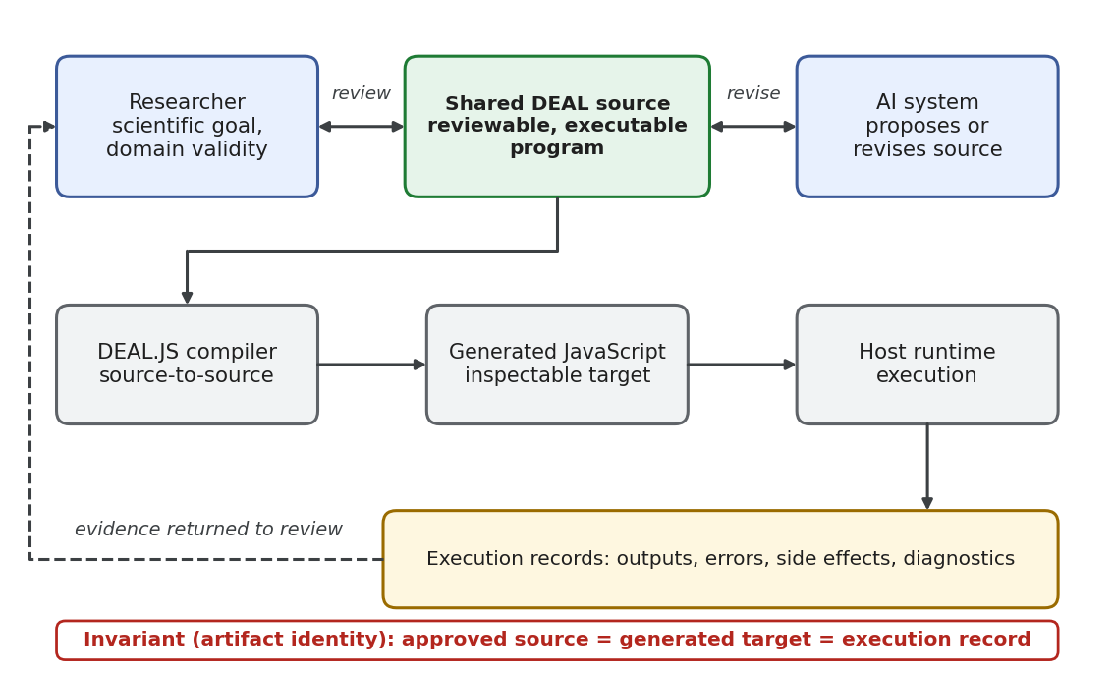
Figure 1. Shared executable representation linking researcher intent, AI-assisted revision, and target execution. The review loop preserves the connection between the approved program and its operational interpretation. AI assistance: Perplexity Computer (GPT 6.1 Sol), SVG-code preparation.

Objectives and requirements
The language design follows seven objectives: reviewable intent, precise execution, incremental adoption, domain reuse, adaptable vocabulary, reproducibility, and cross-language reuse of the core model. Table 1 maps each objective to its structural mechanism and evaluation criterion, which keeps implemented features distinct from empirical utility.
Table 1. Design objectives, corresponding mechanisms, and evaluation criteria.
Objective | DEAL design response | Criterion for evaluation
Reviewable research intent | Domain commands and explicit control structures | Correct comprehension and detection of seeded semantic errors
Precise execution | Constrained grammar and target-source generation | Agreement with independently specified observable behavior
Incremental adoption | Ordinary JavaScript alongside DEAL instructions | Completion of mixed-source tasks without unnecessary rewrites
Reusable domain knowledge | Commands and importable modules | Reuse across tasks with documented input/output contracts
Adaptable human vocabulary | Replacement reserves and optional readability words | Semantic equivalence across vocabulary configurations
Research reproducibility | Executable workflow plus versioned inputs and dependencies | Re-execution from archived materials with matching relevant outputs
Cross-language reuse of the model | Separation of language concepts from backend implementation | Equivalent behavior on a declared portable subset
Reproducible computational research requires careful recording of inputs, program versions, parameters, and intermediate outputs [15, 16]; executable workflow descriptions reduce the divergence between written documentation and actual execution. The FAIR principles likewise emphasize interoperability, explicit vocabularies, provenance, and reuse by both humans and machines [17]. DEAL provides a common representation that supports these goals, but a language alone cannot replace a provenance system or confer FAIR compliance.

Related work and comparative positioning

Controlled language and programming accessibility
Controlled natural languages constrain vocabulary and grammar to balance human accessibility with formal precision [9]. DEAL applies this idea to research programming: familiar terms form precise structural constructions instead of leaving interpretation to a language model at run time. Users work with a defined programming language whose domain vocabulary can grow without altering its core.
Syntax is a legitimate design choice, but it does not by itself guarantee usability. Stefik and Siebert reported empirical differences in novice performance across programming syntaxes and argued for evidence-based rather than tradition-based language design [18]. A later replication indicated that some familiar keywords are intuitive, but that intuitive wording does not make general programming effortless [19]. The readability of DEAL should therefore be measured through comprehension and editing tasks and not inferred from familiar terminology.
The Cognitive Dimensions framework identifies closeness of mapping, hidden dependencies, diffuseness, and error-proneness as key dimensions of notation design [20]. These dimensions expose a trade-off in DEAL: a domain command shortens the distance between a scientific concept and its implementation, whereas contextual state can obscure dependencies. Vocabulary adaptation must therefore preserve clear paths to canonical operations and their formal contracts.
A systematic review of programmers’ mental models links program comprehension to information needs, available evidence, prior knowledge, mental simulation, and behavioral reasoning [21]. This supports our emphasis on whether a reviewer forms an accurate behavioral model of a DEAL program, rather than on whether its keywords sound conversational.
SmellDSL provides a methodological precedent by examining specification effort, correctness, and error rates for a domain-specific notation [22]. For DEAL, the analogous measures concern how accurately researchers comprehend and refine data workflows, which places the work within empirical software-engineering evaluation.

English-like scripting and extensible languages
_hyperscript is a close comparator: it combines English-like, HyperTalk-inspired syntax with first-class DOM selectors, transparent asynchrony, and JavaScript extensibility [23, 24]. Its collection loops, fetching mechanics, and JavaScript interoperability show that readable web interaction is an established design direction. The distinctive contribution of DEAL is a shared research-program artifact centered on explicit target-source generation and fine-grained vocabulary configuration, not a new set of English-like web commands.
LiveCode is another precedent for command-oriented programming with explicit block structures [25]. Its repeat for each construct handles text chunks, array elements, and array keys, which illustrates why readability must be assessed at the level of data representation and task semantics: iterating over comma-delimited text and traversing a structured array are different operations.
SugarJ explores a different design space: imported sugar libraries add grammar productions and desugaring rules that compose syntactic extensions within a host language [26]. DEAL’s RESERVE mechanism is a lighter vocabulary-adaptation strategy for an established structural language. The comparison concerns lightweight extension boundaries and low implementation overhead; it does not claim that lexical aliases match the expressive power of arbitrary grammar rewriting.

Web extraction and executable AI reasoning
WebL established web-document processing as a first-class language task by combining service combinators for retrieval with a markup algebra for extraction and manipulation [27]. Ferrara et al. survey the broader landscape of web data extraction techniques and their reuse across domains [28]. Web scraping therefore serves here as a demanding application domain that exercises DEAL’s integration capabilities; it is not claimed as a novel extraction contribution.
PAL offers an important human–AI precedent: a language model generates a program and a conventional interpreter executes it [29]. PICARD and grammar-constrained decoding show how formal syntactic restrictions can steer language-model output toward structurally valid representations [30, 31]. DEAL is a suitable target representation for such approaches, but we do not assume that foundation models generate DEAL more accurately than conventional languages.
Trust in AI-written software also depends on the interplay between human oversight and validation evidence. A recent single-case preprint examines these dynamics and highlights practical limits of supervision [32]; because it is a preprint, we treat it as illustrative rather than as established evidence. DEAL contributes a representational building block: an explicit program against which both human intent and machine behavior can be verified.

Limitations addressed by the integrated design
Existing languages address different fragments of the software-engineering problem. General-purpose languages offer mature ecosystems and expressive power; English-like scripting languages prioritize readability; extensible languages permit custom syntax; and extraction languages specialize in web operations. Table 2 summarizes the integration problem addressed by DEAL, which combines structural notation, domain commands, adaptable vocabulary, and JavaScript interoperability.
Table 2. Established approaches and the integration problem addressed by DEAL.
Approach | Established strength | Work otherwise left to the user | DEAL response
JavaScript | Target-language execution and rich host integration | Organize low-level operations into a research-facing review vocabulary | Layer domain commands over inspectable target code
Python | Direct sequence iteration and conventional program structure | Coordinate library-specific APIs and distinguish workflow intent from implementation detail | Offer a common command-oriented orchestration surface
_hyperscript | English-like web scripting, selectors, async transparency | Establish research-specific data contracts and provenance conventions | Emphasize a versioned research program and generated target artifact
LiveCode | Human-oriented commands and chunk/array operations | Reconcile its execution and data model with a JavaScript-oriented environment | Preserve a mixed-JavaScript adoption path
SugarJ | Composable syntax extensions and desugaring | Engineer grammar extensions when only vocabulary adaptation is required | Separate lightweight vocabulary changes from structural grammar changes
WebL | Integrated web retrieval and markup processing | Connect extraction notation to a broader human–AI review and localization workflow | Treat extraction as one reusable domain module
The contribution is architectural. We do not claim that earlier languages lacked readability or modularity; JavaScript and Python remain powerful because equivalent domain libraries can be built in either [33]. The evaluation methodology is therefore designed to isolate the cognitive and operational effects attributable to DEAL’s representation.

Research design and analytical framework
This study follows a design-science paradigm [34, 35], linking a concrete research-programming problem to a language artifact, its design rationale, and an illustrative application. The unit of analysis is the executable workflow: a program in which domain operations, control flow, data decisions, and side effects can be audited together. The analysis separates properties of the representation from behavioral outcomes that require empirical or comparative experiments. The worked application is reported with the transparency expected of software-engineering case studies [36], that is, with explicit inputs, rules, and outputs, but it is a synthetic demonstration and not an empirical field study.
The primary artifact is a working JavaScript-targeting language implementation; this article examines its design principles and application mechanics and does not present a speculative roadmap. The analytical component addresses three relationships: translating domain intent into explicit program structure, mapping vocabulary variants to canonical operations, and converting program structure into target-language execution. Compilation determinism and semantic preservation are formalized as contracts over source text, vocabulary configuration, dependencies, execution environment, and runtime observations.
The application component uses a synthetic catalog to demonstrate composition from retrieval to persistent storage. Five records exercise a valid transformation, a duplicate identifier, a missing numeric value, a boundary value of zero, and an invalid discount. Functional validation comprises 19 assertions covering preprocessing, serialization, provenance metadata, a document-shaped test double, and an in-memory storage connector. All assertions were executed under Node.js 20.20.2. Compiler execution time, live web-extraction accuracy, and human performance were intentionally excluded from this experiment.
The case-study helper and test harness were prepared with assistance from Perplexity Computer (GPT 6.1 Sol). All inputs, rules, code snippets, and recorded outputs accompany this article to support independent verification and replication. Broader validation requirements are set out in the evaluation framework.

Language design and syntax

Design principles
Five principles guide the language design: intent-oriented abstraction, explicit compilation, hybrid interoperability, modular extensibility, and reusable operations. They distribute review responsibilities rather than promise a universally effortless notation. A domain expert must inspect the scientific validity of an operation and its data policy; a language implementer must ensure semantic preservation; and a host integrator must supply the required runtime resources.
Despite the word “declarative” in its name, DEAL.JS supports sequencing, loops, assignment, and native JavaScript in the same source file. Intent-oriented commands hide incidental mechanics, but they do not eliminate program state or control flow. Likewise, automatic source generation does not by itself guarantee performance, security, or logical correctness.

The four-part language model
DEAL is organized around four concepts, structures, commands, reserves, and handlers, with conventional JavaScript accessible alongside them. Structures define computation and control flow, commands encapsulate domain operations, reserves adapt human vocabulary, and handlers give contextual access to the active workspace. Table 3 summarizes the constructs most relevant to research automation.
Table 3. Core language mechanisms and representative syntax.
Mechanism | Representative syntax | Computational role
Declaration | ASSUME CONST threshold IS 10; | Bind a constant; alternative forms select let or var
Branching | IF condition, procedure; ELSE procedure; | Make conditional logic explicit
Iteration | FOR EACH item OF items, procedure; | Iterate over collection items (IN denotes distinct behavior)
Conditional repetition | WHILE condition, procedure; | Repeat while a condition holds (do ... while available in JS)
Grouping | BEGIN ... END; or DO ... END; | Delimit a procedure block
Callable block | DOING ... END; | Represent an encapsulated, reusable computation block
Failure handling | TRY ... CATCH err, ... FINALLY ...; | Separate normal execution, error recovery, and cleanup
Continuations | THEN, OTHERWISE, ANYWAY | Express success, rejection, and finalization paths
Promise construction | WILL procedure THEN procedure; | Introduce a promise-oriented asynchronous computation
Function command | COMMAND clean(value = "") { ... } | Register a reusable custom operation
Definition command | COMMAND settings = { ... }; | Register a reusable value or configuration object
Action command | # task BEGIN ... END; | Define and immediately execute a repeatable action
Delegation | const #dataset = value; | Register a case-adapted identifier
Vocabulary replacement | RESERVE into AS ","; | Map human vocabulary to a canonical token sequence
Readability word | RESERVE the; | Admit stylistic words with zero computational overhead
Module inclusion | USE scraper; | Import domain vocabulary and implementation modules
Collection operators | WHERE, ORDER BY, LIMIT | Perform filtering, sorting, and range restriction
Context handlers | DOCUMENT, RESPONSE, LOADED, FETCHED, ITS | Reference the active workspace or current operation
Table 3 lists the principal syntactic forms. A complete normative grammar must also define operator precedence, name resolution, argument binding, scoping, error states, and the observable contract of every library command; for research use, these formal contracts matter as much as surface readability.
Readable operators include BE for assignment, IS for equality, EQUALS for strict equality, and logical connectives such as AND and OR, with context-sensitive interpretation inside declarations. Domain vocabulary can also express data projection and collection building through operations such as SELECT and COLLECT. Familiar wording never replaces a strict operator contract, however: type coercion, field naming, missing-value handling, and argument order remain consequential computational decisions.

Explicit declarations and ordinary source
The ASSUME construction makes binding intent explicit: CONST declares a constant, VAR selects a traditional variable declaration, and LET (or an omitted modifier) establishes a block-scoped lexical binding. Listing 1 pairs the DEAL syntax with its JavaScript translation and shows that readable declarations retain the semantics of the target language.

Code snippet
ASSUME CONST threshold IS 10;
ASSUME VAR attempts IS EQUAL 0;
ASSUME LET accepted BE [];
ASSUME completed EQUALS false;

JavaScript
const threshold = 10;
var attempts = 0;
let accepted = [];
let completed = false;
Listing 1. Explicit declarations make binding intent visible while retaining conventional JavaScript declarations as an alternative. The keyword ASSUME denotes a binding construction here; it is not a probabilistic assertion or a formal proof assumption.
Hybrid source files serve as an adoption bridge. A researcher can use high-level domain commands for routine orchestration and leave complex mathematical expressions or specialized object manipulation in native JavaScript. The aim is not to express every operator in prose but to draw a sensible abstraction boundary between scientific intent and implementation mechanics.

Commands and document-like notation
Commands support actions, functions, definitions, and delegated identifiers, and they can be invoked in a functional or a sentence-like style. Listing 2 shows a research-specific normalization command. The computation inside the reusable command remains standard JavaScript, which separates implementation logic from the domain name used in the workflow.

Code snippet
COMMAND cleanTitle(value = "") {
return String(value).normalize("NFKC")
.replace(/\s+/gu, " ").trim();
}
ASSUME CONST title IS cleanTitle(" Alpha study ");
Listing 2. An author-defined command exposing a clearly named preprocessing operation. The example’s contract is Unicode NFKC normalization, whitespace collapse, and trimming; the name alone is not the specification.
Document-like notation admits selected Markdown-style list markers and emphasis conventions, and heading-like action definitions execute when they are defined. Procedures can thus combine a navigable human presentation with an executable structure. Because an executable heading denotes an action, however, tooling must clearly distinguish actions, comments, declarations, and raw data.
Case-sensitivity rules are likewise selective. Documented language vocabulary is case-adapted, ordinary user identifiers remain case-sensitive unless explicitly registered, and property names after a dot keep their native spelling rules. A predictable programming interface therefore depends on disciplined identifier conventions and not on the assumption that the whole language is case-insensitive.

Compiler architecture and execution model

Configured compilation pipeline
The DEAL.JS compiler is implemented in C# and performs a five-stage source-to-source transformation: tokenization, preprocessing, parsing, assembly, and code generation [8, 37, 38]. It builds on a JavaScript-oriented engine framework in which a generic orchestration layer manages stage transformations and delegates execution to a configurable host [39, 40]. Figure 2 shows how these responsibilities connect without conflating compilation with execution.
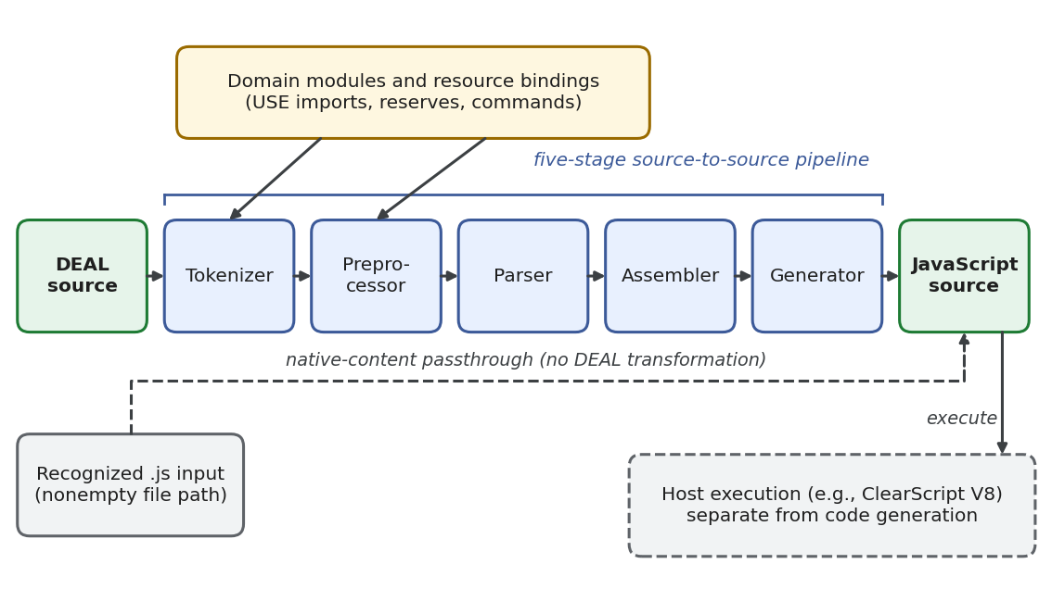
Figure 2. DEAL.JS compilation and execution architecture. DEAL source enters the five-stage transformation pipeline; recognized .js inputs follow the native-content passthrough branch. Domain modules and resource bindings support compilation and host execution, while execution remains distinct from generating JavaScript. AI assistance: Perplexity Computer (GPT 6.1 Sol), SVG-code preparation.
The tokenizer recognizes source elements and vocabulary adaptations, including module imports and reserve mappings, and the preprocessor provides a designated token-processing hook. The parser classifies tokens into abstract nodes such as declarations and block structures; the assembler constructs and lowers their hierarchy; and JavaScript code generation is inherited from the language’s generator extensions. The pipeline is a purely source-to-source transformation and involves no neural translation inside the compiler.
JavaScript interoperability follows two paths. Mixed DEAL/JavaScript programs pass through the full pipeline, whereas any input identified by a nonempty .js file path bypasses it and is returned without DEAL transformation [41]. Existing JavaScript libraries and modules can therefore be reused without rewriting them in DEAL notation.

Representations and stage contracts
The stage interface accepts and returns object representations; each stage interprets its input as a token stream, an AST node collection, a program structure, or source text. Table 4 relates these transitions to semantic-preservation requirements. The contracts describe stage responsibilities and are not enforced by a static pipeline type system.
Table 4. Compilation stages, intermediate representations, and semantic preservation requirements.
Stage | Representation transition | Review obligation
Tokenizer | Source text to positioned tokens | Preserve literals and distinguish vocabulary from user identifiers
Preprocessor | Tokens to a token array; default token processing is pass-through | Make any configured rewrite explicit
Parser | Tokens to locally classified nodes | Preserve statement categories and declaration intent
Assembler | Nodes to a hierarchical, node-derived program | Preserve grouping, scope, and continuation attachment
Generator | Program structure to JavaScript source | Preserve operations and expose inspectable target code
Executor | Generated source to host-defined results and effects | Check permissions, effects, failures, and completion
Tokens carry type, value, and position metadata, whereas AST nodes add child references, parent links, and structural flags; dedicated AST walkers support traversal across these representations. These structures provide attachment points for future source-linked explanations and code instrumentation. Their presence does not, however, imply that complete source maps or diagnostic-location accuracy have been validated.

Modules, commands, and runtime boundaries
The runtime maintains active command dictionaries and reserve mappings, and USE statements resolve dependency resources through the language and engine infrastructure. A domain module thus bundles human vocabulary with concrete implementation resources, and reproducibility requires recording exact module versions together with execution order and environment.
Compilation and execution are strictly separate responsibilities. A ClearScript V8 host is one execution environment: it exposes the engine and selected host facilities [42], and the execution-stage interface also admits alternative hosts. Reusing generated JavaScript requires compatible host APIs and dependencies, whether in a browser, in Node.js, or in an embedded runtime.
The local-resource module exposes file, folder, save, append, prepend, delete, and existence-check operations through a standardized resource provider [43]. Its local.save(object, path) operation delegates to the host’s SetFileContents(path, object) interface. Stating this argument contract explicitly keeps data flow transparent across the language–host boundary.
Module resolution maps extensionless names to .deal, .djs, or .js resources; directory-based modules may resolve through an index or by traversing directory entries. Unregistered resources are compiled and executed before their inclusion is recorded as a successful dependency. Figure 3 shows the successful dependency-loading paths and the difference between first load and subsequent reuse.
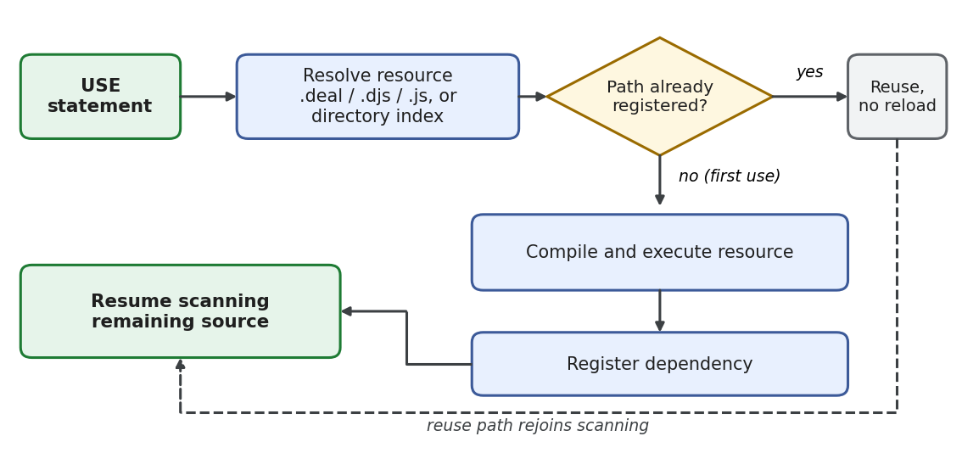
Figure 3. Successful dependency-loading paths after resource resolution. A previously registered path avoids re-loading; first use passes through compilation and execution before dependency registration and resumed scanning. AI assistance: Perplexity Computer (GPT 6.1 Sol), SVG-code preparation.
Because imported modules can introduce side effects as well as custom vocabulary, module loading lies within the research trust boundary. Reproducible deployment therefore requires identifiable dependency versions, explicit host bindings, and controlled resource access. Moreover, because the ClearScript host exposes powerful .NET capabilities, isolation and permission policies must be enforced by the deployment environment and cannot be inferred from readable syntax.
The generic diagnostic model tracks identifiers, severity levels, source ranges, and diagnostic codes, while Output.Errors records error strings and orchestration engines emit log events. These channels should not be mistaken for a validated end-to-end automated-repair interface. Future AI-repair experiments must record the exact diagnostic payloads received by the model and measure whether the resulting repairs satisfy an independent oracle.

Determinism, preservation, and reproducibility
We formalize compilation determinism with the analytical function:

$C_{b}(s,v,m,o,σ_{0})=j_{b},(1)$

where $s$ denotes the source text, $v$ the vocabulary configuration, $m$ the ordered module versions and contents, $o$ the compiler settings, $σ_{0}$ the initial compilation state, and $b$ the target backend. Together, these terms define the compilation context $κ$. The determinism contract guarantees identical target output for identical source code and context, including any influential module-initialization inputs; it does not require external data sources or randomized analyses to remain static across runs.
Translation correctness requires an additional empirical relation:

$Obs(Exec_{b}(C_{b}(s,κ),e))=Spec(s,e),(2)$

where $e$ identifies the controlled execution environment, and the observations include outputs, errors, persistent file modifications, and relevant event order. The right-hand side must originate from an independent specification or oracle: agreement with a compiler’s own generated output is never sufficient as a correctness criterion.
Full research reproducibility extends this record to input-data snapshots, runtime and module versions, external API responses, random-number seeds, locale settings, and permission scopes, consistent with recommendations to archive complete computational workflows and their influential settings [15, 16]. DEAL contributes a reviewable program to that archive; it does not exempt a study from recording its operational environment.

Worked application: web retrieval to research-ready storage

Task and data model
Consider a research workflow that monitors a structured catalog. The workflow retrieves a web page or API response, extracts records, normalizes text fields, computes a derived variable, validates data constraints, discards duplicate identifiers, and stores accepted records separately from rejection reasons. DEAL.JS unifies retrieval, selection, transformation, and output under one orchestration surface. The complete application has the compositional form:

$W(u)=SQNXA(u),(3)$

where $A$ acquires the source URL $u$, $X$ extracts raw fields, $N$ normalizes the data and derives variables, $Q$ validates constraints and removes duplicates, and $S$ serializes and stores the outputs. The output retains both the accepted records and an explicit rejection log. This modular decomposition keeps domain policies visible and allows the acquisition and storage implementations to be replaced independently.
The demonstration uses five synthetic records designed to test specific data policies. A valid record requires a nonempty identifier and title, a finite nonnegative main price, a finite discount in $[0,1]$, and a nonnegative integer quantity. The derived net price is:

$p_{net}=round_{2}(p_{main}(1-d)).(4)$

Missing numeric values are rejected rather than silently coerced to zero. Duplicate handling retains the first valid occurrence of an identifier, so that an invalid row never blocks a later valid row with the same identifier. Applying Equation (4), record p1 receives a net price of round2(100 × 0.90) = 90.00, and record p2 receives a net price of 0.00 because its main price is zero.
Table 5. Input conditions and expected outcomes in the synthetic catalog.
Input record | Main price | Discount | Quantity | Required outcome
$p_{1}$, padded title Alpha study | 100 | 0.10 | 2 | Accept; normalized title; net price 90.00
Duplicate $p_{1}$ | 100 | 0.10 | 2 | Reject as duplicate
$p_{2}$, full-width initial character in Ｂeta study | 0 | 0 | 0 | Accept as Beta study; preserve zero price and quantity; net price 0.00
$p_{3}$, missing main price | Missing | 0 | 1 | Reject as invalid
$p_{4}$, discount outside permitted interval | 10 | 1.25 | 1 | Reject as invalid
Figure 4 outlines the five responsibilities. Retrieval may shift between an API client and a browser adapter, but the normalization, validation, and storage contracts remain invariant. This separation supports scientific review: researchers can inspect both what data were acquired and how records were transformed or excluded.
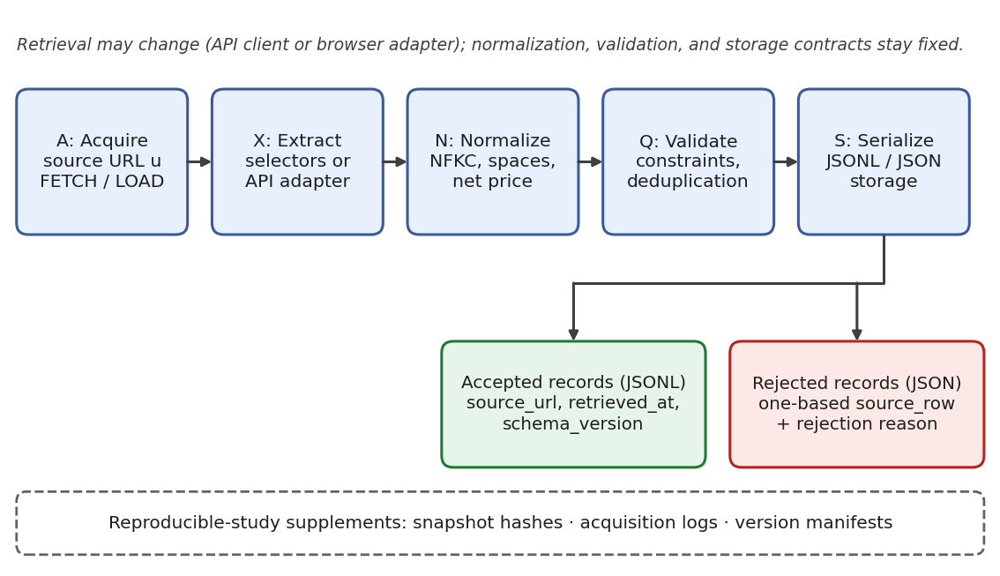
Figure 4. Research-data workflow expressed through DEAL orchestration and reusable implementations. Accepted records retain provenance fields and rejected records retain source-row identifiers and reasons. Snapshot hashes, acquisition logs, and version manifests supplement the pipeline when it is used in a reproducible study. AI assistance: Perplexity Computer (GPT 6.1 Sol), SVG-code preparation.

Acquisition and extraction
The scraper vocabulary includes FETCH for HTTP request/response interactions, LOAD for loading a page into the active context, selectors such as ALL, and the contextual identifiers DOCUMENT, RESPONSE, LOADED, and FETCHED. Listing 3 expresses retrieval, selection, and output in one sequence; the source and destination parameters identify the acquisition targets and the output file.

Code snippet
USE deal;
USE scraper;
FOR EACH url OF sources,
LOAD url,
THEN APPEND ALL "h3.title", TO destination;
Listing 3. Retrieval, title selection, and output through the load-select-append idiom. A multi-source workflow additionally requires an explicit completion and context-isolation policy.
For structured extraction, an author-defined JavaScript helper receives a document and a source identifier explicitly. It selects table.catalog tbody tr, reads each row’s data-id, and extracts the .title, .price, .discount, and .quantity fields. This avoids embedding contextual handlers in the normalization logic and keeps DOM selectors separate from scientific data-processing rules.
An API-first variant should convert incoming responses into a standardized plain-record schema before normalization. With standard JavaScript Response objects, JSON parsing is asynchronous and must be awaited or returned within a promise chain; explicit promise chaining and aggregation define clear completion boundaries [44]. API-based and DOM-based extraction are interchangeable only once their adapters satisfy a common input schema, not merely because they target the same web page.

Preprocessing, processing, and persistence
Listing 4 composes the end-to-end single-page workflow. Domain-specific functions extract raw records, enforce the data contract, and serialize accepted output, while the cleanRecords command encapsulates normalization as a reusable DEAL command. Persistence uses the local resource module, which keeps storage side effects explicit at the orchestration level.

Code snippet
USE deal;
USE scraper;
USE deal/data/local;
USE "./deal-case-helpers.js";
COMMAND cleanRecords(rows = [], source = "", time = "") {
return normalizeRecords(rows, source, time);
}
ASSUME CONST sourceURL IS "https://example.org/catalog";
ASSUME CONST destination IS "results/catalog.jsonl";
LOAD sourceURL,
THEN BEGIN
ASSUME CONST capturedAt IS new Date().toISOString();
ASSUME CONST rawRows IS extractRows(DOCUMENT, sourceURL);
ASSUME CONST report IS cleanRecords(rawRows, sourceURL, capturedAt);
local.save(toJSONL(report.accepted), destination);
local.save(JSON.stringify(report.rejected), "results/rejected.json");
END;
OTHERWISE BEGIN
throw new Error("Retrieval failed: " + sourceURL);
END;
Listing 4. DEAL.JS orchestration for acquisition, normalization, validation, and storage. The domain functions are defined for the case study; example.org represents a configurable endpoint rather than a measured acquisition source.
Our helper decouples validation from duplicate detection and registers an identifier as seen only after validation succeeds. An invalid early record therefore cannot prevent the acceptance of a later valid record that shares its identifier. Unicode normalization, whitespace collapse, interval checks, numeric-finiteness checks, and integer-quantity rules constitute transparent operational policies that domain researchers can audit independently of the orchestration script.
Accepted records are written as JSON Lines and rejection logs as a separate JSON file. Each accepted record carries source_url, retrieved_at, and schema_version metadata; a rigorous research run should additionally archive raw response payloads, cryptographic content hashes, module manifests, compiler versions, and permission scopes. These practices operationalize the provenance and reuse principles of the FAIR guidelines [17].
Persistence can also be decoupled from document manipulation through a connector interface: the JavaScript ChainDoc layer supports connector-based storage and row- or line-level access. The case-validation experiment uses an in-memory connector to isolate serialization and storage behavior from file-system and network variability.

Data contracts and rejection semantics
Table 6 specifies the preprocessing and storage rules of the application. These rules belong to the domain contract rather than to the language grammar, so researchers can review them independently of the web pages or APIs that supply the raw data.
Table 6. Accepted-record schema and rejection policy for the synthetic case.
Field or decision | Contract | Rationale or limitation
id, title | Trim identifier; normalize title with NFKC and collapsed whitespace; require both | Full-width characters normalize; identifier case is preserved
main_price, discount | Finite price at least zero; finite discount in [0, 1] | Missing/blank values are invalid, never silently coerced to zero
quantity, net_price | Nonnegative safe-integer quantity; net price rounded to two decimal places | Valid zeros survive; rounding is an explicit case policy
Duplicate detection | Retain the first valid record per identifier | Invalid records do not consume or reserve an identifier
Provenance | source_url, retrieved_at, schema_version on accepted rows | Fixture timestamp is synthetic and does not record a live retrieval event
Rejected records | One-based source_row and rejection reason | Compact rejection log; raw inputs require separate archiving
Figure 5 shows the ordering required for duplicate handling: validation must precede insertion into the seen-identifier set, because reversing the steps would corrupt behavior. Raw input snapshots must also be retained separately, since compact rejection logs cannot reconstruct excluded source data.
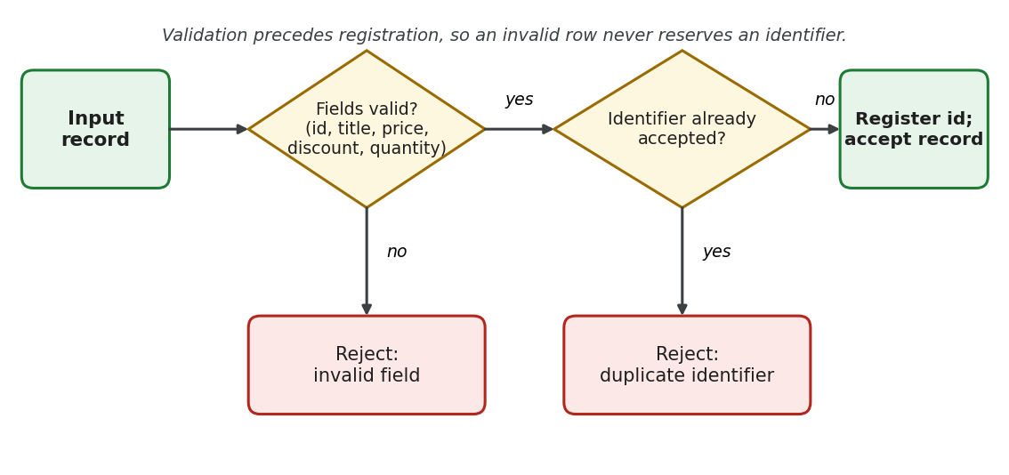
Figure 5. Record validation in the application data contract. Invalid fields or a previously accepted identifier cause rejection; otherwise, the identifier is registered and the record enters the accepted output. Validation therefore precedes duplicate registration. AI assistance: Perplexity Computer (GPT 6.1 Sol), SVG-code preparation.

Completion and failure policy
Asynchronous readability must not obscure ordering requirements. DEAL’s continuation suffixes map directly to JavaScript promise methods [44], so success and failure paths are evaluated in terms of promise completion and not of assumed multithreading. A run is complete only when retrieval, normalization, and all mandatory persistence operations have finished successfully.
The single-page example avoids concurrent mutation of the DOCUMENT context. Multi-page workflows must either process pages sequentially or provide isolated document contexts and aggregate all returned promises. Research protocols should additionally define bounded retry limits, timeouts, error-propagation rules, partial-output handling, and stable identifiers for reruns; logging a success message after launching unmonitored asynchronous requests is never an adequate completion criterion.

Comparative examples and contribution analysis

Matched collection task
Listing 5 compares a standard task across four notations: iterating in order over a three-value collection. DEAL expresses the loop with readable structural keywords, JavaScript and Python use native iteration constructs [33], and _hyperscript uses an English-like collection loop [24]. The comparison isolates representational style while holding computational intent constant.

Code snippet
// DEAL.JS
ASSUME CONST values IS [1, 2, 3];
FOR EACH value OF values, BEGIN
console.log(value);
END;

JavaScript
// JavaScript
const values = [1, 2, 3];
for (const value of values) {
console.log(value);
}

Python
# Python
values = [1, 2, 3]
for value in values:
print(value)

Code snippet
-- _hyperscript
repeat for value in [1, 2, 3]
log value
end
Listing 5. Equivalent iteration intent across four notations. The DEAL form exposes declaration and iteration using readable keywords, but the Python and _hyperscript forms also show that readability is not unique to DEAL.
LiveCode’s corresponding text-container example uses repeat for each item value in values ... end repeat and operates on comma-delimited strings rather than native JavaScript arrays [25]. Such representational differences must be controlled in empirical studies: a fair task comparison aligns the underlying operations and data semantics and not merely the surface appearance.

Extension mechanisms and web computation
Listing 6 shows why SugarJ is an architectural rather than a purely stylistic comparator [26]. An imported sugar library introduces custom pair types and expressions that desugar into standard Java representations, whereas DEAL’s replacement reserves only adapt human vocabulary to express existing computational structures.

Java
// SugarJ
import pair.Sugar;
public class Test {
private (String, Integer) p = ("12", 34);
}

Code snippet
// DEAL.JS Vocabulary Adaptation
RESERVE every AS "for";
RESERVE the;
every item OF the values, console.log(item);
Listing 6. Two distinct extension levels: grammar/desugaring extension in SugarJ and vocabulary adaptation in DEAL. The comparison supports a lightweight-extension design choice, not a claim of equivalent extensibility.
WebL pioneered integrated page retrieval, element operations, and a markup algebra for web-document processing [27]. Listing 7 places WebL’s page/element abstraction beside DEAL’s load-and-select idiom. Both select third-level heading elements; they differ mainly in the language abstractions used to manage documents and outputs.

Code snippet
// WebL-style notation
page := getpage("https://example.org/catalog");
titles := page.Elem("H3");

Code snippet
// DEAL.JS orchestration idiom
LOAD "https://example.org/catalog",
THEN APPEND ALL "h3", TO destination;
Listing 7. Heading-element selection in WebL-style notation and DEAL.JS. The examples align element-selection intent while retaining their respective document and output models.

Innovation and field-level contribution
The central innovation is an integrated communication architecture with explicit extension boundaries. A shared source artifact makes AI-generated proposals editable and reviewable; domain commands encapsulate reusable scientific operations; and mixed-source interoperability supports gradual adoption alongside existing JavaScript code. Together, these mechanisms narrow the gap between a researcher’s scientific description of a method and the software that executes it.
A further contribution is the separation of conceptual operations, human-facing vocabulary, and target implementation technology. A domain module can maintain its operational contract while researchers use different terminology, and the DEAL model can guide implementations in other programming languages. Research workflows thereby become inspectable review objects in which data acquisition, exclusion, transformation, and persistence decisions remain tied to a single source representation.
DEAL.JS realizes these mechanisms in a working language and compiler. Its scientific value rests on the integrated representation and its formal contracts, not on any individual keyword, scraper operation, or translation technique. The evaluation framework tests both the correctness of the representation and its practical utility for human users.

Multilingual vocabulary and implementation in other languages

Vocabulary localization without changing the task
Vocabulary modules allow alternative human-language expressions to denote identical computational operations. This mechanism targets the barriers associated with English-language dominance in programming, including communication friction and the cognitive load of English keywords [45]. Localization should nevertheless remain user-selectable: a replication study with Finnish participants who had strong English skills found limited effects of native-language keywords [19], so benefits cannot be assumed to be uniform across populations.
Listing 8 illustrates Spanish and French surface forms built from replacement reserves and readability words. User identifiers and logging calls are left untouched, which isolates vocabulary adaptation from core computation. The fragments demonstrate the mechanism and are not validated locale packages.

Code snippet
// Spanish vocabulary fragment
RESERVE para AS "for";
RESERVE cada;
RESERVE de AS "of";
para cada value de values, console.log(value);

Code snippet
// French vocabulary fragment
RESERVE pour AS "for";
RESERVE chaque;
RESERVE de AS "of";
pour chaque value de values, console.log(value);
Listing 8. Two localized surfaces for the same canonical iteration. These fragments are alternatives and should be loaded as separate locale configurations rather than indiscriminately mixed.
Let N_{ℓ} map source text written in vocabulary ℓ into canonical DEAL source. Vocabulary equivalence holds when:

$N_{es}(s_{es})=N_{fr}(s_{fr})=s_{c}.(5)$

For a fixed canonical compilation context, identically normalized inputs yield identical target artifacts. This separates localization from execution semantics: an alias module must preserve canonical meaning and not merely supply a literal translation.
A complete localization design must also protect string literals and identifiers, manage Unicode collisions and case behavior, document phrase boundaries, and emit intelligible diagnostic messages. Translation must preserve the scientific task rather than render every token literally. Native-speaker review, bilingual examples, and equivalence testing are needed to determine whether localized commands assist a given researcher community.

Reimplementation and target-language portability
The DEAL model supports two forms of reuse. A language implementer can replicate its structures, commands, vocabulary rules, and contextual interfaces in another host language such as Python, Java, or Rust. Independently, a compiler implementer can build a backend that translates a supported DEAL subset into another target language. DEAL.JS is the concrete JavaScript realization; the model and its semantic contracts define what any alternative realization must preserve.
The configurable compilation and execution stages provide architectural reuse points, while DEAL.JS supplies the JavaScript-oriented translation behavior. Figure 6 separates vocabulary normalization, canonical structure, and target realization. The JavaScript backend is fully implemented; extending DEAL to further target languages is a separate development path.
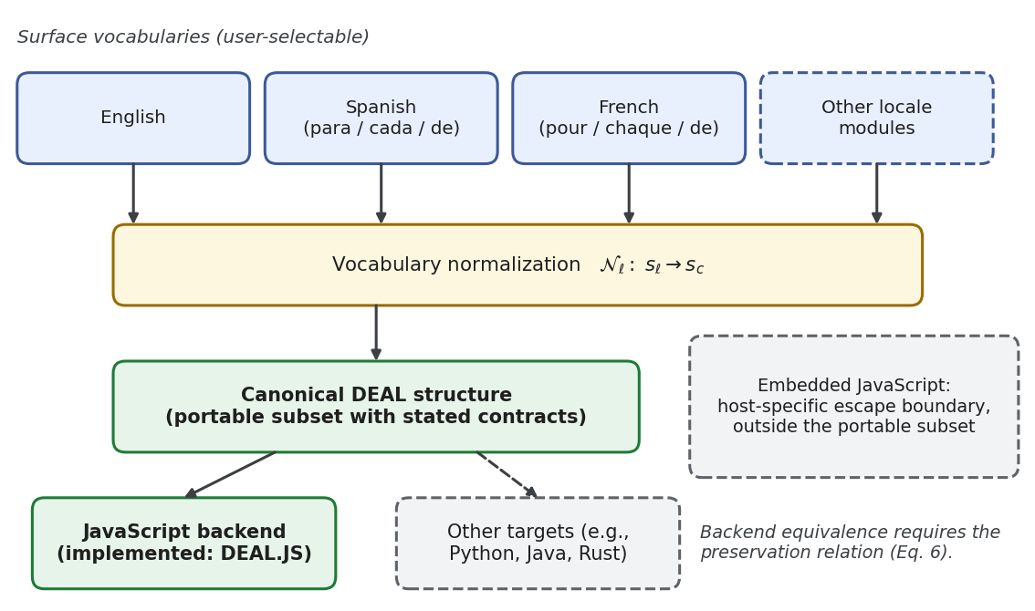
Figure 6. Separation of vocabulary adaptation, canonical language structure, and backend realization. The current concrete target is JavaScript. Other targets require explicit semantic mappings and should reject or isolate embedded JavaScript outside the portable subset. AI assistance: Perplexity Computer (GPT 6.1 Sol), SVG-code preparation.
For any portable program $p$, the cross-backend preservation condition is:

$Obs(Exec_{a}(C_{a}(p),e_{a}))=Obs(Exec_{b}(C_{b}(p),e_{b})).(6)$

Execution environments and observation definitions must be strictly aligned. Numeric precision, string handling, missing-value semantics, event ordering, exception handling, asynchronous effects, and storage encodings are all part of this contract. A backend-neutral subset keeps these obligations tractable, whereas arbitrary embedded JavaScript remains a host-specific escape boundary.
This separation contributes to software language engineering: a domain operation such as normalization can keep a stable, documented contract while its vocabulary and runtime implementation evolve. It also clarifies the limits of unrestricted host interoperability, since a program containing arbitrary native JavaScript cannot be ported automatically to a backend whose host language differs.

Testing strategy and evaluation methodology
The testing strategy separates implementation behavior from collaborative utility. Language conformance addresses translation and execution correctness, application correctness addresses the research data contract, and utility measures how effectively humans or AI systems construct and review workflows. The executed results concern the synthetic catalog’s data contract; the broader protocols define the evidence required for future comparative claims.

Language conformance and regression
Conformance testing links source constructions to independently specified observations. DEAL-specific, native JavaScript, and mixed-source stress cases exercise core structures, custom commands, expressions, nesting depth, and execution continuations. Table 7 organizes these categories by test construction and semantic oracle. Successful translation is judged against specified operational effects and not by surface resemblance to a stored target file.
Table 7. Conformance categories, test constructions, and semantic oracles.
Language feature | Test construction | Semantic oracle
Core structures | Isolated declarations, branches, loops, and exception paths | Expected bindings, outputs, termination, and error states
Embedded JavaScript | Matched native and mixed-source programs | Agreement with specified JavaScript execution behavior
Nested control flow | Combinations of blocks, scopes, and continuations | Binding visibility, effect order, and completion guarantees
Commands and vocabulary | Reusable operations, aliases, and readability words | Stable operation contracts and equivalent canonical meaning
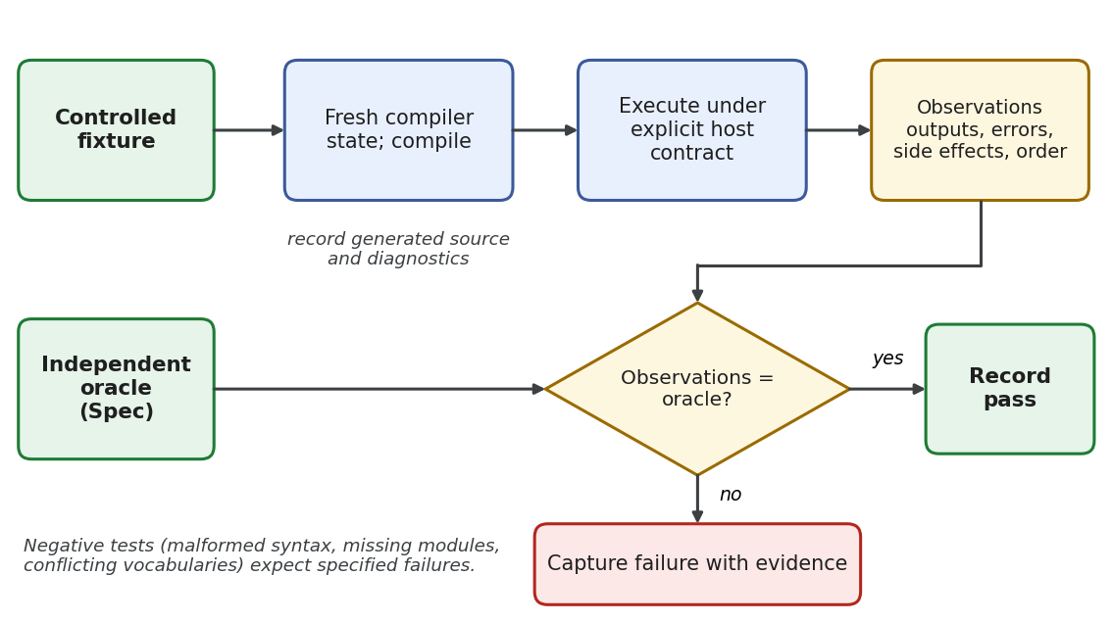
Figure 7. Proposed full-system regression protocol. A controlled fixture and independent oracle drive compilation and execution; observations are compared before recording a pass or capturing a failure. The protocol extends functional application checks to whole-language behavior. AI assistance: Perplexity Computer (GPT 6.1 Sol), SVG-code preparation.
A reproducible conformance protocol starts from a controlled compiler state, records generated source code and diagnostics, and executes under an explicit host contract. Independent oracles cover outputs, exceptions, persistent-storage side effects, and asynchronous completion. Malformed syntax, missing modules, conflicting vocabulary declarations, and unsupported host operations are treated as negative test cases: expected failure behavior is part of the language contract and not an incidental implementation artifact.
The full test suite should be decomposed into minimal tests grouped by declarations, branching, iteration, commands, reserves, handlers, collection operators, module loading, and embedded JavaScript. Property-based and metamorphic testing can check transformations such as adding declared noise words, changing permitted command capitalization, or applying validated locale aliases. The independent test suites should also be expanded, because small test sets tend to overestimate program correctness [6].

Application correctness and extraction quality
The catalog case provides deterministic expected outcomes for data normalization, schema validation, serialization, and in-memory persistence. These checks assess the application data contract independently of live web acquisition. Extraction accuracy requires a separate comparison between acquired fields and independently annotated source documents.
Extraction evaluation uses HTML and JSON fixtures with manually annotated records and fields. Critical cases include missing fields, altered element order, duplicate rows, pagination boundaries, encoding variations, and malformed numeric data. If $R$ denotes the retrieved record set and $G$ the ground-truth reference set, record-level metrics are:

$Precision=\frac{|R∩G|}{|R|},Recall=\frac{|R∩G|}{|G|}.(7)$

Record-matching criteria and the handling of empty denominators must be fixed before scoring. Field-level accuracy, rejection correctness, and persistence round-trip fidelity capture distinct failure modes and are reported separately. Archived snapshots make extraction regressions repeatable, whereas live-site evaluations must additionally record acquisition conditions and timestamps.
Table 8. Evaluation layers and their corresponding evidence.
Evaluation layer | Primary question | Evidence and measures
Language conformance | Does each supported construction preserve its specified behavior? | Independent assertions, failures, side-effects, and completion order
Reproducible translation | Does a fixed compilation context reproduce its exact output? | Repeated fresh runs, cryptographic hashes, manifests, and config
Extraction | Are the intended records and fields accurately acquired? | Annotated snapshots; precision, recall, and field-level accuracy
Data transformation | Are normalization, exclusion, and derived variables correct? | Boundary cases, zero/missing distinctions, duplicate policies
Persistence | Are outputs faithfully preserved and attributable? | Read/write round-trip, schema validation, provenance inspection
Human review | Do researchers understand and correctly approve programs? | Comprehension scores, defect detection, false approvals, and time
AI generation | Can an AI produce correct end-to-end programs within budget? | Functional success, repair iterations, latency, and resource use
Localization and portability | Do alternative surfaces and targets preserve behavior? | Canonical equivalence and cross-runtime observations

Human comprehension and calibrated trust
The human-evaluation protocol compares DEAL.JS with plain JavaScript, Python, and, for overlapping web tasks, _hyperscript. A counterbalanced design separates language effects from task order, and the primary participants are domain researchers with limited professional programming experience. Tasks involving output prediction, modification of extraction criteria, identification of normalization errors, and approval of AI-proposed workflows probe different facets of comprehension.
Accurate review is the primary outcome. The false-approval rate (FAR) indicates whether a readable surface notation induces misplaced confidence. Let $n_{FA}$ be the number of incorrect workflows erroneously approved and $n_{I}$ the total number of incorrect workflows reviewed:

$FAR=\frac{n_{FA}}{n_{I}}.(8)$

Lower values indicate that fewer flawed workflows are mistakenly accepted as correct. Completion times, cognitive-workload surveys, explanation-quality scores, and qualitative interviews provide complementary evidence. Sample sizes will be determined from pilot-informed power and precision analyses that account for outcome uncertainty and task variation.
Equivalent domain APIs, documentation, training materials, and task specifications must be supplied in all experimental conditions. The statistical analysis must account for participant and task variation, prior language familiarity, English proficiency, order effects, and uncertainty intervals. These controls address the distinction among surface syntax, API design, and actual comprehension identified in prior usability research [18, 19].

AI generation, performance, and ablation
The AI-generation protocol holds task specifications, documentation, library contracts, model versions, and automated-repair budgets constant while varying the output representation. Direct JavaScript with identical domain APIs isolates notation quality from library power, and a structured-schema condition can separate the general benefits of constrained program representations from those specific to DEAL syntax.
End-to-end success requires successful parsing, compilation, runtime completion, and all task-specific output validations. For $N$ evaluation tasks, functional success is defined as:

$FS=\frac{1}{N}\sum_{i=1}^{N}{}z_{i}.(9)$

Here, $z_{i}=1$ only if task $i$ satisfies every mandatory verification check, and $z_{i}=0$ otherwise. Malformed source output and missing dependencies count as failures. First-attempt success and success within a fixed repair budget are tracked as separate outcomes, together with token usage, latency, and human correction effort. Execution-based assessment follows established code-generation evaluation practice [5, 6]; grammar-constrained decoding can guarantee structural syntax validity [31] but cannot replace functional verification.
Operational cost is decomposed into compiler execution time, module-initialization overhead, browser and network latency, data-processing time, memory use, output size, and steady-state execution speed. Cold and warm runs are measured as separate conditions. Ablation studies that isolate vocabulary adaptation, document-like presentation, contextual handlers, and domain commands identify which mechanisms drive observed effects, rather than attributing every difference to the language as a whole.
Locale studies must compare identical tasks with fixed identifiers and controlled vocabulary modules instead of assuming that translation benefits all participants equally. Backend studies must begin with a restricted portable subset and document unsupported constructs. Together, these evaluations connect the language design to empirical evidence without treating a working implementation as proof of every intended advantage.

Design analysis and case-validation results

Representation and extension boundaries
Regarding RQ1, the language model provides an explicit path from high-level domain commands and control structures to generated JavaScript and host execution. By separating structural syntax, reusable operations, vocabulary modules, and contextual handlers, DEAL makes each extension decision visible without requiring a new language for every specialized domain. The matched examples locate DEAL within established programming traditions and show that its distinguishing focus is a common, reviewable workflow representation.
Regarding RQ2, vocabulary equivalence is conditional on identical canonical normalization and a fixed compilation context. The argument is direct: substituting identically normalized inputs into the same deterministic compilation function yields identical generated artifacts, and executing those artifacts in aligned environments yields identical specified observations. Cross-backend equivalence, however, requires the additional preservation relation in Equation (6) and cannot be inferred from the existence of a single JavaScript implementation.

Workflow composition and functional validation
Regarding RQ3, the worked application composes data acquisition, field extraction, normalization, validation, derived-variable computation, and persistence while keeping the exclusion criteria visible. The DEAL orchestration layer coordinates these operations, domain functions define the data contracts, and the storage interface records the outputs. Researchers can therefore inspect individual data-processing decisions without conflating them with page selectors or storage-backend details.
All 19 case-validation assertions passed (19/19, 100%). The five-record fixture produced exactly two accepted records (40%) and three rejections (60%): one duplicate identifier, one missing price, and one out-of-range discount (Table 9). The disposition of every record agrees with the required outcome in Table 5. The assertions verify identifier and title normalization, discount arithmetic, preservation of valid zero values, rejection-reason logging, provenance metadata, schema-version tagging, JSONL round-trip serialization, in-memory persistence, and selector-to-field wiring through a document-shaped test double. The fixed timestamp is fixture data and not a live acquisition measurement.
Table 9. Quantitative summary of the case-validation run on the synthetic catalog.
Metric | Observed value | Basis
Input records | 5 | Synthetic catalog fixture (Table 5)
Accepted records | 2 of 5 (40%) | p1 (net price 90.00) and p2 (zero price and quantity preserved)
Rejected records | 3 of 5 (60%) | Duplicate identifier (p1), missing price (p3), out-of-range discount (p4)
Case-validation assertions | 19 executed; 19 passed (100%) | Node.js 20.20.2; in-memory connector and document-shaped test double
Derived net price | p1: 90.00; p2: 0.00 | Equation (4) applied to the accepted records
Not measured | Compiler time, live extraction accuracy, human performance | Excluded by design from this experiment

Interpretation of the evidence
These observations validate the data-processing and persistence rules of the case study for the specified synthetic inputs. They do not establish whole-language conformance, live web-extraction accuracy, localization equivalence, backend portability, or a human-performance advantage. The proposed conformance, extraction, human-review, and AI-generation protocols are designed to address each of these outcomes separately.

Discussion, limitations, and future directions

Implications for human–AI research programming
The principal implication is a shift from exchanging prose descriptions of code to collaborating around a shared, executable program. A domain researcher can review and revise an inclusion criterion at the level at which it is discussed, an AI system can propose refinements to the same source, and execution remains anchored in generated JavaScript. The language thus serves as a communication medium between humans and machines without reducing execution semantics to ambiguous natural language.
Abstraction quality is decisive. A well-designed domain command exposes the aspects of an operation that influence scientific interpretation and encapsulates incidental mechanics. A normalization command, for example, should expose its missing-value and duplicate-handling policies for audit, even when DOM traversal and serialization are handled elsewhere. Workflows remain inspectable only if users can move between these levels of abstraction.

Threats to validity and limitations
The main construct-validity threat is equating surface readability with comprehension. The functional assertions do not measure human oversight, and self-reported usability alone cannot establish accurate code review. The internal validity of the case experiment is bounded by shared assumptions between the helper functions and the test assertions; independent oracles and mutation testing would provide stronger safeguards against latent defects. External validity is limited by the synthetic catalog fixture, a single runtime engine, an in-memory storage connector, and a document-shaped test double.
Domain commands shift cognitive complexity rather than remove it. A concise command may conceal extensive underlying code, a localized synonym may introduce ambiguity or ecosystem fragmentation, and contextual handlers may obscure dependencies. Users must be able to inspect the underlying contracts and reach the raw implementation when necessary, and generated source code, test harnesses, and execution traces must remain accessible.
Hybrid interoperability introduces a deliberate architectural tension. It supports existing libraries and incremental adoption, but arbitrary embedded host code limits static analysis, security guarantees, and cross-backend portability. Readability cannot substitute for permission boundaries, runtime isolation, or testing, and a correct pipeline does not guarantee that acquired data are representative or that a scientific interpretation is valid.
Implementation completeness is distinct from empirical coverage. The recorded experiments establish specified transformation and storage behaviors, whereas participant effects, AI-generation advantages, live-site extraction robustness, and cross-backend equivalence remain unmeasured. The analytical contracts define formal preservation conditions and are not machine-checked proofs for the entire compiler.

Research roadmap
Future work will extend the language along several directions. A formal language standard and machine-checkable module contracts would support independent implementations and conformance certification. Bidirectional tooling that links domain commands to generated JavaScript, exact dependency versions, and execution traces would strengthen multi-level review; the most useful interfaces will highlight data exclusions and side effects and not merely present readable source text.
A third direction is expansion beyond web scraping into bibliographic harvesting, software-repository mining, text-corpus preparation, simulation setup, and experimental data processing. Each new module should contribute reusable contracts, representative fixtures, and domain-review guidance; introducing vocabulary without a stable operational specification would weaken the shared-language objective.
A fourth direction is optional multilingual developer tooling, including localized diagnostics and documentation alongside syntax aliases. A fifth is a backend-neutral subset with explicit foreign-language escape boundaries and cross-implementation conformance tests. A sixth is grammar-aware AI code generation that exploits the language’s constrained structure while prioritizing functional correctness over surface syntax.
Responsible research use further requires permission-aware data acquisition, rate limiting, privacy protection, access control, and transparent retention policies. Provenance and standard serialization formats support scientific reuse, but institutional and legal regulations determine whether a specific acquisition is permissible. These are properties of the surrounding research ecosystem and its governance, not automatic benefits of DEAL.

Conclusion
DEAL introduces a shared programming representation for human–AI research workflows. Structures express control flow, commands encapsulate domain operations, reserves adapt human vocabulary, and handlers expose computational context; DEAL.JS realizes these mechanisms through JavaScript interoperability and staged source-to-source compilation. Together they connect readable research intent to an inspectable, executable program.
The contribution is a working integration of domain-oriented notation, JavaScript execution, modular operations, and adaptable vocabulary. The catalog workflow demonstrates acquisition, extraction, preprocessing, derived-variable computation, validation, deduplication, and storage within this shared representation: all 19 assertions passed, and the five-record fixture produced two accepted and three rejected records as specified. The executed assertions establish the stated application data contract, and the formal account identifies the conditions required for deterministic translation, localized equivalence, and reuse across language implementations.
DEAL therefore provides a language-engineering foundation for inspectable human–AI research programming. Its broader significance lies in decoupling human-facing terminology from computational operations without separating either from executable evidence. Future comparative research can now test when this representation improves the accuracy of review, reduces repair effort, or supports reuse across scientific domains and linguistic communities.

Glossary
- DEAL: Declarative and Extensible Abstract Language, the shared programming model examined in this article.
- DEAL.JS: The JavaScript-targeting realization of DEAL.
- Reserve: A declared vocabulary replacement or a permitted readability word.
- Handler: A contextual reference to a current workspace object or operation.
- Canonical normalization: The analytical mapping from a configured human vocabulary to a common structural representation.
- Portable subset: A declared set of language constructions whose operational behavior is formally specified across target backends.

Data availability
The language implementation, generic compiler framework, and execution host are openly available as DEAL.JS [8], DEAL Engine [39], and DEAL Environment [42]. Each repository is cited at a fixed commit (DEAL.JS: d76dcae3bf157e3969be0bd1f98ed2522defc2b9; DEAL Engine: 8800695b1bbe6274f71f581473943ff7943d5036; DEAL Environment: 9ef64b9ae94e1017273f9780a4466973b4d5747d), so that the exact versions used in this study can be retrieved. The accompanying research materials contain the case-study program, domain functions, synthetic fixtures, validation test suites, recorded outputs, editable diagram sources, and reference metadata. No human-participant or live-acquisition data were used in the case-validation experiment.
The commit hashes above serve as persistent, content-addressed identifiers of the software; the accompanying research package is provided as supplementary material to this submission.

CRediT authorship contribution statement
Mohammad Fathi: Conceptualization, Methodology, Software, Investigation, Writing – original draft. Mehrdad CheshmeSohrabi: Conceptualization, Supervision, Validation, Writing – review & editing. Ahmad Shabani: Methodology, Validation, Writing – review & editing. Ali Mansouri: Supervision, Writing – review & editing.

Declaration of competing interests
The authors declare that they have no known competing financial interests or personal relationships that could have appeared to influence the work reported in this article.

Funding
This research did not receive any specific grant from funding agencies in the public, commercial, or not-for-profit sectors.

Declaration of generative AI and AI-assisted technologies in the writing process
Perplexity Computer (GPT 6.1 Sol) assisted with literature discovery, manuscript drafting and revision, case-study code implementation, and SVG diagram preparation. Diagrams were rendered programmatically with Node.js 20.20.2 and sharp 0.35.4; they represent conceptual explanatory structures rather than generated experimental observations. After using these tools, the authors reviewed and edited all content as needed and take full responsibility for the content of the published article.

Acknowledgements
The authors thank the Department of Knowledge and Information Science, University of Isfahan, for providing the academic environment in which this work was carried out.

References
[1] Ko, A. J.; Abraham, R.; Beckwith, L.; Blackwell, A.; Burnett, M.; Erwig, M.; Scaffidi, C.; Lawrance, J.; Lieberman, H.; Myers, B.; Rosson, M. B.; Rothermel, G.; Shaw, M.; and Wiedenbeck, S. (2011). The state of the art in end-user software engineering. ACM Computing Surveys, 43(3). DOI: 10.1145/1922649.1922658. Available at: https://researchdiscovery.drexel.edu/esploro/outputs/journalArticle/The-State-of-the-Art-in/991019167334204721.
[2] Barricelli, B. R.; Cassano, F.; Fogli, D.; and Piccinno, A. (2019). End-user development, end-user programming and end-user software engineering: A systematic mapping study. Journal of Systems and Software, 149, pp. 101-137. DOI: 10.1016/j.jss.2018.11.041. Available at: https://expertise.unimi.it/resource/item/669695?language=en-US.
[3] Wilson, G., et al. (2014). Best practices for scientific computing. PLOS Biology, 12(1), Article e1001745. DOI: 10.1371/journal.pbio.1001745. Available at: https://doi.org/10.1371/journal.pbio.1001745.
[4] Vaithilingam, P.; Zhang, T.; and Glassman, E. L. (2022). Expectation vs. Experience: Evaluating the usability of code generation tools powered by large language models. Extended abstracts of the 2022 CHI conference on human factors in computing systems, pp. 1-7. DOI: 10.1145/3491101.3519665. Available at: https://dl.acm.org/doi/pdf/10.1145/3491101.3519665.
[5] Chen, M., et al. (2021). Evaluating large language models trained on code. arXiv:2107.03374. Preprint. Available at: https://arxiv.org/abs/2107.03374.
[6] Liu, J.; Xia, C. S.; Wang, Y.; and Zhang, L. (2023). Is your code generated by ChatGPT really correct? Rigorous evaluation of large language models for code generation. Advances in neural information processing systems, 36. Available at: https://proceedings.neurips.cc/paper_files/paper/2023/hash/43e9d647ccd3e4b7b5baab53f0368686-Abstract-Conference.html.
[7] Pearce, H.; Ahmad, B.; Tan, B.; Dolan-Gavitt, B.; and Karri, R. (2025). Asleep at the keyboard? Assessing the security of GitHub Copilot’s code contributions. Communications of the ACM, 68(2), pp. 96-105. DOI: 10.1145/3610721. Available at: https://doi.org/10.1145/3610721.
[8] DEAL-X (n.d.). DEAL.JS: Source code, README, libraries, and samples. Software. Version d76dcae3bf157e3969be0bd1f98ed2522defc2b9; accessed 19 October 2026. Available at: https://github.com/DEAL-X/DEAL-JS.
[9] Kuhn, T. (2014). A survey and classification of controlled natural languages. Computational Linguistics, 40(1), pp. 121-170. DOI: 10.1162/COLI_a_00168. Available at: https://aclanthology.org/J14-1005/.
[10] Spinellis, D. (2001). Notable design patterns for domain specific languages. Journal of Systems and Software, 56(1), pp. 91-99. DOI: 10.1016/S0164-1212(00)00089-3. Linked page is the author’s working-paper rendering, which identifies the preferred publication citation. Available at: https://www.spinellis.gr/pubs/jrnl/2000-JSS-DSLPatterns/html/dslpat.html.
[11] Mernik, M.; Heering, J.; and Sloane, A. M. (2005). When and how to develop domain-specific languages. ACM Computing Surveys, 37(4), pp. 316-344. DOI: 10.1145/1118890.1118892. Available at: https://doi.org/10.1145/1118890.1118892.
[12] Lipton, Z. C. (2018). The mythos of model interpretability. Communications of the ACM, 61(10), pp. 36-43. DOI: 10.1145/3233231. Available at: https://vis.csail.mit.edu/classes/6.859/readings/pdfs/Lipton-TheMythosOfModelInterpretability.pdf.
[13] Doshi-Velez, F.; and Kim, B. (2017). Towards a rigorous science of interpretable machine learning. arXiv:1702.08608. Position-paper preprint. Available at: https://arxiv.org/abs/1702.08608.
[14] Rudin, C. (2019). Stop explaining black box machine learning models for high stakes decisions and use interpretable models instead. Nature Machine Intelligence, 1, pp. 206-215. DOI: 10.1038/s42256-019-0048-x. Available at: https://www.nature.com/articles/s42256-019-0048-x.
[15] Sandve, G. K.; Nekrutenko, A.; Taylor, J.; and Hovig, E. (2013). Ten simple rules for reproducible computational research. PLOS Computational Biology, 9(10), Article e1003285. DOI: 10.1371/journal.pcbi.1003285. Available at: https://journals.plos.org/ploscompbiol/article?id=10.1371/journal.pcbi.1003285.
[16] Peng, R. D. (2011). Reproducible research in computational science. Science, 334(6060), pp. 1226-1227. DOI: 10.1126/science.1213847. Available at: https://doi.org/10.1126/science.1213847.
[17] Wilkinson, M. D., et al. (2016). The FAIR guiding principles for scientific data management and stewardship. Scientific Data, 3, Article 160018. DOI: 10.1038/sdata.2016.18. Available at: https://www.nature.com/articles/sdata201618.
[18] Stefik, A.; and Siebert, S. (2013). An empirical investigation into programming language syntax. ACM Transactions on Computing Education, 13(4), pp. 19:1-19:40. DOI: 10.1145/2534973. Available at: https://eric.ed.gov/?id=EJ1042402.
[19] Lappi, V.; Tirronen, V.; and Itkonen, J. (2023). A replication study on the intuitiveness of programming language syntax. Software Quality Journal, 31, pp. 1211-1240. DOI: 10.1007/s11219-023-09631-7. Available at: https://link.springer.com/article/10.1007/s11219-023-09631-7.
[20] Green, T. R. G.; and Petre, M. (1996). Usability analysis of visual programming environments: A cognitive dimensions framework. Journal of Visual Languages and Computing, 7(2), pp. 131-174. DOI: 10.1006/jvlc.1996.0009. Linked text is the author manuscript. Available at: https://history.futureofcoding.org/history/msg_files/F6R/F6R1A64AF.pdf.
[21] Heinonen, A.; Lehtelä, B.; Hellas, A.; and Fagerholm, F. (2023). Synthesizing research on programmers’ mental models of programs, tasks and concepts: A systematic literature review. Information and Software Technology, 164, Article 107300. DOI: 10.1016/j.infsof.2023.107300. Available at: https://www.sciencedirect.com/science/article/pii/S0950584923001544.
[22] Keemps, R.; Farias, K.; Kunst, R.; Carbonera, C.; and Bolzan, W. (2025). SmellDSL: A domain-specific language to assist developers in specifying code smell patterns. Information and Software Technology, 184, Article 107760. DOI: 10.1016/j.infsof.2025.107760. Available at: https://www.sciencedirect.com/science/article/abs/pii/S0950584925000990.
[23] _hyperscript project (n.d.). _hyperscript: Official language documentation. Online language documentation. Accessed 19 October 2026. Available at: https://hyperscript.org/.
[24] _hyperscript project (n.d.). _hyperscript: Official reference. Online language documentation. Accessed 19 October 2026. Available at: https://hyperscript.org/reference/.
[25] LiveCode (n.d.). LiveCode Script: Repeat control structure. Online language documentation. Accessed 19 October 2026. Available at: https://docs.livecode.com/docs/LiveCode%20Script/Control%20Structures/repeat/.
[26] Erdweg, S.; Rendel, T.; Kästner, C.; and Ostermann, K. (2011). SugarJ: Library-based syntactic language extensibility. Proceedings of OOPSLA, pp. 391-406. Available at: https://www.pl.informatik.uni-mainz.de/files/2019/04/sugarj.pdf.
[27] Kistler, T.; and Marais, H. (1998). WebL: A programming language for the web. Computer Networks and ISDN Systems, 30(1–7), pp. 259-270. DOI: 10.1016/S0169-7552(98)00018-X. Available at: https://www.ra.ethz.ch/cdstore/www7/1832/com1832.htm.
[28] Ferrara, E.; De Meo, P.; Fiumara, G.; and Baumgartner, R. (2014). Web data extraction, applications and techniques: A survey. Knowledge-Based Systems, 70, pp. 301-323. DOI: 10.1016/j.knosys.2014.07.007. Linked record provides an author preprint and the published journal citation. Available at: https://arxiv.org/abs/1207.0246.
[29] Gao, L.; Madaan, A.; Zhou, S.; Alon, U.; Liu, P.; Yang, Y.; Callan, J.; and Neubig, G. (2023). PAL: Program-aided language models. Proceedings of the 40th international conference on machine learning, 202, pp. 10764-10799. Available at: https://proceedings.mlr.press/v202/gao23f.html.
[30] Scholak, T.; Schucher, N.; and Bahdanau, D. (2021). PICARD: Parsing incrementally for constrained auto-regressive decoding from language models. Proceedings of the 2021 conference on empirical methods in natural language processing, pp. 9895-9901. DOI: 10.18653/v1/2021.emnlp-main.779. Available at: https://aclanthology.org/2021.emnlp-main.779/.
[31] Geng, S.; Josifoski, M.; Peyrard, M.; and West, R. (2023). Grammar-constrained decoding for structured NLP tasks without finetuning. Proceedings of the 2023 conference on empirical methods in natural language processing, pp. 10932-10952. Available at: https://aclanthology.org/2023.emnlp-main.674/.
[32] Ferris, L.; and Bonilla, S. (2026). A case study in assuring AI-written software. arXiv:2610.08651v1. Preprint. arXiv version 1; preprint, not used as established general evidence. Available at: https://arxiv.org/html/2610.08651v1.
[33] Python Software Foundation (n.d.). Python tutorial: More control flow tools. Online language documentation. Accessed 19 October 2026. Available at: https://docs.python.org/3/tutorial/controlflow.html.
[34] Hevner, A. R.; March, S. T.; Park, J.; and Ram, S. (2004). Design science in information systems research. MIS Quarterly, 28(1), pp. 75-105. Available at: https://aisel.aisnet.org/misq/vol28/iss1/6/.
[35] Peffers, K.; Tuunanen, T.; Rothenberger, M. A.; and Chatterjee, S. (2007). A design science research methodology for information systems research. Journal of Management Information Systems, 24(3), pp. 45-77. DOI: 10.2753/MIS0742-1222240302. Available at: https://doi.org/10.2753/MIS0742-1222240302.
[36] Runeson, P.; and Höst, M. (2009). Guidelines for conducting and reporting case study research in software engineering. Empirical Software Engineering, 14(2), pp. 131-164. DOI: 10.1007/s10664-008-9102-8. Available at: https://doi.org/10.1007/s10664-008-9102-8.
[37] DEAL-X (n.d.). DEAL.JS: Tokenizer implementation. Software. Tokenizer.cs, commit d76dcae3bf157e3969be0bd1f98ed2522defc2b9; accessed 19 October 2026. Available at: https://github.com/DEAL-X/DEAL-JS/blob/d76dcae3bf157e3969be0bd1f98ed2522defc2b9/DEAL.JS/Tokenizer.cs.
[38] DEAL-X (n.d.). DEAL.JS: Assembler implementation. Software. Assembler.cs, commit d76dcae3bf157e3969be0bd1f98ed2522defc2b9; accessed 19 October 2026. Available at: https://github.com/DEAL-X/DEAL-JS/blob/d76dcae3bf157e3969be0bd1f98ed2522defc2b9/DEAL.JS/Assembler.cs.
[39] DEAL-X (n.d.). DEAL Engine: Generic compiler framework. Software. Version 8800695b1bbe6274f71f581473943ff7943d5036; accessed 19 October 2026. Available at: https://github.com/DEAL-X/Engine.
[40] DEAL-X (n.d.). DEAL Engine: Generic engine implementation. Software. Engine.cs, commit 8800695b1bbe6274f71f581473943ff7943d5036; accessed 19 October 2026. Available at: https://github.com/DEAL-X/Engine/blob/8800695b1bbe6274f71f581473943ff7943d5036/Engine/Engine.cs.
[41] DEAL-X (n.d.). DEAL.JS: Engine configuration and native JavaScript passthrough. Software. Engine.cs, commit d76dcae3bf157e3969be0bd1f98ed2522defc2b9; accessed 19 October 2026. Available at: https://github.com/DEAL-X/DEAL-JS/blob/d76dcae3bf157e3969be0bd1f98ed2522defc2b9/DEAL.JS/Engine.cs.
[42] DEAL-X (n.d.). DEAL Environment: JavaScript execution host. Software. Version 9ef64b9ae94e1017273f9780a4466973b4d5747d; accessed 19 October 2026. Available at: https://github.com/DEAL-X/Environment.
[43] DEAL-X (n.d.). DEAL.JS: Local resource commands. Software. local.djs, commit d76dcae3bf157e3969be0bd1f98ed2522defc2b9; accessed 19 October 2026. Available at: https://github.com/DEAL-X/DEAL-JS/blob/d76dcae3bf157e3969be0bd1f98ed2522defc2b9/Library/deal/data/local.djs.
[44] MDN contributors (n.d.). JavaScript guide: Using promises. Online technical documentation. Accessed 19 October 2026. Available at: https://developer.mozilla.org/en-US/docs/Web/JavaScript/Guide/Using_promises.
[45] Guo, P. J. (2018). Non-native English speakers learning computer programming: Barriers, desires, and design opportunities. Proceedings of the 2018 CHI conference on human factors in computing systems, pp. 396:1-396:14. DOI: 10.1145/3173574.3173970. Available at: https://pg.ucsd.edu/publications/non-native-english-speakers-learning-programming_CHI-2018.pdf.

