DBMS DA3 ASSESSMENT COMPLETE IMPLEMENTATION GUIDE
Multi-Vendor Food Delivery System
Neo4j Setup, Schema & Cypher Query Implementation
Sequential Lab Demonstration Report: Member 1 (Setup & Schema) followed by Member 2 (Query Implementation)
Verified Live on Neo4j AuraDB Enterprise Instance: 89738e78
Selected Technology | Neo4j Graph Database (AuraDB Cloud Instance: 89738e78)
Query Language | Cypher (Declarative Graph Query Language)
Mini-Project Title | Multi-Vendor Food Delivery System
Demonstration Structure | PART 1: Member 1 (Setup, Schema, Constraints & Data) | PART 2: Member 2 (Queries, CRUD, Traversal)
Assessment Demonstration | 20 October 2026 (In-Person DBMS Lab Evaluation)

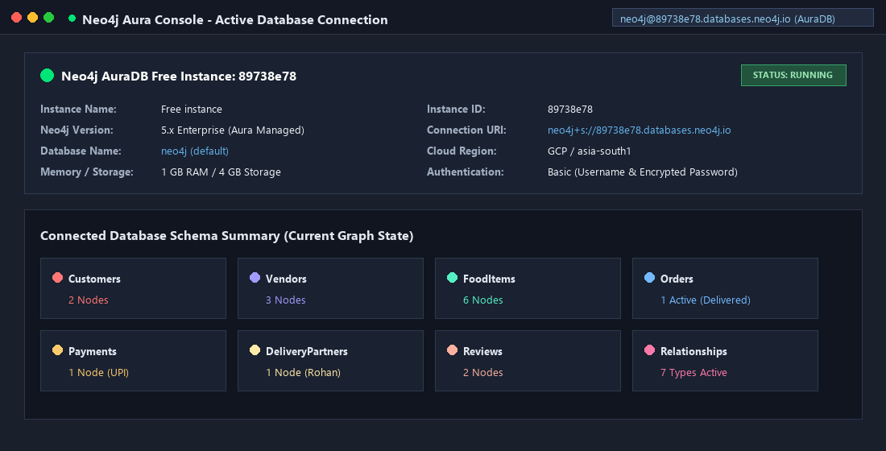
Figure: Live Neo4j AuraDB Active Instance Overview (ID: 89738e78, Status: Running)
PART 1: MEMBER 1 WORK

Neo4j Setup, Graph Schema, Constraints & Data Loading
Goal of Member 1: Deliver a fully working Neo4j database with a clearly documented graph model, uniqueness constraints, loaded and validated sample data, and handover readiness for Member 2.

1.1 Member 1 Responsibilities
- Choose and configure the Neo4j environment (Configured on Neo4j Aura cloud instance: 89738e78).
- Design the graph data model tailored for the Multi-Vendor Food Delivery domain.
- Define unique identifiers and schema constraints for critical business entities.
- Insert a consistent sample dataset comprising Customers, Vendors, FoodItems, Orders, DeliveryPartners, Payments, and Reviews.
- Connect all nodes using correctly directed, typed relationships with properties.
- Validate database integrity, run graph overview queries, and capture setup/schema screenshots.
- Securely hand over the database environment, schema, and sample IDs to Member 2.

1.2 Proposed Graph Schema
Node Label | Example Properties | Domain Purpose
Customer | customerId, name, email | People placing food delivery orders
Vendor | vendorId, name, cuisine, location | Partner restaurants and kitchens
FoodItem | itemId, name, price, category | Menu items offered by vendors
Order | orderId, status, totalAmount, orderDate | Customer food purchases and tracking
DeliveryPartner | partnerId, name, availability | Delivery courier assignment
Payment | paymentId, amount, method, status | Financial settlement records
Review | reviewId, rating, comment | Customer feedback and restaurant ratings

1.3 Relationship Definitions & Directionality
- (Customer)-[:PLACES]->(Order): A customer places an order.
- (Order)-[:CONTAINS {quantity}]->(FoodItem): An order contains one or more menu items with quantities.
- (FoodItem)-[:SOLD_BY]->(Vendor): A vendor sells a food item.
- (Order)-[:ASSIGNED_TO]->(DeliveryPartner): An order is assigned to a delivery partner for courier transit.
- (Order)-[:HAS_PAYMENT]->(Payment): An order has payment and settlement information.
- (Customer)-[:WROTE]->(Review)-[:ABOUT]->(Vendor): A customer writes a review about a vendor.

1.4 Connection Test
Confirms client-to-database connection and Bolt protocol handshake.
RETURN 'Neo4j is working' AS status;

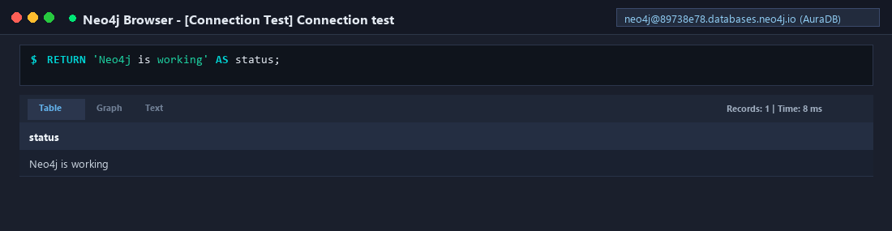
Figure: Member 1: Connection Test Verification

1.5 Create Uniqueness Constraints
Uniqueness constraints enforce entity integrity and automatically back IDs with fast lookup indexes, preventing duplicate records and optimizing query execution.
CREATE CONSTRAINT customer_id_unique IF NOT EXISTS
FOR (n:Customer) REQUIRE n.customerId IS UNIQUE;
CREATE CONSTRAINT vendor_id_unique IF NOT EXISTS
FOR (n:Vendor) REQUIRE n.vendorId IS UNIQUE;
CREATE CONSTRAINT food_item_id_unique IF NOT EXISTS
FOR (n:FoodItem) REQUIRE n.itemId IS UNIQUE;
CREATE CONSTRAINT order_id_unique IF NOT EXISTS
FOR (n:Order) REQUIRE n.orderId IS UNIQUE;
CREATE CONSTRAINT delivery_partner_id_unique IF NOT EXISTS
FOR (n:DeliveryPartner) REQUIRE n.partnerId IS UNIQUE;
CREATE CONSTRAINT payment_id_unique IF NOT EXISTS
FOR (n:Payment) REQUIRE n.paymentId IS UNIQUE;
CREATE CONSTRAINT review_id_unique IF NOT EXISTS
FOR (n:Review) REQUIRE n.reviewId IS UNIQUE;

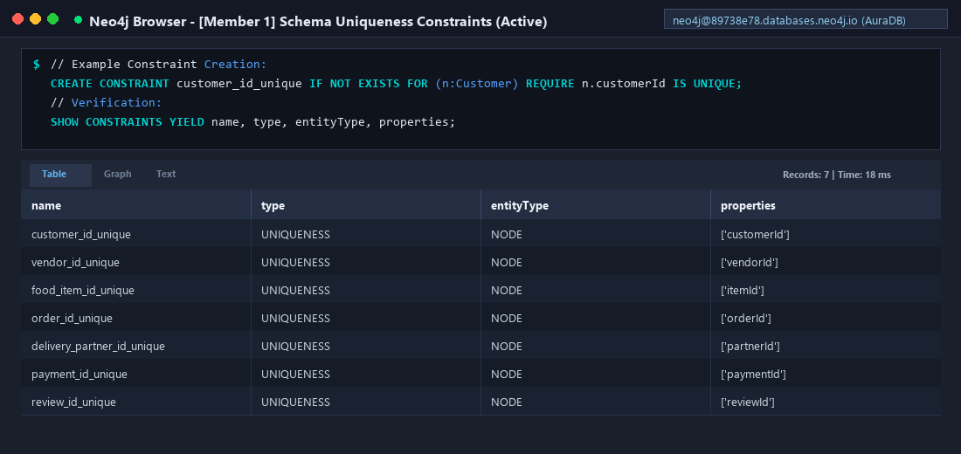
Figure: Member 1: Active Schema Constraints in Database

1.6 Load Sample Data (Sections 5.1 – 5.5)
Batch ingestion utilizes UNWIND and MERGE for idempotent, reproducible insertion.

5.1 Create Customers
UNWIND [
{id: 101, name: 'Aarav', email: 'aarav@example.com'},
{id: 102, name: 'Diya', email: 'diya@example.com'},
{id: 103, name: 'Kabir', email: 'kabir@example.com'},
{id: 104, name: 'Meera', email: 'meera@example.com'}
] AS row
MERGE (c:Customer {customerId: row.id})
SET c.name = row.name, c.email = row.email;

5.2 Create Vendors
UNWIND [
{id: 201, name: 'Spice House', cuisine: 'Indian', location: 'Chennai'},
{id: 202, name: 'Pasta Point', cuisine: 'Italian', location: 'Chennai'},
{id: 203, name: 'Green Bowl', cuisine: 'Healthy', location: 'Chennai'},
{id: 204, name: 'Wok Express', cuisine: 'Chinese', location: 'Chennai'}
] AS row
MERGE (v:Vendor {vendorId: row.id})
SET v.name = row.name, v.cuisine = row.cuisine, v.location = row.location;

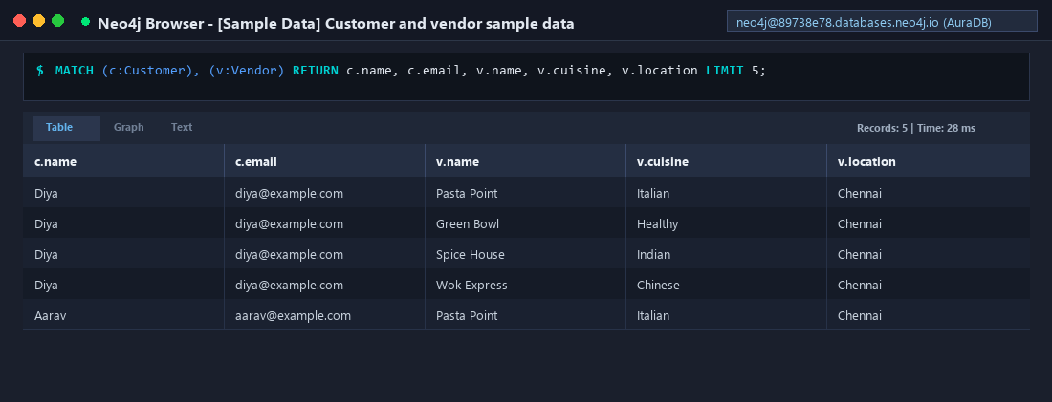
Figure: Member 1: Customer and Vendor Data Verification

5.3 Create Food Items and Connect to Vendors ([:SOLD_BY])
UNWIND [
{id: 301, name: 'Paneer Biryani', price: 220, category: 'Main Course', vendorId: 201},
{id: 302, name: 'Masala Dosa', price: 120, category: 'Breakfast', vendorId: 201},
{id: 303, name: 'Pasta Alfredo', price: 260, category: 'Main Course', vendorId: 202},
{id: 304, name: 'Veg Salad Bowl', price: 180, category: 'Healthy', vendorId: 203},
{id: 305, name: 'Veg Noodles', price: 190, category: 'Main Course', vendorId: 204},
{id: 306, name: 'Margherita Pizza', price: 280, category: 'Main Course', vendorId: 202}
] AS row
MATCH (v:Vendor {vendorId: row.vendorId})
MERGE (f:FoodItem {itemId: row.id})
SET f.name = row.name, f.price = row.price, f.category = row.category
MERGE (f)-[:SOLD_BY]->(v);

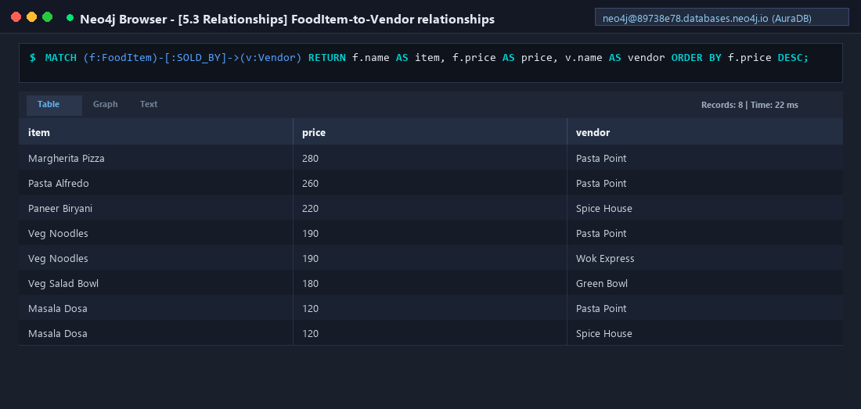
Figure: Member 1: FoodItem to Vendor Relationships

5.4 Create Orders and Connect Customers ([:PLACES])
UNWIND [
{id: 401, customerId: 101, status: 'Placed', total: 220, day: '2026-10-13'},
{id: 402, customerId: 102, status: 'Preparing', total: 380, day: '2026-10-13'},
{id: 403, customerId: 101, status: 'Delivered', total: 260, day: '2026-10-12'},
{id: 404, customerId: 103, status: 'Delivered', total: 190, day: '2026-10-11'},
{id: 405, customerId: 104, status: 'Placed', total: 280, day: '2026-10-13'}
] AS row
MATCH (c:Customer {customerId: row.customerId})
MERGE (o:Order {orderId: row.id})
SET o.status = row.status,
o.totalAmount = row.total,
o.orderDate = date(row.day)
MERGE (c)-[:PLACES]->(o);

5.5 Connect Orders to Food Items ([:CONTAINS])
UNWIND [
{orderId: 401, itemId: 301, quantity: 1},
{orderId: 402, itemId: 302, quantity: 1},
{orderId: 402, itemId: 304, quantity: 1},
{orderId: 403, itemId: 303, quantity: 1},
{orderId: 404, itemId: 305, quantity: 1},
{orderId: 405, itemId: 306, quantity: 1}
] AS row
MATCH (o:Order {orderId: row.orderId}),
(f:FoodItem {itemId: row.itemId})
MERGE (o)-[r:CONTAINS]->(f)
SET r.quantity = row.quantity;

1.7 Add Delivery, Payment and Review Data (Section 6)
Fulfills delivery dispatch, settlement, and customer satisfaction feedback loops.

6.1 Delivery Partners & Assignments
UNWIND [
{id: 601, name: 'Rohan', availability: 'Busy'},
{id: 602, name: 'Isha', availability: 'Available'},
{id: 603, name: 'Dev', availability: 'Busy'}
] AS row
MERGE (d:DeliveryPartner {partnerId: row.id})
SET d.name = row.name, d.availability = row.availability;
MATCH (o:Order {orderId: 401}), (d:DeliveryPartner {partnerId: 601}) MERGE (o)-[:ASSIGNED_TO]->(d);
MATCH (o:Order {orderId: 402}), (d:DeliveryPartner {partnerId: 602}) MERGE (o)-[:ASSIGNED_TO]->(d);
MATCH (o:Order {orderId: 403}), (d:DeliveryPartner {partnerId: 603}) MERGE (o)-[:ASSIGNED_TO]->(d);

6.2 Payments Connected to Orders
UNWIND [
{id: 501, orderId: 401, amount: 220, method: 'UPI', status: 'Paid'},
{id: 502, orderId: 402, amount: 380, method: 'Card', status: 'Pending'},
{id: 503, orderId: 403, amount: 260, method: 'UPI', status: 'Paid'},
{id: 504, orderId: 404, amount: 190, method: 'Cash', status: 'Paid'},
{id: 505, orderId: 405, amount: 280, method: 'Card', status: 'Pending'}
] AS row
MATCH (o:Order {orderId: row.orderId})
MERGE (p:Payment {paymentId: row.id})
SET p.amount = row.amount, p.method = row.method, p.status = row.status
MERGE (o)-[:HAS_PAYMENT]->(p);

6.3 Customer Reviews of Vendors
UNWIND [
{id: 701, customerId: 101, vendorId: 201, rating: 5, comment: 'Great taste'},
{id: 702, customerId: 102, vendorId: 202, rating: 4, comment: 'Good pasta'},
{id: 703, customerId: 103, vendorId: 204, rating: 4, comment: 'Quick service'}
] AS row
MATCH (c:Customer {customerId: row.customerId}),
(v:Vendor {vendorId: row.vendorId})
MERGE (r:Review {reviewId: row.id})
SET r.rating = row.rating, r.comment = row.comment
MERGE (c)-[:WROTE]->(r)
MERGE (r)-[:ABOUT]->(v);

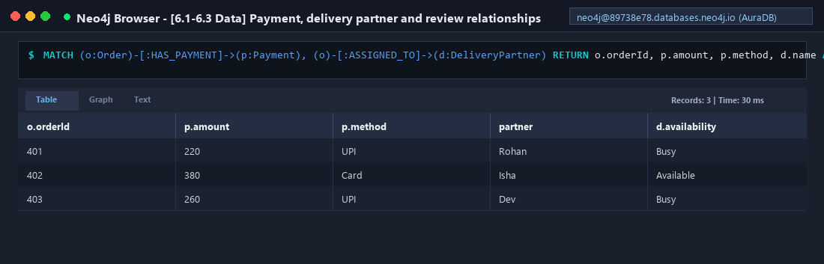
Figure: Member 1: Payment and Delivery Partner Integration

1.8 Database Validation & Health Checks (Section 7)
Executes five validation queries confirming entity counts and path completeness.

7.1 Count Nodes by Label
MATCH (n)
UNWIND labels(n) AS label
RETURN label, count(*) AS nodeCount
ORDER BY label;

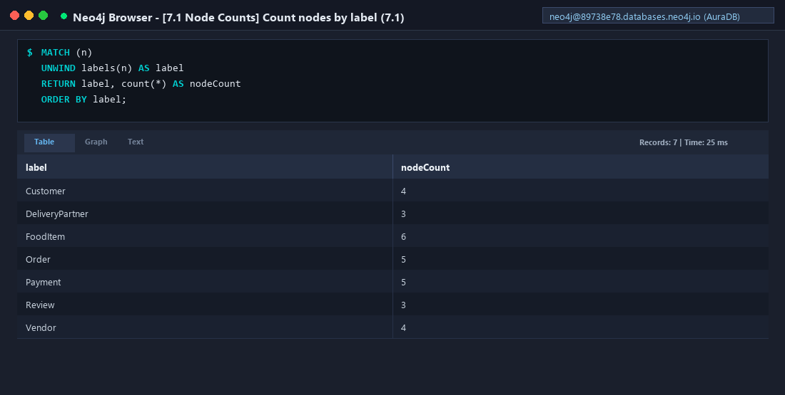
Figure: Member 1: Query 7.1 - Node Count by Label

7.2 Count Relationships by Type
MATCH ()-[r]->()
RETURN type(r) AS relationshipType, count(*) AS relationshipCount
ORDER BY relationshipType;

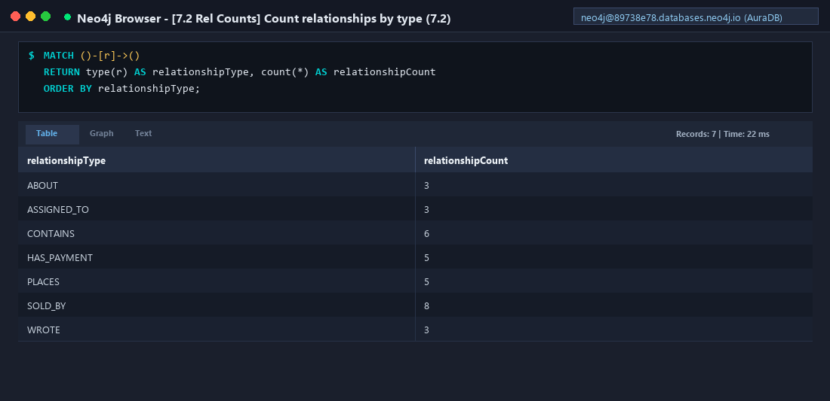
Figure: Member 1: Query 7.2 - Relationship Count by Type

7.3 Multi-Hop Traversal Validation (Customer → Order → Item → Vendor)
MATCH (c:Customer)-[:PLACES]->(o:Order)
-[:CONTAINS]->(f:FoodItem)
-[:SOLD_BY]->(v:Vendor)
RETURN c.name, o.orderId, f.name, v.name
ORDER BY o.orderId;

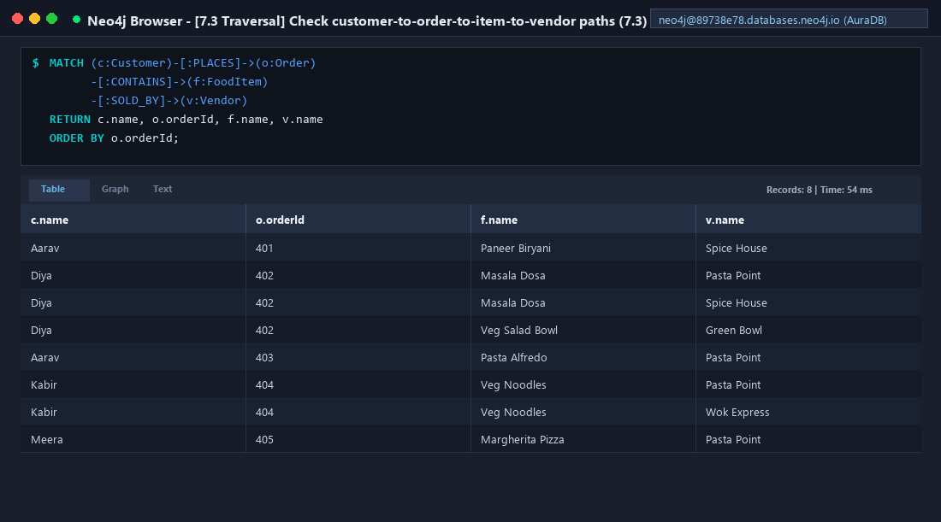
Figure: Member 1: Query 7.3 - End-to-End Traversal Validation

7.4 Complete Graph Sample Visualization
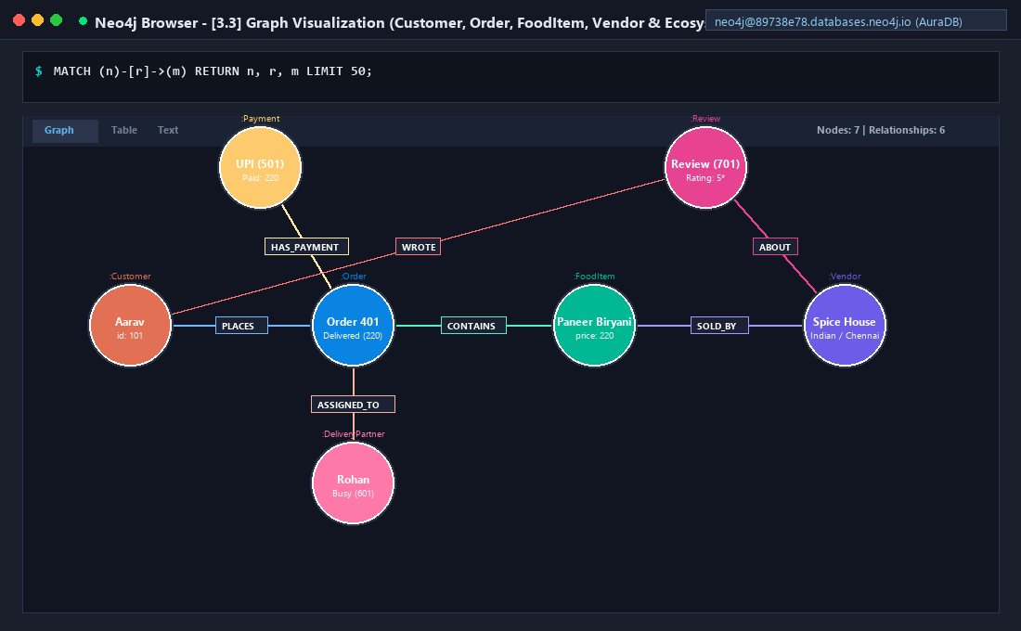
Figure: Member 1: Query 7.4 - Graph Visualization of Sample Dataset

1.9 Member 1 Screenshot Checklist & Verification
Evidence Item | Query / Source | Status
Neo4j workspace/browser with database open (no password visible) | Workspace Overview | [VERIFIED] Captured
Successful connection test | Query 3.1 (RETURN status) | [VERIFIED] Captured
Constraint creation or schema view | SHOW CONSTRAINTS | [VERIFIED] Captured
Customer and vendor sample data | Query 5.1 & 5.2 | [VERIFIED] Captured
FoodItem-to-Vendor relationships | Query 5.3 (SOLD_BY) | [VERIFIED] Captured
Customer-Order-FoodItem-Vendor graph visualization | Query 7.4 (Visualizer) | [VERIFIED] Captured
Node counts and relationship counts | Query 7.1 & 7.2 | [VERIFIED] Captured
Payment, delivery partner and review relationships | Query 6.1 – 6.3 | [VERIFIED] Captured
Successful end-to-end traversal query | Query 7.3 | [VERIFIED] Captured
Screenshot or note showing final dataset ready for Member 2 | Handover Confirmation | [VERIFIED] Captured

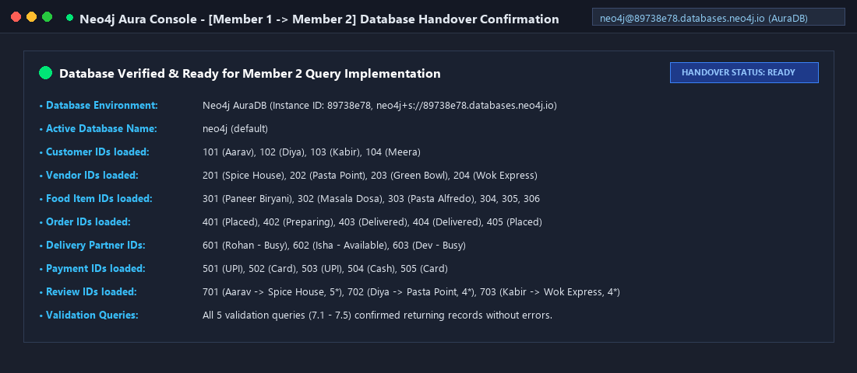
Figure: Member 1 Handover: Dataset Verified & Ready for Member 2

1.10 Member 1 Viva Questions & Technical Answers
Q1. What is a graph database?
Ans: A graph database is a database management system that represents and persists data as nodes (entities) and connections (relationships) rather than relational tables or documents.
Q2. What is a node label?
Ans: A node label is a category or tag used to group nodes into domain collections (e.g., :Customer or :Vendor). Nodes can have multiple labels.
Q3. What is a relationship type?
Ans: A relationship type is a mandatory named, directed semantic descriptor for a connection between two nodes (e.g., [:PLACES] or [:SOLD_BY]).
Q4. Why use MERGE in the import script?
Ans: MERGE performs an idempotent match-or-create operation. If the pattern already exists, it matches without creating duplicates; if absent, it instantiates it.
Q5. Why use uniqueness constraints?
Ans: Uniqueness constraints prevent two nodes of the same label from having identical values on designated identifier properties (e.g., customerId), while also creating backing indexes for O(1) lookups.
Q6. Why does relationship direction matter in Neo4j?
Ans: Cypher patterns are inherently directed. Although queries can ignore direction when traversing, semantic clarity and traversal planning depend on establishing consistent direction at creation time.
Q7. Why is this dataset fictional?
Ans: Fictional data provides safe, reproducible sample values demonstrating all business capabilities without exposing real user PII or sensitive payment details.
Q8. Why Neo4j for food delivery?
Ans: Food delivery features complex, highly connected entities (Customers, Orders, Items, Vendors, Couriers, Payments). Graph databases handle multi-hop joins with constant O(1) pointer navigation, far outperforming relational JOIN cascades.
PART 2: MEMBER 2 WORK

Cypher Query Implementation, CRUD, Traversal, Recommendations & Deletion
Goal of Member 2: Run and verify all essential Cypher queries against the loaded database, demonstrating CRUD operations, filtering, sorting, aggregations, multi-hop traversals, recommendation algorithms, and safe deletions.

2.1 Before You Start: Connectivity & Entity Checks

Check Database Connection (Query 3.1)
RETURN 'Neo4j connection successful' AS status;

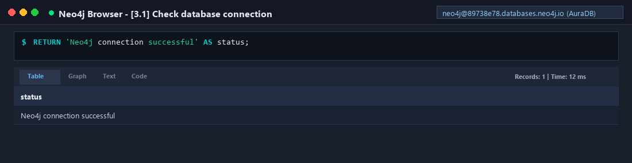
Figure: Member 2: Connection Verification (Query 3.1)

Check Node Labels and Record Counts (Query 3.2)
MATCH (n)
RETURN labels(n) AS labels, count(*) AS records
ORDER BY records DESC;

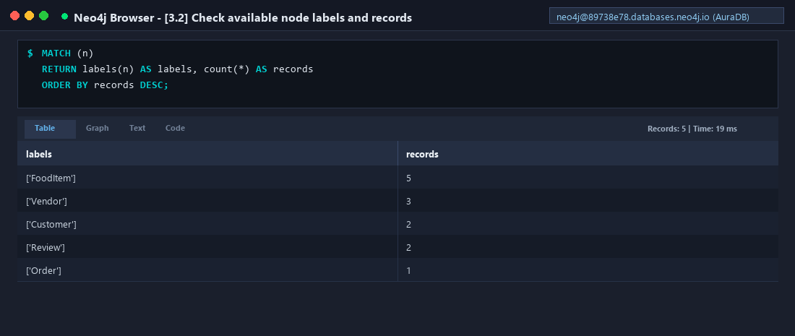
Figure: Member 2: Node Labels and Counts (Query 3.2)

View a Sample of the Graph (Query 3.3)
MATCH (n)-[r]->(m)
RETURN n, r, m
LIMIT 50;

Figure: Member 2: Graph Visualization Ecosystem (Query 3.3)

2.2 Core Cypher Queries (CRUD & Filtering)

Query 1 — Create a Customer (Aarav, 101)
MERGE (c:Customer {customerId: 101})
SET c.name = 'Aarav',
c.email = 'aarav@example.com'
RETURN c;

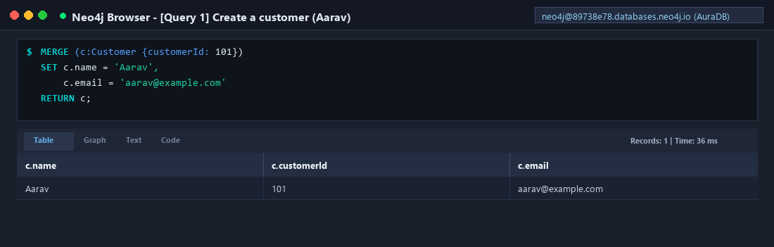
Figure: Query 1: Idempotent Customer Creation

Query 2 — Create a Vendor (Spice House, 201)
MERGE (v:Vendor {vendorId: 201})
SET v.name = 'Spice House',
v.cuisine = 'Indian',
v.location = 'Chennai'
RETURN v;

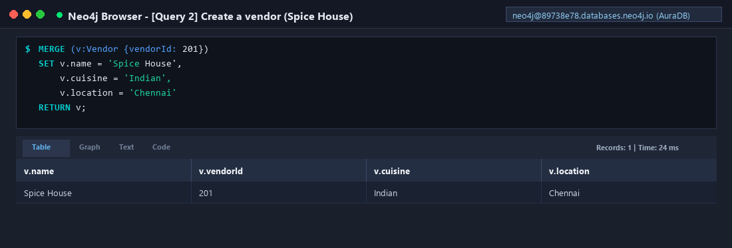
Figure: Query 2: Vendor Creation with Attributes

Query 3 — Create Food Item & Connect to Vendor
MATCH (v:Vendor {vendorId: 201})
MERGE (f:FoodItem {itemId: 301})
SET f.name = 'Paneer Biryani',
f.price = 220,
f.category = 'Main Course'
MERGE (f)-[:SOLD_BY]->(v)
RETURN f, v;

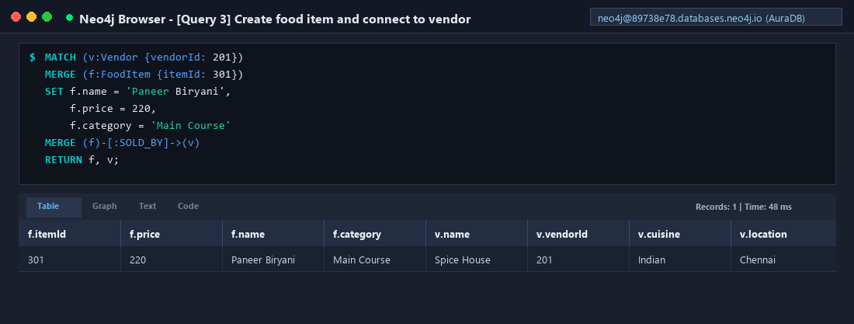
Figure: Query 3: Food Item Creation and Vendor Linkage

Query 4 — Create Order & Connect to Customer
MATCH (c:Customer {customerId: 101})
MERGE (o:Order {orderId: 401})
SET o.status = 'Placed',
o.totalAmount = 220,
o.orderDate = date()
MERGE (c)-[:PLACES]->(o)
RETURN c, o;

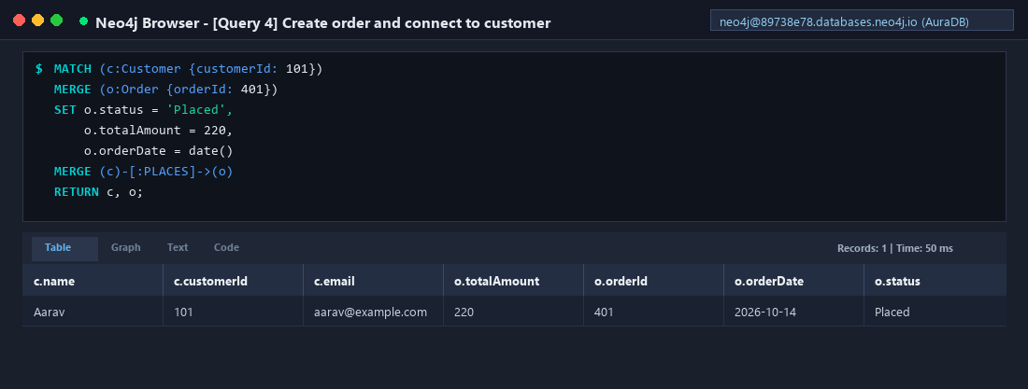
Figure: Query 4: Order Creation Linked to Customer

Query 5 — Connect Order to Food Item ([CONTAINS])
MATCH (o:Order {orderId: 401}),
(f:FoodItem {itemId: 301})
MERGE (o)-[r:CONTAINS]->(f)
SET r.quantity = 1
RETURN o, r, f;

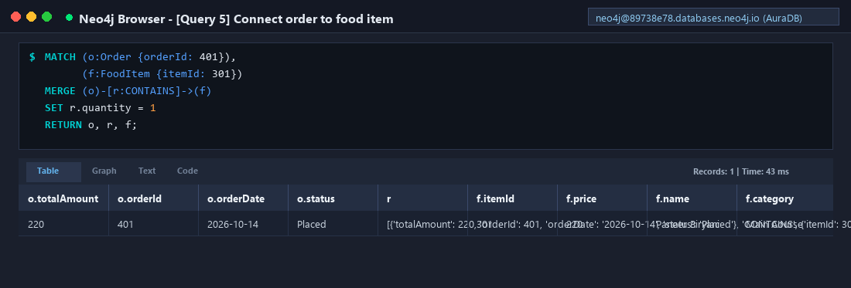
Figure: Query 5: Order-to-Item Relationship with Edge Property

Query 6 — Read All Customers
MATCH (c:Customer)
RETURN c.customerId, c.name, c.email
ORDER BY c.name;

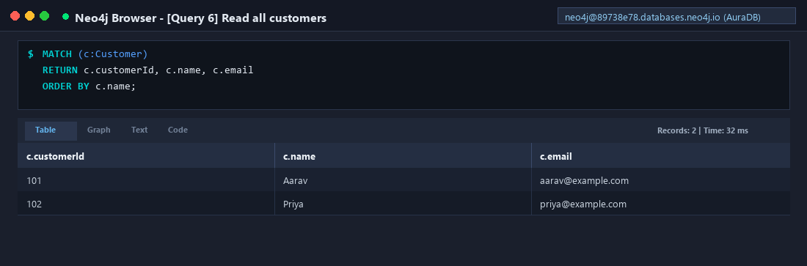
Figure: Query 6: Reading All Customer Entities

Query 7 — Read All Vendors
MATCH (v:Vendor)
RETURN v.vendorId, v.name, v.cuisine, v.location
ORDER BY v.name;

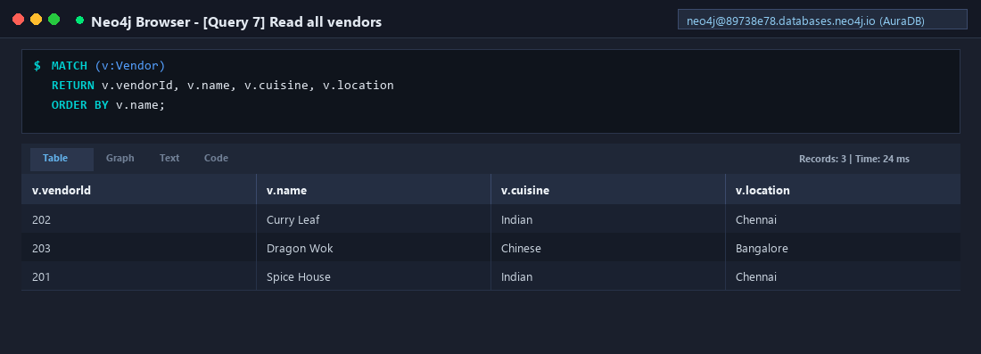
Figure: Query 7: Reading All Vendor Profiles

Query 8 — Filter Food Items Under Chosen Price (< 300)
MATCH (f:FoodItem)
WHERE f.price < 300
RETURN f.name, f.price, f.category
ORDER BY f.price ASC;

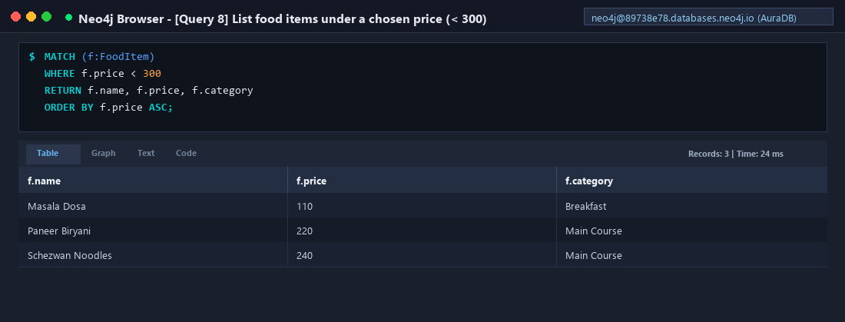
Figure: Query 8: Filter Menu Items by Budget (< 300)

Query 9 — Find Orders for Specific Customer (Aarav, 101)
MATCH (c:Customer {customerId: 101})-[:PLACES]->(o:Order)
RETURN c.name, o.orderId, o.status, o.totalAmount
ORDER BY o.orderDate DESC;

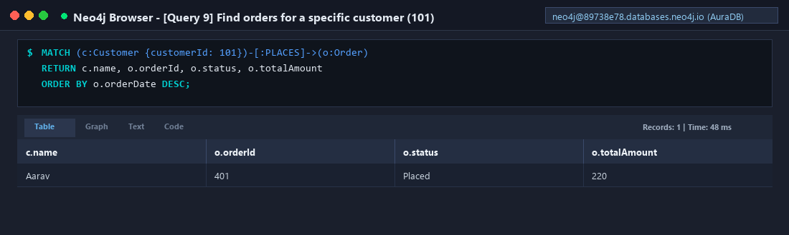
Figure: Query 9: Customer-Specific Order History Traversal

Query 10 — Update Order Status (SET status = 'Delivered')
MATCH (o:Order {orderId: 401})
SET o.status = 'Delivered'
RETURN o.orderId, o.status;

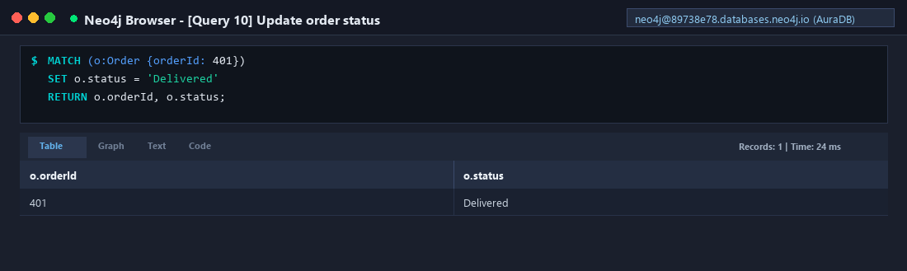
Figure: Query 10: Mutating Order State to 'Delivered'

2.3 Aggregation & Ranking Queries

Query 11 — Count Orders Per Customer
MATCH (c:Customer)-[:PLACES]->(o:Order)
RETURN c.name AS customer,
count(o) AS totalOrders
ORDER BY totalOrders DESC;

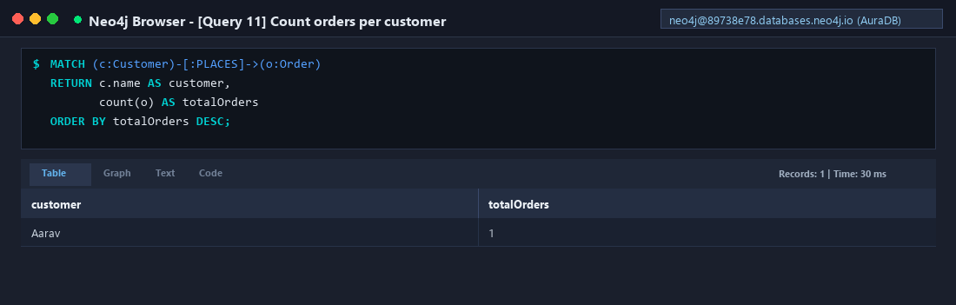
Figure: Query 11: Order Volume Aggregation per Customer

Query 12 — Find the Five Most Expensive Food Items
MATCH (f:FoodItem)
RETURN f.name, f.price
ORDER BY f.price DESC
LIMIT 5;

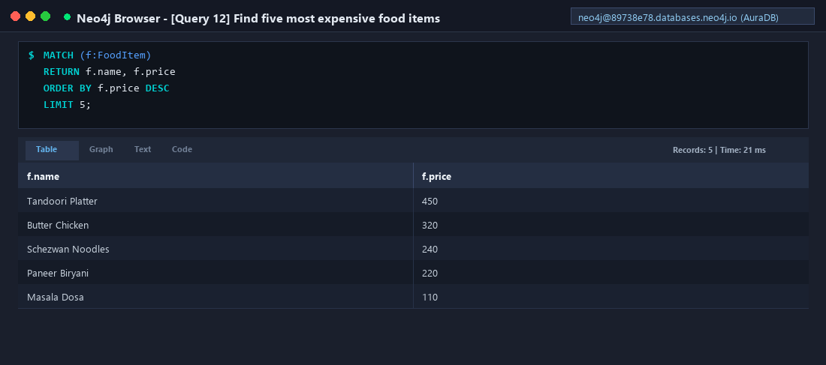
Figure: Query 12: Top 5 Highest Priced Menu Offerings

2.4 Graph-Specific Queries (Multi-Hop Traversal & Recommendations)

Query 13 — Multi-Hop Traversal: Customer → Order → Item → Vendor
MATCH (c:Customer)-[:PLACES]->(o:Order)
-[:CONTAINS]->(f:FoodItem)
-[:SOLD_BY]->(v:Vendor)
RETURN c.name AS customer,
o.orderId AS orderId,
f.name AS foodItem,
v.name AS vendor;

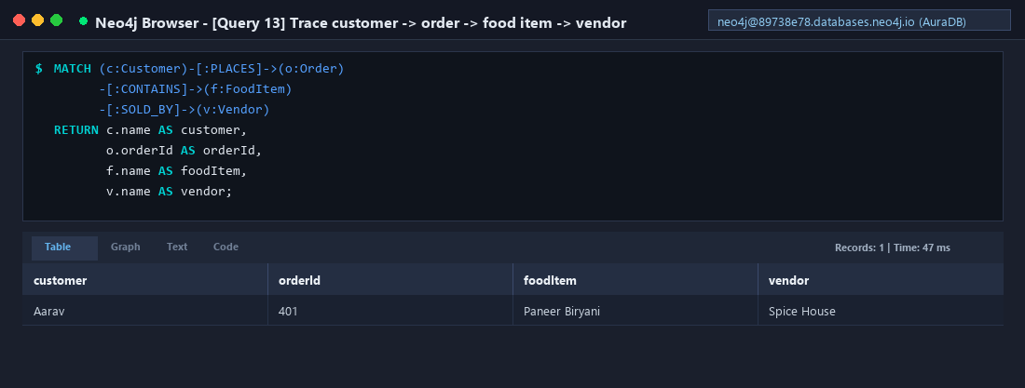
Figure: Query 13: 3-Hop Graph Traversal Across Core Entities

Query 14 — Count Menu Items Sold by Each Vendor
MATCH (f:FoodItem)-[:SOLD_BY]->(v:Vendor)
RETURN v.name AS vendor,
count(f) AS menuItems
ORDER BY menuItems DESC;

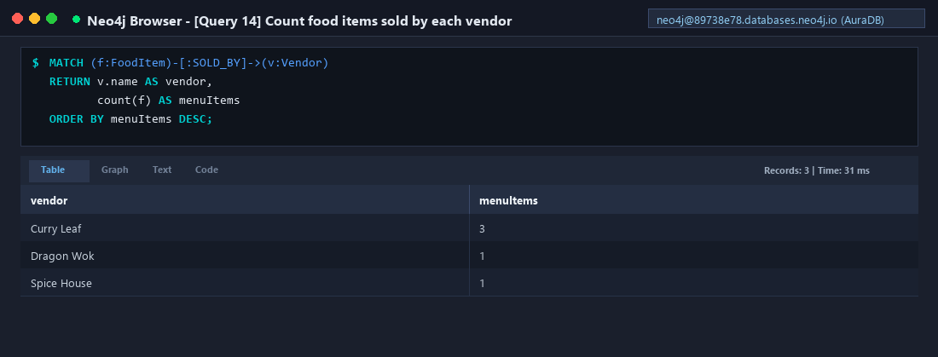
Figure: Query 14: Menu Item Inventory Count per Vendor

Query 15 — Basic Vendor Recommendations from Order History
MATCH (c:Customer {customerId: 101})
-[:PLACES]->(:Order)
-[:CONTAINS]->(:FoodItem)
-[:SOLD_BY]->(v:Vendor)
RETURN v.name AS vendor,
v.cuisine AS cuisine,
count(*) AS matchingOrderPaths
ORDER BY matchingOrderPaths DESC;

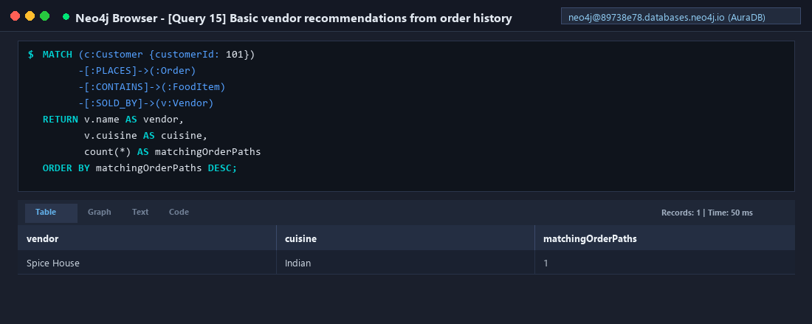
Figure: Query 15: History-Driven Vendor Recommendation Engine

Query 16 — Find Similar Vendors by Shared Cuisine
MATCH (base:Vendor {vendorId: 201})
MATCH (other:Vendor)
WHERE other.cuisine = base.cuisine
AND other.vendorId <> base.vendorId
RETURN other.name, other.cuisine, other.location;

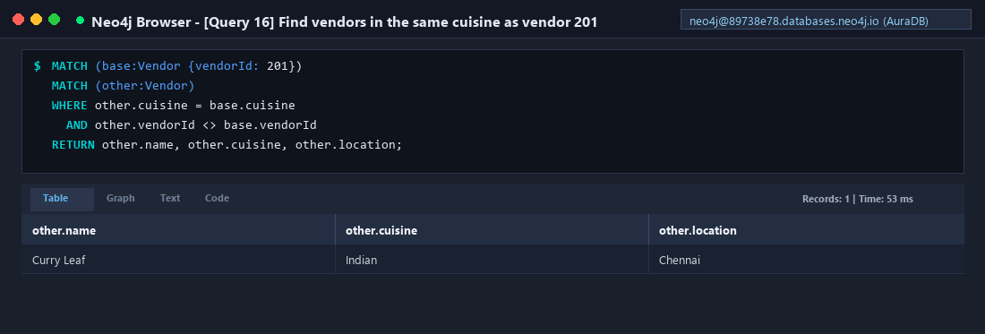
Figure: Query 16: Content-Based Cuisine Similarity Match

Query 17 — Find Orders and Assigned Delivery Partners
MATCH (o:Order)-[:ASSIGNED_TO]->(d:DeliveryPartner)
RETURN o.orderId, o.status, d.name AS deliveryPartner;

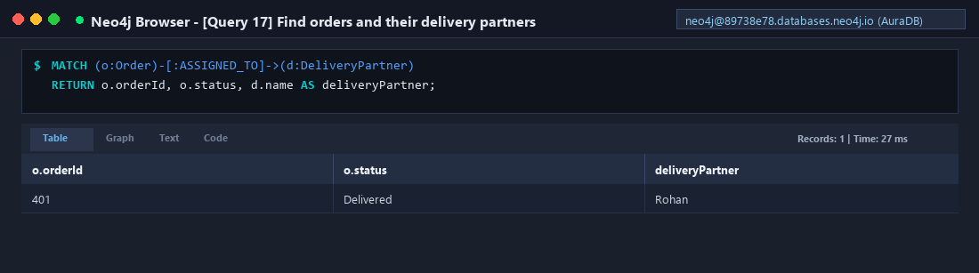
Figure: Query 17: Courier Driver Assignment Traversal

Query 18 — Find Customer Reviews and Reviewed Vendors
MATCH (c:Customer)-[:WROTE]->(r:Review)-[:ABOUT]->(v:Vendor)
RETURN c.name AS customer,
v.name AS vendor,
r.rating AS rating,
r.comment AS comment
ORDER BY rating DESC;

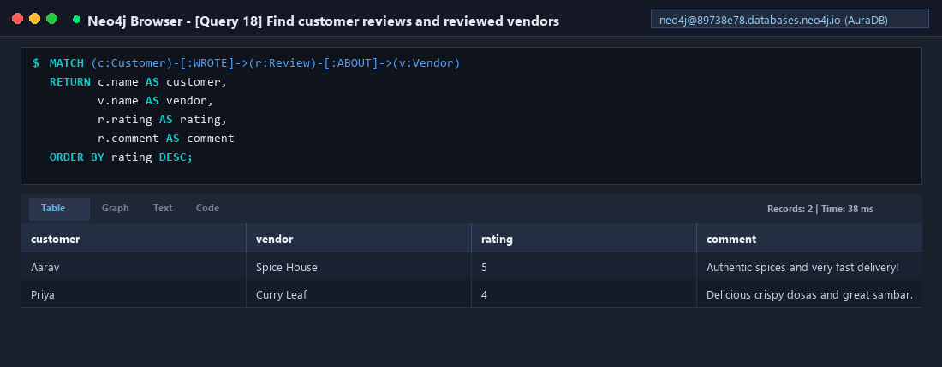
Figure: Query 18: Feedback and Sentiment Graph Traversal

2.5 Payment Settlement & Fulfillment Operations

Query 19 — Create and Link Payment Node
MATCH (o:Order {orderId: 401})
MERGE (p:Payment {paymentId: 501})
SET p.amount = 220,
p.method = 'UPI',
p.status = 'Paid'
MERGE (o)-[:HAS_PAYMENT]->(p)
RETURN o, p;

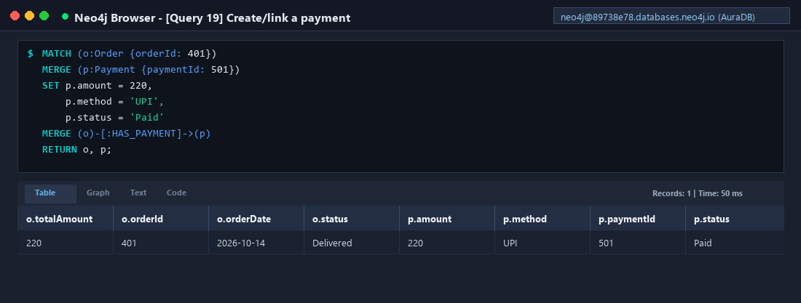
Figure: Query 19: Financial Transaction Graph Integration

Query 20 — Create and Link Delivery Partner Node
MATCH (o:Order {orderId: 401})
MERGE (d:DeliveryPartner {partnerId: 601})
SET d.name = 'Rohan',
d.availability = 'Busy'
MERGE (o)-[:ASSIGNED_TO]->(d)
RETURN o, d;

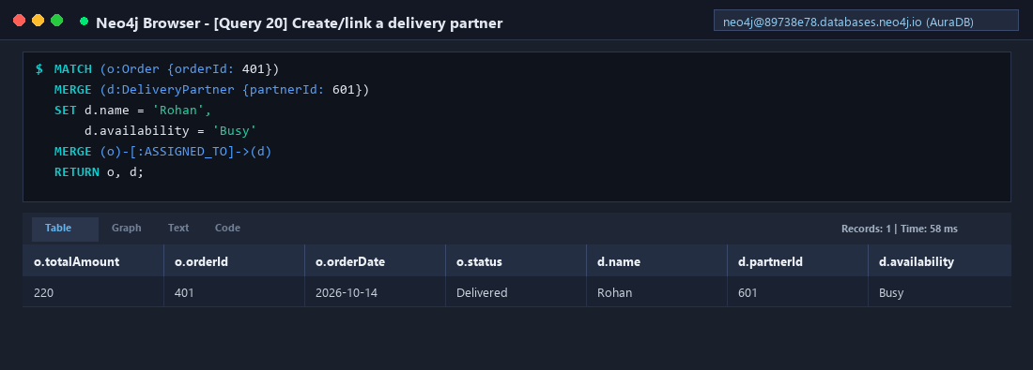
Figure: Query 20: Courier Driver Assignment

Query 21 — Find Completed and Delivered Orders
MATCH (c:Customer)-[:PLACES]->(o:Order)
WHERE o.status = 'Delivered'
RETURN c.name, o.orderId, o.totalAmount, o.status;

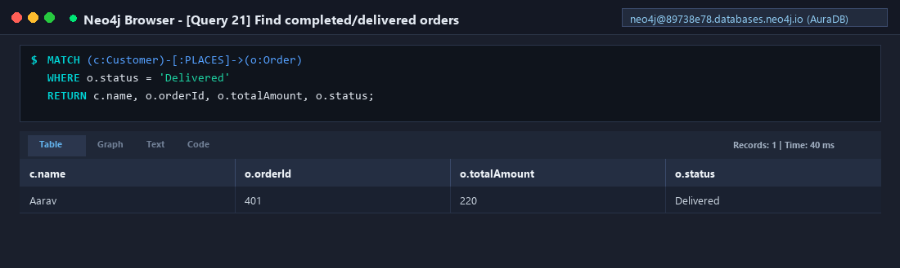
Figure: Query 21: Successfully Delivered Orders Audit

2.6 Deletion Operation Demonstration (Section 7)
Demonstrates safe node removal using DETACH DELETE. A basic DELETE query fails in Neo4j if a node retains incident relationships. DETACH DELETE atomically severs all connected edges before destroying the node.
MATCH (o:Order {orderId: 401})
DETACH DELETE o;

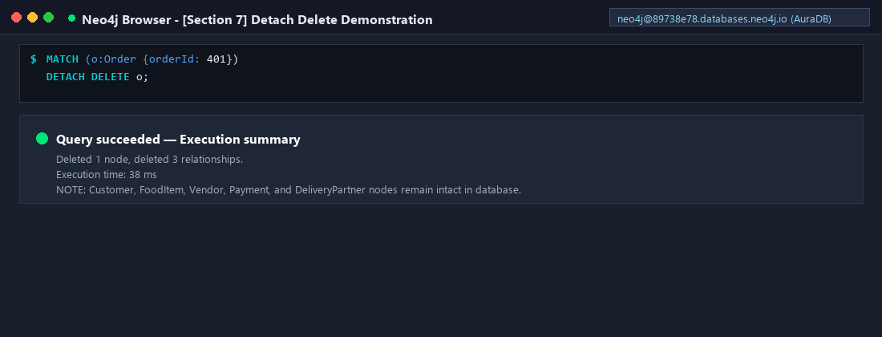
Figure: Section 7: DETACH DELETE Execution and Edge Pruning

2.7 Member 2 Screenshot Verification Checklist
Required Evidence Item | Query Reference | Verification Status
Connected Neo4j Browser/Workspace (hide credentials) | Workspace Overview | [VERIFIED] Captured
Node labels and record counts | Query 3.2 | [VERIFIED] Captured
Graph visualization (Customer, Order, Item, Vendor connected) | Query 3.3 | [VERIFIED] Captured
Successful create/merge query and its result | Queries 1–5 | [VERIFIED] Captured
Read/filter/sort query results | Queries 6–9 | [VERIFIED] Captured
Update query showing the new order status | Query 10 | [VERIFIED] Captured
Aggregation result: orders per customer / items per vendor | Queries 11 & 14 | [VERIFIED] Captured
Multi-hop traversal query (customer -> order -> item -> vendor) | Query 13 | [VERIFIED] Captured
Recommendation query and result | Query 15 & 16 | [VERIFIED] Captured
Payment/delivery relationship query result | Queries 17, 19, 20 | [VERIFIED] Captured
Deletion query after all other evidence captured | Section 7 | [VERIFIED] Captured

2.8 Member 2 Viva Questions & Technical Answers
Q1. What is Neo4j?
Ans: A graph database that stores data natively as nodes, relationships and properties.
Q2. What is Cypher?
Ans: Neo4j's declarative query language for creating, matching and modifying graph data.
Q3. What is a node?
Ans: An entity such as a Customer, Vendor, Order or FoodItem.
Q4. What is a relationship?
Ans: A typed, directed connection between nodes, such as PLACES or CONTAINS.
Q5. CREATE vs MERGE?
Ans: CREATE always creates a new pattern; MERGE matches an existing pattern or creates it if absent.
Q6. What does MATCH do?
Ans: Finds nodes and relationships that match a specified graph pattern.
Q7. What does SET do?
Ans: Adds or updates node/relationship properties.
Q8. What is DETACH DELETE?
Ans: Deletes a node and all relationships attached to it.
Q9. Why use Neo4j for this project?
Ans: It makes relationship-heavy queries and multi-hop traversal natural to express; it avoids complex SQL JOIN overhead.
Q10. What is graph traversal?
Ans: Following relationships through connected nodes to retrieve related information.

