DevOps

Day – 6

Assignment

Name:Debehaa J

Roll No:22CSR037

# Prometheus

Prometheus is an open-source system monitoring and alerting toolkit originally built at

SoundCloud. It is now a standalone open source project . Prometheus joined the

Cloud Native

Computing Foundation in 2016 as the second hosted project, after Kubernetes.

Prometheus Architecture

Prometheus Server – Collects and stores metrics.

Pushgateway – Receives metrics from short-lived jobs.

Exporters – Agents that expose metrics (e.g., Node Exporter for system stats).

Alertmanager – Handles alerts based on defined rules Grafana (Optional) – For visualization.

Common Prometheus Commands

sh CopyEdit prometheus --config.file=prometheus.yml curl http://localhost:9090/metrics promtool check config prometheus.yml promtool query instant up

Common Prometheus Use Cases

* Monitoring Kubernetes clusters
* Tracking system health (CPU, RAM, disk, network)
* Alerting on performance issues
* Logging API response times
* Monitoring microservices

Features

1. a multi-dimensional data model with time series data identified by metric name and key/value pairs
2. PromQL, a flexible query language to leverage this dimensionality
3. no reliance on distributed storage; single server nodes are autonomous
4. time series collection happens via a pull model over HTTP
5. pushing time series is supported via an intermediary gateway
6. targets are discovered via service discovery or static configuration
7. multiple modes of graphing and dashboarding support

PROMETHEUS INSTALLATION:

sudo useradd \

--system \

--no-create-home \

--shell /bin/false prometheus

wget

https://github.com/prometheus/prometheus/releases/download/v2.47.1/promethe us-2.47.1.linux-amd64.tar.gz tar -xvf prometheus-2.47.1.linux-amd64.tar.gz sudo mkdir -p /data /etc/prometheus cd prometheus-2.47.1.linux-amd64/ sudo mv prometheus promtool /usr/local/bin/ sudo mv consoles/ console_libraries/ /etc/prometheus/ sudo mv prometheus.yml /etc/prometheus/prometheus.yml sudo chown -R prometheus:prometheus /etc/prometheus/ /data/

[12:00 PM, 3/22/2025] +91 90928 13114: cd rm -rf prometheus-2.47.1.linux-amd64.tar.gz prometheus --version sudo vim /etc/systemd/system/prometheus.service [12:09 PM, 3/22/2025] +91 90928 13114: [Unit] Description=Prometheus

Wants=network-online.target

After=network-online.target

StartLimitIntervalSec=500

StartLimitBurst=5

[Service]

User=prometheus

Group=prometheus

Type=simple

Restart=on-failure

RestartSec=5s

ExecStart=/usr/local/bin/prometheus \

--config.file=/etc/prometheus/prometheus.yml \

--storage.tsdb.path=/data \

--web.console.templates=/etc/prometheus/consoles \

--web.console.libraries=/etc/prometheus/console_libraries \

--web.listen-address=0.0.0.0:9090 \

--web.enable-lifecycle

[Install]

WantedBy=multi-user.target sudo systemctl enable prometheus sudo systemctl start prometheus sudo systemctl status prometheus journalctl -u prometheus -f --no-pager sudo useradd \

--system \

--no-create-home \

--shell /bin/false node_exporter

wget

https://github.com/prometheus/node_exporter/releases/download/v1.6.1/node_ex porter-1.6.1.linux-amd64.tar.gz tar -xvf node_exporter-1.6.1.linux-amd64.tar.gz

sudo mv \

node_exporter-1.6.1.linux-amd64/node_exporter \

/usr/local/bin/

rm -rf node_exporter* node_exporter --version sudo vim /etc/systemd/system/node_exporter.service

Description=Node Exporter

Wants=network-online.target

After=network-online.target

StartLimitIntervalSec=500

StartLimitBurst=5

[Service]

User=node_exporter

Group=node_exporter

Type=simple

Restart=on-failure

RestartSec=5s

ExecStart=/usr/local/bin/node_exporter \

--collector.logind

[Install]

WantedBy=multi-user.target sudo systemctl enable node_exporter sudo systemctl start node_exporter sudo systemctl status node_exporter journalctl -u node_exporter -f --no-pager

* job_name: 'jenkins' metrics_path: '/prometheus' static_configs:
* targets: ['<jenkins-ip>:8080promtool check config /etc/prometheus/prometheus.yml curl -X POST http://localhost:9090/-/reload sudo apt-get install -y apt-transport-https software-properties-common wget -q -O - https://packages.grafana.com/gpg.key | sudo apt-key add -

echo "deb https://packages.grafana.com/oss/deb stable main" | sudo tee -a /etc/apt/sources.list.d/grafana.list

sudo apt-get update sudo apt-get -y install grafana sudo systemctl enable grafana-server sudo systemctl start grafana-server sudo systemctl status grafana-server

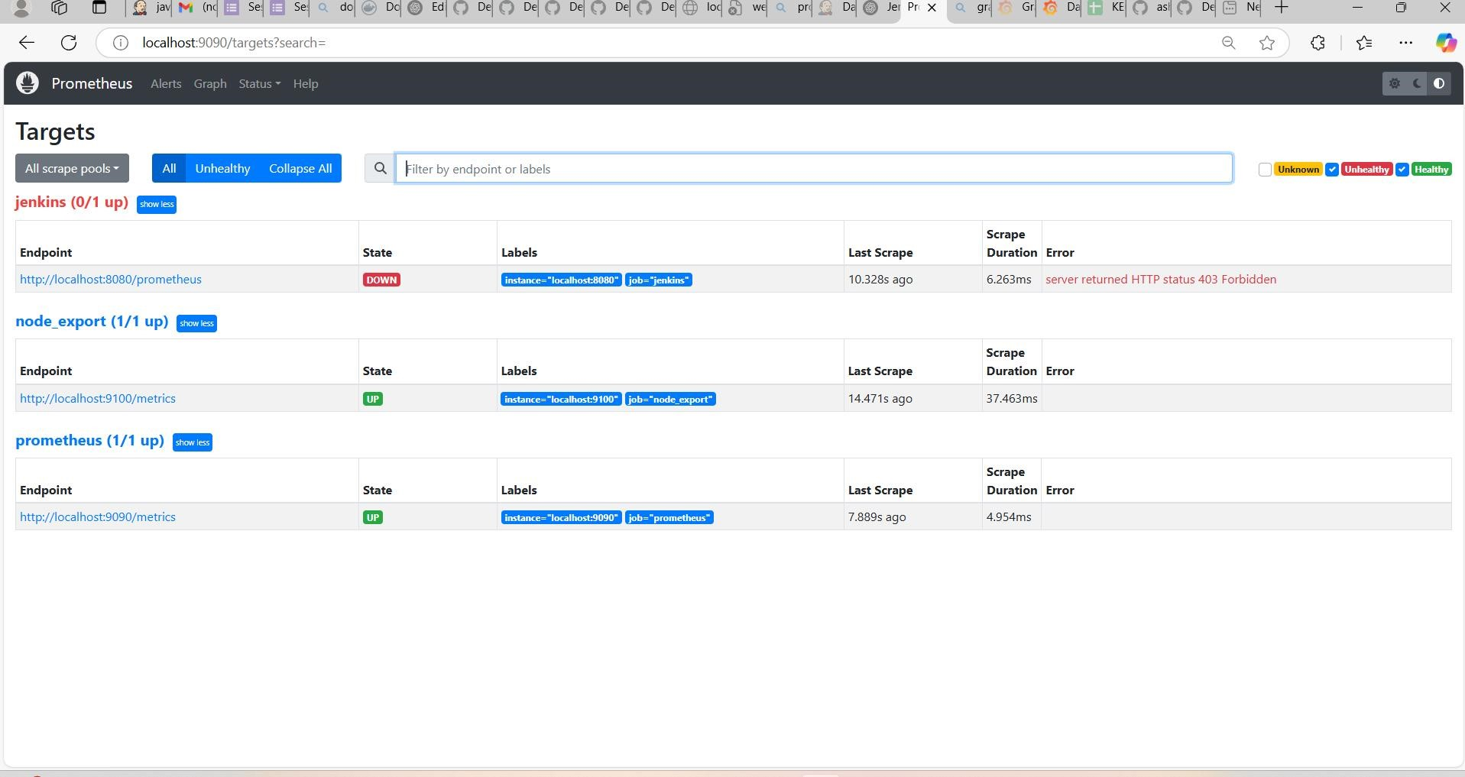

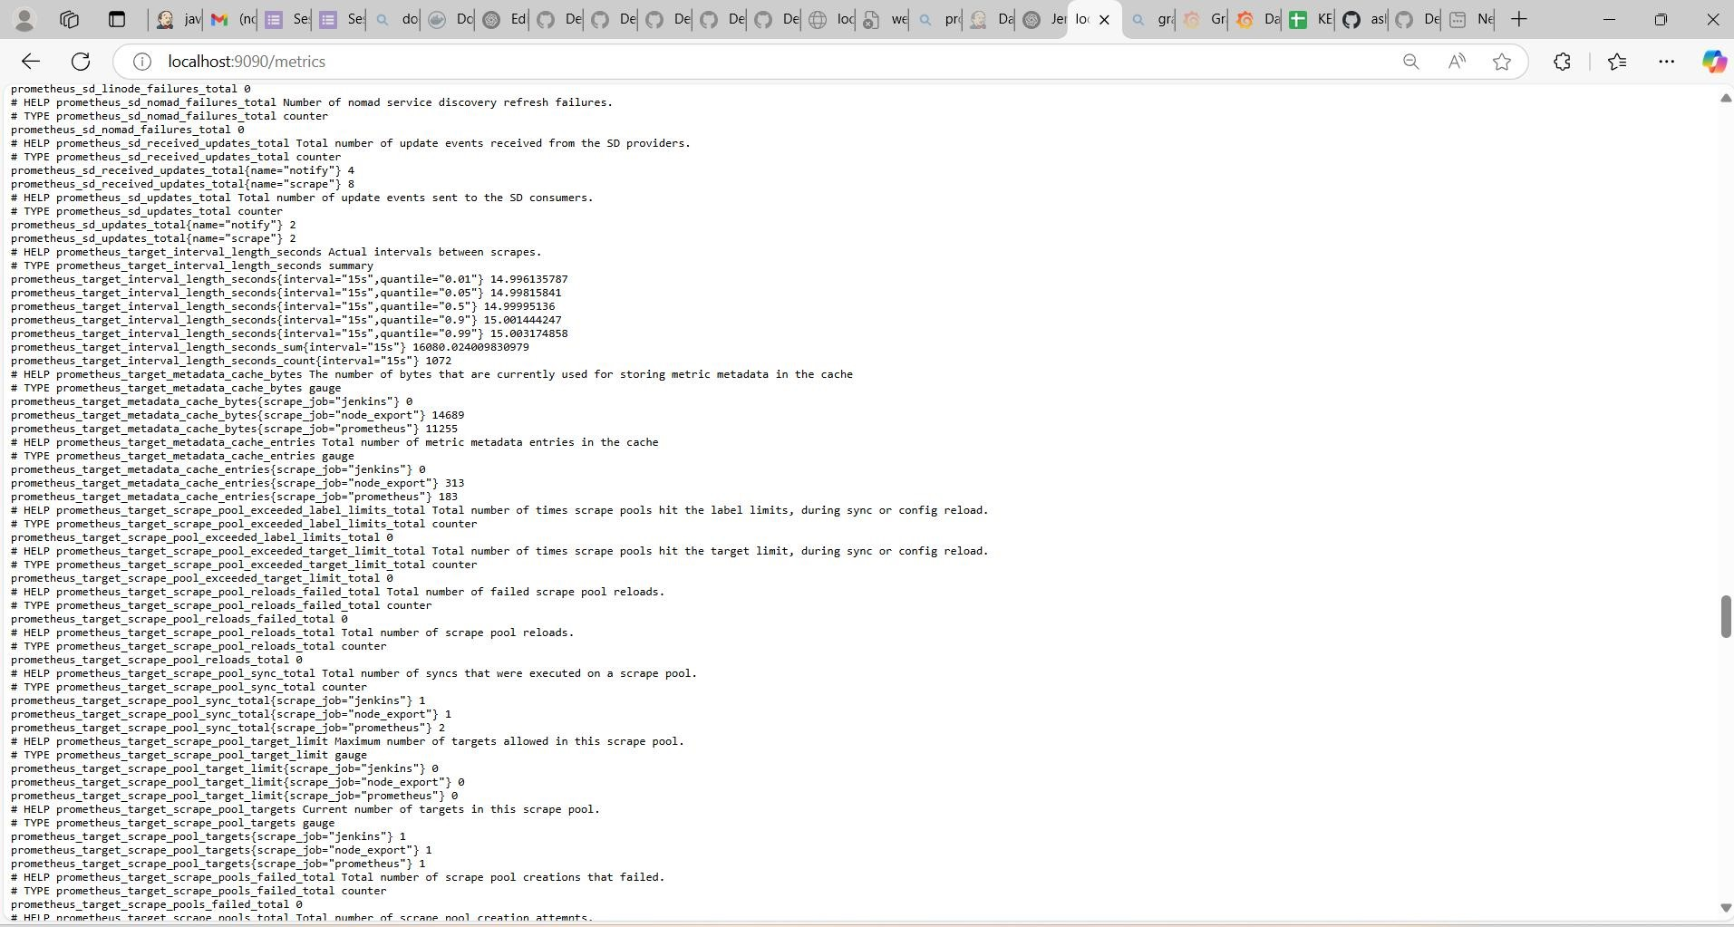

QUERY:

rate(node_cpu_seconds_total{mode="system"}[1m])

node_cpu_seconds_total: This metric represents the total CPU time spent in different modes (user, system, idle, etc.). mode="system": Filters only CPU time spent in system/kernel mode.

rate(...[1m]): Calculates the per-second increase of this metric over the last 1 minute.

What it does:

This query shows the CPU usage in system mode per second over the past 1 minute.

Useful for detecting high system resource consumption by kernel processes.

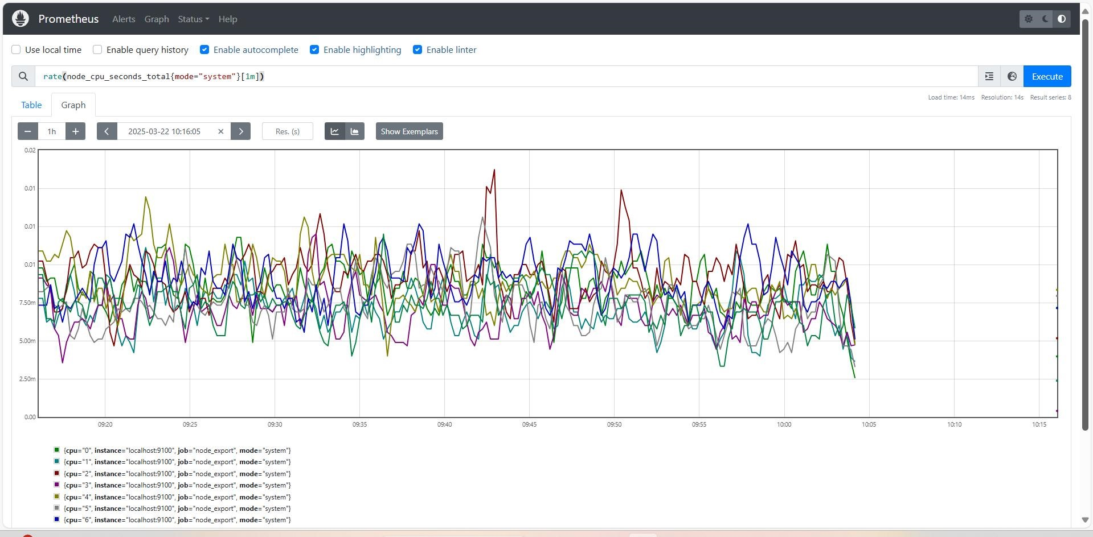

rate(node_network_receive_bytes_total[1m])

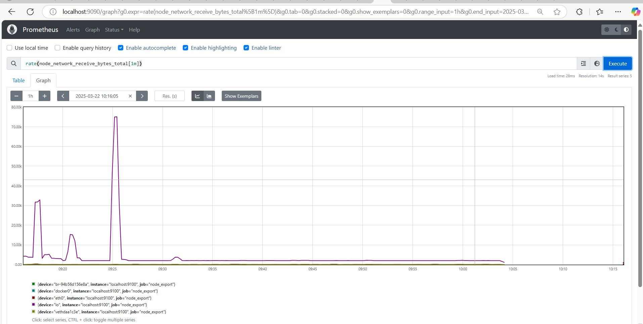

node_load15

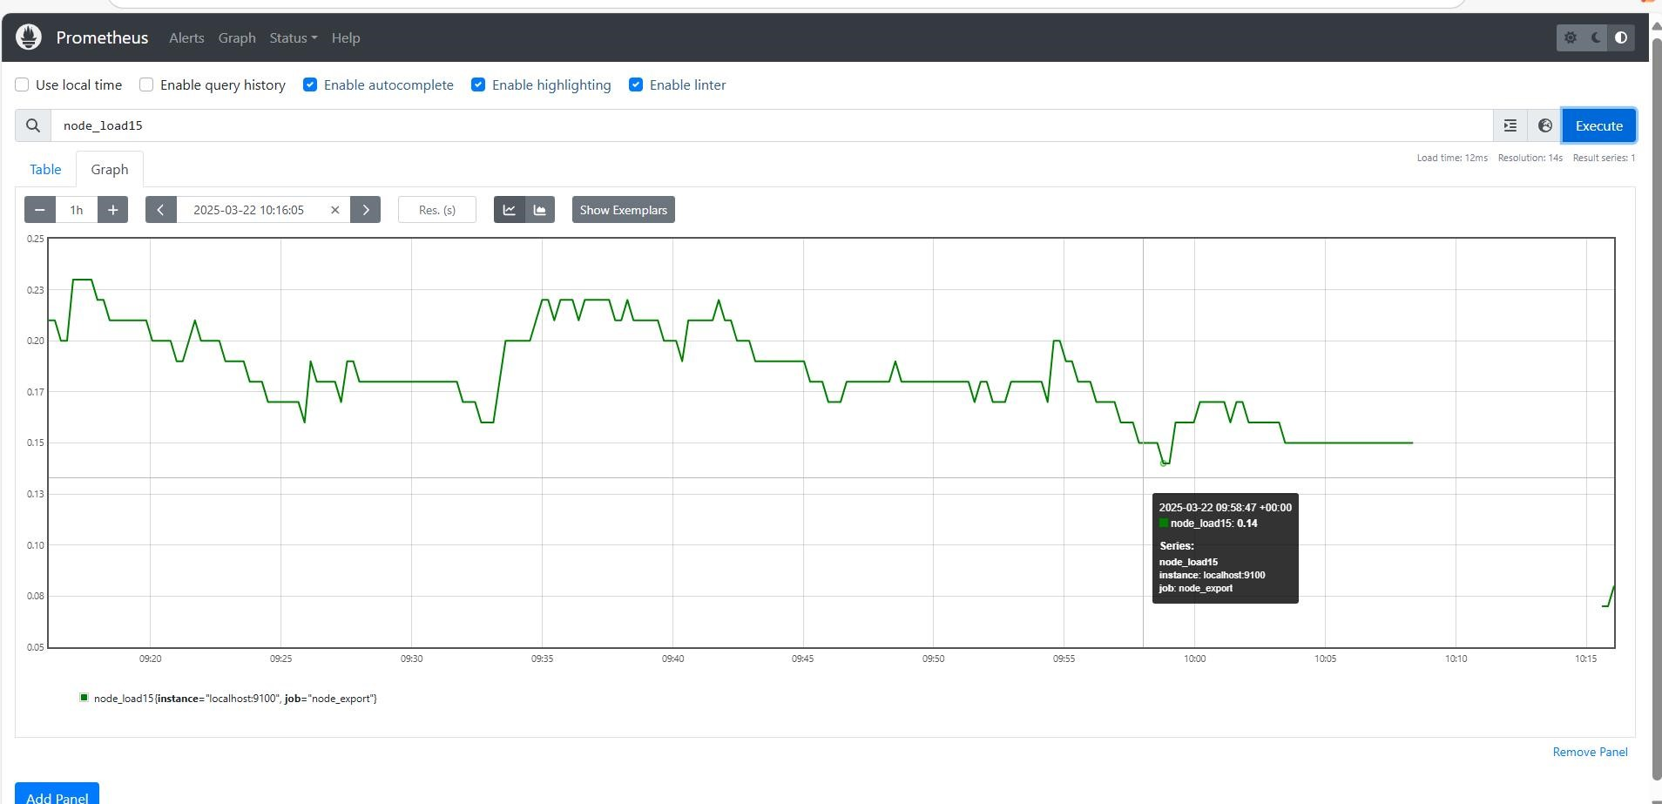

GRAFANA:

Grafana is an open-source analytics and visualization platform used for monitoring and observability. It allows users to create interactive dashboards from multiple data sources like Prometheus, InfluxDB, Elasticsearch, MySQL, and more.

GRAFANA INSTALLATION:

sudo apt-get install -y apt-transport-https software-properties-common wget -q -O - https://packages.grafana.com/gpg.key | sudo apt-key add echo "deb https://packages.grafana.com/oss/deb stable main" | sudo tee -a

/etc/apt/sources.list.d/grafana.list sudo apt-get update sudo apt-get -y install grafana sudo systemctl enable grafana-server sudo systemctl start grafana-server sudo systemctl status grafana-server

