Lesson 3: Describing Quantitative Data; Shape

Homework

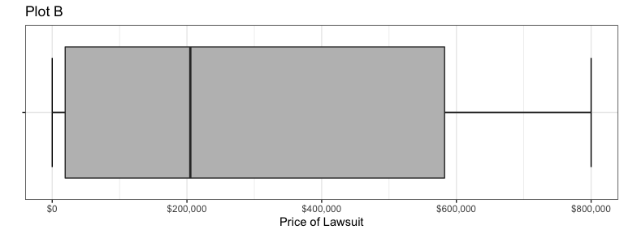

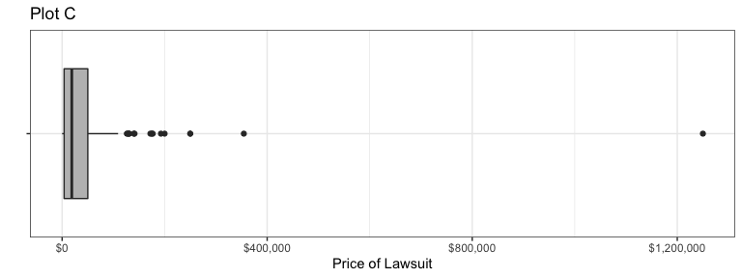

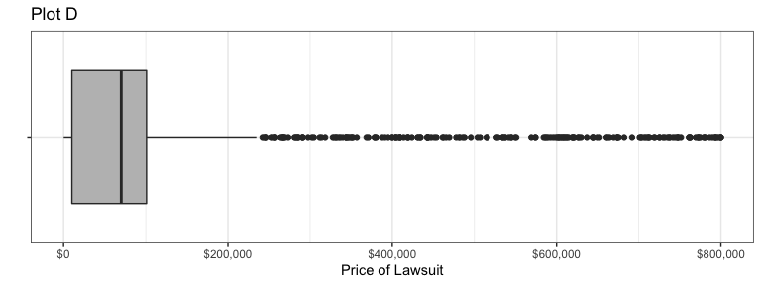

1. What is the shape of the distribution of wrong-patient lawsuit costs?
   1. Right Skewed
   2. Symmetric
   3. Left Skewed
   4. Bell Shaped
2. Find the mean amount hospitals had to pay in wrong-patient lawsuits. Round your answer to the nearest whole dollar.
3. Find the median amount hospitals had to pay in wrong-patient lawsuits.

Use the following information to answer Questions 9 and 10. The graph below illustrates typical student hourly wages for BYU-Idaho.

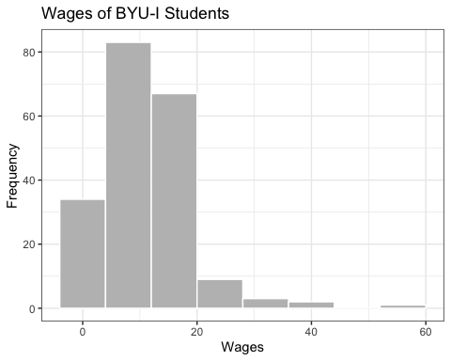

1. Approximately, how many students are in this survey?
2. How would you describe the shape of the distribution of wages?

The number of hours students spent studying for an exam were recorded. The data are represented by the boxplot below. Use this boxplot to answer Questions 11 through 13.

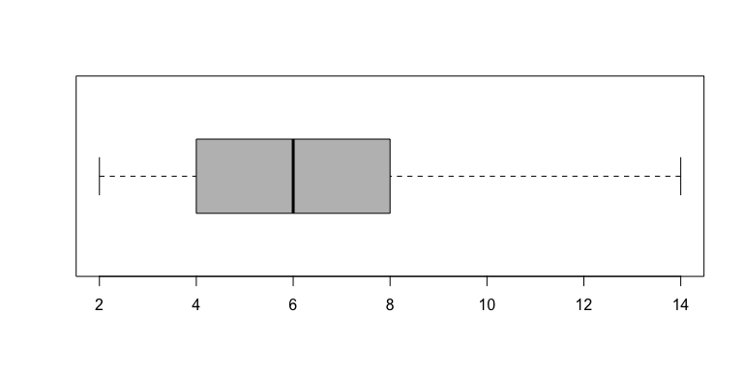

1. Match each graph below to the description of its shape.

Uniform =  
Bell-shaped =  
Right-skewed =  
Left-skewed =  
Symmetric, but not bell-shaped or uniform =

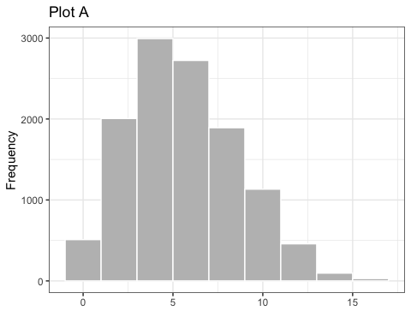

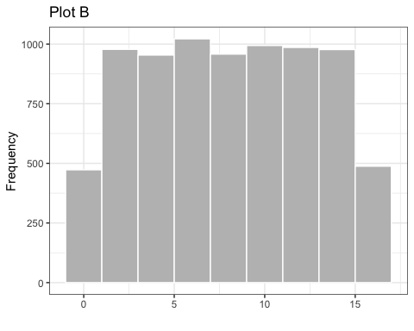

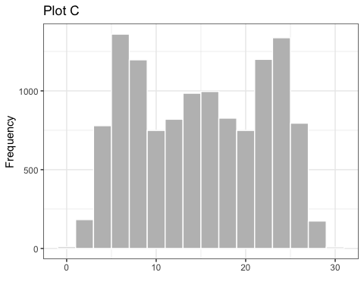

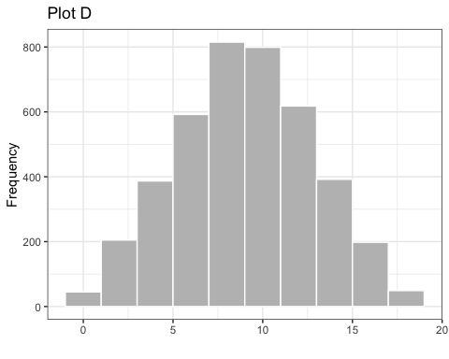

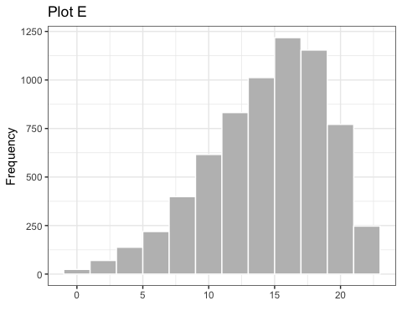

1. A reporter creates a histogram of baseball player salaries and finds that the distribution of salaries is right-skewed. Which measure of center would be greater, the mean or the median?

–>

## Solutions

**Please note that the steps show rounded numbers, but that the final answers to the problems are calculated without rounding.**

|  |  |  |
| --- | --- | --- |
| Problem | Part | Solution |
| 1 | - | a. Right Skewed |
| 2 | - | $46,172 |
| 3 | - | $18,882 |
| 4 | - | This is just a rough estimate, but somewhere between 190 and 200 |
| 5 | - | Right-skewed |
| 6 | A | Uniform = b |
| 6 | B | Bell-shaped = d |
| 6 | C | Right-skewed = a |
| 6 | D | Left-skewed = e |
| 6 | E | Symmetric, but not bell-shaped or uniform = c |
| 7 | - | The mean |