Lesson 6: Sampling Distributions of the Sample Mean; Central Limit Theorem

Preparation

**Directions: Please fill in Part I as you study the Reading Assignment. Once you finish the reading, complete the questions on Part II. You may use your notes, the key, and the help videos. Be sure to take this completed assignment to your group meeting where you can ask and help answer questions on this assignment.**

## Problems

**Part I:** Use the information in the reading assignment to complete these questions.

1. What is the sampling distribution?
2. What is the shape of the sampling distribution of the sample mean when the data are normally distributed?
3. What is the shape of the distribution of sample means when the data are not normally distributed, but the sample size is large?
4. How does the shape of the distribution of sample means change when the sample size is increased?
5. What is the difference between the Central Limit Theorem and the Law of Large Numbers?
6. When is $\overline{x}$ normally distributed?

Please cut out the squares on the following page. Select five at random and compute the sample mean ($\overline{x}$). An alternative to cutting them out is to go to [random.org](http://www.random.org/integers) and generate 5 random integers between 1 and 30. Use the salaries from the 5 squares corresponding to your 5 random integers to compute the sample mean ($\overline{x}$). You will use this information to complete Part II.

**Part II.**

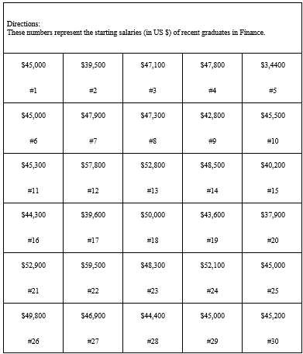

StartingSalaries

1. Randomly select 5 of the 30 salaries and compute the mean.
   1. What is the mean of your sample?
   2. This graph illustrates the distribution of sample means. There are 142,506 possible combinations of the 30 salaries, drawn 5 at a time. This graph represents the distribution of all possible samples. Make a mark on the horizontal axis to indicate the value of your sample mean from part a. 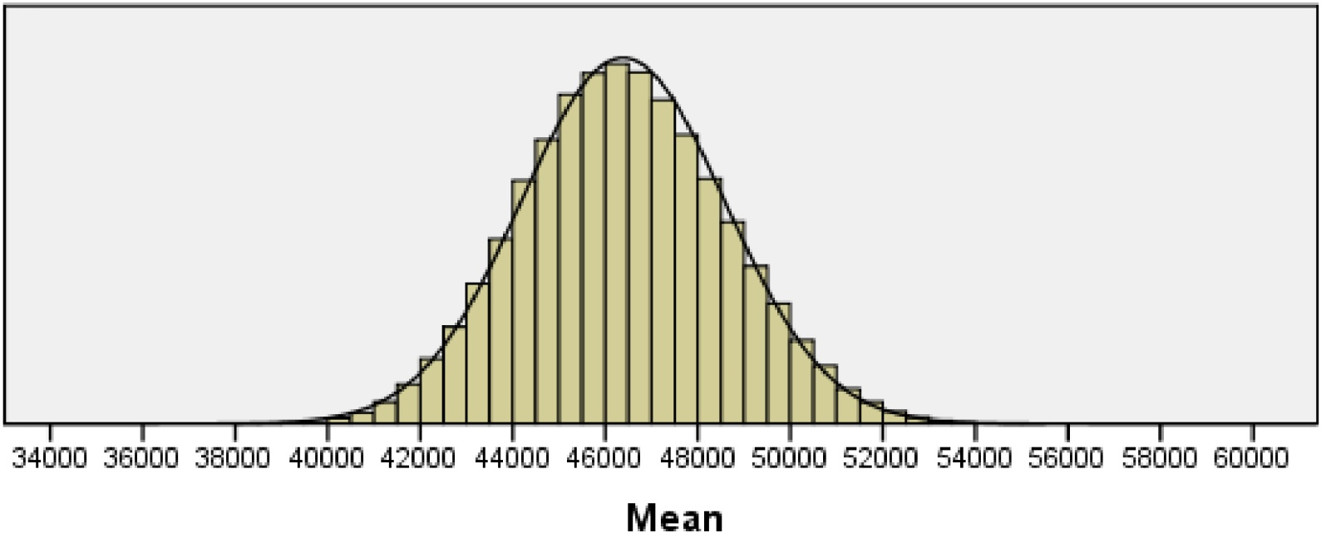
   3. Does your sample mean appear to be unusual? Explain why you think it is (or is not) unusual.
   4. Compare your mean from question 7a to the means obtained by at least three other individuals. What do you notice? In practice, you only get to see the means from the samples you draw. You do not get to observe any other mean that could have occurred.
2. The Graduate Management Admission Test (GMAT) is used as an admission criterion in many masters of business administration (MBA) programs. The scores on the GMAT are normally distributed with a mean of $μ=529$ and a standard deviation of $σ=113$. Consider a simple random sample (SRS) or $n=10$ students taking the GMAT.
   1. What is the shape of the distribution of the sample means for all such samples?
   2. How do you know that the distribution of the sample mean has this shape?
   3. What is the mean of the sampling distribution of sample mean scores for all such samples?
   4. What is the standard deviation of the distribution of sample means scores for all such samples?