SIMATS ENGINEERING
ASSESSMENT TOOL 1
COURSE CODE: CSA1442 COURSE NAME: Compiler Design for Higher
Level Processing
COURSE OUTCOME COVERED
CO2: Construct top-down and bottom up parsers using CFG for parsing conflicts and error recovery for efficient syntax tree generation. (BL3)
Assessment Tool Weightage: 40%

QUESTIONS:4 Total Marks:50

Annexure A DESIGN TASK
Code of Conduct:

I Deepak rao L / 192421170 certify that this submission is my original work and that I have adhered to the guidelines specified for this assessment.
I understand that any violation of academic integrity rules will result in disciplinary action.

Signature of the student:
Deepak Rao L / 192421170

Q1. PREDICTIVE PARSER DESIGN (LL(1) PARSER):
SOLUTION:
Aim:
To construct an LL(1) Predictive Parsing Table for the given grammar and demonstrate its application by parsing the input string:
Input: id + id * id
Step 1: Given Grammar
E → T E'
E' → + T E' | ε
T → F T'
T' → * F T' | ε
F → (E) | id

Step 2: Remove Left Recursion
The given grammar already has no left recursion.
Therefore,
Left recursion removed grammar:
E → T E'
E' → + T E' | ε
T → F T'
T' → * F T' | ε
F → (E) | id

Step 3: FIRST Sets,
FIRST(E)
- → T E'
Since, T → F T'
- → (E) | id
Therefore

FIRST(E) = FIRST(T)
FIRST(E) = {(, id}

FIRST(E')
E' → + T E'
E' → ε
Therefore,
FIRST(E') = {+, ε}

FIRST(T)
T → F T'
FIRST(T) = FIRST(F)
FIRST(T) = {(, id}

FIRST(T')
T' → * F T'
T' → ε
Therefore
FIRST(T') = {*, ε}

FIRST(F)
F → (E)
F → id
Therefore
FIRST(F) = {(, id}

FIRST Table:
Non-Terminal | FIRST
E | {( , id}
E' | {+, ε}
T | {( , id}
T' | {*, ε}
F | {( , id}

Step 4: FOLLOW Sets
Start Symbol
FOLLOW(E) = {$}
F → (E)
')' follows E
FOLLOW(E) = { ), $ }

FOLLOW(E')
From
E → T E'
E' is at the end.
FOLLOW(E') = FOLLOW(E)
FOLLOW(E') = { ), $ }

FOLLOW(T)
From
E → T E'
FIRST(E')= {+, ε}
FOLLOW(T)= {+}

FOLLOW(E)= {),$}
FOLLOW(T) = { + , ) , $ } FOLLOW(T')
From
T → F T'
T' occurs at end.
FOLLOW(T') = FOLLOW(T)
FOLLOW(T')={+,),$}

FOLLOW(F)
From
T → F T'
FIRST(T')={*,ε}
FOLLOW(F)={*}

FOLLOW(T)={+,),$}
Therefore
FOLLOW(F)={*,+,),$}

FOLLOW table:
Non-Terminal | FOLLOW
E | { ), $ }
E' | { ), $ }
T | { +, ), $ }
T' | { +, ), $ }
F | { *, +, ), $ }

Step 5: Construct LL(1) Parsing Table
Non-  Terminal | id | + | * | ( | ) | $
E | E→TE' |  |  | E→TE'
E' |  | E'→+TE' |  |  | E'→ε | E'→ε
T | T→FT' |  |  | T→FT'
T' |  | T'→ε | T'→*FT' |  | T'→ε | T'→ε
F | F→id |  |  | F→(E)

Step 6: Parsing the Input Input String: id + id * id $
Initial Stack: E$
Step-by-Step Parsing
Step | Stack | Input | Action
1 | E$ | id+id*id$ | Apply E→TE'
2 | TE'$ | id+id*id$ | Apply T→FT'
3 | FT'E'$ | id+id*id$ | Apply F→id
4 | idT'E'$ | id+id*id$ | Match id
5 | T'E'$ | +id*id$ | Apply T'→ε
6 | E'$ | +id*id$ | Apply E'→+TE'
7 | +TE'$ | +id*id$ | Match +
8 | TE'$ | id*id$ | Apply T→FT'
9 | FT'E'$ | id*id$ | Apply F→id
10 | idT'E'$ | id*id$ | Match id
11 | T'E'$ | *id$ | Apply T'→*FT'
12 | *FT'E'$ | *id$ | Match *
13 | FT'E'$ | id$ | Apply F→id
14 | idT'E'$ | id$ | Match id
15 | T'E'$ | $ | Apply T'→ε
16 | E'$ | $ | Apply E'→ε

Final Result
Input String Accepted

Complete Algorithm 1. Initialize stack with $E.
- Append $ to input.
- Compare stack top with input symbol.
- If terminal matches input, pop and advance input.
- If non-terminal, use LL(1) parsing table.
- Replace non-terminal with production RHS (push in reverse order).
- Continue until both stack and input become $.
- If both are $, accept; otherwise reject.

C Program (LL(1) Predictive Parsing)
#include <stdio.h> #include <string.h> char stack[100]; int top = -1; void push(char c)
{ stack[++top] = c;
} void pop() { top--; } char peek() { return stack[top]; } int main() { char input[100]; int i = 0; printf("Enter input (use i for id): "); scanf("%s", input); strcat(input, "$"); push('$'); push('E'); printf("\n%-20s %-20s %-20s\n", "Stack", "Input", "Action"); while (top != -1)
{ char x = peek(); char a = input[i]; char stackStr[100]; int k = 0; for(int j = 0; j <= top; j++) stackStr[k++] = stack[j]; stackStr[k] = '\0'; printf("%-20s %-20s ", stackStr, input + i); if (x == '$' && a == '$')
{
printf("Accepted\n"); break; } if (x == 'i' && a == 'i')
{ pop(); i++; printf("Match id\n");
} else if (x == '+' || x == '*' || x == '(' || x == ')' || x == '$')
{ if (x == a) { pop(); i++; printf("Match %c\n", a);
} else
{ printf("Rejected\n"); break;
} } else if (x == 'E')
{ pop(); push('e'); push('T'); printf("E -> T E'\n");
} else if (x == 'e')
{ if (a == '+')
{
pop();
push('e'); push('T'); push('+'); printf("E' -> + T E'\n");
} else if (a == ')' || a == '$')
{ pop(); printf("E' -> epsilon\n");
} else
{ printf("Rejected\n"); break;
} } else if (x == 'T') { pop(); push('t'); push('F'); printf("T -> F T'\n");
} else if (x == 't') { if (a == '*') { pop(); push('t');
push('F');
push('*'); printf("T' -> * F T'\n");
} else if (a == '+' || a == ')' || a == '$')
{ pop(); printf("T' -> epsilon\n");
} else
{ printf("Rejected\n"); break;
} } else if (x == 'F') { if (a == 'i') { pop(); push('i'); printf("F -> id\n");
} else if (a == '(') { pop(); push(')'); push('E'); push('(');
printf("F -> (E)\n");
} else
{ printf("Rejected\n"); break;
}
} } return 0;
}
Output:
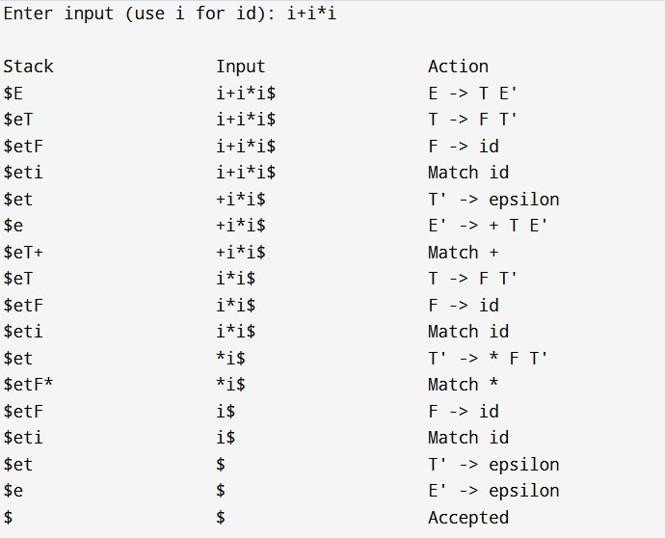
Q7. OPERATOR PRECEDENCE PARSING DESIGN AND EVALUATION:
Aim
To design an Operator Precedence Parser for the given grammar and evaluate its correctness by parsing the input: Input: id + id * id
Step 1: Given Grammar
E → E + E
E → E * E
E → (E)
E → id

Step 2: Operators
The terminals (operators and symbols) are:
Terminal | Meaning
id | Identifier
+ | Addition
* | Multiplication
( | Left Parenthesis
) | Right Parenthesis

Step 3: Define Operator Precedence Relations There are three precedence relations:
Symbol | Meaning
< | Shift (lower precedence)
= | Equal precedence (used for matching parentheses)
> | Reduce (higher precedence)

Step 4: Associativity Rules
Operator | Associativity
+ | Left Associative
* | Left Associative
() | Highest Priority

Precedence Order
Highest
()
*
+
Lowest
Therefore,
- * has higher precedence than +.
- + and * are left associative.

Step 5: Operator Precedence Table
 | id | + | * | ( | ) | $
id | - | > | > | - | > | >
+ | < | > | < | < | > | >
* | < | > | > | < | > | >
( | < | < | < | < | = | -
) | - | > | > | - | > | >
$ | < | < | < | < | - | Accept
- < → Shift
- > → Reduce
- = → Match Parentheses
Step 6: Detect and Resolve Conflicts
Conflict 1: + vs * Expression:
id + id * id
Since
+ < *
Parser shifts * before reducing.
Conflict 2: + vs + Expression:
id + id + id
Since + is left associative
+ > +
Parser reduces the left expression first
Conflict 3: * vs * Expression:
id * id * id
Since * is left associative
* > * Parser reduces the left multiplication first.

Step 7: Step-by-Step Parsing Input
id + id * id $
Initial Stack
$

Parsing Actions
Step | Stack | Input | Relation | Action
1 | $ | id+id*id$ | $ < id | Shift id
2 | $ id | +id*id$ | id > + | Reduce id → E
3 | $ E | +id*id$ | $ < + | Shift +
4 | $ E + | id*id$ | + < id | Shift id
5 | $ E + id | *id$ | id > * | Reduce id → E
6 | $ E + E | *id$ | + < * | Shift *
7 | $ E + E * | id$ | * < id | Shift id
8 | $ E + E * id | $ | id > $ | Reduce id → E
9 | $ E + E * E | $ | * > $ | Reduce E * E → E
10 | $ E + E | $ | + > $ | Reduce E + E → E
11 | $ E | $ | Accept | Accepted

Step 8: Parsing Decisions
Decision 1 Input id + id * id
Parser shifts * because
+ < *
Multiplication is evaluated first.
Decision 2 After reducing id * id expression becomes id + E
Now parser reduces
E + E

Step 9: Evaluation of Correctness Expression id + id * id
Parser produces id + (id * id) instead of
(id + id) * id
Therefore,
- Multiplication has higher precedence than addition.
- Addition is left associative.
- Multiplication is left associative.
- Parentheses have the highest priority.
- No conflicts occur in the precedence table.

C program for an Operator Precedence Parser
#include <stdio.h> #include <string.h> char stack[50]; int top = -1; void push(char ch)
{ stack[++top] = ch;
} void pop() { top--; } char topElement() { return stack[top];
} int precedence(char op)
{ switch(op)
{ case '+': return 1; case '*': return 2; case 'i': return 3; // id case '$': return 0; default: return -1;
}
} int main() { char input[50]; int i = 0; printf("Enter expression (use i for id): "); scanf("%s", input); strcat(input, "$"); push('$'); printf("\n%-20s %-20s %-20s\n", "Stack", "Input", "Action"); while(1)
{
printf("%-20s %-20s", stack, input + i); char a = input[i]; if(a == 'i') { push('i'); printf("Shift id\n"); i++;
printf("%-20s %-20sReduce id -> E\n", stack, input + i);
pop(); push('E');
} else if(a == '+' || a == '*')
{
while(topElement()=='+' || topElement()=='*')
{
if(precedence(topElement()) >= precedence(a))
{ printf("Reduce\n"); pop();
} else break; } push(a); printf("Shift %c\n", a); i++; } else if(a=='$')
{
while(topElement()=='+' || topElement()=='*')
{ printf("Reduce\n"); pop();
}
if(topElement()=='E')
{ pop(); if(topElement()=='$')
{
printf("%-20s %-20sAccepted\n", stack, input+i);
break;
} } else
{ printf("Rejected\n"); break;
}
} else
{ printf("Rejected\n"); break;
} } return 0;
}
Output:
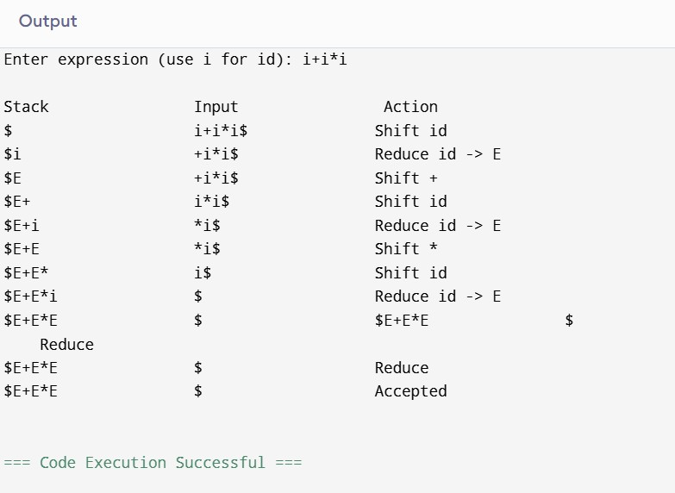
Q6. Comparative Analysis of SLR vs LALR vs CLR

Aim
To construct and compare SLR, LALR, and CLR parsing tables for the given grammar and analyze their conflicts, efficiency, and correctness.
Step 1: Given Grammar
S → L = R
S → R
L → * R
L → id
- → L

Step 2: Augmented Grammar
Add a new start symbol.
S' → S
- → L = R
S → R
L → * R
L → id
R → L

Step 3: FIRST Sets
Non-Terminal | FIRST
S | { *, id }
L | { *, id }
R | { *, id }

Step 4: FOLLOW Sets (Used in SLR)

FOLLOW(S)
Since S is the start symbol,
FOLLOW(S) = { $ }

FOLLOW(L)
From
S → L = R
After L comes '='.
Add '='.
From
R → L
L is at the end.
So add FOLLOW(R).
Therefore
FOLLOW(L) = { = , $ }

FOLLOW(R)
From
S → L = R
R is at the end.
Add FOLLOW(S).
From
L → * R
R is at the end.
Again add FOLLOW(L).
Therefore
FOLLOW(R) = { = , $ }

Step 5: LR(0) Item Sets

I0
S' → •S
S → •L = R
S → •R
L → •*R
L → •id
R → •L

I1
S' → S•

I2
S → L•=R
- → L•

I3
- → R•

I4
L → *•R
R → •L
L → •*R
L → •id

I5
L → id•

I6
S → L=•R
R → •L
L → •*R
L → •id

I7
L → *R•

I8
S → L=R•

Step 6: LR(1) Item Sets (CLR)
CLR keeps look-ahead symbols.
Example
[S → L•=R , $]

[R → L• , $]

[L → id• , =]
Each item contains a look-ahead.
CLR creates more states than LR(0).

Step 7: SLR Parsing Table (Simplified)
State | id | * | = | $ | S | L | R
0 | S5 | S4 |  |  | 1 | 2 | 3
1 |  |  |  | Accept
2 |  |  | S6 | R5
3 |  |  |  | R2
4 | S5 | S4 |  |  |  | 7
5 |  |  |  | R4
6 | S5 | S4 |  |  |  | 8
7 |  |  |  | R3
8 |  |  |  | R1

Step 8: LALR Parsing Table
LALR merges LR(1) states having the same LR(0) core.
Result
- Fewer states
- Same parsing power for most programming languages
- Smaller parsing table
No conflict occurs for this grammar.

Step 9: CLR Parsing Table
CLR keeps every LR(1) state separately.
Advantages
- No unnecessary conflicts
- Most accurate parser
Disadvantage
- Very large parsing table

Step 10: Conflicts

SLR
Possible conflicts may occur because SLR uses FOLLOW sets only.
For this grammar
No Shift-Reduce Conflict
No Reduce-Reduce Conflict

LALR
States are merged.
Still
No conflicts

CLR
Uses complete look-ahead.
Therefore
No conflicts
Step 11: Comparison of Number of States
Parser | Approximate States | Table Size
SLR | 9 | Small
LALR | 9 | Medium
CLR | 14 | Large

Step 12: Comparison Table
Feature | SLR | LALR | CLR
Uses FOLLOW Set | Yes | No | No
Uses LR(1) Items | No | Yes | Yes
Number of States | Small | Medium | Large
Memory Required | Low | Medium | High
Conflict Handling | Moderate | Better | Best
Parser Accuracy | Good | Very Good | Excellent
Practical Usage | Limited | Most Compilers | Rare

Step 13: Parsing the Input Input id = * id $
Parsing Steps
Step | Stack | Input | Action
1 | $ | id=*id$ | Shift id
2 | $ id | =*id$ | Reduce L→id
3 | $ L | =*id$ | Shift =
4 | $ L= | *id$ | Shift *
5 | $ L=* | id$ | Shift id
6 | $ L=*id | $ | Reduce L→id
7 | $ L=*L | $ | Reduce R→L
8 | $ L=*R | $ | Reduce L→*R
9 | $ L=R | $ | Reduce S→L=R
10 | $ S | $ | Accept

Step 14: Result Input : id = * id
Result : String Accepted

Step 15: Conclusion
- SLR is simple and uses FOLLOW sets, but it may produce conflicts for some grammars.
- LALR merges compatible LR(1) states, reducing table size while retaining most of CLR's power.
- CLR (Canonical LR) is the most powerful and accurate because it uses full LR(1) look-aheads, but it requires the largest parsing table.
- For this grammar, all three parsers successfully parse id = * id without conflicts.
- LALR is generally considered the most efficient choice because it offers nearly the same parsing capability as CLR while using much less memory. This is why tools such as YACC and Bison generate LALR parsers.

C program SLR/LR parser simulation
#include <stdio.h>
#include <string.h>

int main() { char input[50];

printf("Grammar:\n"); printf("S -> L = R | R\n"); printf("L -> *R | id\n"); printf("R -> L\n\n");

printf("Use 'i' for id\n"); printf("Example: i=*i\n\n");

printf("Enter the input string: "); scanf("%s", input);

int len = strlen(input);

// Pattern: i=*i if (len == 4 && input[0] == 'i' && input[1] == '=' && input[2] == '*' && input[3] == 'i')
{ printf("\nParsing Steps:\n"); printf("---------------------------\n"); printf("Shift i\n"); printf("Reduce L -> id\n"); printf("Shift =\n"); printf("Shift *\n"); printf("Shift i\n"); printf("Reduce L -> id\n"); printf("Reduce R -> L\n"); printf("Reduce L -> *R\n"); printf("Reduce S -> L = R\n"); printf("\nString Accepted\n");
}
// Pattern: i else if (len == 1 && input[0] == 'i')
{ printf("\nParsing Steps:\n"); printf("---------------------------\n"); printf("Shift i\n"); printf("Reduce L -> id\n"); printf("Reduce R -> L\n"); printf("Reduce S -> R\n"); printf("\nString Accepted\n");
} else
{ printf("\nString Rejected\n");
}

return 0;
}
Output:
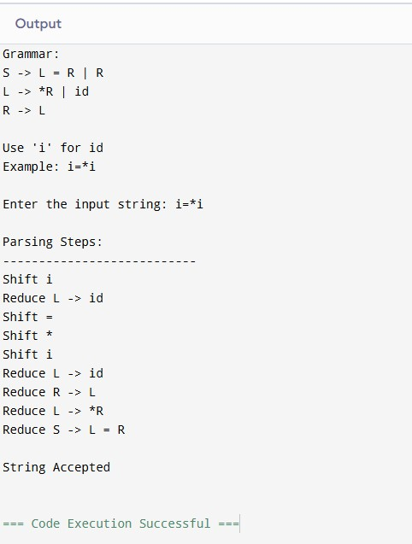

Question 13:
