SIMATS ENGINEERING
ASSESSMENT TOOL 1

COURSE CODE: CSA14 COURSE NAME: COMPILER DESIGN

COURSE OUTCOME COVERED

CO3: Analyse syntax-directed translation method using synthesized and inherited attributes to generate a Parser Tree. (BL4)

Assessment Tool Weightage: 40%

QUESTIONS:5 | Annexure A  EXPERIMENTS | Total Marks:100

Code of Conduct:

I Deepak Rao L / 192421170 certify that this submission is my original work and that I have adhered to the guidelines specified for this assessment.
I understand that any violation of academic integrity rules will result in disciplinary action.

Signature of the student:

Deepak Rao L

Annexure A

EXPERIMENTS

Q1.You are developing a compiler-based desk calculator that evaluates arithmetic expressions using syntax-directed definitions (SDD).
The system should:
- Accept an arithmetic expression with operators +, -, *, / and parentheses
- Use syntax-directed evaluation to compute values based on operator precedence
- Optimize evaluation by reducing unnecessary temporary computations
- Display the final result of the expression
Demonstrate how SDD rules (synthesized attributes) are used for expression evaluation.
SDD
Grammar with semantic rules:
E → E + T { E.val = E1.val + T.val }
E → E - T { E.val = E1.val - T.val }
E → T { E.val = T.val }

T → T * F { T.val = T1.val * F.val }
T → T / F { T.val = T1.val / F.val }
T → F { T.val = F.val }

F → (E) { F.val = E.val }
F → digit { F.val = digit }

CODE:
#include <stdio.h>
#include <stdlib.h> #include <ctype.h> char expr[100]; int pos = 0;
/* Function declarations */ double E(); double T(); double F();

/* E -> E + T | E - T | T */ double E()
{ double val = T(); while (expr[pos] == '+' || expr[pos] == '-')
{
char op = expr[pos++]; double tval = T(); if (op == '+') val = val + tval; // E.val = E1.val + T.val else val = val - tval; // E.val = E1.val - T.val
} return val;
}

/* T -> T * F | T / F | F */ double T() { double val = F(); while (expr[pos] == '*' || expr[pos] == '/')
{
char op = expr[pos++]; double fval = F(); if (op == '*') val = val * fval; // T.val = T1.val * F.val else {
if (fval == 0)
{
printf("Error: Division by zero!\n"); exit(1);
} val = val / fval; // T.val = T1.val / F.val
} }
return val;
}

/* F -> (E) | digit */ double F() { double val;

/* F -> (E) */ if (expr[pos] == '(')
{
pos++; // Skip '(' val = E(); // F.val = E.val

if (expr[pos] != ')')
{ printf("Error: Missing ')'\n"); exit(1);
} pos++; // Skip ')'
}
/* F -> digit */ else if (isdigit(expr[pos]))
{ val = 0;

/* Allows multi-digit numbers */ while (isdigit(expr[pos]))
{ val = val * 10 + (expr[pos] - '0'); pos++;
}

/* F.val = digit */
} else
{ printf("Error: Invalid expression!\n"); exit(1); } return val;
}

int main() { double result; printf("Enter arithmetic expression: "); fgets(expr, sizeof(expr), stdin); result = E(); while (expr[pos] == ' ' || expr[pos] == '\t') pos++; if (expr[pos] != '\n' && expr[pos] != '\0')
{ printf("Error: Invalid expression!\n"); return 1;
}
printf("\nFinal Result = %.2lf\n", result); return 0;
}

OUTPUT:

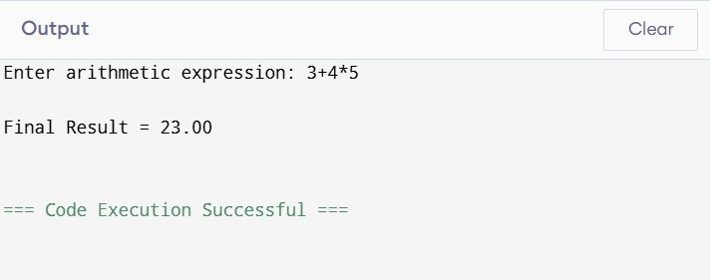

Q2. In a compiler, postfix expressions are evaluated during code generation using stack-based bottom-up evaluation.
Write a C program that:
- Evaluates a postfix expression
- Demonstrates S-attributed definition evaluation (iii) Shows how intermediate results are computed
CODE:
#include <stdio.h>
#include <stdlib.h>
#include <ctype.h>

int stack[100]; int top = -1; void push(int value)
{
stack[++top] = value;
}

int pop() { return stack[top--]; } int main() { char postfix[100]; int i, a, b, result; printf("Enter postfix expression: "); scanf("%s", postfix); printf("\nIntermediate Results:\n"); for (i = 0; postfix[i] != '\0'; i++)
{ if (isdigit(postfix[i]))
{ result = postfix[i] - '0'; push(result); printf("Push %d\n", result);
} else { b = pop(); a = pop(); switch (postfix[i])
{ case '+': result = a + b; break;
case '-': result = a - b; break;
case '*': result = a * b; break;
case '/': if (b == 0)
{
printf("Error: Division by zero\n"); return 1; } result = a / b; break; default: printf("Invalid operator\n"); return 1;
}

printf("%d %c %d = %d\n",
a, postfix[i], b, result); push(result);
} } if (top != 0)
{ printf("Invalid postfix expression\n"); return 1;
}
printf("\nFinal Result = %d\n", stack[top]); return 0;
}
OUTPUT:
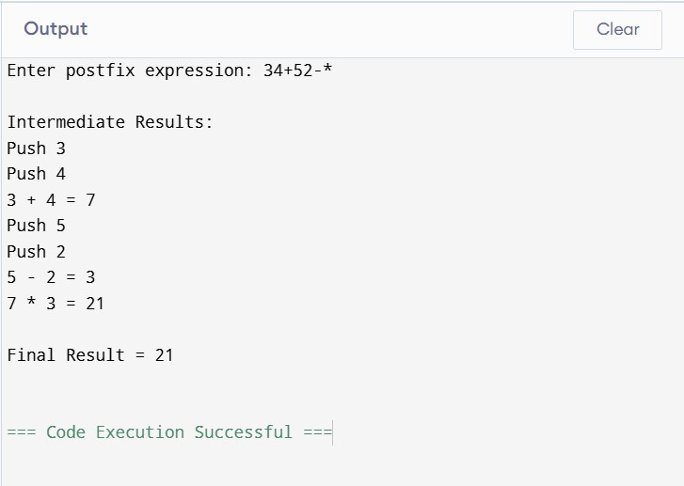
Q3.You are designing a parser that uses L-attributed definitions, where inherited attributes are passed from parent to child.
Write a C program that:
(i).Evaluates a simple expression like a + b * c
(ii) Uses function parameters to simulate inherited attributes
(iii). Ensures correct precedence handling
(iv). Demonstrates top-down evaluation logic
Explain how inherited attributes influence computation.
CODE:
#include <stdio.h>
#include <ctype.h>

char expr[100]; int pos = 0;

/* Function declarations */ int E(); int EPrime(int inherited); int T(); int TPrime(int inherited); int F();

/* E -> T E' */ int E()
{
int t;

t = T(); return EPrime(t);
}

/* E' -> + T E' | epsilon */ int EPrime(int inherited)
{
int t;

if (expr[pos] == '+')
{ pos++; t = T();

/* Pass inherited value to E' */ return EPrime(inherited + t);
}

return inherited;
}

/* T -> F T' */ int T() {
int f;
f = F(); return TPrime(f);
}

/* T' -> * F T' | epsilon */ int TPrime(int inherited) {
int f;

if (expr[pos] == '*')
{ pos++; f = F();

/* Pass inherited value to T' */ return TPrime(inherited * f);
}

return inherited;
}

/* F -> digit */ int F() { int value;
if (isdigit(expr[pos]))
{ value = expr[pos] - '0'; pos++; return value;
}

printf("Invalid expression\n"); return 0; }

int main() { int result;

printf("Enter expression: "); scanf("%s", expr);

result = E();

printf("Expression = %s\n", expr); printf("Result = %d\n", result);

return 0; } OUTPUT:
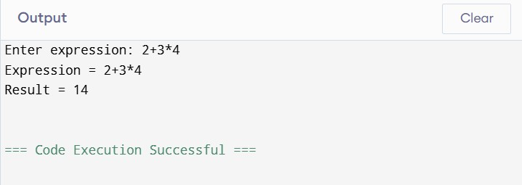

Q4.In a compiler, it is important to check whether two type expressions are equivalent.
Write a C program that:
(i).Accepts two type expressions (e.g., int, float, int*)
(ii).Compares them for type equivalence
(iii).Displays whether they are:
(a).Equivalent
(b).Not equivalent
Extend the logic to handle pointer types (int*, float*).
CODE:
#include <stdio.h> #include <string.h> int main() { char type1[50], type2[50];

printf("Enter first type expression: ");
scanf("%s", type1); printf("Enter second type expression: "); scanf("%s", type2);
/* Compare type expressions */ if (strcmp(type1, type2) == 0)
{ printf("Equivalent\n");
} else
{ printf("Not Equivalent\n");
} return 0;
}

OUTPUT:
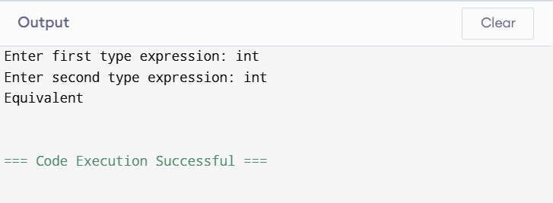

Q5.You are building a semantic analyzer that detects type errors in arithmetic expressions.
Write a C program that:
(i). Accepts two operands and their types
(ii). Checks whether the operation (e.g., +, *) is valid
(iii). Reports:
(a).Valid expression
(b).Type error (e.g., int + char*)
Demonstrate how compilers detect semantic errors during type checking

CODE:
#include <stdio.h> #include <string.h> int main() { char operand1[20], operand2[20]; char type1[20], type2[20]; char op; printf("Enter first operand: "); scanf("%s", operand1); printf("Enter type of first operand: "); scanf("%s", type1); printf("Enter operator (+, -, *, /): "); scanf(" %c", &op); printf("Enter second operand: "); scanf("%s", operand2);

printf("Enter type of second operand: "); scanf("%s", type2);

/*
Arithmetic operations are allowed between int and float types.
*/ if ((strcmp(type1, "int") == 0 || strcmp(type1, "float") == 0) && (strcmp(type2, "int") == 0 || strcmp(type2, "float") == 0))
{ if (op == '+' || op == '-' || op == '*' || op == '/')
{
printf("\nValid expression\n"); if (strcmp(type1, "float") == 0 || strcmp(type2, "float") == 0)
{ printf("Result type: float\n");
} else
{ printf("Result type: int\n");
} } else
{
printf("\nInvalid operator\n");
} } else
{ printf("\nType error\n"); } return 0;
}

OUTPUT:
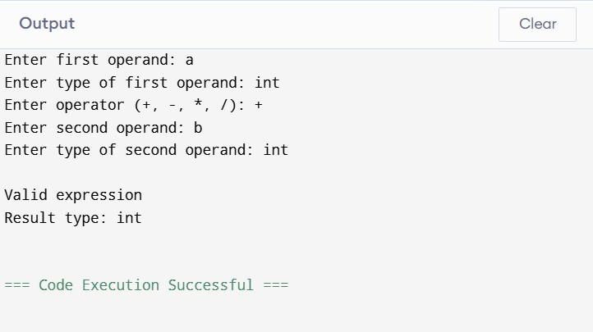

RUBRICS FOR CALCULATION

Criteria | Weightage | Level 4 – Exemplary | Level 3 –  Proficient | Level 2 –  Developing | Level 1 –  Beginning
Understanding of Concepts | 25 | Demonstrates thorough  understanding and  effectively integrates multiple  concepts/technologie  s | Good understanding with proper  integration of most concepts | Basic understanding;  limited or partial integration | Poor understanding; unable to integrate concepts
Experimental Design | 30 | Well-planned, systematic  implementation with optimal solution | Correct implementation with minor issues | Basic implementation with errors or inefficiencies | Incorrect or incomplete implementation
Use of Tools | 20 | Effective and advanced use of  tools/technologies with proper configuration | Appropriate use of tools with correct execution | Limited or inconsistent use of tools | Incorrect or minimal use of tools
Analysis of Results | 15 | Insightful analysis with accurate  interpretation and validation of results | Good analysis with reasonable interpretation | Basic analysis with limited insights | Poor or incorrect analysis of results
Documentatio n | 10 | Clear, well-structured documentation with  diagrams, code, and  results | Organized documentation with necessary details | Basic documentation  with missing details | Poor or incomplete documentation

