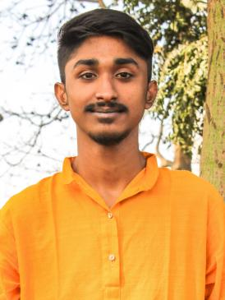

**Anish Mondal**

Email : [anishuem10@gmail.com](mailto:Hello@wps.com)

Phone：8584975903

Address: 12/1a/130 chow baga road bidhan nagar(S) kolkata - 700039

**CONTACT ME**

**PROFESSIONAL ABRIDGEMENT**

A versatile, dynamic and self driven professional

with outstanding ability to manage multiple

assignments together including Management

projects. Willing to add value to the existing process

all the time; Additional capabilities of excellent

- A professional website for PIYALI WELFARE FOUNDATION.

- A blog website.

**PROJECTS**

communication, innovative thinking and quick

adaptability skills. A professional desired to get

instrumental with the comprehensive growth of the

organisation while refining present standards of

skills, knowledge and efficiency regularly.

C

C++

java

PYTHON

AI & ML

HTML & CSS

JAVA SCRIPT

DBMS/SQL

WORDPRESS

REACT,MONGODB

Designing tools

(PS,AE,LR,PR,FILMORA)

**Technical SKILLS**

**A . R . M . S, University of Engineering and Management,Jaipur**

HEAD OF THE DESIGNING AND WEBSITE MANAGEMENT

**I.O.T. Workshop,Robotics Workshop,University of Engineering and Management Jaipur**

Student Volunteer

**Extra curricular activities**

Introduction to SQL, Coursera (January 2021 - February 2021)

Introduction to Data Structures, Coursera (April 2021 - May 2021)

Introduction to Python Data Structures, Coursera (May 2021 - June 2021 )

**COURSES**

**Secondary education** - Jodhpur Park Boys High School(2005-2017), Kolkata

**Higher Secondary education** - Ballygagunge Govt. High School(2017-2019), Kolkata

**Graduation** - B.Tech Computer Science Engineering, University of Engineering & Management,Jaipur,Jaipur(2019-2023)

**EDUCATION**

MANAGEMENT

LEADERSHIP

TEAMWORK

CONFIDENT

**PROFESSIONAL**