Computer Networks   
Lab Assignment Documentation

DEEKSHA S M

RA2211026050041

CSE AIML- A

Lab 1: Introduction to Packet Tracer, Peer-to-Peer Communication, Study of Cables and its Color Codes

1. Open Packet Tracer:

■ Launch Cisco Packet Tracer on your computer.

■ Familiarize yourself with the interface, including the workspace, device selection, and tools.

2. Create a Simple Network:

■ Drag two computers (PC-PT) onto the workspace.

■ Drag a switch (Switch-PT) onto the workspace.

■ Connect each computer to the switch using straight-through Ethernet cables.

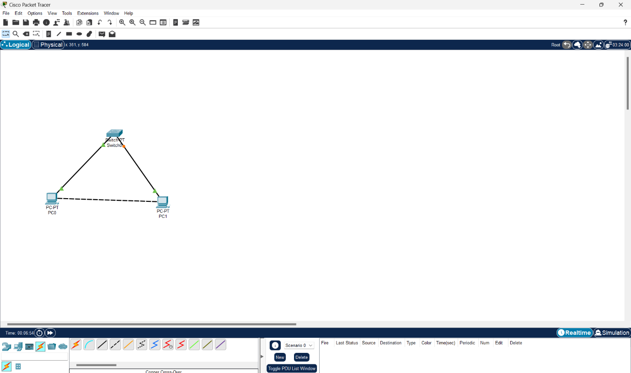

3. Configure IP Addresses:

■ Click on the first computer, go to the Desktop tab, and select IP Configuration.

■ Assign an IP address (e.g., 192.168.1.1) and a subnet mask (e.g., 255.255.255.0).

■ Click on the second computer, go to the Desktop tab, and select IP Configuration.

■ Assign an IP address (e.g., 192.168.1.2) and a subnet mask (e.g., 255.255.255.0).

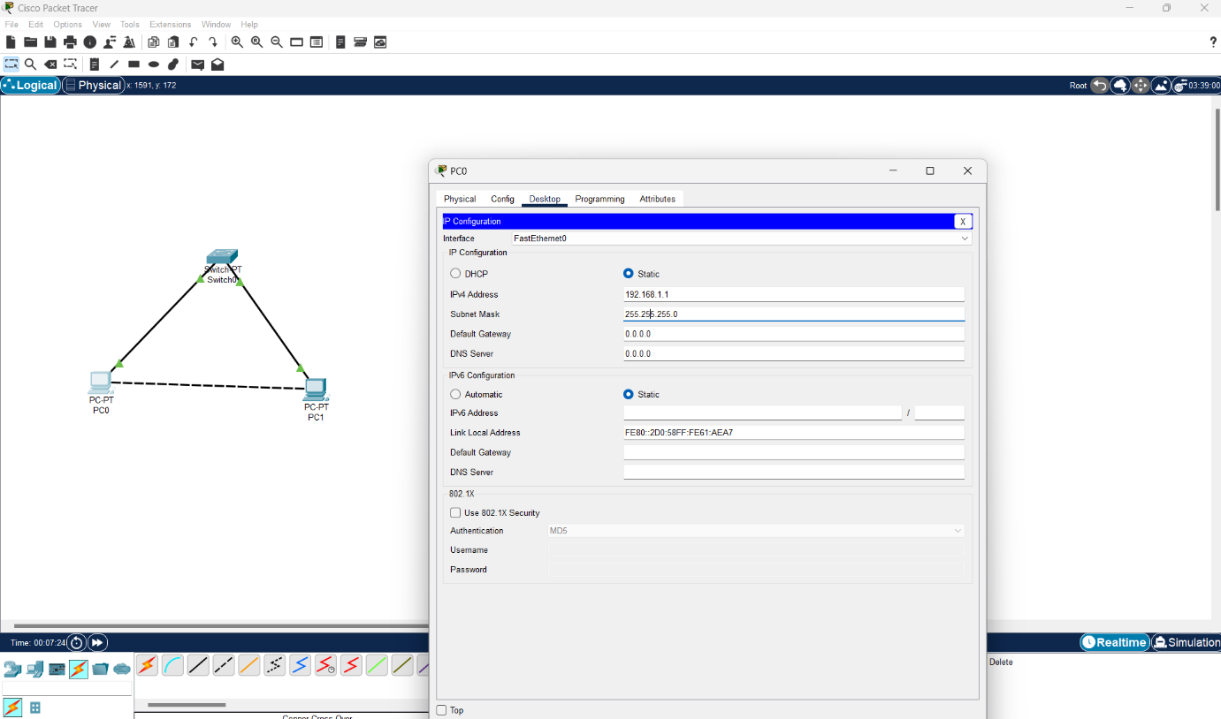

For PC1

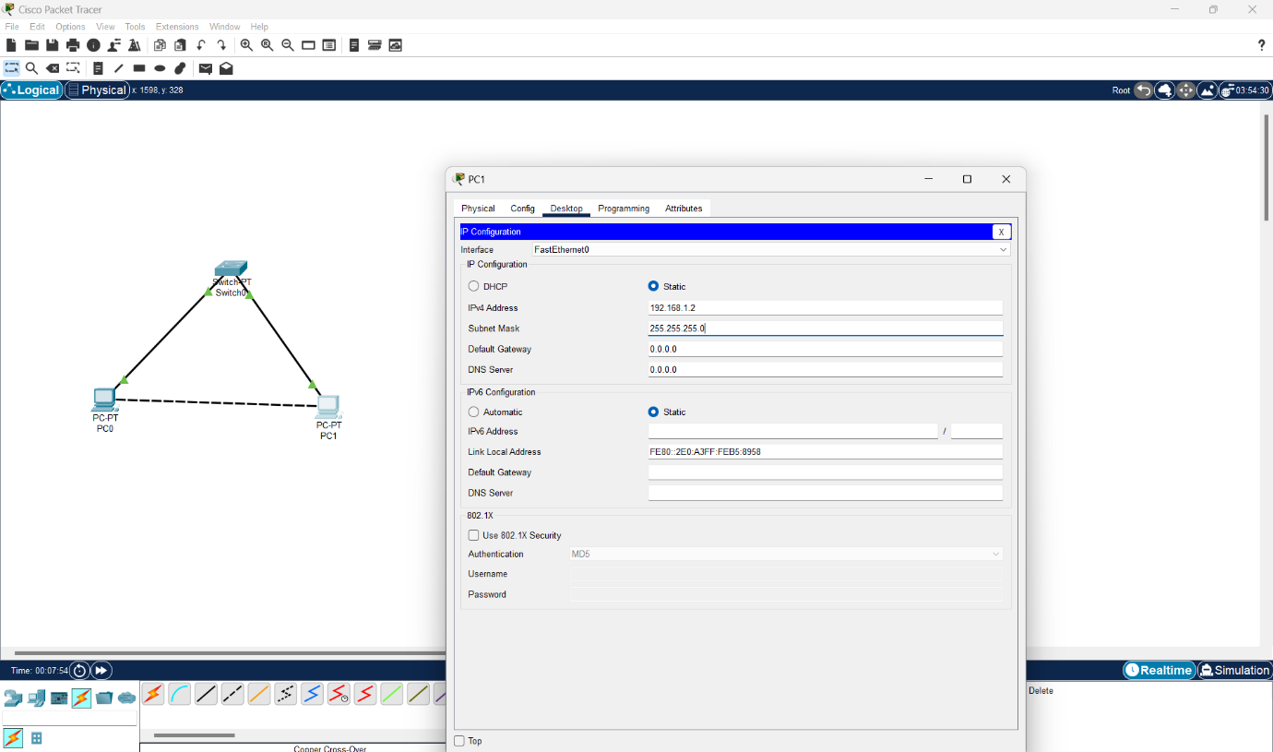

For PC2

4. Test Peer-to-Peer Communication:

■ On the first computer, open the Command Prompt from the Desktop tab.

■Use the ping command to test connectivity to the second computer (e.g.,

ping 192.168.1.2).

■ Observe the response to ensure the computers can communicate.

5. Study Cables and Color Codes:

■ Examine different types of network cables provided (Ethernet, crossover).

**Different types of network cables used in computer networking**

1. Twisted Pair Cables

Twisted pair cables are the most common type of network cable used in LAN (Local Area Network) environments. They consist of pairs of wires twisted together to reduce electromagnetic interference.

a. Unshielded Twisted Pair (UTP):

* Structure: UTP cables have four pairs of wires twisted together. Each pair has a different number of twists per inch to minimize interference between pairs.
* Categories:
  + Cat5e (Category 5e): Supports up to 1 Gbps (Gigabit per second) over a distance of 100 meters.
  + Cat6 (Category 6): Supports up to 10 Gbps over a distance of 55 meters and 1 Gbps over 100 meters.
  + Cat6a (Augmented Category 6): Supports up to 10 Gbps over 100 meters, with better performance against crosstalk.
  + Cat7 (Category 7): Supports up to 10 Gbps over 100 meters, with additional shielding to further reduce interference.
* Applications: Widely used in Ethernet networks for connecting computers, routers, switches, and other network devices.

b. Shielded Twisted Pair (STP):

* Structure: Similar to UTP but with an additional shield around each pair of wires or around all pairs together. The shield can be foil, braid, or both.
* Applications: Used in environments with high electromagnetic interference (EMI) or radio frequency interference (RFI), such as industrial settings or areas near large electrical equipment.

2. Coaxial Cables

Coaxial cables were more commonly used in older network architectures but are still used in some specific applications today.

RG-6 and RG-59:

* Structure: Coaxial cables consist of a central conductor (usually copper), surrounded by an insulating layer, a metallic shield (braid or foil), and an outer protective jacket.
* Applications:
  + RG-6: Used for cable television, satellite TV, and broadband internet connections.
  + RG-59: Used for analog video signals and older CCTV systems. It has a higher attenuation than RG-6, making it suitable for shorter distances.

• Purpose: Transmission of video, data, and internet signals.

• Used: Older Ethernet networks, cable television, broadband internet connections.

3. Fiber Optic Cables

Fiber optic cables are used for high-speed, long-distance data transmission. They transmit data as light pulses rather than electrical signals.

a. Single-Mode Fiber (SMF):

* Structure: SMF cables have a small core (typically around 9 microns in diameter) that allows only one light wave to pass through.
* Advantages:
  + Capable of transmitting data over long distances (up to several kilometers) with minimal signal loss.
  + Higher bandwidth and lower latency compared to multi-mode fiber.
* Applications: Used in long-distance telecommunications, data centers, and internet backbone connections.

b. Multi-Mode Fiber (MMF):

* Structure: MMF cables have a larger core (typically around 50 or 62.5 microns in diameter) that allows multiple light waves to pass through, leading to more signal dispersion.
* Advantages:
  + Easier to install and align than SMF.
  + Typically used for shorter distances (up to 500 meters).
* Applications: Used in local area networks (LANs), data centers, and campus networks.

4. Ethernet Cables

* Structure: A crossover cable is a type of twisted pair cable where the transmit and receive wires are "crossed" at one end. In other words, the pinout at one end of the cable is different from the other.
* Applications: Used to directly connect two network devices of the same type, such as two computers or two switches, without the need for an intermediary device like a switch or hub. With the advent of Auto MDI-X technology, most modern network devices can automatically adjust to straight-through cables, reducing the need for crossover cables.

4.1) Straight-Through Cable

* A straight-through cable uses the same wiring standard on both ends, either T568A or T568B.
* T568A Standard:
  1. Pin 1: White/Green
  2. Pin 2: Green
  3. Pin 3: White/Orange
  4. Pin 4: Blue
  5. Pin 5: White/Blue
  6. Pin 6: Orange
  7. Pin 7: White/Brown
  8. Pin 8: Brown
* T568B Standard:
  1. Pin 1: White/Orange
  2. Pin 2: Orange
  3. Pin 3: White/Green
  4. Pin 4: Blue
  5. Pin 5: White/Blue
  6. Pin 6: Green
  7. Pin 7: White/Brown
  8. Pin 8: Brown
* Purpose of Straight-Through Cables:
  1. Used to connect different types of devices, such as a computer to a switch or a router to a modem.

4.2) Crossover Cable

* A crossover cable uses the T568A standard on one end and the T568B standard on the other end.
* T568A End:
  1. Pin 1: White/Green
  2. Pin 2: Green
  3. Pin 3: White/Orange
  4. Pin 4: Blue
  5. Pin 5: White/Blue
  6. Pin 6: Orange
  7. Pin 7: White/Brown
  8. Pin 8: Brown
* T568B End:
  1. Pin 1: White/Orange
  2. Pin 2: Orange
  3. Pin 3: White/Green
  4. Pin 4: Blue
  5. Pin 5: White/Blue
  6. Pin 6: Green
  7. Pin 7: White/Brown
  8. Pin 8: Brown
* Purpose of Crossover Cables:
  1. Used to directly connect two similar devices, such as two computers or two switches, without an intermediate device like a hub or switch.

5. Patch Cables

* Structure: Patch cables are short cables, typically made from twisted pair, coaxial, or fiber optic materials. They have connectors on both ends, like RJ45 for twisted pair cables.
* Applications: Used to connect devices to a switch, hub, or router within a patch panel or directly between devices in a data center. They are often used in structured cabling systems.

6. Serial and Parallel Cables

Serial and parallel cables were used in older computer networks and peripheral connections before the advent of USB and other modern interfaces.

a. Serial Cables:

* Structure: Serial cables transmit data one bit at a time over a single channel. The RS-232 standard is a common example, often used for connecting modems and other serial devices.
* Applications: Used in older networking setups, point-of-sale (POS) systems, and industrial equipment.

b. Parallel Cables:

* Structure: Parallel cables transmit multiple bits of data simultaneously, with each bit traveling on its own wire. The Centronics connector was commonly used with parallel printers.
* Applications: Primarily used to connect printers and other peripherals to computers. Parallel ports are now largely obsolete, replaced by USB and other modern interfaces.

7. USB and Thunderbolt Cables

* Structure: These cables are used to connect peripheral devices to computers, and they can also be used to connect network adapters, enabling a computer to join a network.
* USB Cables: Universal Serial Bus (USB) cables are commonly used for connecting a wide range of devices, including keyboards, mice, external drives, and network adapters.
* Thunderbolt Cables: A high-speed interface developed by Intel and Apple, Thunderbolt cables can transfer data, video, and power through a single cable.
* Applications:
  + USB Ethernet Adapters: Allow computers without built-in Ethernet ports to connect to a wired network.
  + Thunderbolt Networking: Allows two Thunderbolt-equipped computers to be directly connected for high-speed data transfer.

**SUMMARY:**

Lab_1 made us familiar with cisco packet tracer and how to set up (P2P) communication network. And to study different types of cables used in networking and their colour codes.