**Employee ID: SP 11252**

**Employee Name: DEEKSHITA NAIR**

**Project Name: Online Event Management System for Institutions**

**Project background:**

An online event management system for institutions is designed to simplify the process of planning, organizing and managing various events and activities within a school or a college. Such a system can be used for events like tech fest, cultural events or sports events. How the project works? There will be head coordinators for each event who will manage the entire event. The event coordinators are those who prepare events in a meaningful way and head coordinators can either approve, cancel or queue an event. All students can participate in more than one event also an event can have ‘n’ number of students. Here, too head coordinator will check whether the registration of the student is approved or cancelled. Event details table will hold venue details from venue table so as the student get proper idea about where to attend the event.

**Project Objective:**

An online event management system for institutions aims to automate and digitize the entire event management process. It provides a centralized platform for head coordinators, event coordinators and students to create, schedule, and manage events efficiently.

**Activities:**

**1. Creating Tables using Queries**

I have created 9 tables which will help to connect between events and students.

create table Coordinator

(

Co_id int,

Co_firstname varchar(50),

Co_lastname varchar(50),

Contact varchar(50),

Event_type varchar(50)

)

create table Student

(

S_id int,

first_name varchar(50),

middle_name varchar(50),

last_name varchar(50),

contact varchar(50),

city varchar(50),

Date_of_birth date,

Dept_code int,

Year INT

)

create table Event_Coordinator

(

E_CO_ID int,

E_COOR_name varchar(50),

contact varchar(50)

)

create table Student_Event

(

S_id int,

Event_id int,

status_id int

)

create table Flag

(

Flag_id int,

Flag_name varchar(50)

)

create table department

(

dept_code int,

dept_name varchar(50)

)

create table venue

(

venue_id int,

venue_name varchar(50),

)

create table status

(

status_id int,

status_name varchar(50),

)

create table Event_Details

(

Event_id int,

Event_name varchar(50),

Event_desc varchar(200),

Reg_start_date date,

Reg_end_date date,

Event_start_date date,

Event_end_date date,

Event_start_time time,

Event_end_time time,

E_CO_ID int,

CO_ID int,

flag_id int,

venue_id int,

seats_left int

)

**2.. Data Flow Diagram**

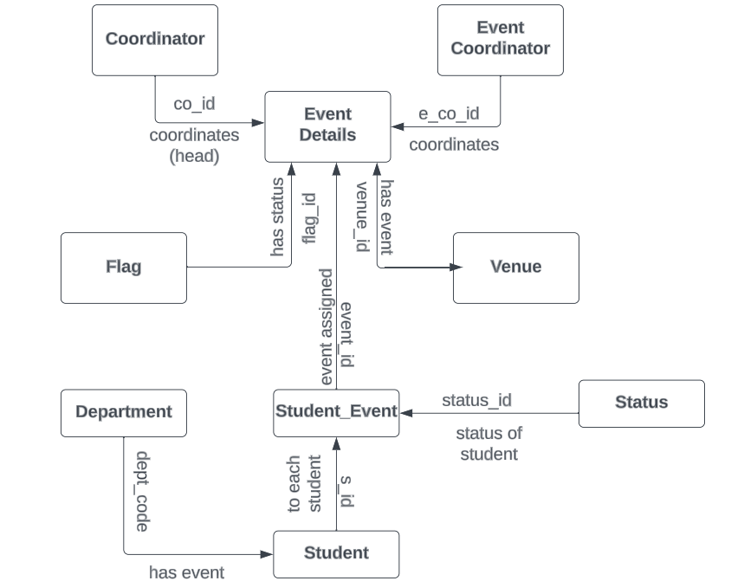

**3.. Schema / Diagram**

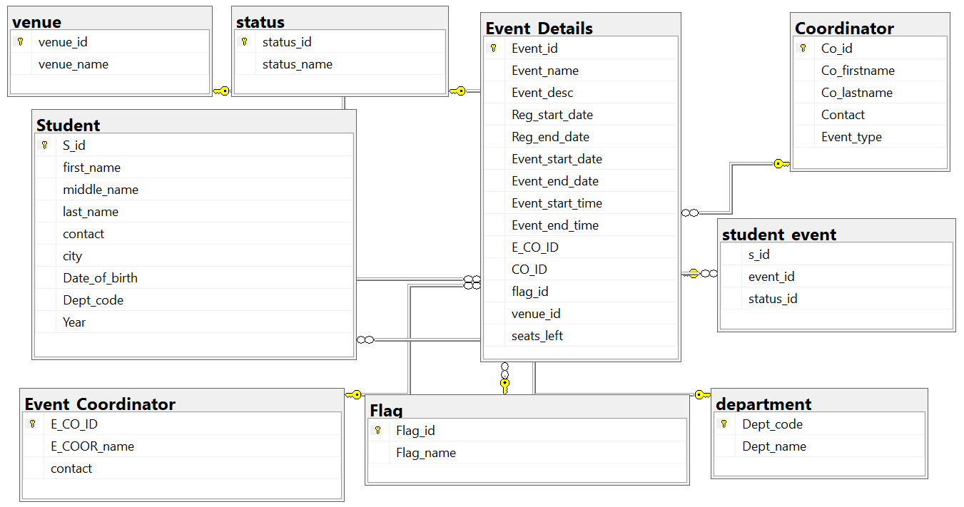

**4. Entering Data in tables using queries and triggers**

* INSERT INTO STUDENT (s_id, first_name, middle_name, last_name, city, contact, date_of_birth, dept_code, year) VALUES (1, 'John', 'William', 'Doe', 'New York', '555-555-5555', '2000-05-15', 'CS101', 2023)
* INSERT INTO DEPARTMENT (Dept_code, Dept_name) VALUES ('CS101', 'Computer Science')
* INSERT INTO COORDINATOR values (1,'Reena','Subhash','45678-89786','CULTURAL')
* INSERT INTO FLAG values(1,'Approved'),(2,'Cancelled'),(3,'Pending')
* INSERT INTO EVENT_COORDINATOR VALUES(1, 'Sarah Johnson', '555-123-4567')
* INSERT INTO event_details VALUES(1, 'Annual Charity Gala', 'Fundraising event for local charities', '2023-04-15', '2023-04-16', '2023-03-01', '2023-04-10', '18:00:00', '22:00:00', 1, 1, 1,1,1)
* INSERT INTO STUDENT_EVENT (s_id, event_id, status) VALUES(1, 1, 'approved')
* INSERT INTO VENUE values(1,'abc')
* INSERT INTO STATUS values(1,'abc')

**Now, I have used two triggers in my project.**

First I have used AFTER INSERT trigger to create new tables (APPROVED, CANCELLED, and PENDING) for each event category based on the "inserted" table (which contains the newly inserted rows in the "Event_details" table)

create trigger triginsert on [dbo].[Event_details]

after insert

as

begin

drop table APPROVED

drop table CANCELLED

drop table PENDING

SELECT event_id,event_name

INTO APPROVED

FROM event_details

where flag_id=1

SELECT event_id,event_name

INTO CANCELLED

FROM event_details

where flag_ID=2

SELECT event_id,event_name

INTO PENDING

FROM event_details

where flag_ID=3

end

go

The second trigger is to be designed to handle events and their available seats based on the student_event table and the event_details table. It updates the seats_left in the event_details table when a student registers for an event and the registration become successful, and it updates the status_id to cancelled in the student_event table when there are no available seats.

create trigger trigafterinsert

on student_event

after insert

as

begin

declare @event_id int;

select @event_id=i.event_id from inserted i;

declare @status_id int;

select @status_id=i.status_id from inserted i;

declare @seats int;

select @seats=seats_left from event_details where event_id=@event_id;

if(@status_id=1 and @seats>0)

update event_details set seats_left=(seats_left-1) where event_id=@event_id

else

update student_event set status_id=2

end

**5. Creating Views**

In this view I have used data from three tables (Coordinator,Event_Details,Venue) so that it becomes easy for anyone to check what event is going on at what place and by whom.

create view venue_event

as

select co_firstname,event_name,venue_name

from Coordinator inner join

Event_details on Event_details.co_id=Coordinator.co_id

inner join venue on venue.venue_id=Event_Details.venue_id;

select * from venue_event

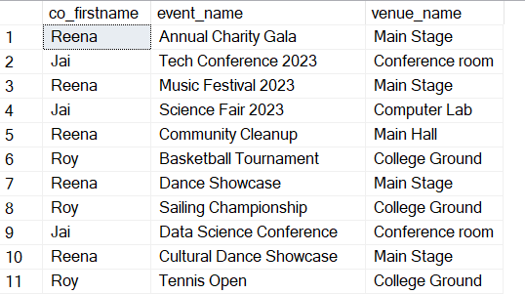

**6. Reports using queries**

1. **Report on the events along with their coordinators and status of approval.**

select event_id,event_name,e_coor_name,flag_name

from flag

inner join event_details

on event_details.flag_id=flag.flag_id

inner join event_coordinator

on event_details.E_CO_ID=Event_Coordinator.E_CO_ID

1. **Report on retrievel of students in each event who got registration successful**

SELECT e.event_name, concat(s.first_name,' ',s.last_name) as Enrolled_Students

FROM event_details e

LEFT JOIN student_event se ON e.event_id = se.event_id

inner JOIN student s ON se.s_id = s.s_id AND status_id=1

1. **Report on number of students in each department according their registration status**

select dept_name,[Registered],[Cancelled]

from (select dept_name,status_name,student.s_id

from department inner join student

on student.dept_code=department.dept_code

inner join student_event on student.s_id=student_event.s_id

inner join status on status.status_id=student_event.status_id) as Tab1

pivot (count(s_id) for status_name in ([Registered],[Cancelled])) as Tab2

1. **Report on getting the details of all the events also the student enrolled for each event with their status of registration**

SELECT E.Event_ID, E.Event_Name, E.event_Start_Time, E.event_End_Time, SE.S_ID, P.status_name

FROM Event_Details E

FULL JOIN Student_Event SE

ON E.Event_ID = SE.Event_ID

full join status P on P.status_id=SE.status_id

1. **Report on count of students in each event irrespective of their registration status**

select event_name,count(s_id) As Number_of_students

from student_event right join

event_details on event_details.event_id=student_event.s_id

group by event_name

1. **Report on the number of events scheduled in each month**

SELECT datename(month,event_start_date) AS Event_date, COUNT( event_id)

AS No_of_events

FROM event_details

group by datename(month,event_start_date),month(Event_start_date)

1. **Report on registered students with their respective events and venue place**

SELECT student.first_name,student.last_name, event_details.event_name,venue.venue_name

FROM student

INNER JOIN student_event ON student_event.s_id = student.s_id

INNER JOIN event_details ON event_details.Event_id = student_event.event_id

inner join venue on event_details.venue_id=venue.venue_id

WHERE event_details.event_id IN (SELECT event_id FROM event_details WHERE flag_id = 3)

and student_event.status_id=1;

1. **Assign username and password to registered students to access important information**

SELECT DISTINCT(CONCAT(student.first_name, ' ',student.middle_name, ' ', student.last_name)) AS full_name,

CONCAT(LOWER(LEFT(student.first_name, 1)), '.', lower(student.last_name), '@gmail.com') AS Username, student.contact AS Password

FROM student

left join student_event on student.S_id=student_event.s_id

inner join status

on status.status_id=student_event.status_id

where status.status_name like 'R%';

1. **Make a report on the events datewise that has been approved**

SELECT distinct(event_details.event_name), event_coordinator.e_coor_name, event_details.event_start_date

FROM event_details

INNER JOIN event_coordinator ON event_details.E_CO_ID = event_coordinator.E_CO_ID

INNER JOIN flag on flag.flag_id=1

ORDER BY event_details.event_start_date;

1. **Make a report on duration needed for each event**

SELECT distinct(event_details.event_name), DATEDIFF(DAY, event_details.event_start_date, event_details.event_end_date) AS duration

FROM event_details

order BY event_details.event_name;

1. **Report on number of events occurring at each venue**

select VENUE_name,[Cultural],[Sports],[Technical]

from (select venue_name,event_type,event_id

from event_details inner join venue

on Event_Details.venue_id=venue.venue_id

inner join coordinator on coordinator.co_id=event_details.co_id) as Tab1

pivot (count(event_id) for event_type in ([Cultural],[Sports],[Technical])) as Tab2

1. **Report on all events that are fully booked**

SELECT event_name FROM event_details e

WHERE NOT EXISTS (

SELECT 1 FROM event_details

WHERE event_id = e.event_id AND seats_left > 0)